Prevention of Central Line-Associated Bloodstream Infections
ICU & Non-ICU
Slide Title and Commentary | Slide Number and Slide
Prevention of Central Line-Associated Bloodstream Infections  SAY:  Welcome to this presentation on the Prevention of Central Line-Associated Bloodstream Infections—which will also be referred to as “CLABSI” for the remainder of this presentation.  This presentation will discuss the importance and implementation of evidence-based best practices to prevent CLABSI as part of an overall approach to preventing methicillin-resistant Staphylococcus aureus (MRSA) in intensive care units (ICU) and non-ICU hospital settings. | Slide 1  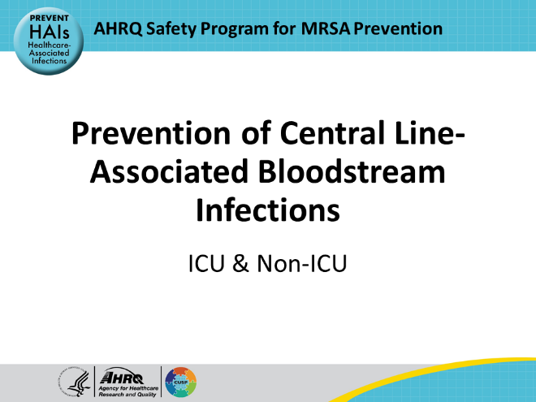
Educational Objectives  SAY:  This presentation will start by defining a central line-associated bloodstream infection (CLABSI) and identifying its significance to patient safety and MRSA prevention. Key evidence-based strategies to prevent CLABSI and implementation approaches to adapt these strategies will be discussed. | Slide 2  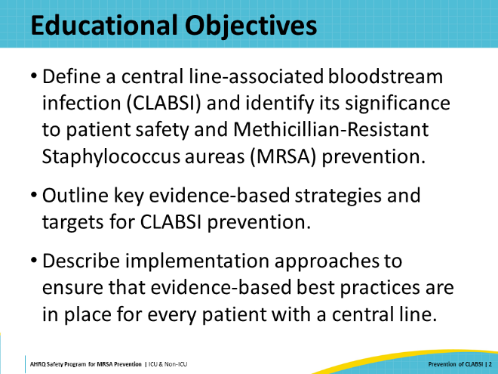
Key Strategies To Take Aim & Target MRSA Infection  SAY:  Preventing infections associated with medical devices and procedures is one of this toolkit’s Four Key Strategies for MRSA Prevention. Treatment with medical devices and procedures is often necessary to provide effective care to hospitalized patients. These devices and procedures are often lifesaving; however, they also place patients at an increased risk for healthcare-associated infections, or HAIs. | Slide 3  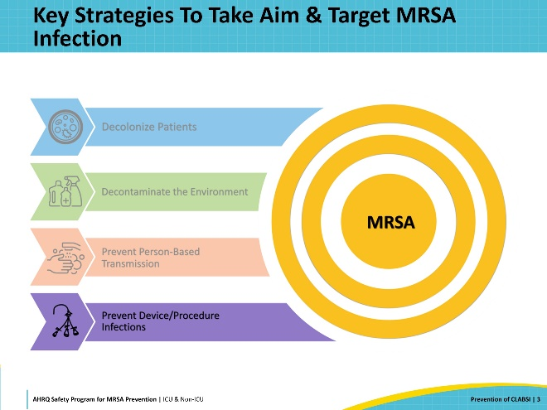
Preventing Device- & Procedure-Related Infections  SAY:  On any given day, approximately 1 in 31 hospital patients has at least one HAI. According to data from the National Healthcare Safety Network (NHSN), MRSA caused 48.4 percent of device-associated HAIs and 41.9 percent of surgical site infections (SSI) in acute care facilities from 2015 to 2017.  Therefore, reducing the burden of MRSA can significantly decrease the incidence of invasive disease due to CLABSI, SSI, and other HAIs.  This presentation periodically refers to materials and resources that were published in AHRQ’s Toolkit for Preventing CLABSI and CAUTI in ICUs. This toolkit is available publicly online on AHRQ’s website at the link provided. For a focused and in-depth review of CLABSI prevention, visit the website and review the contents. These resources can be adapted for use in non-ICUs as well. | Slide 4  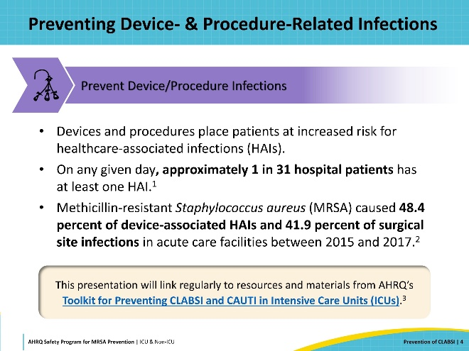
What Is a CLABSI?  SAY:  CLABSI occurs when an organism enters the bloodstream through a central line and develops into an infection. For purposes of surveillance, CLABSI is defined as a laboratory-confirmed bloodstream infection for which an eligible bloodstream infection organism is identified, and an eligible central line is present on the day of event or the day before (per the National Healthcare Safety Network [NHSN] criteria).  A central line is defined as an intravascular catheter that terminates at, or close to, the heart or in one of the great vessels that is used for infusion, withdrawal of blood, or hemodynamic monitoring. This definition includes tunneled and non-tunneled catheters, implanted ports, and umbilical catheters. Central lines are usually inserted by physicians, nurse practitioners, or physician assistants. Nurses are typically responsible for accessing the lines and providing ongoing catheter maintenance and care.  Arterial catheters are usually not considered central lines for CLABSI surveillance, though they can be a source of bloodstream contamination. Also excluded are arterial-venous (AV) fistulas and grafts, atrial catheters, extracorporeal membrane oxygenation (ECMO) lines, intra-aortic balloon pump devices, and ventricular assist devices. | Slide 5  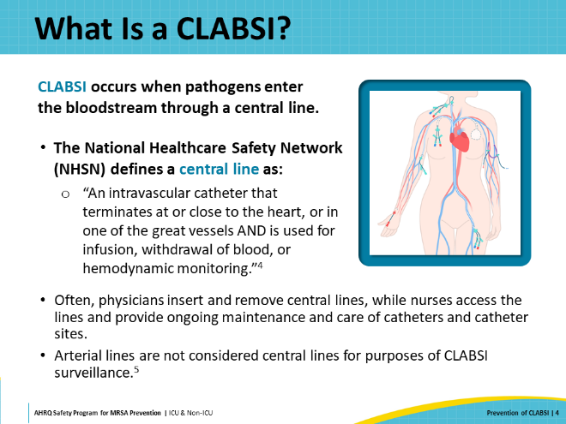
Central Lines Create Entry Points  SAY:  To determine what infection control measures must be implemented to prevent CLABSI, it’s necessary to first understand how central lines allow pathogenic organisms such as MRSA to gain access to a patient’s bloodstream. There are at least three potential entry points associated with a central line, illustrated on this slide:  - Contaminated infusate  - Contamination of the catheter hub  - Migration of bacteria from the skin into the line entry site  Each of these entry points may be vulnerable to intrinsic or endogenous sources of pathogens (such as bacteria on the patient’s skin) and to extrinsic sources of contamination (such as pathogens in the environment or on healthcare personnel’s hands).  Preventing CLABSI in your patients can be achieved by practicing appropriate prevention strategies during each step of the placement and maintaining their central lines. | Slide 6  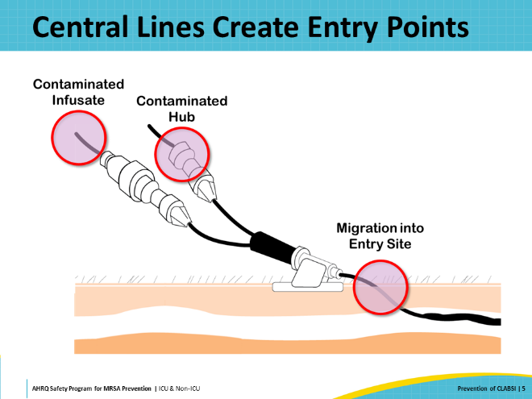
Entry Points: Contaminated Infusate  SAY:  Contaminated fluids or medications infused into the central line can lead to CLABSI. The source of contamination may be intrinsic, occurring during the manufacturing process, or it may be extrinsic, occurring at the healthcare facility because of unsafe handling of infusate.  An example of how unsafe handling of infusate can occur is the use of the same bag of intravenous (IV) fluid throughout the day to draw up flushes. Another example is the reuse of single dose vials or containers which do not have preservatives to prevent bacterial growth. Multidose vials can also become contaminated if not used correctly. | Slide 7  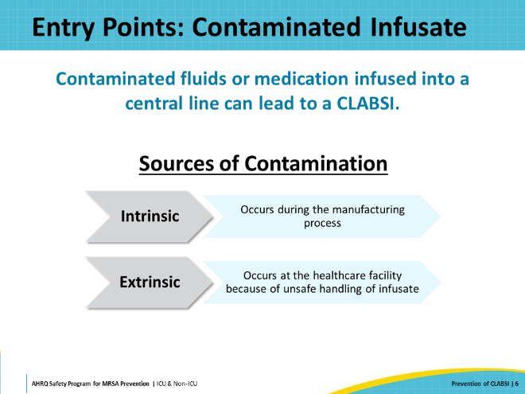
Entry Points: Contaminated Catheter Hub  SAY:  Central line hubs, needleless connectors, injection ports, or any access points along the continuum of the line or tubing can become an entry point if they become contaminated.  Sources for contamination of the catheter hub include the patient’s skin, the hands of healthcare personnel, or environmental sources near the patient. | Slide 8  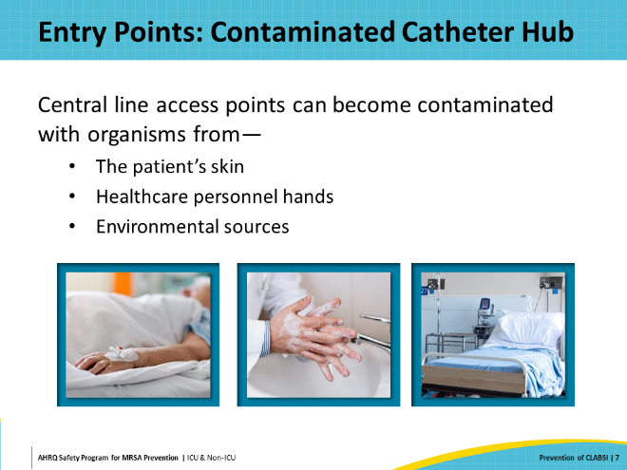
Entry Points: Migration of Bacteria on Skin  SAY:  All people—patients and healthcare professionals—have a variety of microorganisms living on their skin. In addition to the normal skin flora, people’s skin may become colonized with harmful pathogens—such as multidrug-resistant organisms. For patients with a central line, the catheter entry site through the skin is a potential access point for these pathogens to reach the deeper tissues and the bloodstream.  If a central venous catheter is not well secured, the central line can wiggle back and forth with the patient’s movements and during line manipulation. If the external portion of the central line is contaminated and slides beneath the skin, the organisms on the skin can gain access to the bloodstream.  If a catheter site dressing is not clean, dry, and occlusive, the risk of bacterial migration along the outside of the catheter increases.  Even organisms that are part of the normal skin flora, which are not typically harmful, can become opportunistic pathogens if they gain access to the bloodstream by a central line. | Slide 9  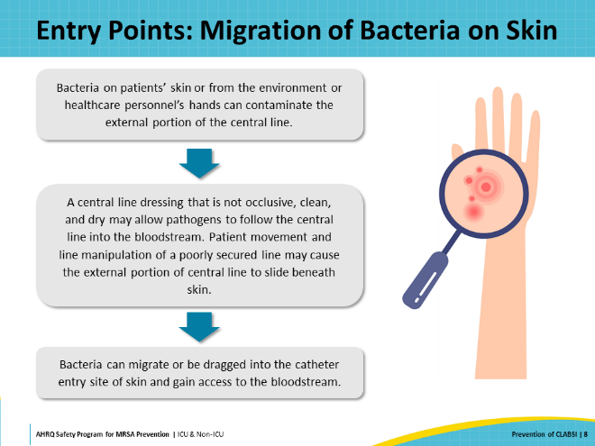
CLABSI Impact  SAY:  Next, let’s review why CLABSI matters.  CLABSI is associated with significant morbidity, mortality, and increased length of hospital stay. A recent review of over 5,000 patients with central venous catheters in a large U.S. health system compared patients who developed CLABSI with patients who had central lines but did not develop CLABSI. The authors found that the patients who developed CLABSI had a 37 percent higher readmission rate, a 36 percent higher hospital mortality rate, and an average 2-day increase in length of hospital stay. This leads to an estimate of excess healthcare costs from $600 million to $2.7 billion.  A significant amount of attention and effort has been focused on reducing the incidence of CLABSI over the past two decades. Despite these efforts, over 23,000 CLABSI were reported by U.S. acute care facilities in 2022, according to the Centers for Disease Control and Prevention’s (CDC) annual HAI progress report. Furthermore, the CDC found that CLABSI rates increased significantly nationwide during the COVID-19 pandemic. | Slide 10  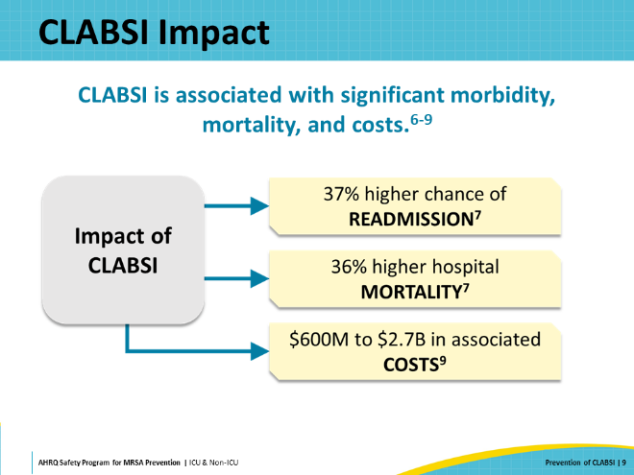
CLABSI Risk Factors  SAY:  Risk factors fall into two categories: nonmodifiable and modifiable. There are many known risk factors that can contribute to a patient’s chances of developing CLABSI. Some of these risk factors, such as the presence of comorbid diseases or age, are categorized as nonmodifiable, because they cannot be changed.  However, most of the risk factors for CLABSI are modifiable. A study conducted in 2011 found that as many as 65 to 70 percent of CLABSI can be prevented through use of evidence-based strategies.  Therefore, CLABSI is preventable. The remainder of this presentation will focus on the evidence-based best practices and recommendations to minimize risk factors for CLABSI. | Slide 11  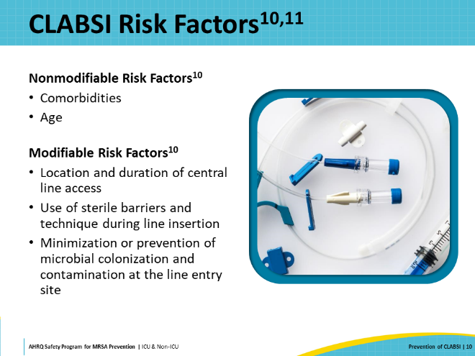
Central Line Catheter Utilization  SAY:  The best way to prevent a CLABSI is to avoid placing a central line catheter in the first place. A review of clinical indications and alternatives must be considered before a catheter is placed. In AHRQ’s “Playbook for Preventing CLABSI and CAUTI in the ICU Setting,” this is referred to as “Step 0,” emphasizing the importance of careful consideration before placing a central venous catheter.  If a central line catheter is essential and must be placed for the patient’s care, then evidence-based best practices need to be implemented at each step in the initial catheter placement and during continuing catheter care, to reduce the risk of infection.  Finally, you should routinely review the continuing need for the central line catheter daily and remove unnecessary lines as soon as possible. | Slide 12  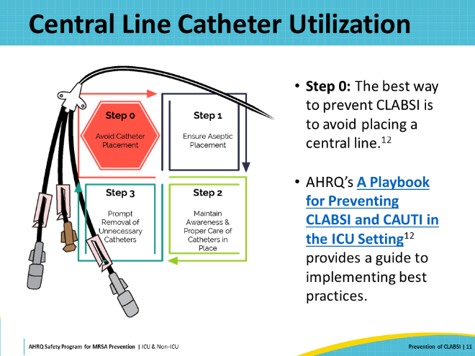
Central Line Appropriateness and Alternatives  SAY:  At “Step 0,” prior to inserting any central line, the clinical team should conduct a review for its necessity. Evidence-based clinical indications for central line placement are listed on this slide. These clinical indications include administration of vasopressors, chemotherapy, or total parenteral nutrition; support for high volume flow for IV therapy; hemodynamic monitoring; venous access; inadequate guidance for peripheral access; or diagnostic indications.  Alternative strategies to avoid central lines include peripheral IVs inserted with ultrasound or vein-finder technology, or midline catheters. These alternatives can be particularly useful for patients who would otherwise have needed a central line due to issues with difficulty obtaining peripheral access.  The AHRQ CLABSI and CAUTI Prevention Module on Central Venous Catheter Indications and Alternatives offers insight into the evidence and challenges associated with the recommended central line indications and alternatives.  Despite these accepted clinical indications and alternate strategies, U.S. acute care facilities reported over 27 million central line days in the CDC’s 2022 progress report. | Slide 13  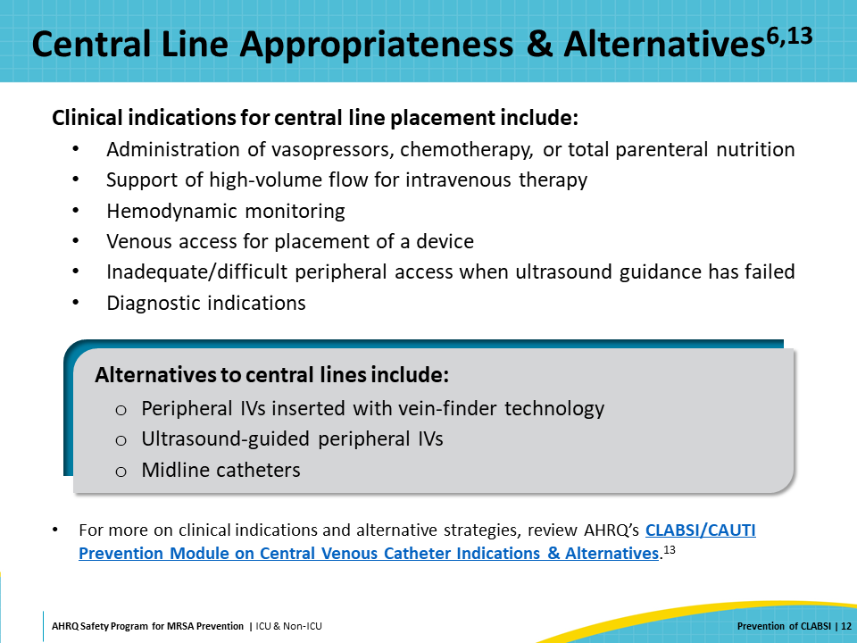
CLABSI Prevention Bundles  SAY:  Of course, there are times when a central line is necessary. If a patient requires a central line, it’s extremely important that the healthcare team use infection prevention bundles throughout the entire lifespan of the central line’s placement. A bundle is a collective group of key evidence-based practices.  When implemented together, bundled practices result in better outcomes than when the practices are executed individually. A systematic review and meta-analysis published in 2016 examined the effectiveness of central line bundles to prevent CLABSI in critically ill patients. The researchers found that between 1990 and 2015, the incidence of infection decreased significantly after bundles were implemented—from a median average of 6.4 per 1,000 catheter days to 2.51 per 1,000 catheter days.  Infection prevention bundles for CLABSI can be divided into two categories: central line insertion bundles and central line maintenance bundles. Both are important in preventing CLABSI. | Slide 14  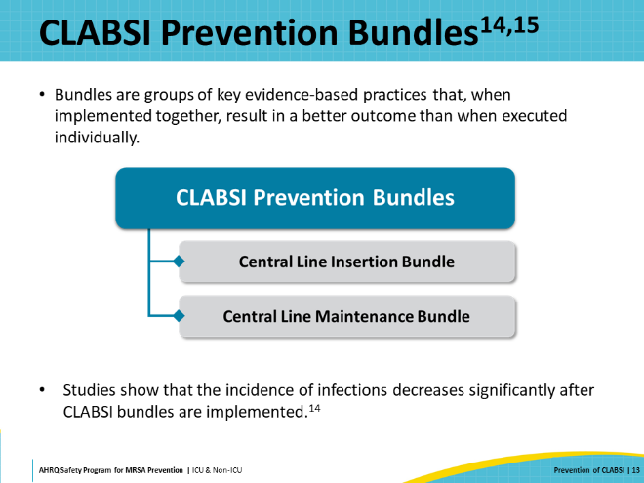
Central Line Insertion  SAY:  Several agencies and organizations have published recommendations and guidelines for CLABSI prevention. The 2022 Compendium of Recommendations from SHEA and IDSA is the most recent update, but the best practices offered in most publications are similar and have not changed much over the past decade.  Whatever guidelines you choose to follow, it is crucial to standardize procedures and products across your healthcare organization to get the maximum impact from these changes. | Slide 15  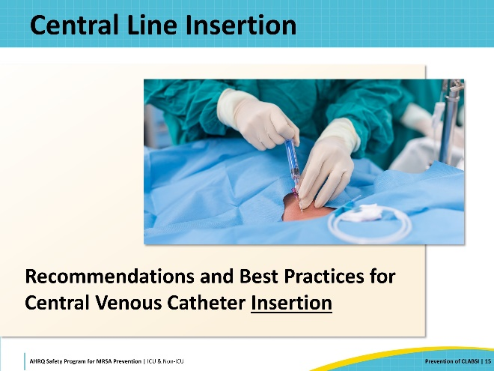
Central Line Insertion Bundles  SAY:  The most widely recognized best practices associated with central line insertion are listed on this slide. Any healthcare professional who is responsible for inserting central lines should practice these components for every patient, every time a line is inserted.  The following slides will review the components listed here. | Slide 16  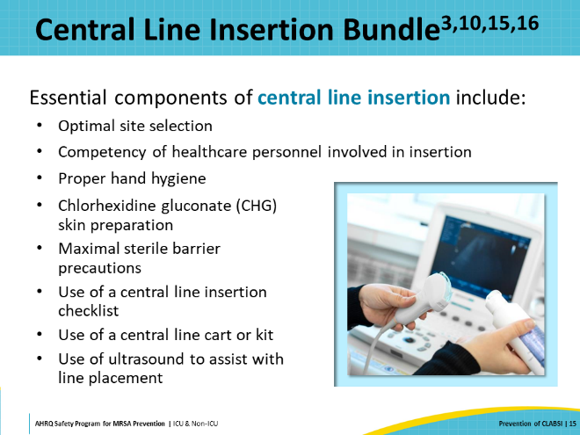
Optimal Site Selection  SAY:  When inserting the central line, site selection matters. There are three main sites where central lines can be placed: the subclavian vein, the internal jugular vein, and the femoral vein. As you can see from the slide, each of these sites has its own set of risks. The goals of care and the patient’s history should be considered carefully prior to selection.  In terms of CLABSI prevention, the subclavian vein is considered the best choice for most patients, followed by the internal jugular vein. The femoral vein should be avoided, if possible, as its proximity to the groin significantly increases the risk of infection.  Another option is to use a peripherally inserted central catheter or PICC, instead. PICCs can be used in many circumstances in place of a central line. However, the vessels in the arm are smaller, and so the lines are narrower, which means they cannot be used for all purposes (e.g., dialysis). Although it is sometimes said that PICCs are safer than central lines, a meta-analysis from 2013 reported that the rate of CLABSI associated with PICCs is like that of conventional central venous catheters in the hospital setting. | Slide 17  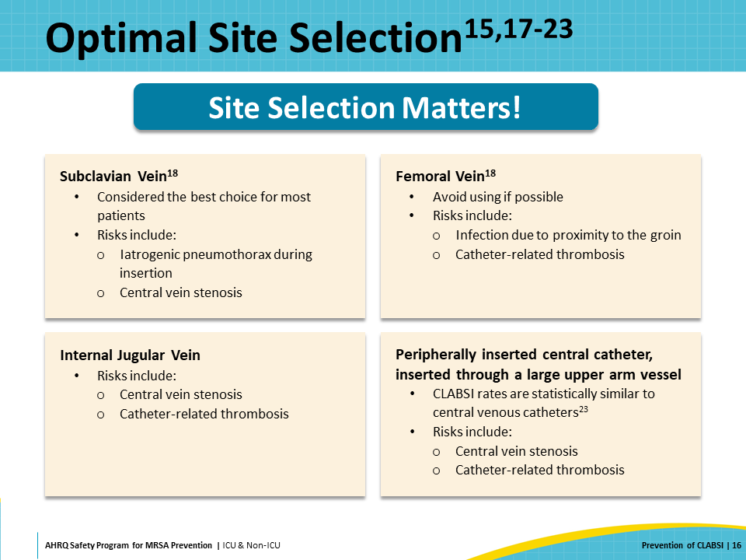
Proper Hand Hygiene  SAY:  Proper hand hygiene prior to catheter insertion is critical to reducing the risk of introducing organisms into the bloodstream during catheter insertion. This is well known, but sometimes forgotten.  Providers must perform proper hand hygiene multiple times throughout the process. This includes before and after palpating catheter insertion sites, and before and after inserting, replacing, accessing, repairing, or dressing an intravascular catheter.  As a reminder, gloves do not eliminate hand hygiene in any of these steps. | Slide 18  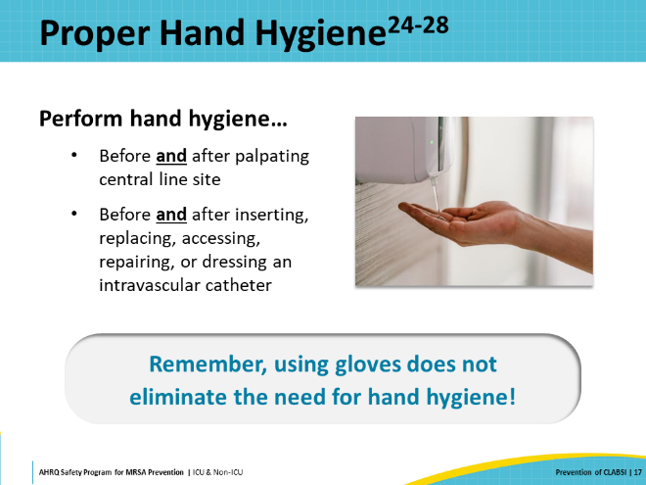
Chlorhexidine Gluconate Skin Preparation  SAY:  Cleaning the skin with chlorhexidine gluconate (CHG) is another important component of safe central line insertion. Published evidence indicates that chlorhexidine-containing skin preparations are superior to other options such as povidone-iodine and alcohol. A meta-analysis conducted in 2002 found that use of a chlorhexidine-containing preparation decreased CLABSI by 49 percent, relative to povidone-iodine preparations.  Before inserting central lines, the entry site should be cleansed with alcoholic chlorhexidine following the manufacturer’s instructions. A firm back-and-forth motion should be used to create friction. Most sites should be cleaned for at least 30 seconds; for the groin, at least 1 minute is required. Do not wipe or blow dry the skin. The CHG must be allowed to dry completely before the skin is punctured. | Slide 19  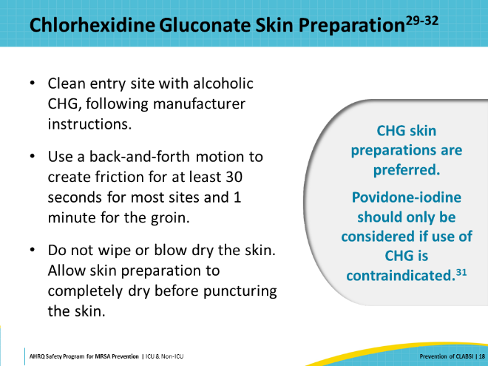
Maximal Sterile Barrier Precautions  SAY:  Maximal sterile barrier precautions must always be used when placing a central line. This means that the patient should be covered head to toe with a large sterile drape, and anyone physically participating in the line insertion should wear a cap that fully covers the hair, a mask, a sterile gown, and sterile gloves.  Maximal sterile barrier precautions during the insertion of central lines substantially reduce the incidence of CLABSI, compared with standard precautions of only sterile gloves and a small drape. | Slide 20  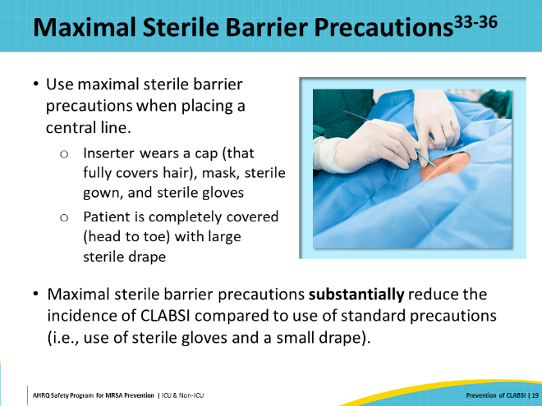
Use of Central Line Insertion Checklist  SAY:  The use of standardized tools and processes is one of the key principles of high reliability in healthcare organizations. This principle applies to central line insertion and CLABSI prevention as well. The use of a standardized central line checklist helps staff ensure that the proper process is performed every time a central line is inserted.  Presented on this slide are several line insertion checklists that are publicly available that you may consider making use of:  - AHRQ Central Line Insertion Care Team Checklist  - CDC Checklist for Prevention of CLABSI  - Johns Hopkins Central Line Insertion Checklist  - Joint Commission Central Line Insertion Checklist  For any of these checklists to be effective, a staff member who is not inserting or assisting with the line insertion procedure should complete the form in real time while observing the line insertion. This staff member needs to feel comfortable speaking up if a step is bypassed or a breach in technique is observed, bringing the breach to the attention of the insertion team, and stopping the procedure if necessary.  AHRQ’s TeamSTEPPS Program provides communication strategies and training drills or simulations, which can help staff feel more comfortable speaking up when these situations occur in real medical situations. | Slide 21  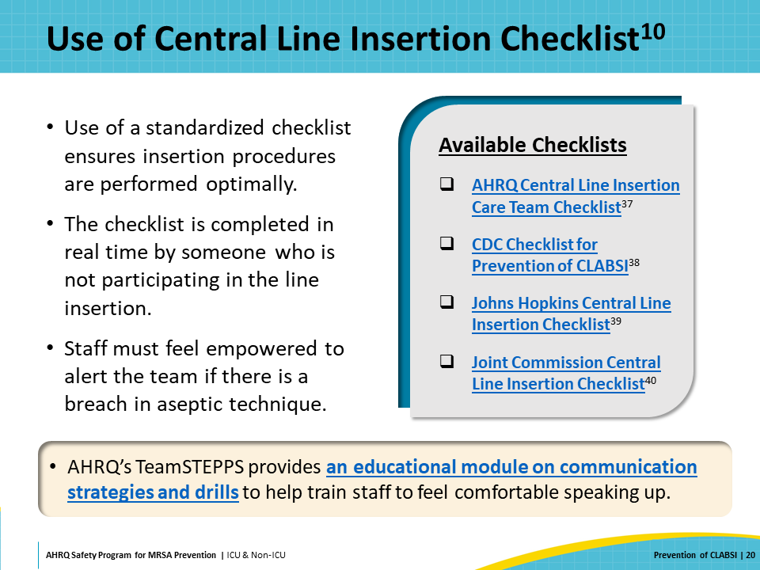
Use of Central Line Insertion Cart/Kit  SAY:  The standardized use of central line carts or kits is another strategy that can ensure team members have ready access to everything they need when they start a central line insertion procedure.  Some manufacturers will customize kits for facilities to include specific items according to their policies. The advantage of a cart is that it is easier for facilities to modify what is included as products and practices change over time.  Regardless of which strategy your facility uses, anytime the contents of a cart or kit are changed, staff must be notified and re-educated, as necessary. | Slide 22  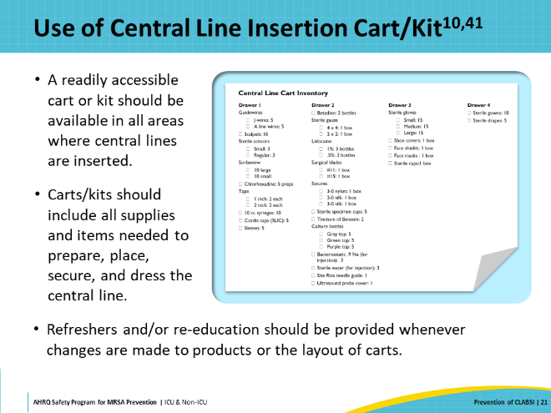
Central Line Maintenance  SAY:  Once a central line is inserted, it must be maintained and cared for meticulously to prevent introduction of pathogens during routine use and care. The next section of this presentation will review the critical components of central line maintenance. | Slide 23  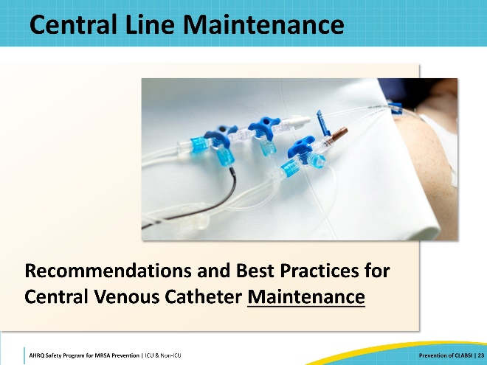
Central Line Maintenance Bundle  SAY:  The primary components of a central line maintenance bundle include:  - Proper hand hygiene  - Central line site care  - Hub disinfection  - Central line dressing change and use of chlorhexidine-containing dressings  - Daily CHG bathing (unless contraindicated)  - Daily review of line necessity and prompt removal of unnecessary lines  Some other practices to consider, which are also supported by strong evidence, include monitoring nurse staffing ratios to ensure that they are adequate and minimizing the use of float nurses to care for patients with central lines. Also helpful is performing ongoing surveillance and conducting a root cause analysis whenever a CLABSI event is identified (in the Comprehensive Unit-based Safety Program [CUSP], root cause analysis can be part of the “Learning From Defects” process). These practices engage clinicians and promote continuous performance improvement. | Slide 24  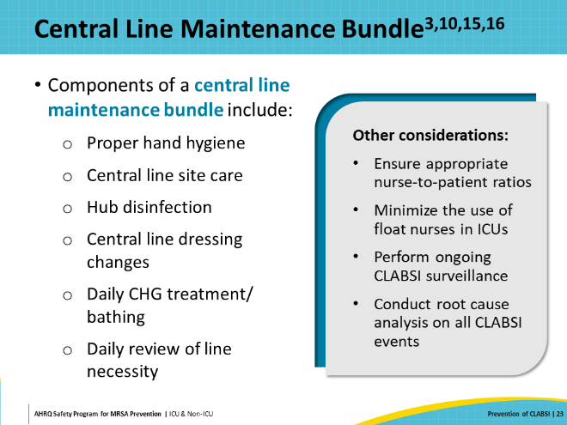
Central Line Site Care  SAY:  All central line sites should be assessed regularly, with particular vigilance for pain and redness. Sites should be checked to ensure there is no blood or drainage present. Insertion site dressings should be examined to ensure they are clean, dry, sealed, and intact. If the dressing is loose or if there is any blood under the dressing, it must be changed immediately.  Hub disinfection is another crucial component. This is sometimes referred to as “scrubbing the hub.” All connection and access ports should be vigorously scrubbed for at least 5 seconds with a chlorhexidine-, alcohol-, or povidone iodine-based disinfectant before accessing. Scrub all parts of the hub, including the sides and the top. Ensure that a new swab is used for each hub; swabs should never be reused. After scrubbing, allow the hub to dry completely without touching anything.  A video demonstration of properly scrubbing the hub is available for training purposes.  Only sterile devices should be used to access the hub. The importance of this can easily be overlooked or neglected, but it is critical. Studies have demonstrated that greater than 50 percent of connection sites are contaminated.  IV tubing and administration sets should be replaced every 7 days, including needleless access connectors. Tubing used for blood products, parenteral nutrition, and lipids should be replaced every 24 hours. | Slide 25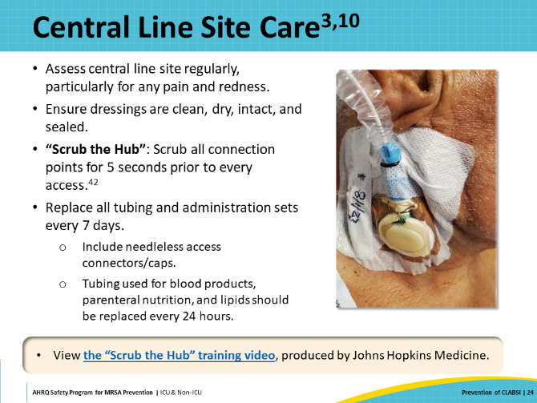
Central Line Dressing Change  SAY:  The preferred choice of dressing for central lines is a transparent dressing that contains CHG. CHG inhibits bacterial growth, and the dressing’s transparency makes it easier for personnel to assess the central line site.  Central line dressings should be changed every 5–7 days, or sooner if they become loose, damp, or visibly soiled. A CHG-based antiseptic should be used to cleanse the site with each dressing change.  If the line insertion site oozes or has blood accumulating underneath the dressing, or the transparent dressing is not properly adherent to the skin, then a gauze dressing can be used instead—but gauze dressings should be changed every 2 days. | Slide 26  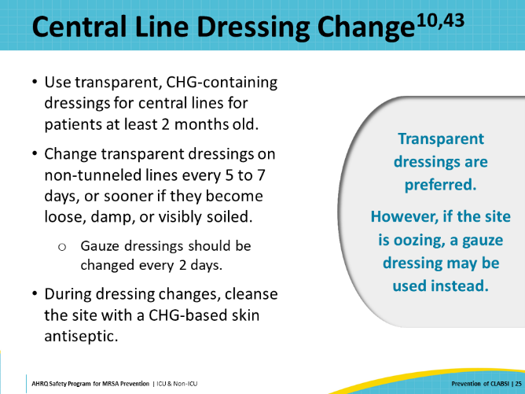
Daily CHG Treatment or Bathing  SAY:  Published evidence shows that routine CHG treatment decreases HAIs, especially in patients with invasive medical devices such as central lines. Chlorhexidine treatment is the process of using CHG-impregnated wipes or a CHG soap and water solution to systematically remove bacteria from the skin daily. This slide displays a diagram on how the CHG should be applied. All areas of the skin should be cleaned, with care to avoid the eyes and ear canals. Also, 6 inches of every line, tube, or drain nearest to the body should also be cleaned with CHG. This process has been shown through numerous trials to reduce MRSA and vancomycin-resistant Enterococcus (VRE) acquisition.  Explaining the purpose of the CHG treatment to the patient can help to overcome their reluctance. Referring to this as a “CHG treatment” rather than “bath” can help to emphasize its medical importance as an infection prevention measure.  For more information on CHG treatment, refer to the section of this toolkit on Decolonization. | Slide 27  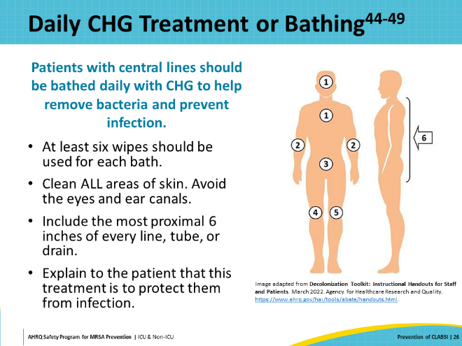
Daily Review of Central Line Necessity  SAY:  As previously mentioned, the most effective strategy to prevent CLABSI is to avoid placement of a central line in the first place (i.e., “Step 0”).  If a central line must be utilized, the next most effective strategy is to minimize the duration of the exposure to the central line. A multidisciplinary team should conduct systematic evaluation every day of the central line’s necessity. Removing lines as soon as they are no longer required strongly reduces the risk of developing a CLABSI.  The decision regarding the need for a central line catheter is complex, and therefore, difficult to standardize into a written guideline. Evaluation should be conducted case-by-case to assess each patient’s individual status. This can be done by conducting routine central line rounds to assess the necessity and care of each patient individually. A form for use with central line rounds is provided as part of the Toolkit. More on central line rounds will be discussed later in this presentation in the Implementation section.  Lines that must remain in for longer than expected should not be changed prophylactically or as part of a routine practice.  A central line rounds info sheet summarizing best practices for line maintenance is available here. | Slide 28  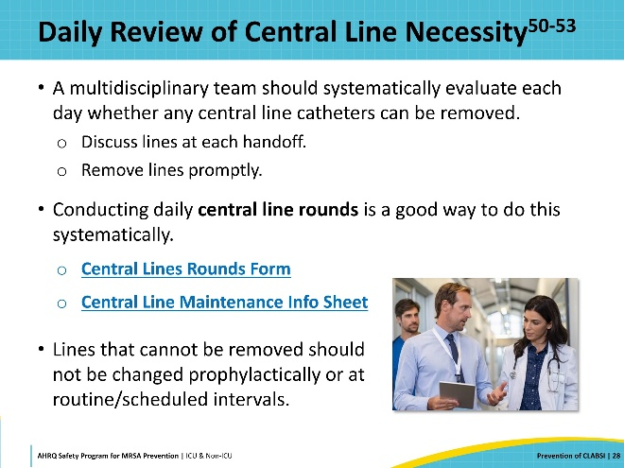
Think About It…  SAY:  Take a minute and think about the current state of your own unit. How many of these central line insertion and maintenance strategies for CLABSI prevention would you say your unit has successfully implemented?  Something commonly reported by units is that the strategies they have implemented are not as successful as they hoped—or that these strategies were effective at the beginning, but no longer seem to be as effective as they were.  The next section will examine implementation of these practices to maximize and sustain their impact. | Slide 29  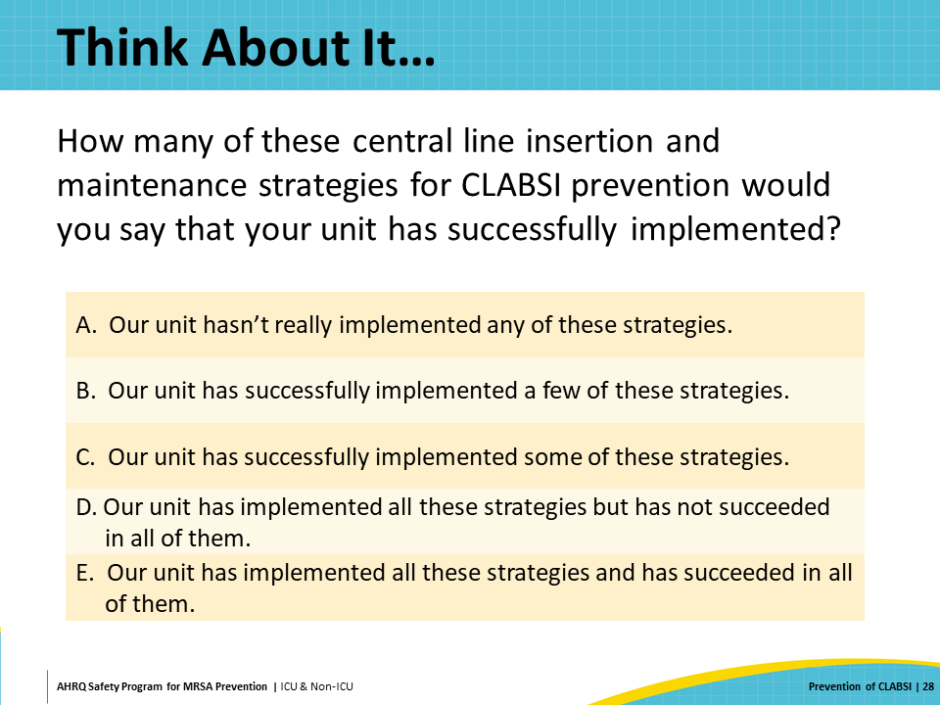
Implementation  SAY:  Having reviewed the best practices, let’s talk about how to ensure that the evidence-based practices happen as intended—and what to do when they don’t seem to be working. | Slide 30  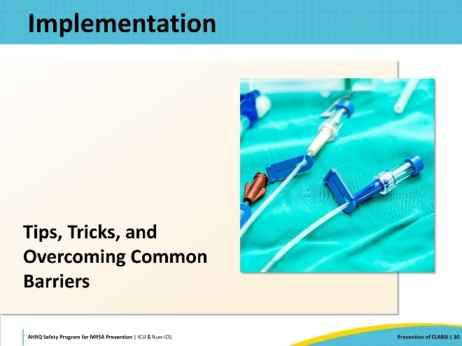
Assess Current Practice  SAY:  If you think your organization is doing everything it can and you are still struggling with CLABSI, then the place to start is to conduct an accurate assessment of current practice. The best way is to go there in person. Don’t assume that just because you’ve incorporated all the best practices into your policy that the staff is doing things the way your program and policy intends. You need to go to the “gemba.”  The gemba is a Japanese term that refers to “the actual place,” or the place where the work is happening. Going to the gemba allows you to observe the actual workflow, engage with frontline personnel, ask questions, gain knowledge about what is actually happening, and learn about opportunities for improvement.  You may be surprised to see how many short-term workarounds have become a normal part of the clinical workflow. There may be many reasons for this: staffing challenges, supply shortages, changes in other workflows that had unintended downstream consequences, complacency—the list goes on. Until a thorough assessment is made of the real-life current practice, you can’t begin to get at the root of why these issues are happening so that you can take steps to address the challenges.  AHRQ provides tools to assess progress on CLABSI prevention that you may find useful in your efforts. | Slide 31  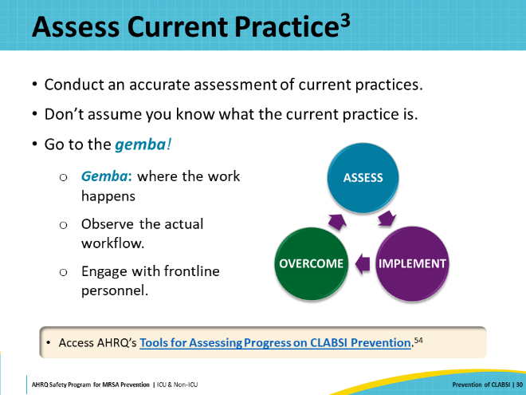
Team Engagement  SAY:  Having an engaged team is key to driving any change. One reason staff may not seem engaged is they don’t know there is a problem. Despite discussing CLABSI rates at staff meetings and posting signs on bulletin boards, you might be surprised by the lack of awareness of a CLABSI issue when you ask personnel directly. If staff don’t know or understand there is a problem, it will be difficult to engage them in efforts to fix it.  Executive leadership can have the same disconnect. Ensuring their awareness of a CLABSI problem allows institutional leaders to play a critical role in ensuring that staff have the resources to address problems, and that staff are not being pulled in too many directions to be able to focus their efforts. Executives can also help reduce or overcome barriers.  Once staff are aware of the issue, it can sometimes be helpful to start with a “back to the basics” approach by ensuring that everyone has a good foundational understanding of the evidence-based best practices and the institution’s policies. This can be done through computer-based learning modules, skills days, or unit-based champions.  AHRQ has a number of documents, videos, and other training tools available on overcoming common challenges with this in the Toolkit for Preventing CLABSI and CAUTI in ICUs. | Slide 32  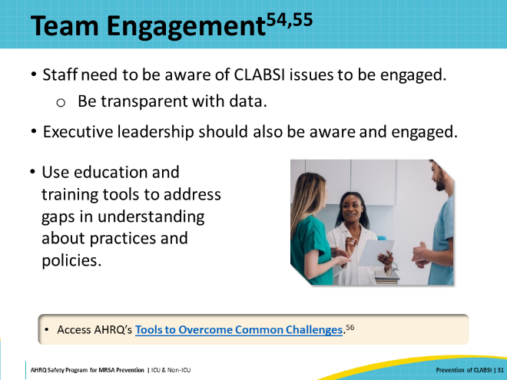
Learning From Defects  SAY:  “Learning From Defects” is a CUSP process and tool that can help to break down big problems and identify the many contributing factors to a patient safety issue. More in-depth information can be found in this toolkit in the CUSP section on Learning From Defects.  AHRQ offers a Learning From Defects Tool modified to be specific to CLABSI that can be used to guide staff through the review of CLABSI events to try to identify gaps in practice and opportunities for improvement. It is strongly recommended that the frontline clinical team take the lead in completing these forms, to give them a sense of ownership over improvements. They may need some extra support from their infection prevention team in the beginning until they understand the tool’s value and get comfortable with its use.  A proactive, risk-mitigation CLABSI prevention approach supports a learning environment and holds people accountable for their behavioral choices. When deviations are identified from expected practice, leadership should discuss these with staff to understand if there are systems issues at play that are preventing staff from complying with the policy.  The next several slides will discuss a case example of a hospital unit implementing CLABSI prevention. | Slide 33  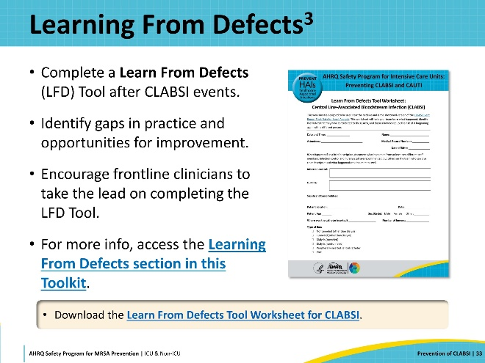
Case Example: Rising CLABSI Rates  SAY:  St. Bob’s Hospital has been experiencing a significant increase in CLABSI in their ICU. The unit’s CLABSI rate climbed to 4.5 per 1,000 central line days, which is well above the national benchmark of 1.0 per 1,000 central line days.  The unit’s CUSP team gathers to address the issue. They perform an assessment of the unit’s current practice and conduct a Learning From Defects analysis. They identify that there is variable compliance with best practices when staff in the unit are performing central line insertions and maintenance. They also identify that central lines are often left inserted for longer than necessary, raising the infection risk.  The team decides to implement intervention strategies focused on better central line insertion and maintenance practices. To improve central line insertion, the ICU orders and stocks specialized central line kits and also implement a standardized line insertion checklist, to be filled out by an uninvolved observer at each insertion.  To improve maintenance practices and timely removal of central lines, the team focuses on introducing daily central lines rounds and use of a Daily Goals checklist as a regular practice in the unit. | Slide 34  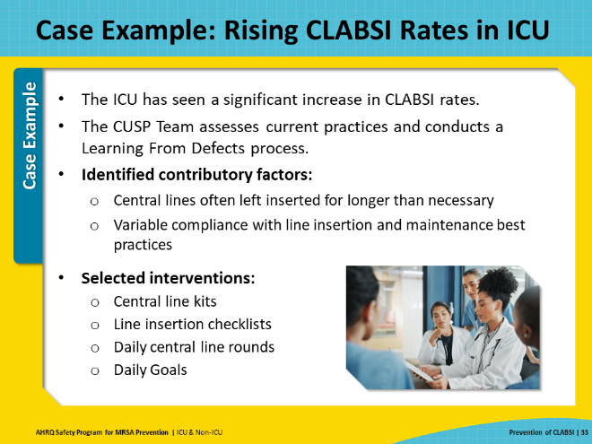
Case Example: Central Line Rounds  SAY:  Central line rounds are conducted daily with a multidisciplinary team. Systematically evaluating the necessity of each patient’s central line enables the prompt removal of unnecessary lines.  Central line rounds are also an opportunity to assess the status of patients’ dressings – when they were changed and whether they are loose, damp, bloody, or soiled – as well as adherence to other maintenance practices.  Ideally, these rounds should include the bedside nurse, provider, infection preventionist, unit-based leadership, and executive leadership. This promotes transparency and collaboration and allows for real-time education. This multidisciplinary approach also helps to avoid the “policing” mentality and reinforces the commitment of leadership to CLABSI prevention.  Central line rounds present an excellent opportunity to collect process measure data. Process measure data should be fed back to unit leadership and the frontline personnel regularly. Units not meeting expectations should create targeted action plans. The data collected during central line rounds can guide interventions and identify ad hoc educational topics to be included in these action plans.  Using a standardized form can effectively support central lines rounds. A form for use with central line rounds is provided as part of this Toolkit. | Slide 35  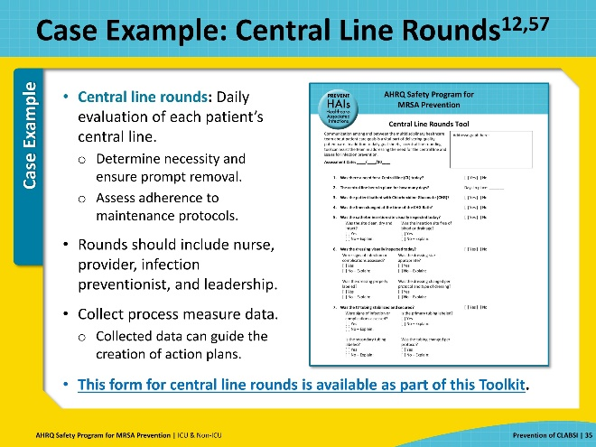
Case Example: Daily Goals Checklist  SAY:  Another useful tool is the implementation of a Daily Goals Checklist. This tool is designed to facilitate communication and coordination among the care team regarding each patient’s plan of care. It prompts the team to focus on what needs to be done and to define the day’s goals for the patient.  The Daily Goals process integrates well into rounds, supporting the team in their review of key items and concerns, such as necessity of the central line, central line maintenance, and necessary tests or procedures.  Sample Daily Goals Checklists are provided as part of this toolkit. The items on the checklist can be edited to fit your unit’s needs:  - Daily Goals Checklist for ICU  - Daily Goals Checklist for Non-ICU  Reviewing the Daily Goals is a straightforward and effective way to make sure that all of the team members are on the same page and have a shared understanding of each patient’s plan of care.  More information on the Daily Goals tool and its use can be accessed on AHRQ’s website. | Slide 36  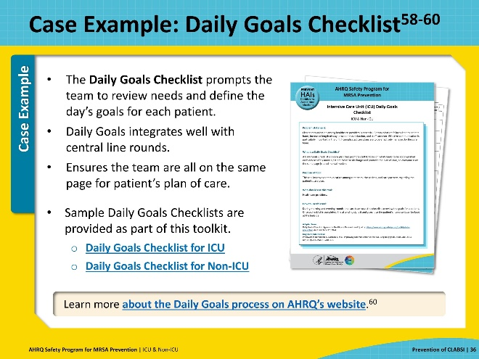
Case Example: Implementation  SAY:  At St. Bob’s, the ICU begins to implement central line rounds and Daily Goals checklists. Particular emphasis is placed on prompt removal of unnecessary lines. Over the next 6 months, CLABSI rates in the ICU decrease back to the national average. The number of total central-line days on the unit also drops considerably.  Process measures collected by the CUSP team show that the Daily Goals Checklist and central line rounding have been quickly adopted and integrated into the ICU’s workflow. Staff feedback also shows the insertion kits are quite popular and well-liked for their convenience, which is corroborated by the usage numbers.  However, the team also notes that there has been inconsistent usage of the line insertion checklist. Interviews with staff and an anonymous survey reveals that many of the staff feel uncomfortable speaking up or stepping in during an insertion procedure to enforce compliance with the insertion checklist.  The CUSP team resolves to adjust their efforts to address this particular barrier in the upcoming months. | Slide 37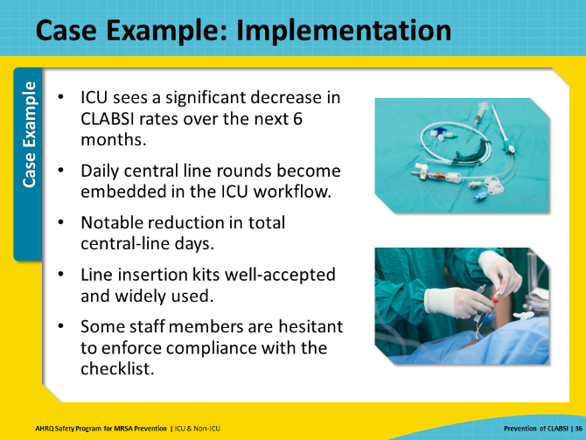
Culture and Safety Climate  SAY:  An organization or unit's culture can play a role in the effectiveness of CLABSI prevention strategies. Staff’s perceptions about whether they can safely speak up when they see breaches in practice are central to performance improvement efforts. If recent safety culture assessments have been conducted, review unit-level data related to psychological safety to see if further work needs to be done in this area. Even in units where staff are not afraid to speak up, differences in communication styles can still contribute to ineffective teamwork.  AHRQ’s TeamSTEPPS framework is a great communication strategy that complements CUSP concepts. The “CUS” technique is particularly helpful to empower personnel to speak up and communicate when they see an issue.  CUS stands for the three key words in the statements: “I am concerned; I am uncomfortable; This is a safety issue.”  For example, if a staff member witnesses a breach in sterile technique during line insertion and their initial attempts to communicate the breach are rebuffed or ignored, then they can use the escalating technique of CUS:  C: "I am concerned that the sterile field has been broken.”  U: “I am uncomfortable continuing with this procedure now that sterility has been compromised.”  S: “This is a safety issue, and I really think this procedure needs to be stopped and sterility regained.”  Training staff to use this technique makes it easier for them to speak up, while also establishing a culture that values patient safety. More information on the CUS technique can be found on the AHRQ website. | Slide 38  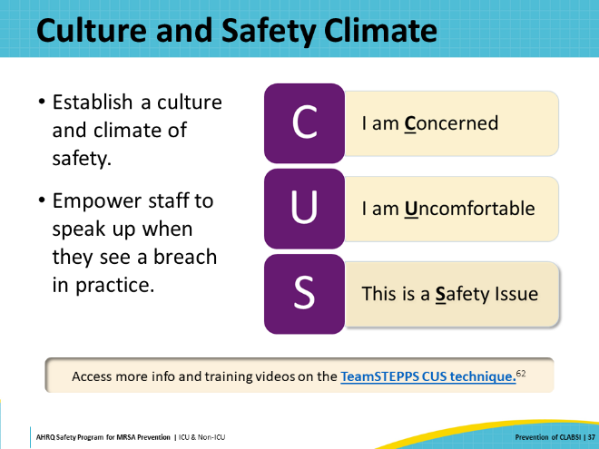
Key Takeaways  SAY:  In summary, this presentation has covered the significance of central line-associated bloodstream infections, reviewed the evidence-based best practices for central line insertion and maintenance, and touched on some of the most common barriers to prevention efforts. Several resources have been provided to help you get started on improvement efforts once you complete your assessment of current practices and identify areas of opportunity for improvement. | Slide 39  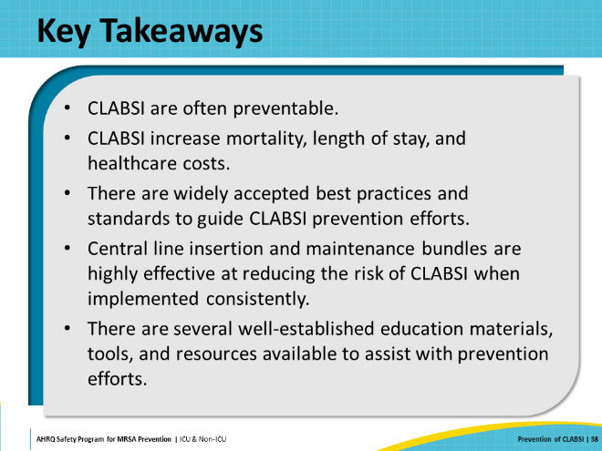
Disclaimer  SAY:  The findings and recommendations in this presentation are those of the authors, who are responsible for its content, and do not necessarily represent the views of AHRQ. No statement in this presentation should be construed as an official position of AHRQ or of the U.S. Department of Health and Human Services.  Any practice described in this presentation must be applied by healthcare practitioners in accordance with professional judgment and standards of care in regard to the unique circumstances that may apply in each situation they encounter. These practices are offered as helpful options for consideration by healthcare practitioners, not as guidelines. | Slide 40  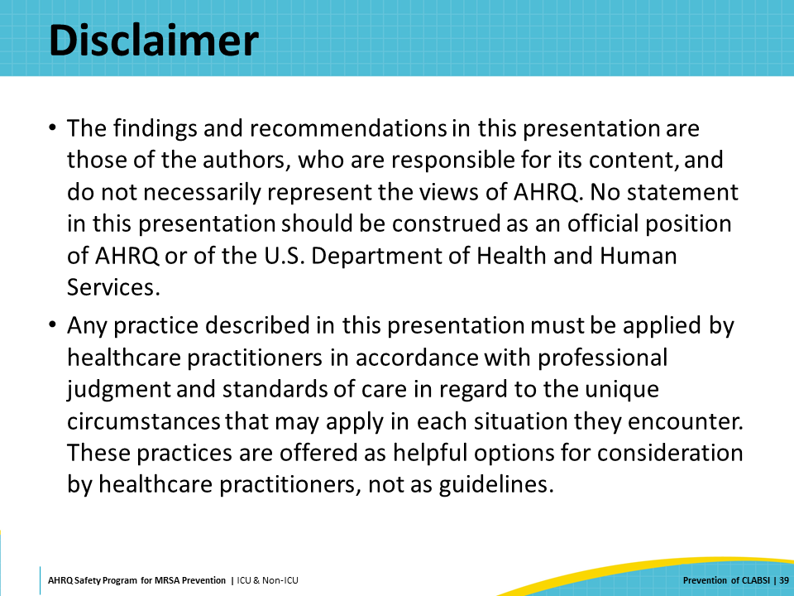
Reference List—1 | Slide 41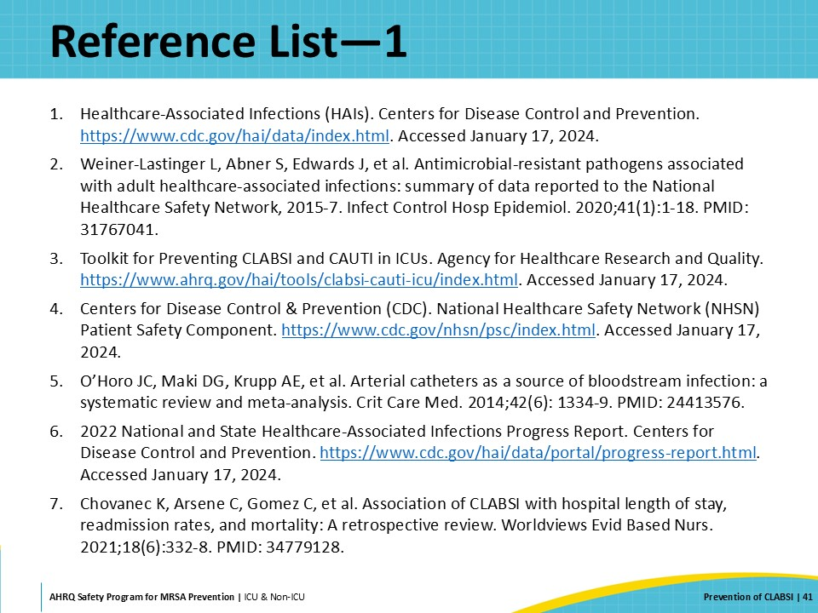
Reference List—2 | Slide 42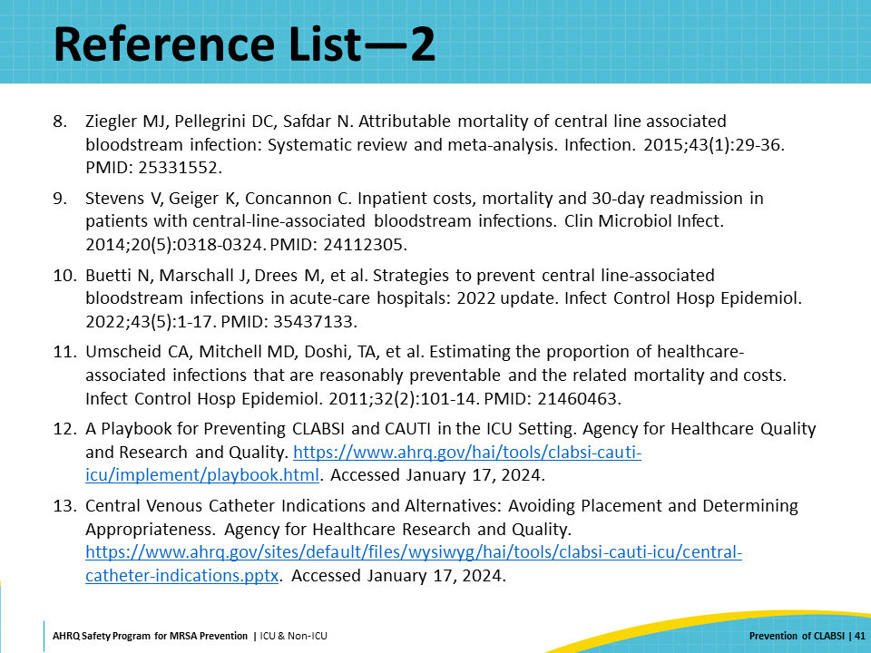
Reference List—3 | Slide 43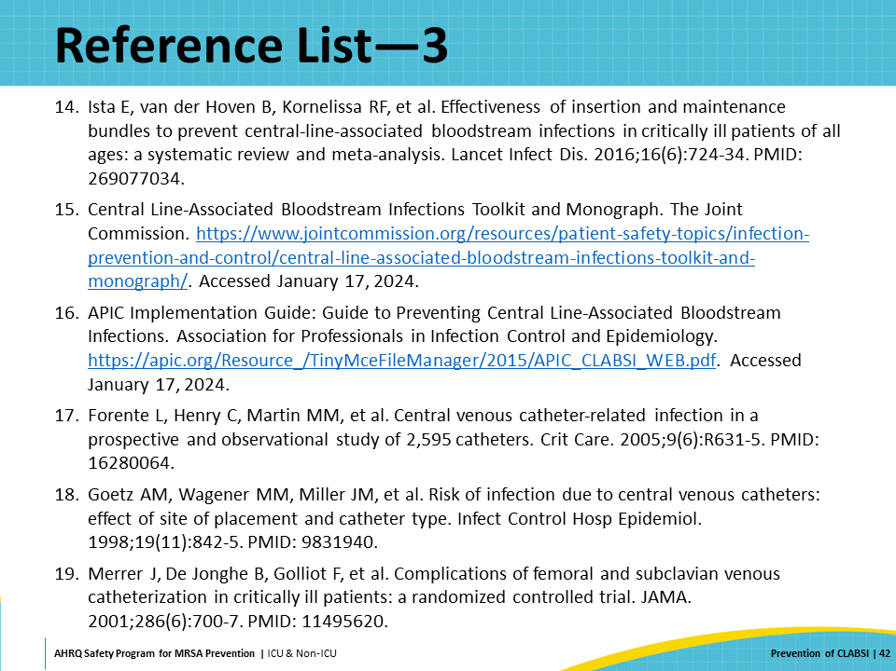
Reference List—4 | Slide 44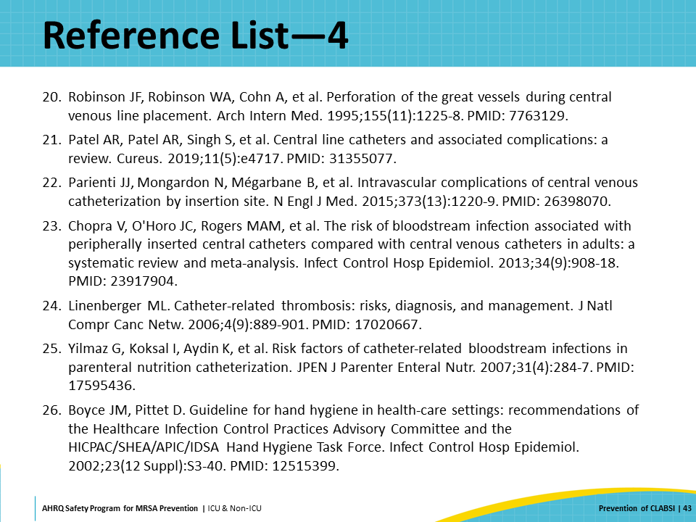
Reference List—5 | Slide 45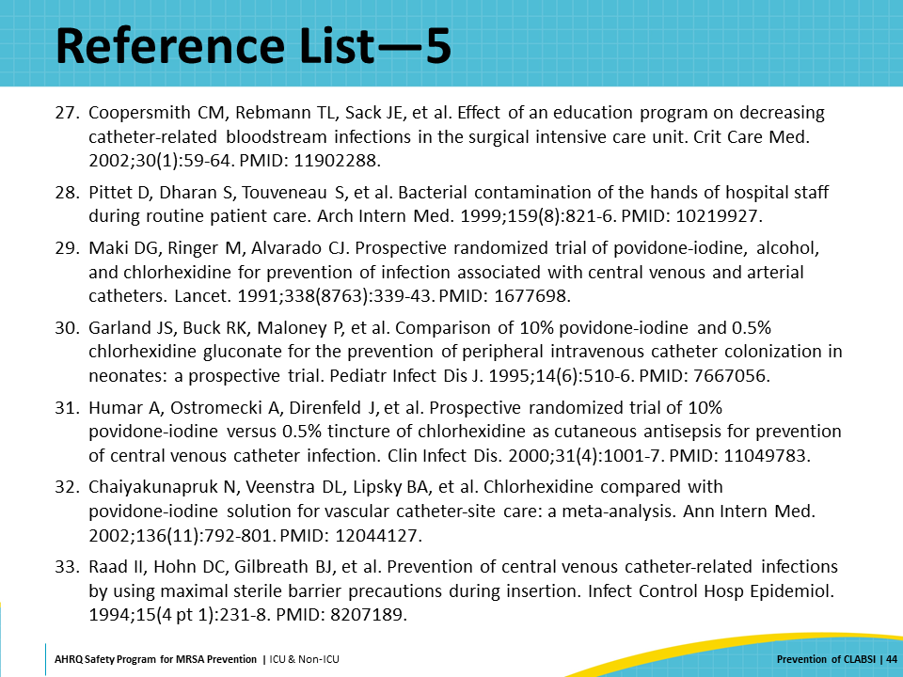
Reference List—6 | Slide 46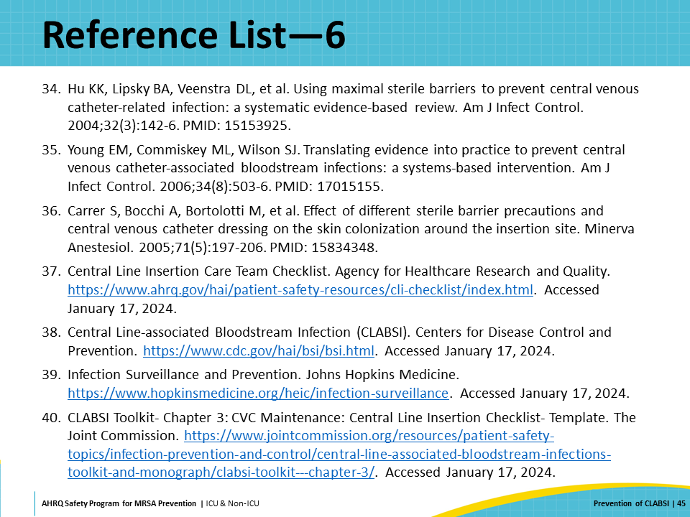
Reference List—7 | Slide 47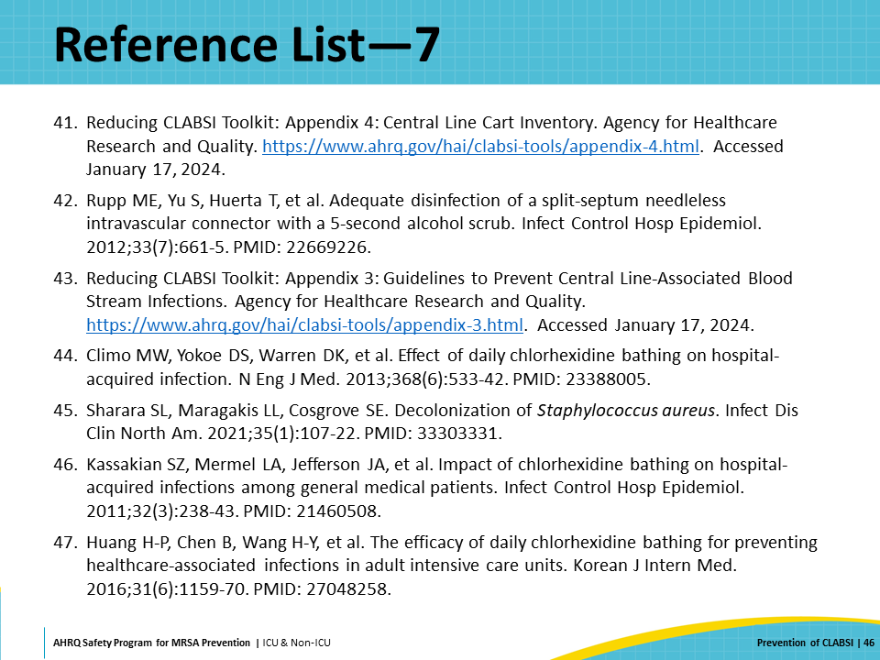
Reference List—8 | Slide 48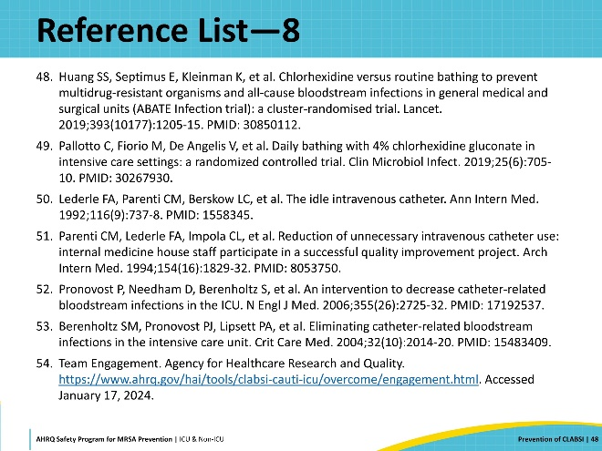
Reference List—9 | Slide 49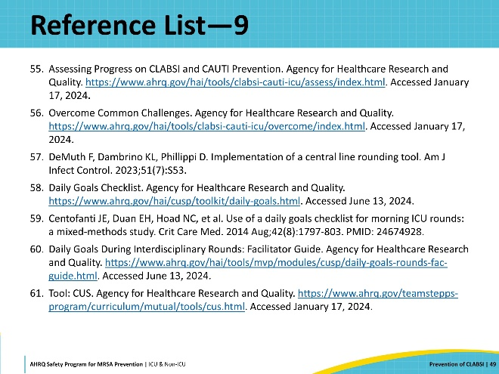

AHRQ Pub. No. 25-0007
October 2024

