Learning From Defects
ICU & Non-ICU
Slide Title and Commentary | Slide Number and Slide
Learning From Defects  SAY:  Welcome to this presentation on Learning From Defects (LFD) as part of an overall approach to preventing MRSA in ICU and non-ICU settings. | Slide 1  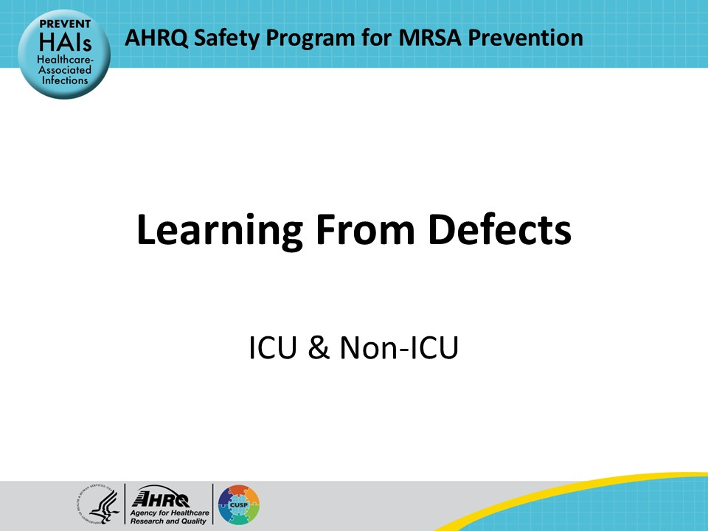
Educational Objectives  SAY:  This presentation will describe a process to help teams learn from defects, explore the Comprehensive Unit-based Safety Program (CUSP) LFD tools, and work through an example of a defect and the process of Learning From Defects using the Investigating a Defect Worksheet. | Slide 2  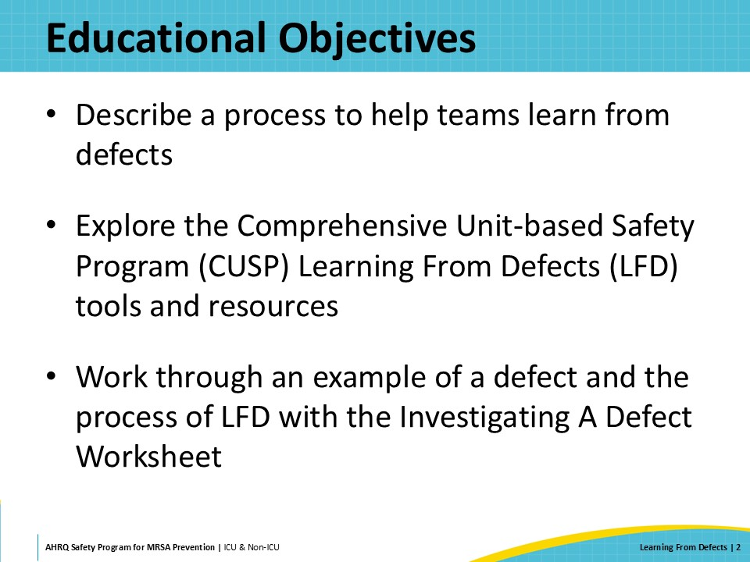
What Is a Defect?  SAY:  Defects are flaws, imperfections, or problems that occurred or could occur in the clinical or operational setting. They can show up in many ways.  Some defects are potential issues that have not yet materialized but are anticipated by staff.  For instance, the unit and the infection prevention team may detect that MRSA has been transmitted from one patient to another patient. Even if the MRSA represents colonization and no infections have occurred, this indicates an infection prevention lapse occurred, and the patient is at increased risk of developing a MRSA infection.  Another example is incomplete cleaning of high-touch surfaces in a patient's room as evidenced by residual fluorescent material during EVS assessment. Failure to remove the fluorescent marking from high-touch surfaces in the patient care environment means that the surfaces are inadequately cleaned. These surfaces are a potential source of multidrug-resistant bacteria, including MRSA, that can be transmitted to patients.  Some defects may show up once and wreak havoc while others may be chronic issues that have become accepted problems without effective solutions.  An example includes failure to perform the intended chlorhexidine gluconate (CHG) bathing and nasal decolonization for a patient at high risk for MRSA infection. If this type of failure happens often, it means that the team needs to reexamine the whole decolonization program to make sure that it is effective and reaches all intended patients.  Frontline personnel are typically taught how to do their clinical job well. The Comprehensive Unit-based Safety Program (CUSP) encourages them to expand their skills by engaging with peers, leading meetings, and fostering a culture where staff feel empowered to voice concerns and drive safety improvements. To support them, the LFD process serves as a structured guide to systematically address defects and to consider all contributing factors. Access the How to Integrate a CUSP Approach on the toolkit website for more information on incorporating CUSP into the unit practice. | Slide 3  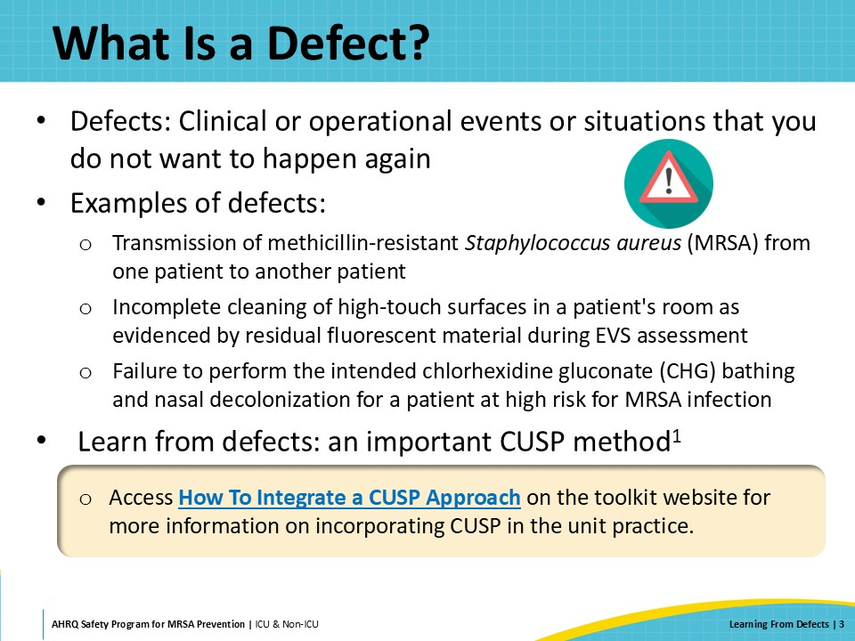
How To Identify Defects  SAY:  There are many ways to identify defects. One powerful CUSP method is to use the Staff Safety Assessment. This tool involves asking all staff to fill out a survey that asks the following: “Please describe how you think the next patient in your unit or clinical area will be harmed,” and “Please describe what you think can be done to prevent or minimize the harm from the identified defects.”  Another method includes an event reporting system. Events can reveal defects, trends, and themes indicating underlying problems that need attention. Staff appreciate knowing they were heard after taking time to enter events, which motivates continued reporting and fosters a healthier reporting culture. Pulling directly from event reports can support and encourage this culture.  Discussions during meetings can lead to significant insights related to problems, provided the culture is psychologically safe and staff feel empowered to speak up.  Huddles are another good forum for checking in with staff to see if there are any safety concerns.  Overall, making defect identification part of the routine is key. Access the How To Integrate a CUSP Approach on the toolkit website for more information on various ways to identify defects and to engage all staff. | Slide 4  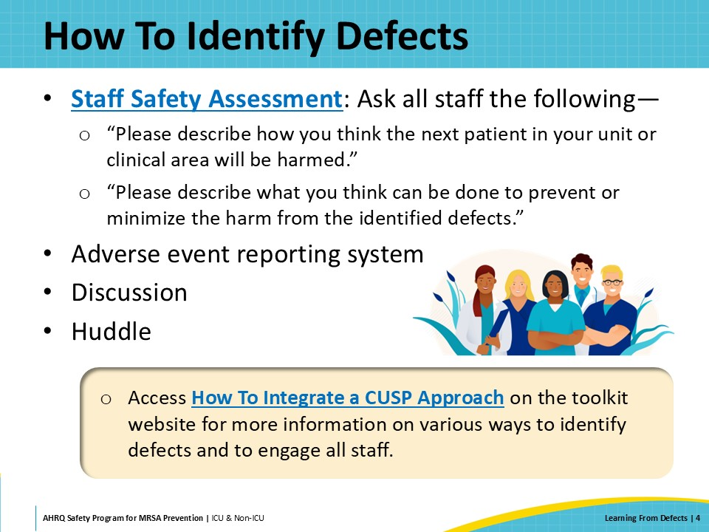
Purpose of the LFD Process  SAY:  The LFD process enables teams to look at the whole system surrounding the defect. This process usually takes some time, so teams should plan time and align expectations.  The structured approach focuses on identifying system factors that contribute to defects, planning interventions and improvements, and sustaining those improvements.  The LFD process for working through understanding defects often results in highly effective interventions that target the root cause of defects. | Slide 5  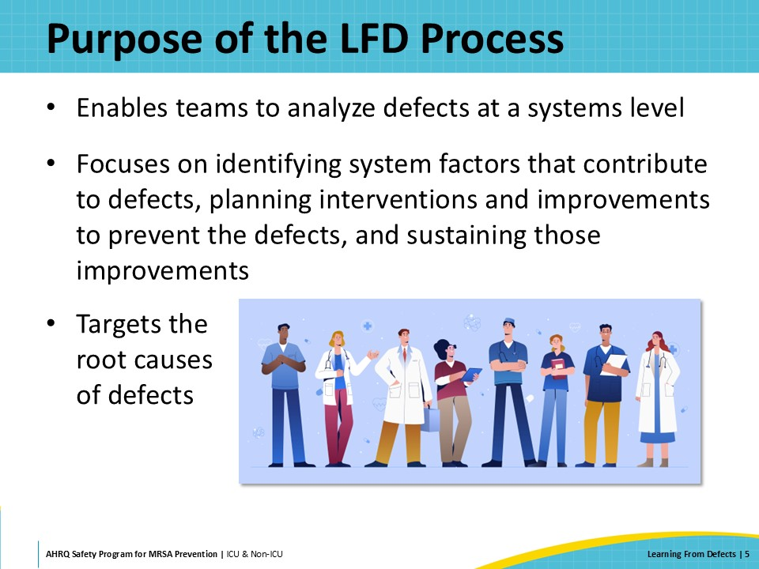
CUSP LFD Tools and Resources  SAY:  Examples of CUSP tools to guide teams through the LFD process include the following:  - Learning From Defects Tool for MRSA Prevention  - Example of a Completed Learning From Defects Tool  - Investigating a Defect Worksheet  For more tools and resources on the LFD process, access the Learning From Defects page on the toolkit website. | Slide 6  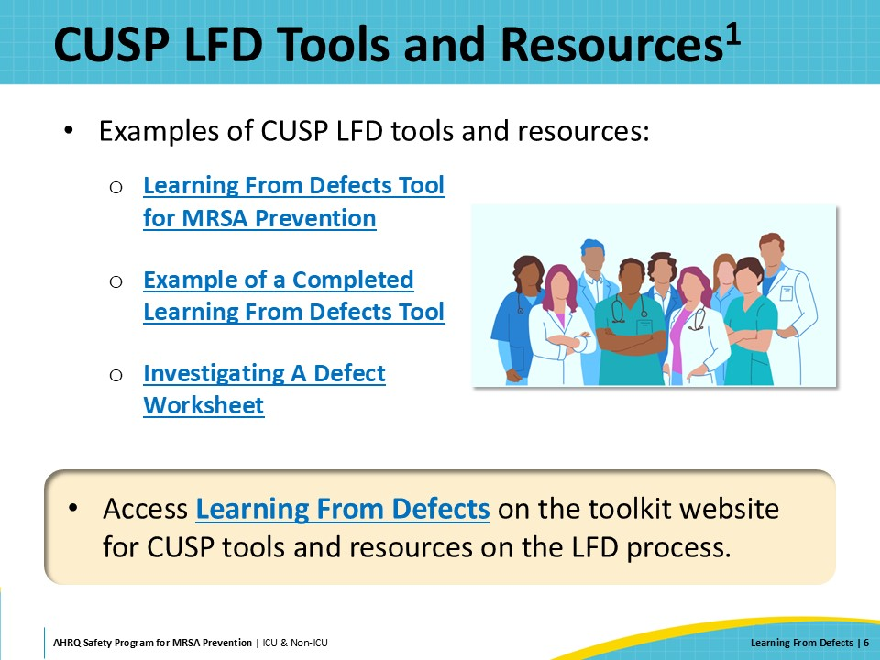
The Four Questions  SAY:  The following four questions help teams address and prevent defects system-wide:  - What happened?  - Why did it happen?  - How will you reduce the likelihood of this defect happening again?  - How will you know the risk is reduced?  To prevent patient harm and to protect patients from preventable pathogens such as MRSA, it is important to identify the causes of defects and make sure all the system factors responsible are addressed. The following sections of the presentation will address each of the four questions. | Slide 7  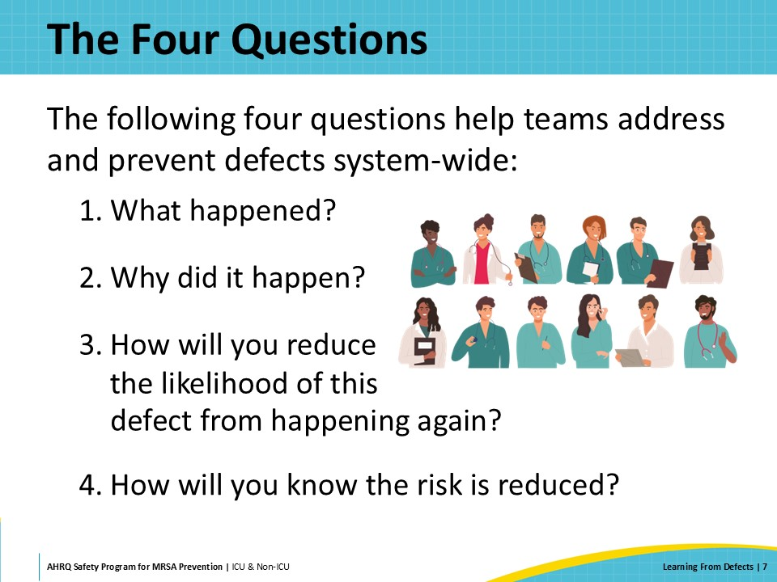
What Happened?  SAY:  This section of the presentation will focus on the first of the four questions of the LFD process: “What happened?” | Slide 8  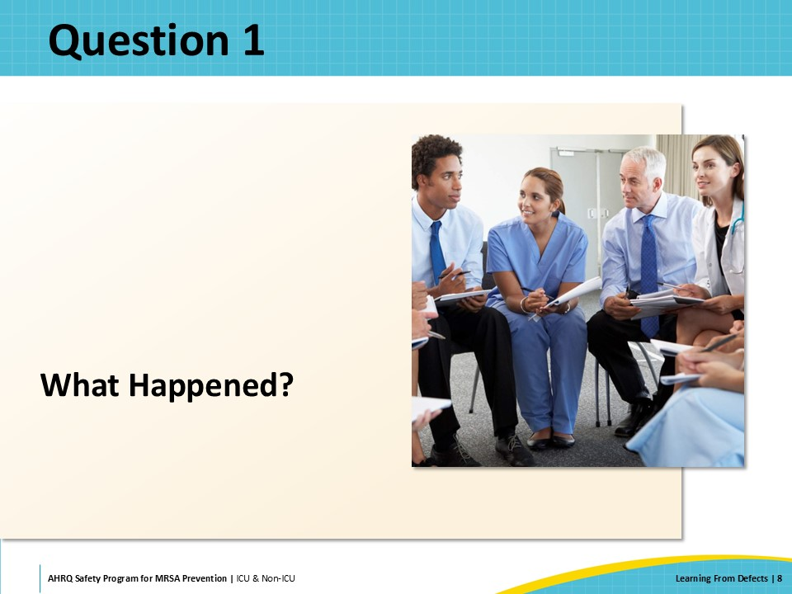
LFD Process: What Happened?  SAY:  To fully understand what happened, everyone involved should be considered and interviewed. The purpose is not intended to blame anyone for the defect, but to get a wide range of perspectives.  Some common questions to consider when interviewing include but are not limited to:  - Who was involved?  - What actions occurred?  - What were people thinking and feeling?  - What else was happening at the time the defect occurred?  - What tools or technologies were being used and how were they being used?  It is important to take time to listen and to seek to understand rather than to judge. It is helpful to ask clarifying questions and followup questions. | Slide 9  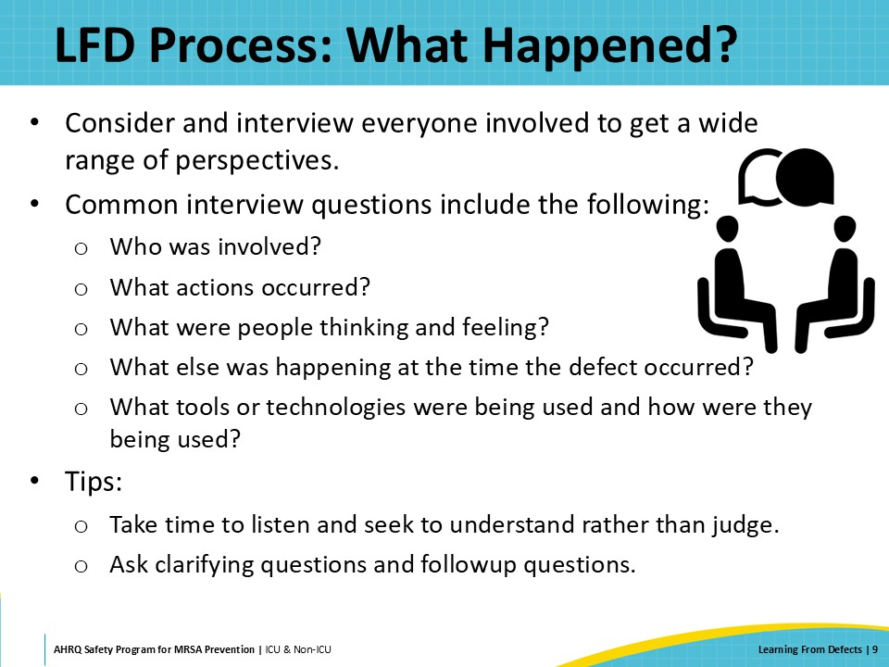
Who To Interview To Understand the Defect  SAY:  Who are the people to interview to understand the defect? Any team member who played a role should be included.  Some common roles that might be interviewed for a MRSA defect include nurses, providers, technicians, vascular access and respiratory therapy personnel, environmental services personnel, patients and families, and infection prevention personnel.  Leveraging these diverse perspectives provides a clearer and more detailed understanding of what happened. | Slide 10  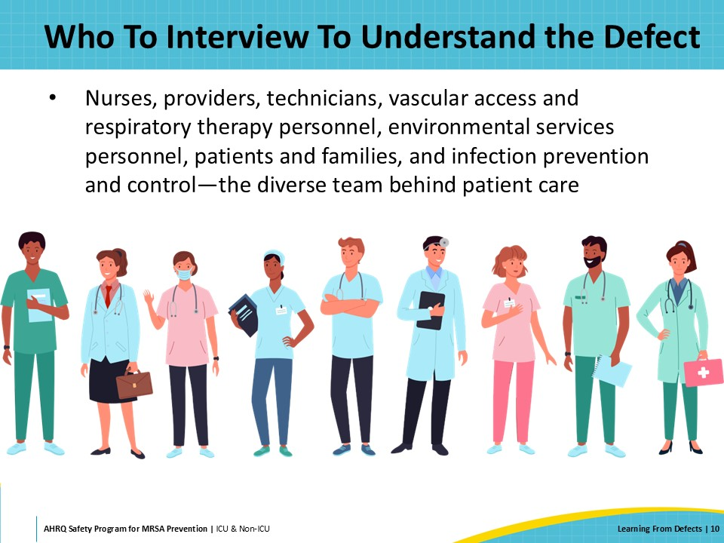
Other Strategies To Understand the Defect  SAY:  In addition to interviews, other strategies to better understand the defect and what happened include observing the process and seeking out similar situations. This may involve reviewing event reports and data sources such as electronic medical records. | Slide 11  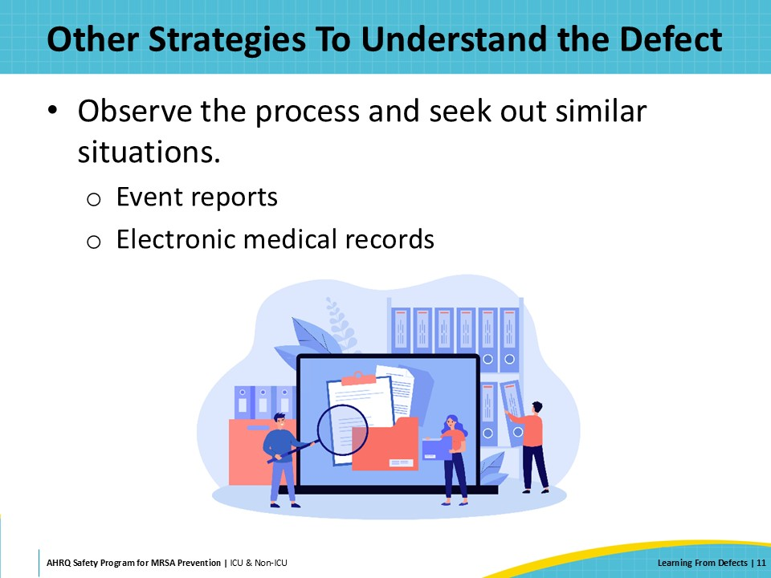
Why Did It Happen?  SAY:  The next section of the presentation will focus on the second of the four questions of the LFD process: “Why did it happen?” | Slide 12  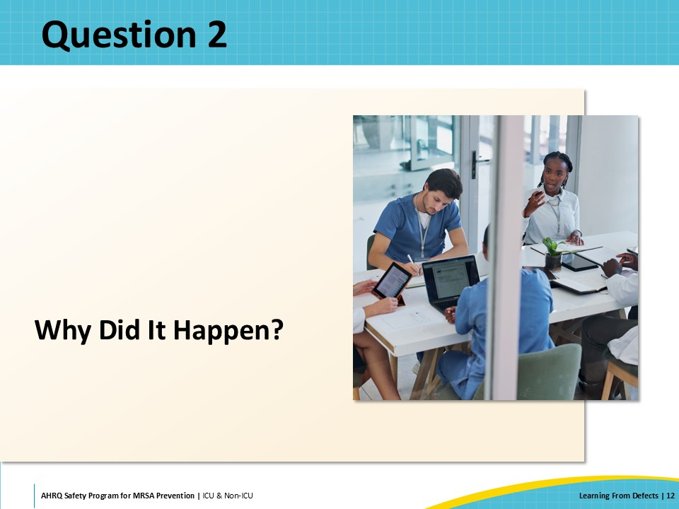
LFD Process: Why Did It Happen?  SAY:  One goal of using the LFD tool is to avoid assumptions. Assumptions are easy, common, and often not 100 percent accurate.  There are usually numerous contributing factors behind each defect. Contributing factors from all levels of the healthcare system impact care delivery and, ultimately, patient outcomes. It is critical to capture all contributing factors before the team considers any interventions or solutions.  Failure to diagnose the contributing factors can lead to wasted time and lack of risk mitigation. To truly understand the cause and the factors, ask “why” five times to drill down to the root. | Slide 13  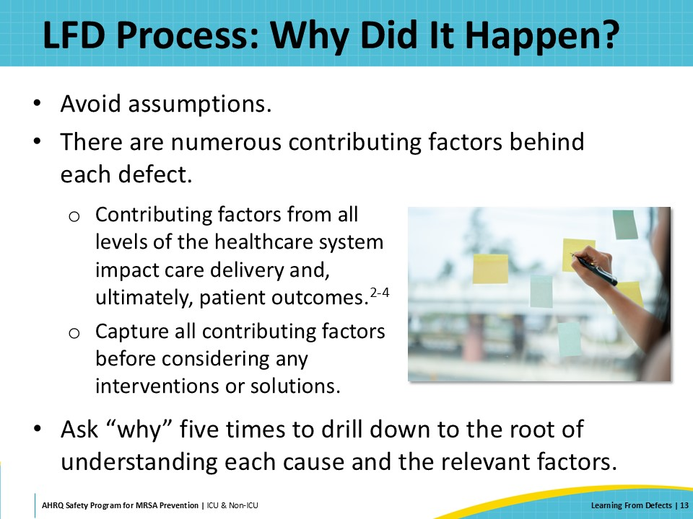
Contributing Factors  SAY:  Contributing factors often include the following:  - Patient factors, related to the clinical conditions of patients  - Technical factors, related to devices, procedures, and information technology  - Healthcare worker factors, related to members of the healthcare team  - Team factors, related to teamwork and communication  - Institutional factors, related to the institution’s policies, workflow, culture, and resources | Slide 14  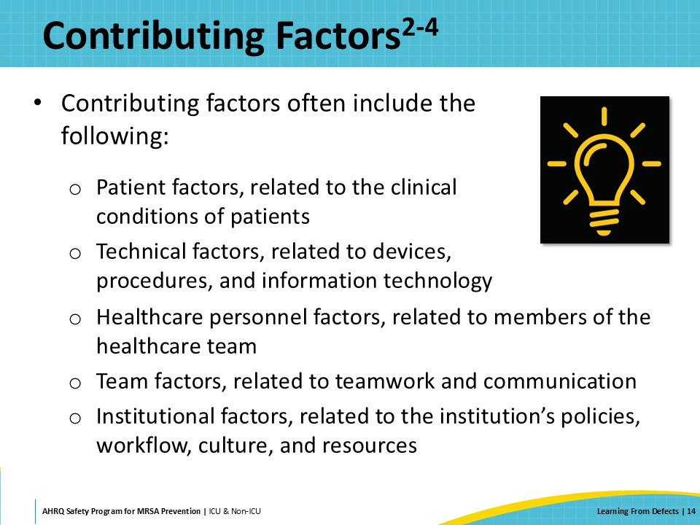
How Will You Reduce the Likelihood of This Defect From Happening Again?  SAY:  This section of the presentation will focus on the third of the four questions of the LFD process: “How will you reduce the likelihood of this defect from happening again?” | Slide 15  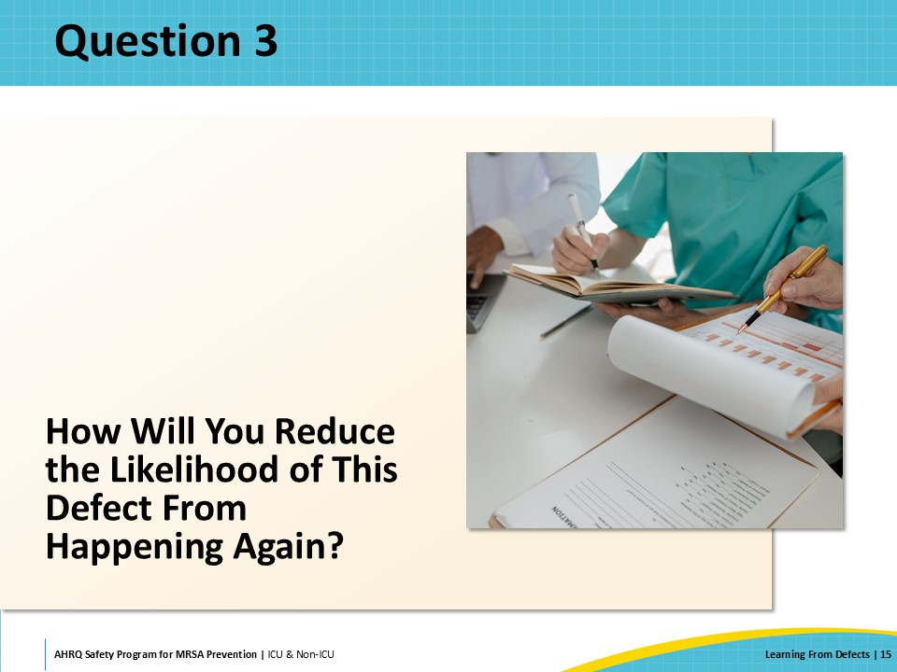
Evaluating Contributing Factors: Cause-Frequency Grid  SAY:  When deciding how to reduce the risk of the defect happening again, the CUSP team can use a case-frequency grid to promote brainstorming and to evaluate the contributing factors.  A contributing factor that is a major reason and occurs commonly is a good target for intervention. Such a factor will likely have a significant impact on risk reduction.  A factor that is not a major reason but commonly occurring may be low hanging fruit and easier to tackle to reduce the risk of the defect from happening again.  A contributing factor that is a major reason but does not occur often offers a potential opportunity for intervention.  A factor that falls in the category of being a minor reason for the defect and rarely occurs may not have much of an impact on reducing the risk.  Benefits of using this approach are that it engages all team members and visualizes the process for choosing intervention targets. | Slide 16  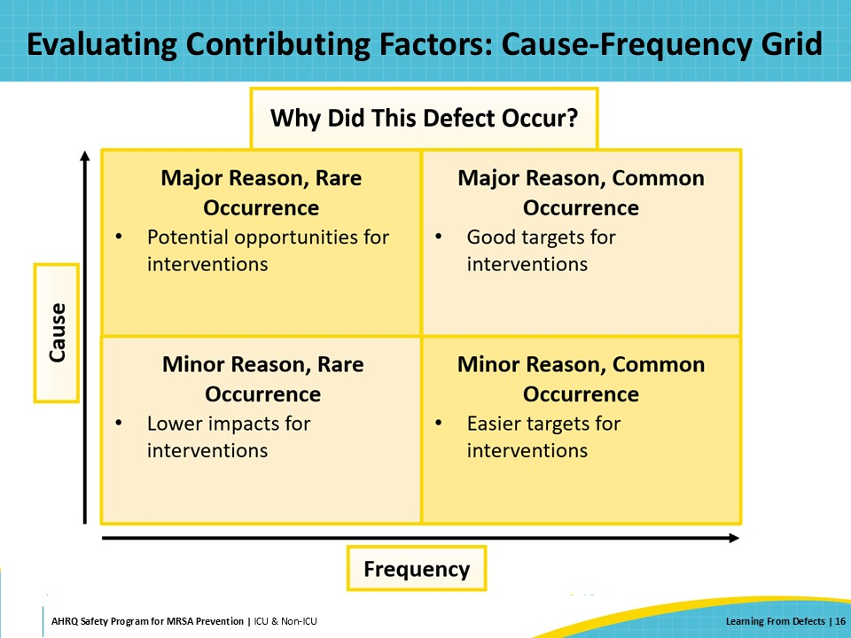
SMART Goals  SAY:  After evaluating the contributing factors, it is helpful to develop interventions with the SMART goal strategy—ensuring that they are specific, measurable, assignable, realistic, and time-specific:  - Specific goals: Target a specific task, area, or metric for improvement  - Measurable goals: Include a clear quantifiable measurement of success  - Assignable goals: Include who will own the goals  - Realistic goals: Should not be impossible  - Time-specific goals: Should have a clear deadline or timeline | Slide 17  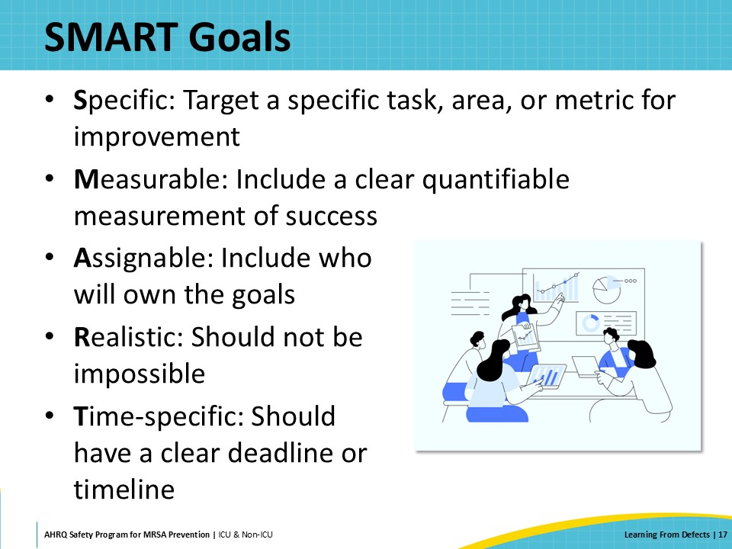
Tips To Reduce the Risk of the Defect From Happening Again  SAY:  Tips for brainstorming interventions include the following:  - Brainstorm with the entire CUSP team to identify interventions that address the key contributing factors.  - Connect with other CUSP teams who may be working on the same defect.  - Not all interventions are created equal; make sure they are appropriate for the area.  Diverse input from all team members can drive creative ideas so engage everyone in the process. Staff generally prefer having a voice in making changes. They are also more likely to adopt the change readily when they are involved in the process of designing the intervention. | Slide 18  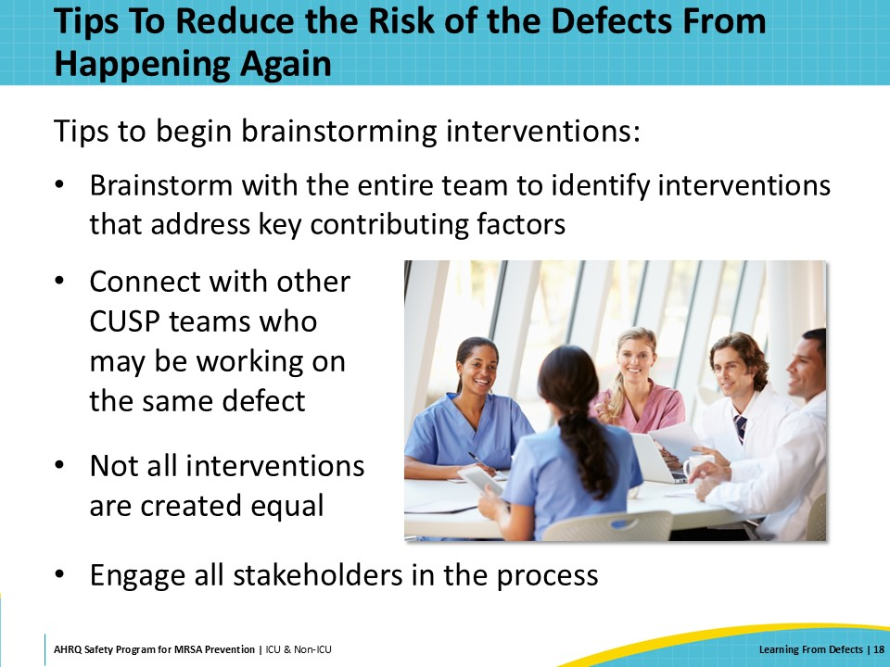
Building Resiliency Into Interventions  SAY:  When considering interventions, reflect on the strength of their effectiveness. Examples of interventions, in order of decreasing strength, include the following:  - Forcing functions and constraints, automation and computerization, and standardization and using protocols: These are the strongest types of interventions.  - Checklists and independent check systems, and rules and policies: While these are strong interventions, not everyone will read or remember them. After all, there are many checklists, rules, and policies.  - Education and information: Education is important, but on its own, it is a weak intervention. Education can make people aware of the problem, but it alone will not eliminate mistakes.  - Vague warnings: These interventions do not offer effective or permanent solutions.  Stronger interventions might require more time and effort but will pay off more in the long run. | Slide 19  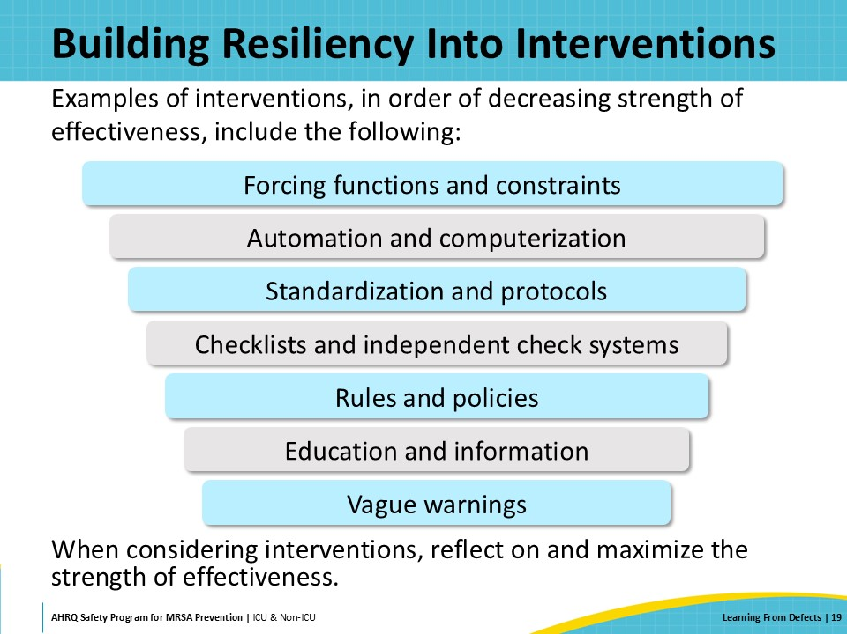
Evaluating Interventions: Impact-Effort Grid  SAY:  After identifying and considering interventions, an impact-effort grid can be used to decide which interventions to choose.  High impact and low effort interventions are preferred options. While high impact and high effort interventions may also be good choices, the CUSP team will need to be realistic about the time and effort required.  Low impact and low effort are easier interventions to implement and could be some low hanging fruit that support the reduction of the defect.  Low impact and high effort interventions are not preferred. | Slide 20  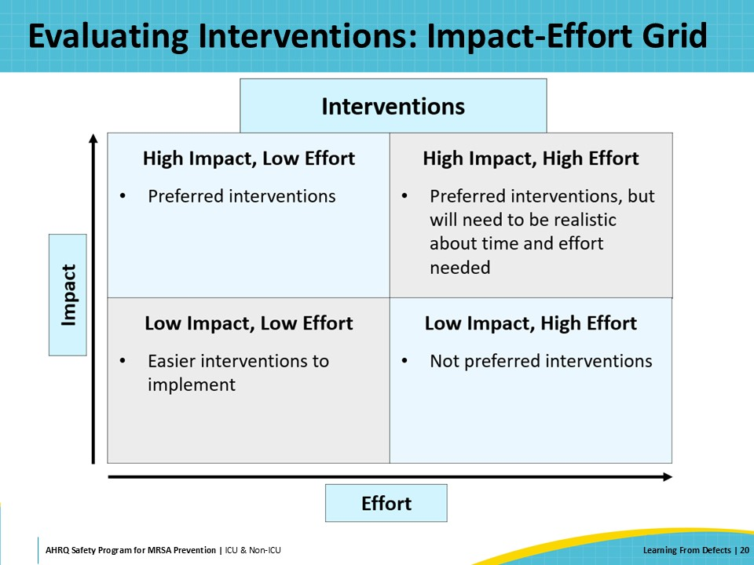
How Will You Know the Risk Is Reduced?  SAY:  The following section of the presentation will focus on the fourth question of the LFD process: “How will you know the risk is reduced?” | Slide 21  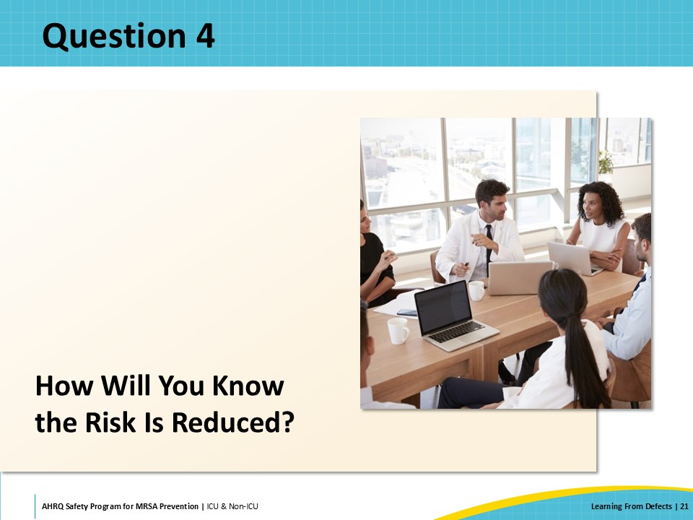
How To Determine the Risk Is Reduced  SAY:  After clearly identifying the defect, determining main contributing factors, and implementing interventions, it is key to measure the effectiveness of the interventions and adjust your approach as necessary.  As a team, identify how to measure success for each intervention.  It is important to put an audit plan into place to track that measure and to include data feedback from all stakeholders.  Make sure to review audits and adjust interventions as needed. This may require thinking about defects again.  The LFD process is continuous and engages all leadership and personnel levels. | Slide 22  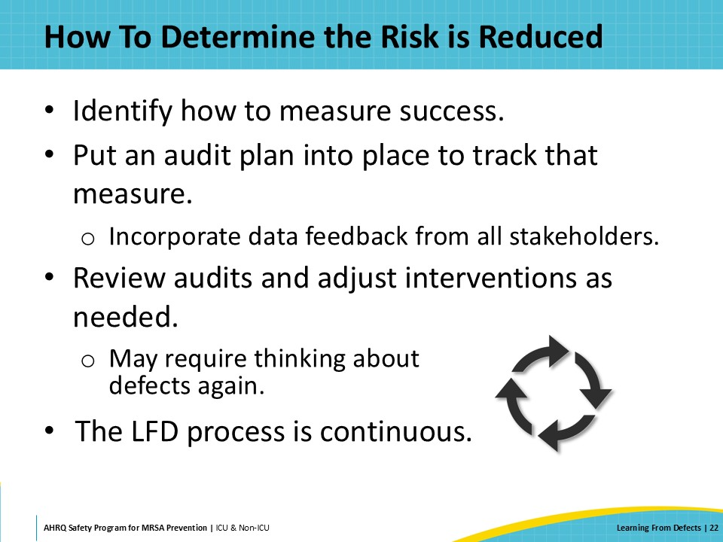
Anticipating Challenges to Using LFD  SAY:  Using the LFD tool can present challenges. The LFD process itself should be used as a guide, and teams will better understand the methodology and become more proficient after going through the process a few times.  Capturing data can be difficult especially when it is not automated. Aim to simplify the process through observational audits or surveys so that the team is not intimidated by the data capture process.  The LFD process is continuous and can be time consuming. Staff are focused on their primary workload so set realistic expectations regarding the time needed.  Team buy-in can also be a struggle. Engage supervisors who might help carve out time for team members to participate in the LFD process. | Slide 23  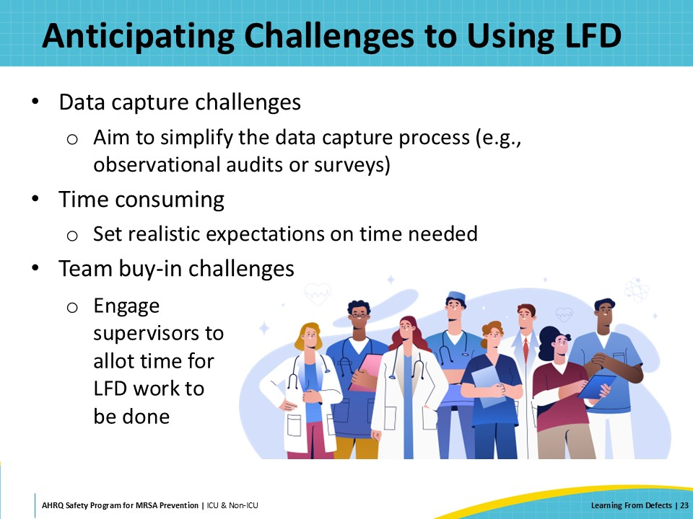
Case Example: An Increase in Healthcare-Acquired MRSA Infections  SAY:  Now, the presentation will transition to a case example to review and apply the LFD process through a study of an increase in healthcare-acquired MRSA infections. | Slide 24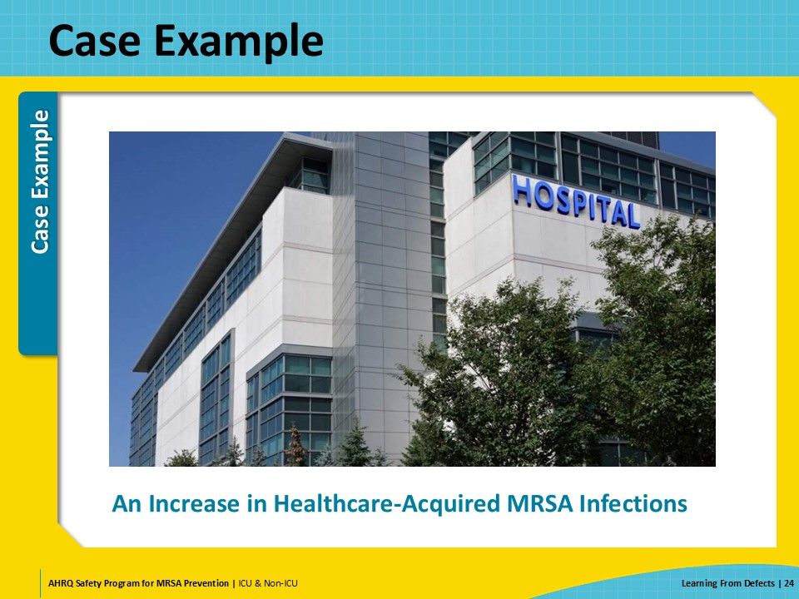
Case Example Using the Investigating a Defect Worksheet: Defect Identified and Key Metrics  SAY:  Using the Investigating a Defect Worksheet is a great way to track progress while working through each step of the LFD process.  For this presentation’s example, the defect was that three patients were determined to have MRSA infections, and all three infections were determined to be healthcare-acquired and preventable.  To determine key metrics, the baseline data came from Hospital Epidemiology and Infection Control (HEIC) reports that were routinely tracked and reported to local units. It was found that MRSA rates increased in April 2024 among patients who were known to be MRSA negative on admission. | Slide 25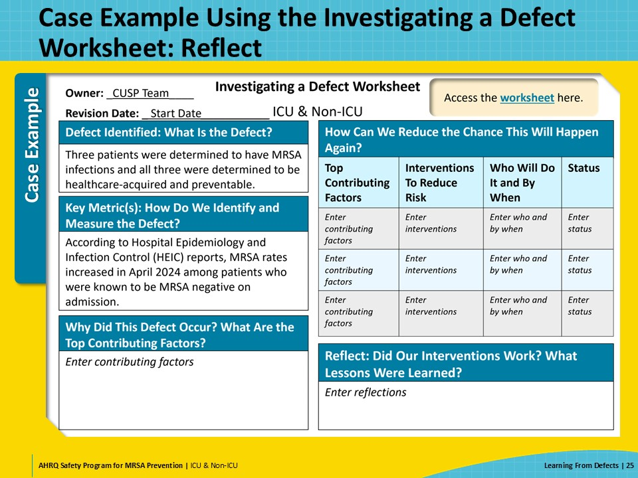
Case Example Using the Investigating a Defect Worksheet: Why Did This Defect Occur?  SAY:  The CUSP team interviewed all staff who work in the area and observed the process.  Following the Investigating a Defect Worksheet, they identified five main root causes that contributed to the three patients’ healthcare-acquired MRSA infections.  The CUSP team found that EVS was short staffed and hand hygiene adherence in the unit was low for the past 90 days.  They also found that the curtains in the rooms were not changed between patients. They identified that there was no clear policy or reference to changing the curtains.  Another contributing factor that staff mentioned was that patients were staying longer than usual.  Finally, a common theme that was mentioned in all interviews was that the appropriate bleach wipes were out of stock, so staff were not sure that bedside equipment was being disinfected between patients. | Slide 26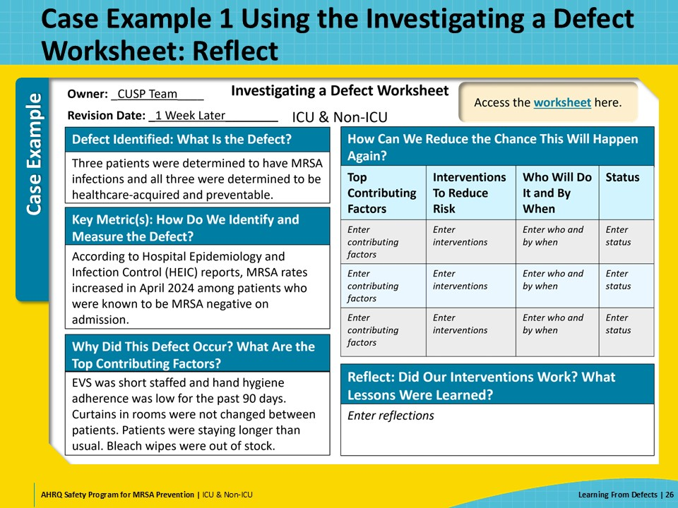
Case Example Evaluating Contributing Factors: Cause-Frequency Grid  SAY:  To evaluate the contributing factors, the CUSP team sorted them using the cause-frequency grid.  Bleach wipes that were out of stock were determined to be a major reason and a common occurrence.  EVS being short staffed and hand hygiene adherence being low for the past 90 days was a major reason but was not a common occurrence on this unit.  Curtains not being changed was listed as a minor reason with common occurrence.  The increased length of stay of patients was not a major contributor, as it was a minor reason with rare occurrence. | Slide 27  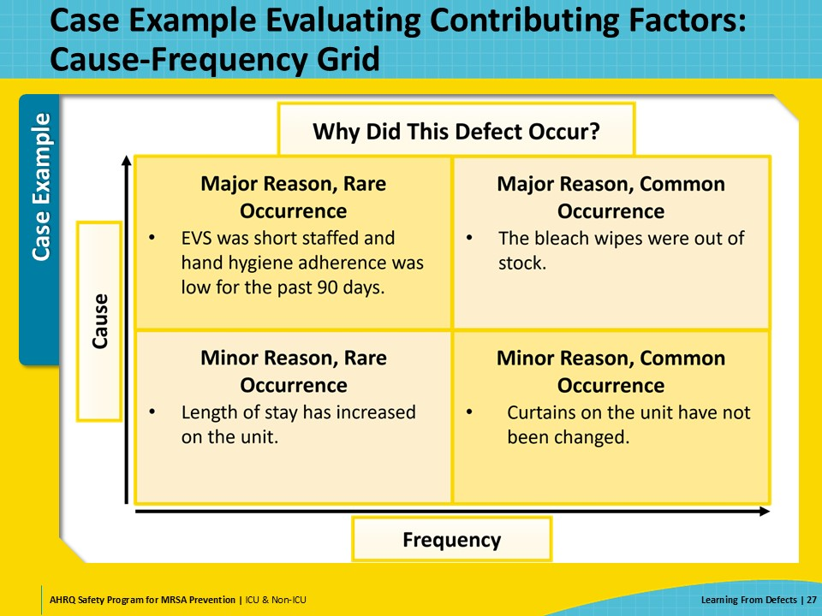
Case Example Evaluating Interventions: Impact-Effort Grid  SAY:  The CUSP team then discussed interventions and categorized them using the impact-effort grid.  Purchasing disposable curtains fell in the high impact and low effort category of interventions. This would allow all staff, not just EVS, to dispose of the curtains between patients and easily replace them with new curtains. This intervention would cost less when factoring in the time required to wash curtains and replace cloth curtains with linen.  Similarly, finding a wipe alternative was identified as high impact and low effort. This would allow all staff to continue cleaning and disinfecting equipment in the patient care environment and would solve the problem of the bleach wipes being frequently out of stock.  High impact, high effort interventions were needed to address the low hand hygiene adherence. These interventions were high effort because it is difficult to change the behavior of all unit personnel so that no hand hygiene opportunities are missed.  A low impact and low effort intervention involved standardization of patient and visitor education so that they are informed about and can support the unit’s MRSA prevention efforts.  The CUSP team did not implement any low impact, high effort interventions. | Slide 28  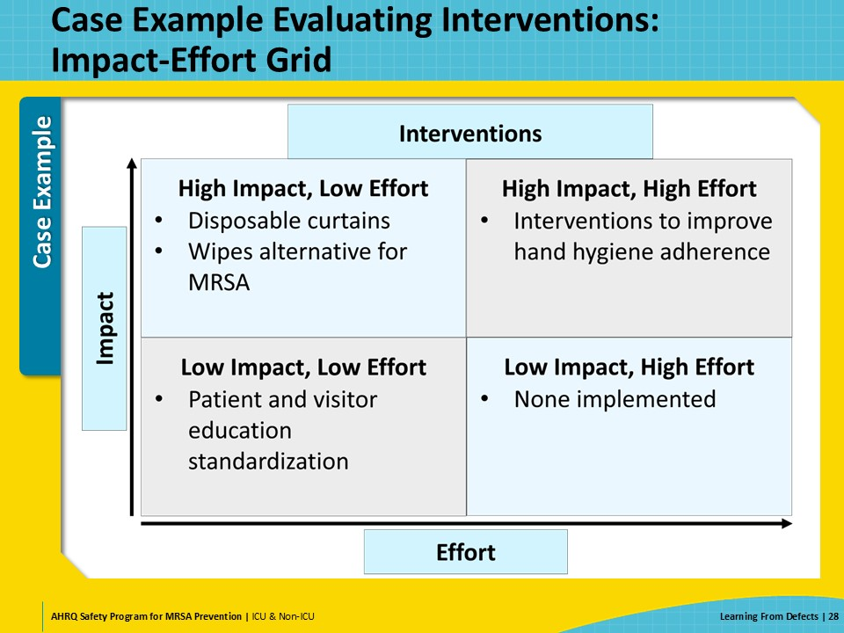
Case Example Using the Investigating a Defect Worksheet: How Can We Reduce the Chance This Will Happen Again?  SAY:  Using the Investigating a Defect Worksheet, the CUSP team tracked the interventions that would reduce the chance of the MRSA infections defect from happening again.  For out-of-stock wipes, the team decided to identify wipe alternatives and for EVS to do so by 6 weeks later. Set hard-date deadlines to drive home the importance of these implementation initiatives for the team.  For unchanged curtains, EVS piloted a disposable brand with a 3-month followup.  Regarding low hand hygiene adherence, the infection prevention and unit leadership team was tasked to disseminate hand hygiene data monthly and hold individuals accountable for their hand hygiene performance by 3 months, or August 23, 2024.  The worksheet allowed the team to track their work on one page and share the information broadly with all team members and stakeholders. | Slide 29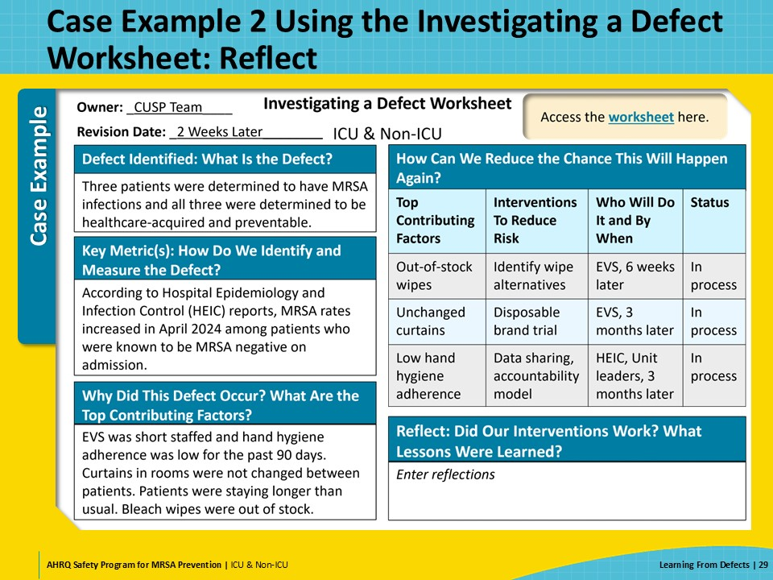
Case Example Interventions and Metrics  SAY:  The CUSP team determined metrics to help accurately capture compliance and effectiveness of the interventions. They specified who was assigned the responsibility, how frequently the data would be captured or reported, where the data would be recorded, when to follow up, and any corrective actions that would be needed.  The CUSP team obtained baseline MRSA transmission data from HEIC infection reports. Weekly measurements would be conducted by HEIC and the data would be recorded on the HEIC dashboard. The results would be discussed during the next CUSP meeting and corrective actions would include observation of the HEIC process.  For wipes replacement, the metric would involve EVS interviews conducted by the Infection Control Practitioner every week and logged at the nursing station. Along with weekly followups, corrective actions would include consulting the EVS supervisor.  Regarding curtains replacement, the measure of success would consist of patient room audits conducted by technicians 3 days per week. The data would be recorded at the nursing station and along with weekly followups, corrective actions would involve consulting the EVS supervisor.  To measure the success of hand hygiene data sharing and the new accountability model, HEIC would utilize “secret shopper” or unknown observers to collect hand hygiene adherence data. They would record the data on the HEIC dashboard and share it widely with all unit personnel and leadership. In addition to monthly followups, corrective actions would consist of holding non-adherent personnel accountable for non-adherence with hand hygiene practices.  As shown through the example interventions, metrics to measure success would help the team strengthen, reinforce, or revise interventions. | Slide 30  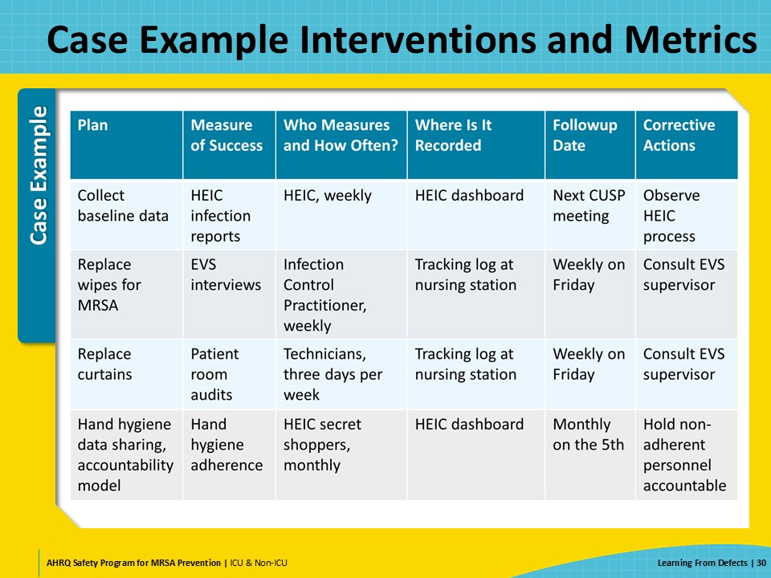
Investigating a Defect Worksheet: Reflect  SAY:  Around 3 months later, the CUSP team reflected on whether the interventions worked and what lessons were learned with the Investigating a Defect Worksheet.  The CUSP team found that after implementing the interventions, the number of healthcare-acquired and preventable MRSA infections was reduced by 70 percent within 3 months.  Overall, every intervention and risk reduction matters, even if the defect is not eliminated. As LFD is a continuous process, once an intervention is fully integrated into practice, it is helpful to think about other contributing factors that might need attention. | Slide 31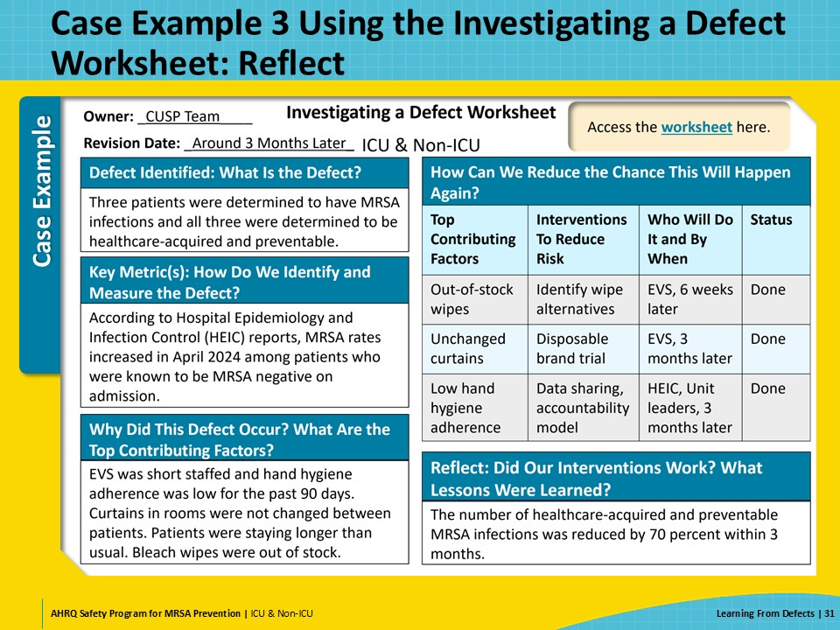
Celebrate Successes  SAY:  The LFD process takes a lot of hard work and effort and requires input from all leadership and personnel levels.  Remember to acknowledge and celebrate successes each step of the way! | Slide 32  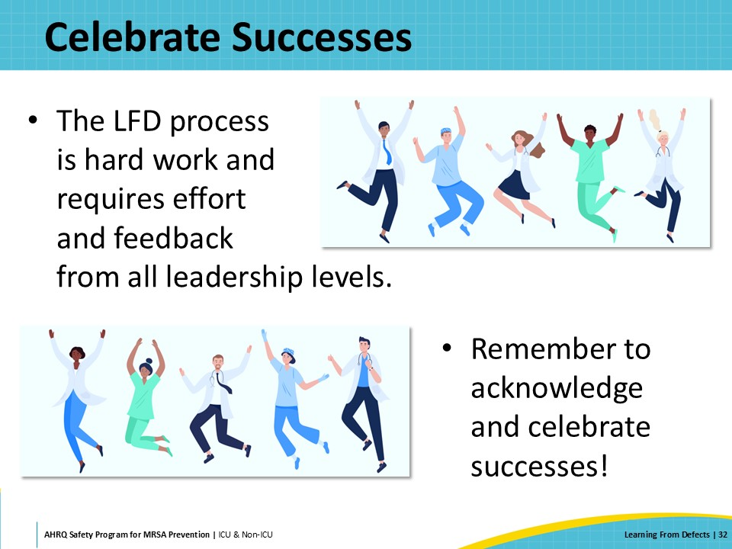
CUSP Tools Summary  SAY:  Examples of CUSP tools to guide teams through the LFD process include the following: Staff Safety Assessment, Learning From Defects Tool for MRSA Prevention, Example of a Completed Learning From Defects Tool, and Investigating a Defect Worksheet. | Slide 33  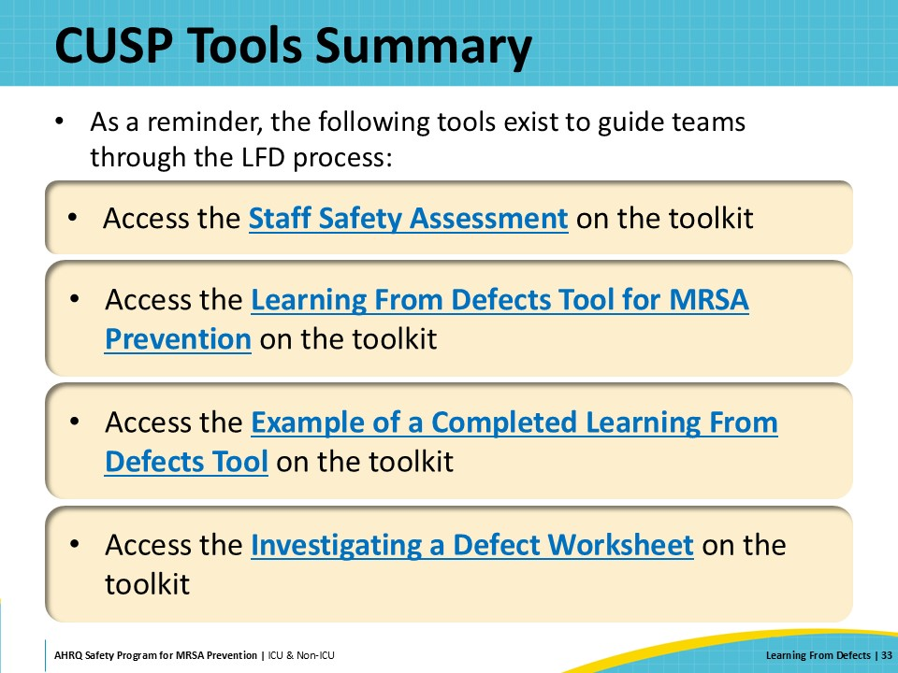
Key Takeaways  SAY:  In conclusion, the presentation discussed the LFD process.  Defects are clinical or operational events that you do not want to happen again.  The LFD process enables teams to look at the system surrounding the defects and their root causes, often resulting in highly effective interventions that target these root causes.  The following four questions help teams address and prevent defects system-wide:  - What happened?  - Why did it happen?  - How will you reduce the likelihood of this defect happening again?  - How will you know the risk is reduced?  The bottom line is that there is no quick fix when it comes to LFD and mitigating the risk of MRSA transmissions in healthcare settings. It is important to work together to protect patients from preventable pathogens such as MRSA and remember to celebrate successes! | Slide 34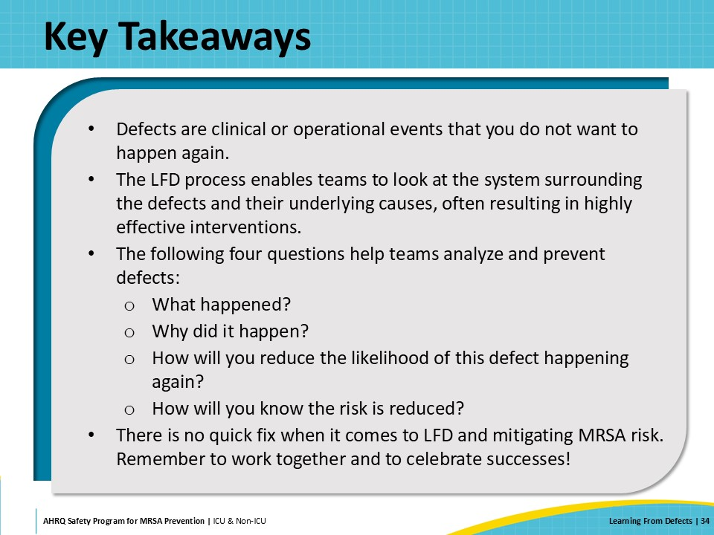
Disclaimer  SAY:  The findings and recommendations in this presentation are those of the authors, who are responsible for its content, and do not necessarily represent the views of AHRQ. No statement in this presentation should be construed as an official position of AHRQ or of the U.S. Department of Health and Human Services.  Any practice described in this presentation must be applied by healthcare practitioners in accordance with professional judgment and standards of care in regard to the unique circumstances that may apply in each situation they encounter. These practices are offered as helpful options for consideration by healthcare practitioners, not as guidelines. | Slide 35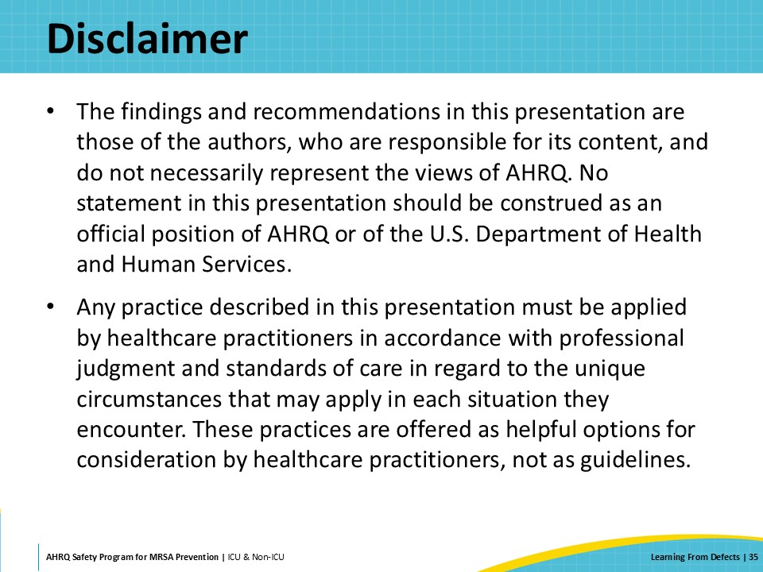
Reference List  SAY:  Please take a moment to review the references. | Slide 36  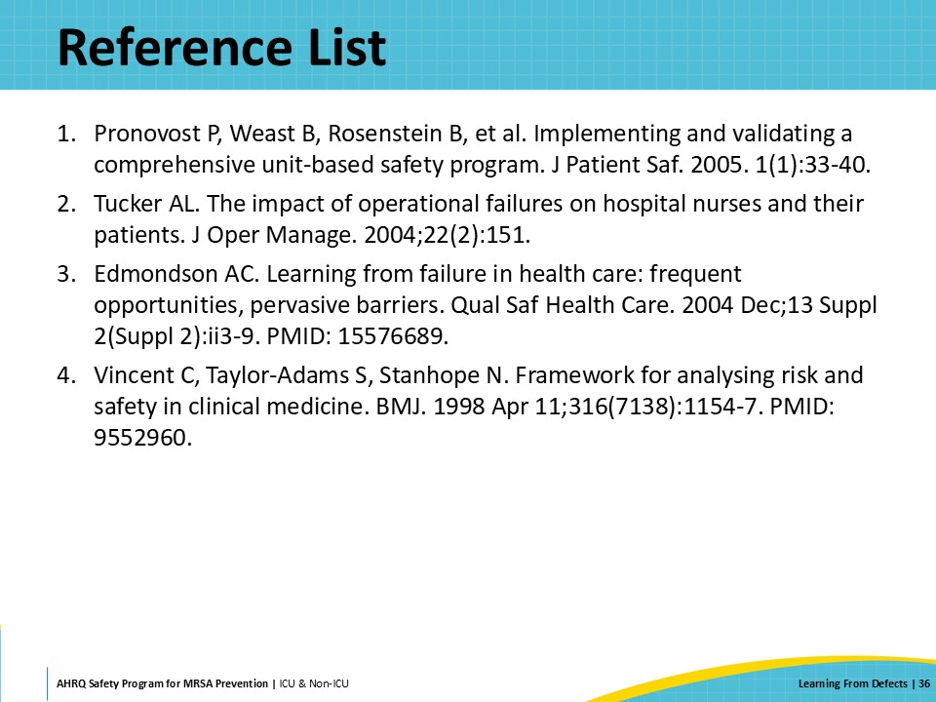

AHRQ Pub. No. 25-0007
October 2024

