Antibiotic Stewardship and MRSA Reduction
ICU & Non-ICU
Slide Title and Commentary | Slide Number and Slide
Antibiotic Stewardship and MRSA Reduction  SAY:  Welcome to this presentation on antibiotic stewardship as part of an overall approach to preventing MRSA in ICU and non-ICU settings.  This webinar will provide information about antibiotic stewardship and its association with MRSA reduction and steps to improve antibiotic stewardship. | Slide 1  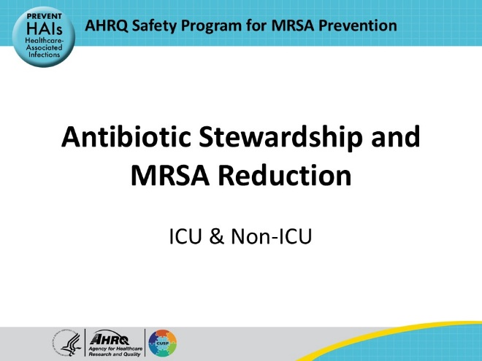
Educational Objectives  SAY:  By the end of this presentation, viewers should be able to:  - Understand the goals of antibiotic stewardship  - Discuss the association between antibiotic use and MRSA colonization and infection  - Describe evidence that antibiotic stewardship can impact risk of MRSA colonization and infection  - Identify approaches that a hospital unit can implement to improve antibiotic decision making | Slide 2  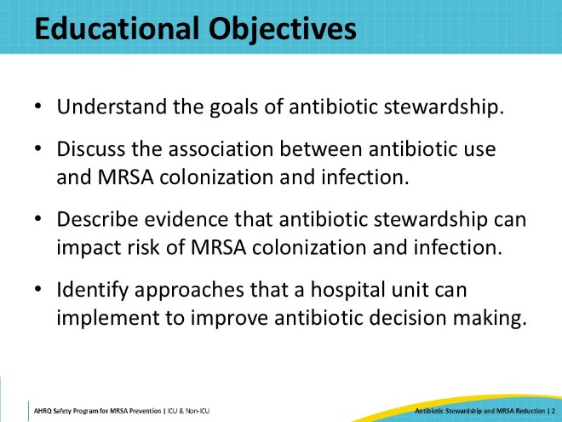
Take Aim to Prevent MRSA  SAY:  The four main strategies to prevent MRSA transmission and infection include decolonizing patients, decontaminating the environment, preventing person-based transmission, and preventing device and procedure related infections. | Slide 3  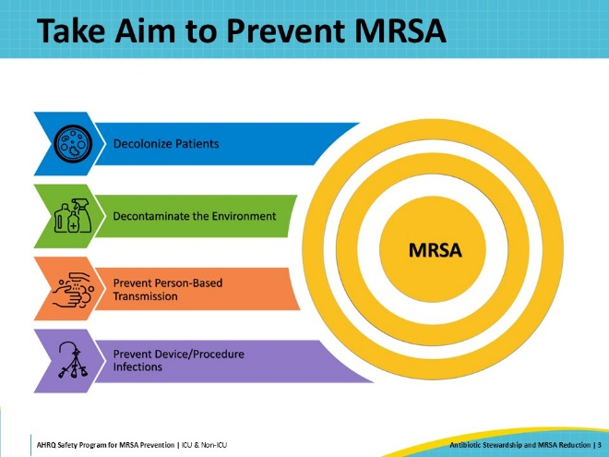
Fundamental Best Practices  SAY:  In addition to the four main strategies, Antibiotic Stewardship and Blood Culture Stewardship are essential best practices that are fundamentally important for MRSA prevention. They do not fall into any specific strategic area but are both interrelated with all four key strategies. These topics need to be highlighted to underscore their significance.  Antibiotic stewardship aims to optimize the use of antibiotics by ensuring antibiotics are prescribed appropriately. Overuse and misuse of antibiotics are primary contributors to the emergence of resistance. Antibiotic stewardship promotes processes to select the right drug with the right dose at the right time for the right duration. | Slide 4  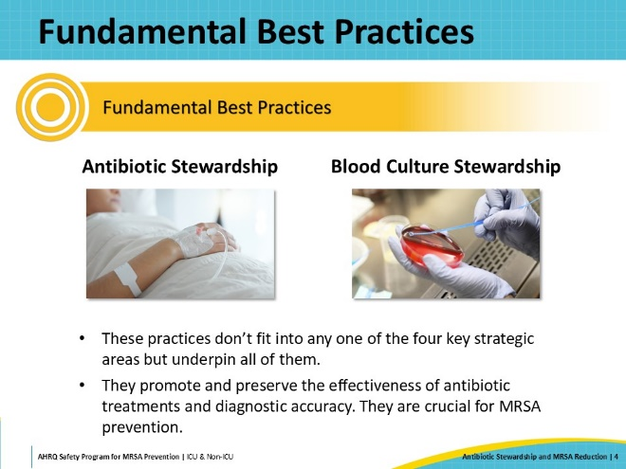
Some Facts About Antibiotic Use  SAY:  Antibiotics have revolutionized modern medicine and saved countless lives. However, their use is not without consequences. One paper found 20% of hospitalized patients experience an adverse reaction related to antibiotic therapy, including GI symptoms, rash, nephrotoxicity, Clostridioides difficile, or C. diff, infection, and emergence of antibiotic-resistant organisms. More than 95% of adverse events associated with antibiotics have clinical ramifications, such as additional hospitalizations, prolonged hospital stays, additional clinic or emergency department visits, incidents of multidrug-resistant organism infections, and additional laboratory and other studies. Many of these adverse events could be avoided given that 30% to 50% of antibiotic use in hospitals is inappropriate. This includes use of antibiotics to which the organism is not susceptible, use of overly broad-spectrum antibiotic regimens, use of antibiotics in patients who do not have signs or symptoms of infection, and excessive durations of therapy. | Slide 5  
What Is Antibiotic Stewardship?  SAY:  The field of antibiotic stewardship has been developed to address safety and overuse concerns associated with antibiotic use. It can be defined as coordinated interventions to improve and measure the appropriate use of antibiotics by promoting the selection of the optimal antibiotic drug regimen, dose, duration of therapy, and route of administration. However, the most straightforward definition is ensuring that every patient gets an antibiotic only when needed, that is the right agent at the right dose for the right duration. | Slide 6  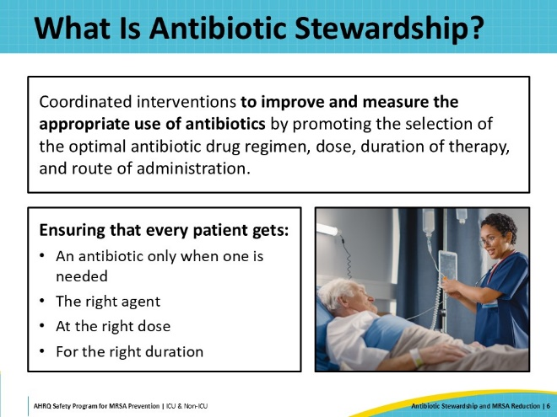
Antibiotic Exposure and MRSA Risk  SAY:  Although failures of infection control practices are often viewed as the main reason that MRSA spreads in healthcare facilities, associations between antibiotic exposure and MRSA colonization and infection have been described. The strongest association appears to be with receipt of fluoroquinolones, such as levofloxacin and ciprofloxacin. Fluoroquinolone exposure has been independently associated with MRSA nasal colonization in a prospective cohort of long-term care patients who underwent weekly screening. It was also independently associated with MRSA infection in hospitalized patients. In addition to fluoroquinolones, glycopeptides, cephalosporins, and beta-lactam antibiotics have also been associated with MRSA colonization and infection in a meta-analysis of several studies. | Slide 7  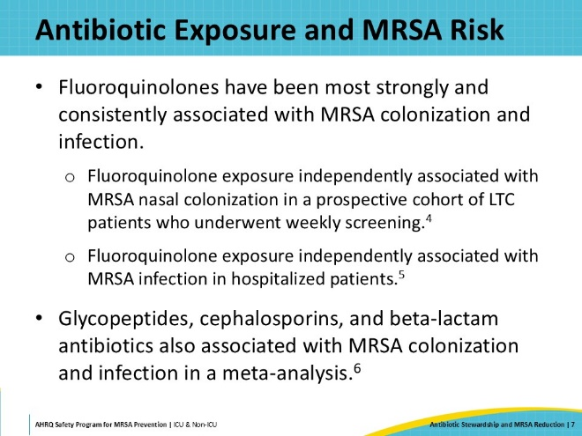
Association Between Antibiotic Stewardship and MRSA Reduction  SAY:  Given the apparent association between antibiotic exposure and MRSA colonization and infection, a reasonable next question is whether antibiotic stewardship approaches can lead to reductions in MRSA cases. In a meta-analysis assessing results from 17 studies, as depicted on this slide, antibiotic stewardship programs were associated with a 37% reduction in MRSA with a pooled incidence ratio of 0.63. | Slide 8  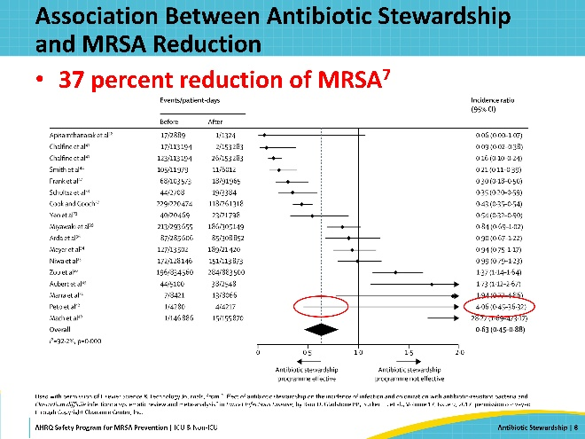
Reductions in MRSA Associated With Reduction of Antibiotic Use in Scotland  SAY:  In a study involving inpatients and outpatients in northeast Scotland, investigators assessed the impact of the Scottish antibiotic stewardship and infection control plan on both hospital and community MRSA rates. This intervention spanned several years and included both antibiotic stewardship interventions and infection control interventions. | Slide 9  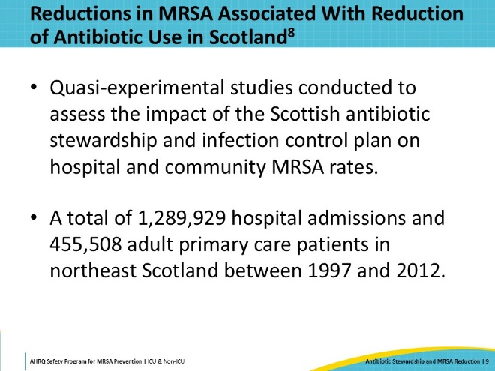
Multiple Interventions  SAY:  The antibiotic stewardship interventions were led by a regional antibiotic stewardship program with pharmacists and infectious diseases specialists who were funded by the National Health Service. The primary intervention focused on reduction of use of four antibiotics referred to as the 4C antibiotics (because in the United Kingdom they start with the “C” sound). These are fluoroquinolones, cephalosporins, amoxicillin-clavulanate, and clindamycin. Of note, an additional goal of the intervention was to reduce C. diff rates; these antibiotics were also selected because of their associations with that infection.  Use of these agents was restricted, with guidelines recommending against their use in favor of other agents, and a requirement for approval from an ID specialist if they were used for a non-approved indication. The infection control interventions included a national hand hygiene campaign starting in 2007, monthly auditing of hospital cleaning starting in 2006, and admission screening for MRSA, initially universal from 2008 to 2011 and then targeted surveillance with decolonization from 2011. | Slide 10  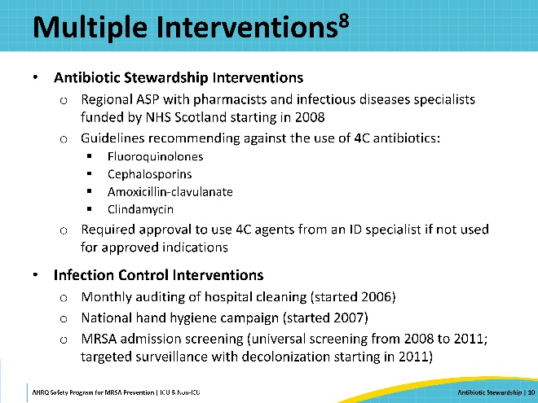
MRSA Reduction in the Hospital  SAY:  These graphs show the results of the intervention over time in two of the participating hospitals, with the gray area representing the time period of the antibiotic stewardship intervention. Interventions for environmental cleaning and hand hygiene as well as MRSA admission screening were in place prior to the start of the stewardship intervention, and MRSA decolonization began during the stewardship intervention.  In both hospitals, the blue dots and lines are MSSA rates. In the hospital represented in the top graph, MRSA rates are in red and in the hospital in the bottom graph, MRSA rates are in green. A significant decrease in MRSA rates can be appreciated in both hospitals, particularly after the initiation of the antibiotic stewardship intervention, suggesting that antibiotic stewardship interventions are an important component of efforts to reduce MRSA colonization and infection. Overall, there was a 50% reduction in hospital cases of MRSA. | Slide 11  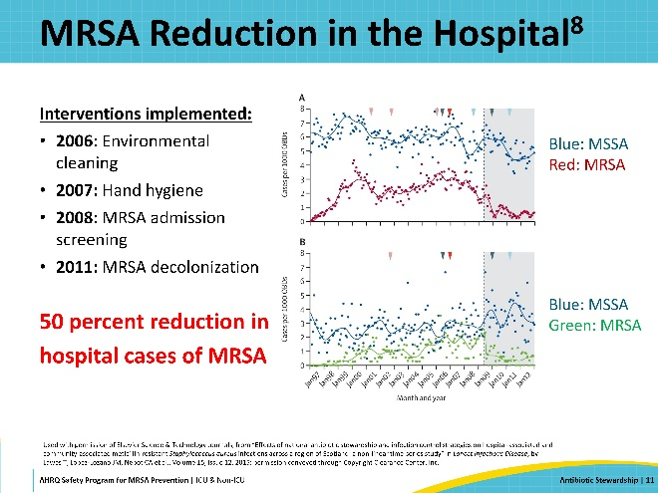
Steps to Improve Antibiotic Stewardship on a Unit  SAY:  Based on the data we have reviewed, initiation of new antibiotic stewardship interventions or enhancement of existing stewardship interventions should be considered to reach the goal of reduction of MRSA colonization or infection on a unit.  There are five steps to consider when implementing new stewardship activities. First, a group of unit-based champions should be identified to work on improving antibiotic use on the unit. Second, your hospital should have an Antibiotic Stewardship Program, and your unit champions should meet with members of the program to ask for assistance. Third, in conjunction with the hospital ASP, the unit should identify specific areas to focus on to improve antibiotic prescribing. Fourth, the unit champions and the ASP should design an intervention to target the areas where improved prescribing is desired. Finally, the unit champions should engage frontline providers on the unit to practice routine, daily self-stewardship, where they take ownership of all prescribing decisions. In the next few slides, we will discuss these steps in more detail. | Slide 12  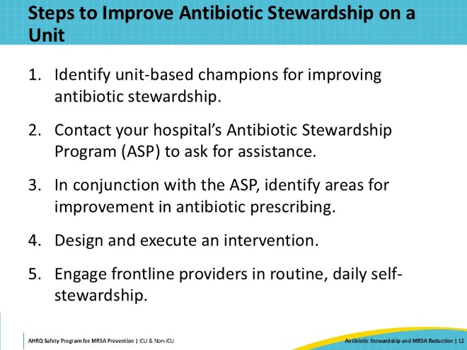
Step 1: Unit-Based Stewardship Champions  SAY:  Having local champions for antibiotic stewardship activities will increase the likelihood that interventions will be successful. Clinicians are more likely to engage in improvement activities if they know that their peers are also involved in the work.  Three important champions should be identified. The first should be someone who prescribes antibiotics who is a thought leader who is trusted by other prescribers. This will usually be a physician – often the medical director of the unit – but in some cases this may be an advanced practitioner who has a specific interest in rational antibiotic prescribing. Depending on the staffing of the unit, identification of a physician and advanced practitioner pair may also be an effective approach. These individuals will be responsible for reviewing current antibiotic prescribing practices, determining what additional prescribing guidance is needed, and championing and executing interventions.  The second champion is a pharmacist. Many units have clinical pharmacists who are already integrated into daily work, but if this is not the case, then the pharmacy department may be able to assign a pharmacist to assist with stewardship activities. Pharmacists often are present on the units regularly rather than rotating on- and off-service and can ensure that daily interventions occur. They may be the primary liaison to the hospital stewardship program and should work closely with the physician and/or advanced practitioner leads to review practice and develop guidance for prescribing. If they are regularly rounding on the unit, they should participate in executing interventions.  Finally, a nurse champion should be identified. Although nurses are not involved in prescription of antibiotics, they administer them and are at the bedside of patients more often than other healthcare workers, where they can observe patients for adverse events and problems with administration. Furthermore, they may be in the best position to prompt daily review of need for antibiotics. | Slide 13  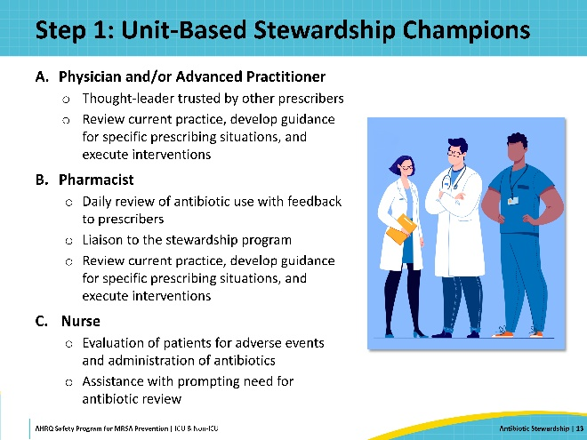
Step 2: Working With the Hospital ASP  SAY:  The unit champions should contact the hospital antibiotic stewardship program to develop intervention approaches. It is highly likely that the ASP will be thrilled to hear from a unit that wants to improve prescribing and will welcome ongoing collaboration. The Centers for Medicare & Medicaid Services, or CMS, and The Joint Commission both have requirements that hospital have antibiotic stewardship programs. These programs are responsible for tracking antibiotic use and resistance, developing guidelines for common infectious diseases syndromes, and performing and evaluating interventions to improve antibiotic prescribing across the hospital.  Your ASP should be able to provide your unit with useful information, including antibiotic use rates for your unit, stratified by antibiotic class. Ideally, they may also be able to benchmark these data based on national data reported to the Centers for Disease Control and Prevention or relative to other similar units in the hospital. The ASP may also have information on the appropriateness of antibiotic use in your unit based on existing interventions or assessment of compliance with local prescribing guidelines. | Slide 14  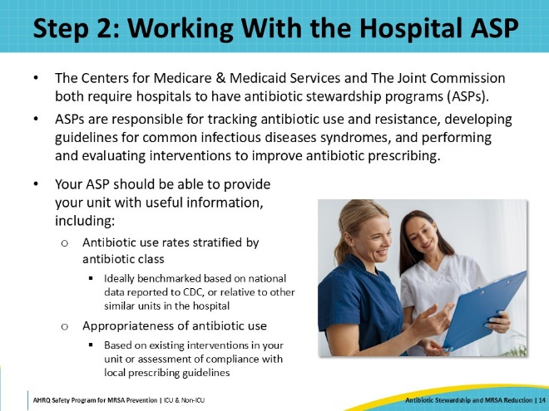
Step 3: Identify Areas for Improved Prescribing  SAY:  Based on data about what antibiotics or syndromes that are contributing to excess or inappropriate antibiotic use, the next step in improving antibiotic use is to decide what antibiotics or syndromes you want to target on the unit. If you elect to target specific antibiotics, fluoroquinolone reduction should be strongly considered, given their association with MRSA. Many hospitals and units have already worked to decrease use of these agents due to their association with C. diff infection and adverse events, such as prolonged QTc intervals, tendinopathy, and altered mental status in older people. Even so, it is likely that there are still opportunities for improvement. In most units, there are also ample opportunities to improve use of ceftriaxone, cefepime, and piperacillin/tazobactam, which are often started empirically and then not re-evaluated regularly.  Targeting syndromes has the advantage of allowing education on all aspects of management of syndromes, including diagnosis, empiric therapy, step-down therapy, and duration of therapy. Furthermore, clinicians tend to prefer to learn optimal management of syndromes rather than indications for antibiotics.  Some common syndromes that are associated with opportunities in improving prescribing are asymptomatic bacteriuria and urinary tract infection, pneumonia, and suspected sepsis.  Urine cultures are often sent in the hospital, and often grow organisms. However, positive urine cultures should only lead to antibiotic therapy if the patient has signs and symptoms of a urinary tract infection with two specific exceptions for asymptomatic patients—those who are pregnant and those about to undergo a urological operation where mucosal bleeding is expected. In the absence of signs and symptoms for all other patients, antibiotic therapy is not indicated, and avoiding such therapy can lead to reductions in overall antibiotic use. Even if a patient meets criteria for a urinary tract infection, there are often opportunities to improve antibiotic use, including using narrow spectrum agents and limiting duration for uncomplicated cystitis.  Pneumonia encompasses community-acquired pneumonia, hospital-acquired pneumonia, and ventilator-associated pneumonia. All can be challenging to diagnose, with diagnostic uncertainty often leading to unnecessary therapy with overly broad therapy and durations that are longer than needed based on available literature.  Finally, suspected sepsis is often associated with initiation of broad-spectrum antibiotics started in the emergency department, which are continued on the unit without re-evaluation of whether infection is present or narrower antibiotics are suitable.  More information on best practices in management of these and other syndromes can be found in the AHRQ Safety Program for Improving Antibiotic Use Toolkit, which includes information for the acute care setting on building and maintaining an antibiotic stewardship program, improving the safety culture around antibiotic prescribing, and diagnosing and treating common infectious disease syndromes. Numerous materials can be found at the website listed to assist units in implementing interventions to improve antibiotic prescribing. | Slide 15  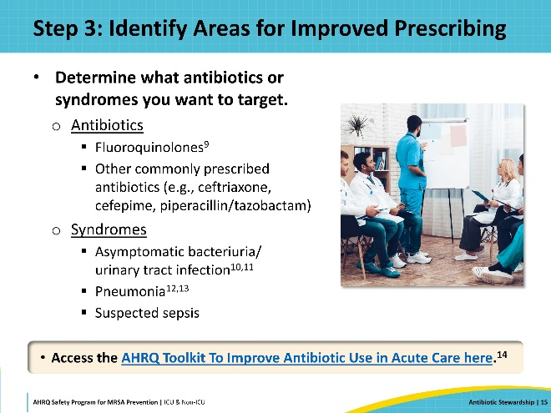
Four Moments of Antibiotic Decision Making  SAY:  The Four Moments of Antibiotic Decision Making is a framework designed to ensure optimal antibiotic prescribing using a structured approach at critical time periods of antibiotic decision making. Clinicians should be encouraged to use the Four Moments framework for all patients receiving antibiotics and whenever the need for antibiotics is being considered.  Moment 1 occurs at the time that initiation of antibiotic therapy is being considered. The prescriber should ask, “Does my patient have an infection that requires antibiotics?” Some patients may have a very low risk of having an infectious cause of their symptoms and others may not need antibiotics immediately.  Moment 2 occurs at the time that the decision has been made to start antibiotics. The prescriber should ask two questions, “Have I ordered appropriate cultures before starting antibiotics? What empiric therapy should I initiate?” Empiric therapy should be based on what organisms are likely to cause the suspected infectious process, the severity of illness, and characteristics of the host. Ideally, guidelines for empiric therapy for different infectious processes will have already been developed by the antibiotic stewardship program in collaboration with prescribers to inform empiric treatment decisions.  Moment 3 occurs on every subsequent day of antibiotic therapy. The prescriber should ask three questions: “Can I stop antibiotics? Can I narrow therapy or change from IV to oral therapy?”  Moment 4 should occur as soon as it is clear what infectious process is being treated and the patient is demonstrating a response to therapy. The prescriber should ask, “What duration of antibiotic therapy is needed for my patient's diagnosis?” | Slide 16  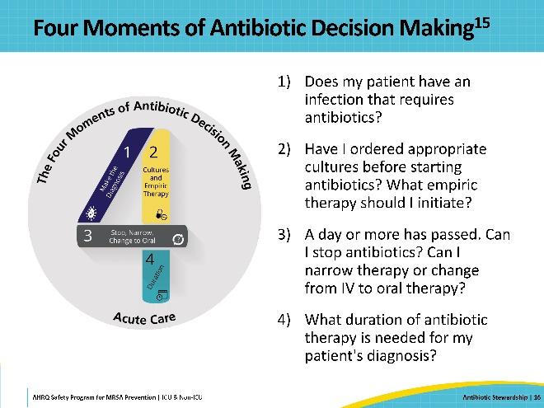
Step 4: Design and Execute an Intervention  SAY:  The fourth step is to design and execute an intervention. It is important to review existing hospital guidelines for the targeted antibiotics and syndromes with the hospital ASP to determine if changes are needed or if new guidelines need to be developed. Remember, guidelines for antibiotics should contain information on when they are indicated. Guidelines for syndromes should contain information on diagnosis, empiric therapy stratified by illness severity and relevant host factors, step-down and oral therapy, and duration.  Then, develop strategies to integrate guidelines into practice. This may include development of order sets with recommended empiric therapy; regular, real time post-prescription review of antibiotic therapy with recommendations for changes in regimens provided to frontline prescribers by the ASP or unit pharmacist, feedback of data on antibiotic use and guideline compliance to chart progress; and integration of the Four Moments of Antibiotic Decision Making into routine practice such as discussing them during rounds or documenting them in progress notes. | Slide 17  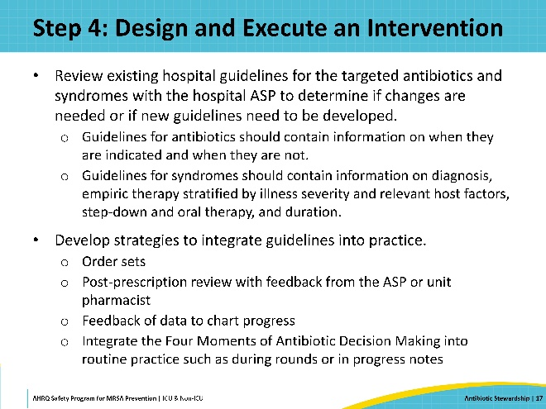
Step 5: Engage Frontline Prescribers  SAY:  Engagement of frontline prescribers is key to making sustained changes in antibiotic prescribing. Stewardship champions should disseminate information on the changes that the frontline prescribers are being asked to make. This can be done via meetings, emails, or one-on-one detailing. It is also important to provide strategies to prompt prescribers to critically review their own antibiotic use daily. One approach is to use a daily antibiotic “time out” in which the Four Moments of Antibiotic Decision Making are discussed, with a particular emphasis on Moment 3: “Can I stop antibiotics? Can I narrow therapy or change from IV to oral therapy?” The stewardship champions should work with frontline providers to make needed tools with the relevant evidence and prescribing recommendations available at the point of care.  Finally, work with your ASP to determine how to collect or obtain data to provide feedback to frontline prescribers. This can be unit-based or individual prescriber-based; the method is less important than developing some type of feedback loop.  In the following two slides, we will review two useful tools that were developed for the AHRQ Safety Program for Improving Antibiotic Use and are available on the website. | Slide 18  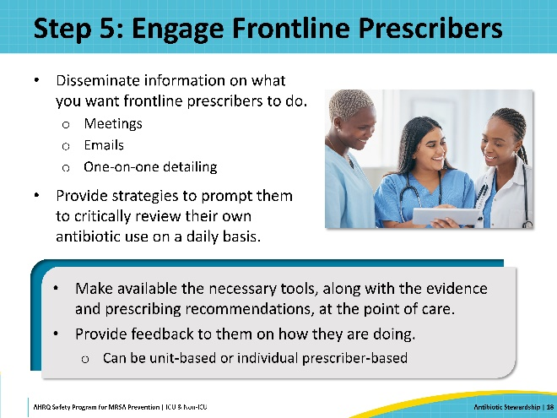
Antibiotic Time Out Tool  SAY:  This is an example of an Antibiotic Time Out Tool. It can be used to facilitate a daily time out that is performed by frontline providers for each patient receiving antibiotics on the unit. On the front, the prescriber is asked to provide an indication for antibiotics, assess whether antibiotic therapy can be stopped, narrowed, or changed to oral therapy, and determine a duration of therapy. The back of the form contains evidence-based recommendations for duration of therapy by infectious syndrome to make this information easily accessible at the point-of-care. | Slide 19  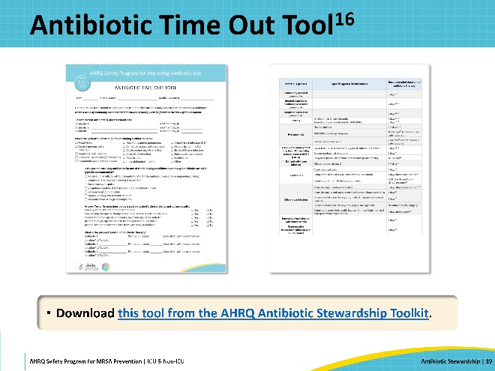
Team Antibiotic Review Form  SAY:  This is the Team Antibiotic Review Form. This form can be used to facilitate team-based discussions on antibiotic use between the ASP and frontline staff using the Four Moments framework. Optimally, the ASP and the frontline team should meet in person and complete these forms based on review of patients currently receiving antibiotic therapy at some pre-specified interval, such as monthly. The ASP can consider providing written summaries of these discussions to the frontline providers, highlighting areas where antibiotic prescribing was appropriate as well as areas for improvement. | Slide 20  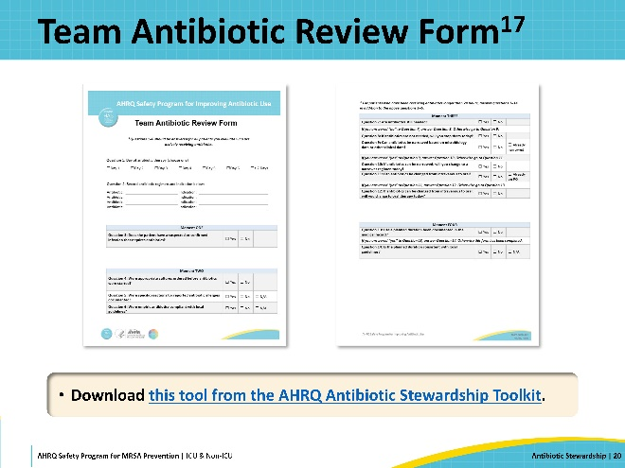
Communicating With Colleagues About Antibiotic Decisions  SAY:  Discussions with colleagues about antibiotic decisions require effective communication approaches because clinicians may have different views about when and what antibiotics may be needed for a patient. It is important to understand and implement techniques to improve communication regarding antibiotic decision making. Clinical team members should develop skills and strategies to ensure they can work together effectively with the goal of improving antibiotic use and preventing harm associated with antibiotics. | Slide 21  
Four Key Components of Effective Communication  SAY:  There are four components of effective communication:  - Effective communication is complete. All relevant communication is relayed but unnecessary details that may cause confusion are avoided. In addition, the relevant team members have easy access to the needed information. For example, reasons that antibiotics were started for a patient the day before are known, understood, and can be communicated by the clinicians caring for the patient today. This is best achieved by documentation in the medical record.  - Effective communication is clear. When speaking with team members, effective communication includes the use of standard terminology. When speaking with patients and families, effective communicators avoid technical terms and jargon and instead use plain language and layman’s terms that are more easily understood.  - Effective communication is brief and concise. Use punctuation in your head when you communicate information rather than long statements that go on and on. Ask the recipient of the information to repeat the message to verify that the message has been received. Avoid too many if/then comments in a row.  - Effective communication is timely. It avoids compromising a patient’s situation by promptly relaying information. It notes times of observations and interventions in the medical record. | Slide 22  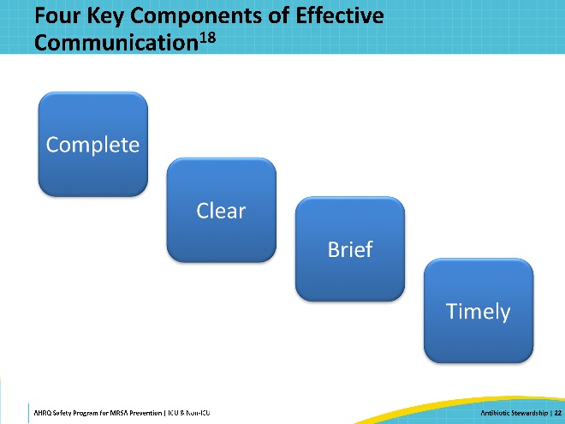
Use Assertive (Not Aggressive) Statements  SAY:  In communication, there is a difference between being assertive and being aggressive. Assertiveness is standing up for your own or a patient’s interests in a calm and positive manner. It is an approach that leads to effective communication. Aggressiveness (whether passive or active) is attacking or ignoring others' opinions in favor of your own.  Being appropriately assertive means seeing yourself as having worth; valuing others equally and respecting their right to an opinion; and engaging in communication respectfully while also respecting your own opinions.  Being assertive does NOT mean being aggressive, hostile, confrontational, demeaning, or condescending. Ineffective communication hinders teams and units. You should focus on productive communication within your team and with individuals outside of your team.  It can also be instructive to detect and observe ineffective communication and its effects in your practice and on your unit. | Slide 23  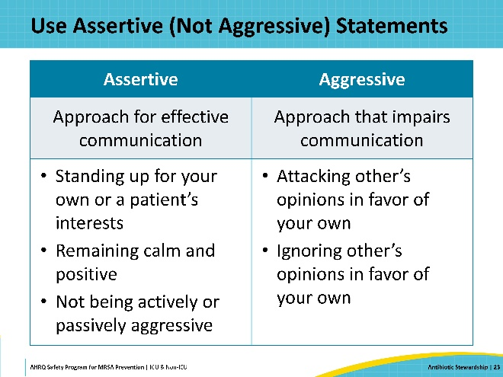
Elements of Appropriate Assertion  SAY:  When advocating for a patient, team members should provide evidence to support their concerns and recommendations. It is best to focus on the common goal of providing the safest care to the patient rather than attacking the perspective of a teammate or sounding judgmental; both actions are likely to lead to lack of consensus. Think about the wording of your statements in advance and gather your thoughts before speaking. | Slide 24  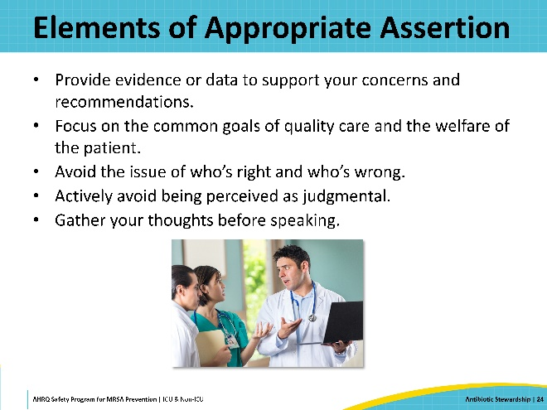
Case: Possible Vancomycin Toxicity?  SAY:  For example, suppose you are taking care of an 80-year-old man admitted with suspected pneumonia from a nursing home. He was initially started on vancomycin and piperacillin/tazobactam. Since his admission, his oxygen requirements and his mental status have returned to normal. Sputum Gram-stain and cultures as well as blood cultures are negative, but his creatinine has increased from 1.2 to 1.5 mg/dL. You propose stopping vancomycin and piperacillin/tazobactam and starting an oral cephalosporin to complete a five-day course of therapy, but a colleague is concerned about stopping MRSA and pseudomonal coverage because the patient came from a nursing home and was quite ill when he was admitted.  Think about ways that you could resolve these different views regarding antibiotic therapy. | Slide 25  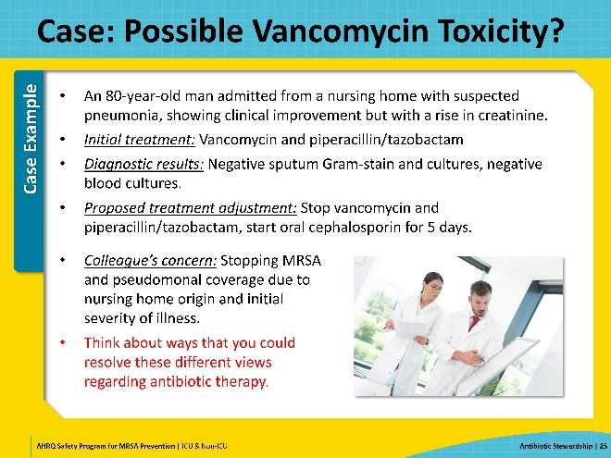
Case: Try an Aggressive Stance  SAY:  You could say, “That’s ridiculous—why do you want to keep giving the patient antibiotics that are hurting his kidneys just because you are nervous?” However, that sounds like a judgmental, personal attack on the other physician and is unlikely to bring about resolution. | Slide 26  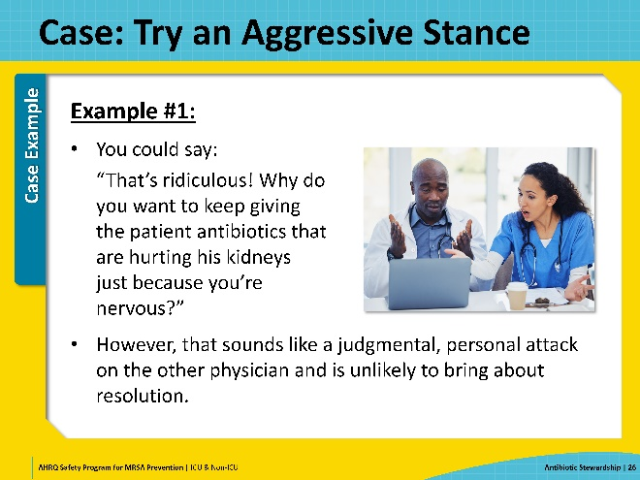
Case: Alternatively, Use an Assertive Tack  SAY:  Alternatively, you could say, “I appreciate your insight as the person who admitted the patient. It’s great that the patient is now doing so much better. I am concerned that his creatinine is increasing on the current regimen. Since his cultures don’t show MRSA or Pseudomonas, I think it would be reasonable to stop the vancomycin today, perhaps then narrow the piperacillin/tazobactam tomorrow if he still looks good. I feel like the risk of vancomycin toxicity is greater than the risk that he has an MRSA infection. Would that approach work for you?” | Slide 27  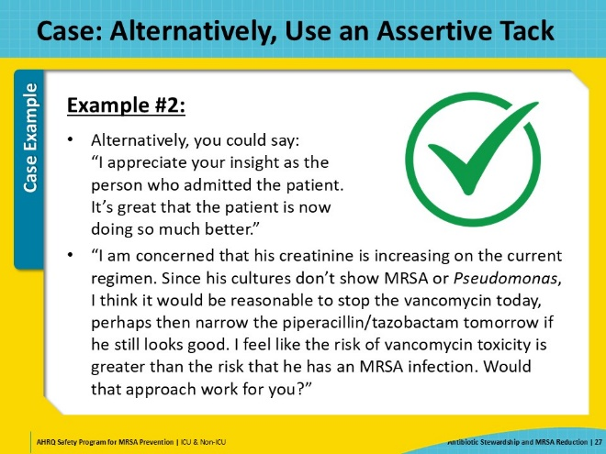
Case: Pull It Together  SAY:  In the second example, you have acknowledged the legitimate concerns of a colleague and offered a reasonable compromise and provided a rationale with the patient’s best interest in mind. If the colleague agrees, it is best to restate the plan out loud—“Let’s stop the vancomycin today. If he looks good on rounds tomorrow, we will switch the piperacillin/tazobactam to cefpodoxime for three more days”—to ensure consensus and make the plan clear. | Slide 28  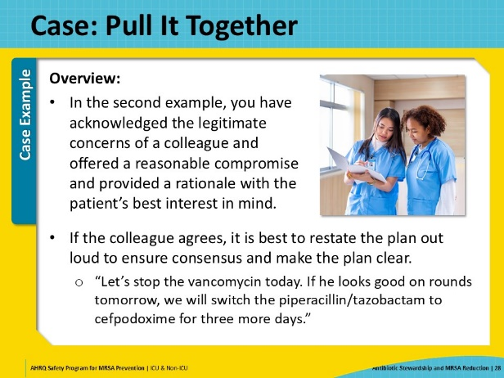
Advocacy and Assertion  SAY:  Just to review, an assertive approach includes:  - Initiating the discussion  - Stating the concern  - Acknowledging other’s points of view  - Offering a solution  - Providing evidence for your concern and recommendations  - Obtaining agreement  By using an assertive, rather than aggressive approach, you can avoid accusation, avoid attacking the judgement of your colleague, and you put forth an attitude supporting the fact that you both want to the patient to have the best care possible. | Slide 29  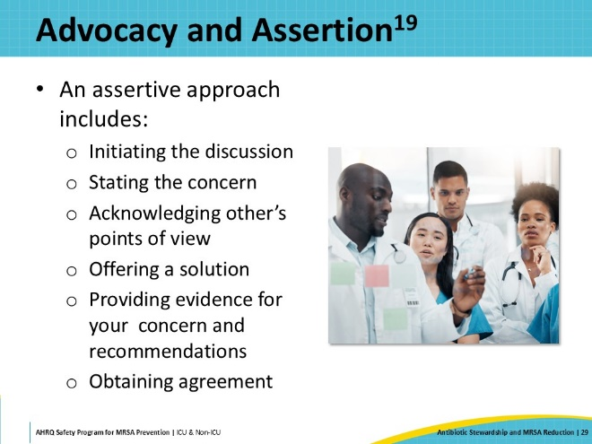
Key Takeaways  SAY:  In summary, there is an association between antibiotic use and MRSA colonization and infection, particularly with fluoroquinolones. Antibiotic stewardship interventions targeted at reducing use of broad-spectrum agents is associated with MRSA reduction.  Improving antibiotic prescribing can be facilitated by implementation of five steps:  - Identify unit-based champions for improving antibiotic stewardship.  - Engage the hospital’s Antibiotic Stewardship Program for assistance.  - In conjunction with the ASP, identify areas for improvement in antibiotic prescribing.  - Design and execute an intervention.  - Engage frontline providers in routine, daily self-stewardship.  Finally, individuals and teams should identify and implement opportunities to improve communication around antibiotic prescribing. | Slide 30  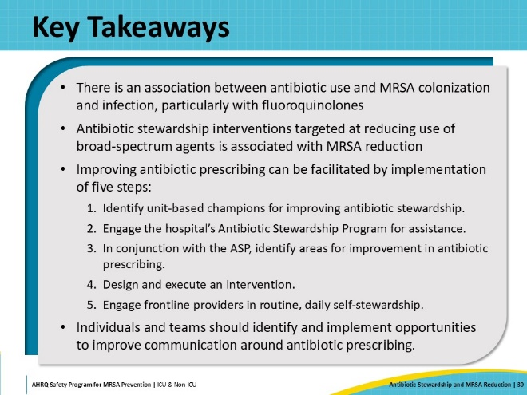
Disclaimer  SAY:  The findings and recommendations in this presentation are those of the authors, who are responsible for its content, and do not necessarily represent the views of AHRQ. No statement in this webinar should be construed as an official position of AHRQ or of the U.S. Department of Health and Human Services.  Any practice described in this presentation must be applied by healthcare practitioners in accordance with professional judgment and standards of care in regard to the unique circumstances that may apply in each situation they encounter. These practices are offered as helpful options for consideration by healthcare practitioners, not as guidelines. | Slide 31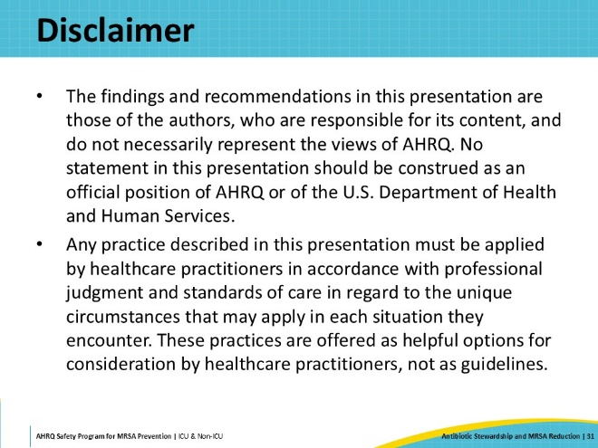
Reference List—1 | Slide 32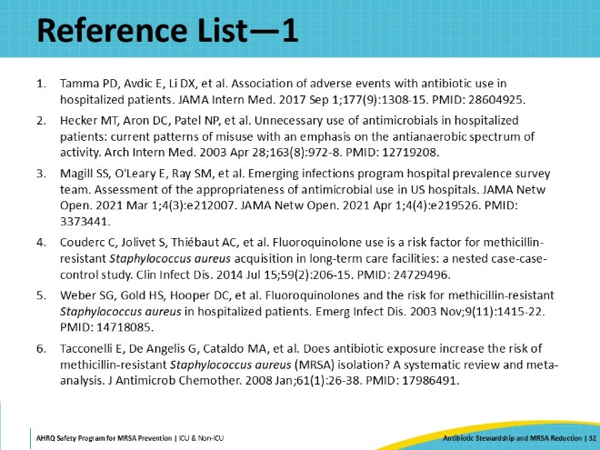
Reference List—2 | Slide 33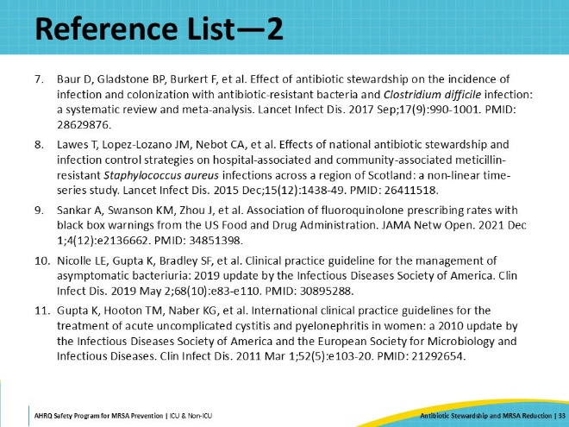
Reference List—3 | Slide 34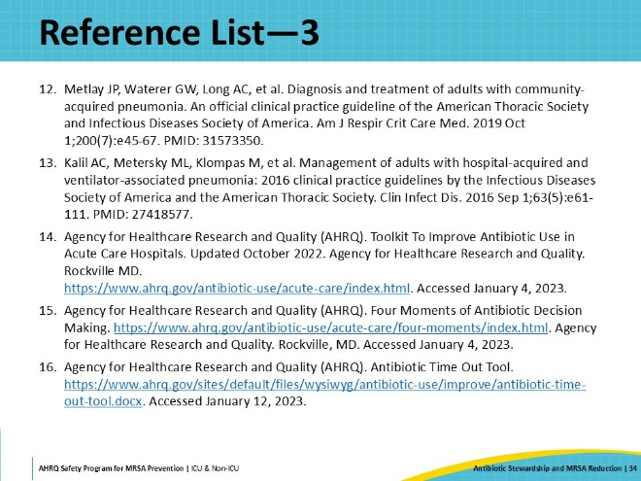
Reference List—4 | Slide 35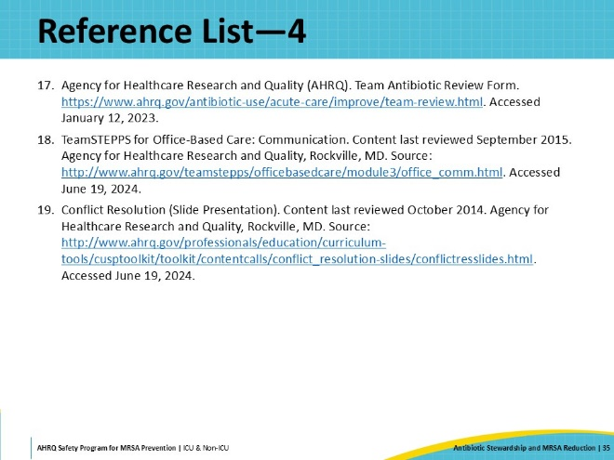

AHRQ Pub. No. 25-0007
October 2024

