Blood Culture Practices and Stewardship
ICU & Non-ICU
Slide Title and Commentary | Slide Number and Slide
Blood Culture Practices and Stewardship  SAY:  Welcome to this presentation about blood culture practices and stewardship.  This presentation will help ensure that units have the best practices in place for blood culture stewardship and avoid blood culture contamination, which are important components of methicillin-resistant Staphylococcus aureus (MRSA) prevention in intensive care unit (ICU) and non-ICU hospital units. | Slide 1  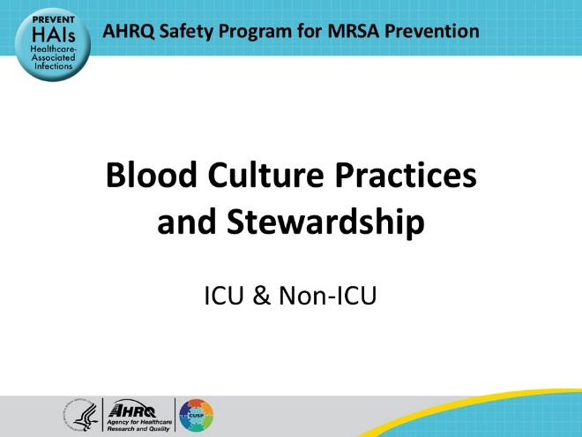
Educational Objectives  SAY:  The objectives of this presentation are to discuss the importance of blood culture stewardship in hospitals; define and discuss the risks associated with blood culture contamination; discuss strategies to promote blood culture stewardship and reduce blood culture contamination; and to discuss strategies to implement performance improvement for these programs. | Slide 2  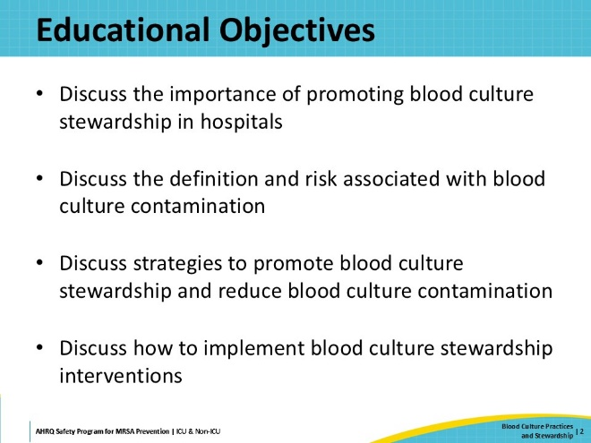
Take Aim To Prevent MRSA  SAY:  The four main strategies to prevent MRSA transmission and infection include decolonizing patients, decontaminating the environment, preventing person-based transmission, and preventing device- and procedure-related infections. | Slide 3  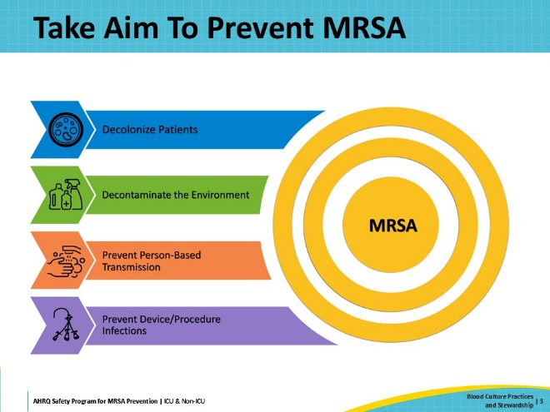
Fundamental Best Practices  SAY:  In addition to the four main strategies, Antibiotic Stewardship and Blood Culture Stewardship are essential best practices that are fundamentally important for MRSA prevention. They do not fall into any specific strategic area but are both interrelated with all four key strategies. These topics need to be highlighted to underscore their significance. | Slide 4  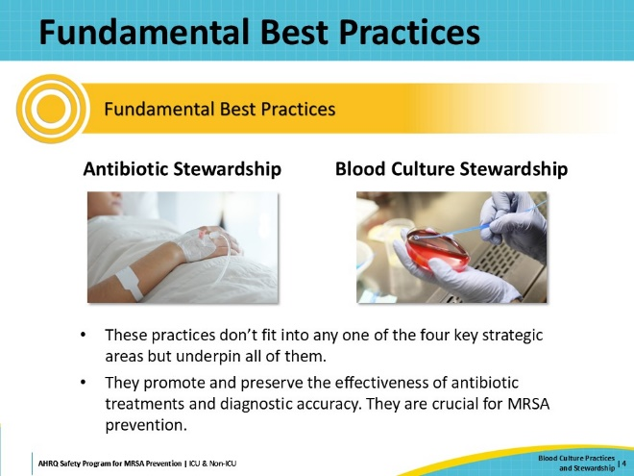
Diagnostic Stewardship  SAY:  While many diagnostic tests are ordered appropriately, they are also often routinely ordered for patients with a low likelihood of infection. Diagnostic stewardship seeks to optimize diagnostic testing, by modifying the processes of ordering, performing, and reporting of diagnostic tests. Conducting unnecessary tests can lead to inaccurate or misleading results, which lead to overdiagnosis or misdiagnosis, which often leads to unnecessary treatment. The Society for Healthcare Epidemiology of America (SHEA) describes diagnostic stewardship as “prioritizing the right test, for the right patient, to prompt the right action.”  Antimicrobial and diagnostic stewardship have been shown to improve antimicrobial use and patient outcomes, including length of stay, as well as reducing multidrug-resistant organism (MDRO) infections, including those caused by MRSA. | Slide 5  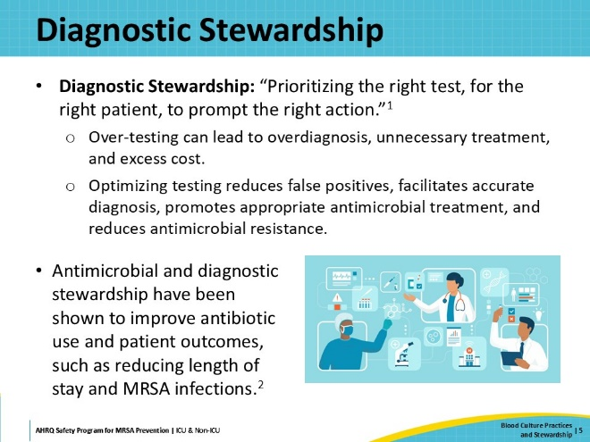
Blood Culture Stewardship  SAY:  Blood culture stewardship is designed to optimize bacteremia detection and to reduce inappropriate antibiotic and diagnostic testing that occur due to false-positive results. It includes activities that aim to optimize use of blood cultures to improve detection and management of bacteremia.  Blood culture stewardship can:  - Ensure appropriate selection of patients for testing.  - Improve blood culture processing activities.  - Improve performance of the test.  - Help avoid false-positive results and improve the yield of blood cultures.  - Improve the process of reporting results to ensure clinicians make the most appropriate decisions.  This cycle is particularly relevant to MRSA prevention because the main objective of blood culture stewardship is to reduce the number of false-positive blood cultures contaminated with skin flora organisms. This reduces unnecessary use of antimicrobials, which, in turn, reduces MRSA prevalence.  The next few slides will describe key considerations and current opportunities for improvement in blood culture stewardship. | Slide 6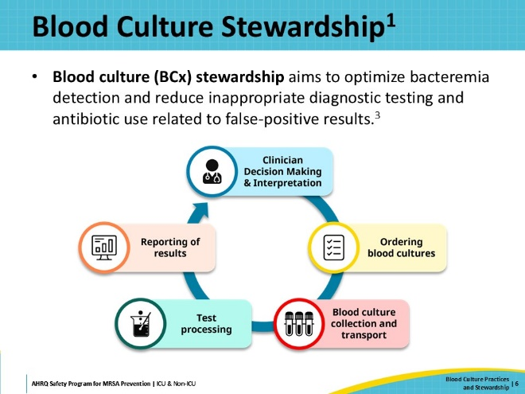
Importance of Blood Culture Stewardship  SAY:  Blood cultures are one of the most common microbiologic tests ordered for the evaluation of hospitalized patients. Most of these blood cultures do not grow any organisms and are considered negative. Most institutions report a positive blood culture rate between 2 and 10 percent. Unfortunately, up to half of these positive blood cultures may represent blood culture contaminants rather than true pathogens.  False positives caused by contamination result in further adverse consequences, including unnecessary antibiotic treatment, extra testing, and additional blood draws. Patients whose blood cultures grow contaminants have an increased length of hospital stay by 2 to 5 days compared to patients with negative blood cultures. They also have scheduled procedures cancelled more often.  Blood culture contamination can also have a negative impact on hospital metrics. One study reported that up to 30% of central-line associated bloodstream infections or CLABSIs were suspected to represent blood culture contamination and not clinical infection. Furthermore, the most common cause of preventable hospital-onset bacteremia was blood culture contamination.  Optimizing the use of blood cultures for patient management both promotes accurate diagnosis and reduces the harms that can result from excessive testing and overdiagnosis. These harms include the emergence of multidrug-resistant organisms (MDROs) such as MRSA. | Slide 7  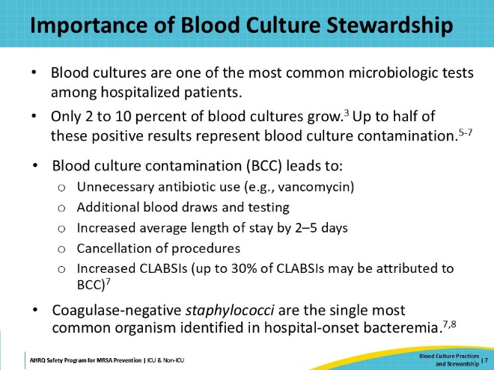
Blood Culture Contamination  SAY:  Monitoring and reporting blood culture contamination rates is a laboratory quality best practice. Probable blood culture contamination is determined by identification of one or more skin commensals found in only one out of a series of blood cultures drawn within a 24-hour period.  Blood culture contamination rates are calculated by dividing the total number of contaminated blood culture sets by the total number of blood culture sets received from a unit or facility.  The Clinical Laboratory Standards Institute (CLSI) recommends calculating monthly rates of blood culture contamination for units that collect more than 50 blood cultures per month, and quarterly rates for units with less than 50 blood cultures drawn per month.  In the United States, traditionally, blood culture contamination rates below 3 percent were considered acceptable, but a growing consensus argued that a more stringent standard was not just achievable but also beneficial. In 2022, CLSI lowered its blood culture contamination benchmark from ≤3 to ≤1 percent.  Blood culture contamination is most often attributed to gaps in the collection process. This presentation includes intervention strategies to address these gaps and prevent blood culture contamination. | Slide 8  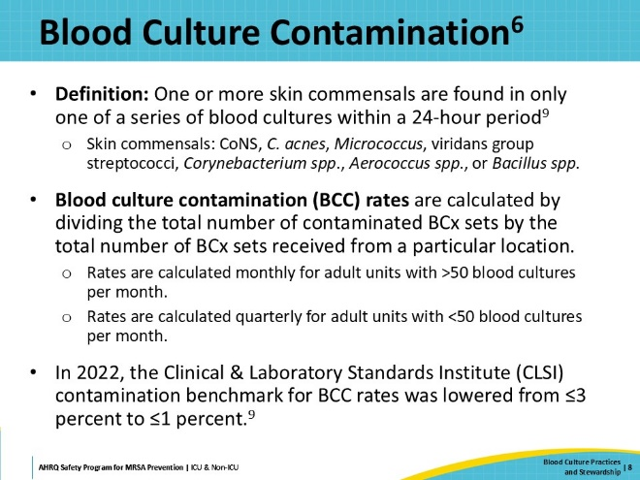
Diagnostic Stewardship and Patient Selection  SAY:  One of the most impactful interventions in blood culture stewardship is to optimize the use of blood cultures. The objective in blood culture optimization is to avoid the use of blood cultures when they are not clinically appropriate. Avoiding unnecessary blood cultures reduces the chances of contaminated tests and false positives, and the resulting consequences. The Society for Critical Care Medicine (SCCM) and Infectious Diseases Society of America (IDSA) advocate for the rational use of blood cultures as a patient safety intervention.  While blood cultures are often ordered when patients develop fever or leukocytosis to assess for bacteremia, this approach is not universally applicable. Studies indicate that fever and leukocytosis are not reliable indicators of bacteremia. For instance, approximately 20 percent of patients with bacteremia do not exhibit fever or leukocytosis, and most patients with a fever do not have concomitant bacteremia.  Blood cultures should not be ordered based solely on the presence of fever or an elevated white blood cell count. Instead, the decision to order blood cultures should be based on a comprehensive evaluation of the patient's clinical condition. | Slide 9  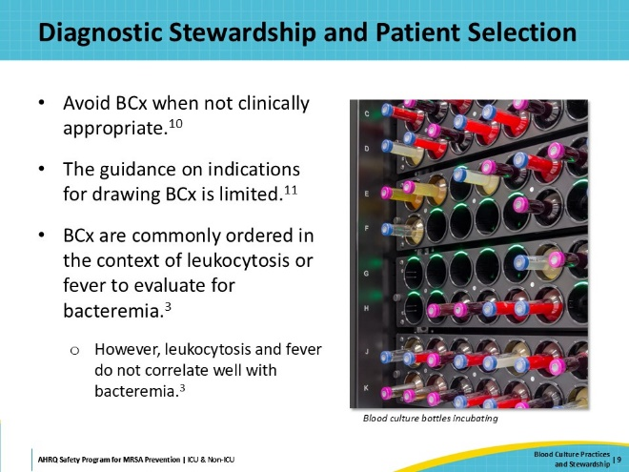
Blood Culture Utilization  SAY:  Rates of blood culture utilization are calculated as the number of blood cultures submitted divided by the number of patient days in each unit or facility. In published literature, this rate varies widely. For example, one study of ICUs in Europe reported a blood culture utilization rate of 60 blood cultures per 1,000 patient days; however, the reported rate was much higher at other institutions, including one study in the United States that reported 250 blood cultures per 1,000 patient days.  Few studies have examined whether blood culture utilization is appropriate based on clinical indications. One study at Johns Hopkins Hospital retrospectively evaluated the indications for blood cultures in the medical ICU and medicine floors, as part of a pilot intervention to reduce unnecessary blood cultures. The results showed that approximately 30 percent of blood cultures ordered in the medical ICU and 50 percent in the medicine units were not clinically indicated. | Slide 10  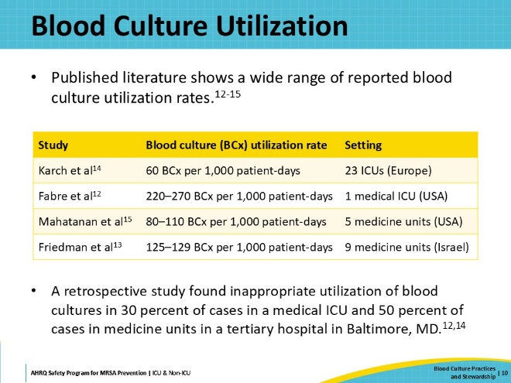
Blood Culture Decision Algorithm  SAY:  This slide shows an algorithm that can guide clinicians about when to obtain blood cultures. This algorithm was informed by a review of the published literature on the value of blood cultures in different clinical scenarios, and then further refined by a multidisciplinary team at Johns Hopkins, including representatives from antimicrobial stewardship, hospital epidemiology, critical care, hospital medicine, surgery, medical microbiology, and infectious disease. The algorithm is presented here as a decision-making flowchart.  This flowchart is available as a printable document as part of the Toolkit.  The algorithm differentiates between initial indications for blood cultures in the setting of a new clinical event, and “followup” blood cultures that are sometimes indicated to determine and document clearance of bacteremia.  For a new clinical event, the first question is whether severe sepsis/septic shock or endovascular infection is suspected. If yes, blood cultures are recommended.  The next step asks the clinician to evaluate the case for pretest probability of bacteremia according to three categories: High, Intermediate, and Low. Common examples are provided in the flowchart. For cases with High pretest probability of bacteremia, blood cultures are recommended. For Low probability, blood cultures are not recommended.  For cases of Intermediate probability, three questions are asked:  - Is the patient at risk for endovascular infection?  - Is the primary site of infection not readily available for culture prior to antibiotic initiation?  - Are blood culture results otherwise likely to impact patient management?  If the answer to all three questions is No, then blood cultures are not recommended.  For followup blood cultures, blood cultures are recommended to document clearance of bacteremia in three scenarios:  - Bacteremia due to Staphylococcus aureus or Staphylococcus lugdunensis  - All cases of infective endocarditis or patients at risk of endovascular infection  - Catheter-related bloodstream infections before a new catheter is placed  If the patient does not meet these criteria, then blood cultures are not recommended unless a followup is needed for a single positive blood culture with skin flora in a symptomatic patient, or if there is concern for persistent bacteremia. The algorithm considers the probability of bacteremia, patient host factors, and the underlying clinical syndrome. For followup blood cultures, both the causative organism and degree of infection source control are addressed. | Slide 11  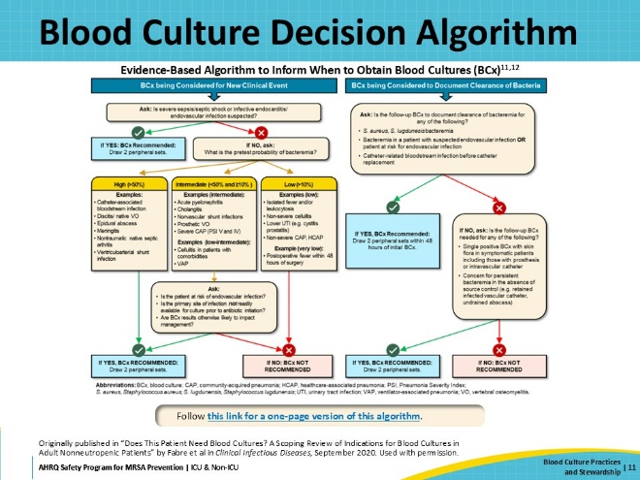
Blood Culture Decision Support  SAY:  This algorithm was developed as part of a quality improvement intervention at Johns Hopkins Hospital, with a goal of reducing unnecessary blood cultures. The intervention had three parts. First, focused education was provided to frontline providers of participating units, through lectures and group discussion of specific cases. Second, this algorithm was provided to clinicians to support decision-making regarding ordering blood cultures. The algorithm was distributed on posters and pocket cards. Third, blood culture utilization rates and examples of inappropriate blood culture indications were monitored. Feedback reports were emailed to unit leadership and chief residents and reviewed during group discussions.  The intervention resulted in a significant reduction in blood culture utilization rates. In the ICU, there was a decrease from 27.7 blood cultures per 100 patient-days to 22.8 per 100 patient-days (an 18 percent reduction). On the medical floors, rates dropped from 10.9 blood cultures per 100 patient-days to 7.7 per 100 patient-days (a 30% reduction). Non-participating units saw no significant decrease in blood culture utilization over the same period.  Additionally, there was also an observed increase in the rates of blood culture positivity not explained by blood culture contamination or S. aureus cases, which require repeated blood cultures. This suggests that the increased positivity rate was related to reduced blood culture rates among patients with low probability of bacteremia. | Slide 12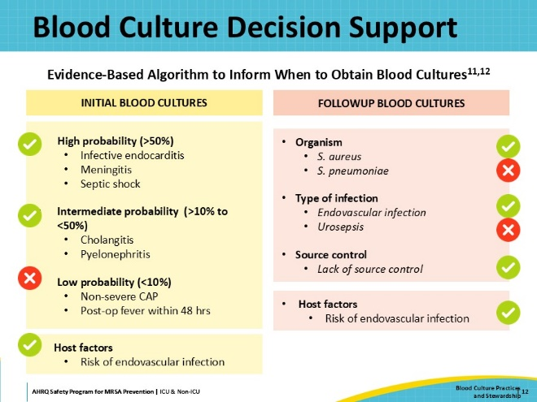
Site Selection: Peripheral vs. Central  SAY:  Once a decision is made to order blood cultures, the next layer of stewardship relates to specimen collection. Suboptimal blood culture collection practices can increase contamination rates and adversely affect the ability to isolate pathogens in blood cultures.  The first item to consider is the choice of collection site. Several studies have evaluated collection sites and contamination—comparing the contamination rates of blood cultures drawn from central venous catheters against contamination rates of blood cultures obtained through peripheral venipuncture. There is very strong evidence that blood cultures drawn from venipuncture will reduce contamination in all settings, while blood cultures from central lines are more likely to give false-positive results. For this reason, peripherally drawn blood cultures are considered best practice for the collection site. If your data demonstrates that this is an opportunity for improvement within your organization, consider limiting catheter blood culture to specific circumstances, such as cases of suspected catheter-related bloodstream infections.  Common barriers that hospitals may encounter when implementing this guidance include patient refusal of repeated sticks for blood draws, difficulty accessing peripheral veins, and challenges with time and resources. | Slide 13  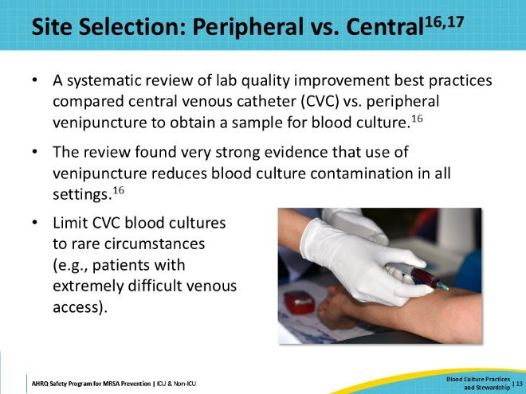
Hand Hygiene  SAY:  Aseptic technique during blood culture collection is paramount in preventing specimen contamination.  Guidelines for appropriate hand hygiene and glove use should be observed for blood culture collection. Please refer to the presentation on Hand Hygiene in this toolkit for more details. | Slide 14  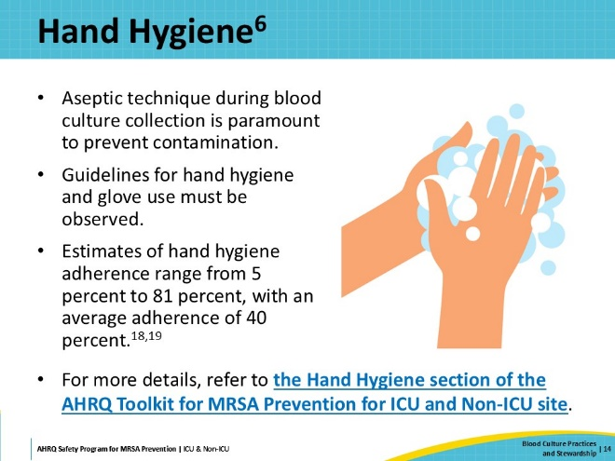
Skin Antisepsis  SAY:  Thorough skin antisepsis must be performed prior to drawing blood cultures. The main source of blood culture contaminants is the commensal bacteria that colonize the patients’ skin. Skin antiseptics containing alcohol are recommended over povidone-iodine preparations for this purpose. | Slide 15  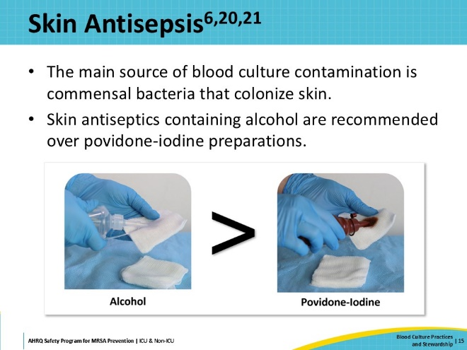
Blood Culture Bottle Disinfection  SAY:  The top diaphragm of blood culture bottles must be disinfected prior to use. The rubber stoppers of the bottles are not sterile and must be cleaned with an antiseptic. Seventy percent isopropyl alcohol is recommended for this purpose. Use of iodine alone is not recommended, as it can erode the rubber. | Slide 16  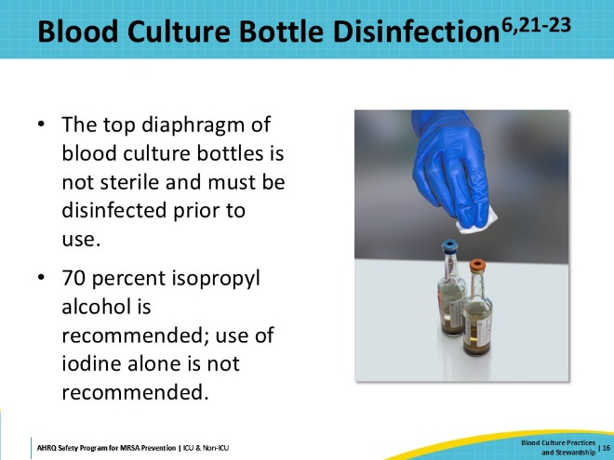
Blood Culture Collection Process  SAY:  When collecting blood cultures, the number of sets of samples is an important consideration. The gold standard for blood culture specimens is to collect at least two separate sets of samples. The two sets should be drawn from separate venipunctures to better assist with identification of contamination.  Unfortunately, studies demonstrate that up to 40 percent of blood cultures are collected as single sets. Single sets are problematic, as the data show that single sets can miss 30 to 40 percent of bloodstream infections caused by common pathogens such as enterococcus, Pseudomonas, and yeast, and 20 percent of streptococcal bacteremia, and 10 percent of staphylococcal bacteremia.  Adequate blood volume is another important consideration. Collecting an inappropriate volume of blood for analysis can affect the sensitivity of blood cultures. Both under- and over-filling blood culture bottles may decrease sensitivity. It has been reported that up to 80 percent of blood culture bottles received in the microbiology lab are inappropriately filled. | Slide 17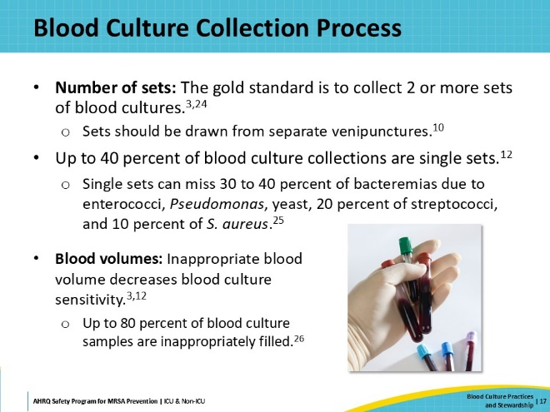
Phlebotomy Teams and Education on Proper Technique  SAY:  Studies have shown that there are often considerable gaps in education among staff on proper blood collection technique.  To address these gaps, the ideal solution would be to employ specially trained phlebotomy teams whenever possible. Multiple studies have consistently shown that blood cultures drawn by dedicated phlebotomy personnel are less likely to be contaminated, as compared to blood cultures collected by non-phlebotomy staff in hospital settings. Unfortunately, in many hospitals, phlebotomy teams are not well resourced enough to provide this service.  Especially if a dedicated phlebotomy team is not an option, training of clinical staff in best practices for blood culture sample collection is crucial. Training initiatives should focus on proper techniques for patient selection, site selection, collection process, and aseptic technique. Continual reinforcement is necessary as well. | Slide 18  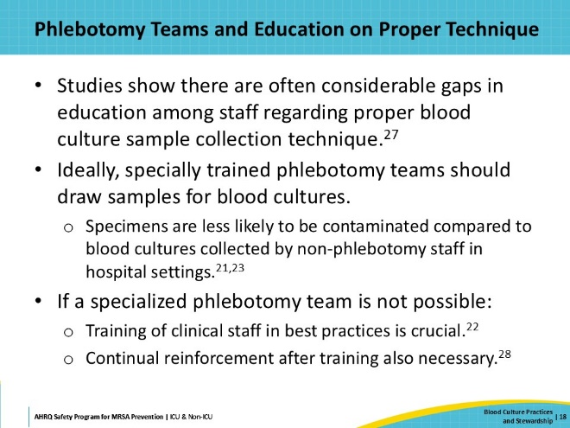
Other Strategies To Consider  SAY:  Two other intervention strategies are displayed on this slide. These are emerging strategies that have shown some encouraging results, but do not yet have strong evidence to support them.  The first one is initial specimen diversion, or blood diversion. Skin fragments that are colonized with microbes can be dislodged when performing a venipuncture and enter the culture bottle, resulting in contamination. Studies have shown that the diversion of the first milliliter of blood may be able to mitigate this as a source of contamination. This diverted blood can be used for other labs, such as chemistries or Complete Blood Count. A manual method has been described, in which a clean blood specimen tube is used to draw off the first millimeter of blood before switching to the collection bottle. Dedicated diversion devices are also commercially available, which use a closed design that does not require manual swapping.  In published literature, blood specimen diversion has shown encouraging results; however, the current evidence is limited in quality and generalizability.  The second strategy to consider is the implementation of standardized blood culture collection kits. Making these self-contained packs of supplies ensures that staff have ready access to all the equipment to complete thorough skin antisepsis and bottle disinfection. This helps to encourage staff to adhere to best practices and to standardize processes. Such kits are also available for purchase commercially. Collection kits have been shown in some studies to reduce contamination rates and costs, but the evidence is currently still limited. | Slide 19  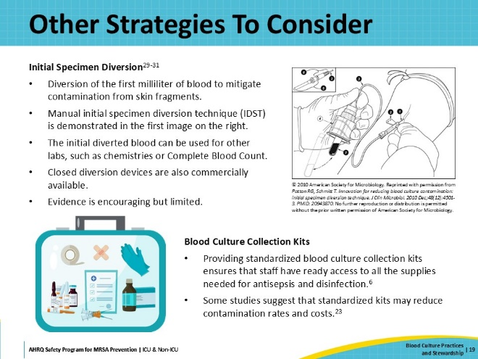
Implementation  SAY:  In the next section, the focus will shift to implementation of blood culture stewardship interventions. The following slides will describe how organizations can improve current blood culturing practices, while also tracking a case example of one hospital’s efforts to set up a blood culture stewardship program. | Slide 20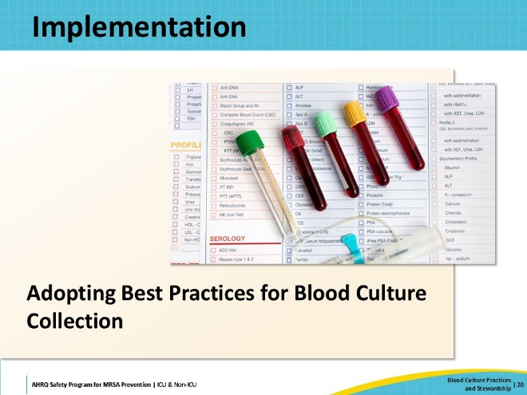
Implementation Strategies: The 4 Es  SAY:  The AHRQ Toolkit for MRSA Prevention utilizes the CUSP 4 Es framework for implementation. The 4 Es consist of: Engage, Educate, Execute, and Evaluate. These describe four basic stages to develop and implement your initiative.  For more information on the 4 Es, please refer to the section on the Toolkit for MRSA Prevention in the ICU and Non-ICU website. Resources in the section include a presentation and a one-pager.  If your hospital already has a CUSP program implemented, the departmental or unit-based CUSP teams can be a great resource to help support this work. | Slide 21  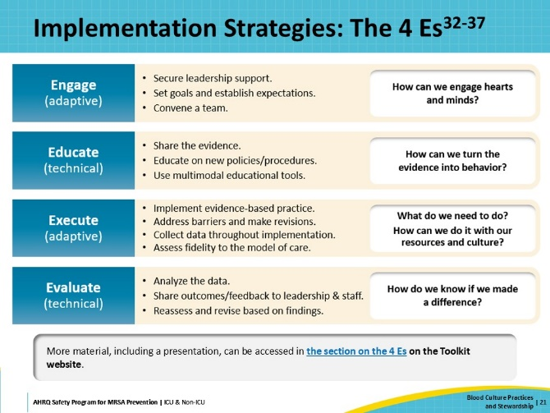
Case Example: ABC Hospital  SAY:  The hospital in our case example does not have a CUSP program in place. ABC Hospital (ABCH) is a small hospital in a rural area that has had long-standing challenges with blood culture contamination, but over the past two quarters, they have had a major spike in their contamination rates, with rates as high as 20 percent.  A group of ABCH staff members decides to set up a blood culture stewardship program to examine and address these problems. | Slide 22  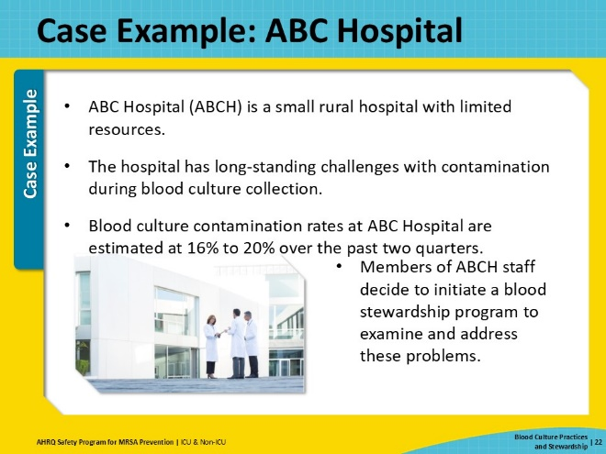
Case Example: Engaging Team, Leadership, and Staff  SAY:  The first E is to Engage. The aim is to engage hearts and minds, and subsequently change attitudes and behaviors.  The staff at ABCH assembles a CUSP team focused on blood culture stewardship. Their team is made up of individuals from relevant roles and teams, including physicians, nurses, personnel from Microbiology, personnel from Infection Control, and members of the Phlebotomy Department. They also open their meetings to others who are interested in joining them.  The team reaches out to hospital leaders and to frontline staff to gain their support and involvement.  When engaging, the first thing the team needs to do is convey that a problem exists and the potential harm that the problem could cause. A common reason for lack of engagement is that individuals are unaware of a problem. The team uses the hospital’s baseline data from the past 6 months, along with national benchmarks and published literature, to communicate that there is a problem.  The team also uses storytelling as an effective method of engagement. They relate the story of a recent patient at ABCH who, due to a series of mistakes in blood culture collection, was misdiagnosed twice and given multiple courses of broad-spectrum antibiotics that she did not need, and subsequently developed a severe Clostridium difficile infection. Relating this patient’s case helps demonstrate the harm that blood culture contamination can cause.  Then, the team discusses their proposed intervention and communicates the goals of their intervention. Sharing goals helps to set expectations and get everyone on the same page on how to define success.  One of the team’s meetings is with the hospital’s Director of Nursing, who shows great interest and enthusiasm, so the team invites her to join the team. As a senior executive member of a CUSP team, she is very helpful in connecting them to key resources and stakeholders, aligning goals and plans with hospital goals and existing programs, and addressing challenges and barriers. Among other things, she helps them by informing them of an upcoming initiative to upgrade the hospital’s electronic health records (EHR) software, providing an opportunity to improve how blood culture contamination rates are collected and disseminated. | Slide 23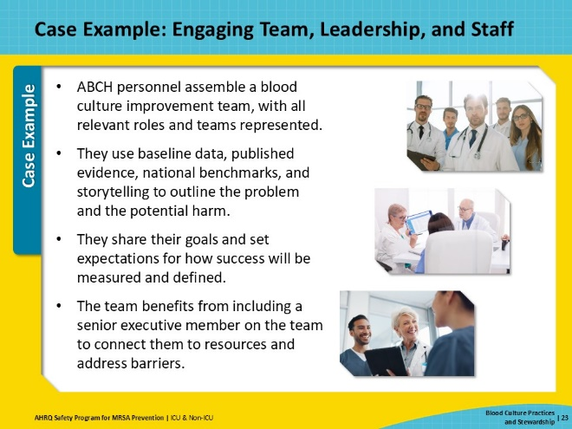
Case Example: Assessing Current Practice  SAY:  Many factors can contribute to blood culture contamination, so it is crucial to assess current practice and build an accurate picture of how things work in your unit or facility. Don’t assume that what’s written in policy is standard practice. Until a thorough assessment is made of the real-life current practice, there is no way to get to the root of WHY blood culture contamination is occurring.  The most effective way to assess current practice is to go to where the work is happening and gather the information firsthand. To assess current practice, the ABCH team visits all the units in-person, speaking at rounds, talking with staff, and observing workflows.  The CUSP team quickly learns that staff at ABCH are generally unaware of the blood culture contamination problem. There is a significant delay before contamination rates are available—usually several months—and the rates are not typically shared with staff.  However, once aware of the blood culture contamination issue, staff members are eager and willing to help. They are open and candid when asked about their workflow and truly seem to value the opportunity to contribute. | Slide 24  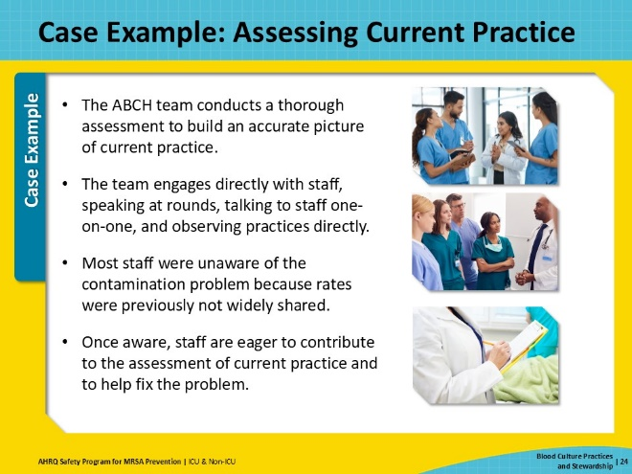
Case Example: Identifying Contributory Factors  SAY:  After assessing practice and conducting a root cause analysis, the team identifies four major contributory factors.  First, most blood cultures at ABCH are collected by unit staff, which is a recent change. Previously, a dedicated phlebotomy team was called for most collections, but the phlebotomy department was recently downsized. Many units have since begun relying on their staff to collect blood cultures. This coincided with the recent spike in contamination rates.  Second, there is a knowledge gap of best practices for blood culture collection among unit staff. Many staff members say that they aren’t up to date on the latest guidance. No standard training exists—training is mainly given ad hoc, on the job, from one staff member to another.  Third, an analysis of ABCH’s electronic records shows an abnormally high number of blood culture orders. Many of these orders were inappropriate, as the patients did not meet clinical indications for blood culture. Discussions reveal that awareness of the clinical indications and blood culture stewardship among ABCH clinicians is low. A few clinicians admit to viewing blood cultures as a sensible and harmless test.  Fourth, a review of ABCH’s policies reveals that there is no clear guidance regarding blood culture collection practices. ABC Hospital needs a clear policy with streamlined and standardized procedures. | Slide 25  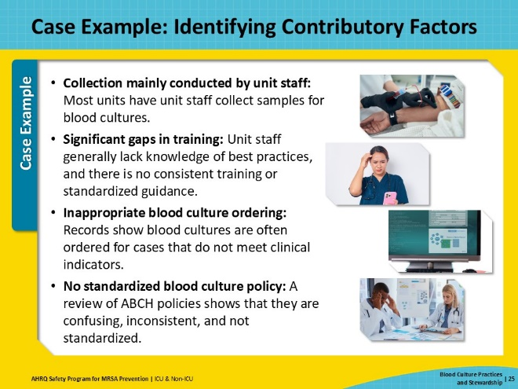
Case Example: Identifying Interventions  SAY:  Next, the ABCH team uses this list of factors to identify and prioritize interventions. The team determines that their first priority is to standardize the blood culture collection process for all units in the hospital. They roll out a standardized, streamlined policy, in line with national benchmarks, to be followed in all units.  ABCH also implements an overhauled surveillance and feedback system within the EHR. Working with Microbiology and IT, the team created a useful dashboard to be viewed by unit leaders and staff. Contamination rates are updated as soon as they are available. Monthly reports will be disseminated to each unit, and unit champions will regularly discuss progress at rounds.  The ABCH team also implements the use of a blood culture decision-making algorithm. Clinicians are all familiarized with the use of the algorithm. The EHR software is now configured to ring up a pop-up prompt with a checklist that guides the user through the algorithm whenever a blood culture is ordered. Pocket cards with the algorithm are also made available. | Slide 26  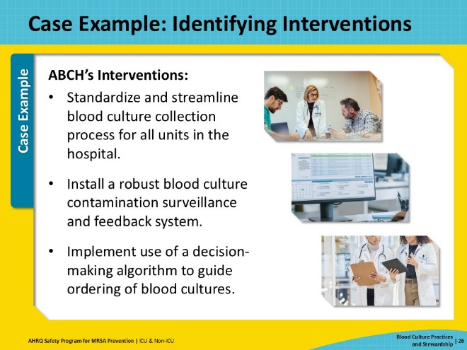
Case Example: Educating  SAY:  The second E of the 4 Es is Educate. Educating about the problem and the intervention helps to raise their engagement and vice versa.  Education, when implemented by itself, is generally considered a “weak” intervention because it primarily relies on individuals’ memory and decision-making to effect change. However, education can be very impactful as part of a multi-intervention improvement plan, reinforcing and combining with other interventions.  At ABCH, the new standardized policy is accompanied by a new standardized training package designed to be comprehensive and to ensure all staff learn the same practices.  Because blood culture collection is a complex multi-part process, simulation-based education is typically more effective. Aware of this, the team schedules regular simulation training sessions. Attending this training is now mandatory for all staff who draw blood cultures, and online refresher training is required every year.  The ABCH team bases their training heavily on existing procedural recommendations. You may also want to refer to some of these for your own program.  - CLSI M47 | Principles and Procedures for Blood Cultures, 2nd Edition  - CDC: Preventing Adult Blood Culture Contamination: A Quality Tool for Clinical Laboratory Professionals  - Elsevier: Specimen Collection: Blood Cultures (Ambulatory) - CE/NCPD | Slide 27  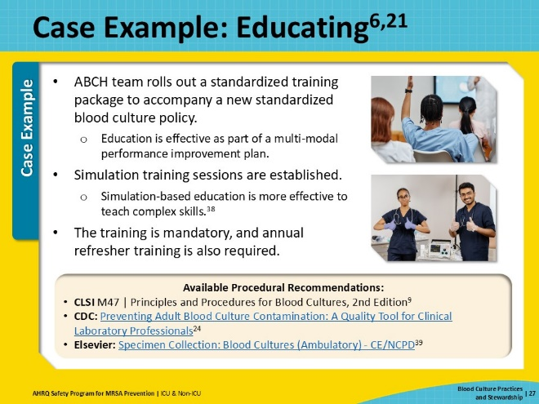
Case Example: Executing  SAY:  The third E, Execute, is putting your plans into action. For successful execution, follow the principles of safe system design: simplify the system, create redundancy, and learn from mistakes.  During execution, it’s important to track progress. This involves continuous monitoring and regular review of your chosen metrics. It also involves maintaining open lines of communication—among team members, with staff, and with leadership—to facilitate coordination, keep people engaged, and address issues promptly.  At ABC Hospital, over the next 12 months, the CUSP team rolls out their interventions. They meet regularly to review performance. At each meeting, they ask: How well is execution aligning with our targets? What barriers and challenges have emerged? What adjustments need to be made?  Early on, the team receives staff feedback that it’s difficult to remember all the guidelines. A very useful and handy blood culture checklist is accessible on the EHR software, but many units do not have computers in patient rooms. The CUSP team decides to adjust by creating a printable version of the checklist and distributing the checklist to all the units. Copies of the checklist are placed wherever blood culture collection supplies are stored, to make it easier and straightforward for staff members to grab a copy as a reference.  The aim of execution is to embed new practices into daily routines and ensure that staff can and will continue to follow them consistently. The guiding principle is to make it easy for staff to make the right decision. | Slide 28  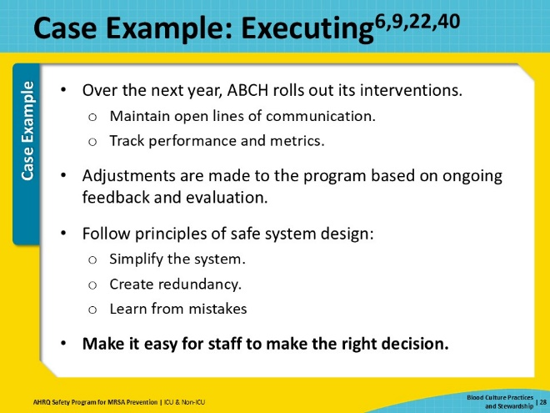
Case Example: Evaluating  SAY:  The 4th E is Evaluate, as data are collected, analyzed, and reported to track the progress. This allows your team to review and learn from defects and to tweak interventions as needed.  Surveillance and feedback are particularly important in blood culture stewardship. Studies have shown that implementing surveillance and feedback mechanisms can improve blood culture contamination rates. It is an established laboratory quality best practice, which integrates well into patient safety improvement programs.  At ABCH, the improved surveillance and feedback system is a major success. Data shows that the dashboard to track blood contamination rates is widely accessed and viewed. Monthly summaries are posted for each unit. The best-performing units are recognized and rewarded. Poorly performing units are quickly identified and targeted feedback is provided.  A key component of Evaluation is the continuous feedback loop. The CUSP team makes sure to share their data broadly and in a timely manner, with providers, leadership, and frontline staff. The Infection Prevention and Antimicrobial Stewardship committees are also included in reports, along with key members of senior leadership, to foster continuing engagement. | Slide 29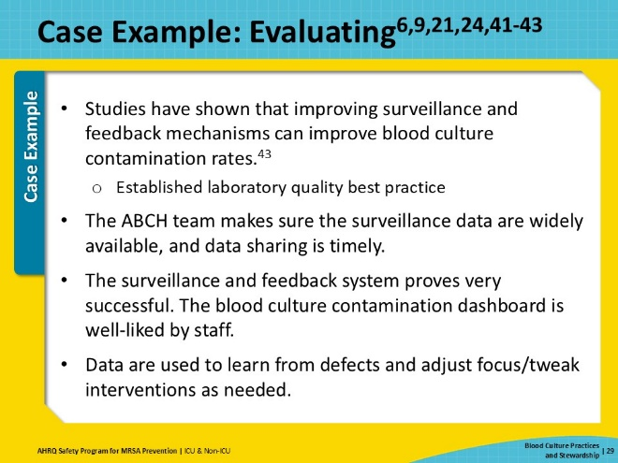
Case Example: Results  SAY:  Over the next 12 months, ABC Hospital successfully reduced its contamination rates down to 3 to 5 percent. This leads to more accurate diagnoses and better patient outcomes. The team takes time to mark and celebrate the successes in the hospital newsletter, to boost staff morale and confidence.  The team continues to work to reduce contamination rates to the CLSI standard of 1%. The campaign also helps to convince staff and leadership that patient safety interventions can be impactful, fostering an environment and culture that is more open to future patient safety initiatives. | Slide 30  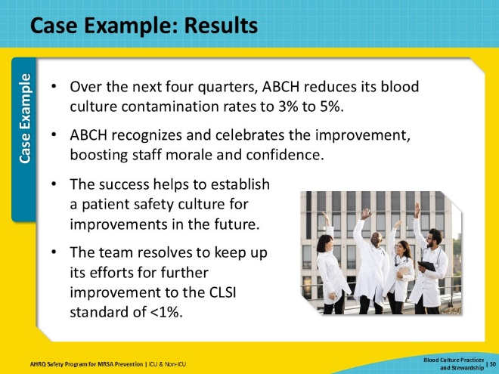
Key Takeaways  SAY:  The situation in your hospital may not be as dramatic as the one in the case example. However, pursuing improvements in blood culture practices should still be a priority consideration for any unit or hospital. Blood culture stewardship is a fundamental best practice in patient safety and the prevention of MRSA. Blood culture contamination poses significant risks to patient care, including negative outcomes, extended hospital stays, and unnecessary treatments. To mitigate these risks, blood culture stewardship focuses on optimizing diagnostic testing, reducing false positives, and minimizing inappropriate antimicrobial use. By doing so, it plays a critical role in reducing the risk of MRSA acquisition among patients.  Site selection, hand hygiene, standardization, and training on proper blood culture sample collection can reduce contamination rates to below 1%.  Implementation of interventions at the different stages of the collection process can safely reduce unnecessary blood cultures while improving diagnostic accuracy and patient outcomes. Decision support tools can provide key guidance to clinicians on when it is appropriate to order blood cultures based on clinical scenarios and the likelihood of bacteremia.  The implementation of blood culture stewardship is vital in the battle against antimicrobial resistance and the improvement of patient outcomes. Blood culture stewardship improves the care of today’s patients and contributes to the broader goal of sustainable healthcare by preserving the efficacy of existing therapies and treatments. | Slide 31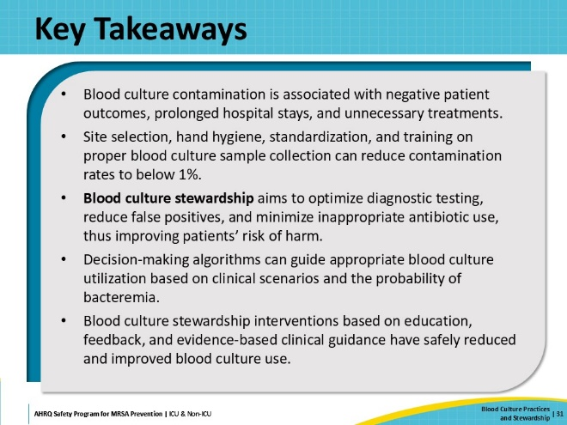
Disclaimer  SAY:  The findings and recommendations in this presentation are those of the authors, who are responsible for its content, and do not necessarily represent the views of AHRQ. No statement in this presentation should be construed as an official position of AHRQ or of the U.S. Department of Health and Human Services.  Any practice described in this presentation must be applied by healthcare practitioners in accordance with professional judgment and standards of care in regard to the unique circumstances that may apply in each situation they encounter. These practices are offered as helpful options for consideration by healthcare practitioners, not as guidelines. | Slide 32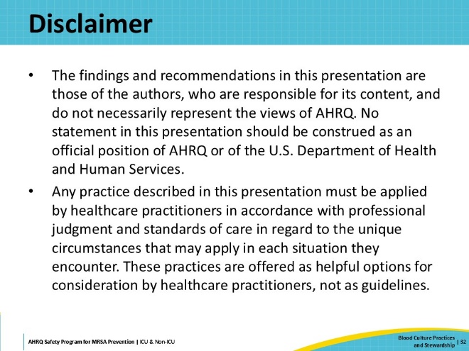
Reference List—1 | Slide 33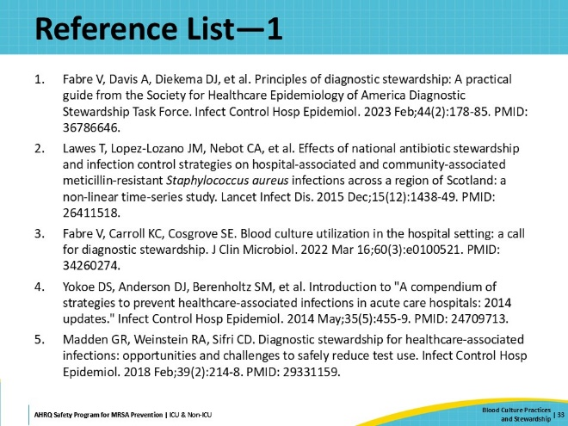
Reference List—2 | Slide 34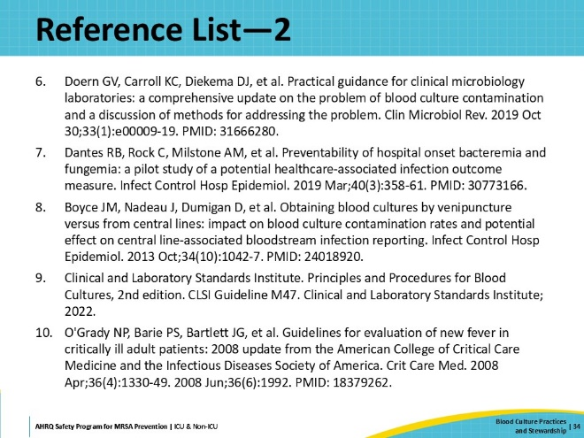
Reference List—3 | Slide 35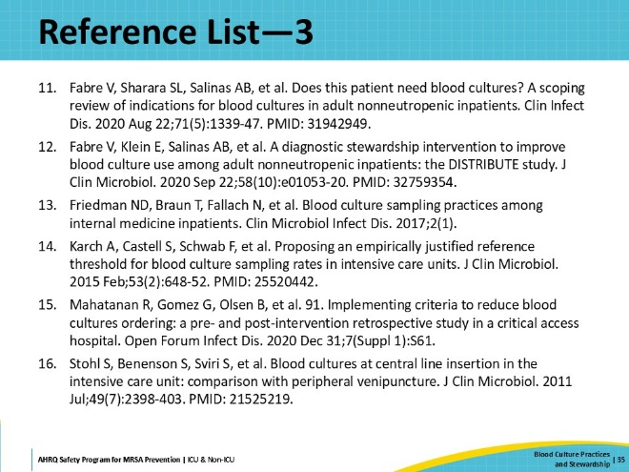
Reference List—4 | Slide 36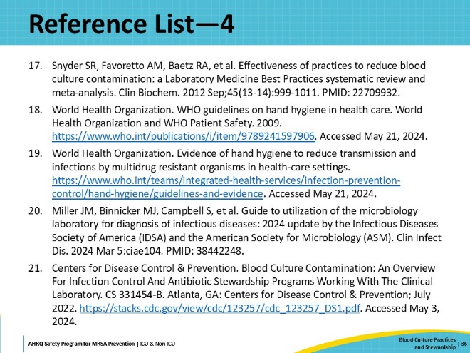
Reference List—5 | Slide 37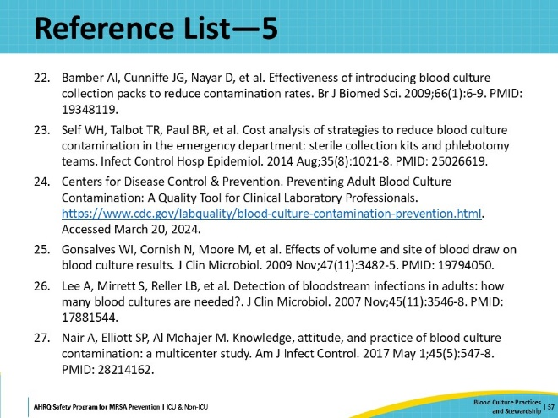
Reference List—6 | Slide 38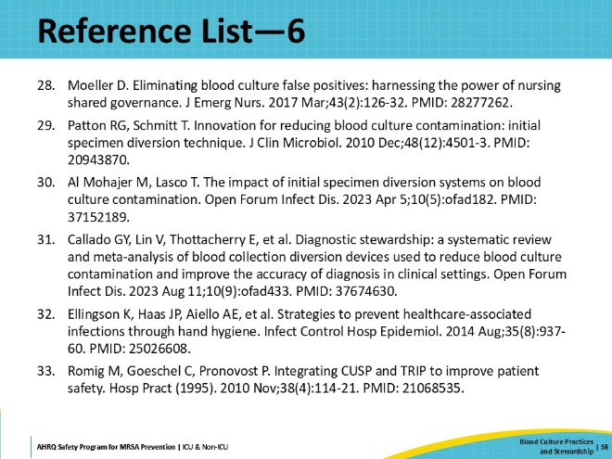
Reference List—7 | Slide 39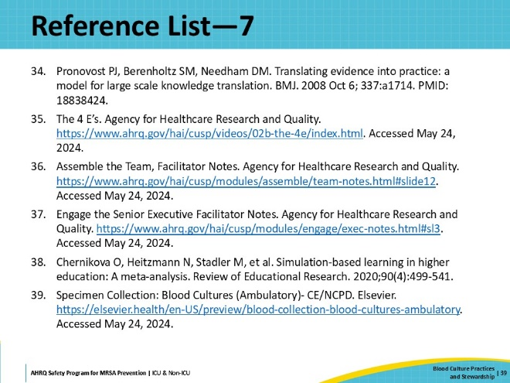
Reference List—8 | Slide 40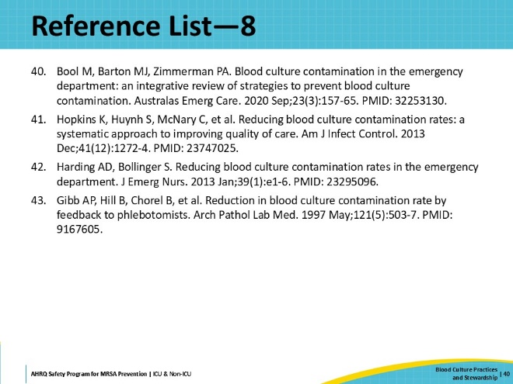

AHRQ Pub. No. 25-0007
October 2024

