ICU & Non-ICU

# Optimize Patient Selection for Blood Cultures.1

* Use a [**Blood Culture Decision Support Tool**](https://www.ahrq.gov/sites/default/files/wysiwyg/hai/tools/mrsa/014-bcx-algorithm-decision-support-tool.docx) to guide ordering of blood cultures to limit inappropriate cultures.
* Optimizing patient selection for testing reduces false positives, facilitates accurate diagnosis, promotes antimicrobial stewardship, and reduces antimicrobial resistance.

# Use Venipuncture To Draw Blood Cultures; Avoid Central Line Blood Draws.2

* 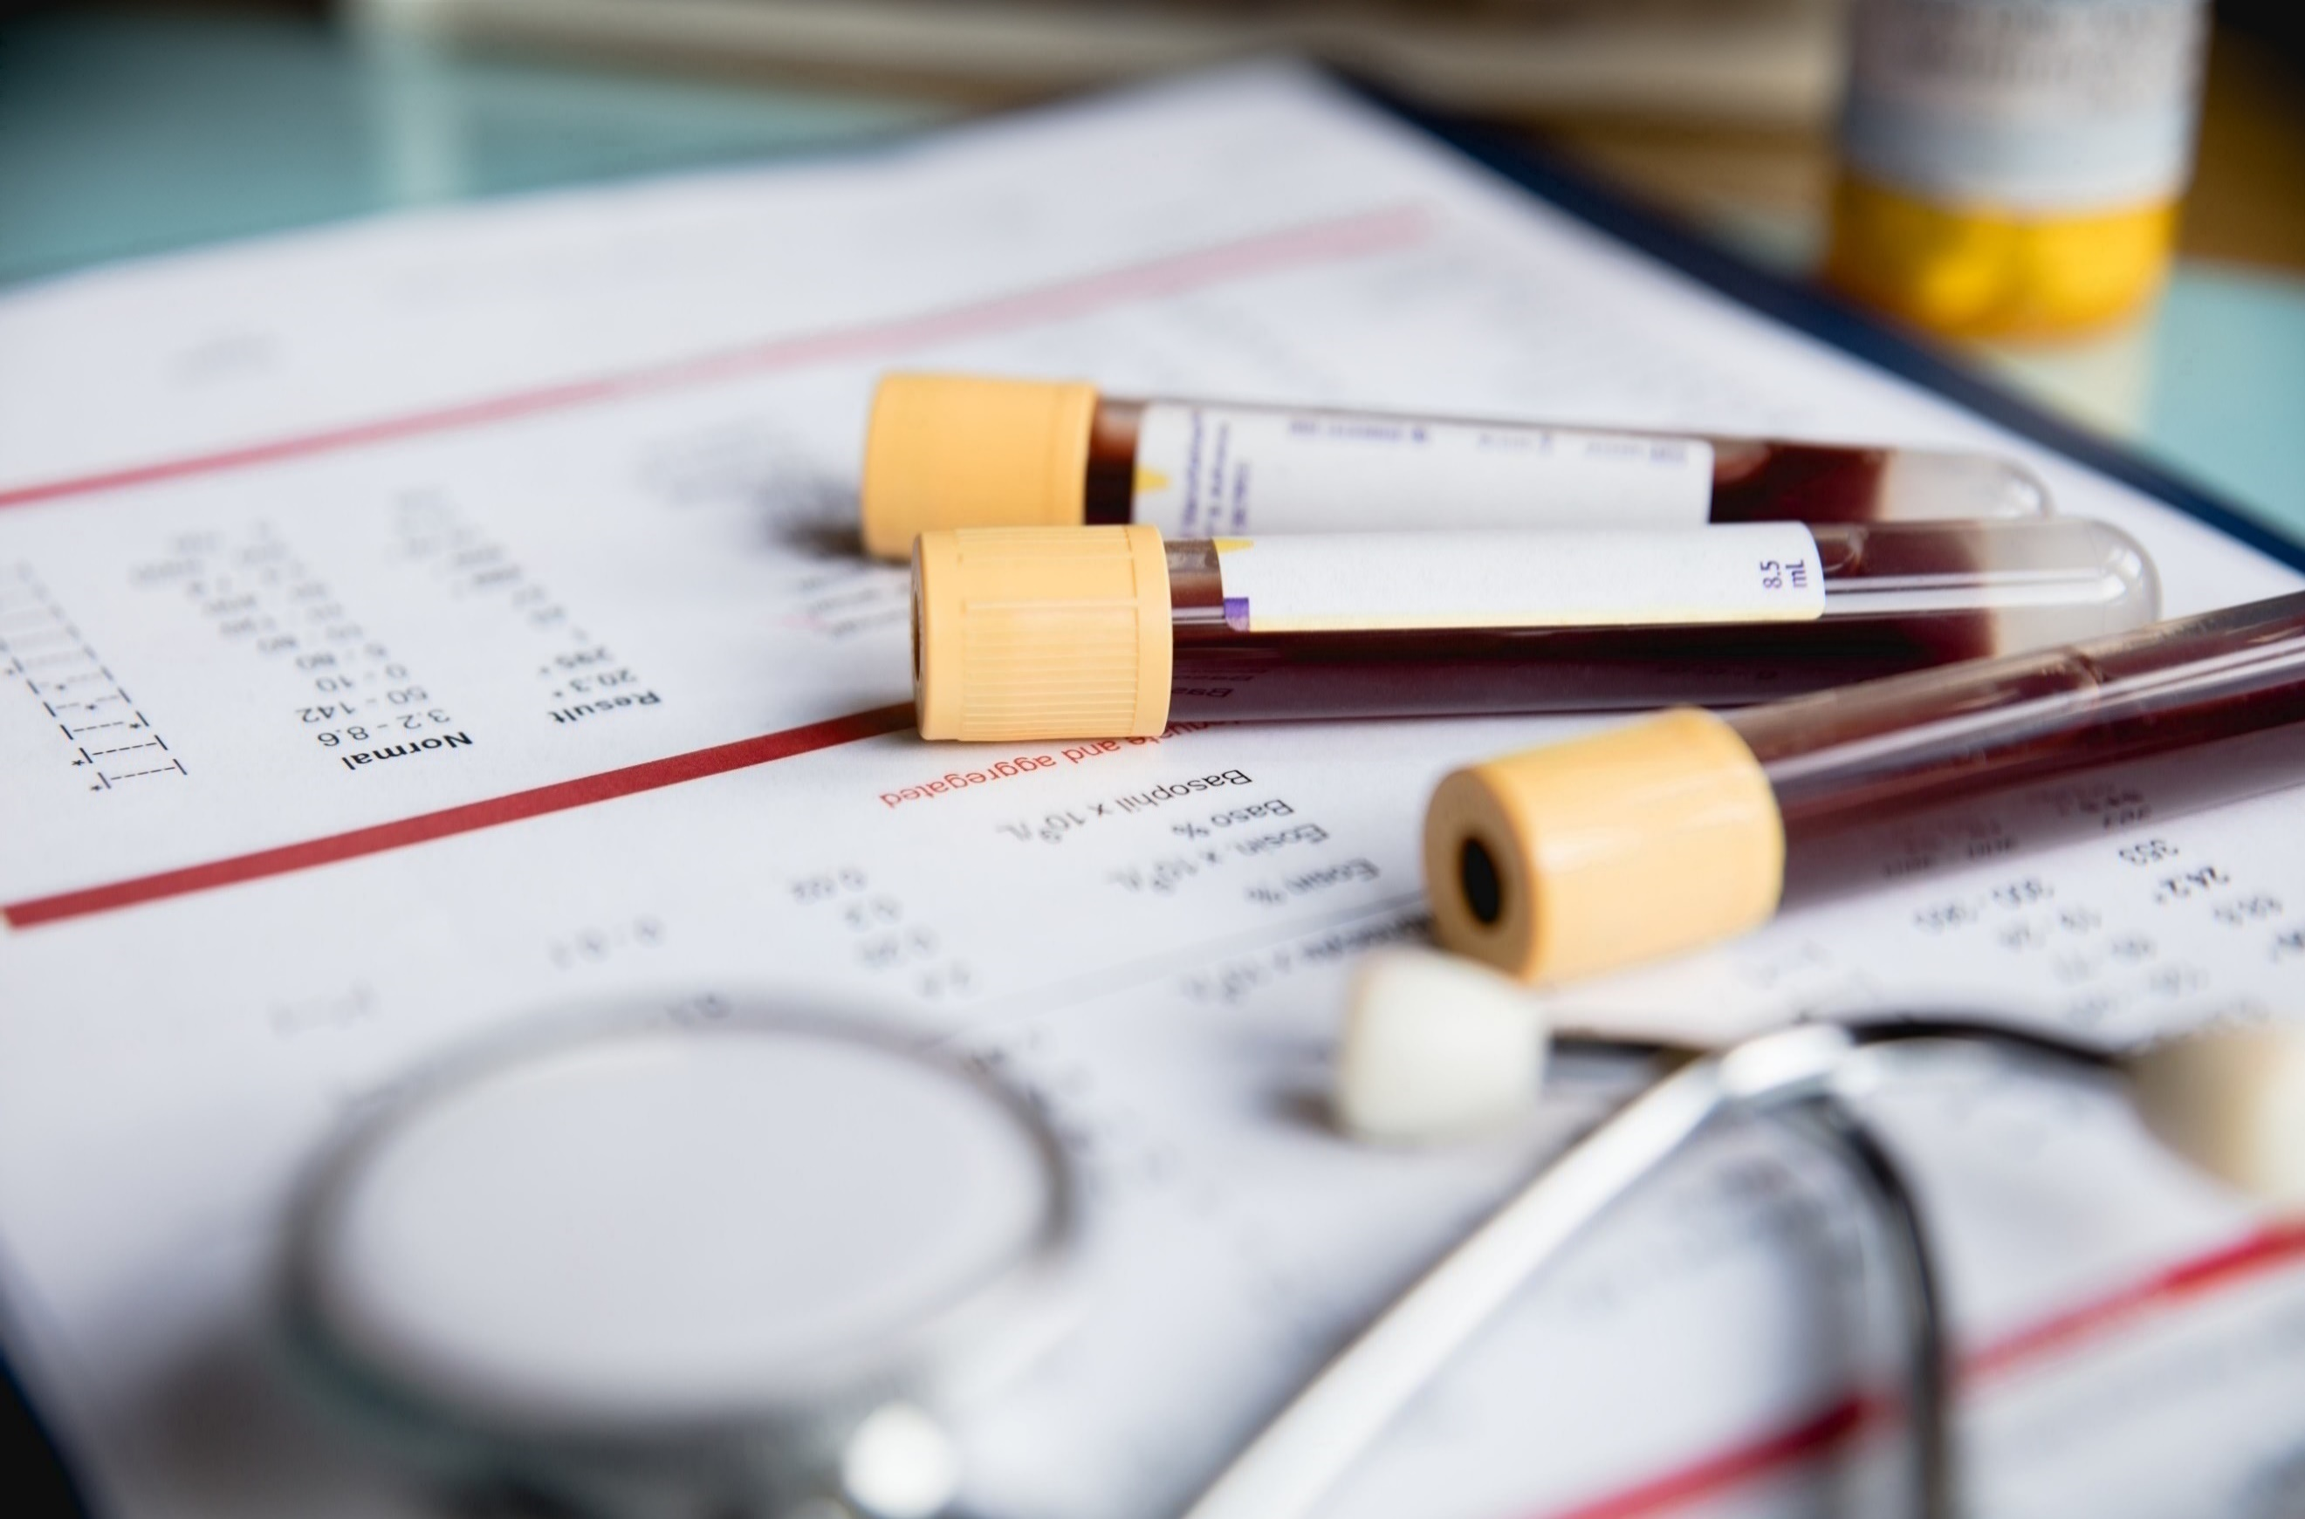Peripherally drawn blood cultures are considered the gold standard.
* Central venous catheter and peripheral line-drawn cultures are more likely to give false positive results and should be limited.

# Observe Proper Hand Hygiene.2,3,4,5

* Always perform hand hygiene before interacting with patients.
* Don gloves prior to drawing blood cultures.

# Perform Proper Skin Antisepsis.2,4

* Perform thorough skin antisepsis at collection site.
* Disinfectants containing alcohol are recommended over povidone-iodine preparations.

# Disinfect the Blood Culture Bottle.2,4

* The rubber stoppers of collection bottles are not sterile and must be disinfected before use.
* An antiseptic with 70% isopropyl alcohol is recommended.

# Draw At Least Two Sets of Blood Cultures. Ensure Adequate Blood Volumes.2,4

* At least two sets of blood cultures should be collected, ideally drawn from two separate venipuncture sites.
* Single sets can miss a large number of bloodstream infections caused by common pathogens.
* Blood volumes must be adequate for accurate results. Under- or over-filling bottles decreases sensitivity.

# Educate and Refresh Staff on Proper Technique. Utilize Phlebotomy Teams.2,6

* Ensure that all staff who collect blood cultures are up to date on best practices and technique. Refresher training should be regularly provided.
* Consider requiring completion of a competency for blood culture collection.
* Whenever possible, trained phlebotomy teams should be employed for blood culture collection.

# Maintain Surveillance of Blood Culture Contamination and Provide Feedback Regularly.2

* Surveillance data should be transparent and shared with leaders and staff in a timely manner.
* Share data with providers, unit leadership, infection Control, CUSP teams, frontline staff, and relevant committees.
* Use data to learn from defects and adjust as needed.
* Surveillance and feedback mechanism have been shown to positively impact contamination rates on their own.

# Consider These Other Preventive Actions You Can Take.

## Initial Specimen Diversion1,2,7

* Discarding the first milliliter of blood can mitigate contamination from incompletely sterilized skin fragments.
* Closed commercial devices for diversion are now available on the market.

## Standardized Blood Culture Collection Kits2,6

* Providing collection kits with all blood culture supplies ensures staff have ready access to all necessary equipment.
* This can help to encourages staff to adhere to best practices and standardized operating procedure.

# References

1. Fabre V, Davis A, Diekema DJ, et al. Principles of diagnostic stewardship: A practical guide from the Society for Healthcare Epidemiology of America Diagnostic Stewardship Task Force. Infect Control Hosp Epidemiol. 2023 Feb;44(2):178-85. PMID: 36786646.
2. Centers for Disease Control & Prevention. Blood Culture Contamination: An Overview for Infection Control and Antibiotic Stewardship Programs Working with the Clinical Laboratory. CS 331454-B. Atlanta, GA: Centers for Disease Control & Prevention; July 2022. <https://stacks.cdc.gov/view/cdc/123257/cdc_123257_DS1.pdf>. Accessed May 3, 2024.
3. Glowicz JB, Landon E, Sickbert-Bennett EE, et al. Strategies to prevent healthcare-associated infections through hand hygiene: 2022 Update. Infect Control Hosp Epidemiol. 2023 Mar;44(3):355-76. PMID: 36751708.
4. Doern GV, Carroll KC, Diekema DJ, et al . Practical guidance for clinical microbiology laboratories: a comprehensive update on the problem of blood culture contamination and a discussion of methods for addressing the problem. Clin Microbiol Rev. 2019 Oct 30;33(1):e00009-19. PMID: 31666280.
5. World Health Organization, WHO Patient Safety. WHO Guidelines on Hand Hygiene in Health Care. WHO/IER/PSP/2009/01.2009. <https://www.who.int/publications/i/item/9789241597906>. Accessed May 3, 2024.
6. Self WH, Talbot TR, Paul BR, et al. Cost analysis of strategies to reduce blood culture contamination in the emergency department: sterile collection kits and phlebotomy teams. Infect Control Hosp Epidemiol. 2014 Aug;35(8):1021-8. PMID: 25026619.
7. Patton RG, Schmitt T. Innovation for reducing blood culture contamination: initial specimen diversion technique. J Clin Microbiol. 2010 Dec;48(12):4501-3. PMID: 20943870.

AHRQ Pub. No. 25-0007

October 2024