Contact Precautions for MRSA Prevention
ICU & Non-ICU
Slide Title and Commentary | Slide Number and Slide
Contact Precautions for MRSA Prevention  SAY:  Welcome to this presentation on contact isolation precautions to prevent MRSA, or methicillin-resistant Staphylococcus aureus. This presentation will cover what contact precautions add to standard precautions, the evidence and guidelines that support their use, and how a hospital might go about implementing contact precautions. | Slide 1  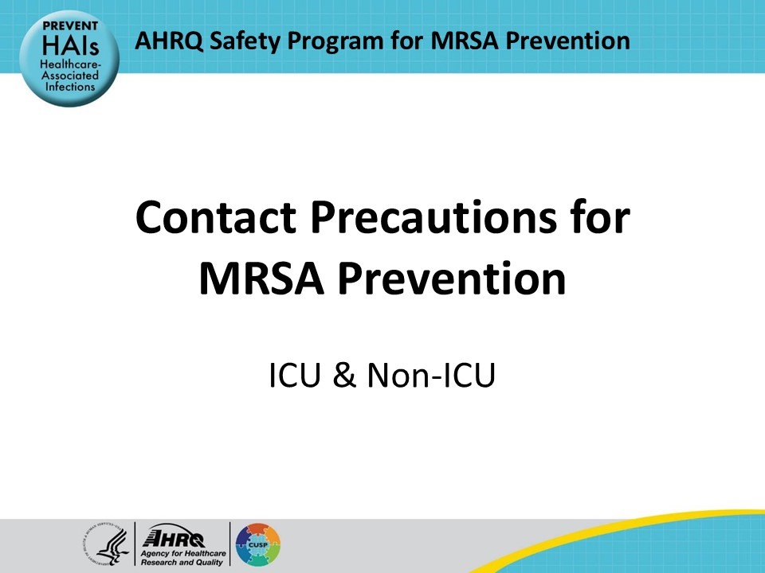
Educational Objectives  SAY:  At the end of this presentation, viewers will be able to discuss the purpose of contact precautions and how to incorporate contact precautions into their patient care bundle. and to enumerate the different elements of contact precautions. They will also be able to discuss how to implement contact precautions in their units. | Slide 2  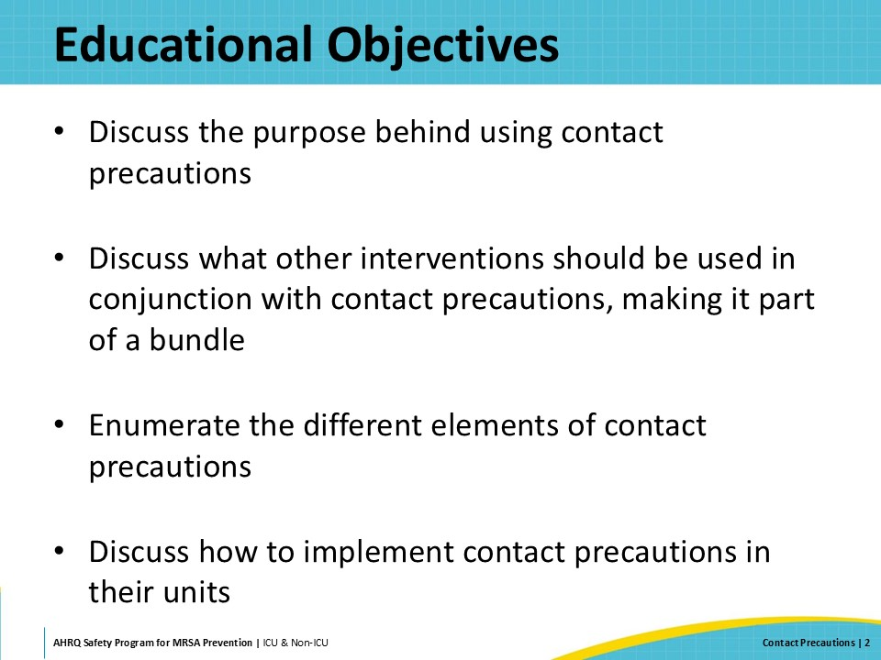
Key Strategies To Take Aim & Target MRSA Infection  SAY:  The Four Key Strategies To Prevent MRSA are decolonizing patients, decontaminating the healthcare environment, preventing person-based transmission, and preventing device- and procedure-associated infections.  This presentation will focus on the third strategy, preventing person-based organism transmission, using contact isolation precautions. | Slide 3  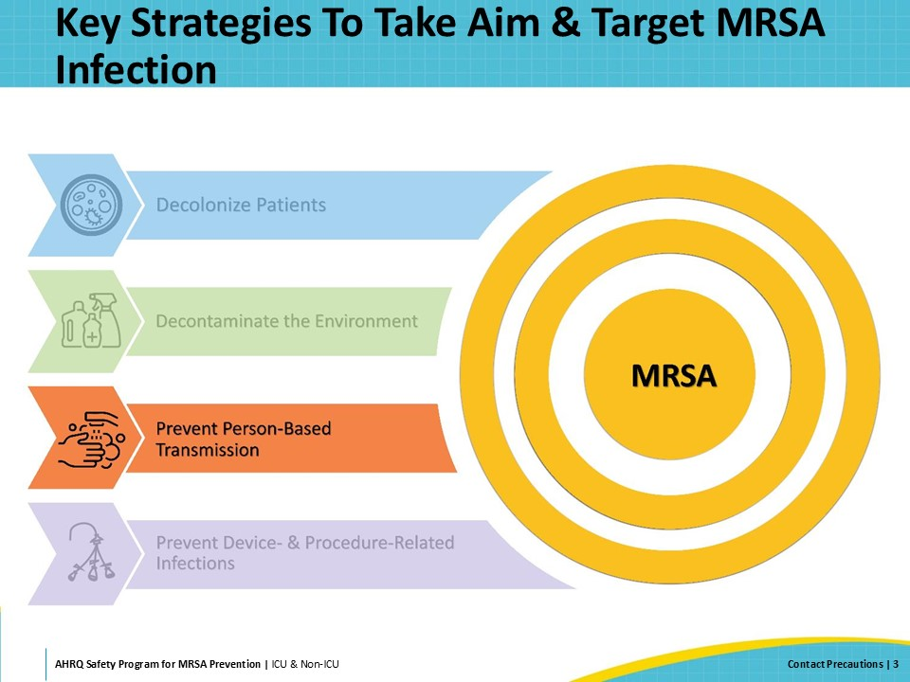
MRSA Transmission Pathways  SAY:  MRSA is spread through direct contact, from person to person, or indirect contact, by touching something in the environment that had been previously contaminated. The use of transmission-based precautions—and specifically contact precautions—is a widely recommended practice, designed to interrupt direct contact transmission between healthcare personnel and patients (depicted by the left arrow) and indirect contact transmission between healthcare personnel and the environment (depicted by the right and bottom arrows). | Slide 4  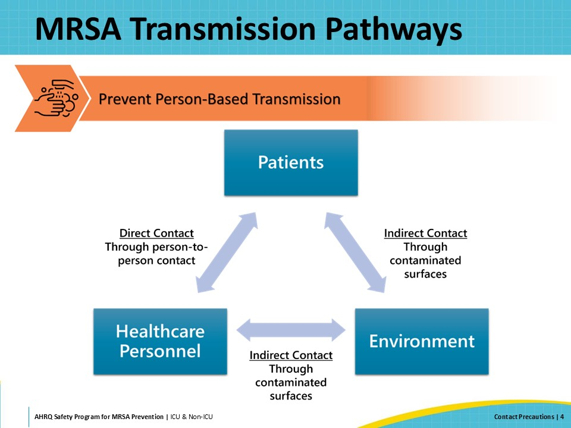
Standard Precautions  SAY:  The most basic level of precautions is Standard Precautions. All patients should be under standard precautions to protect those patients and healthcare workers who come in contact with them from any bacteria or viruses they may harbor.  The Centers for Disease Control and Prevention (CDC) defines standard precautions as “the minimum infection prevention practices that apply to all patient care, regardless of suspected or confirmed infection status.” Following standard precautions for all patient care protects both healthcare workers and patients.  Key elements of standard precautions include:  - Performing proper hand hygiene whenever hands are visibly soiled, before eating, after using the bathroom, and both before and after contact with patients, patients’ environment, or patients’ equipment. Hand hygiene must also be performed before donning and after doffing gloves.  - Using personal protective equipment (PPE) as appropriate whenever contact with nonintact skin, bodily fluids, or mucous membranes is anticipated. This can include any combination of gloves, gowns, goggles, masks, or face shields, depending on the patient’s syndrome and the clinical situation.  - Observing respiratory hygiene and cough etiquette, including source control measures (e.g., covering mouth and nose when coughing, masking), and hand hygiene following contact with respiratory secretions.  - Cleaning and disinfecting the patient care environment and patient care equipment and instruments.  - Practicing sharps safety and administrative control measures to prevent accidental needle sticks.  - Using safe injection practices to minimize the risk of contamination and infection transmission.  - Handling patient textiles and laundry safely to avoid potential contamination of healthcare personnel clothing and other surfaces, and aerosolization of potentially transmissible diseases. | Slide 5  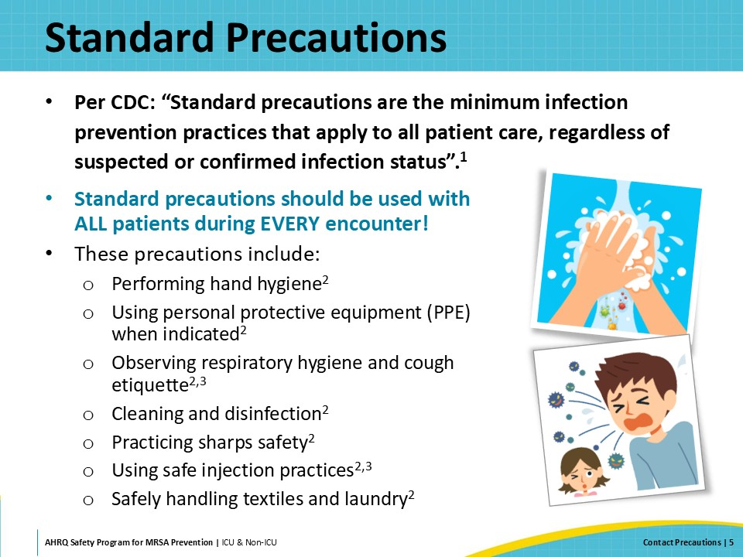
Contact Precautions  SAY:  The next step up after standard precautions is contact precautions. Contact precautions are used for organisms that spread through direct contact with an infected (or colonized) person or through indirect contact with contaminated surfaces or equipment. Contact precautions are most commonly used for patients who are infected with or colonized by epidemiologically important organisms, such as MRSA, vancomycin-resistant S. aureus, and vancomycin-resistant Enterococcus. Contact precautions are also used for Clostridioides difficile and other organisms.  Contact precautions are centered around the following principles:  - Ensure appropriate patient placement  - Use PPE appropriately, including at least gowns and gloves  - Limit transport and movement of patients  - Use disposable or dedicated patient-care equipment  - Prioritize cleaning and disinfection of the rooms  Each one of these requirements will be covered in later slides. | Slide 6  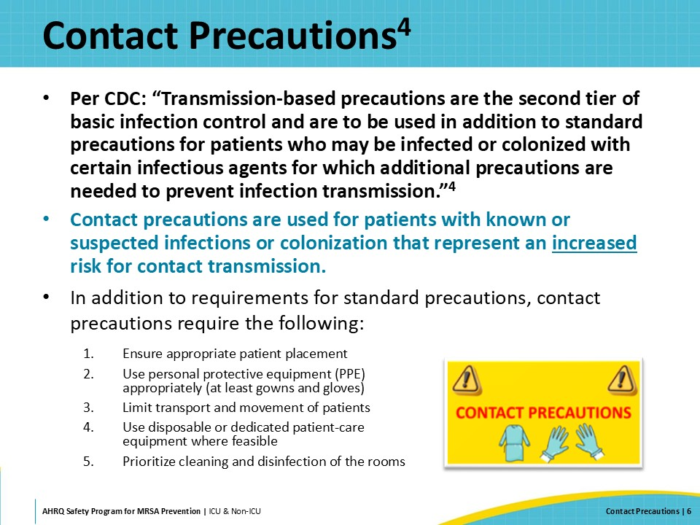
Why Use Contact Precautions?  SAY:  This next section will cover the evidence and the guidelines regarding the use of contact precautions for MRSA prevention. | Slide 7  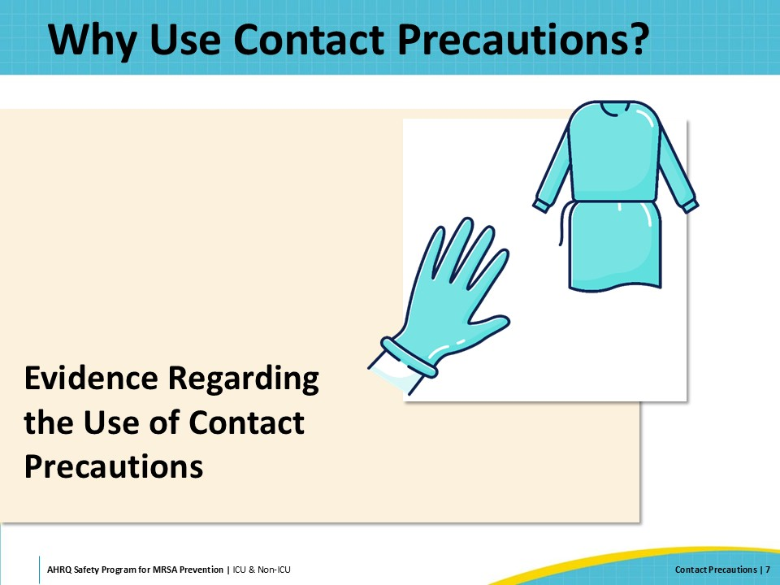
Do Healthcare Workers (HCW) Become Contaminated From the Environment?  SAY:  The first question in looking at the effectiveness of contact precautions is: Do HCW really become contaminated from the environment? Several observational studies have shown MRSA frequently contaminates the environment of hospital patients colonized or infected with MRSA. This happens in about 16 percent of the interactions with these patients. Of course, the odds of becoming contaminated vary with role, the specific activities performed, and the items and surfaces that have been touched. In the absence of hand hygiene, contaminated HCWs may frequently transmit MRSA to subsequent patients.  Contact precautions are intended to reduce these risks.  Contact precautions should be used as part of a bundle of care for patients infected with or colonized by the organisms discussed earlier. | Slide 8  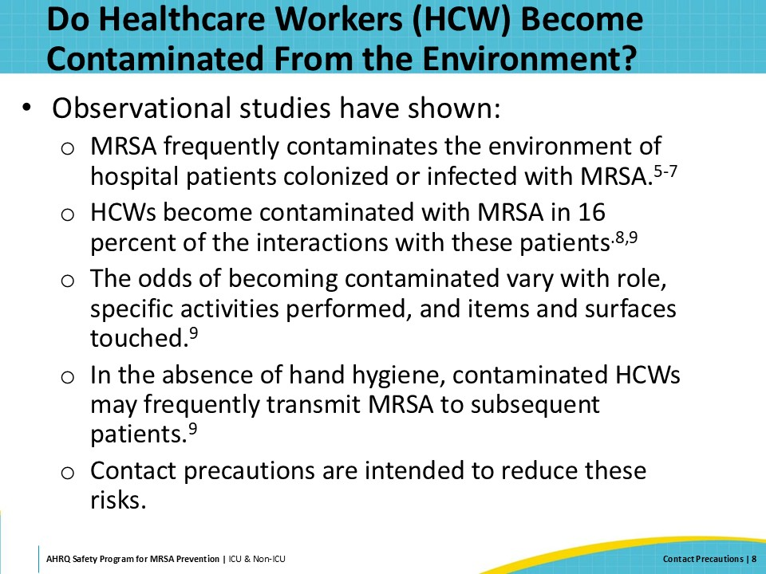
Reduction in Transmission at the VA  SAY:  Along with the guidelines mentioned earlier, several articles support the use of contact precautions. A few of these will be discussed here.  Khader et al., with the U.S. Department of Veterans Affairs (VA), performed a retrospective study in 108 VA hospitals, using a bundled intervention to reduce MRSA transmission. Their goal was to estimate the association between contact precautions and transmission of MRSA across this group of hospitals. Across these hospitals, transmission reduction ranged from 62 percent to 45 percent.  Mathematical modeling was used to determine the extent of the influence contact precautions had on this reduction. Forty-seven percent of the MRSA transmission reduction was found to be due to the use of contact precautions. | Slide 9  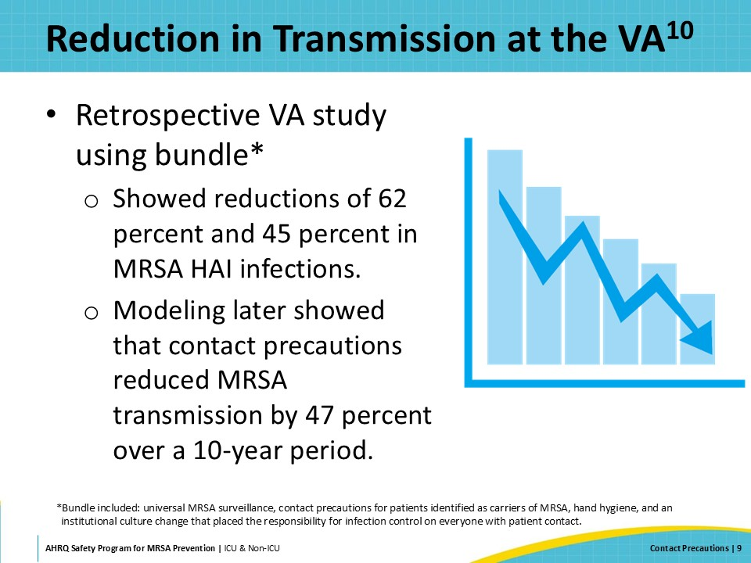
BUGG Study  SAY:  The BUGG Study assessed whether universal gloves and gowns or universal contact precautions for all patient contact in the ICU had an effect on the acquisition of MRSA or vancomycin-resistant enterococcus (VRE).  While there was no significant change in acquisition for combined rates of MRSA and VRE, the primary outcome. However, they did find a 40.2 percent relative reduction in the rates of MRSA acquisition in the intervention group compared with a 15.0 percent reduction in the control group, p=0.007.  Through mathematical modeling, they were able to determine that 44 percent of the decrease was attributable to universal contact precautions, 38.1 percent from hand hygiene upon exiting a patient’s room, and 14.5 percent from reduced contact with patients.  Interestingly, hand hygiene adherence upon exiting a patient room increased when universal contact precautions were implemented. And the use of universal contact precautions reduced HCW’s clothing contamination by 70 percent. | Slide 10  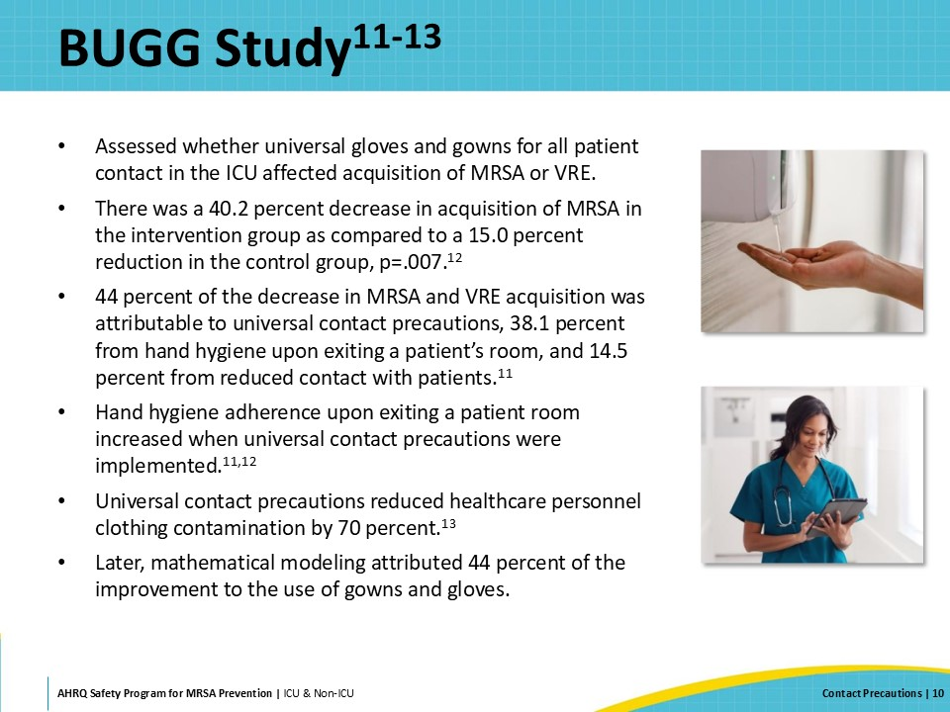
Recommendations and Guidelines Regarding the Use of Contact Precautions  SAY:  Agencies and organizations that recommend or endorse contact precautions for MRSA Prevention include the Centers for Disease Control and Prevention (CDC), Association of Professionals in Infection Control (APIC), the Society for Healthcare Epidemiology of America (SHEA), and the Infectious Disease Society of American (IDSA). | Slide 11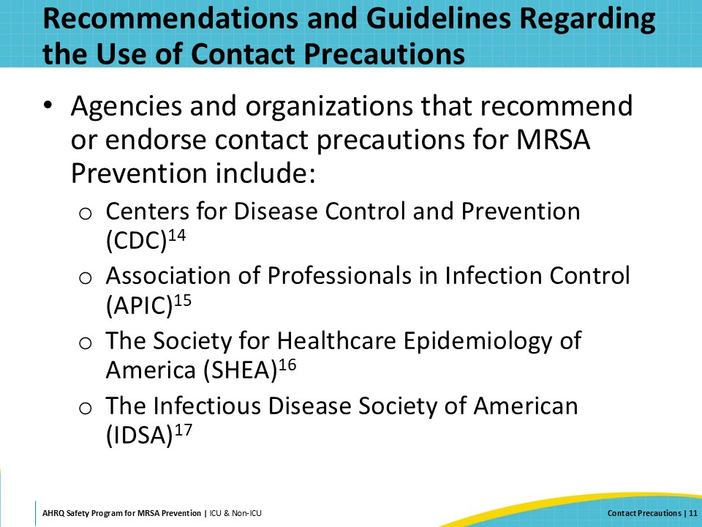
Summary of the Evidence  SAY:  Many studies have been done on the effectiveness of contact precautions in preventing the spread of infections that can be due to direct or indirect contact, though none of these studies have been conducted in such a way as to encompass all clinical situations. Some support its use, some don’t. For more information regarding some highlighted studies, review the document “Summary of Evidence for Contact Precautions To Prevent MRSA” for more information. While there are differing views regarding the use of contact precautions, guidance from multiple professional organizations recommends use of contact precautions for patients colonized or infected with MRSA, especially in hospitals with evidence of ongoing MRSA transmission. | Slide 12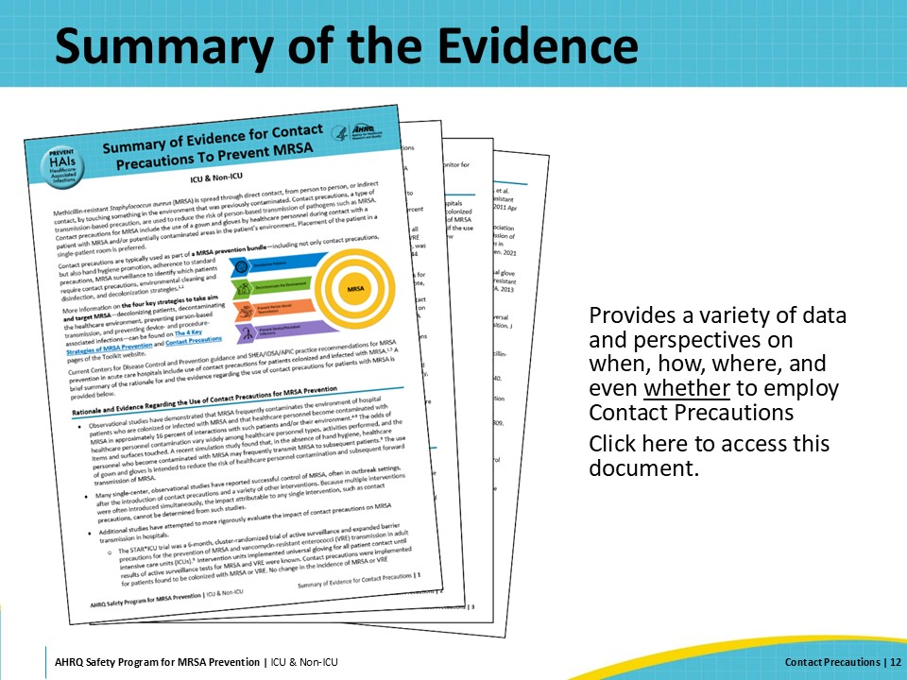
How Are Other Facilities Using CP?  SAY:  Even with the supporting evidence and guidelines, there is a wide range of approaches to contact precautions being used in the field, from no use of contact precautions for prevention of MRSA to the use contact precautions, together with MRSA surveillance on admission, for all patients determined to be infected with or colonized by MRSA.  Some health systems use a risk-based strategy—contact precautions or gowns and gloves are used in those situations and settings within a hospital where the risk of contamination of healthcare personnel is the greatest.  Others start to use contact precautions if and when their MRSA rates are going up.  Some of the guidelines mentioned earlier support this “sometimes” approach, stating that if the facility has a strong and active hand hygiene and decolonization programs, and their MRSA rates are low and remain low, contact precautions may not be necessary in some or all locations and/or populations. | Slide 13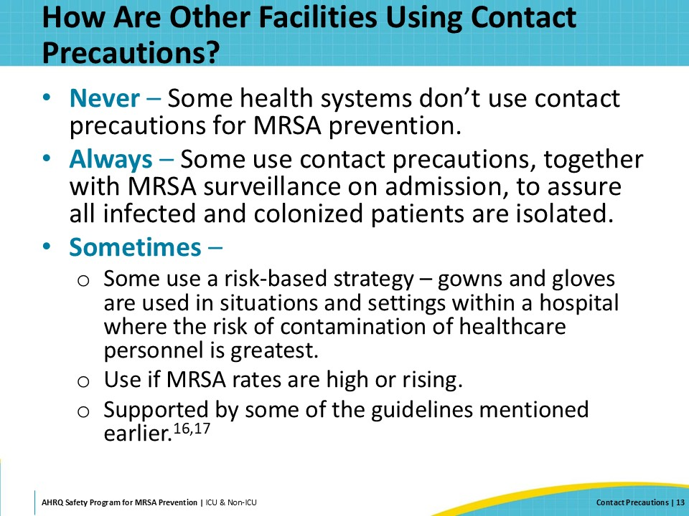
Contact Precautions for MRSA Prevention  SAY:  The next section will discuss how to assure your use of contact precautions has the best possible results. Correct utilization of contact precautions helps to prevent contamination of healthcare personnel and interrupts transmission of MRSA to other hospitalized patients. | Slide 14  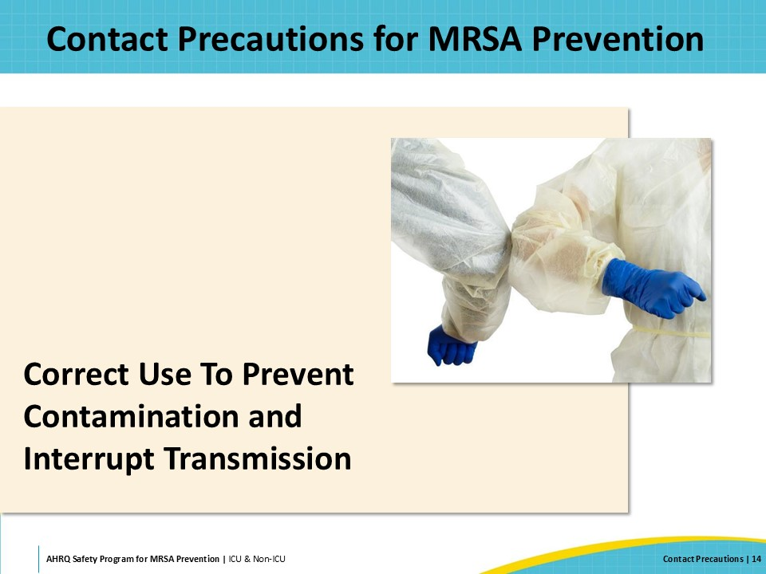
Contact Precautions  SAY:  Contact precautions are one of the CDC’s three sets of transmission-based precautions, designed to prevent transmission of infectious agents through direct or indirect contact. Contact precautions are recommended for patients known to be infected or colonized with several different epidemiologically significant bacteria, including MRSA.  There are six key components to the proper use of contact precautions for prevention of MRSA transmission:  - Specific patient placement  - Proper hand hygiene  - Use of gloves by healthcare personnel  - Use of gowns by healthcare personnel  - Removal of PPE prior to leaving the patient’s room or care area  - Dedicated patient care equipment and disinfection of any reusable patient care equipment between patients  To be effective, contact precautions should be clearly communicated to healthcare personnel by using appropriate signage and by flagging the patients’ medical records. This helps ensure that precautions are implemented appropriately throughout the continuum of care and upon hospital readmission. Facilities can also establish a criteria-based approach for the discontinuation of contact precautions. | Slide 15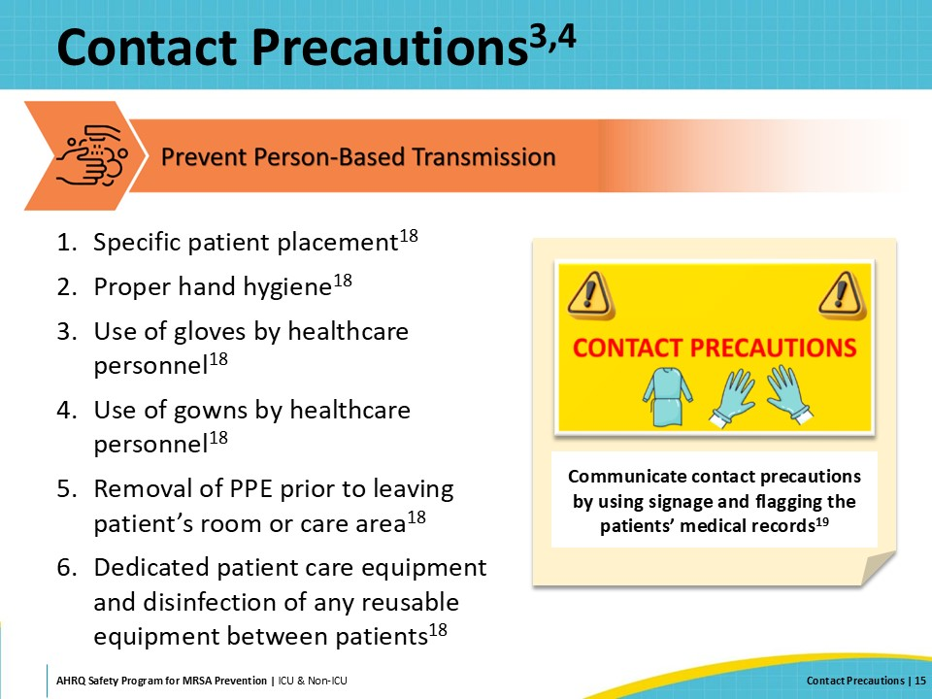
Patient Placement and MRSA Surveillance  SAY:  Current guidelines recommend placing patients known to be colonized or infected with MRSA in a private room. Facilities without an active surveillance program can base the implementation of contact precautions on prior clinical culture results. Facilities with an active surveillance program can utilize both prior clinical culture results and results from active surveillance cultures to decide which patients require isolation precautions. Isolating newly admitted patients until the surveillance culture result is available can prevent MRSA transmission during this period, especially in high-risk populations and high-prevalence areas.  Cohorting patients with the same pathogens may be necessary if private rooms are not available. If a private room is not available for a patient colonized or infected with MRSA, consultation with the Infection Preventionist can help to ensure the best options for determining a safe cohorting strategy. All cohorted patients should have a minimum of 3 feet of space in between their beds. Cohorting two patients with MRSA is preferred over cohorting patients with different multidrug-resistant pathogens. Avoid cohorting patients with open or draining wounds, those who are immunocompromised, and incontinent patients.  If a patient with MRSA must be cohorted with a patient who doesn’t have MRSA colonization or infection, clinical teams should consult infection prevention personnel who can help clinical teams mitigate the risk of MRSA transmission. | Slide 16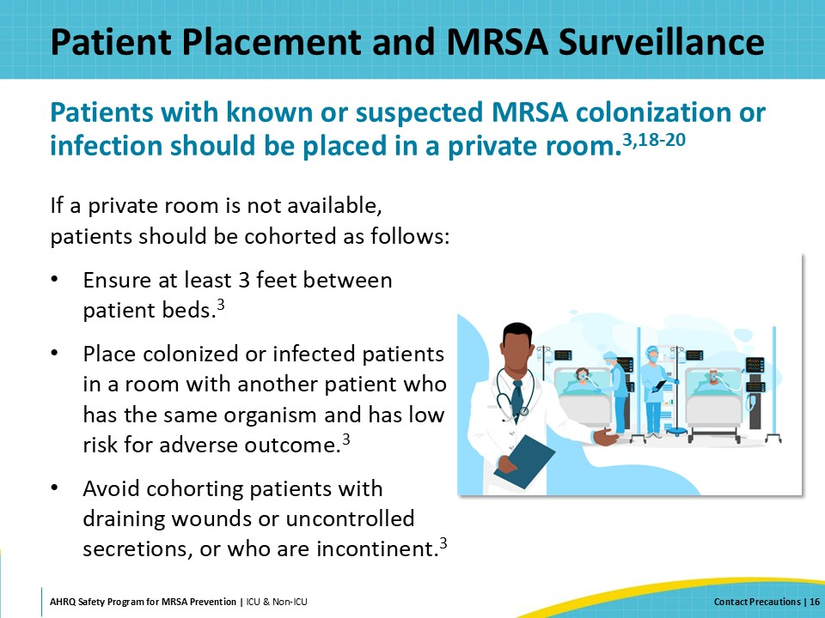
Donning and Doffing PPE  SAY:  Your hospital should have a policy on contact precautions and the proper use of hand hygiene and personal protective equipment. Train staff and practice the appropriate sequence and process for donning and doffing personal protective equipment, including discarding these items prior to leaving the patient’s room or clinical care area.  For specific and detailed instructions on how to appropriately don and doff your PPE, please review this CDC document. | Slide 17  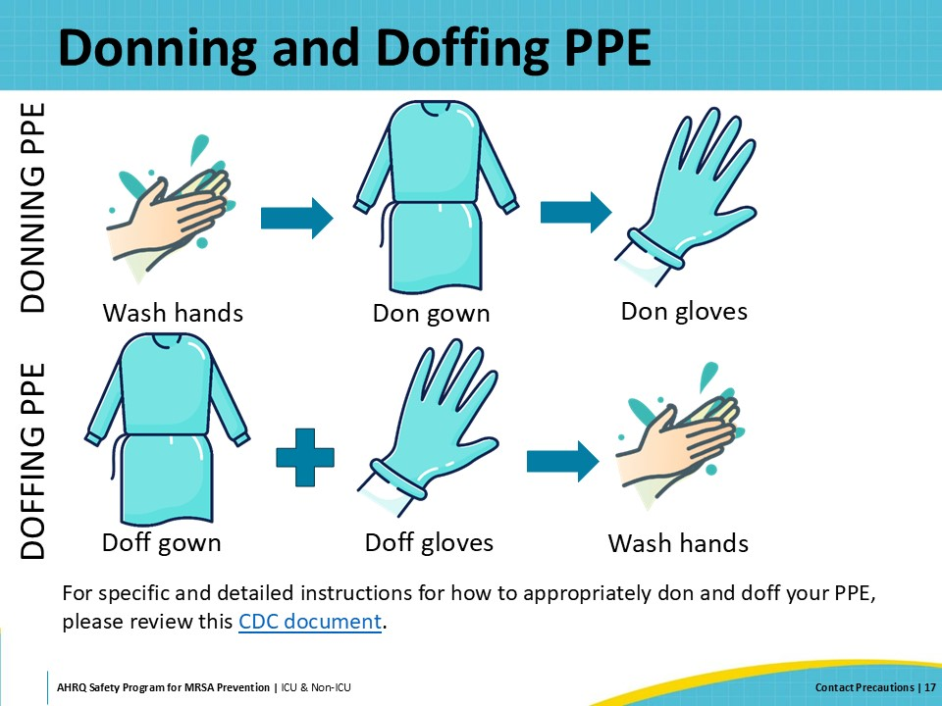
Importance Of Proper PPE Use  SAY:  Studies indicate that healthcare personnel frequently make errors in PPE doffing, particularly when removing gloves, which can lead to hand contamination. To improve the use of PPE among personnel, it is important to emphasize education and training. Training sessions should include hands-on demonstrations and ample time for participants to practice. Education should highlight the technique of properly donning and doffing PPE without self-contaminating and emphasize the importance of hand hygiene upon removing gloves and exiting a patient’s room. | Slide 18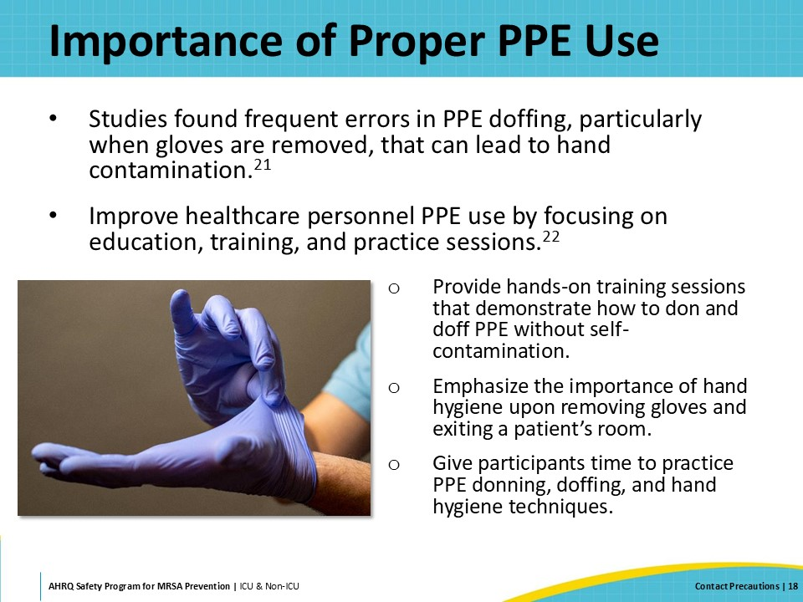
Dedicated Patient Care Equipment  SAY:  Persistent MRSA contamination of the patient care environment is well documented for patients infected or colonized with MRSA. MRSA can survive on some surfaces for weeks or months. Therefore, the use of dedicated patient care equipment is recommended whenever possible.  For patient care equipment that must be reused, it is important to properly clean and disinfect it between patient uses. This means following the manufacturer’s instructions, utilizing an approved disinfectant, and ensuring that the wet or contact time is followed. It is important to ensure that appropriate disinfectants are readily available, and to verify that staff are trained in the proper use of disinfectants. Staff are more inclined to follow these steps if disinfectants are readily accessible and easy to use. | Slide 19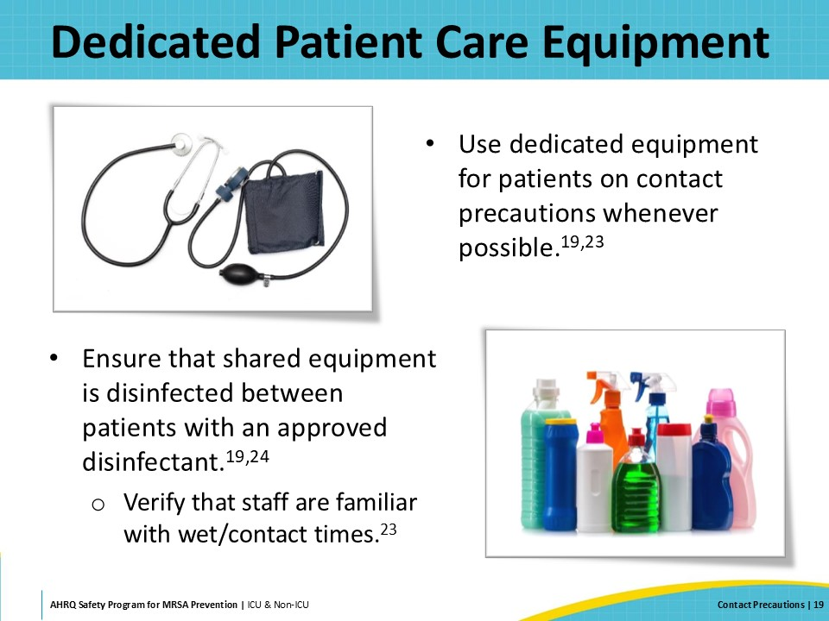
Communication, Signage, and Flagging  SAY:  For contact precautions to be effective, there needs to be a way to communicate the need for these additional transmission-based precautions. When a patient is identified as colonized or actively infected with MRSA and placed on contact precautions, many facilities post a contact precautions sign at the room entrance. An example of a contact precautions sign from CDC can be seen on this slide. In addition, most electronic health records now have the ability to “flag” patients as another way to alert the healthcare team. A flag in the system conveys information about contact precautions to everyone involved in the patient’s care. Using gowns and gloves, with other evidence-based best practices, interrupts MRSA transmission among healthcare personnel and patients. | Slide 20  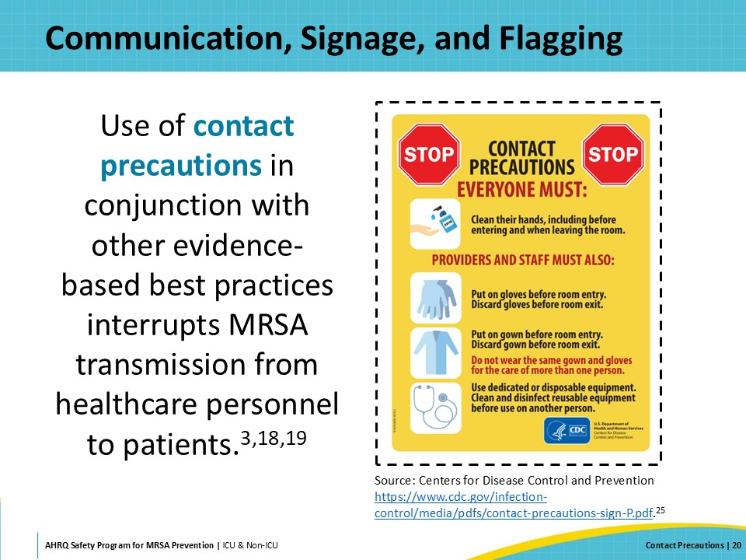
Implementation  SAY:  The next section of the presentation shifts the focus to strategies for the implementation of contact precautions to prevent MRSA transmission. It includes a case example depicting a community hospital's implementation of contact isolation precautions to address a rising trend of MRSA transmission among patients. | Slide 21  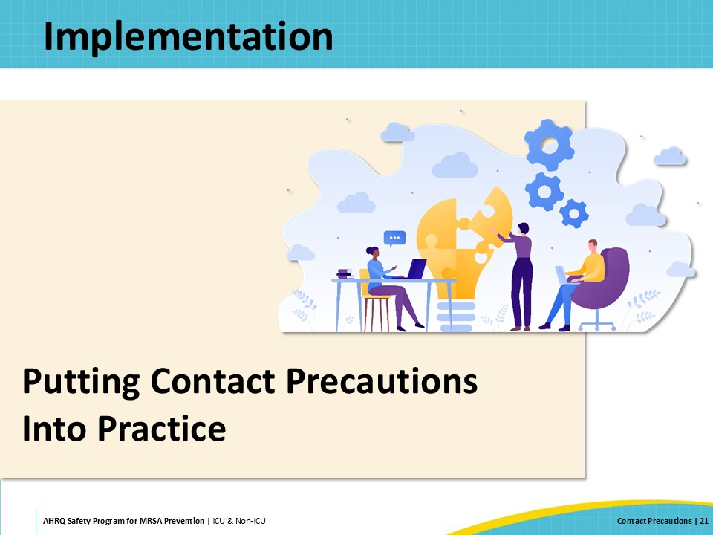
Implementation Strategies: The 4 Es  SAY:  The AHRQ Toolkit for MRSA Prevention utilizes the Comprehensive Unit-based Safety Program (CUSP) 4Es framework for implementation. The 4Es consist of: Engage, Educate, Execute, and Evaluate. These describe four basic stages to develop and implement your initiative.  For more information, please refer to the section on the 4 Es on the toolkit website. Resources in the section include a presentation, one-pager, and CUSP tools and resources.  If your hospital already has a CUSP program implemented, the departmental or unit-based CUSP teams can be a great resource to help support this work. | Slide 22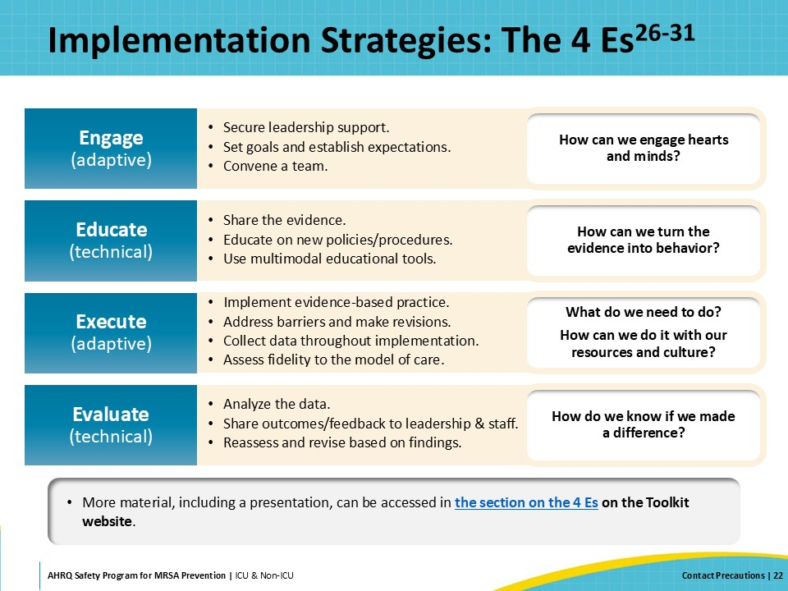
Case Example: County General Hospital  SAY:  Now, let us review a hypothetical case example of how one community hospital, County General Hospital, approached a slow increase in MRSA rates across the hospital.  Their Infection Preventionists (IPs) notice their MRSA rates have been slowly increasing throughout the last year.  For background, County General was hit pretty hard with COVID-19 cases during the pandemic. It had used contact precautions for many years as part of its MRSA Prevention bundle. However, during the COVID-19 pandemic, it stopped. As many other hospitals had to, due to the shortage of PPE during this time, County General was saving PPE for COVID patients only.  As things slowly got back to normal after the pandemic, the hospital chose not to go back to contact precautions for MRSA prevention. | Slide 23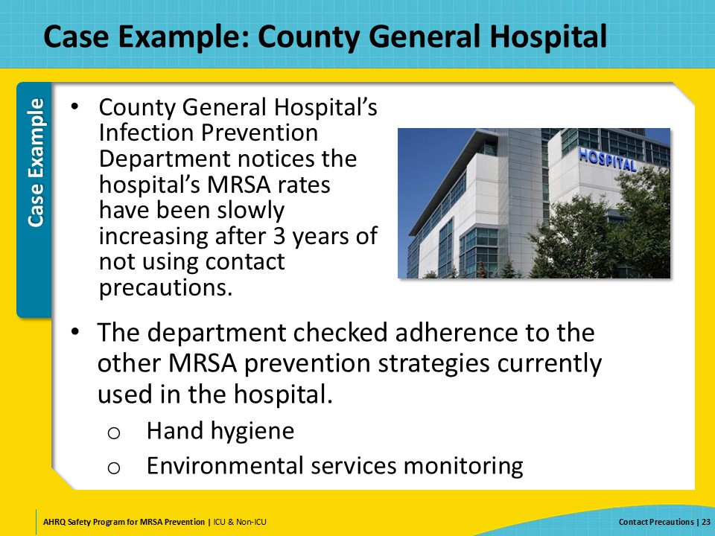
Case Example: Investigate the Current Status  SAY:  Before doing anything else, the IPs checked adherence rates for hand hygiene and reviewed the data for their environmental services monitoring program.  Adherence rates were good, and the environmental services monitoring program is a success.  They decided to talk to and observe the staff to see if there was a problem in practice. They went to the gemba, a Japanese term that refers to “the actual place,” or the place where the work is happening. Going to the gemba allows you to observe the actual workflow, engage with frontline personnel, ask questions, gain knowledge about what is actually happening, and learn about opportunities for improvement.  They talked to the staff to see if anyone had an idea of what was going on—nothing. They went to the literature and the guidelines to determine if there was any new evidence or any strategies in the guidelines they were missing. While they had been decolonizing ICU patients for several years and compliance was high, they found evidence for decolonizing patients in non-ICUs with medical devices, and they began planning for implementation of this intervention in units with highest utilization.  From their guideline review, the one core strategy they weren’t using was contact precautions. Contact precautions are listed as an “Essential” strategy for MRSA prevention and it is recommended that hospitals that discontinue the use of contact precautions monitor MRSA rates and consider reintroduction of contact precautions if rates go up. | Slide 24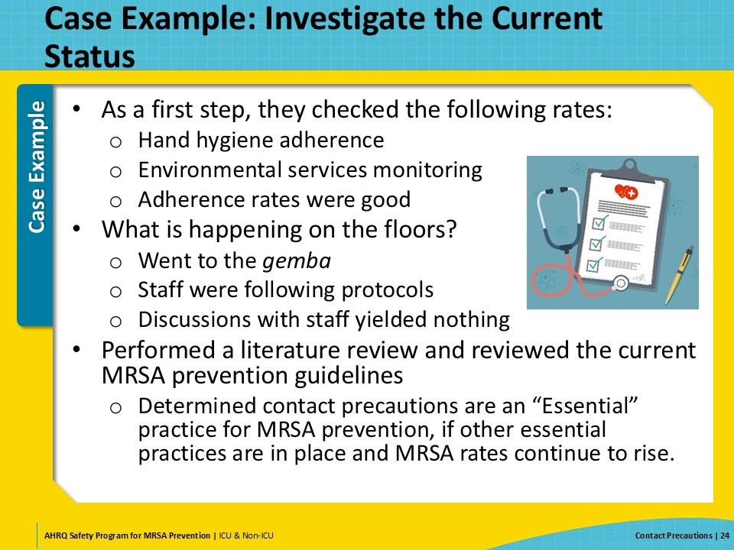
Case Example: Heart to Heart Discussion  SAY:  While the next step seemed rather obvious, the IPs balked. They knew that while contact precautions seemed the right way to go, they also knew they were going to get a lot of pushback.  So, they strategized. They looked into articles about implementation and decided to use the 4 Es to help them bring the program to leadership and to staff. They also found a few articles that would help address issues brought up around contact precautions and their effects on patients: patients on contact precautions don’t receive the care they would otherwise and patients on contact precautions get anxious and depressed.  Through their research, they found several articles they thought might help address common concerns about contact precautions.  - Patients become depressed and anxious while on contact precautions. While most HCWs believe that patients on contact precautions are more likely to become depressed and anxious while in the hospital, they found an article that showed that if you control for preexisting depression or anxiety on admission, there is no difference in the anxiety or depression patients develop whether on contact precautions or not. Another article suggested educating the patients to help prevent the possibility of this outcome.  - Staff do not like having to use contact precautions. They found an article that summarized the results of focus groups with HCWs discussing the use of contact precautions. Participants in the focus groups felt that advantages of and motivating factors for using contact precautions included: protecting yourself, protecting patients, peace of mind/feelings of safety, protecting your family, and staff satisfaction.  The IPs decided to incorporate this information into their presentations to staff. | Slide 25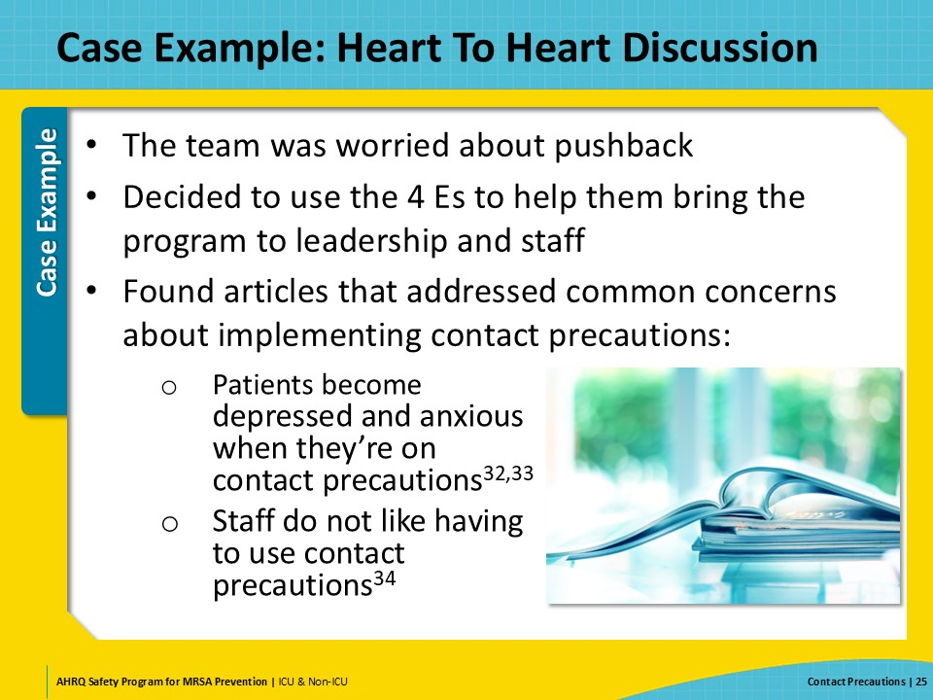
Case Example: Engaging Team, Leadership, and Staff  SAY:  Back to the 4 Es: The first E is to Engage. The aim is to engage hearts and minds, and subsequently change attitudes and behaviors. When engaging, the first thing the team needs to do is convey that a problem exists and the potential harm that the problem could cause. A common reason for lack of engagement is that individuals are unaware of a problem.  First, the IP team met with the hospital leadership. The team shared its data and gave a history of how the hospital got to the point that MRSA rates were increasing. The team discussed the rationale behind its decision to reinstitute contact precautions. It reviewed costs for supplies and projected savings, given its projection of lower MRSA rates. After much discussion, leadership agreed with the decision and made commitments to support the effort. Next, the IP team started meeting with the unit CUSP Teams. Again, the IP team shared the MRSA data and the history, and then went on to discuss its rationale for reinstituting contact precautions. The team discussed with each group how contact precautions will lower MRSA rates, leading to better outcomes for patients.  Having prepared discussion points and sample handouts for patients around patient anxiety and depression and how to mitigate this problem was helpful, as was sharing discussion points about the advantages of contact precautions.  While there was some pushback at the beginning of some of the presentations, the IP team’s preparedness paid off and the units agreed that this was the best choice in controlling MRSA in their hospital. | Slide 26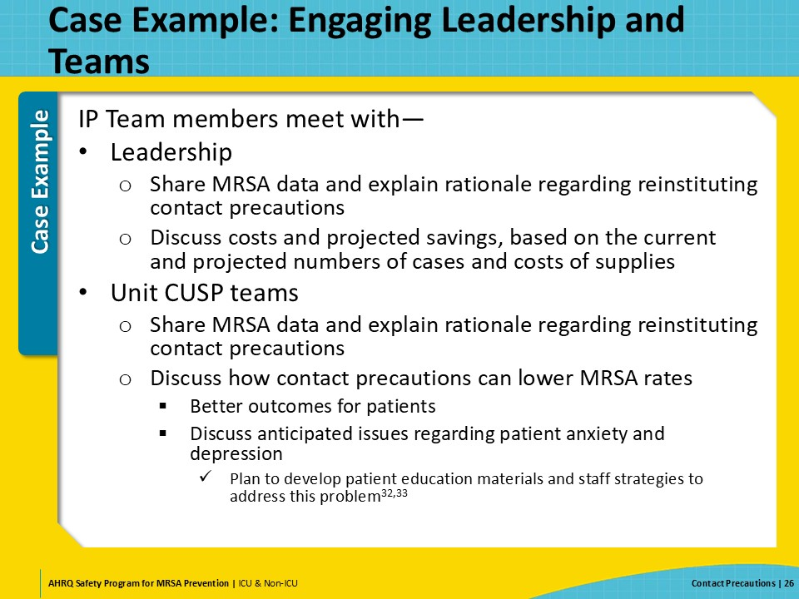
Case Example: Educate Staff  SAY:  The second E in the 4 Es framework is Educate. Educating staff about both the problem and the intervention is crucial for boosting their engagement. Engaged staff are more likely to apply what they learn.  Education alone is often seen as a “weak” intervention because it depends heavily on individuals remembering and acting on what they’ve been taught. However, when paired with other strategies, education can be highly effective as part of a broader improvement plan, reinforcing and enhancing other interventions.  The CUSP teams in the units reviewed the information from the IPs with their staff. They each discussed implementation strategies appropriate to their units. In many of the units, staff were concerned about the quality of care their patients would be receiving, as well as their patients’ mental health.  The teams discussed evidence that the quality of care can be maintained, and they shared with staff the information the IPs had given them on how patient mental health issues can be avoided. Educational meetings were held to bring everyone up to speed on the specifics of the rollout and how contact precautions would be handled on a day-to-day basis.  Refresher education sessions were added to enhance effectiveness. Annual online refresher training was required to maintain compliance. Visual reminders were also added at nursing stations, reminding staff about contact precautions. | Slide 27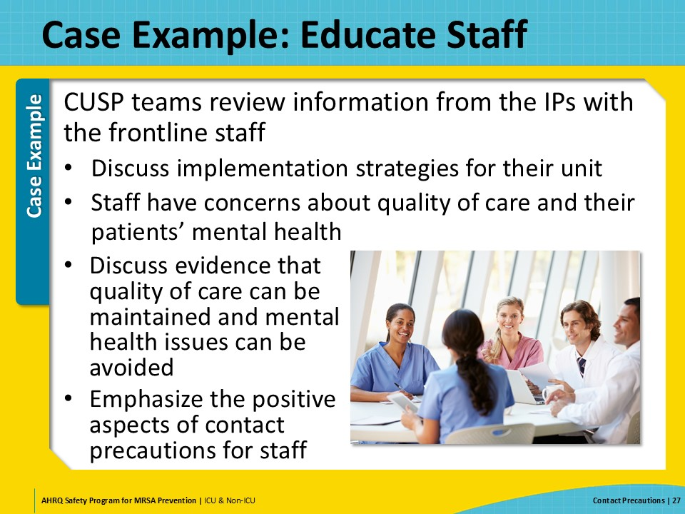
Case Example: Execute  SAY:  The third E, Execute, is putting your plans into action. During execution, it is important to track progress. This involves continuous monitoring and regular review of your chosen metrics. It also involves maintaining open lines of communication—among team members, with unit personnel, and with leadership—to facilitate coordination, keep people engaged, and address issues promptly.  Contact precautions were rolled out on all units on December 1. Stocked isolation carts were in place, signs were posted as appropriate, decisions were made prior to the launch regarding which patients needed to be moved, and patients and families were given educational material. Also, observers were in place to start the tracking of appropriate usage of gowns, gloves, and hand hygiene.  In CUSP meetings after the rollout, open discussion time was held to make sure attendees had time to talk about how the program was going, if there were any hiccups, what barriers and challenges may have emerged, and what adjustments were needed.  The aim was to embed new practices into daily routines and to ensure that staff would continue to follow them consistently. The guiding principle was to make it easy for staff to make the right decision and do the right thing. | Slide 28 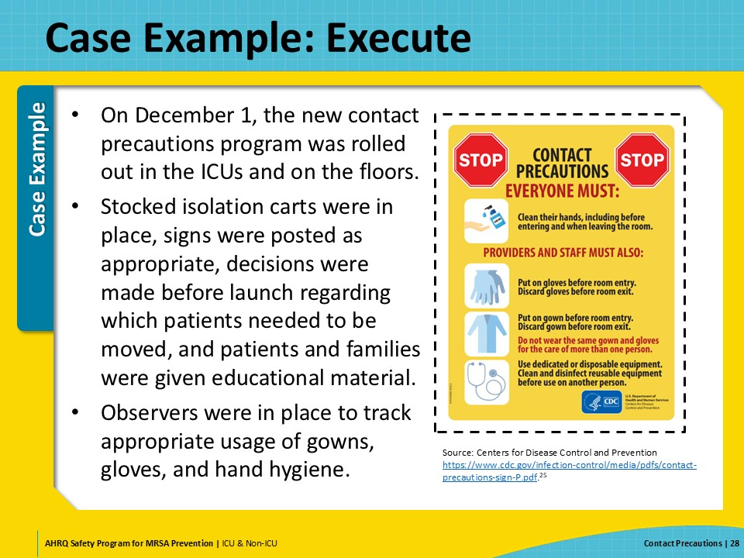
Case Example: Evaluate  SAY:  The 4th E is Evaluate. This involves collecting, analyzing, and reporting data to track intervention progress. Regular evaluation allows your team to identify problems, learn from defects, and adjust interventions as needed.  Observers were in place, collecting adherence data from the beginning. Data from the environmental services monitoring program, documentation data from the decolonization program, and MRSA rate data was collected going forward.  After 6 months, adherence rates for contact precautions rose from 54 percent to 95 percent. The rates for all other MRSA prevention activities remained constant.  The MRSA rates dropped a bit over the first quarter. Then they dropped significantly through the following year and have remained at the lower rate going forward. | Slide 29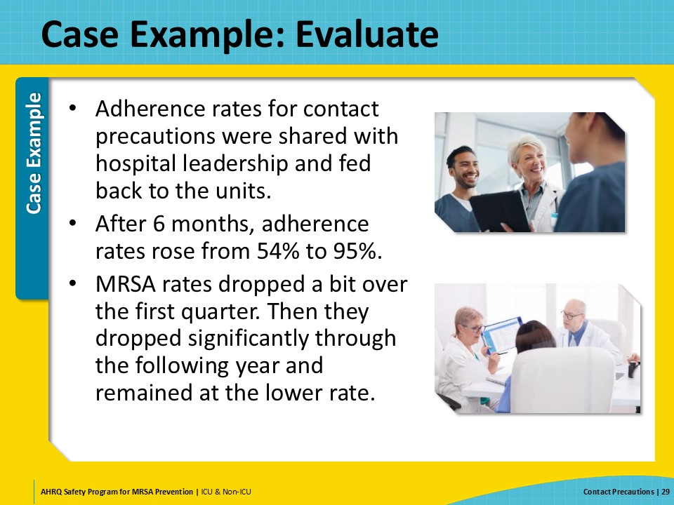
Celebrate Successes  SAY:  At County General Hospital, the interventions were a major success. All staff completed the updated yearly training, and the unit met the goal of 90 percent PPE adherence. Unit personnel who were observed not following the hospital’s policy were coached in real time, and if new barriers were identified the CUSP Champion took them to the manager for discussion at the next huddle. Data regarding PPE adherence, newly identified MRSA cases and trends on the unit were shared regularly with staff and hospital leadership. Over the next 12 months, PPE adherence increased on the unit and MRSA incidence decreased.  The CUSP team celebrated the successes in the hospital newsletter to boost staff morale and confidence. Implementing contact precautions requires hard work, multiple approaches, and sustained effort from all levels. Make sure to acknowledge and celebrate accomplishments! | Slide 30  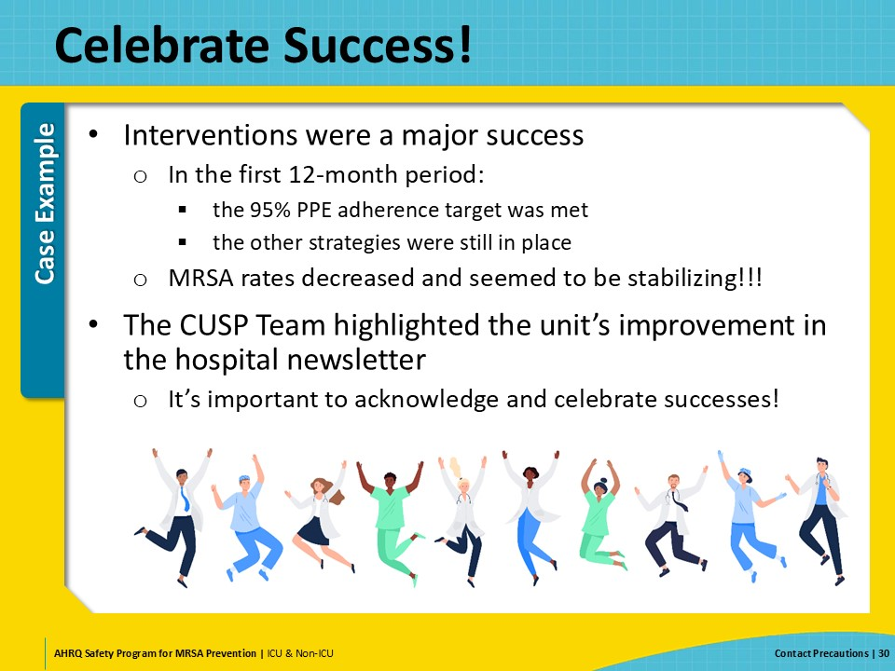
Key Takeaways  SAY:  Here are a few key takeaways from today’s presentation on contact precautions.  Contact precautions have been shown to be effective at reducing MRSA transmission, especially when they are used as part of a multifaceted approach. Your facility can use active or passive MRSA surveillance to identify patients who are colonized or infected with MRSA.  Important elements of contact precautions are patient placement, hand hygiene, appropriate use of PPE, and dedicated patient care equipment. Communication, signage, and a system for flagging medical records are also important aspects for the implementation of contact precautions. Consider and balance the benefits and potential disadvantages of contact precautions, including spending appropriate amounts of time with patients on contact precautions and promoting their well-being. | Slide 31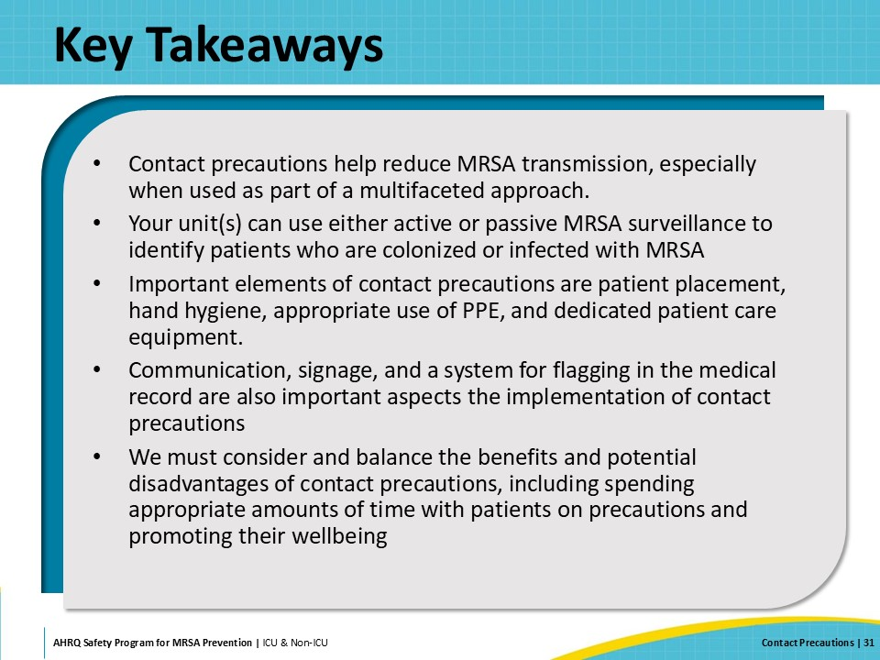
Disclaimer  SAY:  The findings and recommendations in this presentation are those of the authors, who are responsible for its content, and do not necessarily represent the views of AHRQ. No statement in this presentation should be construed as an official position of AHRQ or of the U.S. Department of Health and Human Services.  Any practice described in this presentation must be applied by healthcare practitioners in accordance with professional judgment and standards of care in regard to the unique circumstances that may apply in each situation they encounter. These practices are offered as helpful options for consideration by healthcare practitioners, not as guidelines. | Slide 32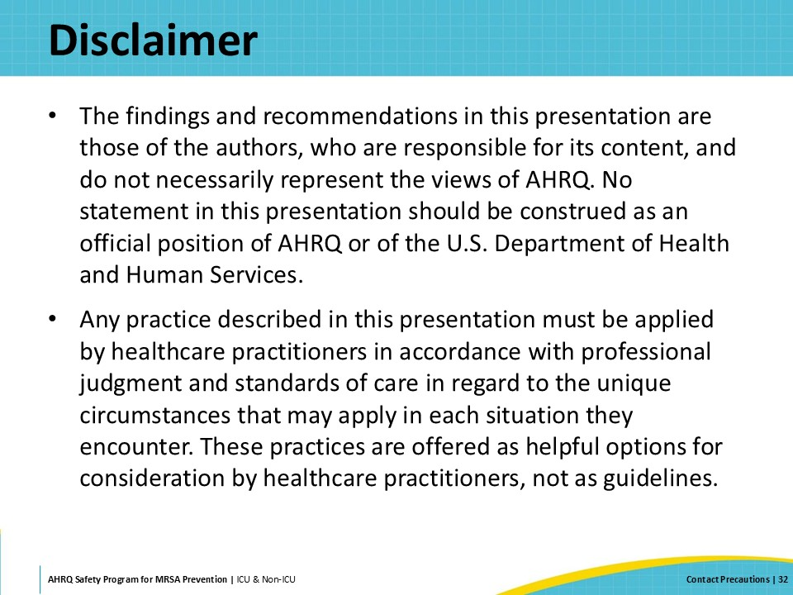
Reference List—1 | Slide 33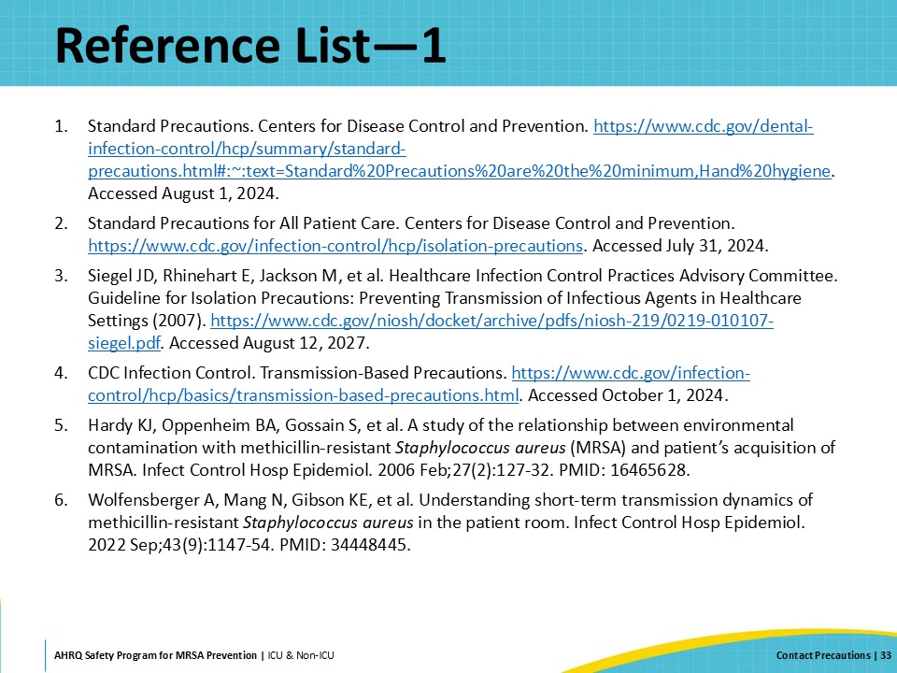
Reference List—2 | Slide 34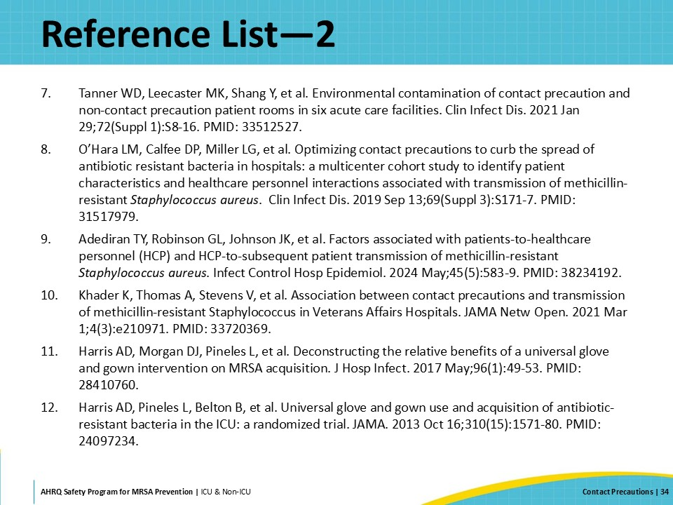
Reference List—3 | Slide 35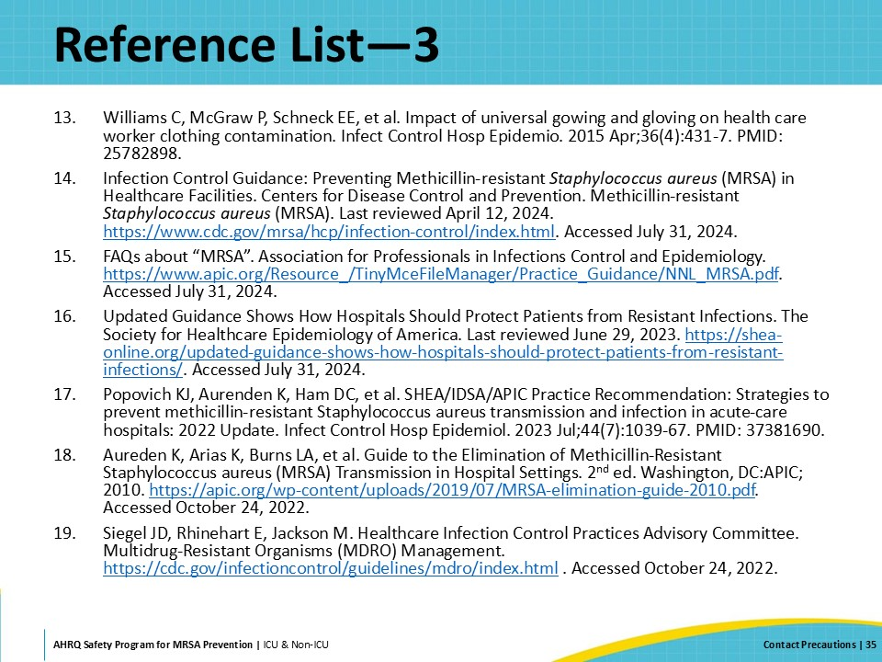
Reference List—4 | Slide 36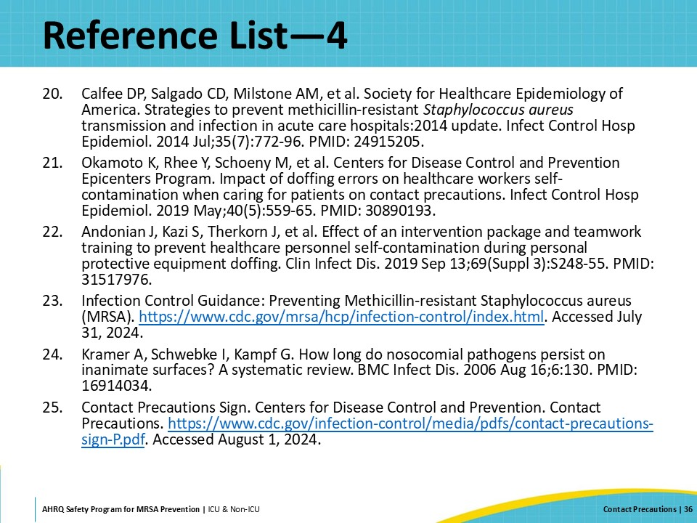
Reference List—5 | Slide 37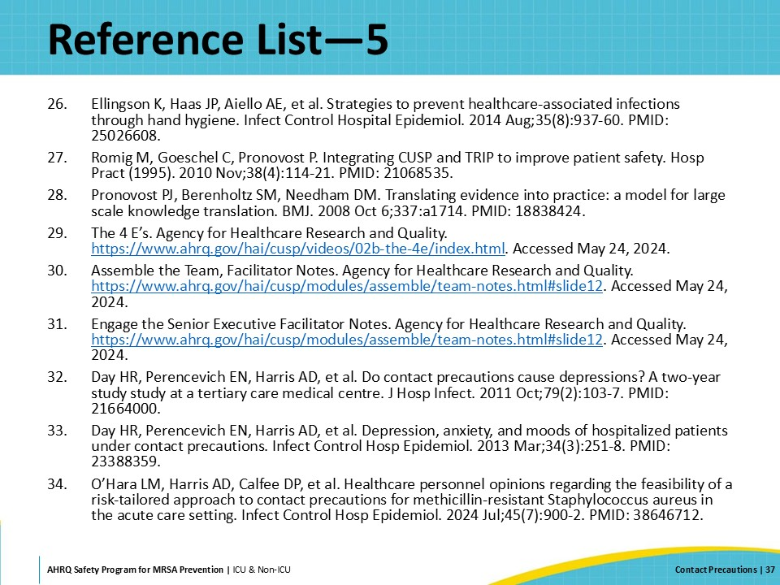
AHRQ Pub. No. 25-0007
October 2024

