**Contact Precautions refers to the use of gowns and gloves to help prevent the spread of infection. Germs can spread by skin-to-skin contact or by touching personal items and objects in patients’ rooms. You can help prevent the spread of infection by following the steps below.**

**BEFORE YOUR VISIT**

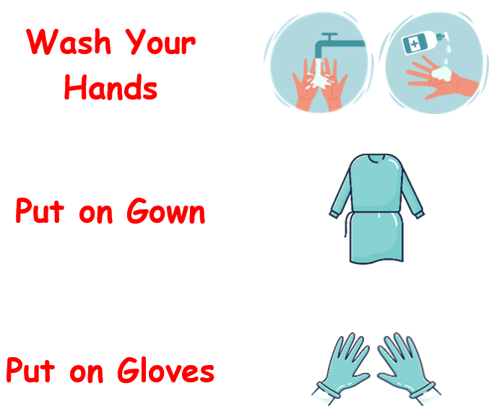

**Step 1:**

Before you visit your family member in their room, it is important to **wash your hands** to prevent the spread of infection.

**Step 2:**

**Put on a gown.** The gown helps prevent germs from getting on your clothes or skin. This prevents germs from spreading. The gown should be tied in the back.

**Step 3:**

**Put gloves on both hands.** The correct size gloves for your hands should cover your entire palm and wrist. Although gloves help prevent germs from getting onto your hands, the gloves can still spread germs. Gloves protect you, and also protect other people that you come into contact with.

**AFTER YOUR VISIT**

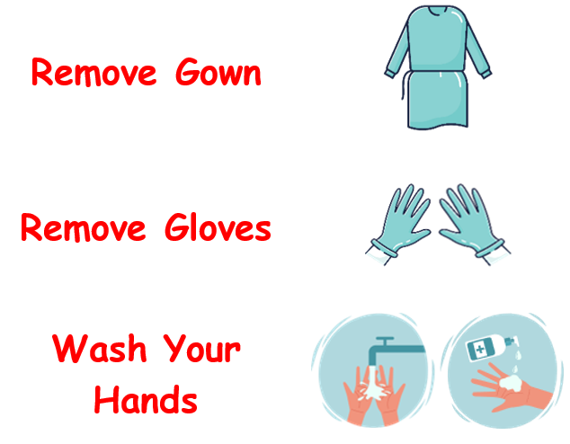

**Step 1:**

Before you leave the patient’s room, **untie and remove the gown.** Fold the gown inside out as you remove it. Try not to touch the outer surface where germs may be. Place the gown into the trash can.

**Step 2:**

**Remove the gloves one at a time.** Try not to touch the outside of the gloves with your bare hands. Place the gloves in the trash can.

**Step 3:**

**Wash your hands.** This helps prevent the spread of infection after you leave the room.