Optimizing Environmental Cleaning
ICU & Non-ICU
Slide Title and Commentary | Slide Number and Slide
Optimizing Environmental Cleaning  SAY:  Welcome to this presentation on optimizing environmental cleaning and incorporating effective environmental cleaning practices as part of an overall approach to preventing MRSA in ICU and non-ICU settings. | Slide 1  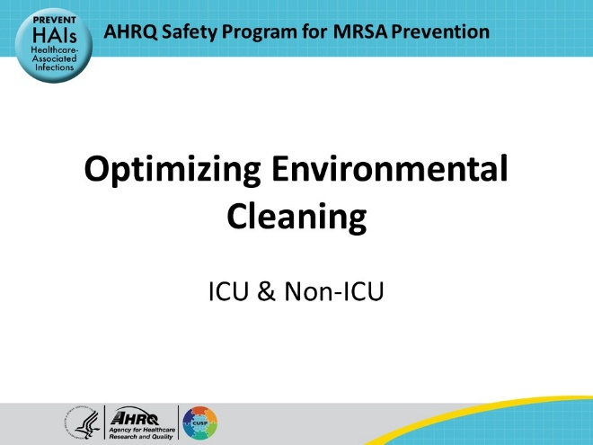
Educational Objectives  SAY:  This presentation will discuss why environmental cleaning is crucial for infection prevention, delve into the current research regarding environmental cleaning, and explore key facets of environmental cleaning. | Slide 2  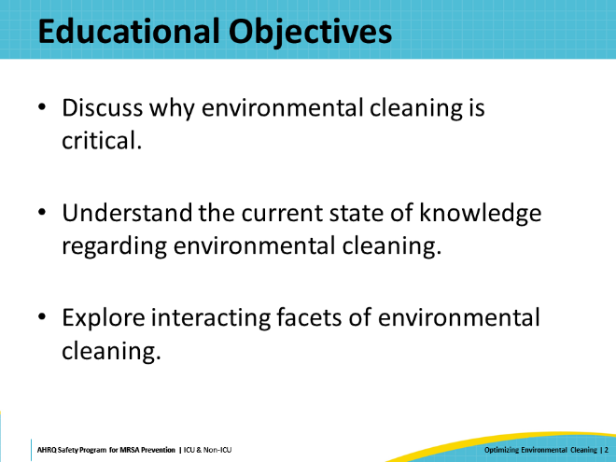
MRSA And Other Pathogens on Hospital Surfaces  SAY:  The hospital environment is commonly contaminated with drug-resistant pathogens including methicillin-resistant Staphylococcus aureus (MRSA) and other healthcare-associated infection (HAI)-causing pathogens such as Clostridioides difficile.  This is particularly true of high-touch surfaces—surfaces frequently touched by healthcare workers, such as intravenous poles, bedrails, and over-bed tables. If not removed through proper cleaning and disinfection, these pathogens can persist on surfaces for extended periods and pose a risk to patients.  Therefore, high-touch surfaces serve as reservoirs for pathogens that can be transmitted to patients through direct contact, healthcare workers, or shared equipment. | Slide 3  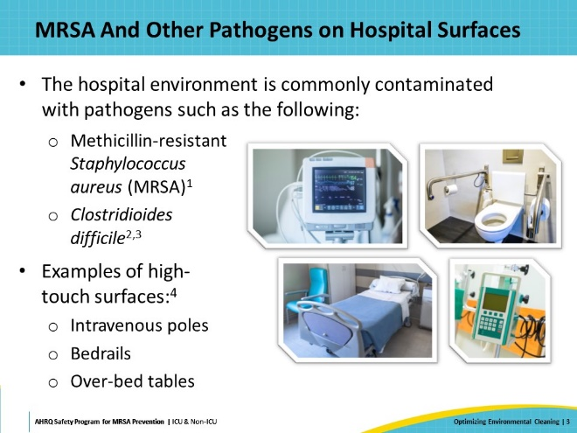
Transmission From Environment to Patients  SAY:  Prior bed occupancy by a patient infected or colonized with a multidrug-resistant organism (MDRO) is an exposure factor that is closely associated with the MDRO acquisition rate among subsequent bed occupants in intensive care units (ICUs).  A meta-analysis published in 2023 by Gu et al. investigated the risk of MDRO acquisition from prior bed occupants in the ICU. This meta-analysis demonstrated that prior bed occupants in the ICU who have been infected or colonized with MDROs can increase the odds of MDRO acquisition in subsequent bed occupants by 1.8. Sub-group analysis of patients infected or colonized with multidrug-resistant Gram-positive or Gram-negative bacteria indicated that prior bed occupancy by someone who was infected or colonized could significantly increase the risk of MDRO acquisition in subsequent bed occupants in the ICU, which was consistent with the overall meta-analysis results. | Slide 4  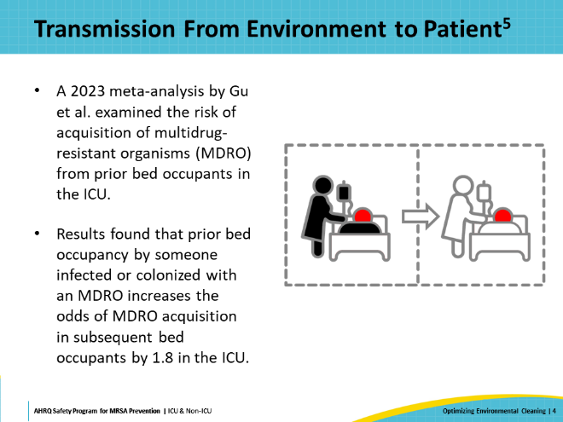
Additional Studies on Transmission From Environment to Patient  SAY:  This table serves as a resource for delving deeper into other notable studies on the topic, categorized by organism and location.  The first study examined cases of patients who developed HAIs, and found they were 5.83 times more likely to have had a prior bed occupant and 4.82 times more likely to have had a roommate with an HAI, than matched controls of patients without HAIs.  The next two studies were both ICU-based retrospective cohort studies and included MRSA among the organisms examined. The study by Huang et al. was conducted across eight adult ICUs, assessing the risk of transmission of MRSA or vancomycin-resistant Enterococcus (VRE) to subsequent room occupants. In a statistical model accounting for clustering by unit and adjusting for variables, the adjusted odds ratio of MRSA acquisition was found to be 1.4 (95 percent CI, 1.0 to 1.8).  The next study, by Datta et al., involved 10 ICUs and evaluated the effect of an environmental cleaning intervention on the risk of acquiring MRSA and VRE from prior room occupants. The researchers found that the acquisition of MRSA from prior occupants was lowered in the intervention phase compared with the baseline phase—a reduction in the odds ratio from 1.4 to 1.1.  Through a retrospective cohort study of an ICU at a tertiary care hospital, Shaughnessy et al. evaluated the risk of acquiring C. difficile following admission to a room previously occupied by a patient with C. difficile infection.  The study found a hazard ratio of 2.4 when controlling for age, Acute Physiology and Chronic Health Evaluation III score, exposure to proton pump inhibitors, and antibiotic use.  Nseir et al. performed a prospective cohort study that assessed the risk of subsequent patients acquiring multidrug-resistant Gram-negative bacilli (MDR-GNB) from prior bed occupants of an ICU, specifically MDR A. baumannii, P. aeruginosa, and extended-spectrum beta-lactamase (ESBL)-producing GNB. The researchers found that exposure to rooms previously occupied by patients with MDR A. baumannii and MDR P. aeruginosa resulted in significantly higher odds of infection or colonization—with odds ratios of 4.2 (95 percent CI, 2.0 to 8.8) and 2.3 (95 percent CI, 1.2 to 4.3), respectively.  These studies suggest that the environment is frequently contaminated and not sufficiently cleaned and disinfected between patients, leading to the subsequent occupant acquiring the organism. | Slide 5  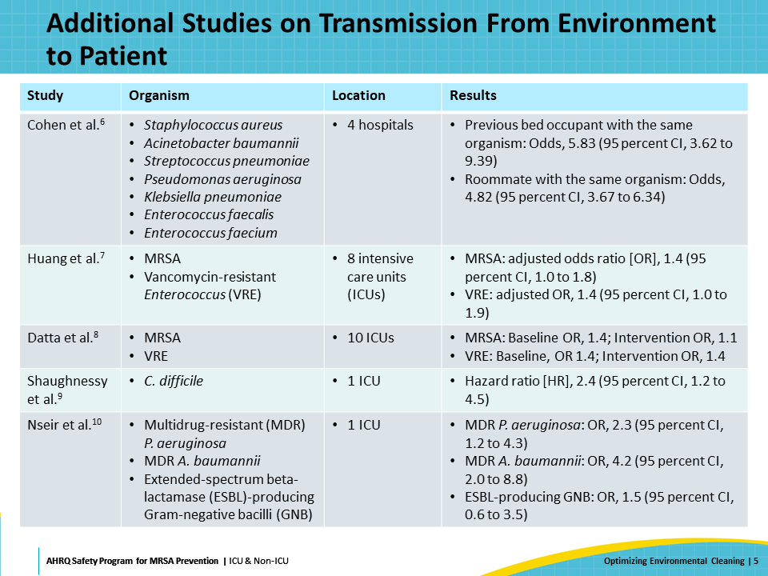
Three Key Facets of Environmental Cleaning  SAY:  This presentation will investigate three strongly interacting facets of hospital environmental decontamination—quality of cleaning monitoring methods, effective disinfectants, and adjunct cleaning methods. | Slide 6  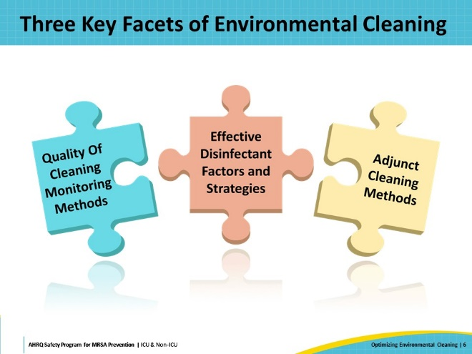
Quality Of Cleaning Monitoring Methods  SAY:  This next section will focus on monitoring quality of cleaning, which includes assessing the current status within a facility and discussing methods for quality control of cleaning. | Slide 7 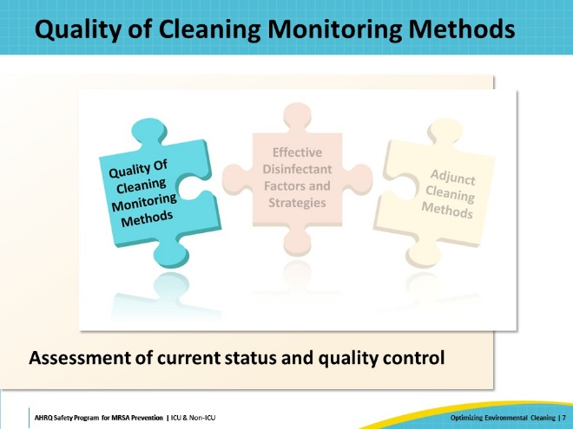
Assessing The Current Quality of Cleaning  SAY:  To start, let’s consider the current status of environmental cleaning in your unit or facility, and the methods currently implemented to understand quality of cleaning.  Ask the following questions:  What percentage of high-touch surfaces in the unit are adequately cleaned?  Is feedback given within the unit? Who gives the feedback, and who receives it?  Is the feedback appreciated? Is the feedback acted upon?  Based on the answers to these questions, consider again: How adequate and effective is the unit’s current quality monitoring? | Slide 8  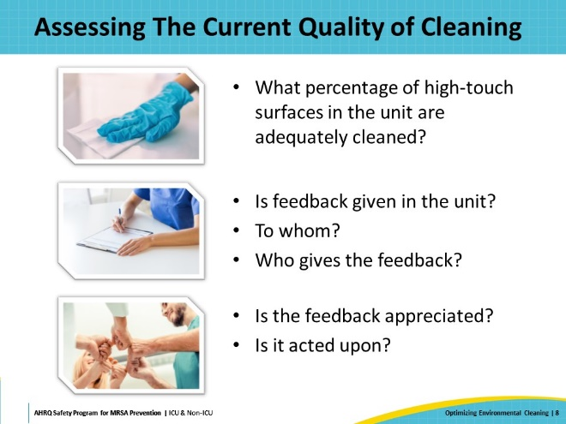
Observation And Culturing  SAY:  Quality control and monitoring of environmental cleaning is what allows us to determine what percentage of high touch surfaces are being adequately cleaned and disinfected.  There are four common methods to monitor the quality of cleaning of the patient's environment. The first is observation: visually inspecting the room to see if it appears clean. This is the quickest and easiest monitoring method; it doesn’t require significant skill and is simple to put into practice. The major limitation of this method is that surfaces may appear clean and free of visible soiling, but this does not indicate that a surface has been adequately disinfected.  The second method is culturing, which involves sampling surfaces with a swab or sponge and sending them to the microbiology laboratory to be processed to check for the presence of pathogens. This method is usually not part of standard hospital programs but may be conducted as part of funded research projects or specific outbreak or cluster investigations. Results typically take a couple of days to return, making them not immediately actionable. Culturing is also labor-intensive, from the staff taking the samples to the technicians in the microbiology lab. Also, microbiology testing generally needs to be targeted towards one specific organism of concern, rather than evaluating for any pathogen.  The last two methods—fluorescent gel monitoring and adenosine triphosphate (ATP) monitoring system —are commonly used by infection prevention programs and will be the focus of the next few slides. | Slide 9  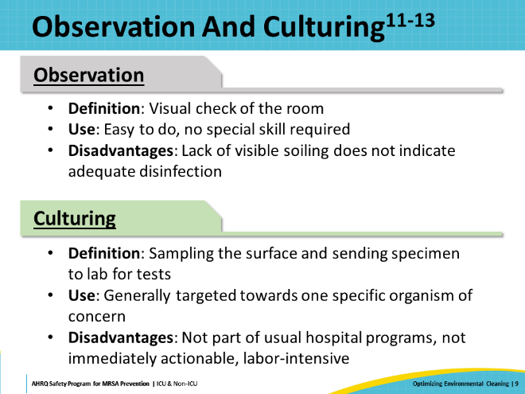
Fluorescent Gel Monitoring  SAY:  Fluorescent gel monitoring involves applying fluorescent gel, which is invisible to the naked eye, but glows under ultraviolet (UV) light. A marker is used to apply fluorescent gel on high-touch surfaces in the patient environment, such as bed rails and overbed tables. After a set interval—typically a day—the evaluator returns to the patient environment and re-examines the surfaces with a UV light.  If no fluorescent gel is visible, the interpretation is that the surfaces have been adequately cleaned. If fluorescent gel is still visible, it can be assumed that those surfaces have not been adequately wiped in the interval between when the gel was applied and when it is being assessed. | Slide 10  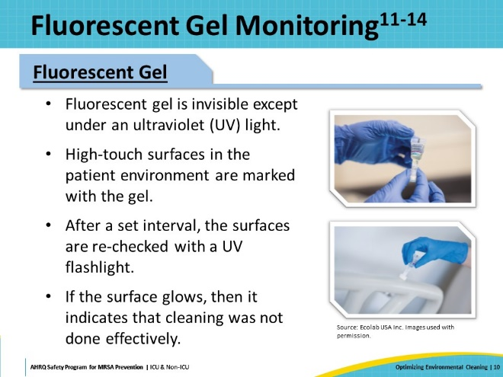
Adenosine Triphosphate (ATP) System  SAY:  The fourth method of evaluating the quality of cleaning is an ATP monitoring system.  ATP is an energy molecule found in all plants, animals, and microbial cells. All organic matter—living or once-living—contains ATP, including food, bacteria, mold, and other microorganisms.  ATP testing devices use luciferase, a natural enzyme found in fireflies. This enzyme creates a simple bioluminescent light-producing reaction upon contact with ATP. To test a surface, a specialized swab containing luciferase is used to sample the surface and is then inserted into an ATP meter, which then analyzes the sample for light being emitted. The quantity of light generated by the reaction is proportional to the amount of ATP present in the sample. By measuring the amount of bioluminescence, the ATP meter estimates organic matter on the surface, which indicates surface cleanliness. High levels of organic matter indicate a surface has not been sufficiently cleaned.  The ATP meter can detect even very low levels of bioluminescence. This high level of sensitivity allows for the detection of any organic matter on surfaces. However, the method does not necessarily indicate whether the ATP is from living organisms, as inactivated organisms can also return detectable ATP results. | Slide 11  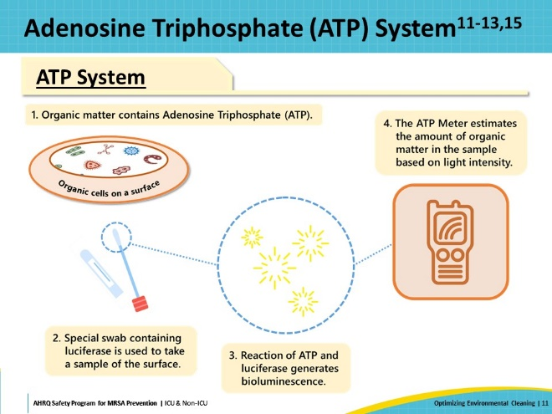
Fluorescent Gel Versus ATP  SAY:  This table compares the two methods, fluorescent gel monitoring and ATP system, across various categories.  Both methods are supported by strong evidence. Evidence supports the correlation between the presence or removal of fluorescent gel with aerobic colony counts of bacteria. Additionally, other studies have found ATP to be associated with a reduction in incidence rate of multidrug-resistant organism (MDRO) infection or colonization.  In terms of ease of use and understanding, fluorescent gel may be more intuitive for frontline environmental care associates. They can be present when the evaluator uses UV light to assess for the presence of gel. If the gel glows, then the surface has not been sufficiently cleaned. By contrast, the ATP process may be less intuitive, as it provides a quantitative readout, representing the amount of ATP present in the sample, which may be difficult to correlate with the effectiveness of cleaning and disinfection actions.  Neither of these methods identify pathogens.  The ATP system may be more objective due to its quantitative readout. However, a high ATP reading can indicate the presence of either live or inactivated bacteria in the sample. In contrast, fluorescent gel monitoring provides a qualitative assessment primarily based on the evaluator’s determination of the presence or absence of the gel. This method may have a stronger Hawthorne effect, wherein the presence of observers influences the behavior being observed. Also, despite adequate environmental cleaning, some gel may remain. Cleaning is typically considered sufficient when half or more of the fluorescent gel is removed.  A positive aspect of both methods is that they provide immediate and reliable feedback. A drawback is that they can be expensive. ATP systems are generally costly. Costs for fluorescent gel monitoring will depend on the product selected. | Slide 12  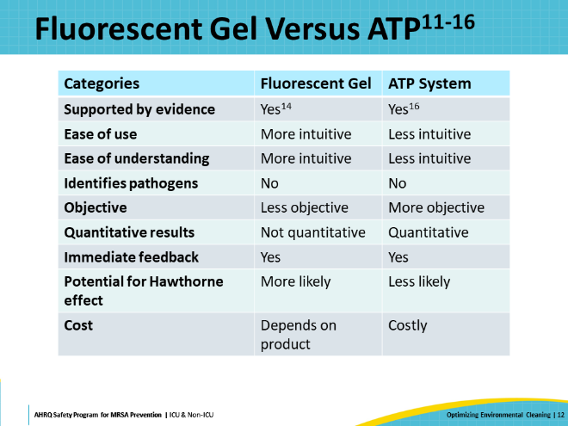
Effective Quality Control of Cleaning Programs  SAY:  Regardless of which monitoring system is used, there are some overarching key principles for any effective quality control program.  The first principle is to establish a clear purpose for the program, with clear expectations and goals. This applies to individual environmental care associates and unit and departmental levels. Crucially, monitoring should be implemented in a supportive environment, so that feedback can be given fairly and justly, and the system can be set up to optimize tools, education, and supervisory support.  It is also important to promote data feedback along with defined action plans with rewards and retraining. This feedback may be directed to various stakeholders, such as individual environmental care associates, Comprehensive Unit-based Safety Program (CUSP) or other quality improvement teams, unit leadership, hospital leadership, infection control committees, and hospital executive committees. | Slide 13  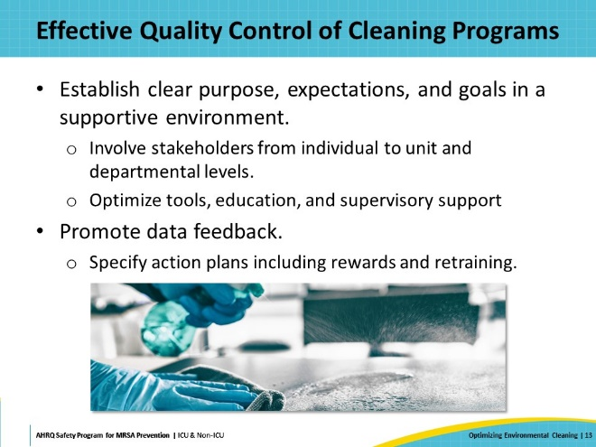
Implementing Quality Control  SAY:  When implementing a system to monitor quality of cleaning, some questions to ask include:  - What system and product will be used?  - How many surfaces should be checked?  - How many rooms need to be checked?  - Which rooms need to be checked?  - Which healthcare worker role can take on this task of quality control checking?  Additional information on implementing quality control of cleaning, with greater focus on fluorescent gel monitoring, is discussed in the presentation Assessing Environmental Cleaning Effectiveness available on the Toolkit website. | Slide 14  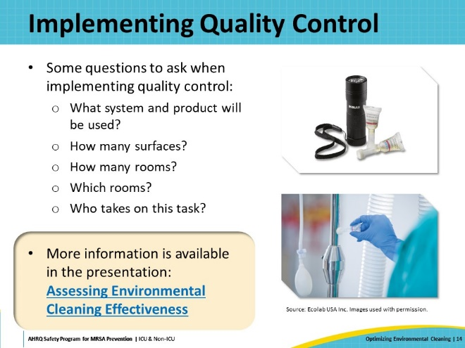
Effective Disinfectant Factors and Strategies  SAY:  This next section will delve into the types of cleaning and disinfection chemicals available for environmental cleaning of patient surfaces and the associated factors and strategies. | Slide 15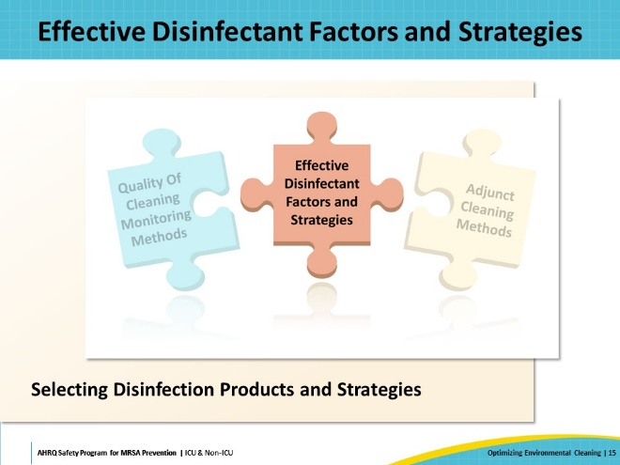
Effective Disinfectants  SAY:  When disinfection products enter the market, they undergo registration with the United States (U.S.) Environmental Protection Agency (EPA) and receive a listing that indicates the organisms they can effectively disinfect.  From a healthcare perspective, the primary difference lies in sporicidal disinfectants that eliminate environmentally hardy spores, such as those from C. difficile, compared to non-sporicidal disinfectants. For instance, the EPA List K indicates the registered antimicrobial products that are effective against C. difficile.  In addition to the targeted organisms, many factors influence the decisions regarding disinfection product selection, including the ease of use, cost, and surface type. | Slide 16  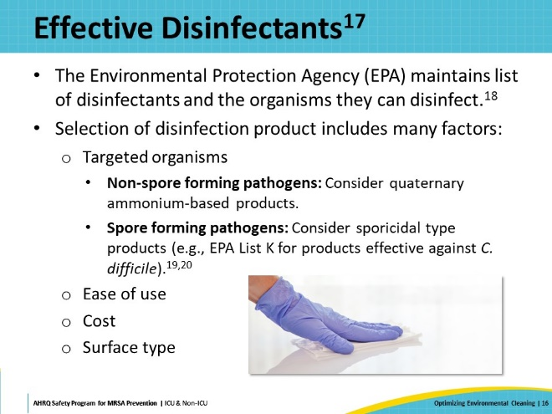
Sporicidal Disinfectants  SAY:  This table provides an overview of some available sporicidal disinfectants. No product is perfect, and each option comes with advantages and disadvantages.  One option is sodium hypochlorite or traditional bleach. It is relatively inexpensive but has drawbacks, such as the need for pre-cleaning of surfaces, potential surface damage, residue formation that requires rinsing, strong odor, irritant properties, and short shelf life.  Alternatively, there are some newer bleach-neutralizer combinations now available, such as Clorox Healthcare® Fuzion® Cleaner Disinfectant. This product combines sodium hypochlorite with a neutralizer, forming hypochlorous acid. It offers the advantage of being a one-step cleaner and disinfectant, with a milder odor and less surface damage. However, it tends to be relatively expensive and, at present, is only available in spray form.  Chlorine-based sodium dichloroisocyanurate (NaDCC) has the advantage of being a one-step cleaner and disinfectant. However, its disadvantages include residue, mild odor, and a complex mixing and dilution process that requires personal protective equipment.  Hydrogen peroxide or peracetic acid, produced by reacting with acetic acid and hydrogen peroxide, is also a one-step cleaner disinfectant and is less damaging to surfaces than bleach without leaving residue. However, it has a mild odor and a higher associated cost, and the chemicals require careful attention to ensure they are being dispensed and diluted to correct concentrations.  Lastly, there is a novel sporicidal hydrogen peroxide disinfectant, PDI’s Sani-HyPerCide® with 4.04 percent hydrogen peroxide and less than 10 percent acetic acid. It is a one-step cleaner and disinfectant with a wipe and spray mechanism but has limited availability currently. | Slide 17  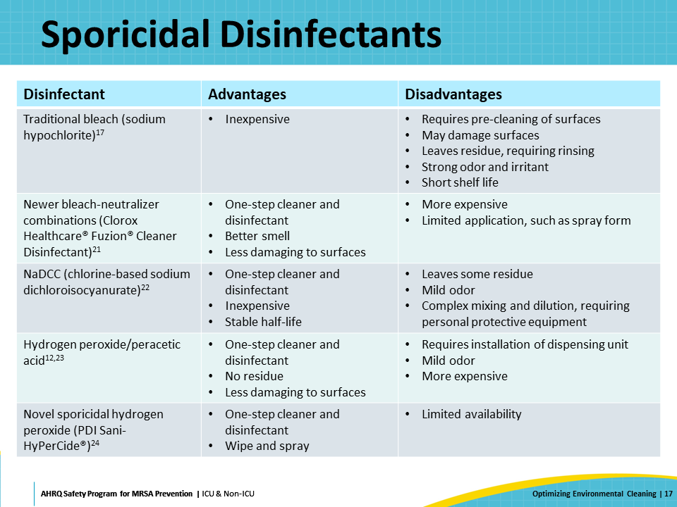
Use Of Sporicidal Disinfectants  SAY:  Do many hospitals use a sporicidal agent as the standard disinfectant product?  The answer is no; many hospitals currently do not use a sporicidal agent for environmental cleaning and disinfection. Instead, they will use a non-sporicidal and less expensive disinfectant – such as quaternary ammonium cleaner - for regular non-contact isolation rooms.  A 2019 survey of 47 environmental services personnel representing different U.S. hospitals across 26 states found that bleach was the most frequently used sporicidal disinfectant. Five of the 47 hospitals, or 10.6 percent, routinely used sporicidal disinfectants during daily disinfection of regular rooms. Eight out of 47 hospitals, or 17 percent, routinely used sporicidal disinfectants during terminal disinfection of regular rooms, when patients were discharged. | Slide 18  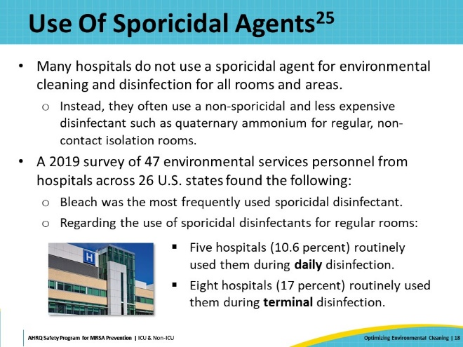
Universal Sporicidal: Advantages and Disadvantages  SAY:  Should a hospital consider using a universal sporicidal strategy?  A universal sporicidal strategy means using a sporicidal disinfectant product for every type of room and for every cleaning, not just circumstances in which a patient is known to harbor C. difficile or another pathogen which necessitates a sporicidal agent.  One advantage of a universal sporicidal strategy is its potential to decrease C. difficile rates, particularly in cases where there are undetected environmental reservoirs in rooms where the patient is not known to harbor C. difficile. Additionally, it streamlines the process for environmental care associates responsible for room cleaning by eliminating the need to train them on two different products (e.g., one quaternary ammonium-based and the other sporicidal-based). Simplifying the process, especially in environments with high staff turnover and significant training needs, may lead to more effective and standardized disinfectant use. Moreover, this strategy minimizes the risk of mistakenly cleaning a room requiring a sporicidal agent with a non-sporicidal product.  However, there are some potential disadvantages. There is a lack of strong clinical evidence to support the effectiveness of universal sporicidal agents in reducing rates of C. difficile or other pathogens when they are at endemic—meaning non-outbreak or usual—levels. Also, frequent use of a universal sporicidal agent, especially if it is a bleach product, may lead to surface damage over the long term. Additionally, these products often come with associated odors, and they tend to be more costly compared to non-sporicidal disinfectants. | Slide 19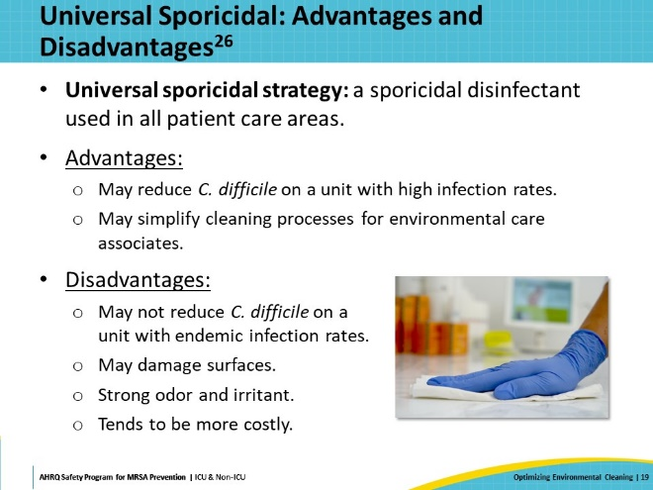
Universal Sporicidal: Strategy Based on Infection Rates  SAY:  There are flexible universal sporicidal approaches to consider. One strategy involves implementing universal sporicidal for daily and terminal cleaning when C. difficile or MDRO rates are above the typical endemic rates on a particular clinical unit. Even if suboptimal cleaning did not cause the increase in infection rates, colonization pressure—more of the organism on a unit—may lead to environmentally-related transmissions.  When the rates normalize, then the unit reverts to usual cleaning and disinfection processes. | Slide 20  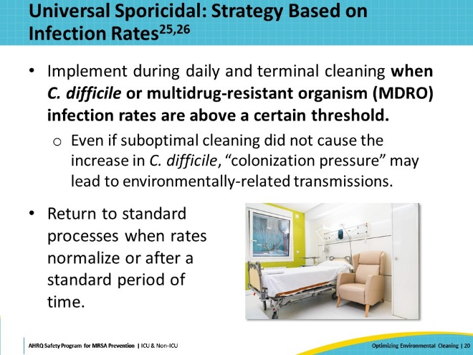
Universal Sporicidal: Terminal Cleaning Strategy  SAY:  Another strategy involves implementing universal sporicidal agents at discharge only, regardless of C. difficile or MDRO rates.  Since the cleaning agents are used during terminal cleaning only, there is less damage to surfaces and equipment. Additionally, since patients are not in the room during use of the products, they are less of an irritant.  However, this creates potential for confusion between products used for daily cleaning and those used for terminal cleaning. Terminal cleaning will be more standardized, as the same product is used regardless of the patient's infectious status. However, daily cleaning procedures will still vary. | Slide 21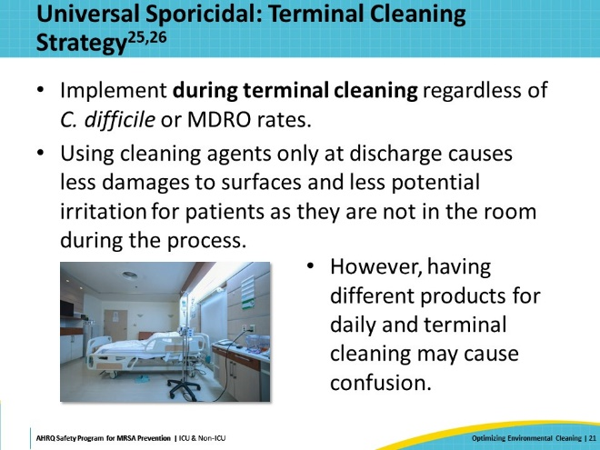
Adjunct Cleaning Methods  SAY:  This next section explores some of the adjunct room cleaning and disinfection methods that are available. These methods involve no touch technologies that generally do not require a disinfectant product to be manually placed on surfaces. | Slide 22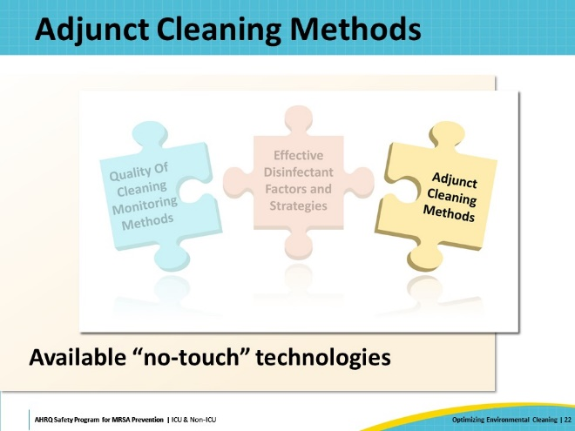
No-Touch Technologies  SAY:  Currently, there are two main types of no-touch technologies that are in use—Ultraviolet-C (UV-C) or hydrogen peroxide vapor (HPV). Both will be discussed. | Slide 23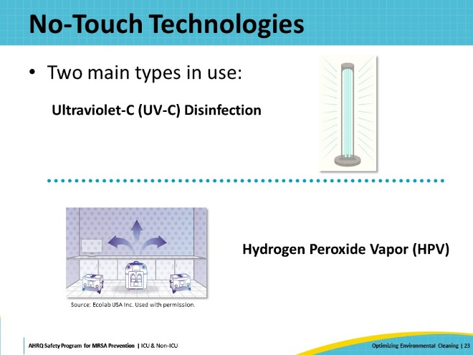
Examples Of UV-C Machines  SAY:  Here are a few examples of what UV-C machines look like. | Slide 24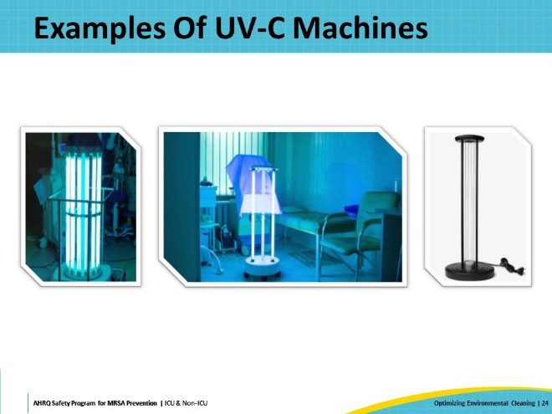
UV-C Disinfection  SAY:  How does UV-C technology work for environmental cleaning?  Light in the UV-C spectrum, with wavelengths ranging between 200 and 280 nanometers, has germicidal or germ-killing properties. At these wavelengths, the absorbed light can inactivate the ability of microbes to replicate. | Slide 25  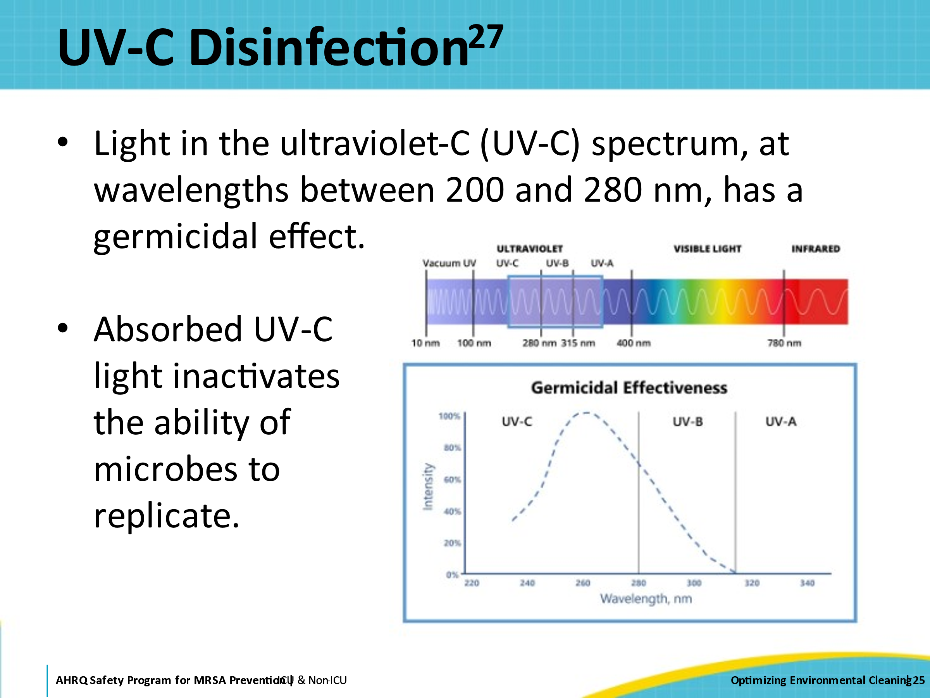
UV-C Disinfection: The Evidence  SAY:  Numerous studies have examined the use of UV-C light in relation to patient outcomes. However, these studies are primarily before-after analyses, where hospitals or units introduce UV-C alongside an infection prevention bundle to address high rates of MDRO or C. difficile infections, resulting in a subsequent decrease in these rates.  Such studies are challenging to interpret regarding UV-C, as it is difficult to attribute improvements to UV-C intervention. Factors such as publication bias may come into play, where only hospitals with favorable outcomes are motivated to publish their results. Additionally, published findings might merely reflect MDRO rates returning to normal or "regressing to the mean." Few studies have investigated the effectiveness of UV-C when infection rates are at endemic levels. | Slide 26  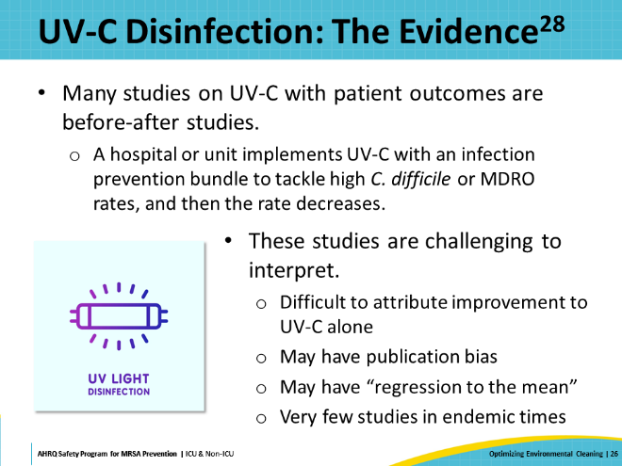
The Benefits of Enhanced Terminal Room Disinfection Study  SAY:  The Benefits of Enhanced Terminal Room Disinfection Study was the first major study to examine UV-C in a systematic way. It was a cluster-randomized, crossover trial of nine hospitals in the southeastern U.S and assessed pathogen acquisition and infection of the subsequent room occupant following enhanced terminal room disinfection for four MDRO organisms—MRSA, VRE, MDR Acinetobacter, and C. difficile.  The study included four strategies for terminal room disinfection:  - For the reference group: quaternary ammonium disinfectant, except in rooms of patients with C. difficile, where bleach was used.  - Quaternary ammonium disinfectant and UV-C light except in rooms with C. difficile, where bleach and UV-C were used.  - Bleach for all rooms.  - Bleach and UV-C for all rooms. | Slide 27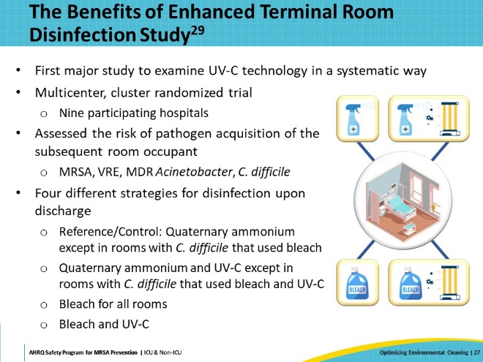
The Benefits of Enhanced Terminal Room Disinfection Study: Results  SAY:  The study found that when looking at all target organisms, there was an improvement in acquisition and infection of pathogens when UV-C was added to quaternary ammonium disinfectant, relative to the reference group. However, this decrease was comparable to when using bleach. There were no significant changes when bleach and UV-C were used.  When specifically focusing on MRSA, there was an improvement when UV-C was added to quaternary ammonium disinfectant, relative to the reference group. There appeared to be no significant improvement when UV-C was added to bleach. | Slide 28  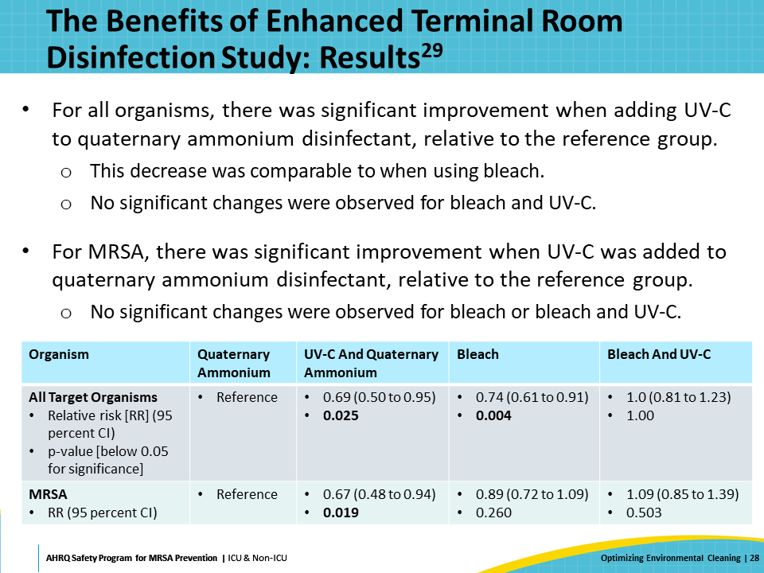
Advantages Of UV-C Disinfection  SAY:  UV-C has some advantages and some disadvantages.  The process of using UV-C is relatively quick, generally taking about 15 minutes after manual cleaning.  Although no one can be in the same room when the UV-C light is activated, general safety features such as auto shut-off mechanisms when the door is opened make them safe for widespread use.  UV-C is proven effective at killing bacteria and viruses on surfaces. Simulated studies show massive log reductions in the number of pathogens on surfaces after UV-C is used.  Additionally, patients generally have a positive opinion of UV-C technology. A survey conducted among patients in units receiving daily UV-C disinfection at Johns Hopkins Hospital showed an overall positive patient perception. Patients felt it was an additive safety feature and remarked that the odor dissipated quickly.  Notably, UV-C is easy to use and to teach, and it can be performed by hospital staff and does not require outside experts, which allows for easier integration into current cleaning and disinfection processes. | Slide 29  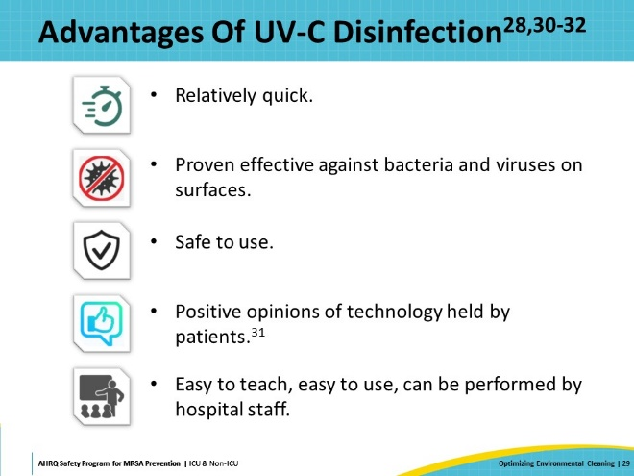
Disadvantages Of UV-C Disinfection  SAY:  UV-C also has some disadvantages. It is important to note that UV-C light cannot penetrate through shaded areas or solid surfaces and cannot disinfect surfaces where the light does not directly shine. Thorough cleaning of a room may require moving the device or moving furniture.  UV-C machines require a designated person or role to use the machine. Many healthcare workers, including environmental care associates and technicians, already feel overburdened, and staffing is an issue for many acute care hospitals. Adding UV-C use to their workflow can therefore feel excessive.  UV-C adds additional time to the terminal cleaning process, during which period the room being cleaned cannot be entered or used. This adds pressure to the discharge and turnover of patient rooms. Coordination of patient intake needs to be very precise to avoid conflicts.  UV-C machines also pose practical and logistical concerns. Machines need to have space to be properly stored. Machines have maintenance needs, such as bulb replacement. In larger units and hospitals, multiple machines may be required to avoid delays.  There are associated costs, which include the expense of the devices themselves, the initial costs of operationalization, and the ongoing costs of labor and maintenance.  Finally, it can be difficult to evaluate the impact of UV-C. If a unit sees no immediate reduction in the rates of HAIs, does that mean the UV-C has had no effect or that other aspects of the environmental cleaning process need to be addressed? If a reduction does occur, how much of that is attributable to the use of UV-C technology? | Slide 30  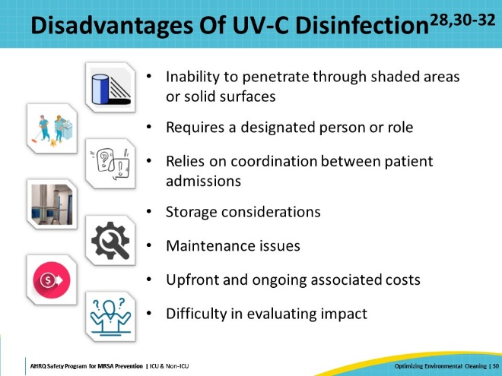
Hydrogen Peroxide Vapor (HPV)  SAY:  The other main no-touch technology is HPV.  The device holds hydrogen peroxide liquid, typically 30 to 35 percent by weight, which meets a hot plate. The liquid is then vaporized and emitted into the air of the sealed patient room.  When the hydrogen peroxide vapor concentration is higher than that of the surrounding air, a thin layer of hydrogen peroxide condensate settles on the surrounding surfaces and kills pathogens.  After a pre-set interval, the remaining hydrogen peroxide vapor in the air breaks down into water vapor and oxygen over time. Note that the patient room cannot be opened before the process is finished, due to the danger of the high hydrogen peroxide concentration. | Slide 31  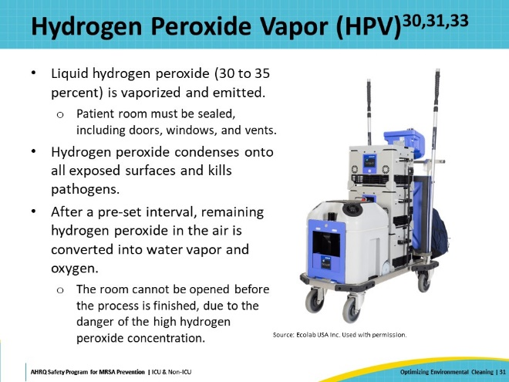
Environmental Decontamination With HPV  SAY:  A 30-month prospective cohort intervention study published in 2013 by Passaretti et al. evaluated the impact of HPV room disinfection with prior known occupants known to be infected or colonized with epidemiologically significant MDRO—VRE, MRSA, C. difficile, or multidrug-resistant Gram-negative rods (MDR-GNR).  The study included six high-risk units in a tertiary care hospital.  Patients subsequently admitted to rooms decontaminated using HPV were 64 percent less likely to acquire any MDRO and 80 percent less likely to acquire VRE compared to those receiving standard cleaning, when compared to those admitted to standard cleaning rooms and after adjusting for other factors. | Slide 32  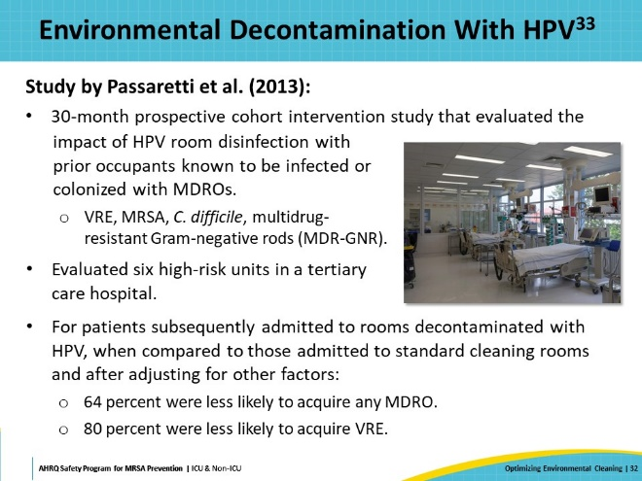
Advantages Of HPV  SAY:  Advantages of using HPV for room disinfection and cleaning include being safe to use when protocols are followed properly and being proven effective against bacteria and viruses on surfaces.  Also, HPV leaves no residue or irritants and provides uniform coverage, dispersing evenly throughout the room to include corners and hard to reach areas. | Slide 33  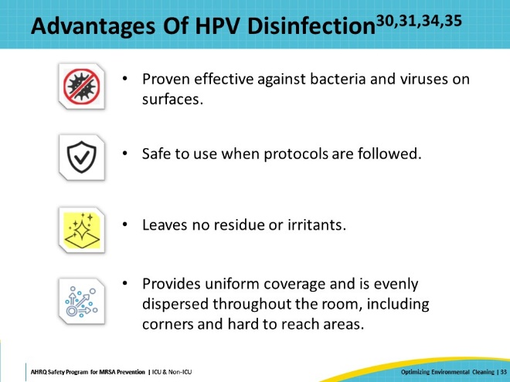
Disadvantages Of HPV  SAY:  HPV, however, has disadvantages that include requiring specialized training for setup and use.  Additionally, the process necessitates that the room be fully vacated and sealed with the doors taped and ventilation shut off.  HPV cleaning and disinfection requires two to five hours without interruption and relies on coordination between patient admissions as no one can be in the room during use.  There are also maintenance issues, storage considerations, and upfront and ongoing associated costs to be aware of.  Finally, it is difficult to evaluate the impact of HPV alone. If a unit sees no immediate reduction in the rates of HAIs, does that mean the HPV has had no effect or that other aspects of the environmental cleaning process need to be addressed? If a reduction does occur, how much of that is attributable to the use of HPV? | Slide 34  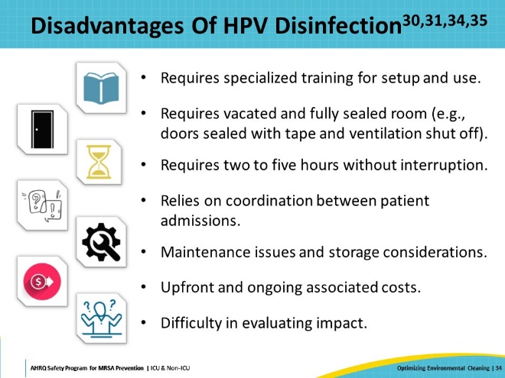
Comparison Of No-Touch Technologies  SAY:  When comparing the two main types of no-touch technologies, both UV-C and HPV have been shown to be effective at reducing microbial burden. Both represent substantial capital costs, up front and in ongoing maintenance.  Both technologies require pre-cleaning to be effective. It’s important to note these are adjunct cleaning methods only and should not replace standard cleaning and disinfection. For one thing, neither method will remove visible dust or stains, which will upset patients. Additionally, rooms must be empty when either of these technologies are in use, which limits their use to terminal or discharge cleaning only.  UV-C is quicker to use, generally requiring minutes, while HPV will require hours. HPV requires rooms and vents to be sealed to function effectively, which UV-C does not. However, UV-C is limited by line of sight, whereas HPV is effective throughout the room regardless of sight-view.  The precise impact of both UV-C and HPV technologies is still not fully understood. Although these methods effectively kill bacteria on surfaces, whether there is a direct link between this action and reductions in MDRO rates remains unclear. Presently, there is a shortage of large-scale studies with high-quality data. It is possible that with thorough monitoring of cleaning practices—ensuring the sporicidal agent reaches high-touch surfaces—there may be no need for adjunct no-touch technologies. | Slide 35  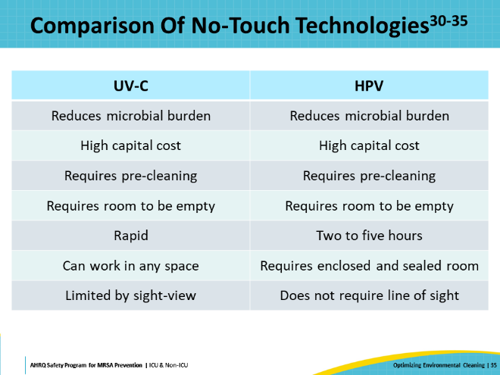
Case Example: An Uptick in C. difficile Rates in the Department of Medicine  SAY:  Now, the presentation will transition to a case example to review and apply the material through a study of a hospital with an uptick in C. difficile rates in the Department of Medicine. | Slide 36  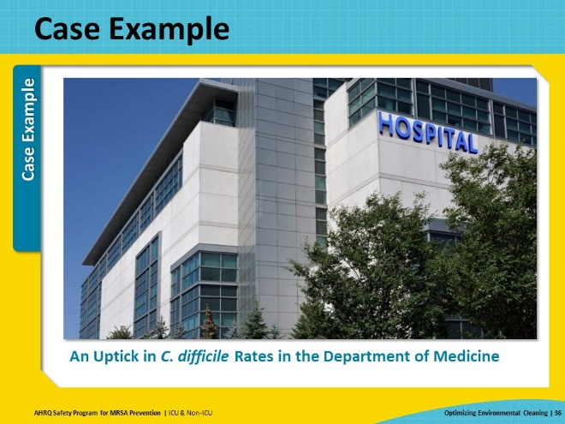
Using The Learning From Defects Tool  SAY:  This case example will use the AHRQ Learning From Defects Tool to investigate the issue.  This CUSP tool assists teams in problem-solving and defect identification. A defect is defined as anything that you do not want to have happen again.  The tool facilitates a guided process based on four key questions:  - What happened?  - Why did it happen?  - How do we reduce the likelihood of this defect from happening again?  - How do we know the risk is reduced?  Following these questions allows the CUSP team to delve deeper into the issue and places the team in the perspectives of those involved. When using the Learning From Defects Tool, it is important to ask questions, walk through, and understand the process with as much detail as possible without judgment or blame. | Slide 37  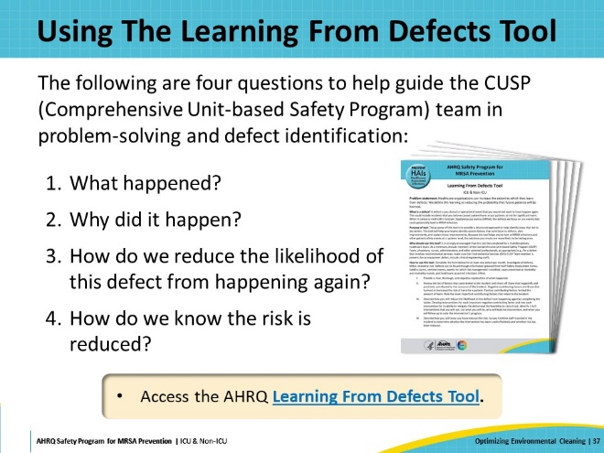
Case Example: What Happened?  SAY:  The first section of the Learning From Defects Tool tasks the team to reconstruct the timeline of events and to provide an explanation of what occurred.  The CUSP team reviewed the HAI infection data and the processes for routine cleaning of patient rooms. They noted an increase in C. difficile rates, with most cases occurring in rooms previously occupied by patients with C. difficile infections.  Further investigation revealed a change in cleaning agents recently occurred.  Additionally, reports from environmental services (EVS) and hospital staff indicated complaints about the smell of the product, with some experiencing difficulty breathing and eye irritation. | Slide 38  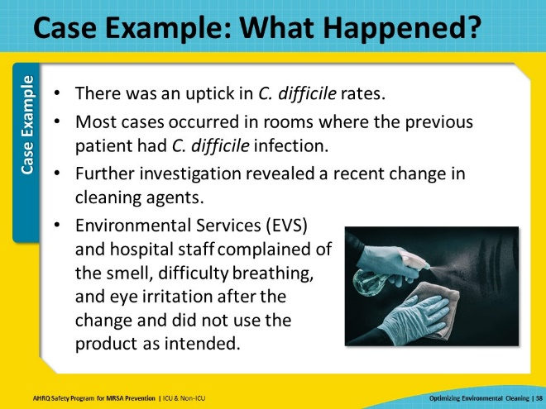
Case Example: Why Did It Happen?  SAY:  Next in the Learning From Defects process is to determine why the issue occurred and to examine the systemic factors that contributed to the event. These may include latent factors or production pressures.  Upon investigation, the team learned that over a year ago, there was a transition from non-sporicidal quaternary ammonia products to sporicidal agents. In the last few months, however, there was an issue with the supplier and the availability of the usual cleaning products.  Consequently, a new sporicidal agent was obtained and distributed. The staff were not informed of the reason for the switch to the new product, nor were they provided instructions for use. Staff were not notified of the need to consider wearing a mask during use or about the strong odor of the product that would dissipate over time. | Slide 39  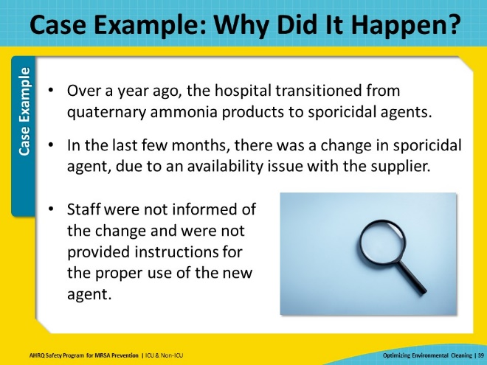
Case Example: Identify Contributing Factors  SAY:  The next step in the Learning From Defects tool is to create a list of negative and positive factors that contributed to the harm.  In this case, the CUSP team identified a lack of training about the new products and a lack of knowledge of the strong odor and potential irritations when staff used the products.  Factors that limited the impact of the harm included an established CUSP team and an established partnership between the Infection Prevention and Control (IPC) and EVS teams. | Slide 40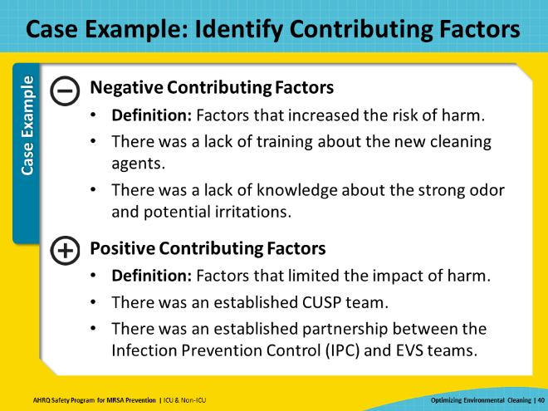
Case Example: How Do We Reduce the Likelihood of the Defect From Happening Again?  SAY:  Using the strengths of the established CUSP team and the collaboration with the IPC and EVS teams, the group identified and implemented an educational intervention regarding the new product.  They realized they needed to develop talking points for staff to explain the rationale behind the product change. This encompassed information on the odor of the new product and the importance of wearing masks during its use.  The training initiative was made accessible to all impacted by the introduction of the new agent. | Slide 41  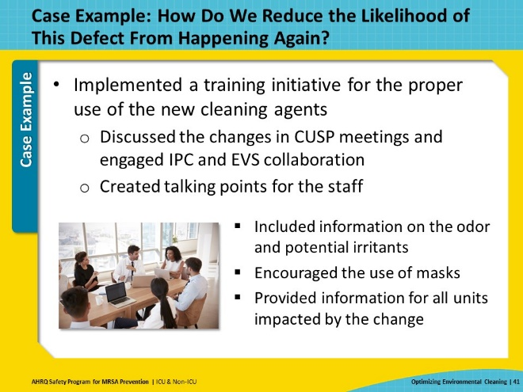
Case Example: How Do We Know the Risk Is Reduced?  SAY:  Finally, the final step of the Learning From Defects Tool involves gathering feedback from frontline staff to determine whether the intervention reduced the risk of further harm.  The CUSP team in this case example obtained staff feedback, with emphasis on the following points:  - Rate the effectiveness of the intervention.  - How has it changed the workflow?  - What impact did it have on the identified problems?  - What impact did it have on the infection rates?  The CUSP team implemented the additional training and the feedback from the staff was positive.  In summary, using the Learning From Defects tool is one way to effectively investigate a defect and implement change. | Slide 42  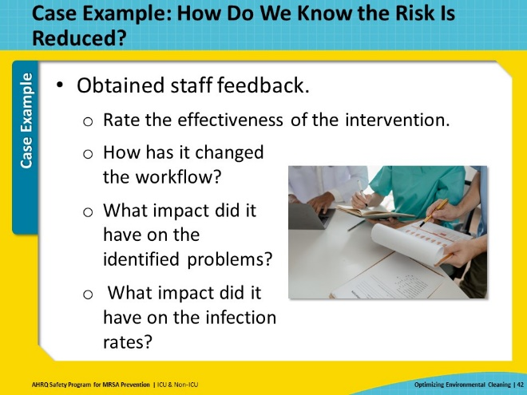
Analyze And Disseminate Data  SAY:  When implementing an environmental cleaning program, remember to analyze the data collected and share the results widely with all levels of the organization.  It is important to inform and engage stakeholders about the performance of the program to drive improvement efforts and accountability. | Slide 43  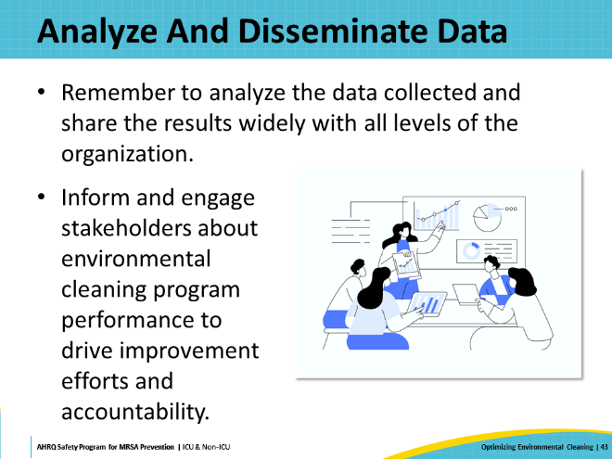
Celebrate Successes  SAY:  Establishing an effective environmental cleaning program takes a lot of hard work and effort and requires input from all leadership levels.  Remember to acknowledge and celebrate successes each step of the way! | Slide 44  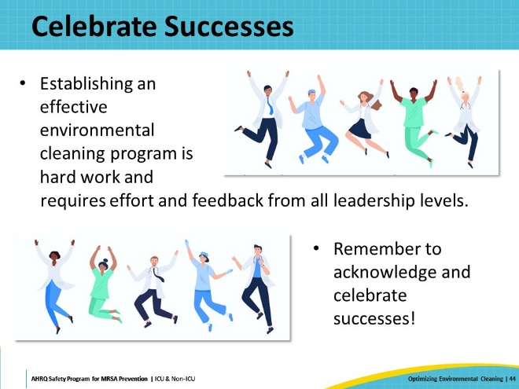
Key Takeaways  SAY:  The bottom line is that there is no quick fix when reducing environmental contamination and mitigating MRSA and other MDRO transmissions in healthcare settings.  This presentation discussed strategies for monitoring environmental cleaning quality, including observation, culturing, fluorescent gel monitoring, and ATP systems.  Many factors are involved in the selection of disinfection products—sporicidal or non-sporicidal, ease of use, cost, and surface type.  Consider adjunct cleaning methods such as UV-C and HPV. While effective at eliminating pathogens on surfaces, additional studies are needed to determine their precise impact.  Don’t forget, share the results from your work with stakeholders at all levels. It helps maintain focus on the changes you have made to keep your unit cleaner.  In conclusion, developing and maintaining environmental cleaning programs takes continuous effort from every level of leadership, and it is important to work together to protect patients from preventable pathogens such as MRSA. | Slide 45  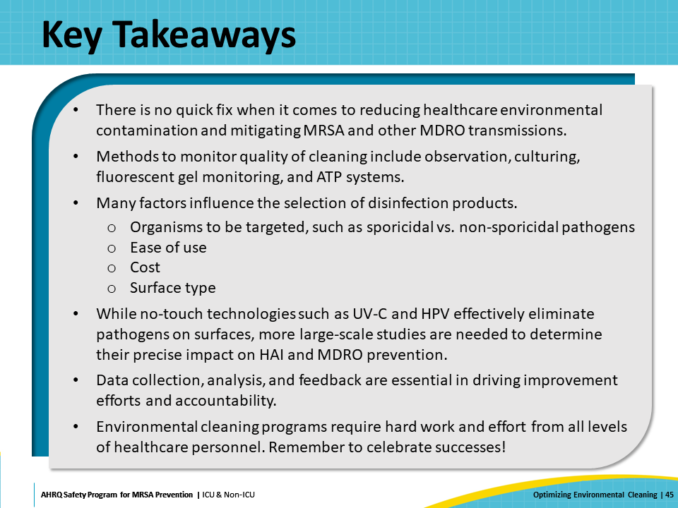
Disclaimer  SAY:  The findings and recommendations in this presentation are those of the authors, who are responsible for its content, and do not necessarily represent the views of AHRQ. No statement in this presentation should be construed as an official position of AHRQ or of the U.S. Department of Health and Human Services.  Any practice described in this presentation must be applied by healthcare practitioners in accordance with professional judgment and standards of care in regard to the unique circumstances that may apply in each situation they encounter. These practices are offered as helpful options for consideration by healthcare practitioners, not as guidelines. | Slide 46  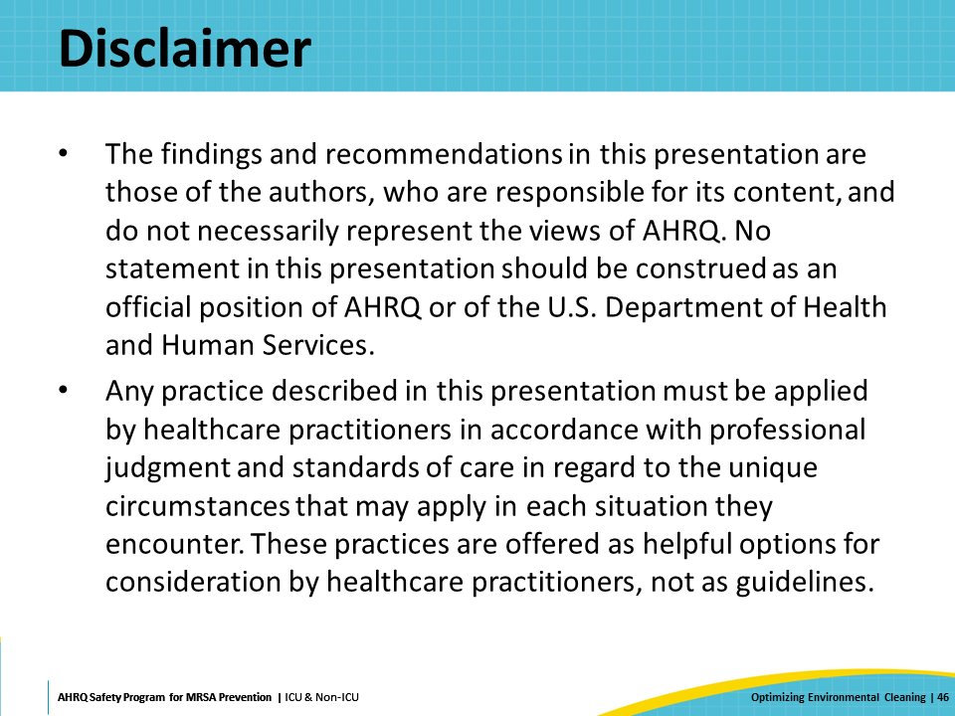
Reference List—1 | Slide 47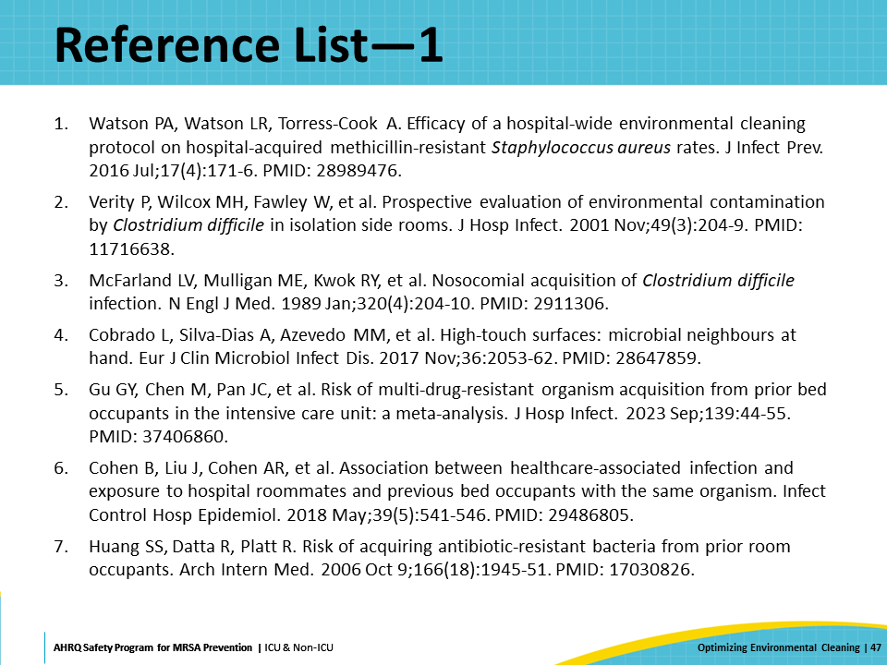
Reference List—2 | Slide 48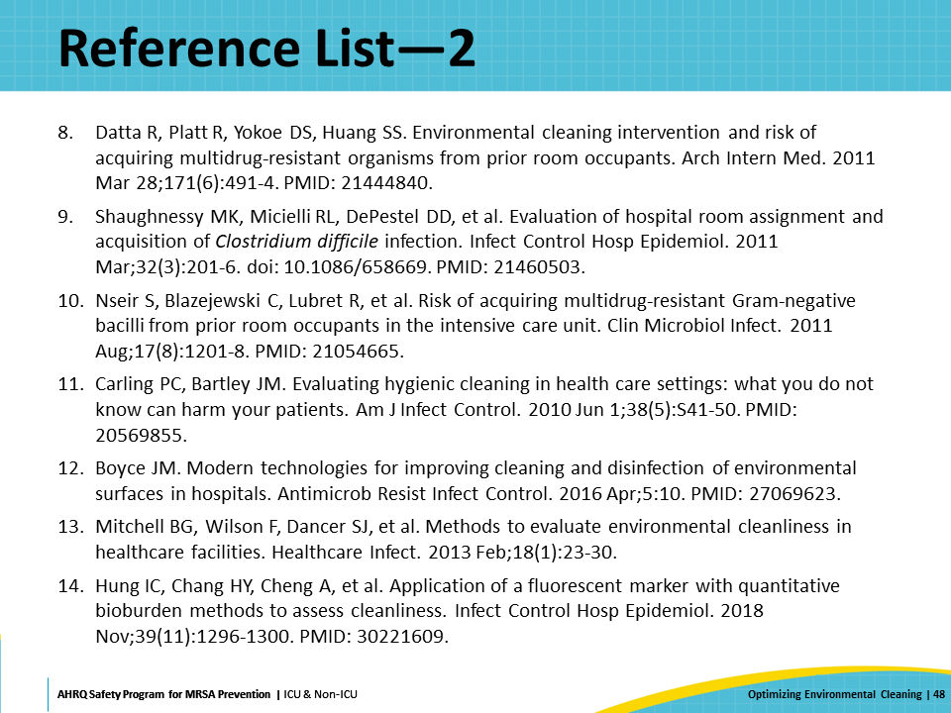
Reference List—3 | Slide 49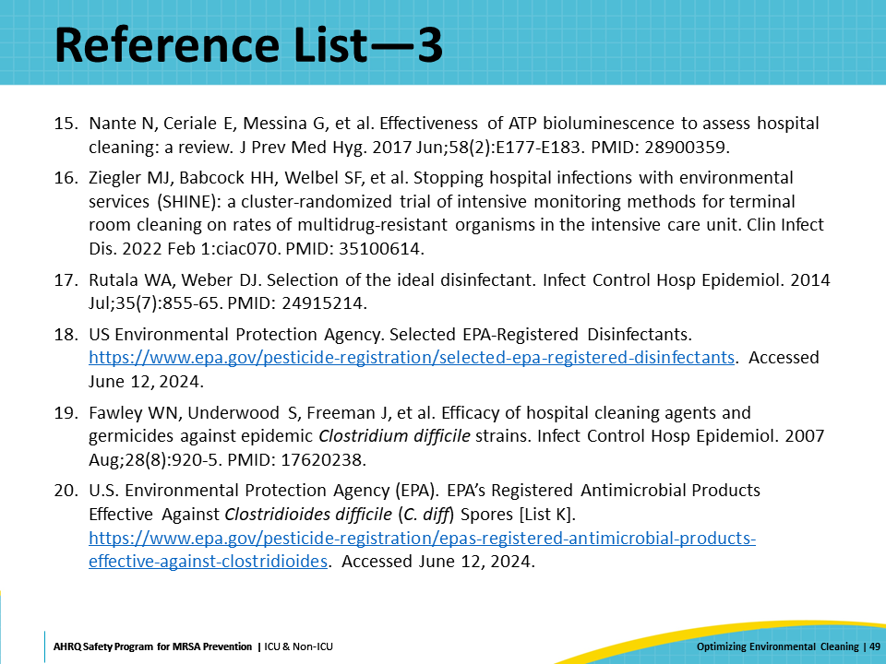
Reference List—4 | Slide 50  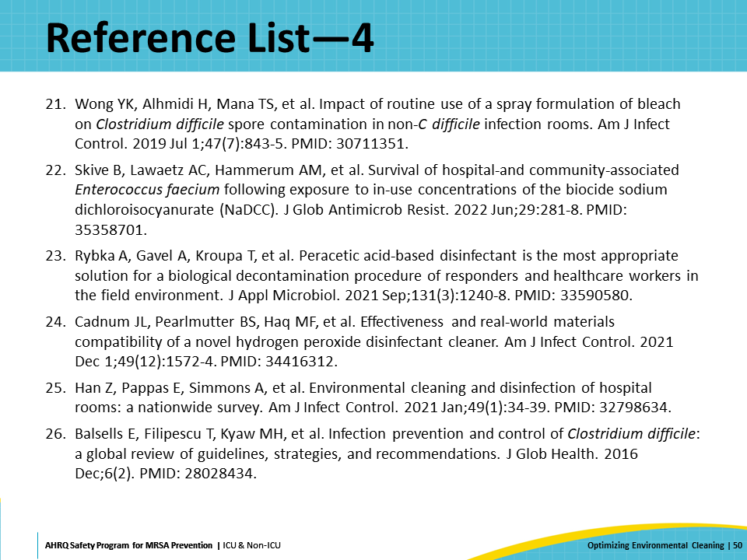
Reference List—5 | Slide 51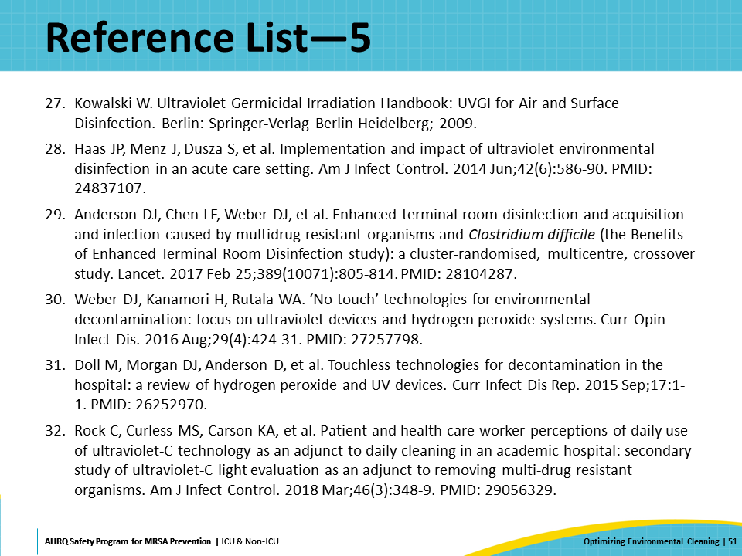
Reference List—6 | Slide 52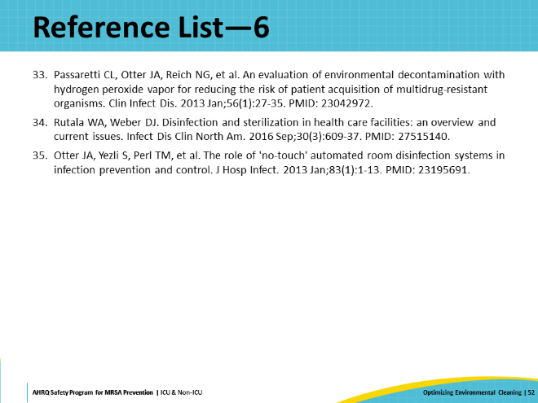

AHRQ Pub. No. 25-0007
October 2024

