In the patient care environment, quality of cleaning is measured by which and what percentage of high-touch surfaces (HTSs) are adequately cleaned and disinfected. Below, the four most common methods of monitoring are discussed, including their pros and cons.

# Observation1-3

* 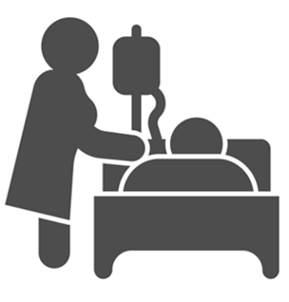A supervisor or trained staff conducts visual inspection of HTSs and observes cleaning practices.

|  |  |
| --- | --- |
| **Advantages** | **Disadvantages** |
| * Quick and easy monitoring method. * Simple to put into practice. * Does not require special skills or training. | * Surfaces may appear clean and free of visible soiling but are still not adequately disinfected. |

# Culturing1-3

* Samples are swabbed from HTs and cultured in a microbiology lab to identify and quantify organisms.

|  |  |
| --- | --- |
| **Advantages** | **Disadvantages** |
| * Helpful in targeting one specific organism of concern. * Can provide a high level of detail. | * Labor intensive and requires lab expertise. * Delayed results; no immediate feedback. * Not standard practice in hospitals; may be done for research or specific outbreak investigations. |

# Fluorescent Gel Monitoring1-4

* HTSs are marked with fluorescent gel, which is invisible to the eye, but glows under ultraviolet (UV) light.
  + After a set interval (usually a day), the surfaces are rechecked with a UV flashlight.
  + 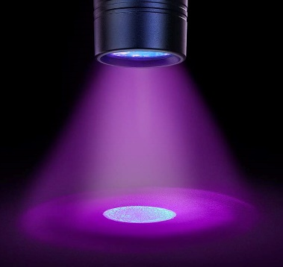If the surface glows, then it has not been adequately cleaned.

Source: Ecolab USA Inc. Images used with permission.

|  |  |
| --- | --- |
| **Advantages** | **Disadvantages** |
| * Supported by evidence.4 * Easy to teach and to use. * Results are intuitive and easy to interpret. * Provides immediate visual feedback. | * Does not identify pathogens. * Requires a subjective yes/no judgment from observer. * More likely to induce Hawthorne effect—the observer’s effect on behavior being assessed. * Cost depends on the product used. |

# ATP (Adenosine Triphosphate) Monitoring System1-3,5-6

* A device measures organic material on HTSs by detecting ATP, an energy molecule found in all organic cells.
  + A specialized swab containing luciferase—a natural enzyme found in fireflies—is used to sample the surface.
    - Luciferase produces bioluminescent light on contact with ATP.
  + The swab is inserted into an ATP meter, which analyzes the sample for light being emitted.
  + By measuring bioluminescence, the meter can estimate the amount of organic matter on the surface.

|  |  |
| --- | --- |
| **Advantages** | **Disadvantages** |
| * Supported by evidence.6 * Provides quantitative data. * Results may be more objective. * Provides immediate feedback. | * Does not identify pathogens. * ATP readings can’t differentiate live and inactivated pathogens. * Results are less intuitive to interpret. * Costly; requires specialized equipment and maintenance |

# References

1. Carling PC, Bartley JM. Evaluating hygienic cleaning in health care settings: what you do not know can harm your patients. Am J Infect Control. 2010 Jun 1;38(5):S41-50. PMID: 20569855.
2. Boyce JM. Modern technologies for improving cleaning and disinfection of environmental surfaces in hospitals. Antimicrob Resist Infect Control. 2016 Apr;5:10. PMID: 27069623.
3. Mitchell BG, Wilson F, Dancer SJ, et al. Methods to evaluate environmental cleanliness in healthcare facilities. Healthcare Infect. 2013 Feb;18(1):23-30.
4. Hung IC, Chang HY, Cheng A, et al. Application of a fluorescent marker with quantitative bioburden methods to assess cleanliness. Infect Control Hosp Epidemiol. 2018 Nov;39(11):1296-1300. PMID: 30221609.
5. Nante N, Ceriale E, Messina G, et al. Effectiveness of ATP bioluminescence to assess hospital cleaning: a review. J Prev Med Hyg. 2017 Jun;58(2):E177-83. PMID: 28900359.
6. Ziegler MJ, Babcock HH, Welbel SF, et al. Stopping Hospital Infections with Environmental Services (SHINE): a cluster-randomized trial of intensive monitoring methods for terminal room cleaning on rates of multidrug-resistant organisms in the intensive care unit. Clin Infect Dis. 2022 Feb 1:ciac070. PMID: 35100614.

AHRQ Pub. No. 25-0007

October 2024