Assessing Environmental Cleaning Effectiveness
ICU & Non-ICU
Slide Title and Commentary | Slide Number and Slide
Assessing Environmental Cleaning Effectiveness  SAY:  Welcome to this presentation on Assessing Environmental Cleaning (EVC) Effectiveness and incorporating effective environmental cleaning practices as part of an overall approach to preventing transmission of methicillin-resistant Staphylococcus aureus (MRSA) and other multidrug-resistant organisms (MDROs) in intensive care unit (ICU) and non-ICU settings. | Slide 1  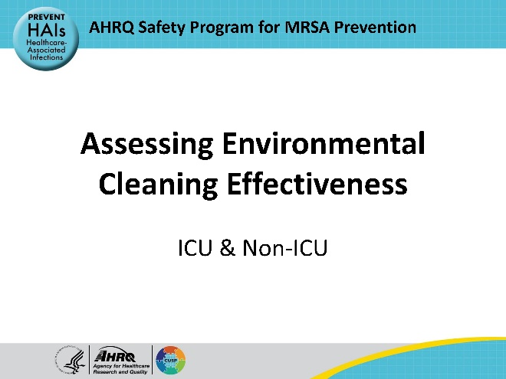
Educational Objectives  SAY:  This presentation will discuss aspects of an effective EVC monitoring program. It will describe strategies and considerations of quality of cleaning monitoring methods, focusing on fluorescent gel (FG) monitoring systems. It will then discuss essential steps when implementing an EVC monitoring program. The presentation will additionally explore roles best suited to conduct EVC monitoring as well as review methods for effective data feedback to drive improvement efforts and accountability of an EVC monitoring program. | Slide 2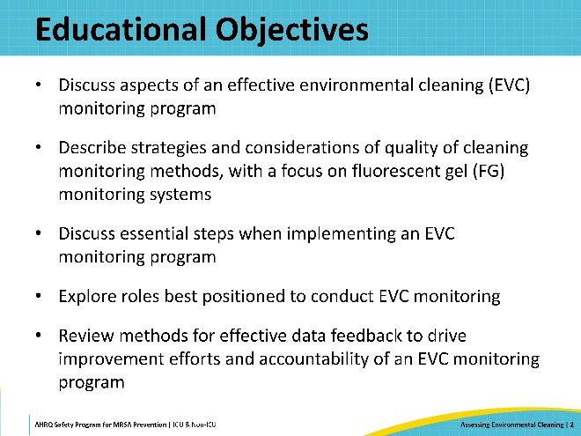
Key Strategies To Take Aim and Target MRSA Infections  SAY:  The AHRQ Toolkit for MRSA Prevention in the ICU and non-ICU focuses on four key strategies to prevent MRSA. The key strategies are the following:  - Decolonizing patients  - Decontaminating the healthcare environment  - Preventing person-based transmission  - Preventing device and procedure-associated infections such as central line-associated bloodstream infections and surgical site infections  This presentation on assessing EVC is part of the second strategy, decontaminating the healthcare environment. | Slide 3  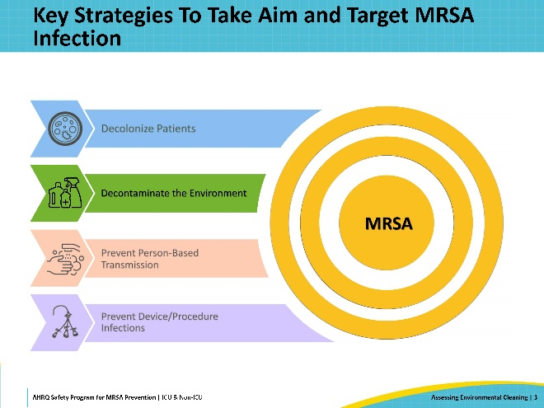
EVC Monitoring Program  SAY:  The first section of the presentation will delve into essential aspects of an effective EVC monitoring program. | Slide 4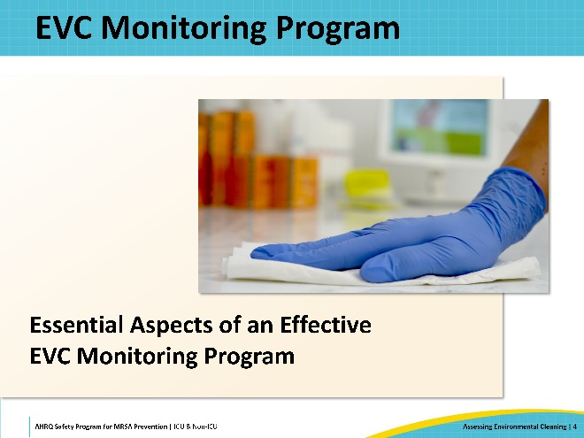
Cornerstone of EVC Improvement  SAY:  The cornerstone of EVC improvement is effective performance assessment and constructive feedback in a non-blame, empowering culture.  An EVC monitoring program requires a strong and collaborative team effort based on trust, where everyone works towards the same patient safety goals in a respectful and inclusive manner.  Key members of the team include EVC associates, supervisors, and other members of the EVC team, as well as nursing staff, providers, patient safety personnel, and other Comprehensive Unit-based Safety Program (CUSP) team members.  It is important not to overlook the critical role of the EVC team and associates to help control the spread of MDROs and reduce healthcare-associated infections. Multidisciplinary teamwork and collaboration are key to prevent infection and the spread of pathogens in the healthcare environment. | Slide 5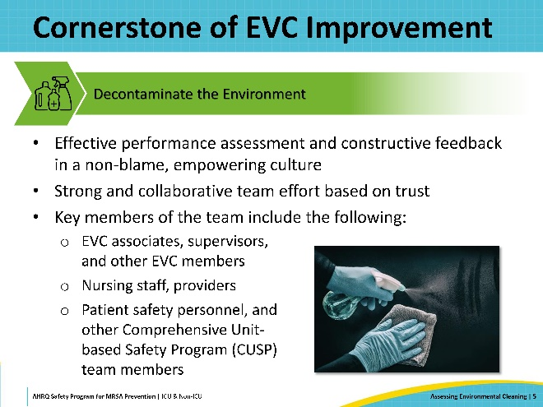
Points To Consider for an Effective EVC Monitoring Program  SAY:  In order to improve outcomes in any task, it is important to understand the current process and how effectively it is being carried out. This same approach is required to improve the cleaning process in the healthcare environment—starting with bringing the team and stakeholders together to discuss the process of evaluating EVC.  To begin the collaborative process of an effective EVC monitoring program, establish a clear purpose along with clear expectations and goals. This information should be shared with all stakeholders in the program, including individual EVC associates, as well as those at the unit and departmental levels. It is crucial that this is implemented in a supportive environment, so that feedback can be given in a fair and just manner and the system is set up in a way that optimizes available tools, education, and supervisory support.  A clear layout of data feedback is important. This can involve many stakeholders, such as individual EVC associates, CUSP or other quality improvement teams, unit leadership, hospital leadership, infection control committees, and hospital executive committees. | Slide 6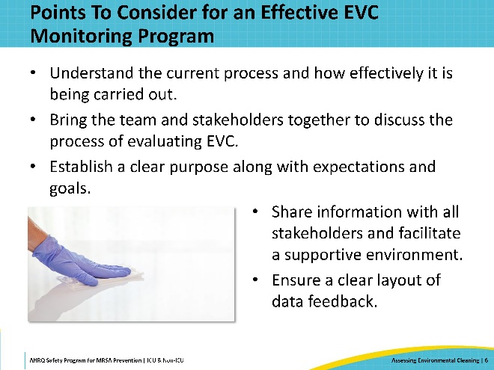
Fluorescent Gel Monitoring Systems  SAY:  After going over aspects of an effective EVC monitoring program, this next section will cover strategies and considerations of fluorescent gel monitoring systems. | Slide 7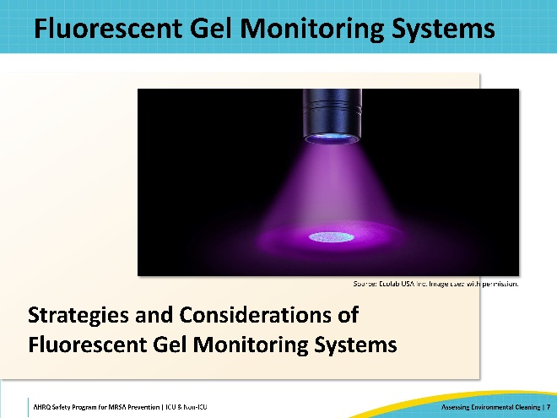
Fluorescent Gel Monitoring  SAY:  This part of the presentation focuses on FG monitoring systems, which are generally easier to use and implement, especially for those who have not yet started an EVC monitoring program. More information on methods to monitor quality of cleaning— including observation, culturing, FG monitoring, and adenosine triphosphate (ATP) systems—can be found in the Environmental Cleaning page of the Toolkit website.  To review, FG monitoring involves applying FG, which is invisible to the naked eye, but glows under ultraviolet (UV) light. A marker is used to apply FG on high-touch surfaces (HTSs) in the patient environment, such as bed rails, intravenous (IV) poles, and overbed tables. After a set interval of time—typically a day—the evaluator returns to the patient environment and re-examines the surfaces with an UV light.  If no FG is visible, the interpretation is that the surfaces have been adequately cleaned. If FG is still visible, it can be assumed that those surfaces have not been adequately wiped in the interval between when the gel was applied and when it is being assessed. | Slide 8  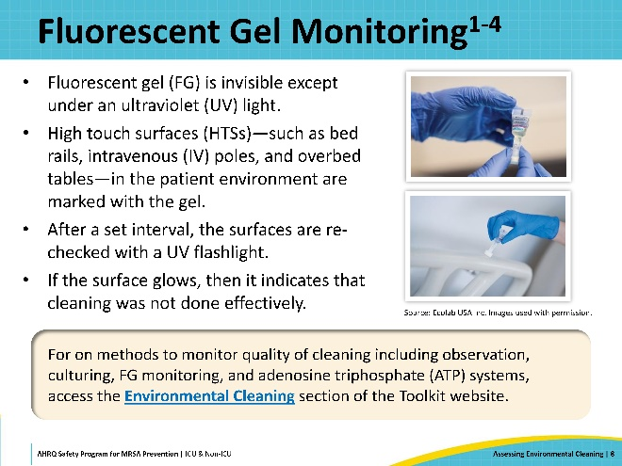
Questions To Ask When Implementing FG Monitoring  SAY:  Key questions to ask when implementing FG monitoring include the following:  - Which FG product should be used?  - How many rooms and HTSs should be checked?  - How should they be selected?  - Who should take on the task of EVC monitoring?  This section will focus on the first three questions and the final question will be addressed later in the presentation. | Slide 9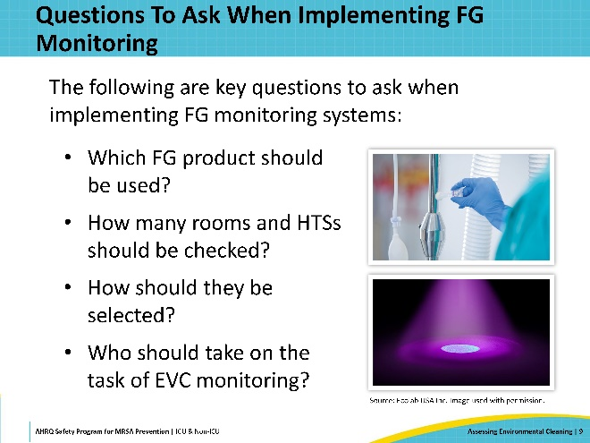
Which FG Product Should Be Used?  SAY:  There are a variety of FG compositions and application methods available (e.g., gel, paint, and pen markers). In 2019, Rock et al examined the impact of different FG markers (FGMs).  The study evaluated two different FGMs: a purpose-made metered applicator for FG and a generic cotton swab dipped in FG lotion. Many other FGMs were excluded because there were clearly visible to the naked eye or because they were not removed despite expected best cleaning.  In the first phase of the study, 787 HTSs across 38 randomly selected patient rooms in nine different units were studied over a 2-day period at an academic hospital. Each HTS was divided into halves, with a different FGM used on each half.  In a second phase of the study, eight trained “markers” applied the two products on an HTS of an unoccupied patient room used for training and simulations, which was later wiped to mimic real-world cleaning. The study assessed the diameter of the FGM dots, the visibility of the FGM to the naked eye, and the ease of FGM removal. | Slide 10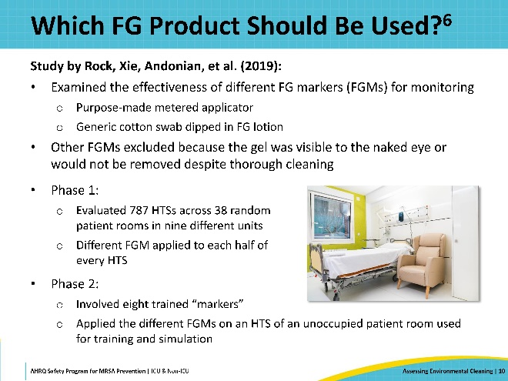
Evaluation of Different FGMs  SAY:  Based on the results of the first phase of the study, the removal rates were 60.5 percent, or 476 of 787 HTSs, for the metered applicator and 64.3 percent, or 506 of 787 HTSs, for the cotton swab dipped in FG lotion.  In the second phase of the study, the researchers observed larger variability in the FG dot sizes with the cotton swab even after training in methodology.  Also, the cotton swab was more visible to the naked eye and consequently, more preferentially removed. This suggests that the cotton swab may not be an optimal choice due to lack of standardization and reproducibility.  The metered applicator was more adhesive to the HTSs when compared to the cotton swab, with 83 percent and 50 percent of not removed, respectively. Since manual pressure is needed to remove more biofilm from dry surfaces in the patient environment, a less easy-to-remove FGM is preferred, which favors the metered applicator.  In terms of cost, the metered applicator is more expensive than the cotton swab product. | Slide 11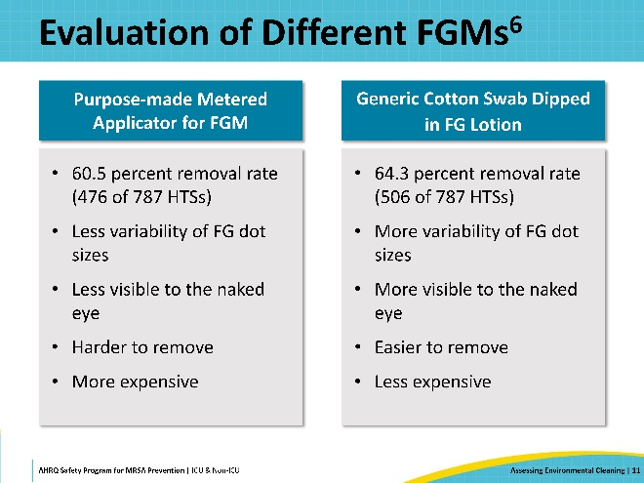
How Many Rooms and HTSs Should Be Checked? How Should They Be Selected?  SAY:  When implementing an effective FG monitoring system, it is important to consider how many rooms and HTSs should be selected and how they should be selected to give the best overall representation of the cleaning.  However, the time and resources needed to implement this system is often perceived as a barrier. This perception may limit uptake in hospitals across the country.  A 2019 study compared FGM sampling strategies, in order to determine the least number of HTSs and rooms that needed to be marked with FG to accurately predict FG removal rates of rooms and unit.  This study was conducted in an academic hospital with 2,942 HTSs in 228 randomly selected rooms on 13 units. | Slide 12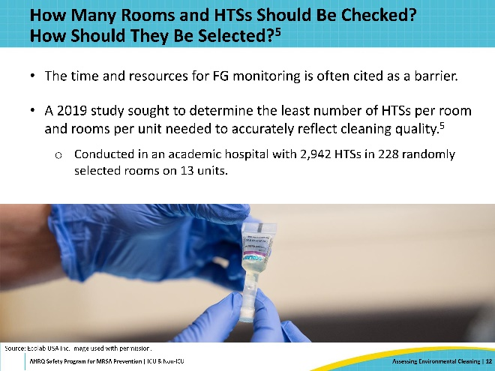
FG Monitoring Strategies  SAY:  The study involved six different sampling strategies to evaluate the least number of HTSs needed per room: one, two, three, four, or five random HTSs per room, or one random HTS in the main room with one HTS in the bathroom.  The optimal sampling strategy involved the least number of HTSs for which all samples had less than or equal to 10 percent sampling error frequency.  Rooms were stratified into high (i.e., greater than or equal to 80 percent) FG removal rate and low (i.e., less than 80 percent FG removal rate) as well as discharge and daily cleaning, and the researchers applied the same aforementioned approach as to sample rooms on a unit. | Slide 13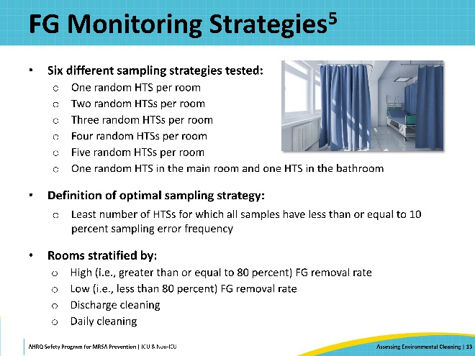
Optimal Number of Rooms and HTSs for FG Monitoring  SAY:  Using a statistical method that uses random sampling with replacement, the researchers demonstrated that randomly selecting three HTS in two rooms per unit every 2 weeks optimally predicted the overall removal rate on that unit. The study estimated that employing the strategy on five units would require 5 hours per month.  This indicates that FG monitoring is actually less resource intensive than many infection control programs may have anticipated. | Slide 14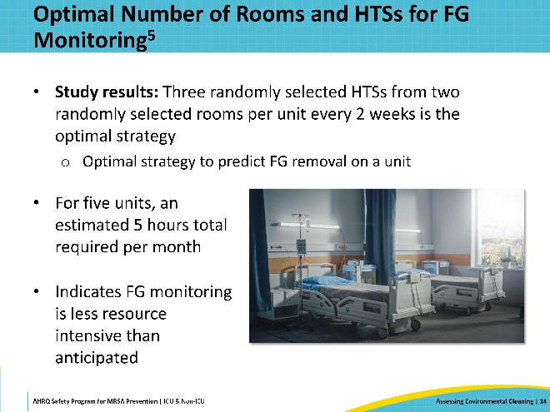
EVC Monitoring  SAY:  After reviewing strategies and considerations of FG monitoring systems, this next section will discuss essential steps when implementing an EVC monitoring program. | Slide 15  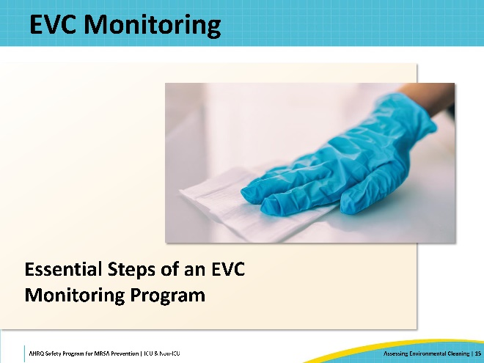
Evaluating EVC  SAY:  There are five steps for starting or improving an existing EVC monitoring program.  - Step 1: Randomize rooms and HTSs.  - Step 2: Place FG.  - Step 3: Clean patient rooms.  - Step 4: Check for FG with UV light.  - Step 5: Share data feedback.  While the focus of this presentation is on FG monitoring systems, which are generally easier to use and implement, the last step is applicable to all quality of cleaning monitoring methods that additionally include observation, culturing, and ATP systems. More information on EVC, including methods to monitor quality of cleaning, can be found in the Environmental Cleaning page of the Toolkit website. | Slide 16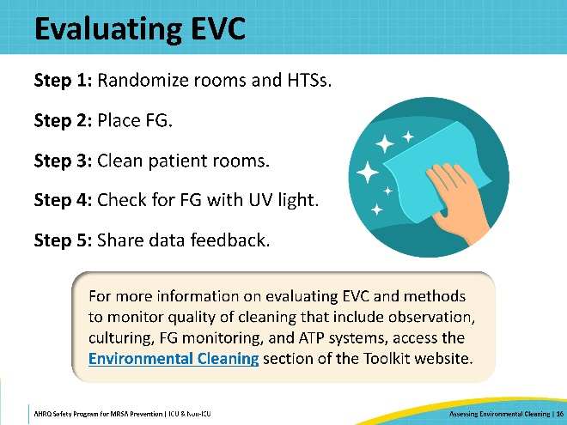
The Monitoring Process  SAY:  Before starting an appraisal of the cleaning process on a unit, rooms and HTSs must be randomized.  The following tools can help with the data collection and randomization process, which will also be discussed in more detail later in this presentation:  - Evaluating Environmental Cleaning With Fluorescent Gel: Data Collection Instructions and Form  - How To Randomly Order Lists of Rooms and High-Touch Surfaces Tool | Slide 17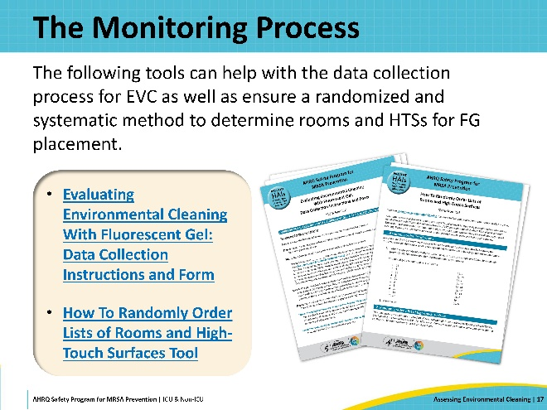
Step 1: Randomize Rooms and HTSs  SAY:  Usually, evaluating two rooms of a unit and three HTSs within those rooms is sufficient for tracking cleaning progress. If the unit is performing poorly, there may be some benefit in increasing the number of rooms or HTSs and the frequency of evaluations.  To assess day-to-day cleaning and minimize process changes that might occur if an EVC associate knows a particular room is being monitored with FG, work with the EVC team to set up random and blinded monitoring. | Slide 18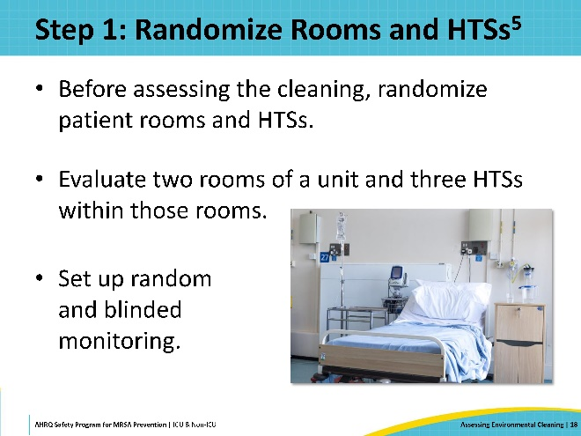
Step 2: Place FG  SAY:  Next, place the FG on the HSTs in the patient rooms that were selected using the data collection and randomization processes from the previous step.  Apply an approximately 2-centimeter FG dot on the selected HTS. | Slide 19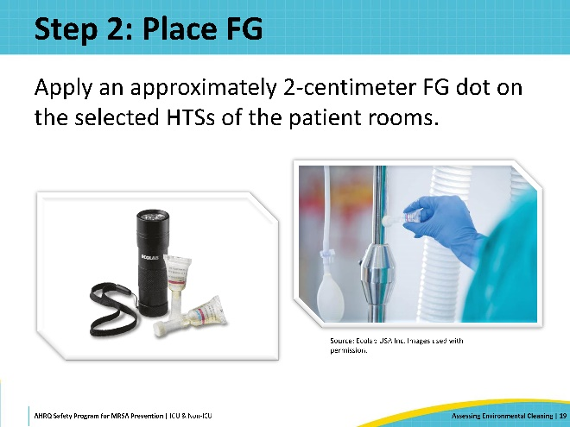
Step 3: Clean Patient Rooms  SAY:  The EVC associate then cleans the patient rooms during their normal cleaning routine of the day. During the cleaning of HTSs, FG dots can be easily wiped away but will remain on uncleaned surfaces. | Slide 20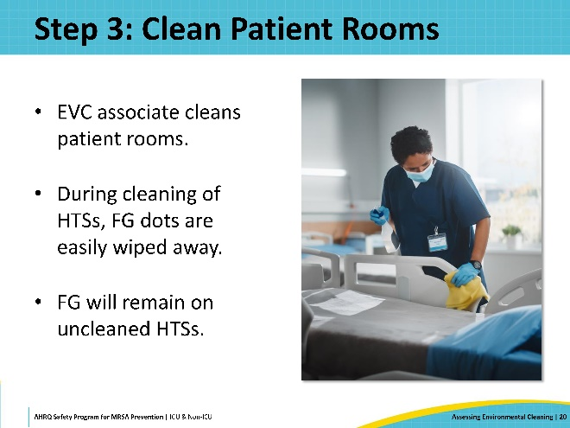
Step 4: Check for FG With UV Light  SAY:  The HTSs are checked approximately a day later using a UV flashlight. If the fluorescent gel is not visible or is smeared under the UV flashlight, the surface is considered clean. If the fluorescent gel dot is still visible under the UV flashlight, the surface is deemed not adequately cleaned. | Slide 21  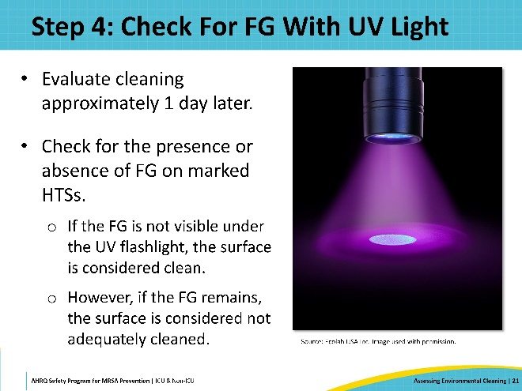
Step 5: Share Data Feedback  SAY:  Sharing findings is key to making improvements. This can be done by sharing findings in real time with the EVC associate, either with or without their EVC supervisor present depending on how the program was designed. For HTSs where FG remains, identify and explore barriers to cleaning. Sharing these findings, including barriers, more broadly with EVC leadership and hospital committees is key to driving improvement. | Slide 22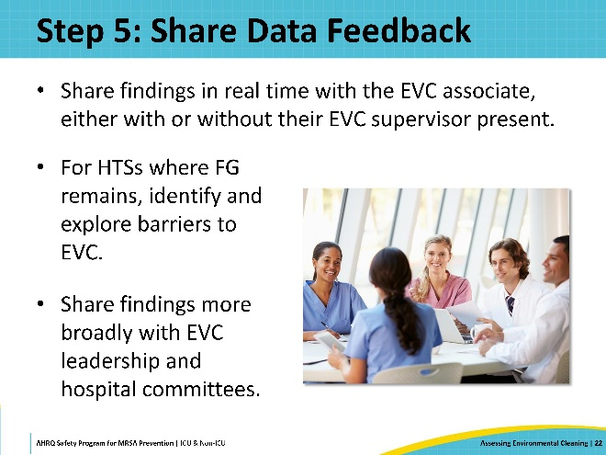
Task of EVC Monitoring?  SAY:  After reviewing essential aspects, strategies, and considerations, and steps associated with implementing an EVC monitoring program, this next section explores who is best positioned to perform the task of EVC monitoring. | Slide 23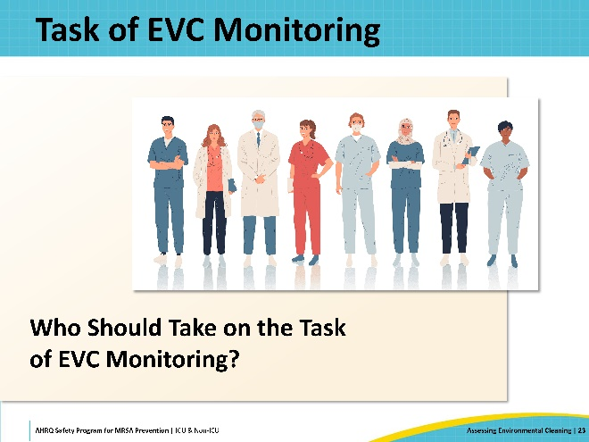
Infection Control Practitioner (ICP)  SAY:  The obvious first role to consider is the infection control practitioner (ICP). There are many advantages of having this person perform the role: they are objective, have a vested interest in obtaining accurate results, understand the importance of the task, and are experienced with giving constructive feedback.  However, this may be resource intensive, as ICPs have many other tasks and commitments. | Slide 24  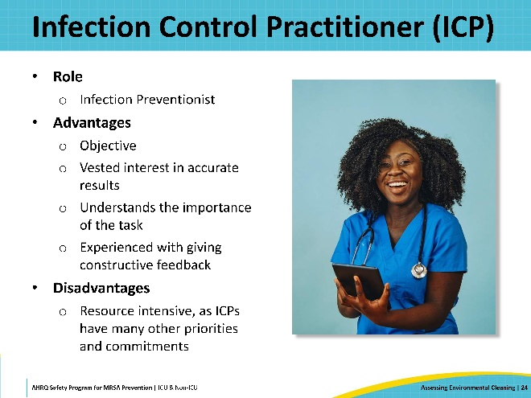
Unit Nurse  SAY:  What about the unit nurse? Advantages include strengthening EVC and Nursing collaborations, helping to delineate EVC and Nursing cleaning responsibilities, facilitating data discussion at unit quality improvement meetings, and incorporating the potential to monitor EVC at all shifts.  Disadvantages include the need to ensure feedback is constructive, the competing nursing priorities, and the need to train nurses on each unit. | Slide 25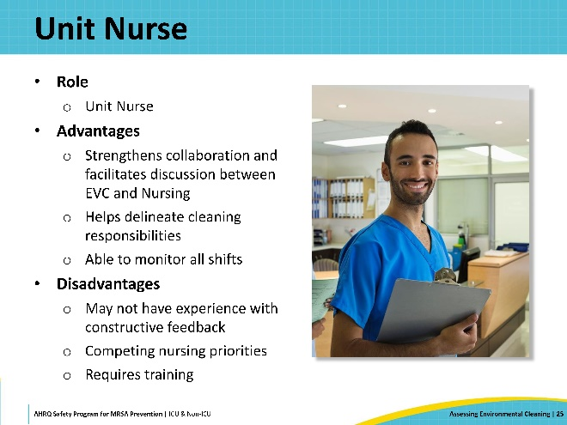
EVC Supervisor  SAY:  Another role to consider is that of the EVC supervisor. Advantages here include that the EVC associate is accountable to their supervisor and that the feedback from associate to supervisor may help identify systemic problems that can be addressed.  Disadvantages include a potential lack of objectivity, as the EVC supervisor is inherently also accountable for the data. It is also important to consider how you can ensure that data are consistently communicated and shared outside the EVC team. | Slide 26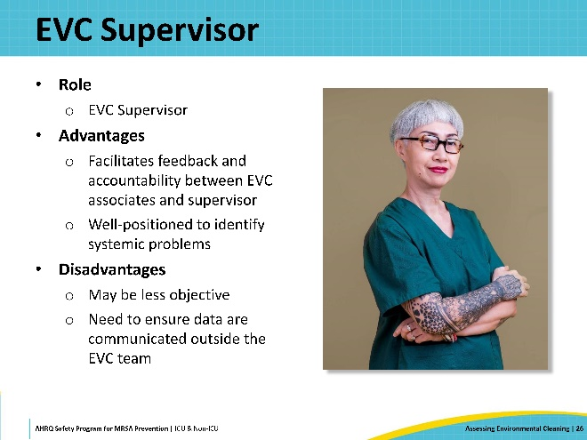
EVC Associate  SAY:  If EVC associates take ownership of the monitoring task themselves, it could empower them to drive performance improvements. Furthermore, the EVC associate can identify problems that may lead to improved processes and all shifts can be monitored.  Potential disadvantages include a potential lack of objectivity with self-monitoring, and if done by different EVC associates, peer-to-peer monitoring and feedback are known to be challenging to conduct as well as give and receive. | Slide 27  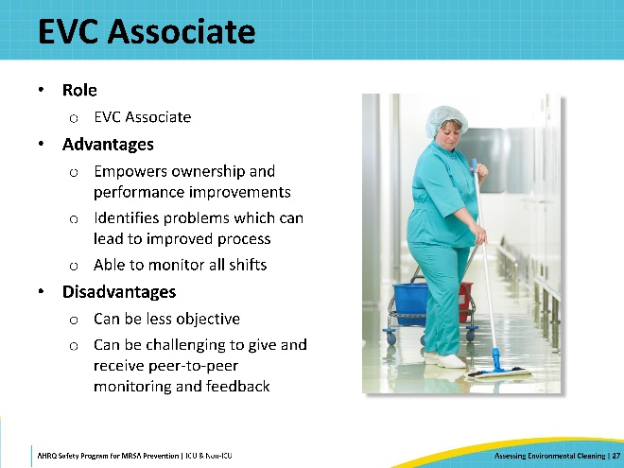
“Secret Shopper”  SAY:  The “secret shopper” concept is commonly used with hand hygiene monitoring. It involves using an observer who is unknown to the unit or team being assessed. Typically, these tasks may be performed by a redeployed healthcare worker who is generally not known in the area they are assessing.  Advantages of this include reducing the risk of the Hawthorne effect, or the effect of subjects changing their behavior because they know they are being observed. This may lead to inaccurate assessments.  Disadvantages include the need for significant oversight to ensure valid data, frequent turnover of secret shoppers to maintain anonymity, and constant need to train new “secret shoppers.” | Slide 28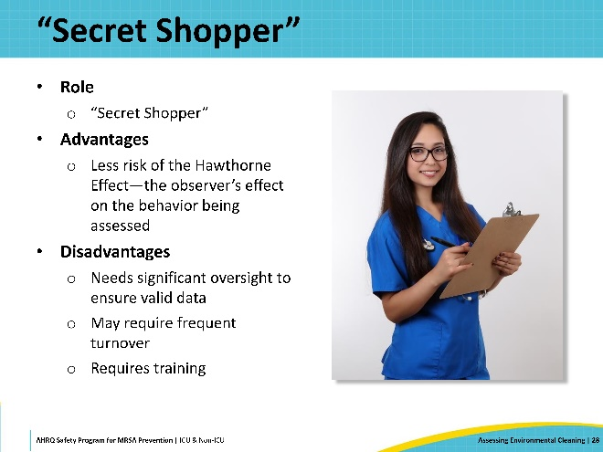
Mixed: Nurse and EVC Associate  SAY:  Finally, there could be a hybrid or mixed role, such as Nurse and EVC associate. Advantages of this hybrid role include clarification regarding cleaning responsibilities between nurses and EVC associates (e.g., who is supposed to clean IV poles), joint accountability, and bidirectional feedback between EVC associates and nurses.  Disadvantages include a potential lack of ownership and the need to ensure constructive and respectful feedback processes. | Slide 29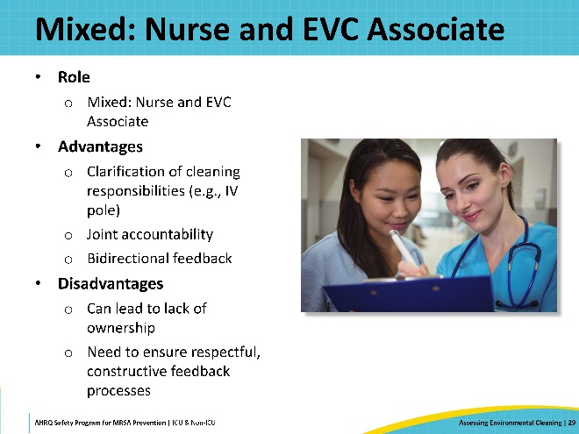
Data Feedback  SAY:  The next section focuses on sharing effective data feedback.  The primary aim is to share feedback in a constructive and collaborative manner. It is important to promote and maintain an environment where everyone is working towards common goals and where everybody’s work and contribution are recognized and celebrated. | Slide 30  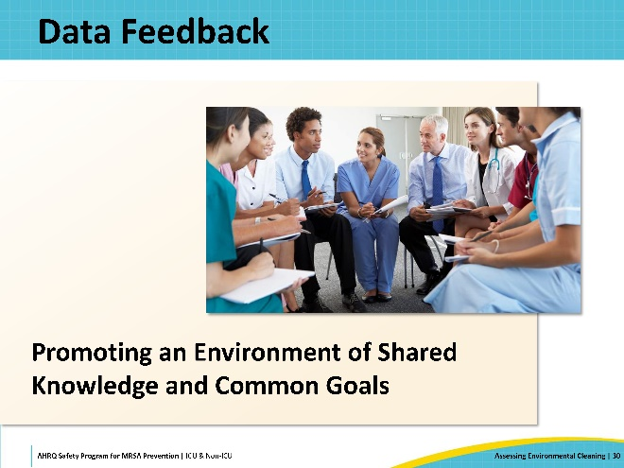
Effective Data Feedback to the EVC Associate  SAY:  EVC associates need immediate feedback. Including them in the process of checking FG dots can be a good learning opportunity.  Make sure to recognize strong performers. Examples of rewards can include:  - Merit uniform t-shirt, meal vouchers, and pizza parties  - Hospital-wide recognition on digital displays and newsletters  - Certificates of appreciation  If needed, establish a supportive improvement plan with retraining, clear milestones, and an accountability plan.  Share aggregate data during EVC morning huddles to help identify and address common barriers to effective cleaning. | Slide 31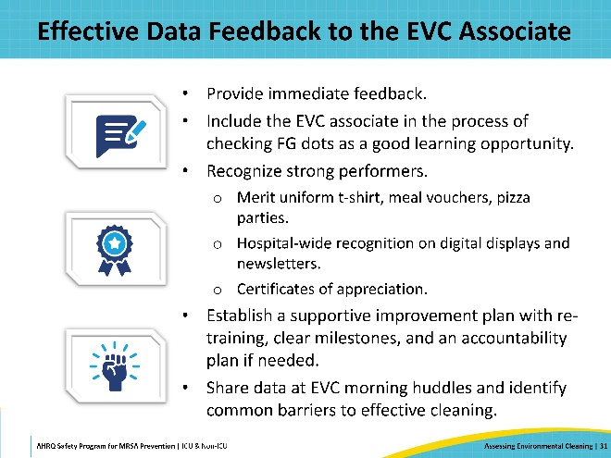
Effective Data Feedback to the EVC Supervisor  SAY:  It is important to present the overall performance data to the EVC supervisor and leadership team. If scores are poor, early heightened awareness and appropriate real-time interventions are needed.  This may be done by sharing the Evaluating Environmental Cleaning With Fluorescent Gel: Data Collection Instructions and Form in real time with EVC leadership. | Slide 32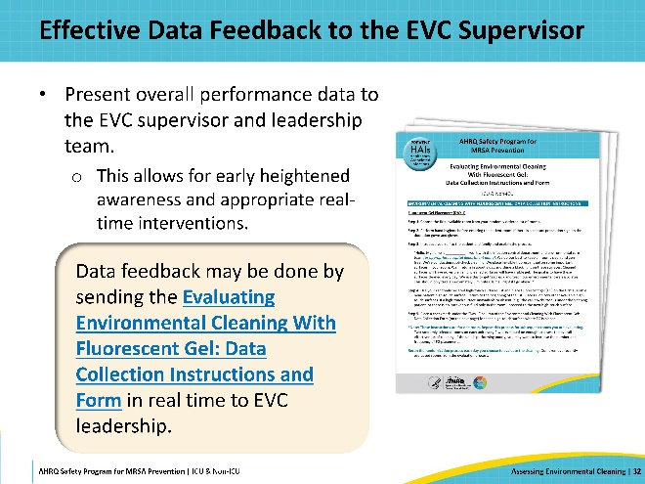
Effective Unit Level Feedback  SAY:  Remember to disseminate the data at unit CUSP and quality improvement meetings and to discuss collaborative performance improvement plans.  EVC associates are important members of the CUSP team, and their attendance is integral to CUSP team meetings. The ICP is often in a position to support the EVC associates at CUSP meetings and to facilitate collaborative and informative discussions to improve processes. | Slide 33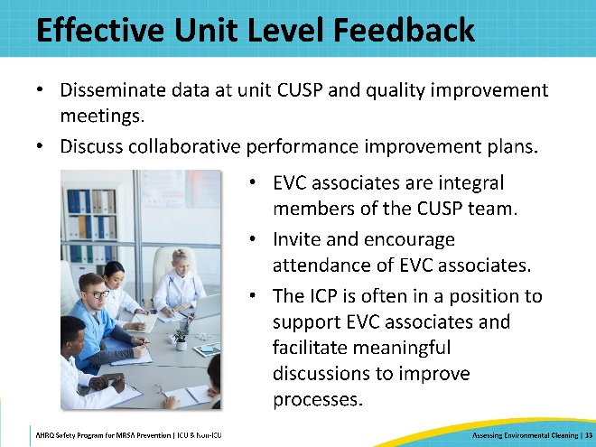
Effective Data Feedback: Hospital-Wide Committees and Executives  SAY:  It is also important to share effective data feedback with hospital-wide committees and executives. Opportunities include sharing data during hospital infection control committee, quality and safety meetings, and executive meetings. | Slide 34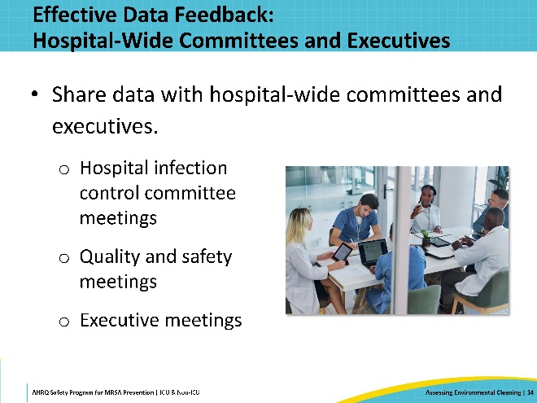
Evaluation and Aggregation of EVC Data  SAY:  One way to demonstrate the evaluation and aggregation of EVC data for a hospital committee or executive meeting is through the use of the template shown on the slide. This template is included in the Evaluating Environmental Cleaning With Fluorescent Gel: Data Collection Instructions and Form.  This sample template is for a large academic hospital with multiple buildings. The data is categorized into All, Daily, and Discharge Cleaning, and presented by month and location. The different colors indicate various performance levels: red for lower rates, yellow for medium rates, and green for high removal rates.  When implementing an environmental cleaning program, remember to analyze the data collected and share the results widely with all levels of the organization.  It is important to inform and engage stakeholders about the performance of the program to drive improvement efforts and accountability. | Slide 35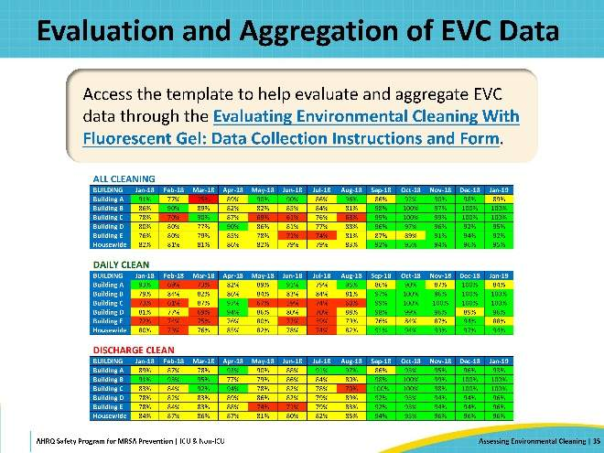
Analyze and Disseminate Data  SAY:  When implementing an environmental cleaning program, remember to analyze the data collected and share the results widely with all levels of the organization.  It is important to inform and engage stakeholders about the performance of the program to drive improvement efforts and accountability. | Slide 36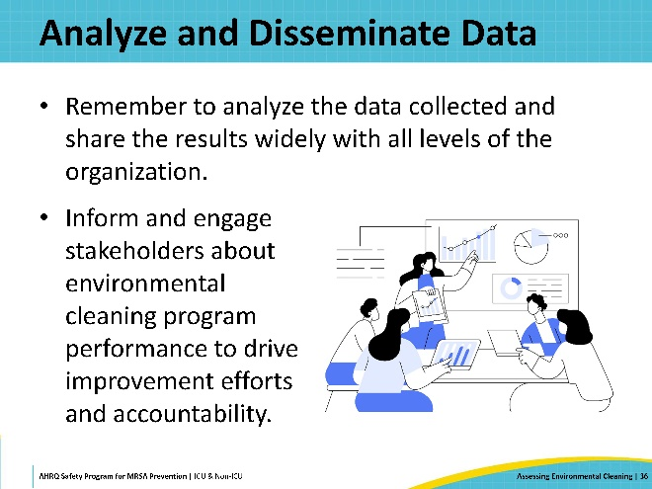
Case Example  SAY:  Now, the presentation will transition to a case example to review and apply the material through a study of a hospital with an uptick in MRSA rates in a surgical inpatient unit. | Slide 37  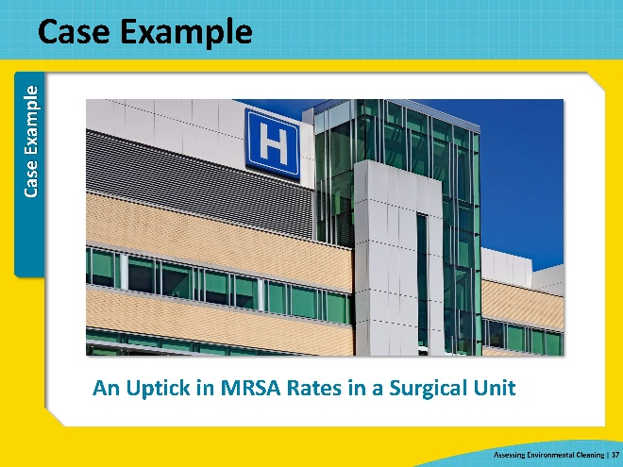
Using the Learning From Defects Tool  SAY:  This case example will use the AHRQ Learning From Defects Tool to investigate the issue.  This CUSP tool assists teams in problem-solving and defect identification. A defect is defined as anything that you do not want to have happen again.  The tool facilitates a guided process based on four key questions:  - What happened?  - Why did it happen?  - How do we reduce the likelihood of this defect from happening again?  - How do we know the risk is reduced?  Following these questions allows the CUSP team to delve deeper into the issue and places the team in the perspectives of those involved. When using the Learning From Defects Tool, it is important to ask questions, walk through, and understand the process with as much detail as possible without judgment or blame. | Slide 38  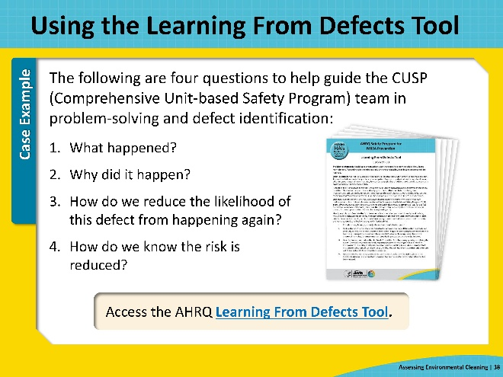
Case Example: What Happened?  SAY:  The first section of the Learning From Defects Tool tasks the team to reconstruct the timeline of events and to provide an explanation of what occurred.  In this case, there was an uptick in healthcare-associated MRSA cases in a surgical inpatient unit.  Using the Learning From Defects tool, the team discovered that in most of the cases, the prior room occupant had MRSA. The Infection Prevention and Control (IPC) team surmised that there were lapses in EVC that contributed to the increased cases, possibly involving the Environmental Services (EVS) personnel.  To investigate further, the IPC team initiated an FG monitoring program in the unit. This was done without telling any of the staff, using “secret shoppers” as observers.  The findings revealed that many of the fluorescent dots remained after patient room cleaning. These data were shared with the CUSP team, infection control committee, and hospital executives – without the knowledge of EVS leadership.  After the data were shared, the hospital leadership requested a performance improvement plan. The EVS team was surprised; they thought they had a collaborative relationship with the IPC team and felt that trust had been broken. | Slide 39  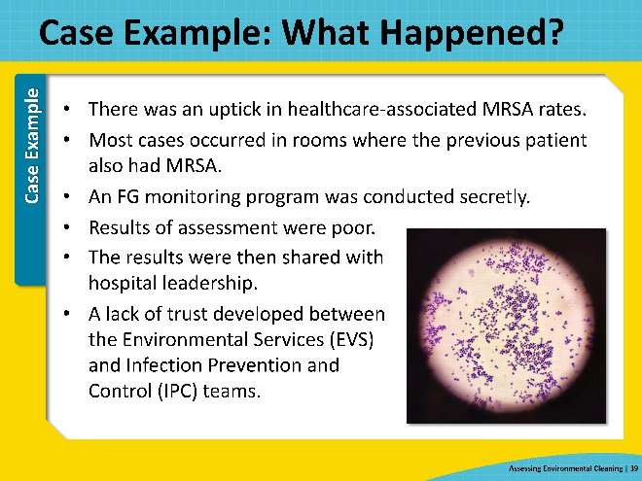
Case Example: Identify Contributing Factors  SAY:  Next in the Learning From Defects process is to determine why the issue occurred and to examine the systemic factors that contributed to the event. These may include latent factors or production pressures.  The team created a list of negative factors – factors that increased the risk of harm – and positive factors – factors that limited the impact of harm.  Negative contributing factors in this case included that assumptions had been made about the reasons why there were increased MRSA cases without verification. Additionally, the FG monitoring program was enacted without the EVS team being aware. The results of the program were also shared widely across the hospital, including with hospital leadership. Consequently, hospital leadership team requested an immediate performance improvement plan. The EVS team felt blindsided and felt that trust was broken between them and the IPC team.  The positive factors in this situation were the strengths of the EVS and IPC teams. However, this was on shaky ground because of EVS’s lack of awareness of the FG monitoring program. | Slide 40  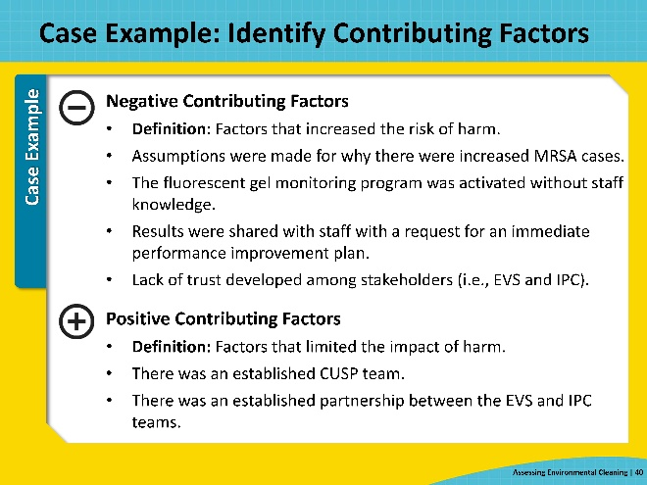
Case Example: How Do We Reduce the Likelihood of the Defect From Happening Again?  SAY:  Hospital leadership, the EVS team, and the IPC team met to review and collaboratively design a new FG monitoring program. To operationalize this, they widely disseminated information about the FG monitoring system and educated staff on its importance and use in the clinical setting. After the team learned about the process, the program was piloted on one floor with support from the CUSP team to help with the initiative. | Slide 41  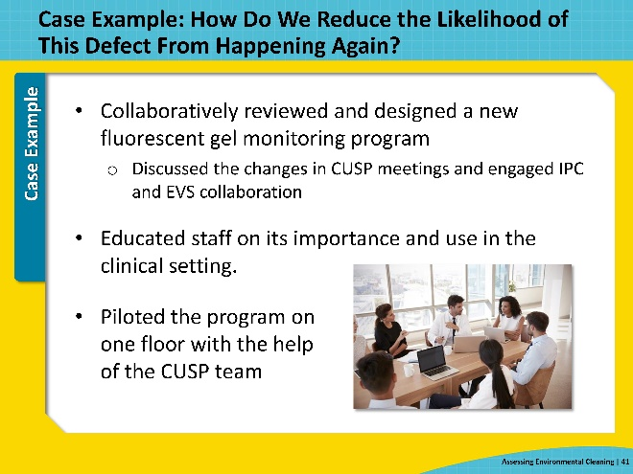
Case Example: Review of Data and Interventions  SAY:  After implementing the program and collecting data, it is important to review the data and share them with all levels of the organization in a collaborative manner.  In this case example, a review of the results revealed gaps in EVS training, highlighting the need for more formalized onboarding and annual training to improve outcomes. It was also discovered that EVS staff often struggled to find stocked carts with cleaning agents or materials needed to perform their jobs adequately. Using a team approach and the input of stakeholders, the process of stocking and restocking cleaning carts was revised, with plans put in place to regularly reevaluate this process.  Following the steps of the Learning From Defects tool, this case example uncovered issues at systemic and local levels. It also revealed gaps in teamwork and communication. In this and any quality improvement program, it is crucial for all team members to communicate and collaborate effectively to develop a plan to improve environmental cleaning and patient care. | Slide 42  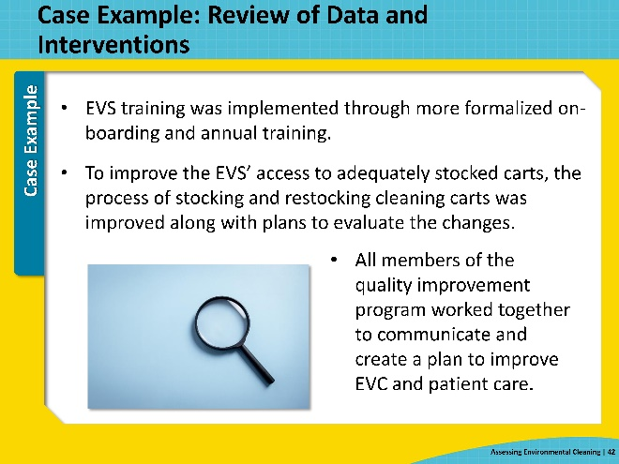
Case Example: How Do We Know the Risk Is Reduced?  SAY:  Last but not least, the final step of the Learning From Defects Tool involves gathering feedback from frontline staff to determine whether the intervention reduced the risk of further harm.  The CUSP team in this case example obtained staff feedback, with emphasis on the following points:  • Rate the effectiveness of the intervention.  • How has it changed the workflow?  • What impact did it have on the identified problems?  • What impact did it have on the infection rates?  The CUSP team implemented the interventions and the feedback from the staff was positive.  In summary, using the Learning From Defects Tool is one way to effectively investigate a defect and implement change. | Slide 43  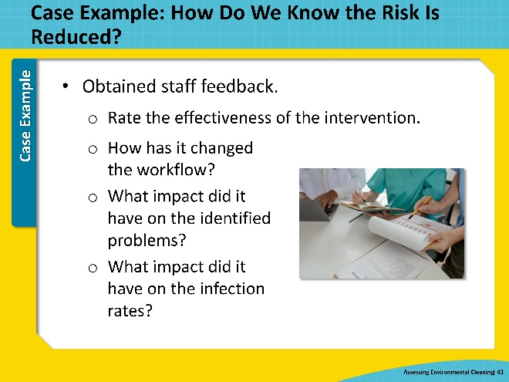
Celebrate Successes  SAY:  Establishing an effective environmental cleaning program takes a lot of hard work and effort and requires input from all leadership levels.  Remember to acknowledge and celebrate successes each step of the way! | Slide 44  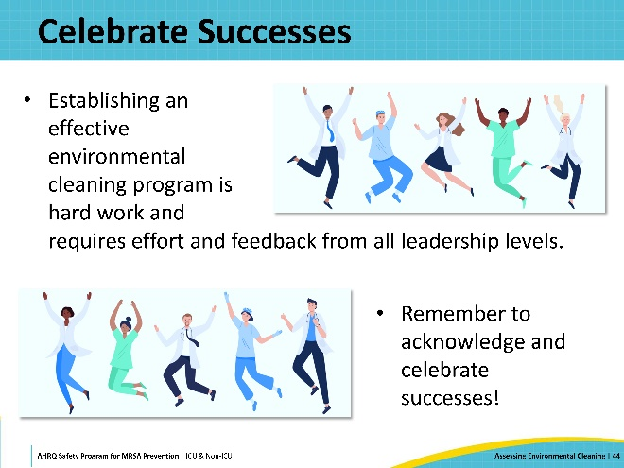
Key Takeaways  SAY:  In conclusion, this presentation discussed strategies and considerations for assessing EVC effectiveness.  The cornerstone of EVC improvement involves conducting effective performance assessments and providing constructive feedback in a non-blame, supportive culture.  Strategies and considerations for FG monitoring systems include selecting products to use as well as determining which and the optimal number of rooms and HTSs to assess.  Steps to evaluate EVC such as with FG monitoring systems include the following: randomize rooms and HTSs, place FG, clean patient rooms, check FG with UV light, and share data feedback.  It is important to consider who is best to take on the task of performing EVC monitoring. Possible roles include the ICP, unit nurse, EVC supervisor, EVC associate, secret shopper, or a mixed role such as nurse and EVC associate.  Effective data feedback is essential to drive improvement efforts and accountability of an EVC monitoring program.  The bottom line is that there is no quick fix when it comes to reducing environmental contamination and mitigating MRSA and other MDRO transmissions in healthcare settings. It is important to work together to protect patients from preventable pathogens such as MRSA and remember to celebrate successes! | Slide 45  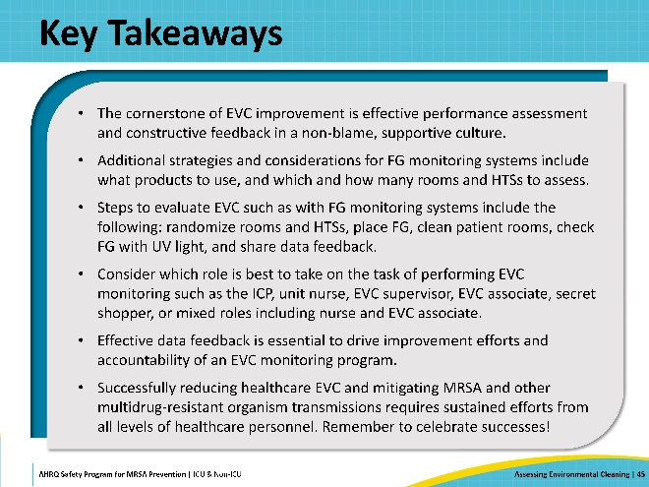
Disclaimer  SAY:  The findings and recommendations in this presentation are those of the authors, who are responsible for its content, and do not necessarily represent the views of AHRQ. No statement in this presentation should be construed as an official position of AHRQ or of the U.S. Department of Health and Human Services.  Any practice described in this presentation must be applied by healthcare practitioners in accordance with professional judgment and standards of care in regard to the unique circumstances that may apply in each situation they encounter. These practices are offered as helpful options for consideration by healthcare practitioners, not as guidelines. | Slide 46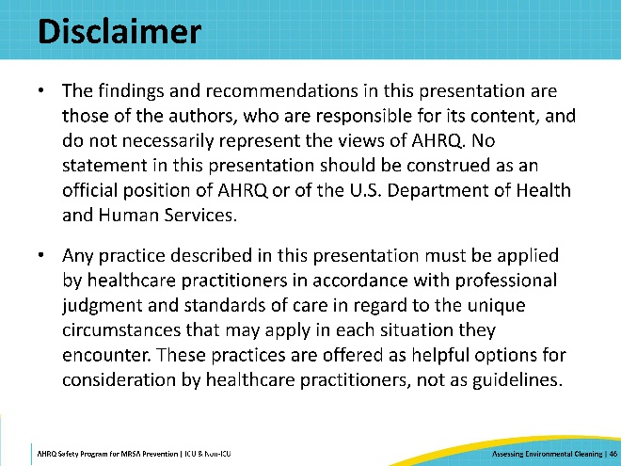
Reference List | Slide 47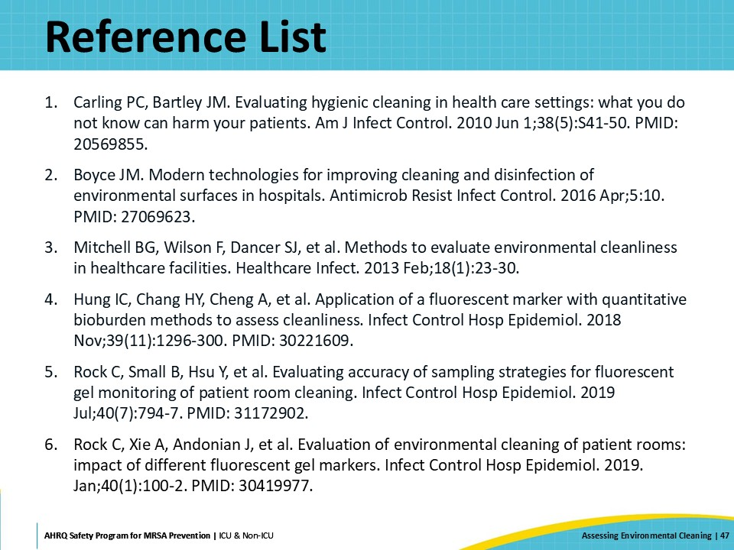

AHRQ Pub. No. 25-0007
October 2024

