Evaluating Environmental Cleaning With Fluorescent Gel:   
Data Collection Instructions and Form

ICU & Non-ICU

# ENVIRONMENTAL CLEANING WITH FLUORESCENT GEL: DATA COLLECTION INSTRUCTIONS

### Fluorescent Gel Placement (DAY 1)

**Step 1:** Choose the first available room from your randomly ordered list of rooms.

**Step 2:** Perform hand hygiene before entering the patient room. If there is a contact precaution sign on the door, don gown and gloves.

**Step 3:** Introduce yourself to the patient and family and explain the process.

“Hello. My name is __________. I work with the infection control department and environmental care team ***[or appropriate hospital department name]***. We do our best to keep all rooms clean and germ free. We’re conducting spot-check cleaning. We place invisible fluorescent gel on some important surfaces in your room. We’ll return in about a day and shine a black light on these surfaces. Cleaned surfaces will have no visible gel; uncleaned surfaces will have visible gel. The goal is to have these surfaces cleaned every day. We use this to get feedback and teach our environmental care associates. This should only take approximately 5 minutes. Is it all right if I go ahead?”

**Step 4:** Use your randomly ordered high-touch surfaces list and place fluorescent gel (FG) on the first available near-patient high-touch surface. Return to the beginning of the list. Place FG on two other available high-touch surfaces. If a high-touch surface is unavailable or absent (e.g., the call box/button is under the sleeping patient, or there is no intravenous fluid pole in the room), proceed to the next high-touch surface.

**Step 5:** Place a checkmark under the “Day 1” column of the Environmental Cleaning With Fluorescent Gel: Data Collection Form (on the next page) for each high-touch surface where FG is placed.

**\*Note: These instructions are for one room. Repeat this process for subsequent rooms you are evaluating.** Two randomly selected rooms on each unit every 2 weeks should be enough to assess the overall effectiveness of cleaning. If the unit is performing poorly, you may want to increase the number and frequency of FG placements.

**Rerun the randomization process each day you choose to evaluate the cleaning.** Don’t remove recently evaluated rooms from the evaluation process.

### Fluorescent Gel Checking (DAY 2)

**Step 1:** Return to the patient’s room and check for FG removal. Shine the ultraviolet flashlight on each area where FG was placed.

**NOTE:** Patient conversations on day 2 will vary depending on daily or discharge clean.

**Step 2:** Place an **R**, **NR**, or **N/A** on the “Day 2” column of the Environmental Cleaning With Fluorescent Gel: Data Collection Form for each high-touch surface where FG was placed.

* **R** = Removed (FG clearly removed, partially removed, or smeared)
* **NR** = Not removed (FG intact and brightly visible)
* **N/A** = Not assessed (e.g., surface is no longer in the patient room)

# ENVIRONMENTAL CLEANING WITH FLUORESCENT GEL: DATA COLLECTION FORM

**Unit: __________ Room: __________**

**Observer Name: _________________________**

**Environmental Cleaning Associate Name: _________________________**

**Environmental Cleaning Supervisor Name: _________________________**

**Near-Patient High-Touch Surfaces**

Bed rails/controls

Over-bed tray table

Call box/button

Telephone

Bedside table

Intravenous fluid pump control

Intravenous fluid pole (grab area)

Vital signs monitor

Ventilator control panel

Computer mouse

Computer keyboard

Supply cart

**Contact Precautions:**

NO / YES, *Clostridioides difficile* / YES, Other

**Day 2:**

Discharge clean /

Daily clean

**Day 1**

**________**

**________**

**________**

**________**

**________**

**________**

**________**

**________**

**________**

**________**

**________**

**________**

**Day 2**

**________**

**________**

**________**

**________**

**________**

**________**

**________**

**________**

**________**

**________**

**________**

**________**

**Other High-Touch Surfaces**

Room sink

Room faucet

Room light switch

Room inner doorknob

Chair

Closet door handle

Bathroom outer doorknob/plate

Bathroom light switch

Bathroom handrails by toilet

Bathroom sink

Bathroom faucet (if touch)

Bathroom soap dispenser

Towel bar

Toilet seat

Toilet flush handle

**Day 1**

**________**

**________**

**________**

**________**

**________**

**________**

**________**

**________**

**________**

**________**

**________**

**________**

**________**

**________**

**________**

**Day 2**

**________**

**________**

**________**

**________**

**________**

**________**

**________**

**________**

**________**

**________**

**________**

**________**

**________**

**________**

**________**

Environmental Cleaning associate was present during reading of FG: YES / NO

Environmental Cleaning associate comments/challenges discussed, give details:

# REPORTING ENVIRONMENTAL CLEANING WITH FLUORESCENT GEL CLEANING PROGRESS

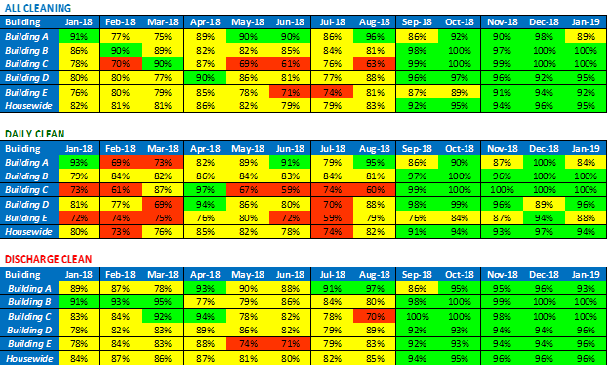

Staff want to know the progress they’re making as this program goes on. Giving feedback is essential to keep staff interested and involved. Set an overall goal of perhaps 70 percent at the beginning of the program and move that goal up as they improve. The percentage of high-touch surfaces that have been appropriately cleaned should improve over time.

This example shows how the data would be prepared for a board or committee meeting. It’s an aggregate of the department level (building) to give a high-level picture of how the process is evolving, rather than individual unit, room, or surface level.

A similar table could be developed to share data with unit or department staff so they can keep tabs on their progress.

AHRQ Pub. No. 25-0007

October 2024