Hand Hygiene Promotion
ICU & Non-ICU
Slide Title and Commentary | Slide Number and Slide
Hand Hygiene Promotion  SAY:  Welcome to this presentation about hand hygiene promotion and how it impacts MRSA prevention.  This presentation will provide information about hand hygiene indications and techniques, as well as guidance on how to implement a hand hygiene promotion program and how to measure adherence to hand hygiene policies.  This presentation will help ensure that units have a comprehensive program in place to promote excellent hand hygiene practices as part of an overall approach to preventing methicillin-resistant Staphylococcus aureus (MRSA) in intensive care units (ICUs) and non-ICU hospital units. | Slide 1  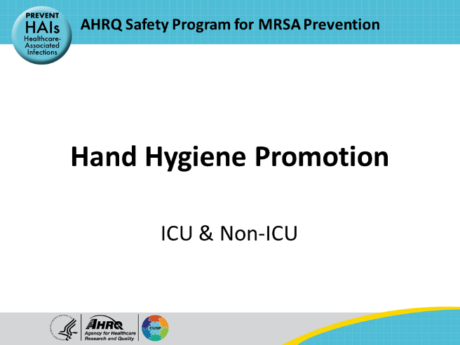
Educational Objectives  SAY:  This presentation will describe the key best practices regarding hand hygiene in healthcare settings. It will then discuss the advantages and disadvantages of various hand hygiene measurement methodologies. Finally, it will review recommendations for implementing a comprehensive hand hygiene promotion and measurement program to optimize hand hygiene adherence and prevent MRSA transmission and infection. | Slide 2  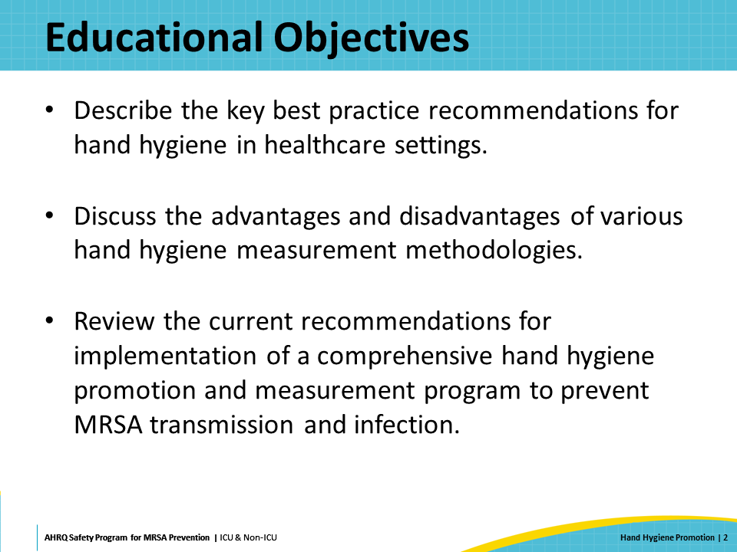
Key Strategies To Prevent MRSA Infection  SAY:  The AHRQ Toolkit for MRSA Prevention in the ICU and non-ICU focuses on four key strategies to prevent MRSA. The key strategies are the following:  - Decolonizing patients  - Decontaminating the healthcare environment  - Preventing person-based transmission  - Preventing device and procedure-associated infections such as central line-associated bloodstream infections (CLABSI) and surgical site infections (SSI)  This webinar on hand hygiene promotion is part of the third strategy, preventing person-based organism transmission. | Slide 3  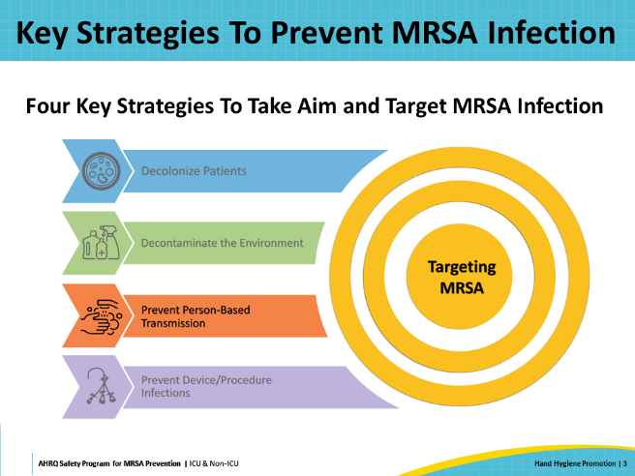
Prevent Person-Based MRSA Transmission  SAY:  Performing hand hygiene at key moments using appropriate technique is a critical component in interrupting the transmission of MRSA from healthcare personnel to patients. The Joint Commission has included hand hygiene as one of the U.S. National Patient Safety Goals for over a decade due to its critical role in preventing the transmission of pathogens and healthcare-associated infections (HAIs). The 2024 National Patient Safety Goals advise organizations to follow hand hygiene guidelines from the Centers for Disease Control and Prevention (CDC) or the World Health Organization (WHO), both of which will be discussed in this presentation. | Slide 4  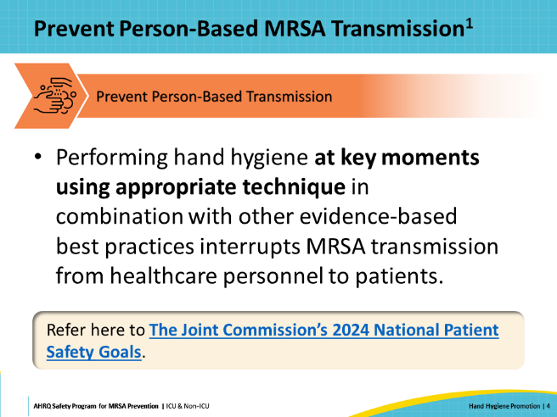
Hand Hygiene Adherence Is Often Low  SAY:  Hand hygiene has been widely recognized as a fundamental and vitally important component of reducing HAIs for over 150 years. Studies demonstrate that improving hand hygiene practices can reduce HAIs and the transmission of multidrug-resistant organisms (MDROs). However, despite these findings, estimates of hand hygiene adherence range from 5 percent to 81 percent, with an average healthcare personnel adherence of only 40 percent.  According to many organizations including the Healthcare Infection Control Practices Advisory Committee (HICPAC)/Society for Healthcare Epidemiology of America (SHEA)/Association for Professionals in Infection Control and Epidemiology (APIC)/ Infectious Diseases Society of America (IDSA) Hand Hygiene Task Force and WHO, a comprehensive bundled approach to hand hygiene promotion is more effective than only implementing one or two interventions alone. To improve and sustain adherence to effective hand hygiene protocols, hospitals need to utilize multiple approaches to hand hygiene promotion—including garnering leadership support, establishing clear hand hygiene policies, engaging and educating healthcare personnel, implementing a measurement and reporting system, and holding healthcare personnel accountable for hand hygiene adherence. | Slide 5  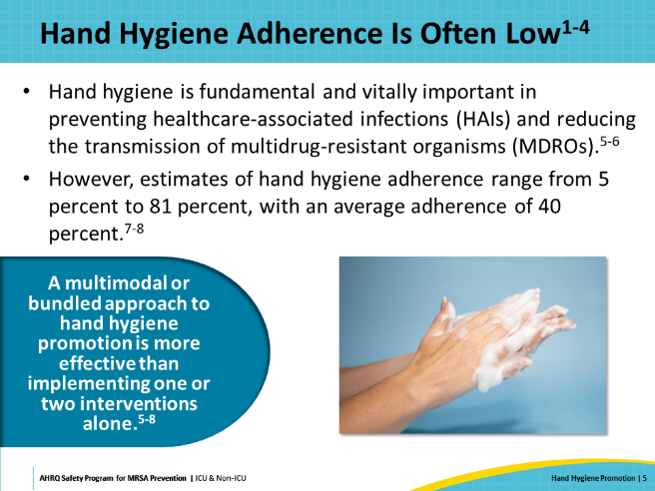
Evidence-Based Practices: Indications for Hand Hygiene and Recommended Procedures  SAY:  Hand hygiene is a key foundation of infection prevention and reduces the risk of transmission of MDROs, including MRSA. This next section will discuss evidence-based practices, indications, and recommended procedures for hand hygiene. | Slide 6  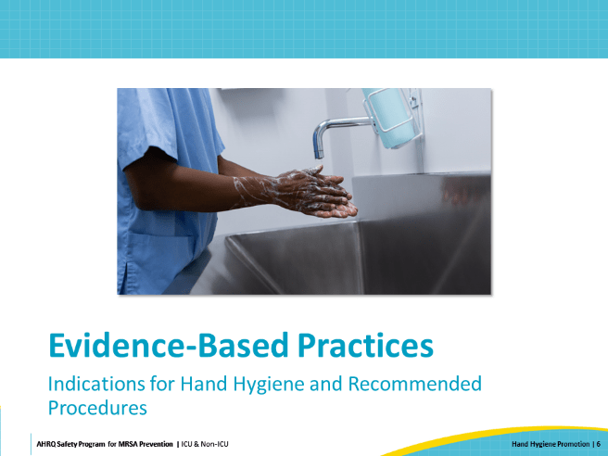
Hand Hygiene Guidance  SAY:  Numerous agencies and organizations have published guidelines and practice recommendations related to hand hygiene in the healthcare setting. Some of the most comprehensive hand hygiene guidance documents include the following:  - HICPAC Guideline for Hand Hygiene in Health-Care Settings, endorsed by the HICPAC/SHEA/APIC/IDSA Hand Hygiene Task Force  - World Health Organization (WHO) Guidelines on Hand Hygiene in Health Care, which include the frequently referenced 5 Moments for Hand Hygiene  - SHEA/IDSA/APIC Practice Recommendation: Strategies to Prevent Healthcare Associated Infections through Hand Hygiene: 2022 Update, published as part of the Compendium of Strategies to Prevent HAIs | Slide 7  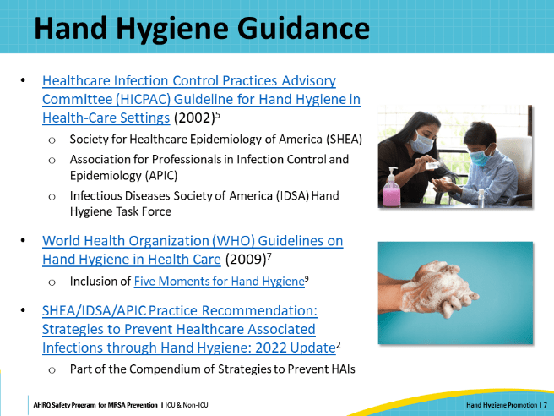
Start With Healthy Hands  SAY:  Effective hand hygiene starts with healthy hands. CDC estimates that healthcare providers may wash their hands over 100 times during a normal 12-hour shift. Literature demonstrates that anywhere between 15 percent and 69 percent of healthcare providers report some level of skin compromise; this includes dry skin, eczema, irritant contact dermatitis, or allergic contact dermatitis, among others. When not managed, these skin conditions can lead to breaks in the skin or increase the risk of pathogen colonization and transmission.  Getting input from healthcare personnel during the process of selecting hand hygiene products can help ensure that the product is accepted, well tolerated, and readily used when indicated. | Slide 8  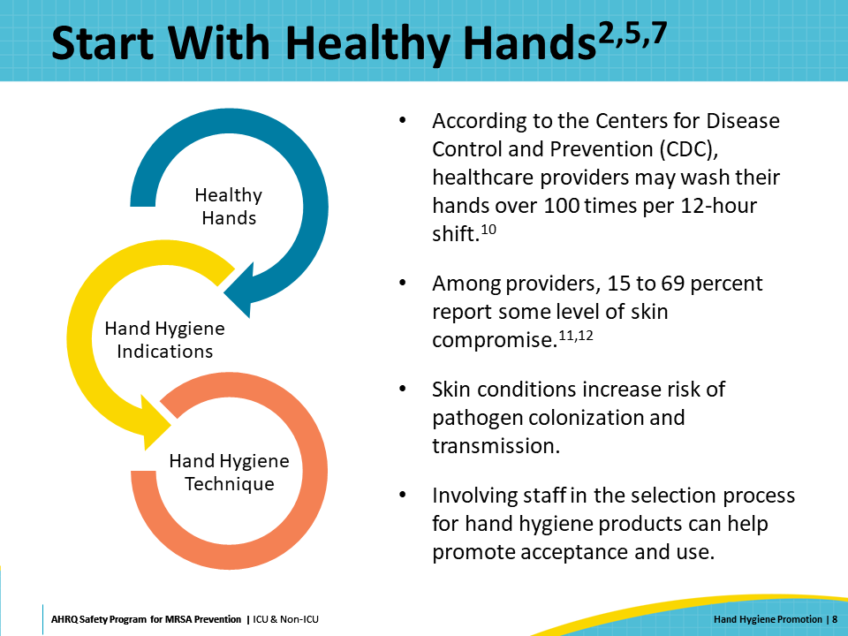
Considerations for Healthy Hands  SAY:  In addition to skin health, having clean, short, natural fingernails is important for healthcare personnel. This helps to prevent the pathogen colonization that can occur with longer and artificial nails. Facilities should have hand hygiene policies that address these issues, including rules about nail polish, gel, and shellac overlays.  Restrictions on jewelry are only recommended in guidelines related to surgical and perioperative hand scrub. However, there is research that demonstrates that the presence of rings is associated with increased hand contamination. Facilities should address their stance on jewelry in their hospital policy.  Facilities should also make sure that personnel have ready access to hand moisturizer to counteract the drying effect of hand sanitizers. Moisturizers should be made available in the same areas where hand hygiene is expected to occur, and staff should be encouraged to utilize them to prevent skin irritation.  When considering moisturizer products, ensure that the moisturizers selected are compatible with all hand hygiene products and types of gloves used within the facility. | Slide 9  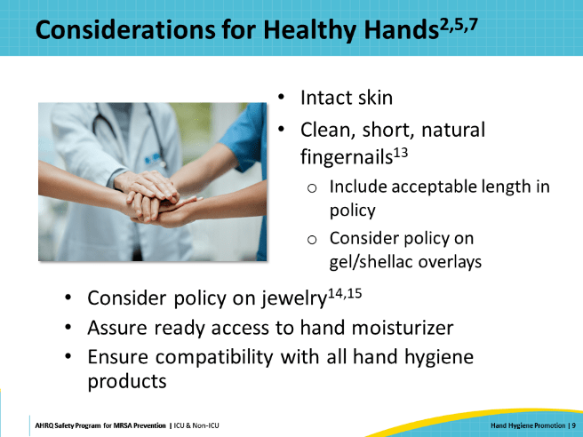
Hand Hygiene Products  SAY:  There have been several studies which compared soap versus alcohol-based hand rub (ABHR). The vast majority of these found ABHR to be superior to both non-antimicrobial soap with water and antimicrobial soap with water. According to several studies, alcohol-based hand rub has significantly better efficacy against a variety of viruses than soap formulations. Use of ABHR is thus strongly recommended. | Slide 10  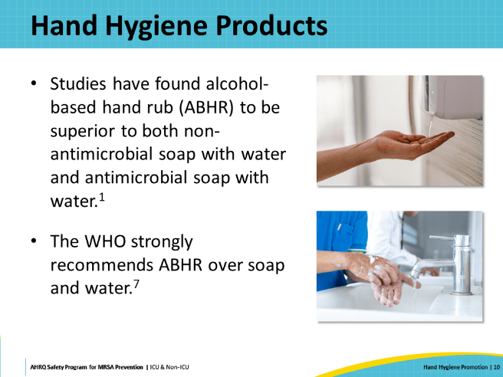
When To Use ABHR or Soap and Water?  SAY:  While ABHR is the preferred method for hand hygiene in most situations, there are times when the use of soap and water is more appropriate than ABHR. Use soap and water—  - When hands are visibly soiled or dirty  - When there is a noticeable buildup from ABHR  - After using the bathroom  - When caring for patients who are known to be infected or colonized with spore-producing organisms like Clostridioides difficile (C. difficile)  As an additional consideration, if your facility provides ABHR for staff, WHO recommends that plain, non-antimicrobial soap should be provided for use in situations when hand washing with soap and water is required (e.g., after using the restroom), due to conflicting data on the safety and efficacy of the active ingredients in some antimicrobial soaps. | Slide 11  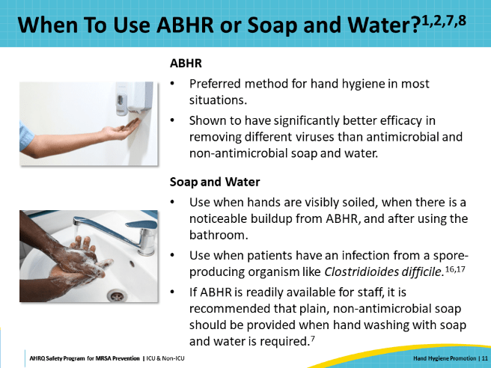
Hand Hygiene Indications  SAY:  WHO and CDC identify indications for hand hygiene in the healthcare setting. As shown on the slide, WHO’s Five Moments of Hand Hygiene align quite well with CDC’s recommendations. Both guidelines cover important hand hygiene indications that include the following:  - Before touching a patient  - Before a clean or aseptic procedure  - After contact with blood, body fluids, or contaminated surfaces  - After touching a patient  - After touching patient surroundings, before moving from work on a soiled body site to a clean body site on the same patient, and immediately after glove removal  In addition to these specific hand hygiene indications during patient care, both organizations also recommend washing hands when visibly soiled, before eating, and after using the restroom. | Slide 12  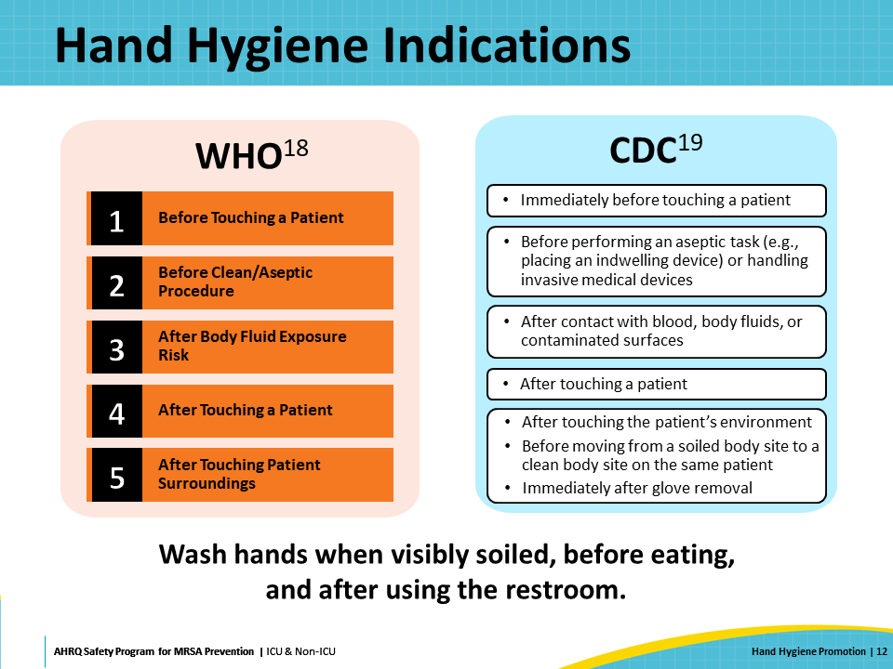
Hand Hygiene Technique: ABHR  SAY:  The minimum recommended time for hand hygiene with ABHR is 15 to 20 seconds. WHO’s guidelines on how to hand rub provide the most specific directions for ABHR technique. This six-step method focuses on ensuring that the most frequently missed areas—the thumb, the fingertips, and between the fingers—are included in the hand rub process. When these steps are followed, proper hand hygiene with ABHR takes 20 to 30 seconds.  It is important to ensure that the amount of product applied to hands is sufficient to cover all hand surfaces and remain wet for the time needed to complete the hand rub process. The average volume of product dispensed from ABHR pumps is between 0.6 and 1.3 milliliters. Automatic pumps should be adjusted so that they dispense an adequate amount of product. The appropriate amount of product depends on the size of each healthcare worker’s hands. For instance, an individual with larger hands may need to dispense more than one pump. This should be considered when evaluating hand hygiene technique. | Slide 13  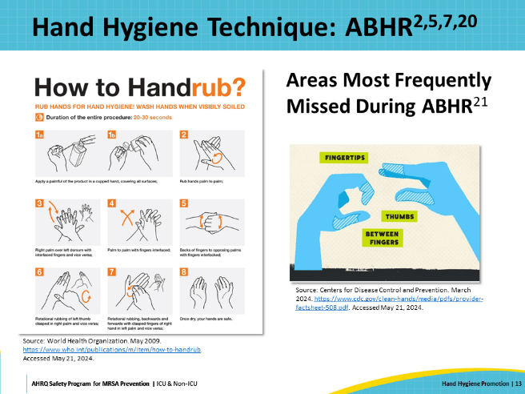
Hand Hygiene Technique: Soap and Water  SAY:  As mentioned previously, hand hygiene with soap and water is preferred in certain circumstances:  - When hands are visibly soiled  - When a buildup of alcohol-based hand rub can be felt  - After using the restroom  - After touching patients with spore-forming pathogens, such as C. difficile or their environment.  Similar to ABHR, WHO’s guidelines on how to hand wash provide the most specific directions for hand hygiene technique with soap and water. The hand washing method focuses on ensuring that the most frequently missed areas—the thumb, the fingertips, and between the fingers—are thoroughly washed. When these steps are followed, proper hand hygiene with soap and water takes 20 to 30 seconds.  Soap and ABHR should not be used at the same time. To avoid confusion between the products, consider installing dispensers in separate physical locations and ensure that they are clearly marked. | Slide 14  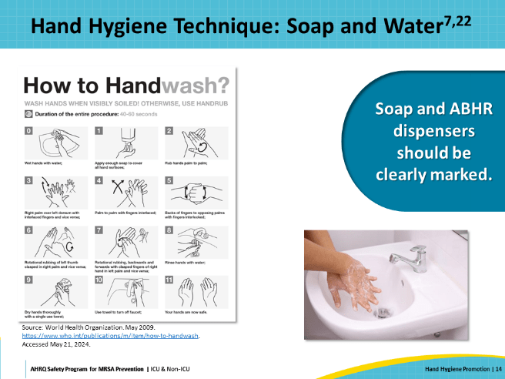
Appropriate Glove Use  SAY:  Appropriate glove use, along with hand hygiene, should be encouraged to prevent transmission of multidrug-resistant pathogens, including MRSA, through hand contact.  WHO and CDC recommend donning single-use, disposable gloves for the following indications:  - Before an aseptic procedure  - When anticipating contact with blood or bodily fluid  - When in contact with a patient, patient equipment, or patient environment during care of a patient who is on contact isolation precautions  Gloves may need to be changed during a patient encounter. Indications for glove removal include the following:  - When gloves are damaged, or integrity is suspect  - After contact with blood, another body fluid, nonintact skin, or mucous membranes occurs  - After contact with a patient and their surroundings, or a contaminated body site  - When care moves from a dirty site to a clean site  - When there is an indication for hand hygiene  Hand hygiene should be performed before donning gloves and promptly after removing gloves since hands can become contaminated during glove removal. Glove use should never be considered a substitute for hand hygiene. | Slide 15  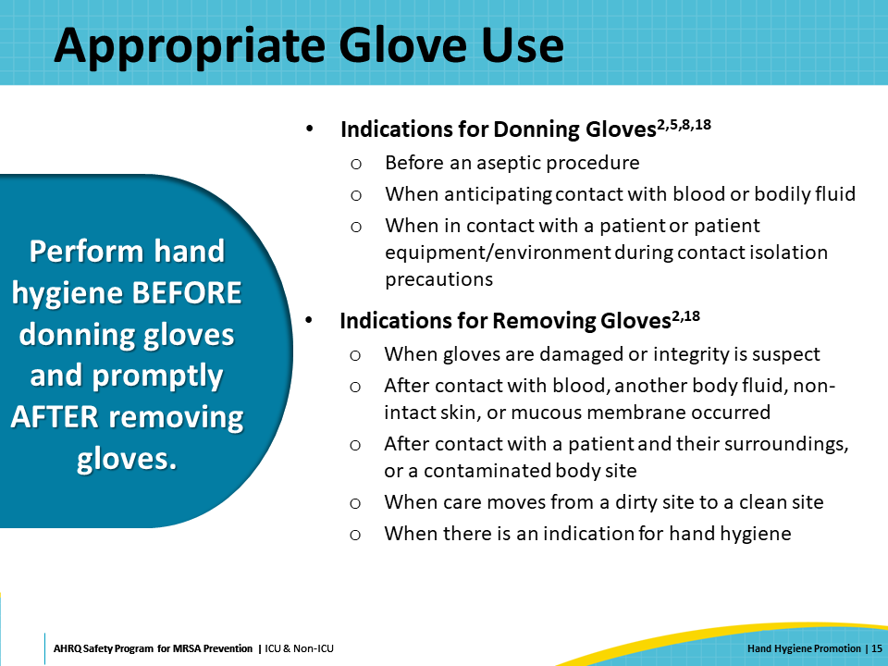
Glove Donning and Doffing Technique  SAY:  When gloves are used, it is important for staff to follow the proper procedure for putting on (donning) and taking off (doffing) gloves to reduce the chance of hand contamination.  As highlighted by CDC’s fact sheet, gloves are not a substitute for hand hygiene. Hand hygiene should always be performed before donning gloves and after doffing gloves.  A 2019 study found that 37 percent of healthcare providers inadvertently contaminated their hands during glove removal, and the fingertips and wrists are the most often contaminated areas.  WHO outlines a step-by-step process for donning and doffing gloves. | Slide 16  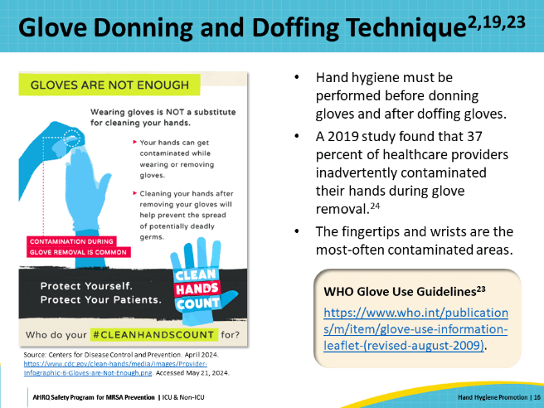
Adherence Monitoring: Methods for Monitoring and Measuring Hand Hygiene Adherence  SAY:  Having reviewed when and how healthcare personnel should perform hand hygiene, this presentation will now focus on different methods to monitor staff adherence to hand hygiene requirements.  To preface, there is no single perfect way to do this. There are several options, each with its own strengths and limitations. Most guidelines recommend utilizing more than one monitoring approach to improve accuracy and trust in the data. | Slide 17  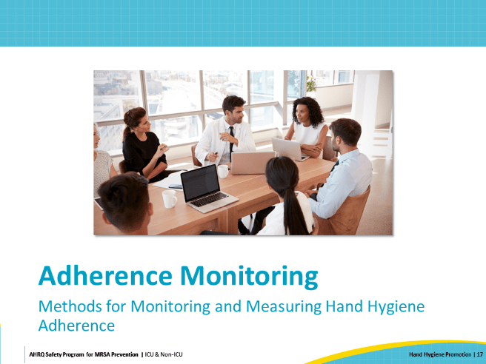
Before You Start  SAY:  The Joint Commission states that organizations must implement a hand hygiene program, set goals for improving hand hygiene adherence, and improve hand hygiene adherence. It does not, however, explicitly dictate how organizations must measure hand hygiene adherence.  To design a hand hygiene adherence monitoring program that meets the needs of an organization, first ask what the goals are. Then identify what needs to be measured, how to measure it, and who will collect the data. Finally, determine how and to whom the data will be disseminated. | Slide 18  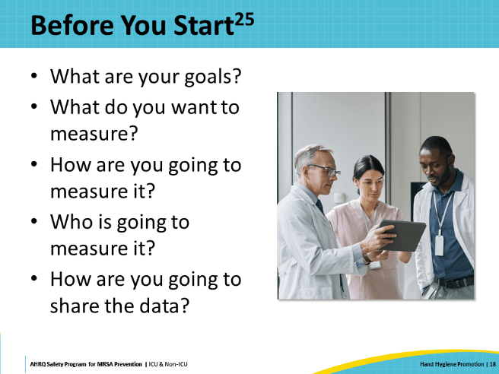
What To Monitor?  SAY:  As discussed earlier, there are many indications for hand hygiene in the healthcare setting during patient care. However, monitoring hand hygiene adherence at every hand hygiene indication can be difficult or impossible to implement. Many of these moments occur behind closed doors or behind curtains during patient care and are therefore not easily observed.  As a result, many healthcare facilities choose to monitor hand hygiene adherence by observing healthcare personnel as they enter and exit a patient’s room or clinical environment. These hand hygiene opportunities are easier to observe and evaluate objectively as compliant or not. Studies have demonstrated that data collected during entry and exit correlate with hand hygiene compliance during the other parts of the patient encounter. | Slide 19  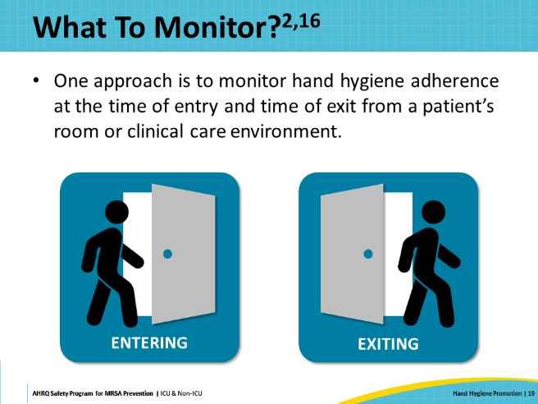
How to Monitor Hand Hygiene Adherence  SAY:  The most frequent methods for measuring hand hygiene adherence include the following:  - Direct observation  - Automated monitoring  - Product volume or event count measurement  - Surveys or patient reports  Every method has its own strengths and weaknesses, and each may be helpful in different phases of implementing and sustaining an effective hand hygiene program. | Slide 20  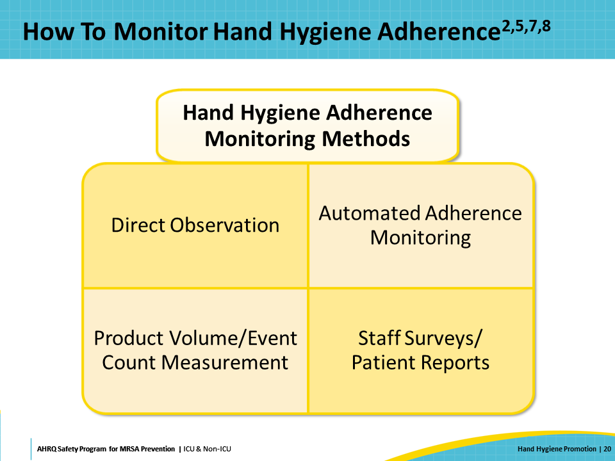
Direct Observation  SAY:  Direct observation is the most frequently utilized method and considered to be the “gold standard” for adherence monitoring. Direct observation can be completed utilizing covert, overt, or technology-assisted data collection.  Covert observation by an unknown or undercover (“secret shopper”) observer is helpful because it facilitates more accurate data collection by minimizing the Hawthorne effect—the observer’s effect on the behavior being observed. Retail businesses hire secret shoppers to help them evaluate things like customer service and cleanliness without employees knowing. Similarly, in healthcare, well-trained covert observers can help identify patterns of missed hand hygiene opportunities and provide insight into hand hygiene barriers. A drawback of covert observation is the inability to intervene in real time when personnel miss hand hygiene opportunities. There is also the possibility that the observer’s identity will become known, especially with prolonged observations, and this may affect the validity of the data.  Overt observers can intervene when hand hygiene opportunities are missed, enabling real-time education of frontline healthcare workers and reducing risk of patient harm. They can engage staff in conversations about hand hygiene practices and may gain insight into systems issues or barriers that covert observers might miss. Providing this type of feedback to personnel requires training and skill. However, because staff know that they are being monitored, hand hygiene adherence is likely to be overestimated if data are collected by this method.  Both covert and overt direct observations require an investment in human capital, including extensive training and checks for observation reliability and validity. Additionally, hospitals must ensure that observers are available to collect data on all shifts and weekends to get the full picture of the organization’s hand hygiene adherence.  Some facilities have utilized technology-assisted direct observation systems by placing cameras in hallways and patient rooms. Trained observers monitor the cameras, usually retrospectively, and collect data on hand hygiene adherence. These systems allow for the assessment of a significantly larger number of hand hygiene opportunities for data collection. Data can be collected on all shifts and there is little risk of observer bias. Like covert observation, this method does not allow for real-time intervention with staff. Also, systems such as these can be costly to install and may pose risks to patient privacy. | Slide 21  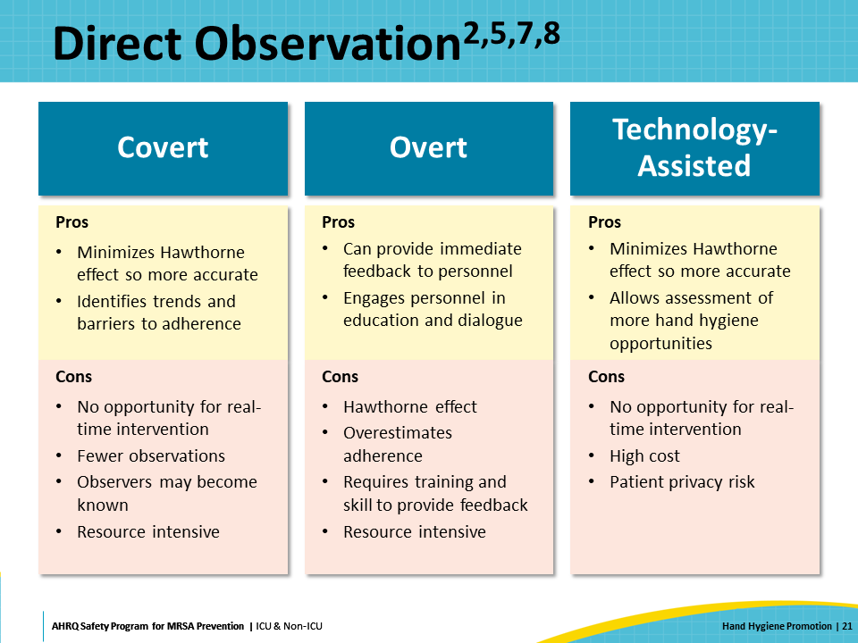
Indirect Observation  SAY:  Indirect observations include volume or event count measurement of products and automated adherence monitoring systems.  The volume or event count measurement method tracks the amount of product used or dispensed over time. This method is useful for studying trends in the frequency of hand hygiene over time or between units. However, it cannot identify who used the product, whether it involved healthcare personnel, patients, visitors, or other individuals. Also, hand hygiene adherence rates cannot be determined because hand hygiene opportunities and behaviors are not recorded. Additionally, dispensing hardware can malfunction at times, so the volume needs to be validated periodically to ensure that the expected amount of product is being dispensed when the pump is activated.  The automated adherence monitoring method uses devices worn by staff to record their hand hygiene behavior via motion sensor devices, badge technology, or reminder and feedback systems. These automated systems eliminate selection bias and recall bias that may affect human observers. Historically, this technology was very costly and technical issues were reported frequently—such as dead batteries, nonoperative dispensing units, and recording errors—making these systems impractical and unreliable. Recent advances address some of these concerns and make the technology more affordable for organizations that want to consider this method. | Slide 22  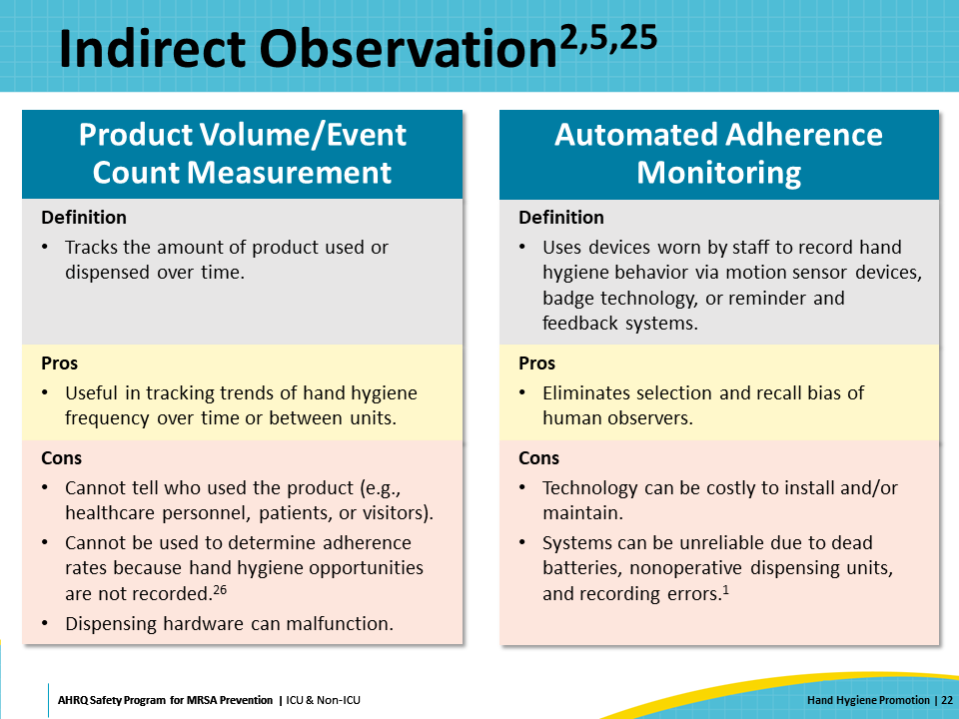
Staff Surveys and Patient Reports  SAY:  Surveys of staff and patient reports can also be used to assess hand hygiene adherence.  Staff surveys of self-reported hand hygiene compliance rarely provide accurate data, but they can help raise self-awareness around hand hygiene practices. These surveys are more useful for gathering data from personnel about their satisfaction with hand hygiene products and availability, knowledge levels, opportunities for additional education, as well as the safety culture concerning hand hygiene and HAI prevention.  Patients may also be engaged in hand hygiene promotion by asking them to provide data on the hand hygiene adherence of the members of their healthcare team. Because patients cannot realistically be trained in all the nuances of what defines a hand hygiene opportunity, the data are less reliable. However, the process encourages patients and their families to advocate for their safety and provides another way to emphasize the importance of hand hygiene. It may also serve as a reminder for staff who may have missed a hand hygiene opportunity. | Slide 23  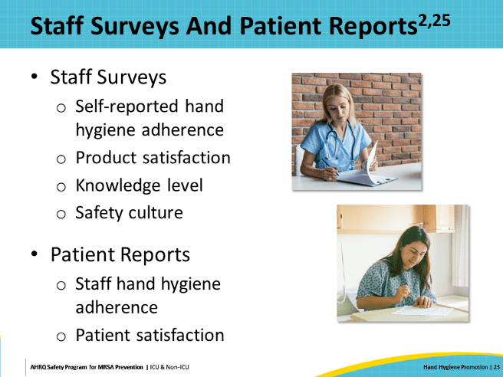
Data Collection  SAY:  Regardless of the chosen metrics and measurement methodology or combination thereof, it is important that there is accurate, consistent, and ongoing data collection. A well-defined numerator and denominator should be selected and monitored over time to assess the effectiveness of interventions aimed at promoting hand hygiene adherence. This slide provides examples of both direct and indirect observations.  Data analysis can be used to identify trends in hand hygiene adherence rates by discipline, shift, department, and unit. These trends can then be used to target further interventions. Periodic validation of the data should be conducted, and this information should be shared with leadership and staff to help foster transparency and build trust in the hand hygiene promotion program. | Slide 24  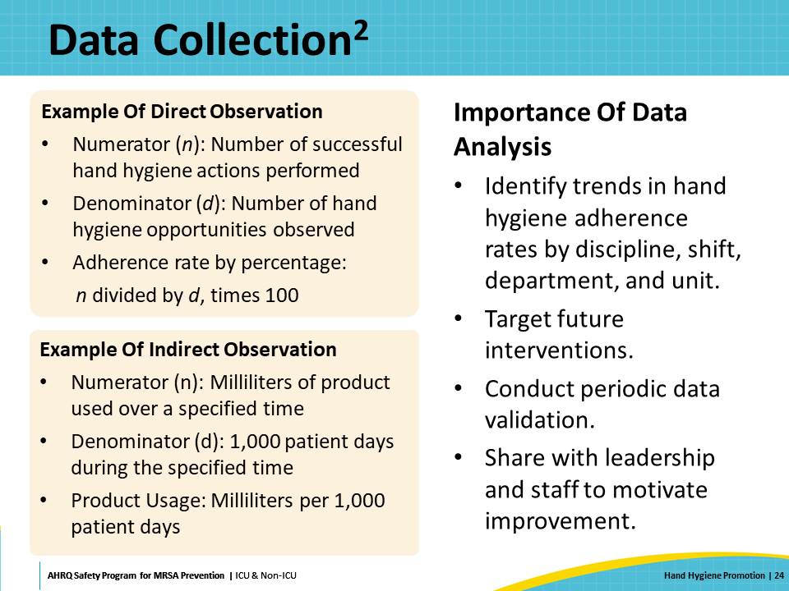
Dissemination  SAY:  Data regarding hand hygiene adherence should be important to everyone in the organization because it represents a foundational element of infection prevention. Hand hygiene adherence data should be shared widely at all levels of the organization, from the board of trustees and executive leadership to frontline healthcare providers and ancillary and support service personnel.  Data should be shared consistently in a timely manner. When deciding the best way to disseminate data, consider the hospital and unit culture. It may be optimal to utilize multiple avenues and methods to share hand hygiene adherence data to reach as wide an audience as possible. | Slide 25  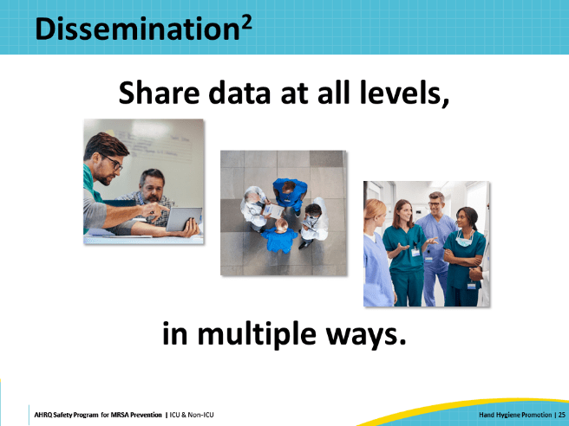
Program Implementation: Developing and Implementing a Hand Hygiene Monitoring Program and Intervention Strategies  SAY:  Following the review of the basic elements of hand hygiene and adherence, the next section will now go over implementation and hand hygiene promotion strategies. | Slide 26  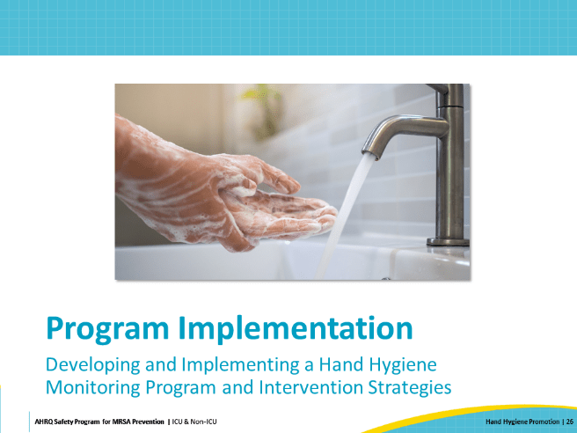
Program Implementation Strategies: The 4 Es  SAY:  The SHEA/IDSA Compendium of Strategies to Prevent HAIs through Hand Hygiene Practice discusses an implementation strategy framework that corresponds to the 4 Es: Engage, Educate, Execute, and Evaluate. Additional AHRQ resources on the 4 Es include a presentation, a facilitator guide, and a one-pager. The next few slides will go into detail about some of the specific actions that can be taken within each of these domains. | Slide 27  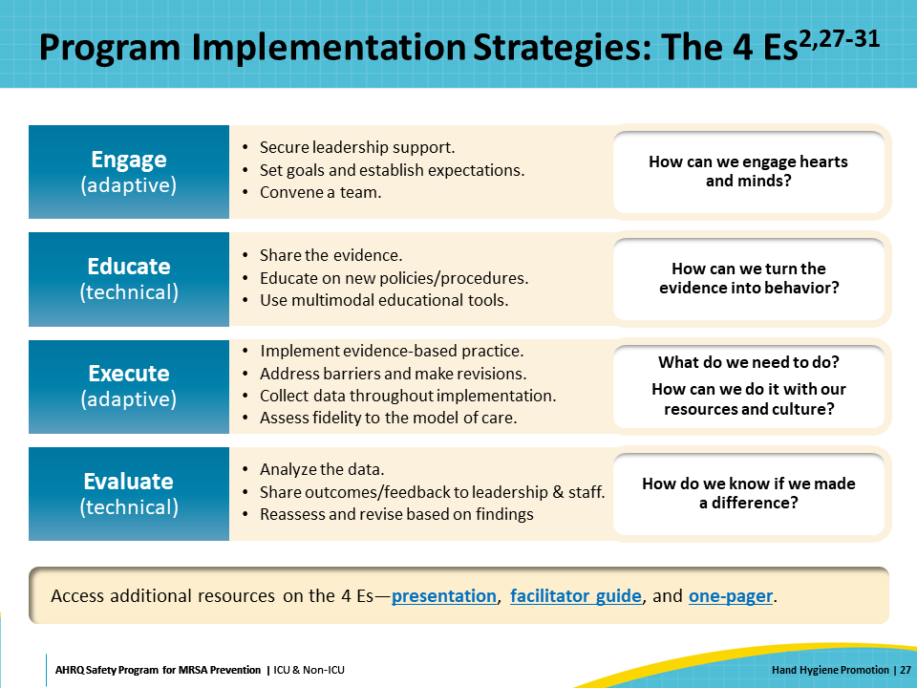
Engage  SAY:  Whether just starting out or working to revitalize an existing program, it is important to engage leadership to ensure the support needed to invest the necessary effort into the program. Executive and senior leadership can also assist throughout the program by mitigating and removing barriers to the hand hygiene experience by personnel.  Leadership input regarding the set goals ensures alignment with reporting requirements and other strategic objectives. Institutional leaders should also understand the pros and cons of various data collection methodologies, along with the resources required to collect and analyze hand hygiene data. It is essential to commit to ongoing resources for these responsibilities to sustain the program. | Slide 28  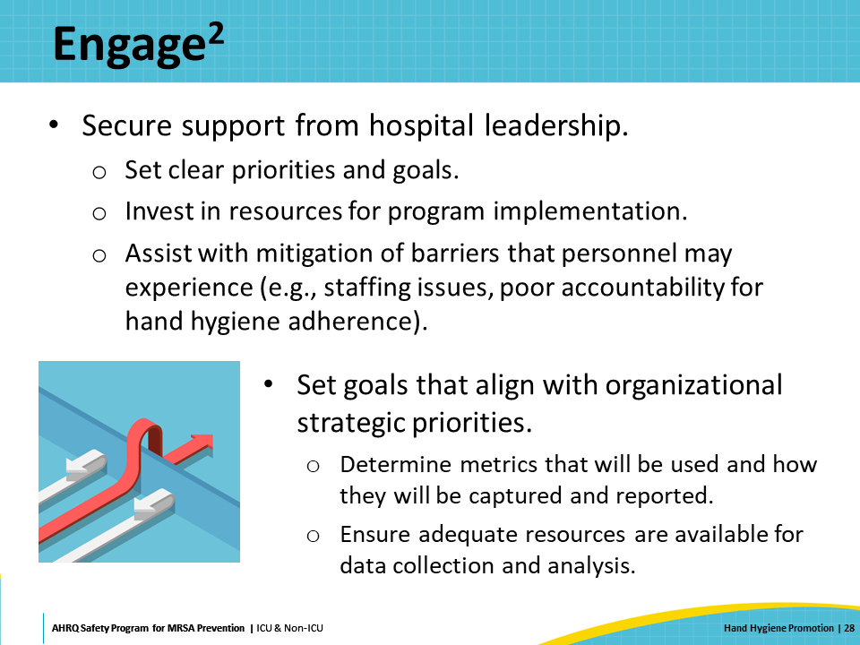
Engage: Establishing Clear Expectations  SAY:  To establish clear expectations, develop or review existing hand hygiene policies to ensure they outline clear expectations for healthcare workers on when and how to perform hand hygiene. Policies should contain, at a minimum, all required elements from The Joint Commission and align with nationally recognized standards and guidelines.  Facilities with existing programs that are not yet achieving desired outcomes could consider adding an accountability structure. This helps to clearly define the process and expectations for managing noncompliance with the policies and procedures. | Slide 29  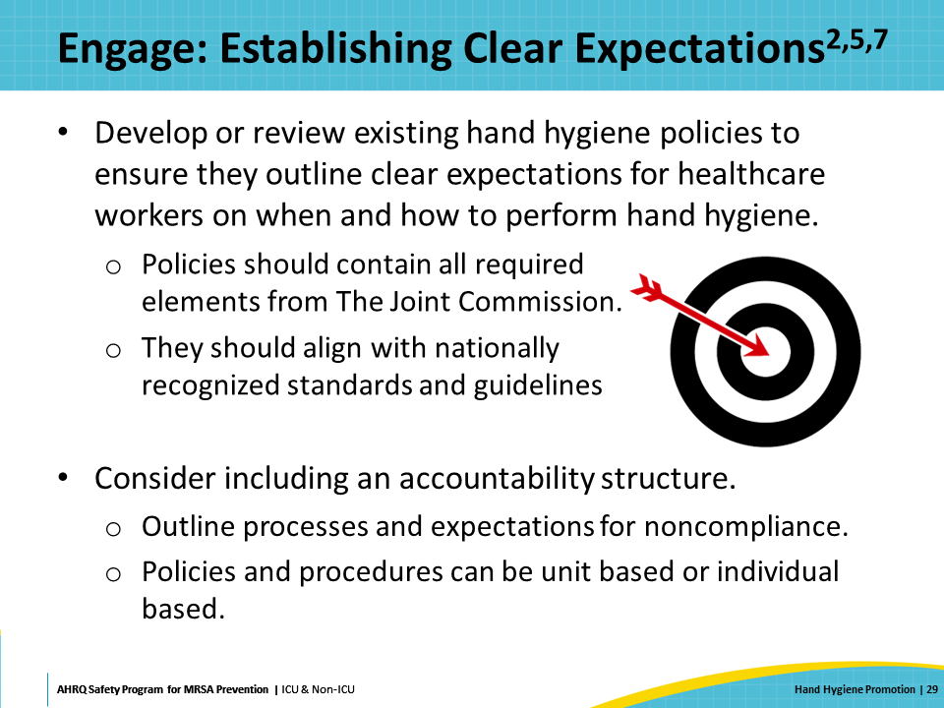
Engage: Sample Accountability Models  SAY:  Accountability models can be based on unit-level data or individual staff behavior.  An example of an accountability model for a unit could include the following:  - After 2 continuous months of compliance below goal, a unit manager develops an improvement plan in partnership with infection control.  - After 3 continuous months of compliance below goal, a unit manager presents an updated plan to hospital leadership, who visit the unit to show urgency of the issue and support of the plan.  Accountability at the personal level might look something like this:  - After one formal observation of a missed hygiene opportunity, the manager is notified of noncompliance.  - After two formal observations within a 12-month period, training and development of a personal improvement plan are initiated.  - After three formal observations within a rolling 12-month period, suspension is applied. | Slide 30  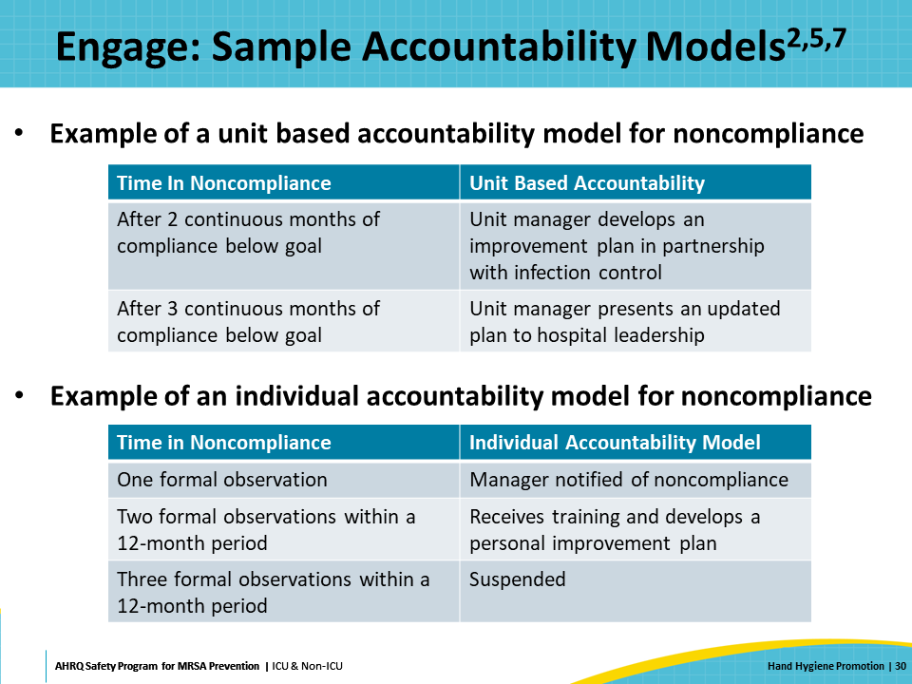
Engage: Hand Hygiene Team  SAY:  An organization’s hand hygiene committee or team should coordinate the overarching activities of the hand hygiene monitoring program. This involves developing and reviewing hand hygiene policies and plans, operationalizing the system being used to gather data, and disseminating data to hospital leadership, unit leadership, and any outside organizations required for public reporting. | Slide 31  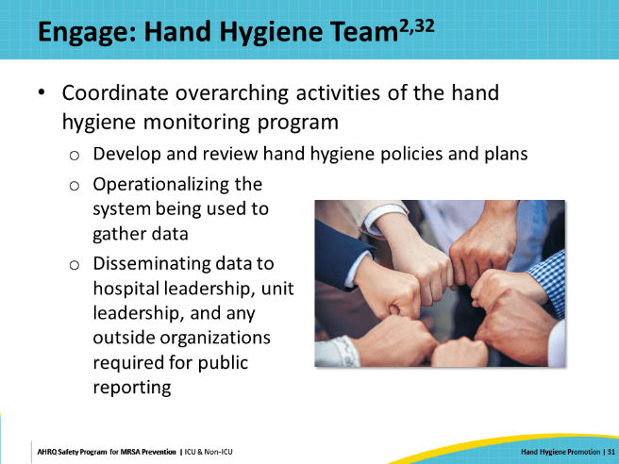
Engage: Convening a Team  SAY:  The hand hygiene team should consist of hand hygiene champions from various departments and units to ensure that the plan is being implemented locally. It is important to include champions from all disciplines and units.  The hand hygiene champions should then act as the liaison between the central hand hygiene committee and the local CUSP or quality improvement teams. They act as the voice of the customer by planning implementation and conducting program evaluation, communicating data with the staff on the unit, and driving local performance improvement and promotion strategies by identifying and addressing barriers specific to the workflows and culture within the department.  Finally, the hand hygiene team consists of observers. The program lead and champions should not be covert observers because they are the “face” of the program. They are well positioned to act as overt observers, and are the ones directly communicating with staff, receiving feedback, and presenting data.  Covert observers should be managed separately and can include staff hired directly for the role, redeployed staff from the facilities, or staff on light duty or workers’ compensation. Consider the composition of the team, as well as the implications of including covert observers in meetings if it may affect their anonymity. | Slide 32  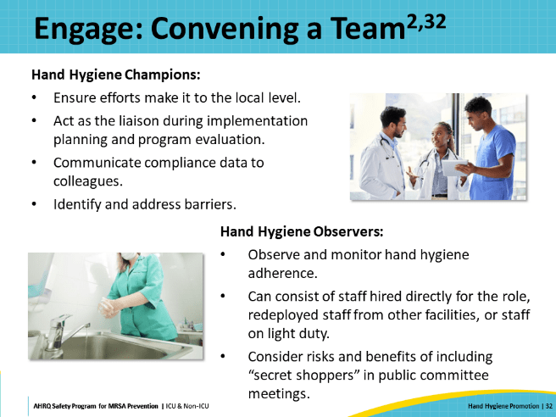
Educate  SAY:  Education regarding hospital hand hygiene policies, instruction on product use, and demonstration of proper hand hygiene technique should occur for personnel at the following times:  - Initial training at the time of hire or upon joining the organization  - Refresher training which should occur at least once annually thereafter  CDC provides examples of hand hygiene training courses. Initial training should also include a return demonstration to assess hand hygiene technique and allow for early correction of missed opportunities. If an organization does not already have a hand hygiene training program in place, or if it could benefit from some enhancements, both CDC and WHO have established resources that may be helpful. | Slide 33  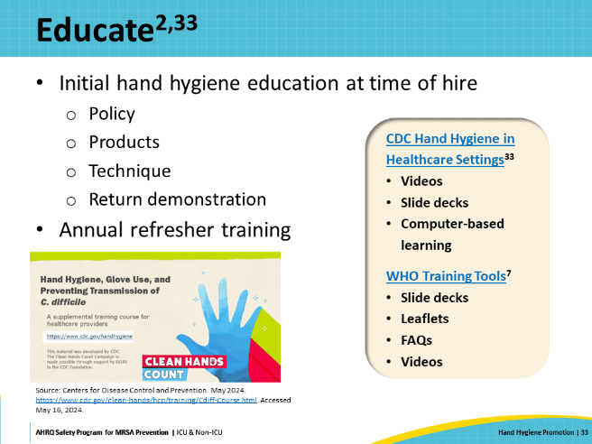
Execute: Intervention Strategies  SAY:  The HICPAC Guideline for Hand Hygiene in Health-Care Settings identifies the most used strategies for successful hand hygiene promotion in hospitals, based on published literature. Intervention strategies include the following:  - Education to improve awareness  - Routine observation and feedback  - Engineering controls  - Patient education  - Reminder campaigns  - Accountability models and recognition or reward programs  - Promotion and facilitation of skin care for healthcare providers  - Safety climate improvement  - Enhancement of staff self-efficacy  - Management of staffing and workload | Slide 34  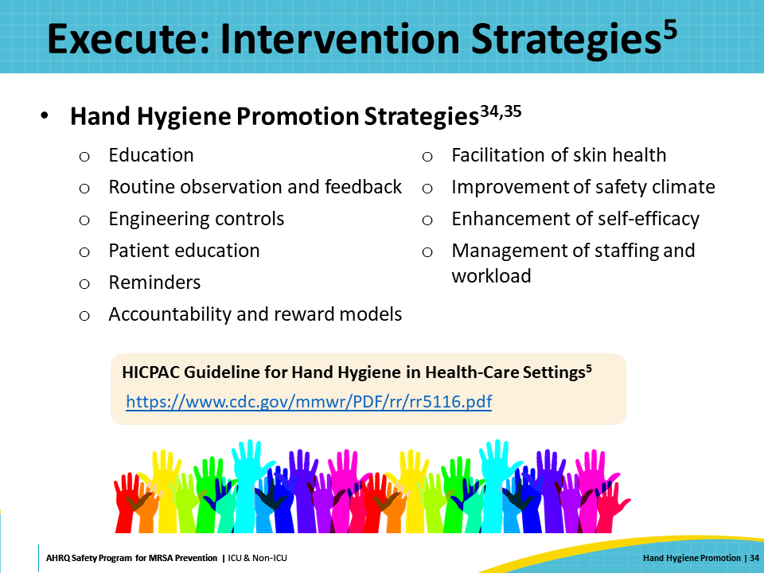
Execute: Multimodal Hand Hygiene Programs  SAY:  Most successful hand hygiene programs are multimodal, meaning they consist of several elements aimed at changing behaviors and improving outcomes. A multimodal approach could include education, facility design, and performance feedback.  For example, a local unit could sponsor a monthlong campaign to educate staff about hand hygiene importance, current hand hygiene rates, and recent updates to the hospital policy. This could occur concurrently with the installation of several new alcohol-based hand rub dispensers in prominent locations throughout the unit. The month could conclude with a request for staff to sign a “pledge” to adhere to the policy. New data should be shared in a timely manner so staff can see the impact of their efforts.  The overall goal of the intervention strategy should not only be to improve hand hygiene adherence rates, but also to shift the unit’s culture to one characterized by safety, improved collaboration, and clearer expectations. | Slide 35  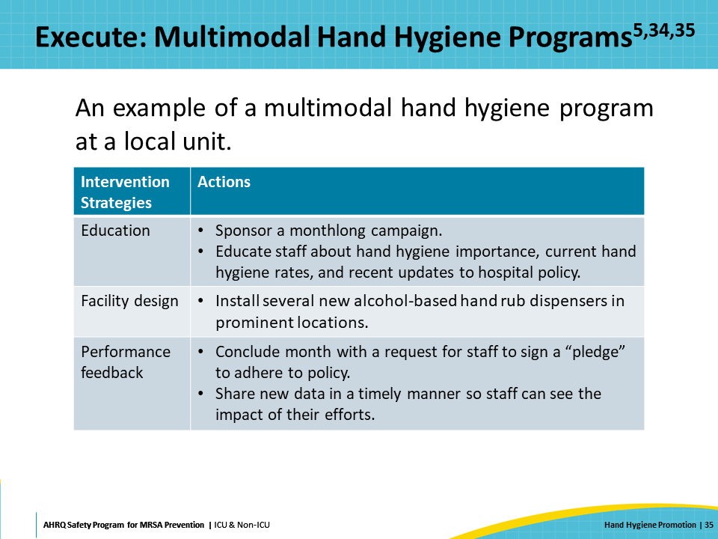
Execute: Promotion and Communication  SAY:  Motivating staff and keeping hand hygiene at the forefront is critical to sustaining the program’s success. Like most other infection prevention metrics, hand hygiene adherence requires continuous attention to achieve and sustain a high level of performance.  The good news is that many public health organizations, including CDC and WHO, have developed promotional and campaign materials that can be used and adapted by organizations.  CDC’s “Clean Hands Count” campaign is geared specifically toward healthcare professionals and offers a range of materials including videos, posters, factsheets, brochures, media and social media tools, and educational resources. CDC additionally recognizes Global Hand Washing Day in October each year and usually offers supplementary resources to help promote hand hygiene during that week. | Slide 36  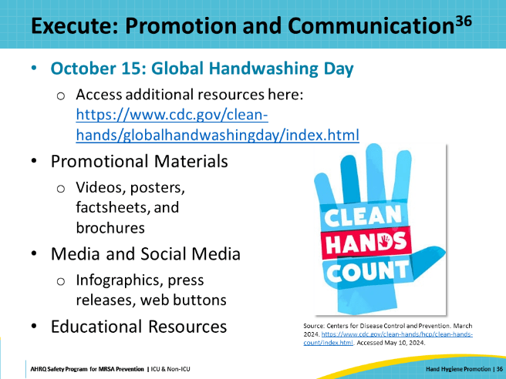
Execute: Implementation Tools  SAY:  WHO offers similar resources, and also includes additional tools to help facilities conduct a self-assessment, build an action plan and observation form, collect data, and communicate with their teams and with patients. WHO recognizes World Hand Hygiene Day each May, with a campaign that focuses on hand hygiene and provides associated resources.  The two dates from CDC and WHO therefore provide hand hygiene teams opportunities at least twice a year to put the importance of hand hygiene back in the spotlight! | Slide 37  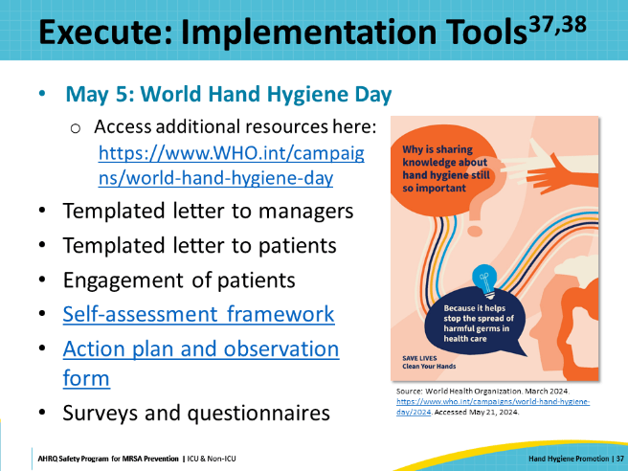
Evaluate: Data Analysis and Sharing  SAY:  To evaluate and determine impact, the hand hygiene program lead should regularly analyze adherence rates and the result of interventions across all levels of the organization. Data that can be parsed to identify trends by department, unit, role, and shift can help target future interventions. Departmental and unit based leadership, along with hand hygiene champions, should be responsible for communicating the data directly to their team members. This can be achieved through daily announcements at huddles or displayed on a huddle board. Data should be presented in a format that is easy to visualize and to track hand hygiene trends over time.  For data sharing to be effective, it must be meaningful to the recipient. It may therefore be necessary to display the data differently depending on the target audience. While executive leadership may be interested in organizationwide hand hygiene adherence, a patient care unit may only want to see their unit’s data. Nurses may want to compare their data with that of physicians, and vice versa. Facilities with access to automated monitoring may provide staff with individualized data specific to their hand hygiene behaviors. | Slide 38  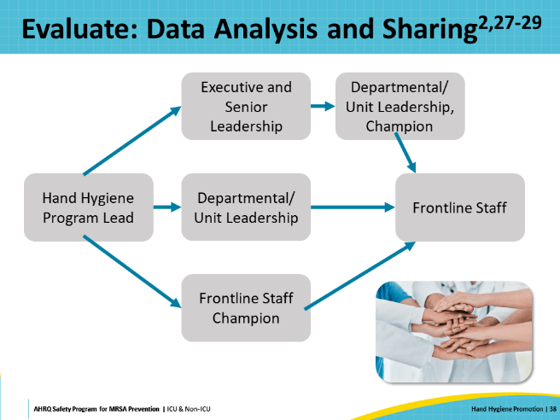
Celebrate Successes  SAY:  Developing and implementing hand hygiene monitoring programs, such as through the 4 Es framework, requires hard work, multiple approaches, and sustained effort from all leadership levels.  Hand hygiene teams invest significant effort and should acknowledge and celebrate their accomplishments! | Slide 39  
Case Example of Low Adherence: Background  SAY:  Now, the presentation will transition to a case example to review and apply the material through a study of a hospital implementing a hand hygiene program.  In this example, a local community hospital recently transitioned from years of using overt observation to an automated adherence monitoring method.  Despite consistently reporting high adherence to hand hygiene for over a decade, their rates dropped dramatically after the new system was implemented.  Previously, baseline data from overt observation consistently reported hand hygiene adherence rates from 91 to 94 percent.  Following the transition, baseline data reported that adherence was from 52 to 56 percent. | Slide 40  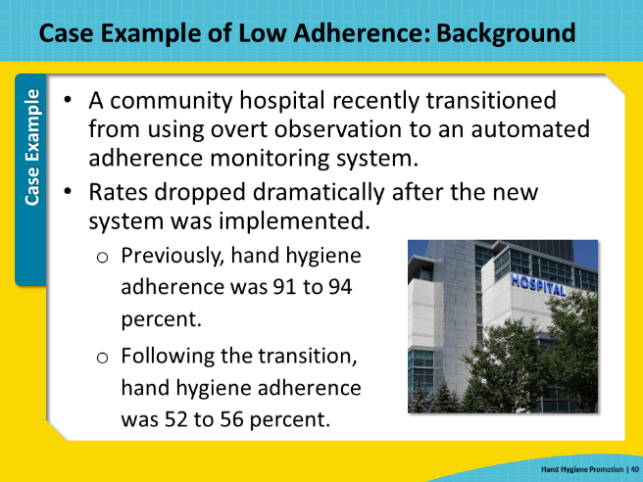
Case Example Continued: Examination of the Problem  SAY:  Hospital leadership believed the reports using data from the automated adherence monitoring system were incorrect, so the infection prevention team conducted a real-time point prevalence audit to validate the data.  After confirming the low adherence rate, focus group sessions—including representation from all clinical and ancillary staff departments—sought to try to understand the reasons for the frequently missed hand hygiene opportunities. | Slide 41  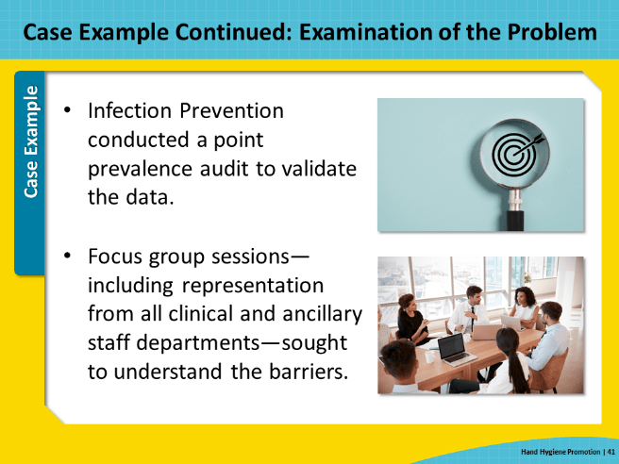
Case Example: Ishikawa Diagram  SAY:  The Ishikawa diagram, also known as the fishbone diagram, was used to analyze the feedback received from the focus groups.  The tool summarizes the barriers, usually grouped into one of six main categories, to look at the issue globally and prioritize interventions.  During the assessment, it is important to note that each facility needs to assess barriers specific to their facility, as barriers may vary from institution to institution and even among units and disciplines within the same organization.  The categories and related examples include the following:  - Man, which encompasses issues like poor training among individuals or units  - Method, such as outdated policies or improper glove use  - Machine, including concerns like inadequate staffing or high patient acuity  - Material, such as empty dispensers, inconvenient sink placement, or skin irritation  - Environment, which involves factors like a low safety climate or lack of accountability  - Measurement, including issues like distrust in data, lack of belief in risk of low hand hygiene adherence, or Hawthorne effect  The HICPAC Guideline for Hand Hygiene in Health-Care Settings offers additional well-known barriers to hand hygiene and mitigation strategies that may be helpful when getting started. | Slide 42  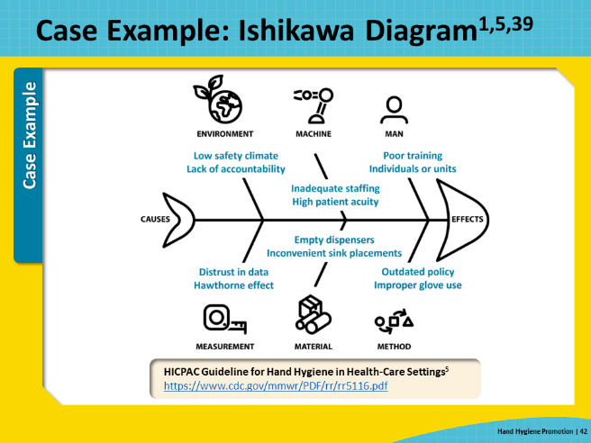
Case Example: Action Planning  SAY:  The Infection Prevention team reconvened a Hand Hygiene Committee to formulate an action plan to increase adherence. A representative from each department’s CUSP, or performance or quality improvement, team was invited to participate.  The committee reviewed the current policy and found it to be vague. They identified several opportunities to clarify expectations, including procedures for when to perform hand hygiene that were not always obvious, such as meal tray delivery and patient transport.  Once the new policy was completed, the committee launched a robust multimodal educational campaign. Updated computer-based learning modules were developed and assigned to all new staff at hire, as well as to current staff annually. Posters, fliers, and signage served as visual cues and reminders throughout the units. Hospital leadership sponsored an educational fair, where a simulated escape room was set up. Staff who successfully completed the challenge were entered into a raffle for prizes.  Lastly, an accountability model was rolled out 3 months after the new policy and education updates began. The accountability model focused on both individual behavior and unit or department level trends. Staff and units that consistently demonstrated high adherence were recognized and rewarded. Staff who had repeated violations underwent coaching and counseling, followed by progressive disciplinary action if required. Units that failed to meet the hospital goal for 3 months were required to create a local action plan and present it to executive leadership. | Slide 43  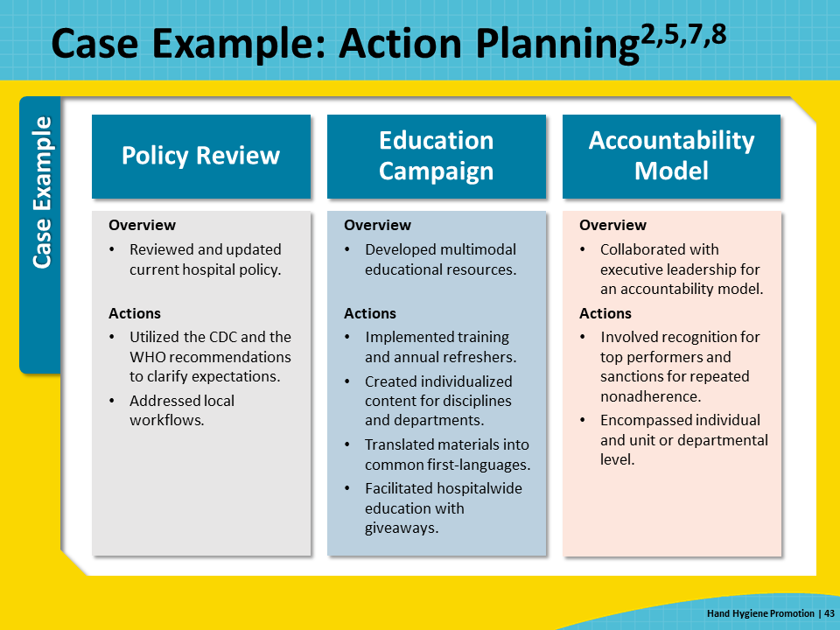
Case Example: Results of Intervention  SAY:  Although it took some time to fully implement the action plan, the hospital eventually began to see their adherence rates rise. Within a year, they were back at their target of 90 percent.  To monitor staff adherence to hand hygiene requirements, the hospital transitioned from overt observation, which, in this case example, involved the Hawthorne effect and overestimated hand hygiene adherence, to an automated adherence monitoring system. This method eliminated selection and recall bias of human observers. With the consistency of the automated adherence monitoring system along with the policy review, educational campaign, and accountability model, the hospital has thus far been able to sustain the gains.  As shown through the case example, a robust and sustained program involves multiple approaches and leads to successful hand hygiene adherence. | Slide 44  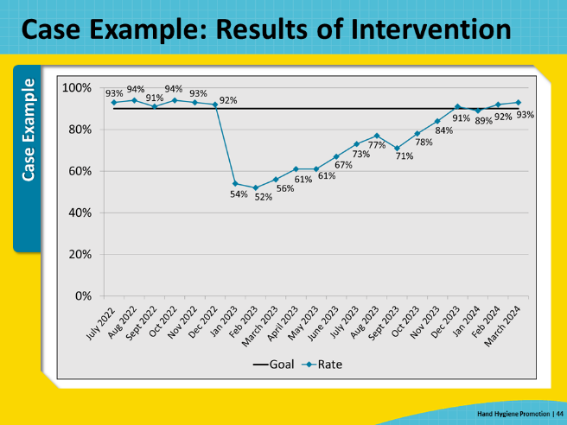
Key Takeaways  SAY:  In summary, hand hygiene is a fundamental cornerstone of infection prevention to reduce the risk of HAIs and the transmission of MDROs, including MRSA.  Good hand hygiene starts with a program that promotes and facilitates healthy hands and appropriate fingernails.  WHO and CDC emphasize the importance of hand hygiene in the healthcare setting as well as provide indications, techniques, and appropriate glove use methods.  Hand hygiene promotion programs should be multifaceted and align with national standards and guidelines. They should include education for healthcare personnel, routine measurement and monitoring of hand hygiene adherence, and ongoing hand hygiene promotion to achieve and sustain excellent practices.  Measurement and monitoring of hand hygiene adherence is challenging, and often requires resources, accurate and ongoing data collection and dissemination, and more than one approach.  The 4 Es serve as an effective implementation strategy framework. Furthermore, accountability programs can help to ensure that each member of the organization takes their role seriously in using hand hygiene properly and consistently to prevent infections.  In conclusion, hand hygiene is a fundamental element of preventing MRSA. It is important to work together and utilize key strategies such as decolonizing patients, cleaning and disinfecting the healthcare environment, implementing evidence-based interventions to prevent device and procedure-associated infections, and preventing person-to-person transmission. By doing so, healthcare personnel can work together to protect patients from MRSA. | Slide 45  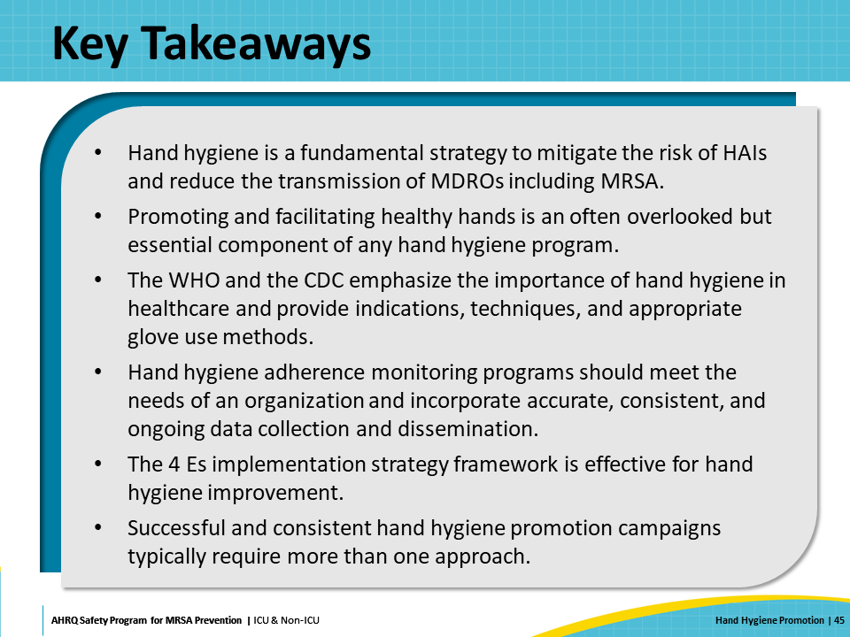
Disclaimer  SAY:  The findings and recommendations in this presentation are those of the authors, who are responsible for its content, and do not necessarily represent the views of AHRQ. No statement in this presentation should be construed as an official position of AHRQ or of the U.S. Department of Health and Human Services.  Any practice described in this presentation must be applied by health care practitioners in accordance with professional judgment and standards of care in regard to the unique circumstances that may apply in each situation they encounter. These practices are offered as helpful options for consideration by health care practitioners, not as guidelines. | Slide 46  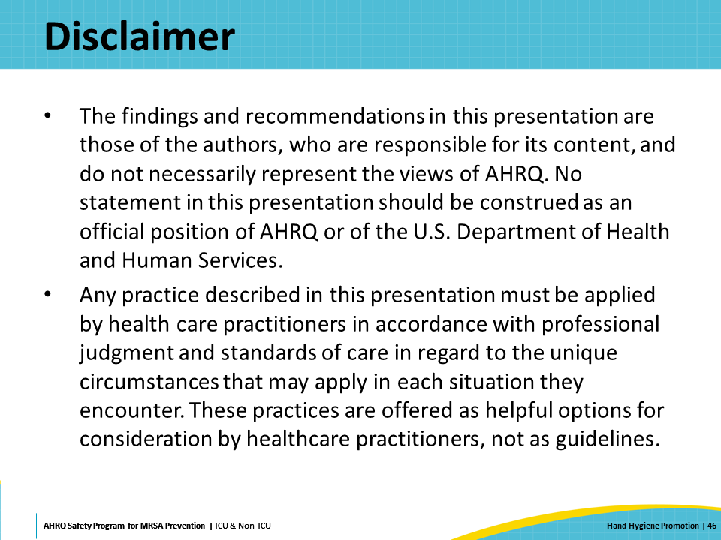
Reference List—1 | Slide 47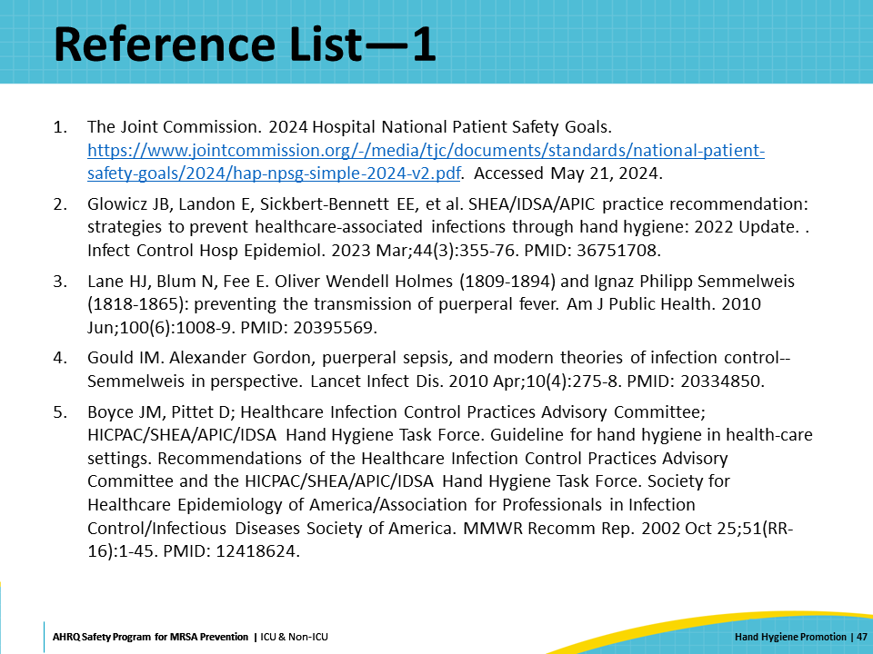
Reference List—2 | Slide 48  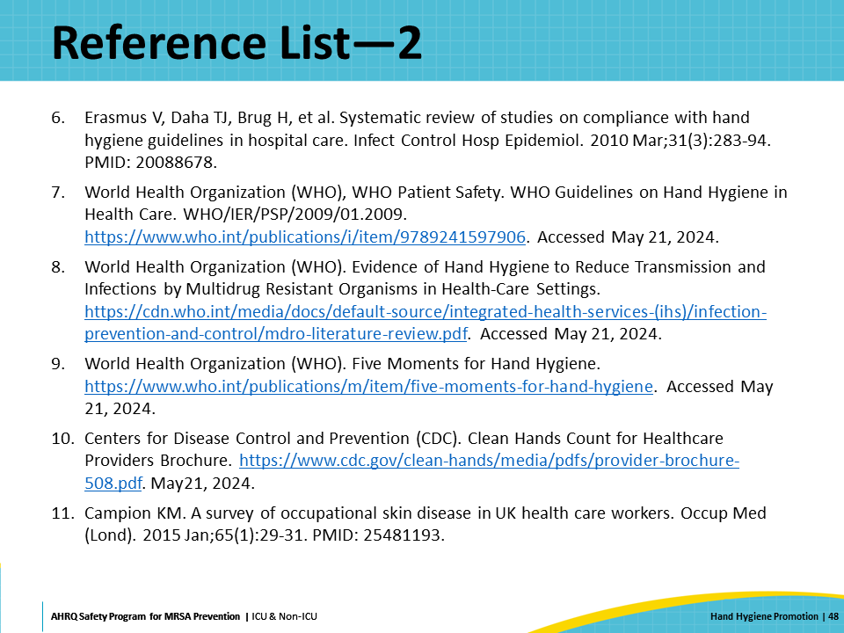
Reference List—3 | Slide 49  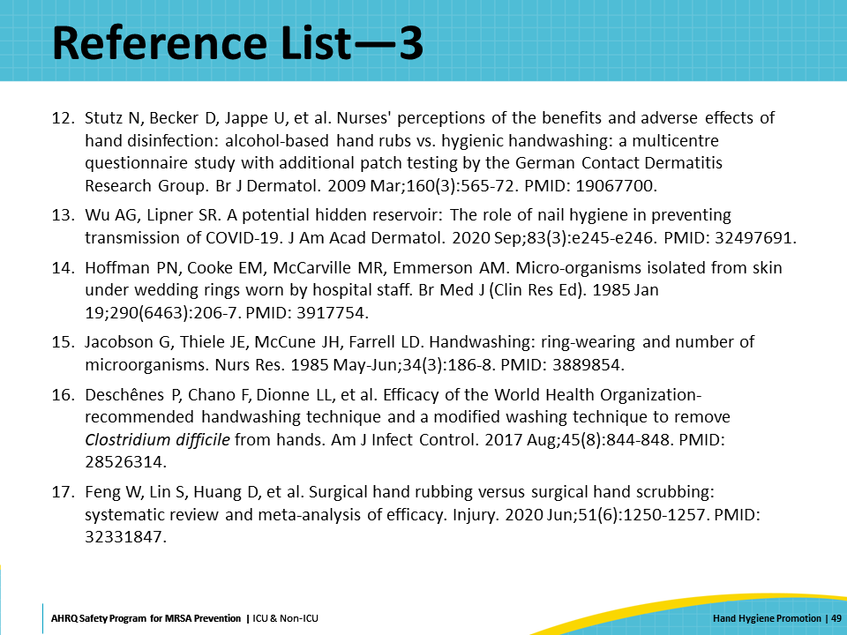
Reference List—4 | Slide 50  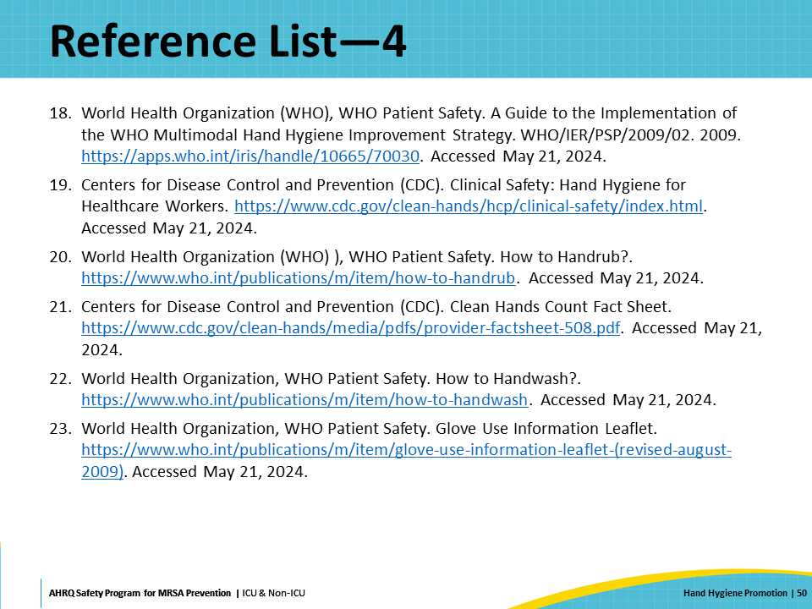
References List—5 | Slide 51  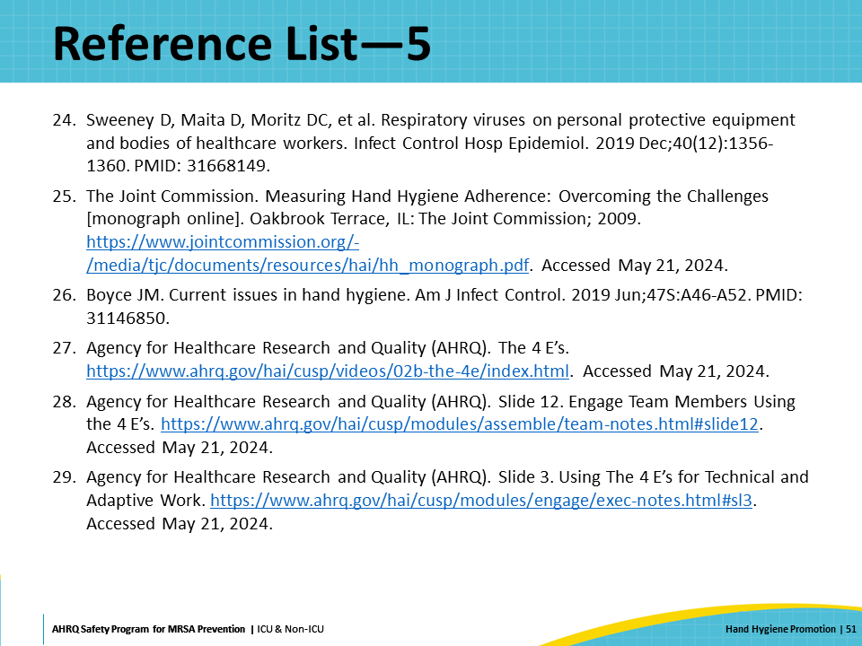
References List—6 | Slide 52  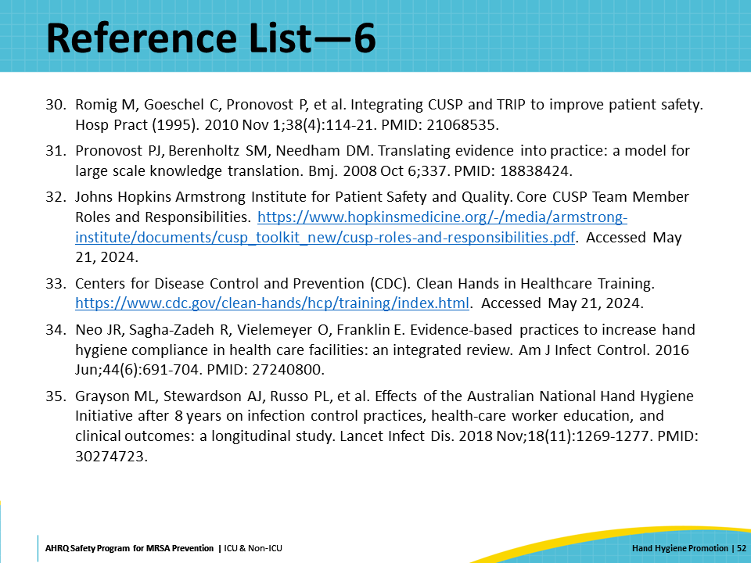
References List—7 | Slide 53  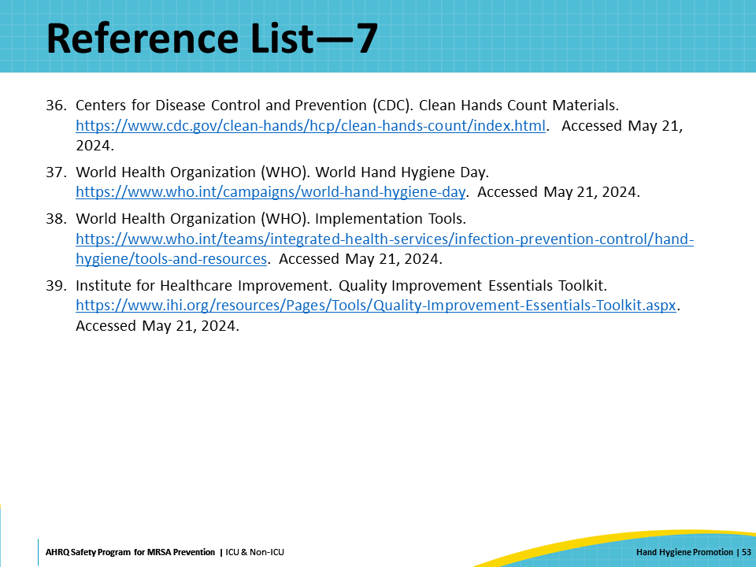

AHRQ Pub. No. 25-0007
October 2024

