The Importance of MRSA Prevention
ICU & Non-ICU
Slide Title and Commentary | Slide Number and Slide
The Importance of MRSA Prevention  SAY:  Welcome to this presentation on the Importance of Methicillin-Resistant Staphylococcus aureus (MRSA) Prevention. This presentation will outline the severity of the threat that MRSA poses to patients in intensive care units (ICU) and non-ICU hospital units. | Slide 1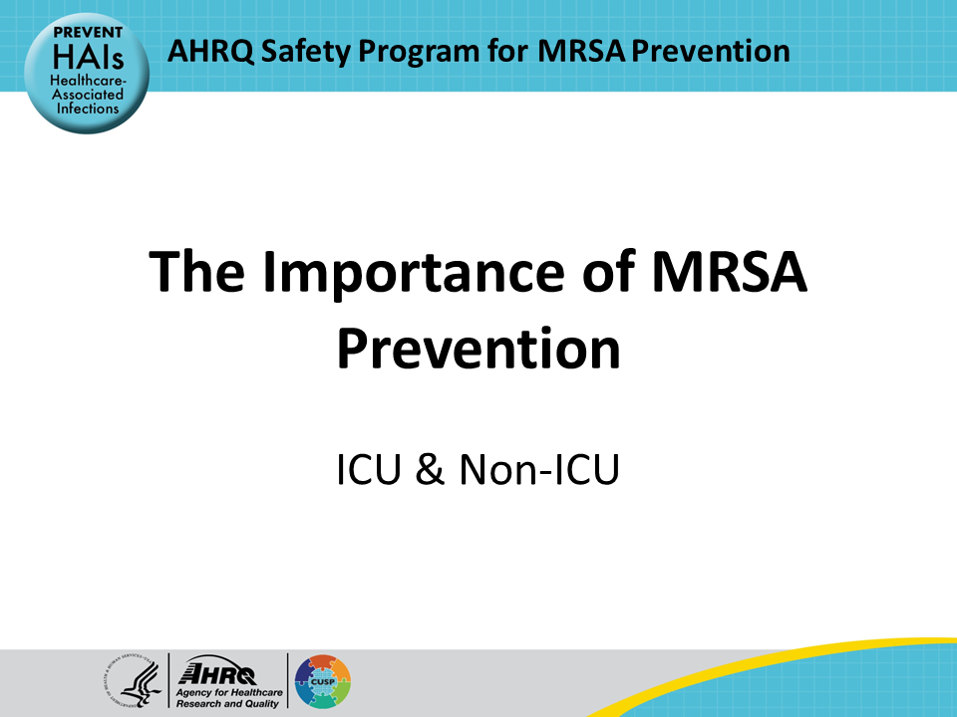
Educational Objectives  SAY:  This presentation will discuss the harm and adverse outcomes associated with MRSA, describe the sources of MRSA on people and in the healthcare environment, for both ICU and non-ICU units, and finally, outline the key strategies and targets for MRSA prevention, with specific focus on defining the central concepts of MRSA surveillance and MRSA decolonization. | Slide 2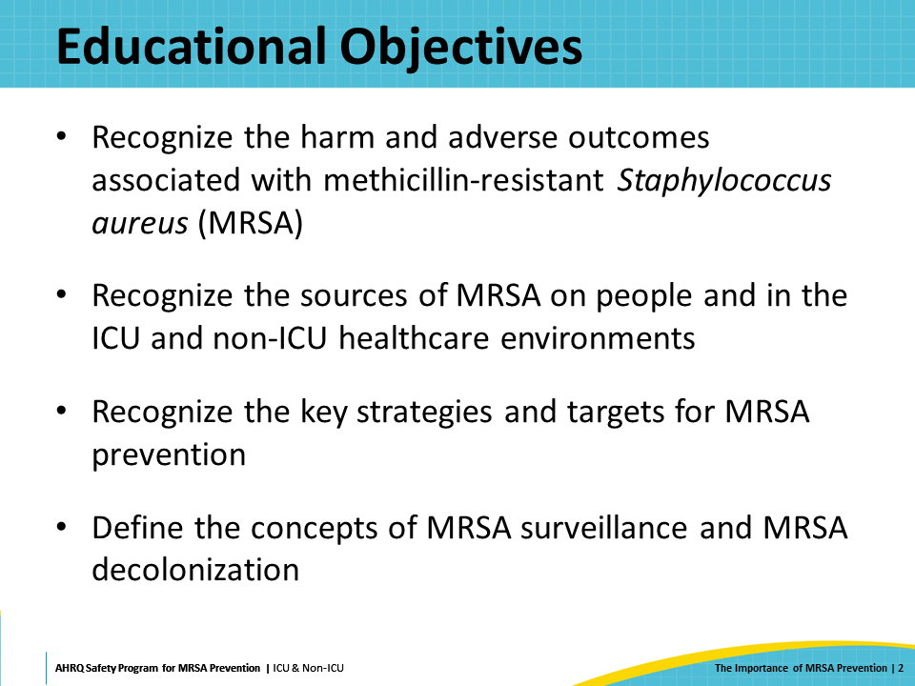
MRSA Is a Serious Threat  SAY:  Staphylococcus aureus infections, both methicillin-susceptible S. aureus (MSSA) and methicillin-resistant S. aureus (MRSA), are associated with adverse outcomes, including prolonged length of hospital stay, increased healthcare costs, and increased morbidity and mortality. MRSA affects people in both community settings and healthcare facilities, but most of the morbidity and mortality occurs in critically and chronically ill patients.  While both MSSA and MRSA present serious threats to patients, this AHRQ toolkit focuses specifically on MRSA because there are fewer treatment options for these strains of S. aureus, and they therefore present a greater threat of patient harm. However, the MRSA prevention strategies in this toolkit are also effective for preventing MSSA infection. | Slide 3  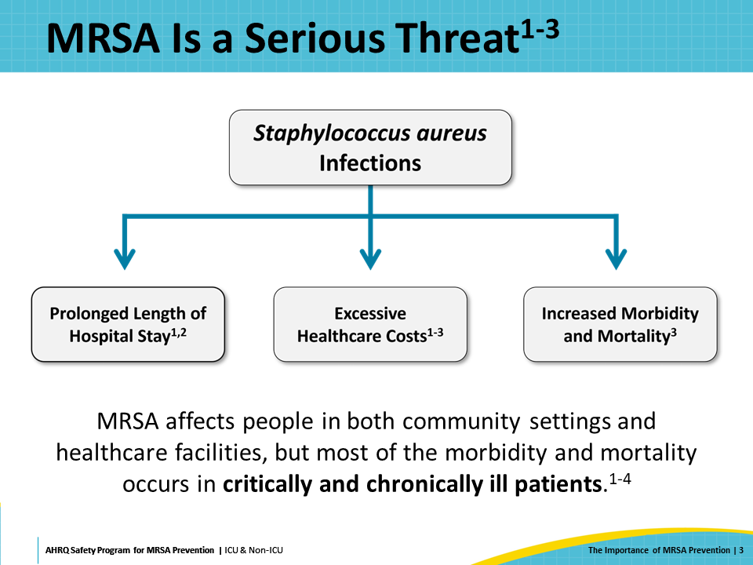
MRSA Is Invasive and Deadly  SAY:  MRSA is invasive and deadly. There is no doubt that MRSA is one of the most invasive and deadly multidrug-resistant organisms (MDRO). MRSA is a pathogen that is resistant to many available antimicrobial agents, complicating the treatment of MRSA infections. In 2019, the CDC reported that more than 2.8 million antibiotic-resistant infections occur in the United States each year, and more than 35,000 people die as a result. At a time when there are only a few antibiotics effective against MRSA, new resistance patterns continue to develop. | Slide 4  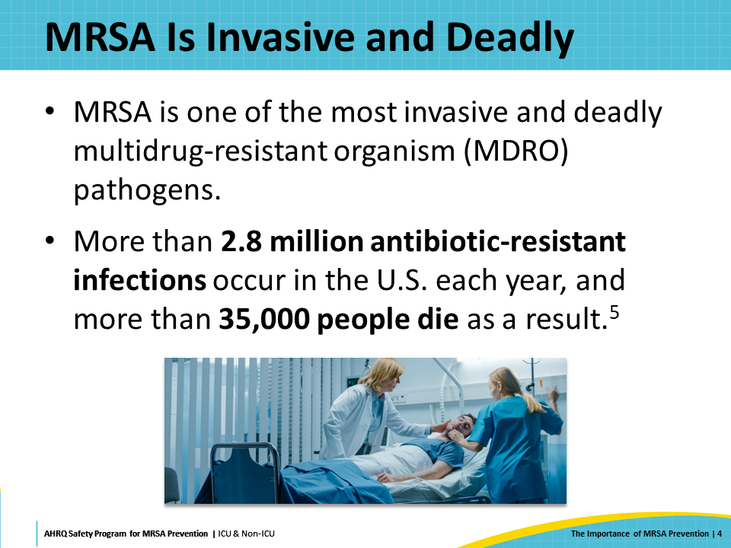
MRSA and Hospitalized Patients  SAY:  As a subset of antibiotic-resistant infections, MRSA incidence has decreased since 2013, but the pathogen continues to be a serious threat, with more than 323,000 cases detected in hospitalized patients and over 10,000 deaths reported each year. In addition, data from 2020 shows an increase in healthcare-associated antimicrobial-resistant infections, including MRSA bacteremia, during the COVID-19 pandemic.  Therefore, preventing MRSA infection and MRSA transmission among hospitalized patients is a very important patient safety goal. | Slide 5  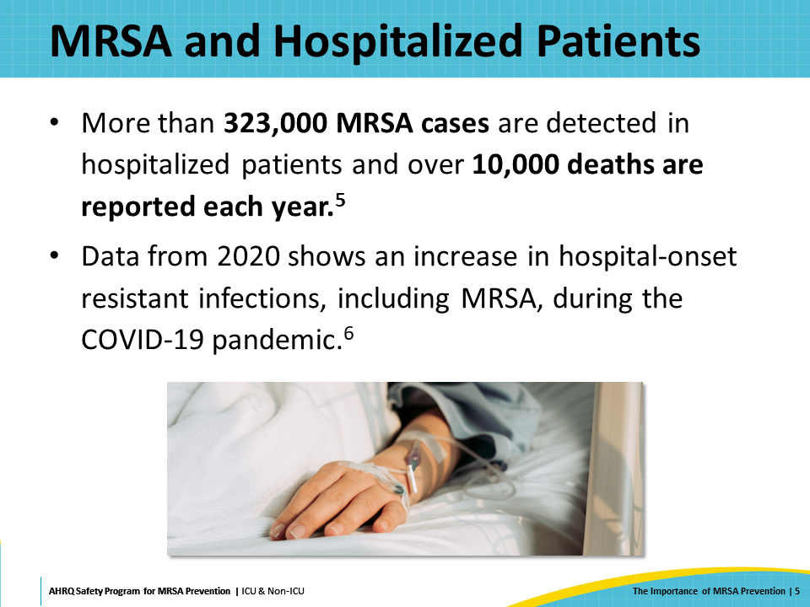
Healthcare-Associated Infections (HAIs)  SAY:  MRSA is a prominent cause of central line-associated bloodstream infections (CLABSI), ventilator-associated pneumonia (VAP), and surgical site infections (SSI).  In addition to the severe patient harm that these infections cause, many HAIs are publicly reported. Laboratory-identified (LabID) MRSA bacteremia is a publicly reported HAI, and CLABSI caused by MRSA adds to the incidence of MRSA bacteremia. HAIs, including those caused by MRSA, not only cause patient harm, but can negatively impact hospitals’ reputation and financial reimbursement from the Centers for Medicare & Medicaid Services (CMS). | Slide 6  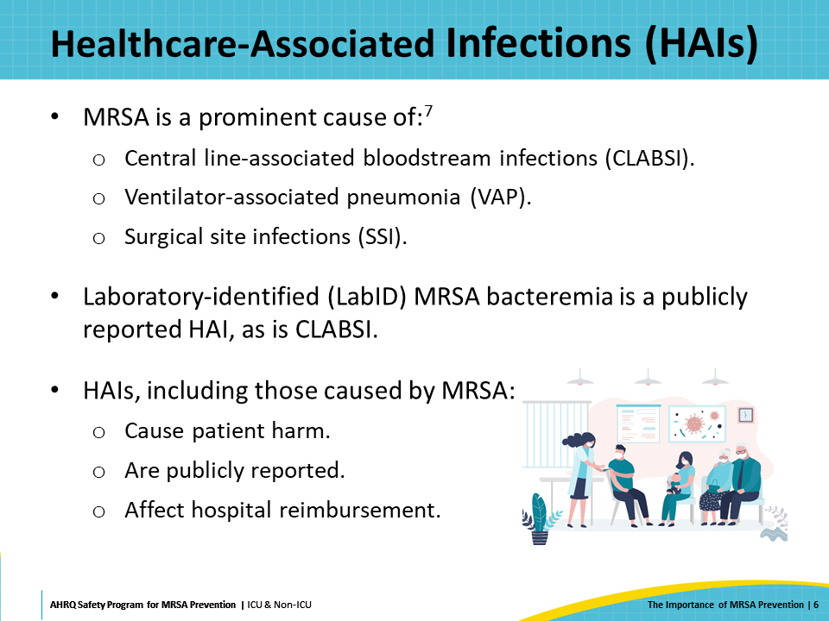
Antibiotic Resistance  SAY:  MRSA infections increase the use of antibiotics, which puts further pressure on the emergence and proliferation of antimicrobial-resistant organisms. Antibiotic pressure, caused by treating patients with courses of antibiotics with activity against S. aureus, can lead to selective advantage for antibiotic-resistant strains of S. aureus. This antibiotic pressure can also induce the expression of antibiotic resistance genes in S. aureus, leading to increasing antimicrobial resistance and treatment failures.  Overall, roughly 75 percent of S. aureus infections in ICUs are methicillin-resistant, as are approximately 60 percent of S. aureus infections in non-ICUs. As discussed, these MRSA infections are associated with increased cost, length of hospital stay, and increased patient morbidity and mortality. | Slide 7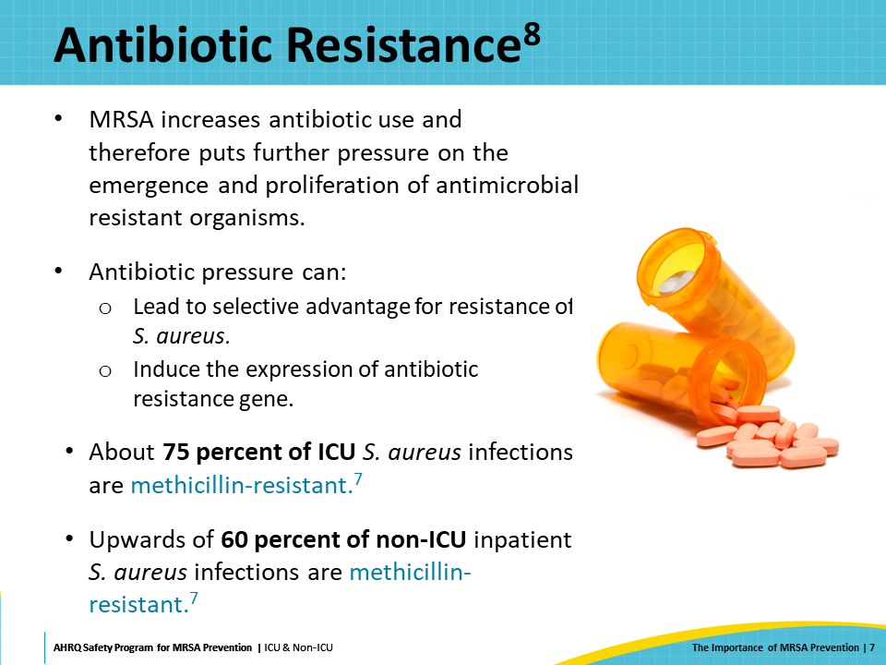
Summarizing MRSA as a Threat  SAY:  To recap, the major harms from MRSA infections include prolonging the length of hospitalization for both ICU and non-ICU patients and increasing patients’ morbidity and mortality, especially for those who are critically or chronically ill and those whose defenses are reduced or bypassed by medical devices and procedures. MRSA infections increase the cost of healthcare and negatively impact hospitals’ reputation and reimbursement through public reporting and pay for performance programs.  MRSA also increases patients’ risk of HAIs, including CLABSI, VAP, and SSI, and leads to increased antibiotic utilization, which adds to the emergence and proliferation of antimicrobial-resistant organisms. | Slide 8  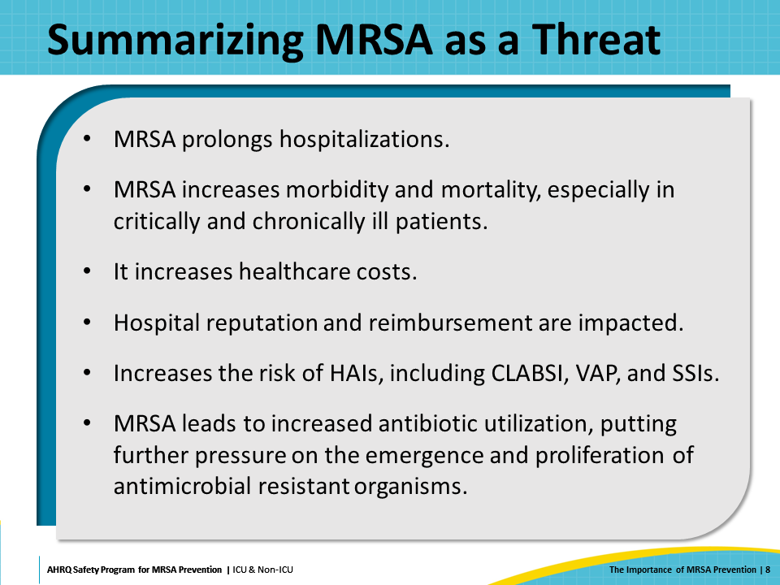
MRSA Transmission  SAY:  The next section will outline the common sources and pathways of MRSA transmission and infection. Understanding how MRSA spreads and occurs is important for purposes of MRSA prevention. | Slide 9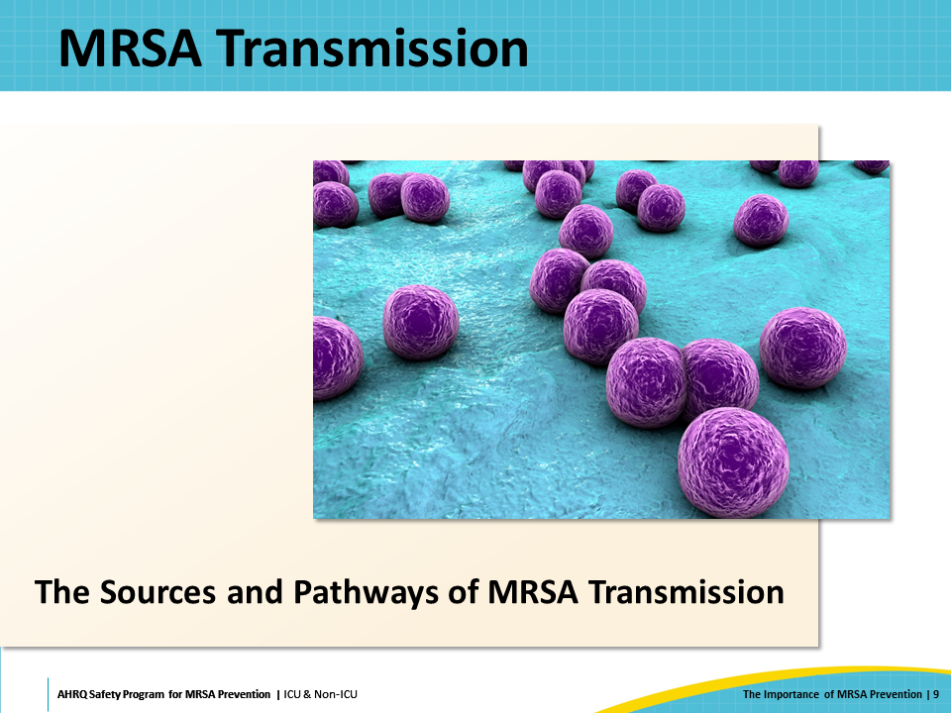
Pathways of MRSA Transmission and Infection  SAY:  There are several different potential pathways of MRSA transmission and infection.  A person’s own MRSA colonization can progress to invasive MRSA infection. Alternatively, a patient may acquire MRSA from another person who is colonized with MRSA and become infected. The environment around a patient with MRSA can become contaminated with the pathogen—particularly high-touch surfaces like bedrails, door handles, and medical equipment. MRSA from the environment or on colonized and infected patients can be transmitted to other patients via healthcare personnel or shared medical equipment.  Therefore, implementing multiple strategies to target different mechanisms of transmission and infection is important for effective MRSA transmission. | Slide 10  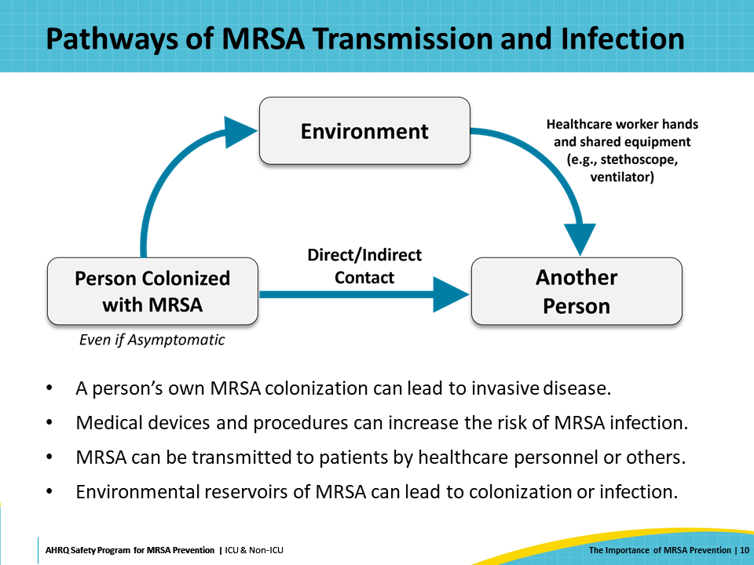
Colonization Is One Pathway to MRSA Infection  SAY:  MRSA can colonize a patient’s skin, nares, and body, becoming a part of their microbiome. People can be colonized with MRSA without experiencing any symptoms. However, during hospitalization, underlying illnesses or treatment with medical devices and procedures can decrease or bypass patients’ natural defenses, placing them at increased risk for HAIs and invasive MRSA infection. | Slide 11  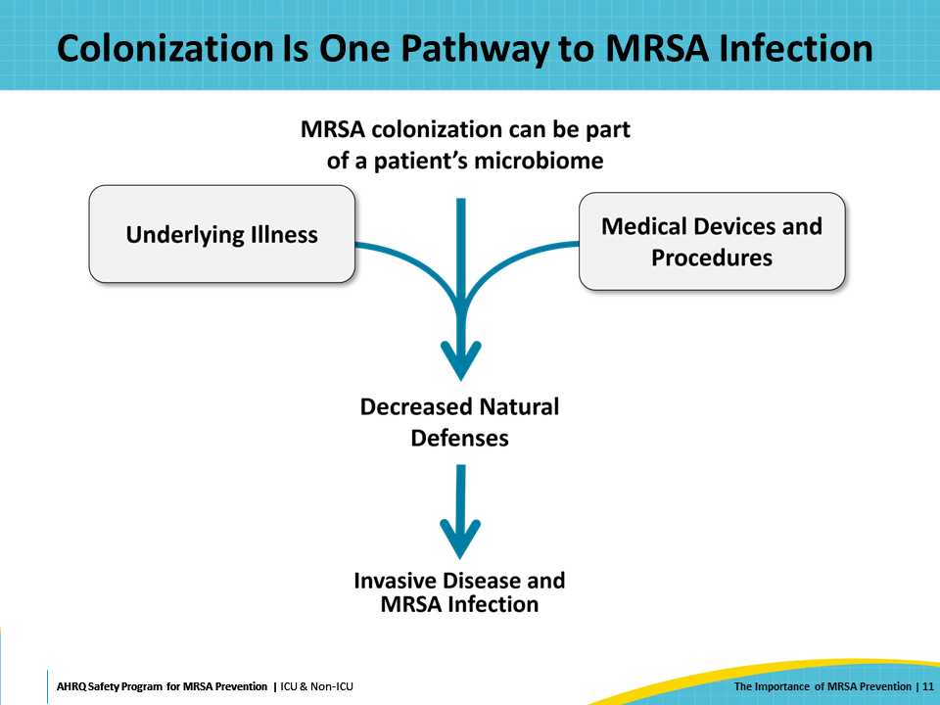
Patients Colonized With MRSA  SAY:  There are several important reservoirs—or sources—of MRSA that can ultimately lead to MRSA transmission and invasive disease. One significant reservoir is asymptomatic patients who are colonized with MRSA. One national survey estimated that around 7 percent of patients already harbor MRSA at the time of their hospital admission.  Not only is carriage common in healthcare settings, but the risk of progression to clinical disease among hospitalized patients who carry MRSA is high. Up to 11 percent of inpatients who test positive for MRSA colonization develop MRSA disease during their hospital stay. Among patients who are critically ill, this risk is higher, up to 30 percent. Prior work evaluating a large cohort of patients at an academic hospital showed that 33 percent of newly identified MRSA carriers experienced invasive MRSA disease in the subsequent year, and that 17 percent of these infections caused MRSA-attributable death.  Therefore, active MRSA surveillance is important. Surveillance enables a hospital or unit to know the burden of MRSA colonization among their patients. Appropriate steps to intervene and prevent transmission to other patients can be taken. For colonized patients, measures can be taken to prevent progression to invasive infection. | Slide 12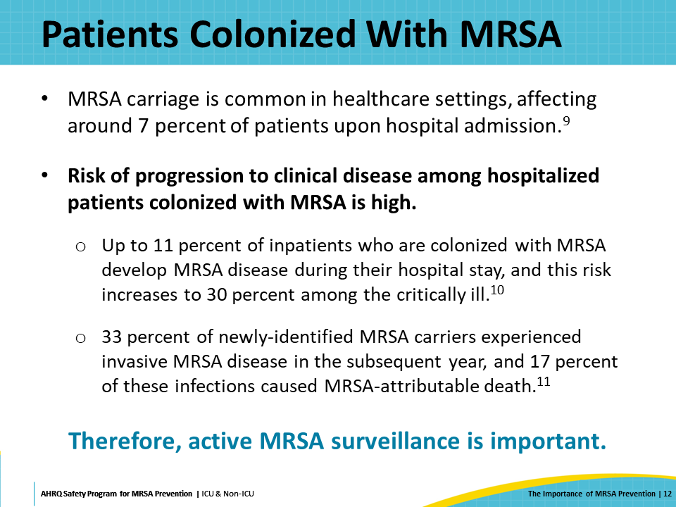
Sources of MRSA: Patient Care Environments  SAY:  MRSA can be transmitted through the patient care environment. High-touch surfaces and fomites can harbor MRSA and other pathogens that can be transmitted to vulnerable patients. Examples of high-touch surfaces include but are not limited to door handles, phones, counters, chairs, faucets, keyboards, IV pump buttons, bedrails, and curtains—as well as items that are often but not always in the environment directly around the patient, such as the overbed table. | Slide 13  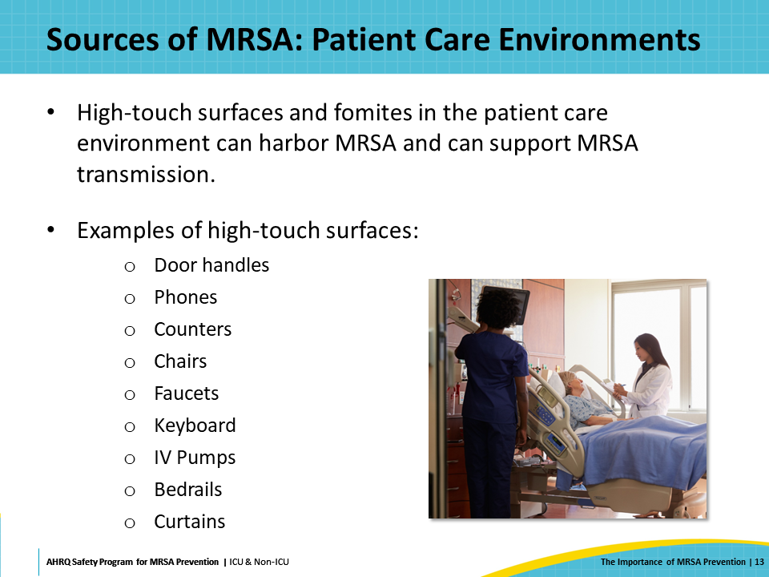
Sources of MRSA: Healthcare Personnel  SAY:  Healthcare personnel can inadvertently pick up and transfer organisms among patients and surfaces, leading to colonization or infection. For over 150 years, hand hygiene has been a fundamental and vitally important infection prevention practice. Several studies demonstrate that improving hand hygiene practices can lead to a reduction of HAIs and/or transmission and colonization by MDROs.  Despite these findings, estimates of hand hygiene adherence rates range from 81 percent to as low as 5 percent, with an average of 40 percent. Reasons for low adherence can include inconvenient location of sinks, task burden during staffing shortages, and skin irritation, as well as a lack of role models or systems of accountability for non-compliance with the guidelines.  Many tools exist for monitoring and improving hand hygiene adherence, but many inpatient units still have room for improvement in this fundamental infection prevention practice. | Slide 14  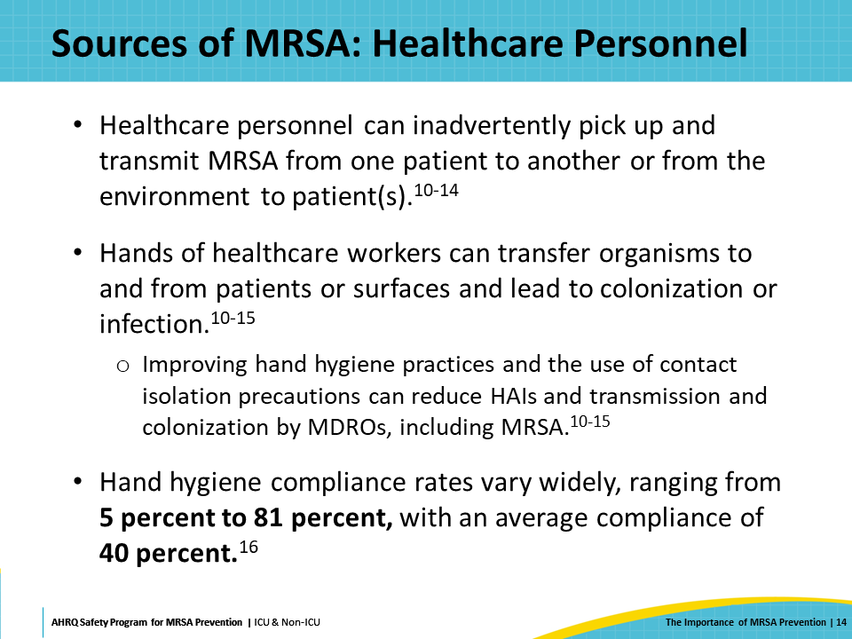
Portals of Entry for MRSA: Medical Devices and Procedures  SAY:  Treatment with medical devices or procedures are often necessary and can be lifesaving, but they can also place patients at increased risk for invasive MRSA infection and HAIs. Openings in the skin can provide a portal of entry for MRSA into the body. Central lines are particularly well-known as portals of entry for MRSA. Relatedly, CLABSI is a major contributor to invasive MRSA bacteremia. | Slide 15  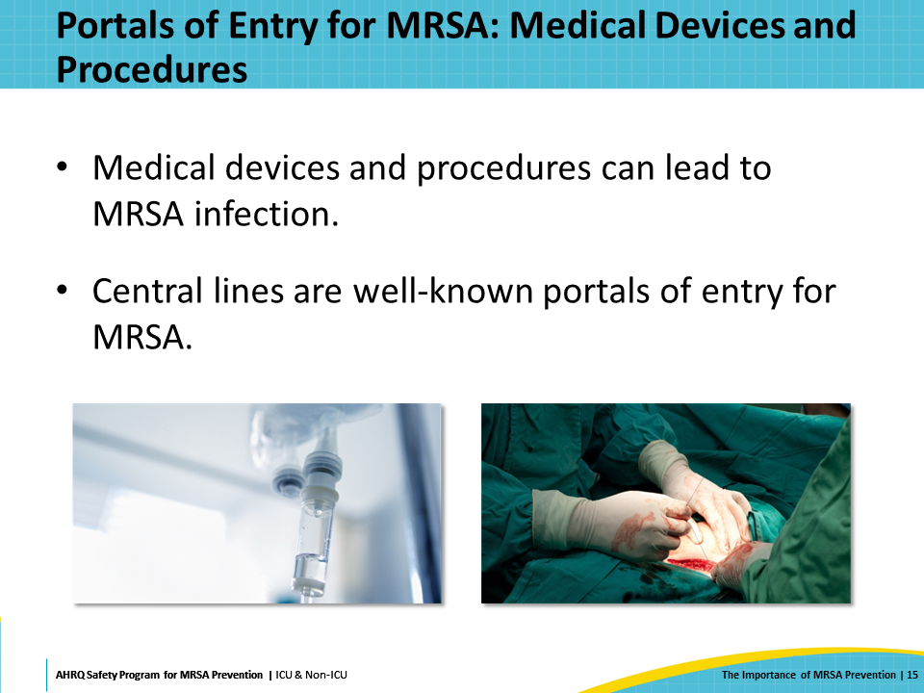
Summarizing Sources of MRSA  SAY:  In summary, to target and prevent MRSA, it is necessary to understand the four main sources or reservoirs of MRSA. These are patients colonized or infected with MRSA, contaminated environments and high-touch surfaces, people, including healthcare personnel, who can accidentally transmit MRSA, and medical devices and procedures. | Slide 16  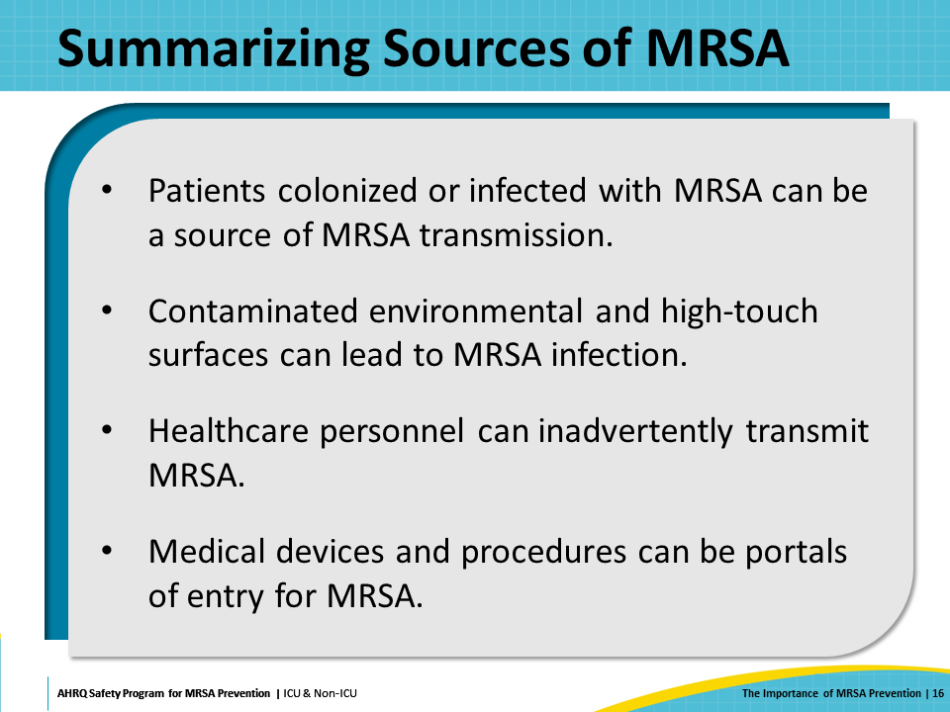
Take Aim and Target MRSA  SAY:  Next, this presentation will discuss four key strategies to take aim and target MRSA. | Slide 17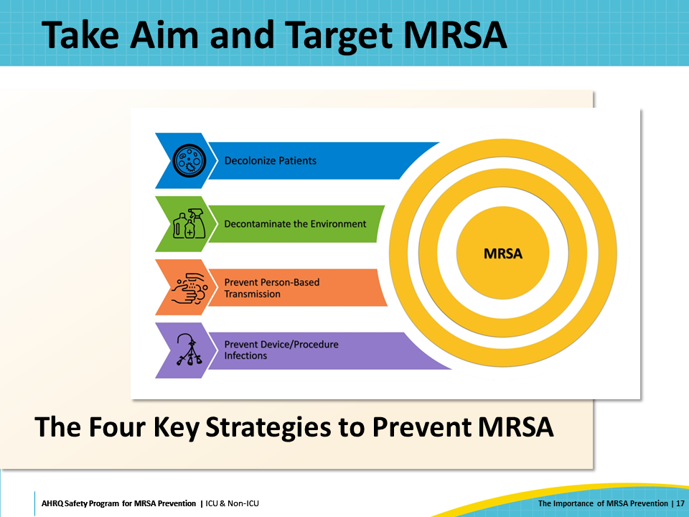
Key Strategies to Take Aim and Target MRSA Infection  SAY:  Now for some good news! MRSA is often preventable, and hospitals, units, and staff can do many things to prevent MRSA transmission and infection. In this project, we are going to focus on Four Key Strategies to Take Aim and Target MRSA Infection. These four strategic areas aim to prevent MRSA by interrupting the sources of MRSA, MRSA’s transmission among patients, and MRSA’s progression from colonization to invasive infection.  The Four Key Strategies are:  - Decolonizing Patients  - Decontaminating the Healthcare Environment  - Preventing Person-Based Transmission  - Preventing Device- and Procedure-Related Infections  This toolkit also covers two fundamental best practices, antibiotic stewardship and optimization of blood culture practices, which supplement the four key strategies to prevent MRSA. The next few slides will give a very brief overview of these four key strategies and the fundamental best practices. | Slide 18  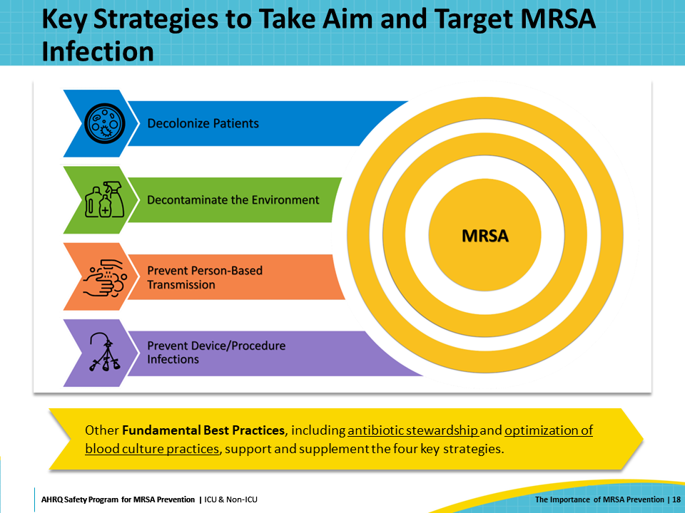
MRSA Colonization and Infection  SAY:  Although both colonization and infection involve the presence of MRSA, they affect patients in very different ways. MRSA colonization is defined as the presence of MRSA on or in a patient’s body without any current signs or symptoms of infection. Many microorganisms occur in the natural flora of the skin, intestines, and other organs, and do not cause adverse consequences. MRSA sometimes resides among this flora without causing any symptoms. Many people are colonized with MRSA without being aware of it.  However, even without current infection, MRSA colonization can still be dangerous, both to the colonized patient and to others. MRSA can still be spread from colonized patients to others, even if the colonized patient is asymptomatic.  MRSA infection occurs when MRSA on or in a patient’s body begins to cause invasive disease or adverse effects, observed as signs and symptoms of infection. | Slide 19  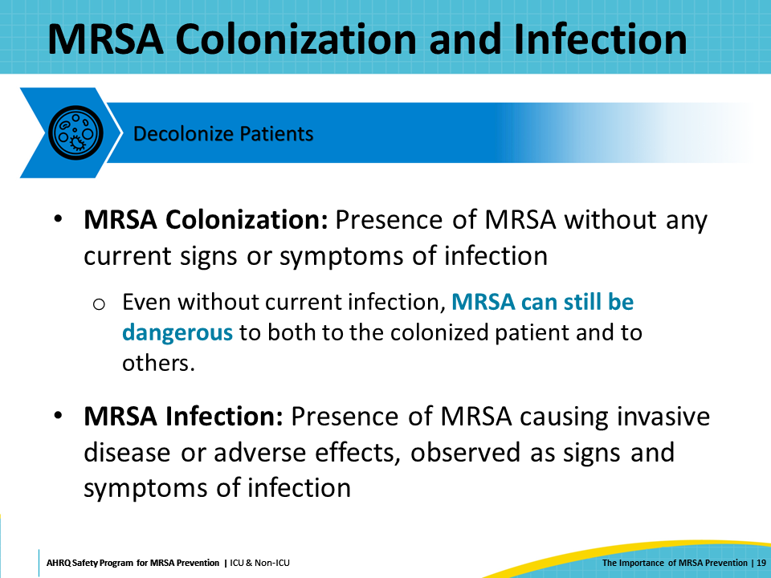
Transition From MRSA Colonization to Infection  SAY:  The progression from MRSA colonization to infection can happen due to several reasons, such as reduced immunity due to medications or underlying illness; devices, procedures, or wounds providing portals of entry; increased virulence and pathogenic properties of a given MRSA strain; or an altered microbiome due to antibiotic treatment. | Slide 20  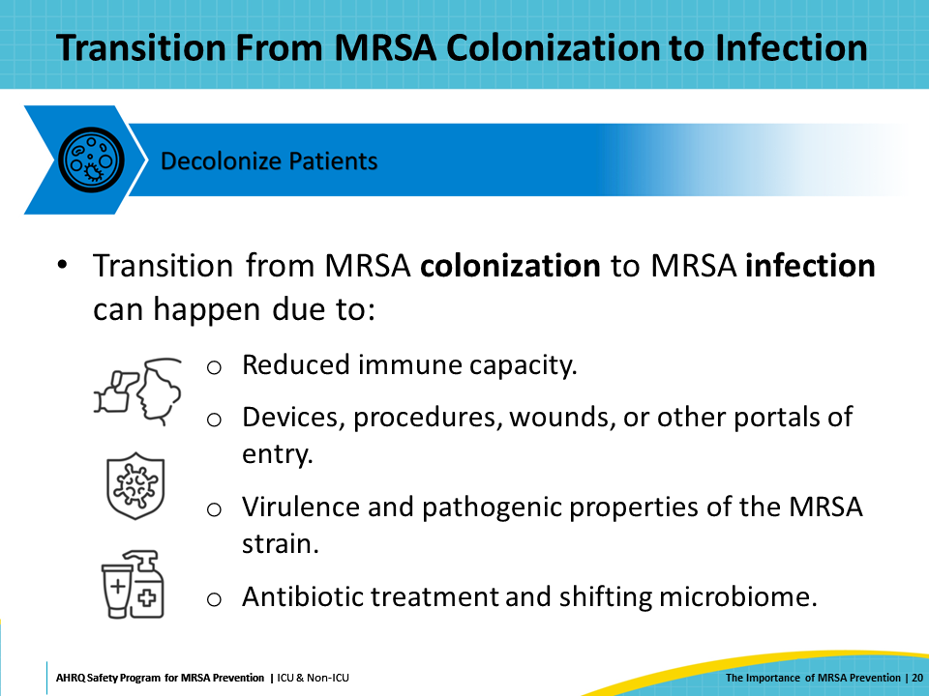
Decolonization Methods  SAY:  Because of the increased risk during hospitalization, decolonizing patients can be a very impactful practice. Decolonization refers to eliminating or reducing colonizing bacteria on a patient's body.  MRSA decolonization prevention generally consists of skin treatment with daily bathing using a chlorhexidine gluconate solution, and nasal decolonization with application of nasal mupirocin or iodine-based products. These strategies reduce the MRSA burden, which reduces the likelihood of MRSA infection and transmission. | Slide 21  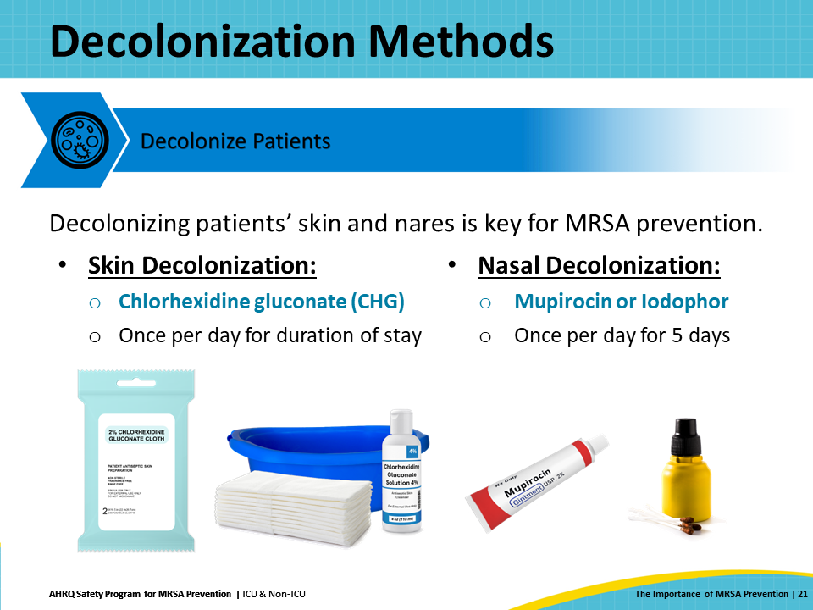
Benefits of Decolonization  SAY:  Decolonization decreases MRSA colonization of the skin, nares, and other microbiome reservoirs and reduces the likelihood of progression to MRSA infection via medical devices, wounds, or other portals of entry. It also reduces the risk of MRSA transmission to other patients via environmental reservoirs, healthcare personnel, or medical devices. | Slide 22  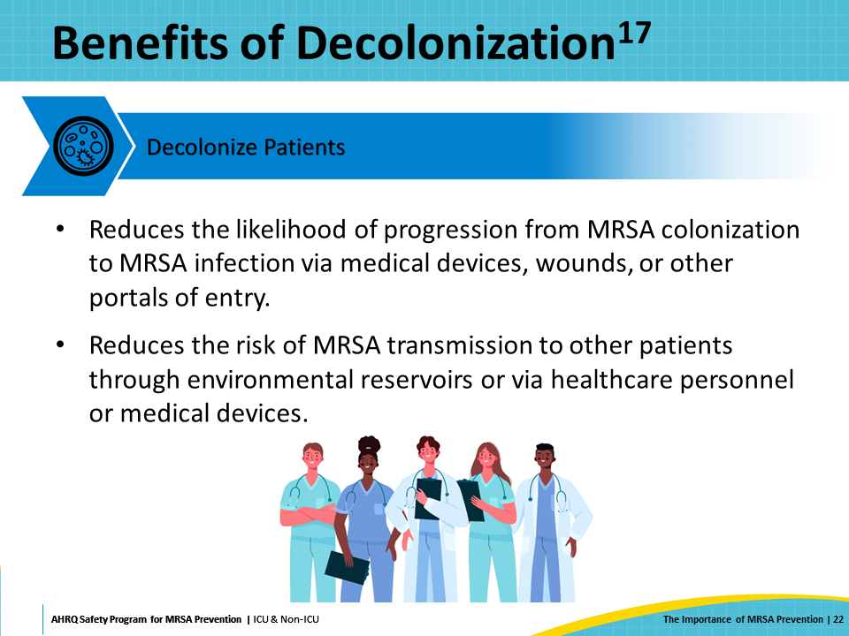
Decontaminate the Environment  SAY:  The second key strategy in targeting MRSA is to decontaminate the environment. The practice of thorough daily room cleaning and disinfection is important to prevent MRSA transmission to susceptible patients. Daily cleaning and disinfection of the patient’s entire room should be supplemented with frequent cleaning and disinfection of high-touch surfaces. To ensure that environmental cleaning is optimized, it is also important to monitor, measure, and report on the effectiveness of environmental cleaning and disinfection. | Slide 23  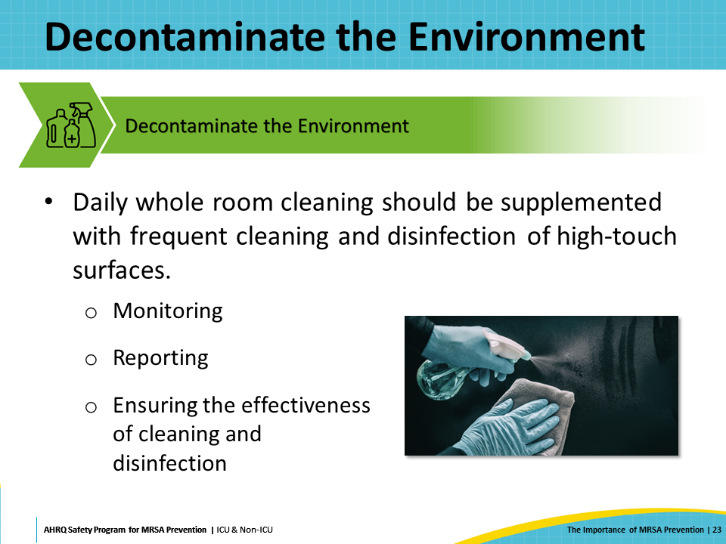
Environmental Cleaning  SAY:  Interventions to improve environmental cleaning and disinfection can be complex and multi-faceted. Enhanced training and clarification of cleaning and disinfection protocols are essential to ensure that the proper products, disinfectants, and methods are employed. Cleaning personnel must feel engaged and included in the improvement and patient safety interventions to improve and sustain excellent environmental cleaning and disinfection of the patient care environment. | Slide 24  
Prevent Person-Based Transmission  SAY:  The third key strategy for targeting MRSA is to prevent person-based transmission. People, including healthcare personnel, can inadvertently become vectors of MRSA transmission among patients if they are not vigilant and meticulous in their adherence to infection prevention practices. These practices include, but are not limited to, hand hygiene, the proper use of personal protective equipment, and the practice of standard precautions or transmission-based isolation precautions. Therefore, robust programs to promote and hold healthcare personnel accountable for these practices are important for MRSA prevention. | Slide 25  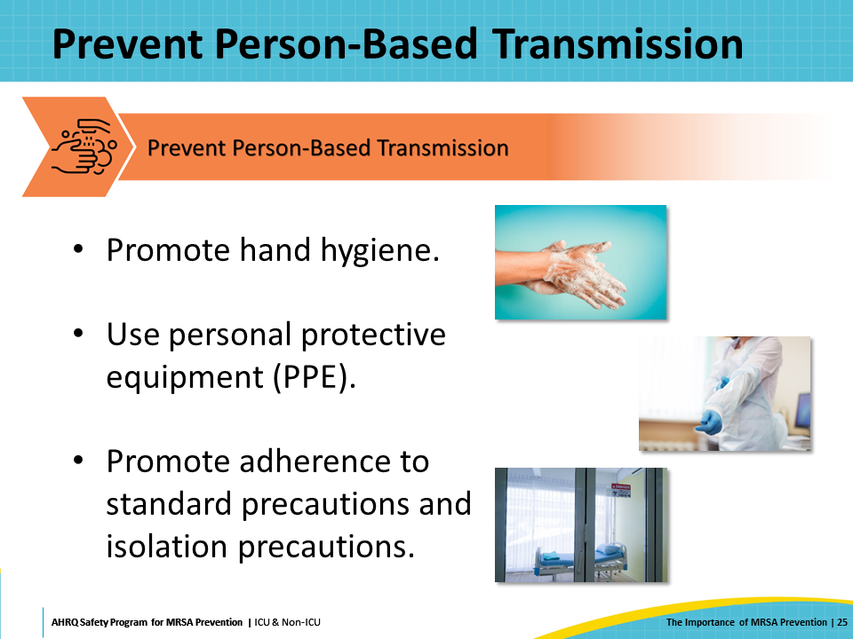
Prevent Device- and Procedure-Related Infections  SAY:  The fourth key strategy to take aim and target MRSA is to prevent MRSA infection from devices and procedures. This is accomplished by employing evidence-based interventions to optimize prevention of healthcare-associated infections including central-line-associated bloodstream infection (CLABSI) and ventilator-associated pneumonia (VAP). Implementing interventions to prevent infections such as CLABSI and VAP helps to prevent MRSA and other infectious pathogens broadly. | Slide 26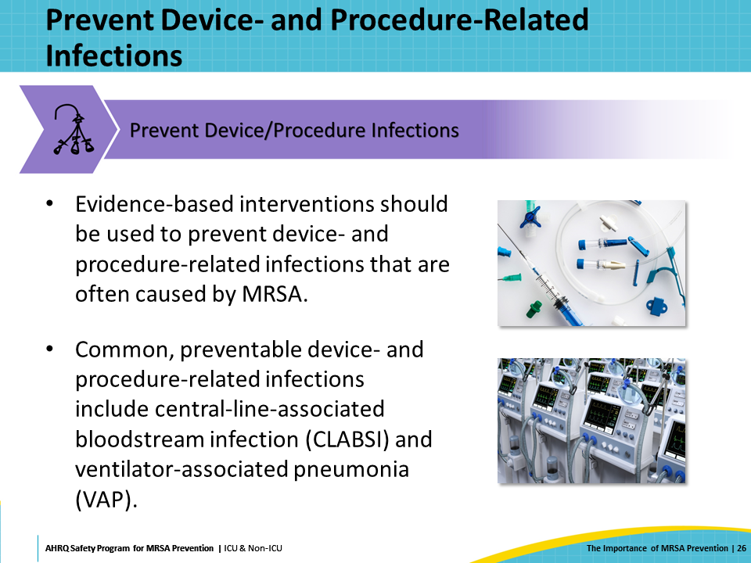
Fundamental Best Practices  SAY:  Antibiotic Stewardship and Blood Culture Stewardship are essential best practices that do not fall in one of the four key strategies but are fundamentally important for MRSA prevention. Antibiotic stewardship aims to optimize the use of antibiotics by ensuring antibiotics are prescribed appropriately. Overuse and misuse of antibiotics are primary contributors to the emergence of resistance. Antibiotic stewardship promotes processes to select the right drug with the right dose at the right time for the right duration.  Blood culture stewardship focuses on optimizing the use of blood cultures to promote diagnostic accuracy and reduce inappropriate antibiotic treatment based on contaminated results. Blood cultures are one of the most common microbiologic tests ordered in hospitalized patients. Blood culture stewardship efforts improve the accuracy and reliability of blood cultures, which improves the use of antibiotics and reduces the spread of resistance.  Consequently, antibiotic stewardship and blood culture stewardship are crucial for MRSA prevention. Improving diagnostic accuracy and optimizing the use of antibiotics are vital to maintaining the effectiveness of current treatments, reducing healthcare costs, and improving patient outcomes. | Slide 27  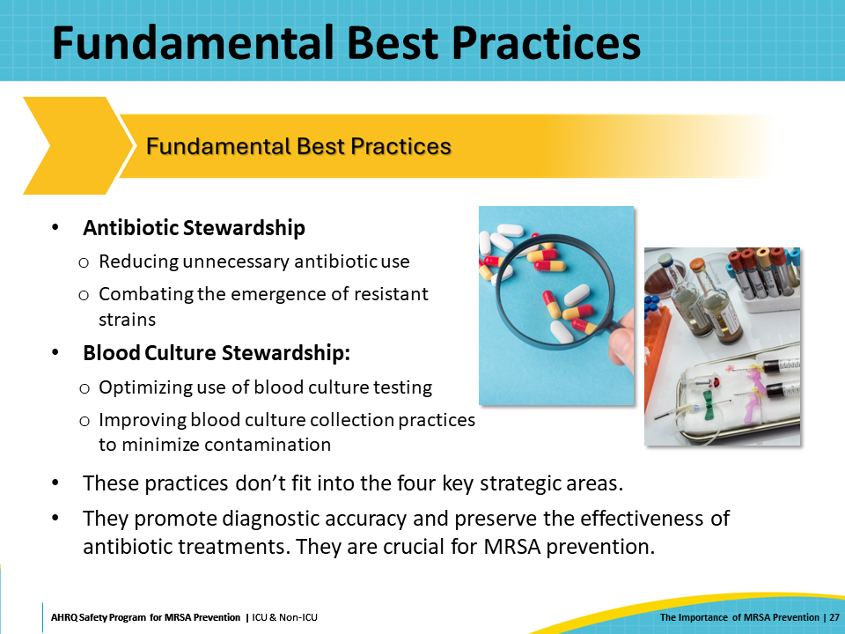
Key Strategies: Take Aim and Target MRSA Infection  SAY:  Even though MRSA is one of the most ubiquitous, invasive, and deadly MDROs, basic infection prevention practices can be used to reduce its transmission and prevent infections. The AHRQ Toolkit for MRSA Prevention in the ICU & Non-ICU optimizes MRSA prevention by focusing on decolonizing patients, decontaminating the environment, preventing MRSA transmission from healthcare personnel, and implementing evidence-based best practices for prevention of device- and procedure-related HAIs. These Four Key Strategies to take aim and target MRSA infection are evidence-based, basic infection prevention practices. Working together and using these key strategies, hospitals, units, and staff can protect patients from MRSA transmission and infection. | Slide 28  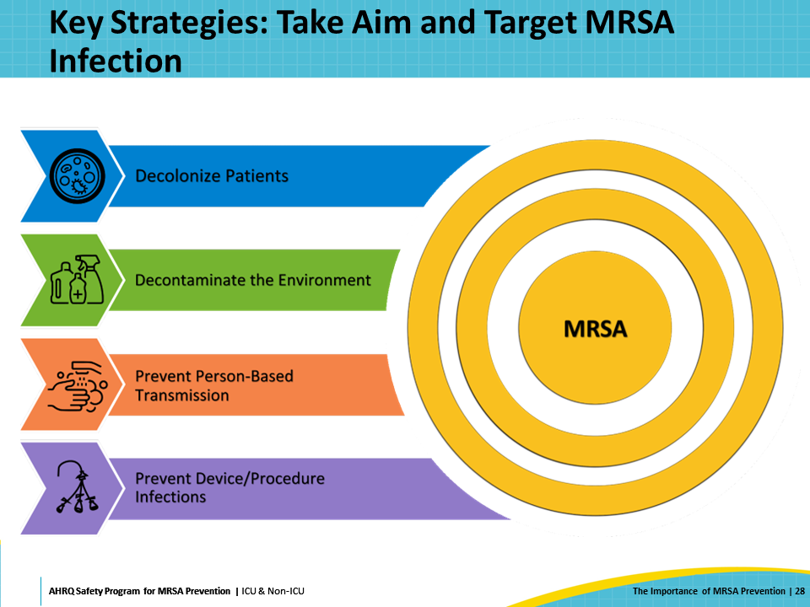
Key Takeaways  SAY:  In conclusion, MRSA infections are associated with many adverse outcomes, including prolonged hospital stays and increased mortality. It is crucial to take steps to prevent MRSA infections. Sources and pathways of MRSA transmission can include people and the environment, especially high-touch surfaces such as door handles, bedrails, counters, and more. Cleaning and disinfecting surfaces, hands, and medical devices are especially important to prevent MRSA infections. The four key strategies to target MRSA can be summarized as decolonization, decontamination, preventing person-based transmission, and preventing device or procedure transmission. | Slide 29  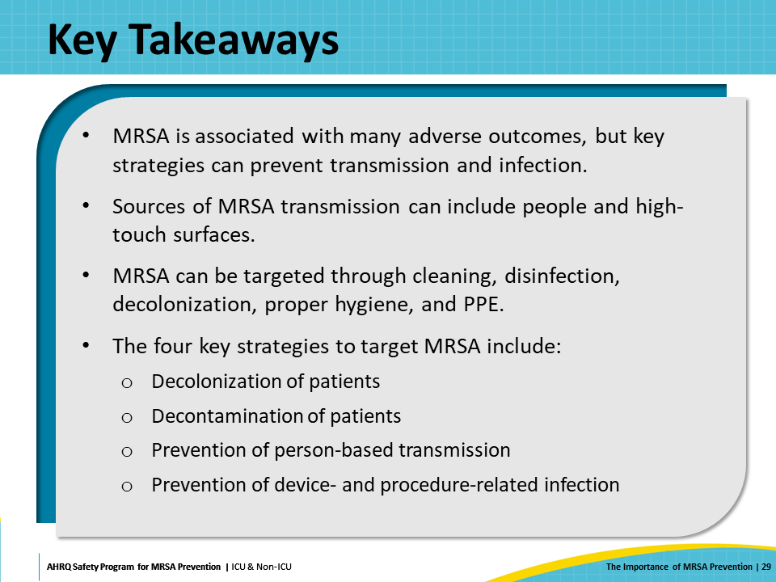
Disclaimer  SAY:  The findings and recommendations in this presentation are those of the authors, who are responsible for its content, and do not necessarily represent the views of AHRQ. No statement in this presentation should be construed as an official position of AHRQ or of the U.S. Department of Health and Human Services.  Any practice described in this presentation must be applied by healthcare practitioners in accordance with professional judgment and standards of care in regard to the unique circumstances that may apply in each situation they encounter. These practices are offered as helpful options for consideration by healthcare practitioners, not as guidelines. | Slide 30  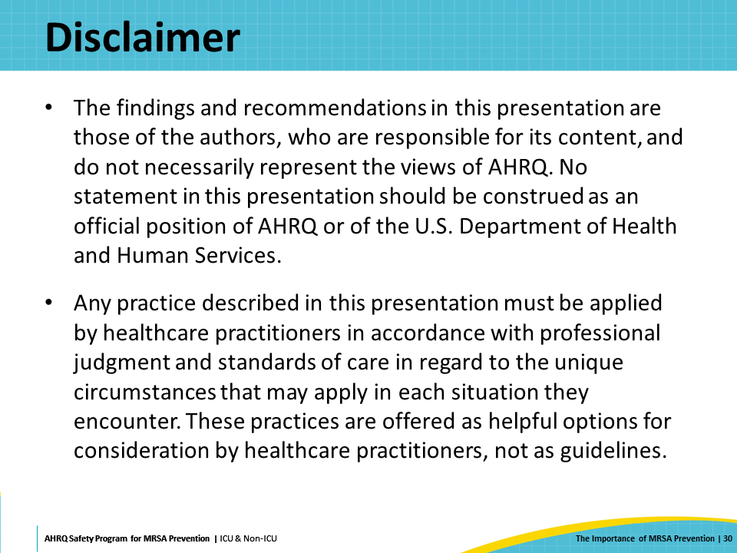
Reference List—1 | Slide 31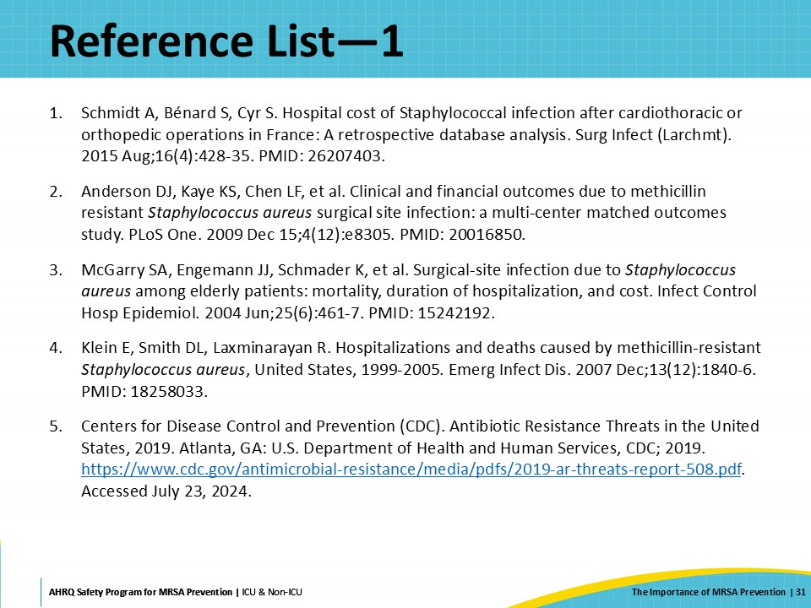
Reference List—2 | Slide 32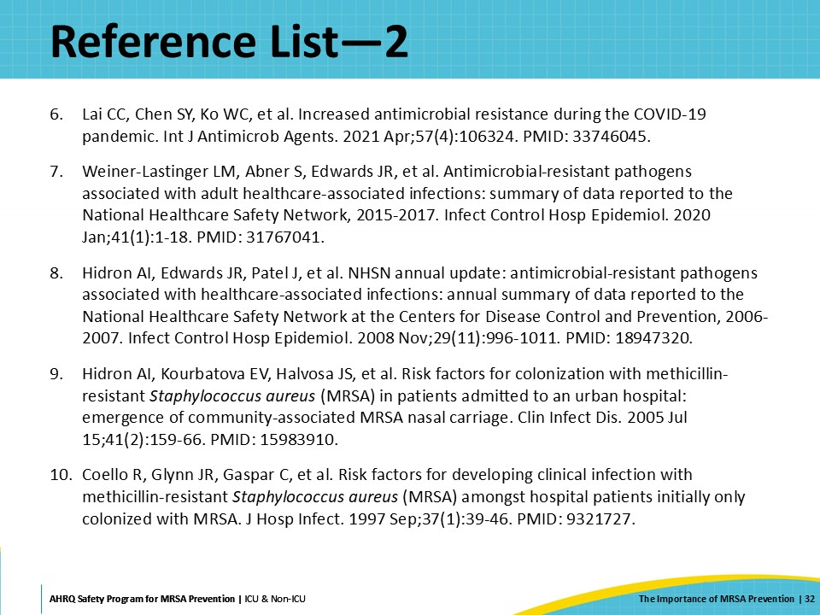
Reference List—3 | Slide 33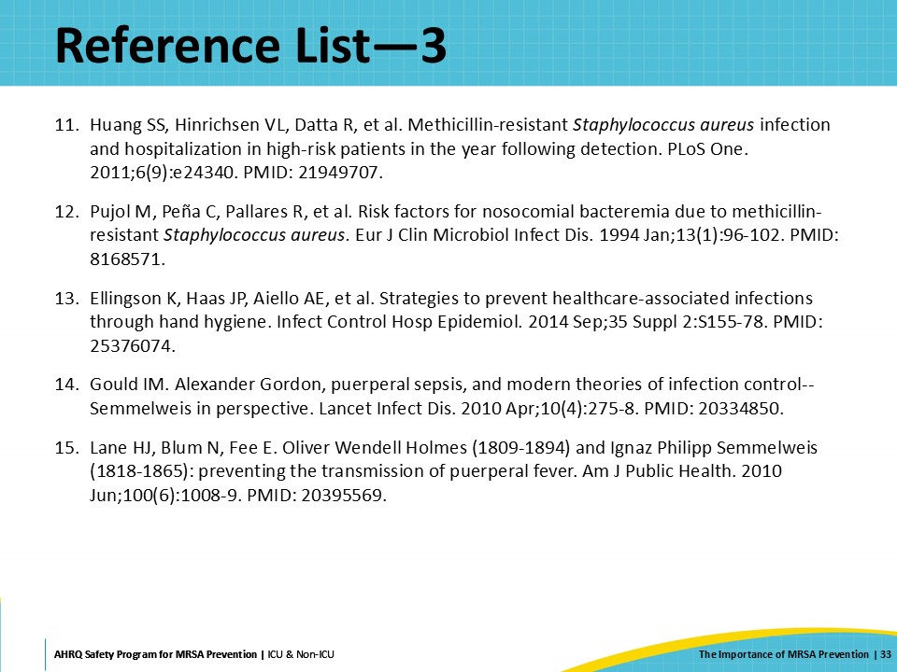
Reference List—4 | Slide 34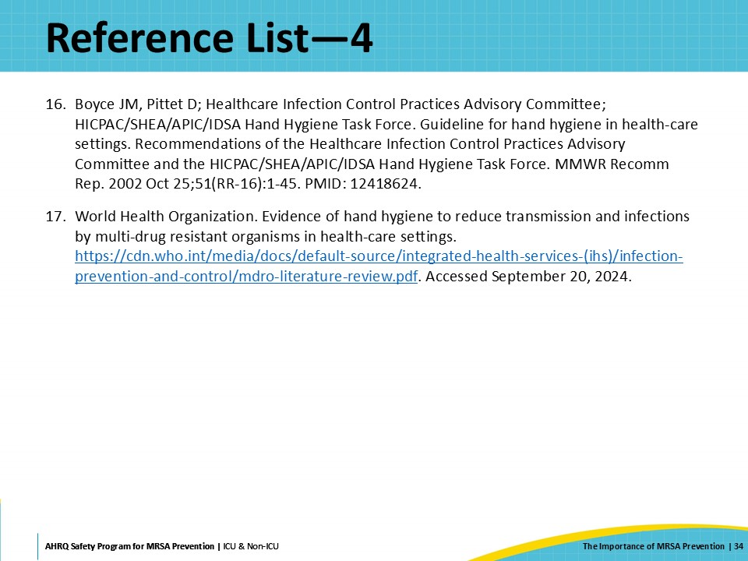

AHRQ Pub. No. 25-0007
October 2024

