# The Impact of Methicillin-Resistant *Staphylococcus aureus* (MRSA)

## MRSA is one of the most invasive and deadly multi-drug resistant organisms (MDROs).

* + Over 2.8 million infections and over 35,000 people die in the U.S. every year.1
  + MRSA infections are associated with the following:
    - Prolonged length of stay in hospital.2-3
    - Excessive healthcare costs.2-4
    - Increased morbidity and mortality.4
  + MRSA is a leading cause of central line-associated bloodstream infections, ventilator-associated pneumonia, and surgical site infections (SSIs).5

## Treatment of MRSA adds to the emergence and proliferation of antimicrobial-resistant organisms.5-6

* Treating patients with courses of antibiotics against *S. aureus* can cause antibiotic pressure, leading to selective advantage for antibiotic-resistant strains.
* The majority of *S. aureus* infections among hospitalized patients are methicillin-resistant: about 75 percent in the intensive care unit (ICU) and upwards of 60 percent in the non-ICU.5,7

# Four Main Sources and Pathways of MRSA Transmission and Infection

## A person’s own MRSA colonization can lead to invasive disease.

* + MRSA can colonize the skin, nares, or other parts of the body without signs or symptoms.
    - MRSA carriage is common in healthcare settings, affecting 7 percent of inpatients upon admission.8
  + Infection occurs when colonization progresses to invasive disease. Hospitalization raises the likelihood of this happening.
    - Up to 11 percent of hospital inpatients who are colonized with MRSA will develop invasive infection during their stay, and this risk increases to 30 percent among the critically ill.9
  + People colonized with MRSA can spread it to others or the environment, even if they are asymptomatic.

## Environmental reservoirs of MRSA can lead to colonization or infection.10

* + High-touch surfaces (HTS) and fomites can harbor MRSA and other pathogens.
    - This can then be transmitted between patients or from surfaces to a vulnerable patient.
  + Examples of HTS include but are not limited to intravenous poles, bedrails, and over-bed tables.

## Healthcare personnel can transfer organisms to patients or surfaces, leading to colonization or infection.

* + Healthcare personnel can inadvertently transmit MRSA between patients or from the environment to patient(s).9,11-14
  + Improving hand hygiene practices can lead to a reduction of healthcare-associated infections (HAIs) and/or transmission and colonization by MDROs.9,11-15
  + However, hand hygiene compliance rates vary widely in healthcare settings, ranging from 5 percent to 81 percent, with an average compliance of 40 percent.16

## Medical devices and procedures can decrease or bypass patients’ natural defenses.

* + Medical devices or procedures can be life-saving but poses increased risk for HAIs by creating portals of entry.
  + MRSA caused 48.4 percent of device-associated HAIs and 41.9 percent of SSIs in acute care facilities from 2015 to 2017.5

**To take aim and target MRSA, it is necessary to understand and address the four main sources or reservoirs of MRSA.**

1. 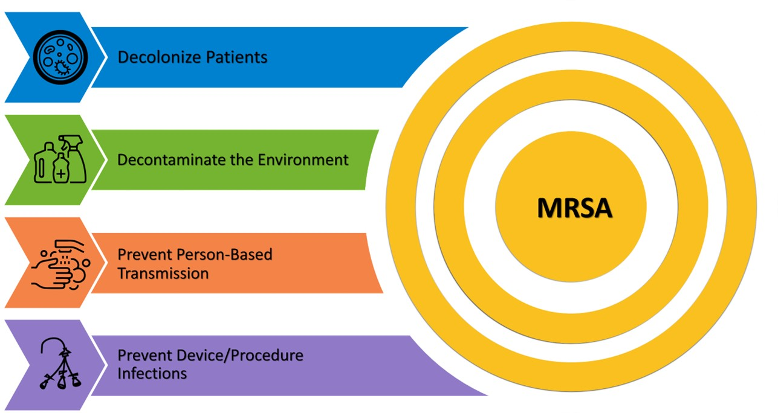**Decolonizing patients** targets individuals colonized with MRSA, who represent the primary reservoir of MRSA.
2. **Decontaminating the healthcare environment** removes MRSA from HTS and fomites.
3. **Preventing person-based transmission** reduces the likelihood of healthcare workers spreading MRSA.
4. **Preventing device- and procedure-related infections** addresses the elevated infection risks that devices and procedures pose.

More info can be found on [**The 4 Key Strategies of MRSA Prevention**](https://www.ahrq.gov/hai/tools/mrsa-prevention/toolkit/key-strategies.html) and [**The Importance of MRSA Prevention**](https://www.ahrq.gov/hai/tools/mrsa-prevention/toolkit/importance.html) pages of the Toolkit website.

# References

1. Centers for Disease Control and Prevention (CDC). Antibiotic Resistance Threats in the United States, 2019. Atlanta, GA: U.S. Department of Health and Human Services, CDC; 2019. <https://www.cdc.gov/antimicrobial-resistance/media/pdfs/2019-ar-threats-report-508.pdf>.
2. Schmidt A, Bénard S, Cyr S. Hospital cost of staphylococcal infection after cardiothoracic or orthopedic operations in France: a retrospective database analysis. Surg Infect (Larchmt). 2015 Aug;16(4):428-35. PMID: 26207403.
3. Anderson DJ, Kaye KS, Chen LF, et al. Clinical and financial outcomes due to methicillin resistant *Staphylococcus aureus* surgical site infection: a multi-center matched outcomes study. PLoS One. 2009 Dec 15;4(12):e8305. PMID: 20016850.
4. McGarry SA, Engemann JJ, Schmader K, et al. Surgical-site infection due to *Staphylococcus aureus* among elderly patients: mortality, duration of hospitalization, and cost. Infect Control Hosp Epidemiol. 2004 Jun;25(6):461-7. PMID: 15242192.
5. Weiner-Lastinger LM, Abner S, Edwards JR, et al. Antimicrobial-resistant pathogens associated with adult healthcare-associated infections: Summary of data reported to the National Healthcare Safety Network, 2015-2017. Infect Control Hosp Epidemiol. 2020 Jan;41(1):1-18. PMID: 31767041.
6. Hidron AI, Edwards JR, Patel J, et al. NHSN annual update: antimicrobial-resistant pathogens associated with healthcare-associated infections: annual summary of data reported to the National Healthcare Safety Network at the Centers for Disease Control and Prevention, 2006-2007. Infect Control Hosp Epidemiol. 2008 Nov;29(11):996-1011. PMID: 18947320.
7. Jarvis WR, Schlosser J, Chinn RY, et al. National prevalence of methicillin-resistant *Staphylococcus aureus* in inpatients at US health care facilities, 2006. Am J Infect Control. 2007 Dec;35(10):631-7. PMID: 18063126.
8. Hidron AI, Kourbatova EV, Halvosa JS, et al. Risk factors for colonization with methicillin-resistant *Staphylococcus aureus* (MRSA) in patients admitted to an urban hospital: emergence of community-associated MRSA nasal carriage. Clin Infect Dis. 2005 Jul 15;41(2):159-66. PMID: 15983910.
9. Coello R, Glynn JR, Gaspar C, et al. Risk factors for developing clinical infection with methicillin-resistant *Staphylococcus aureus* (MRSA) amongst hospital patients initially only colonized with MRSA. J Hosp Infect. 1997 Sep;37(1):39-46. PMID: 9321727.
10. Cobrado L, Silva-Dias A, Azevedo MM, et al. High-touch surfaces: microbial neighbours at hand. Eur J Clin Microbiol Infect Dis. 2017 Nov;36:2053-62. PMID: 28647859.
11. Pujol M, Peña C, Pallares R, et al. Risk factors for nosocomial bacteremia due to methicillin-resistant *Staphylococcus aureus*. Eur J Clin Microbiol Infect Dis. 1994 Jan;13(1):96-102. PMID: 8168571.
12. Huang SS, Hinrichsen VL, Datta R, et al. Methicillin-resistant *Staphylococcus aureus* infection and hospitalization in high-risk patients in the year following detection. PLoS One. 2011;6(9):e24340. PMID: 21949707.
13. Ellingson K, Haas JP, Aiello AE, et al. Strategies to prevent healthcare-associated infections through hand hygiene. Infect Control Hosp Epidemiol. 2014 Sep;35 Suppl 2:S155-78. PMID: 25376074.
14. Gould IM. Alexander Gordon, puerperal sepsis, and modern theories of infection control--Semmelweis in perspective. Lancet Infect Dis. 2010 Apr;10(4):275-8. PMID: 20334850.
15. Lane HJ, Blum N, Fee E. Oliver Wendell Holmes (1809-1894) and Ignaz Philipp Semmelweis (1818-1865): preventing the transmission of puerperal fever. Am J Public Health. 2010 Jun;100(6):1008-9. PMID: 20395569.
16. Boyce JM, Pittet D; Healthcare Infection Control Practices Advisory Committee; HICPAC/SHEA/APIC/IDSA Hand Hygiene Task Force. Guideline for hand hygiene in health-care settings. Recommendations of the Healthcare Infection Control Practices Advisory Committee and the HICPAC/SHEA/APIC/IDSA Hand Hygiene Task Force. MMWR Recomm Rep. 2002 Oct 25;51(RR-16):1-45. PMID: 12418624.

AHRQ Pub. No. 25-0007

October 2024