MRSA Surveillance
ICU & Non-ICU
Slide Title and Commentary | Slide Number and Slide
MRSA Surveillance  SAY:  Welcome to this presentation on MRSA Surveillance, which will explain how various approaches to MRSA surveillance help to prevent transmission of MRSA in intensive care unit (ICU) and non-ICU settings. | Slide 1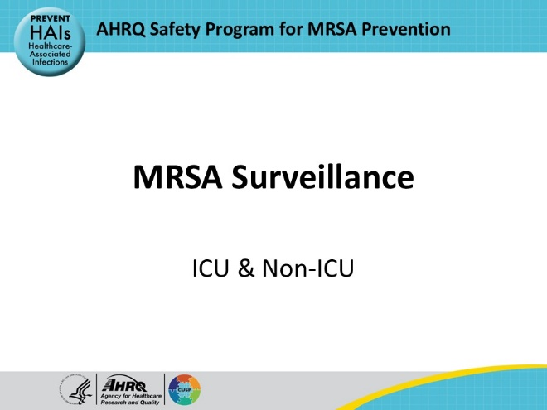
Educational Objectives  SAY:  This presentation will describe both active and passive approaches to surveillance of methicillin-resistant Staphylococcus aureus (MRSA), discuss the pros and cons of various approaches to MRSA surveillance, and outline how these types of surveillance offer beneficial information that can inform MRSA prevention approaches and help to optimize antimicrobial treatment even in the setting of ICU and non-ICU hospital units that utilize universal MRSA decolonization strategies. | Slide 2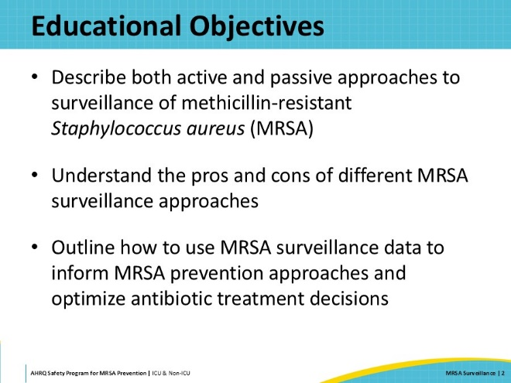
Key Strategies To Take Aim & Target MRSA Infection  SAY:  The four main strategies to prevent MRSA transmission and infection include decolonizing patients, decontaminating the environment, preventing person-based transmission, and preventing device- and procedure-related infections.  MRSA surveillance is interrelated with decolonizing patients and preventing person-based transmissions. | Slide 3  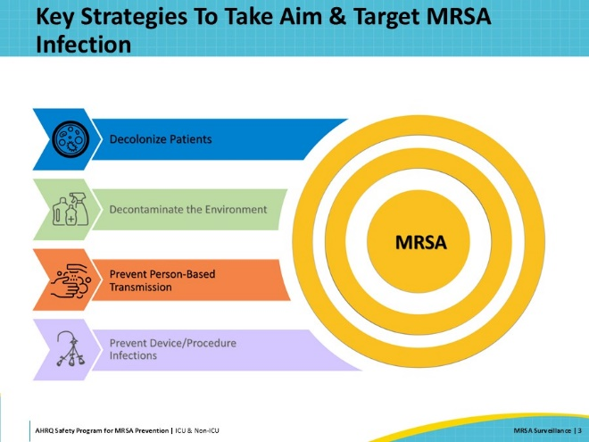
MRSA Is a Serious Threat  SAY:  MRSA is a serious threat to patient safety.  According to the Centers for Disease Control and Prevention (CDC), each year more than 323,000 cases of MRSA are detected among hospitalized patients, leading to over 10,000 deaths in the United States. CDC estimates that the attributable healthcare costs are 1.7 billion US dollars. | Slide 4  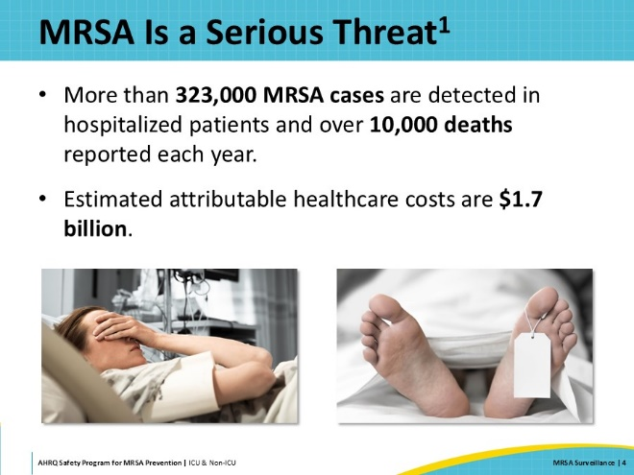
MRSA Carriage Is Common in Healthcare Settings  SAY:  Colonization is defined as the presence of a microorganism on or in a patient’s body without any signs or symptoms of infection. These microorganisms can be dangerous to the colonized patient and to others. Colonization can progress to infection, and organisms can be spread from colonized patients to others. National and hospital surveys estimate MRSA carrier prevalence among hospitalized inpatients is between 5 and 7 percent. | Slide 5  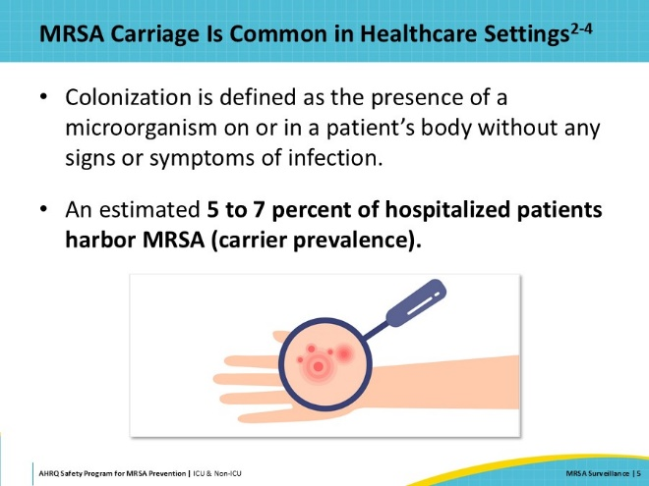
High Risk of MRSA Progressing to Clinical Disease  SAY:  Not only is MRSA colonization common in healthcare settings, but the risk of progression to clinical disease among hospitalized patients who carry MRSA is high. Between 18 and 33 percent of adult patients colonized with MRSA go on to develop MRSA invasive disease including pneumonia, skin and soft tissue infection, or bloodstream infection. Among pediatric patients, 8.5 percent of children colonized with MRSA upon hospital admission and 47 percent of children who acquired MRSA during care in a pediatric critical care unit developed invasive MRSA infections. | Slide 6  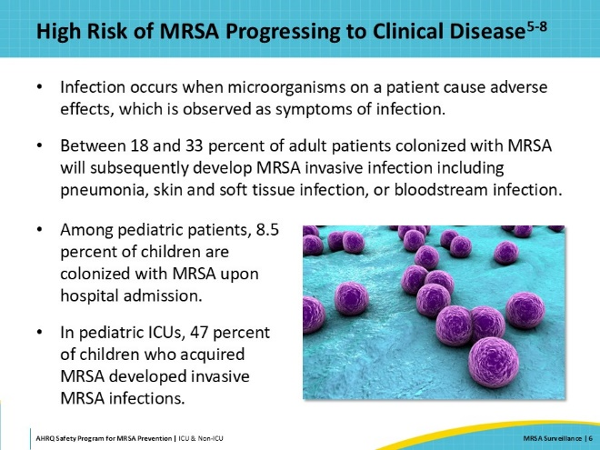
Consequences of MRSA Infections  SAY:  Both methicillin-susceptible Staphylococcus aureus (MSSA) and MRSA infections are associated with adverse outcomes, including prolonged hospital length of stay, increased healthcare costs, and increased morbidity and mortality. MRSA affects people in both community settings and healthcare facilities, but most of the morbidity and mortality occurs among critically and chronically ill patients. This toolkit specifically targets MRSA because there are fewer treatment options for these strains of Staphylococcus aureus, and MRSA therefore presents an even greater threat of patient harm. The MRSA prevention strategies in this project are also effective to prevent MSSA transmission and infection. | Slide 7  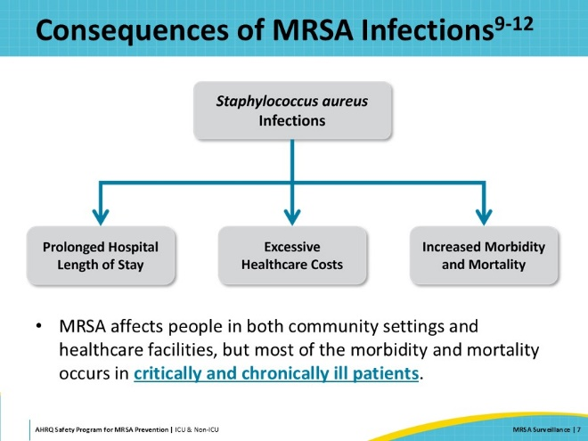
Benefits of Detecting MRSA  SAY:  What are the benefits of detecting which patients are colonized or infected with MRSA? Detecting MRSA colonization or infection is important for both prevention and treatment decisions. People who are colonized with MRSA can spread it via direct or indirect contact to another patient, environmental surfaces, healthcare workers, and medical devices. Staphylococcus aureus, including MRSA, can survive for months on dry surfaces including bed rails and bedside tables. Therefore, it is important to detect patients who are colonized or infected with MRSA so that you can intervene to prevent MRSA transmission. It is also important to know which patients are colonized or infected with MRSA to make informed antimicrobial therapy treatment choices. | Slide 8  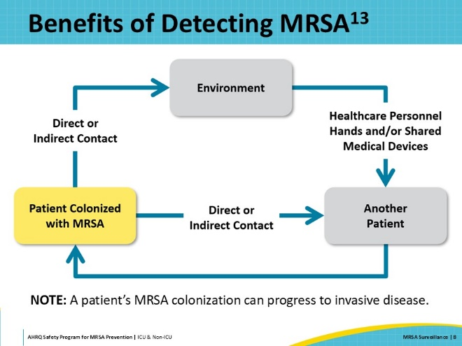
MRSA Surveillance  SAY:  To protect patients from adverse outcomes and develop effective MRSA prevention strategies, facilities must know the MRSA prevalence among their patient population and when and where transmission occurs. This type of insight can be gained by conducting MRSA surveillance. The two main strategies for conducting MRSA surveillance are active surveillance and passive surveillance. Passive surveillance is conducted by monitoring the results of clinical cultures for MRSA. Active surveillance, on the other hand, is performed by collecting surveillance cultures from body sites at pre-determined times such as at the time of patients’ hospital admission and/or during hospital stay and at the time of discharge. | Slide 9  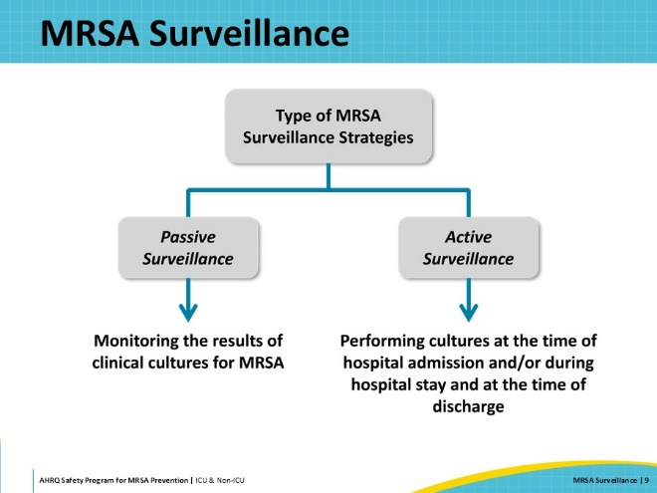
Passive MRSA Surveillance  SAY:  Passive surveillance gathers data from samples that are collected for clinically indicated reasons. Most U.S. hospitals report laboratory-identified (LabID) MRSA bacteremia since it is a publicly reported hospital-associated infection (HAI). This is a form of passive surveillance that only detects patients with MRSA central line-associated blood stream infections. Another passive surveillance method is to monitor the results of all clinical cultures collected from symptomatic patients. According to the Society for Healthcare Epidemiology of America (SHEA) - Infectious Diseases Society of America (IDSA) Compendium of Strategies to Prevent Transmission of Methicillin-Resistant Staphylococcus aureus in Acute Care Hospitals, the routine use of clinical cultures alone does not identify the full reservoir of asymptomatically colonized patients, underestimating the overall hospital-wide prevalence of MRSA by as much as 85 percent.  One of the advantages of passive surveillance is that it is easier to accomplish and requires fewer resources than active surveillance. However, one of the downsides of passive surveillance is that it misses a significant proportion of the full burden of MRSA on the unit. | Slide 10  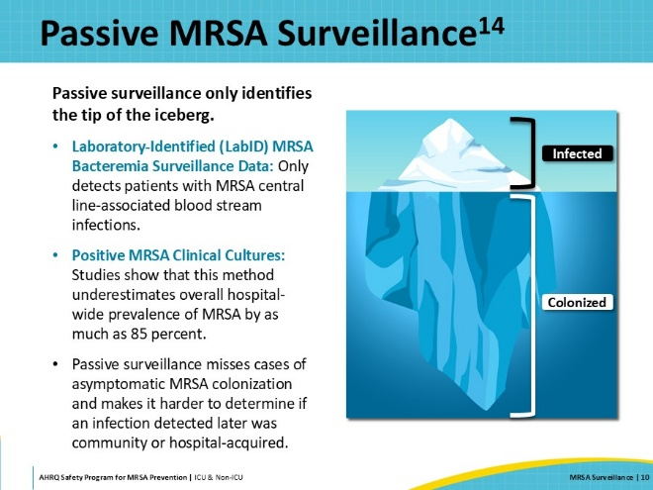
Active MRSA Surveillance  SAY:  Active surveillance is the collection of cultures from asymptomatic patients to identify those colonized with MRSA. It is a more comprehensive and effective tool to reduce MRSA transmission compared to passive surveillance. With a better understanding of the true burden of MRSA, units can take appropriate steps to intervene to prevent detrimental MRSA-associated outcomes.  One of the disadvantages of active surveillance is the need for additional resources, including increased supplies and staff time to collect and process the surveillance cultures. | Slide 11  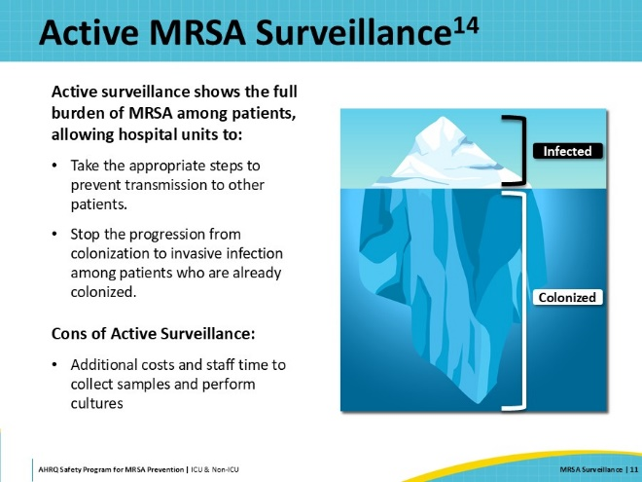
Decline in Active MRSA Surveillance  SAY:  Hospitals reportedly decreased the use of active MRSA surveillance from approximately 90 percent in 2013 to 69 percent in 2018. This shift away from active MRSA surveillance reduces units’ ability to accurately measure the prevalence of MRSA and increases the chance that patients remain undetected sources of MRSA transmission. Active surveillance and MRSA prevention strategies targeting high‐risk patients help reduce MRSA prevalence. | Slide 12  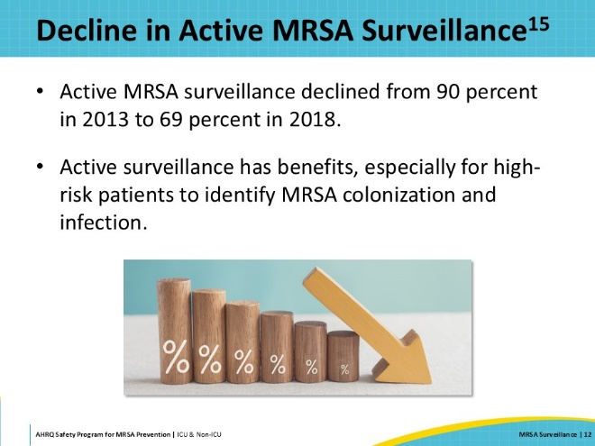
Establishing an Active MRSA Surveillance Program  SAY:  When developing an active MRSA surveillance program, you must first consider which patient population is at highest risk. Surveillance might be performed for all patients, patients from selected units, or selected high-risk patient populations. Once this is determined, logistics must be considered including who will perform the surveillance, how the data will be collected and utilized, who will collect the cultures, which body sites will be cultured, and what interval, days, or times the cultures will be collected. | Slide 13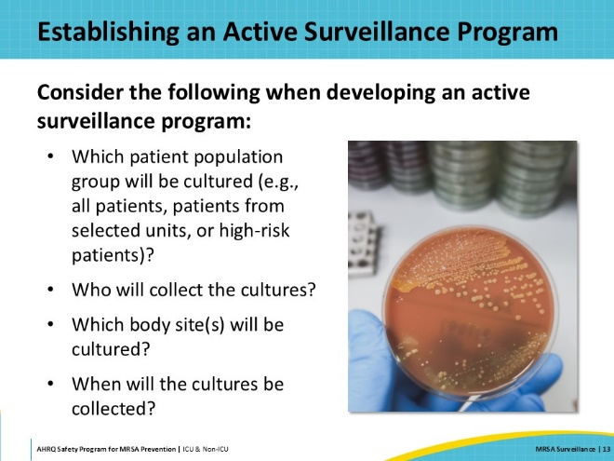
Culture Collection Sites  SAY:  The sensitivity of surveillance specimens obtained from different body sites has been evaluated in different settings and patient populations. Although no single sample collection site allows you to detect all MRSA colonization, the anterior nares is the site that has highest yield, with a reported sensitivity ranging from 48 to 93 percent. Due to its higher yield and the site's accessibility, the anterior nares are considered the primary site for sampling in MRSA active surveillance programs. Other collection sites include wounds, axillae, and groin. | Slide 14  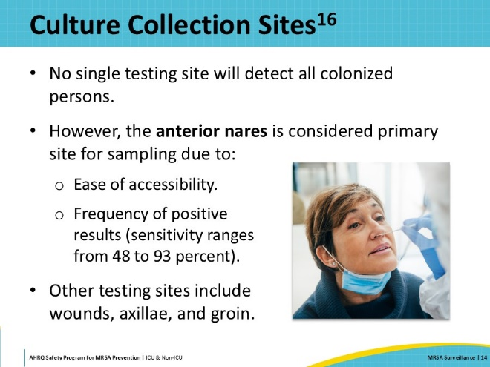
When To Collect Cultures  SAY:  Active surveillance cultures can be collected at predetermined times to assess patients for MRSA colonization. Cultures can be collected at hospital admission, regular intervals during admission, and/or at discharge. Admission surveillance cultures detect patients colonized with MRSA at admission. If MRSA is detected upon admission, it is considered community-associated, although it might still be healthcare-associated if the patient was recently in a healthcare facility or dialysis center. Weekly surveillance cultures are utilized to detect patients who become colonized between the time of hospital admission and the time of the weekly surveillance culture. The advantage of performing cultures upon admission and at intervals such as weekly is that it allows healthcare personnel to promptly implement interventions such as contact isolation precautions to decrease transmission to other patients. It also allows the facility to track MRSA transmission data over time and assess the effectiveness of the MRSA prevention interventions.  MRSA surveillance cultures can also be obtained at the time of hospital discharge to help the facility identify patients who became colonized during their hospital stay. Any combination of these time points can be utilized. | Slide 15  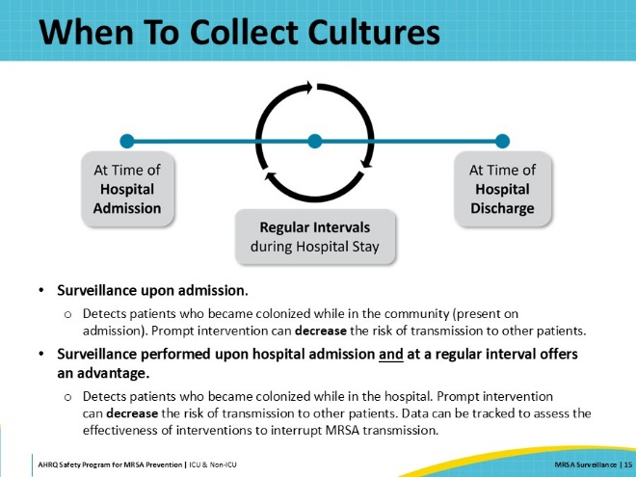
Tracking and Utilizing MRSA Surveillance Data  SAY:  Ongoing analysis and dissemination of MRSA surveillance data, whether from active or passive MRSA surveillance, is important to prevent MRSA transmission within healthcare settings. Data tracked over time allows teams to detect outbreaks, spot unexpected increases in disease occurrence, and evaluate and adjust the effectiveness of prevention intervention strategies. | Slide 16  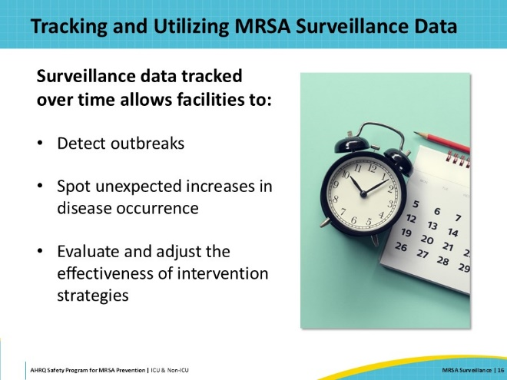
Contact Precautions  SAY:  There are data and national guidelines indicating that patients colonized or infected with MRSA should be placed on contact precautions, in combination with other infection prevention strategies. This isolation category requires the use of gloves and gown to enter a patient’s room regardless of whether patient contact will occur.  The use of contact precautions is recommended by the Centers for Disease Control and Prevention to prevent the transmission of multidrug-resistant organisms (MDROs) and is a standard of care for patients colonized or infected with MDROs, including MRSA. A study examined the effectiveness of contact precautions in preventing MRSA transmission in 108 Veterans Affairs acute care hospitals across the United States. The study found that the use of contact precautions reduced MRSA transmission by 47 percent when it was part of a multidimensional approach, but not when contact precautions were used alone. Please see the Contact Precautions presentation for more information.  Data from MRSA surveillance determine which patients are colonized or infected with MRSA so that you can intervene with comprehensive and multifaceted strategies, including contact precautions. | Slide 17  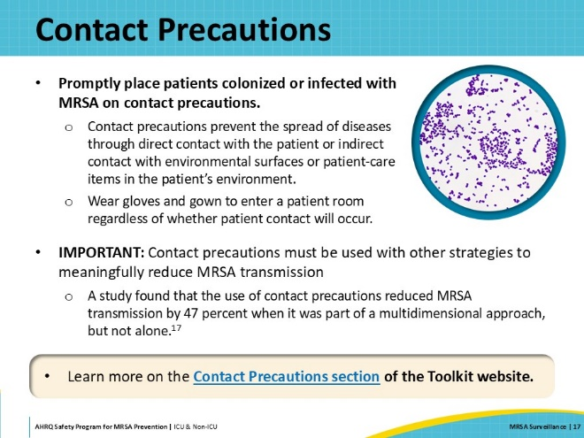
MRSA Decolonization Is Incomplete  SAY:  You might wonder why a hospital or hospital unit would conduct MRSA surveillance if they utilized a universal decolonization strategy. Several reasons you might consider MRSA surveillance include a desire to know how much community-acquired MRSA burden is present at the time of patients’ admission to the hospital, to monitor and measure in-hospital MRSA transmission events, to optimize antimicrobial treatment decisions, and to evaluate the effectiveness of a comprehensive MRSA prevention program.  The fact that MRSA decolonization doesn’t always work is another reason to conduct MRSA surveillance even in the setting of universal decolonization. In this trial involving 98 patients colonized with MRSA, patients were bathed daily with chlorhexidine gluconate (CHG). In addition to CHG, they were randomized to receive either 5 days of mupirocin or 5 days of placebo, and they were cultured periodically. Please look at the numbers in the boxes outlined in green, which represent the percentage of patients in each group who had all body sites cleared of MRSA.  To note, the followup period was up to 26 days (plus or minus 3 days) after initiation of therapy. Regarding decolonization effectiveness, the study researchers indicated that the trial results were not related to exogenous recolonization or high-level resistance—excluding the possibility that successfully decontaminated patients were recolonized from external sources in all but two cases and observing no treatment failure due to the resistance mechanism.  The study shows that decolonization is not 100 percent effective at clearance of MRSA colonization. A significant proportion of the patients remained colonized with MRSA even after decolonization. Therefore, MRSA prevention requires a layered approach that builds upon decolonization and protects patients with a variety of prevention strategies.  For more information on the study and the importance of mupirocin, in addition to CHG, for decolonization, access “The Evidence Behind Decolonization Strategies for MRSA” in the Decolonization section on the toolkit website. | Slide 18  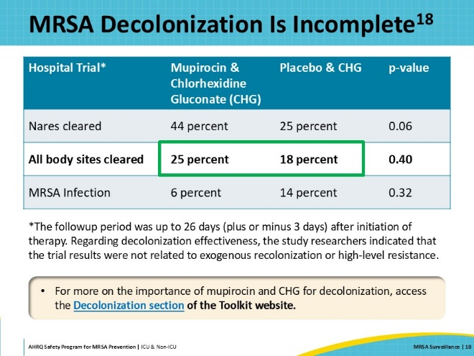
Antibiotic Treatment Selection  SAY:  MRSA surveillance provides information about MRSA colonization, which can be useful for antimicrobial treatment decisions. Knowing a patient is colonized with MRSA can help facilitate choosing wisely regarding vancomycin and other antimicrobial agents if the patient develops signs or symptoms of an infection that requires empiric antimicrobial therapy.  For more information, please access the Antibiotic Stewardship section of the Toolkit website | Slide 19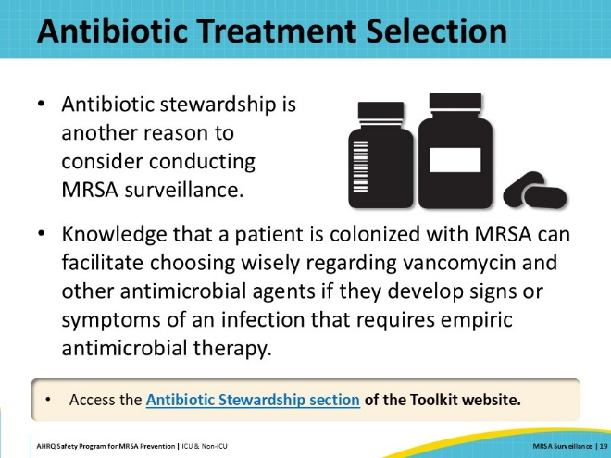
MRSA Surveillance Recommendations  SAY:  The toolkit’s intervention bundle encourages you to make the best choice for your hospital regarding MRSA surveillance. Assess your current practice, your available resources, and the information included in this presentation to determine if you want to add or change any aspect of your MRSA surveillance as you work to prevent MRSA transmission and infection in your unit and hospital. | Slide 20  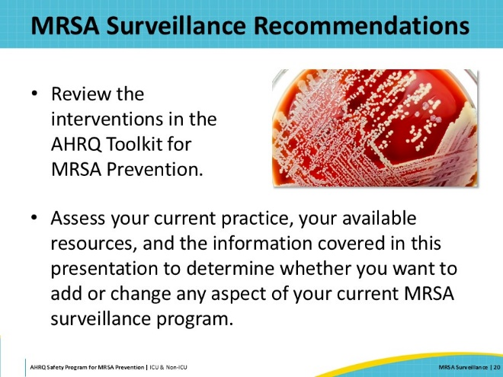
Case Example  SAY:  In the next section, the presentation will discuss a case example to review and apply the MRSA surveillance material through a study of a hospital experiencing an increase in MRSA rates. | Slide 21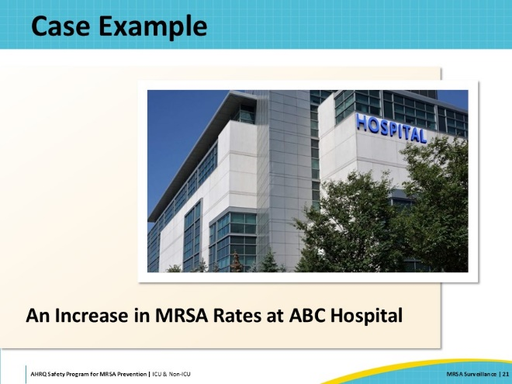
Case Example: Increasing MRSA Rates  SAY:  Four years ago, ABC Hospital implemented universal MRSA decolonization in all units. Despite a few challenges, all went well. The MRSA rates, measured through passive surveillance of clinical culture results, decreased. The unit personnel and hospital leadership were happy with the results.  The low MRSA rates were sustained for 2 years and then began to increase again. The Infection Preventionists (IPs) shared the MRSA passive surveillance data with the units—encouraging them to make sure every patient received MRSA decolonization at the time of hospital admission.  However, even with the reminder, the MRSA rate continued to increase. What was going on? Why was the MRSA rate increasing? | Slide 22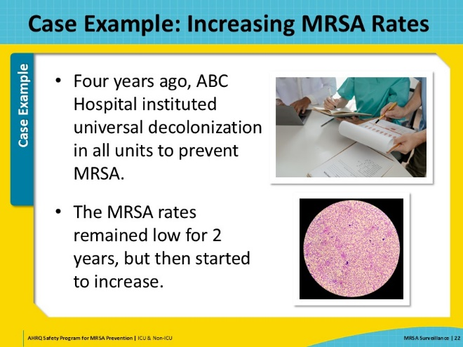
Case Example: What Is Happening?  SAY:  The IPs reviewed the MRSA cases. Most of the cases were residents from nearby nursing homes. Was this the source of the problem? Only a few of the patients were known to have had MRSA in the past. And, even if these patients were colonized with MRSA, decolonization should have taken care of that problem. Right?  The Comprehensive Unit-based Safety Program (CUSP) team reviewed the literature and found out that MRSA decolonization isn’t complete. In fact, they found in a study by Harbarth et al. that only 25 percent of the patients who were known to be colonized had all their body sites cleared of MRSA after finishing a 5-day decolonization process with both mupirocin and CHG.  With this information, they decided to adjust their MRSA prevention protocol. | Slide 23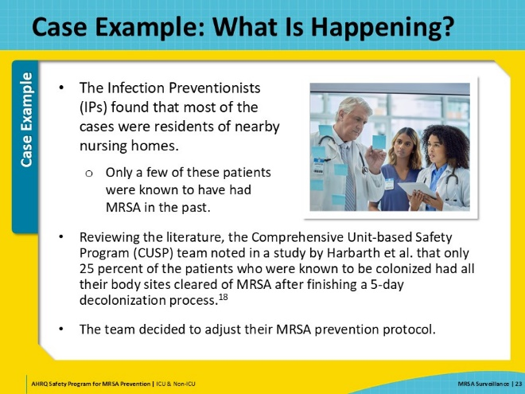
Case Example: New Plan  SAY:  Based on all the information they found, the CUSP team made the following adjustments:  - All patients known to have had MRSA infections or to have been colonized with MRSA will be placed on contact isolation precautions on admission.  - All patients transferring from nursing homes or other hospitals will be tested for MRSA on admission.  - While waiting for results, these patients will be placed on contact isolation precautions.  - If a tested patient has a negative MRSA surveillance test, they will be removed from contact isolation precautions.  - If a tested patient has a positive MRSA surveillance test, they will remain on contact isolation precautions throughout their stay in the hospital. | Slide 24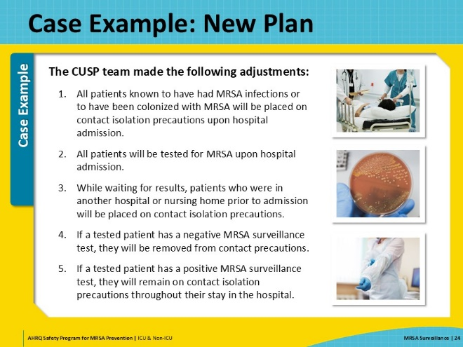
Case Example: Next Steps and Results  SAY:  After 6 months, the unit personnel and hospital leadership were pleased to see that the MRSA rate had dropped. For this hospital, the rates of MRSA colonization in the surrounding nursing homes were driving their hospital unit MRSA rates. Universal decolonization was helpful but incomplete. Implementation of active surveillance cultures and contact precautions allowed them to identify previously unrecognized MRSA colonization and interrupt MRSA transmission. | Slide 25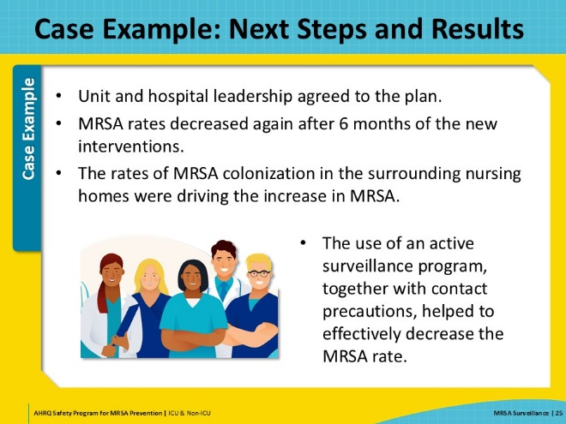
Celebrate Successes  SAY:  Implementing MRSA surveillance and using the four key strategies to break the chain of MRSA transmission and infection takes a lot of hard work and effort and requires input from all personnel.  Remember to acknowledge and celebrate successes each step of the way! | Slide 26  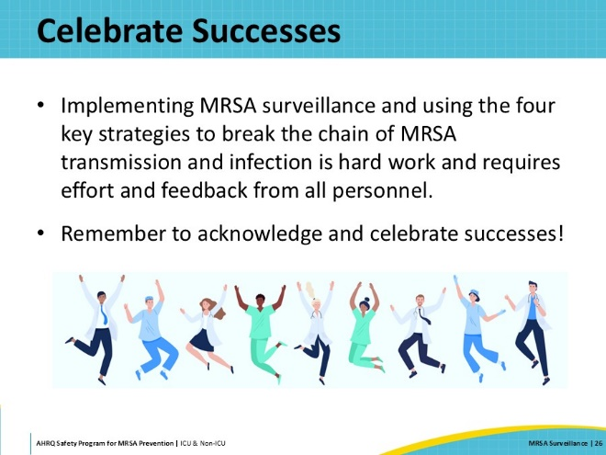
Key Takeaways  SAY:  In summary, a multifaceted approach is needed to successfully reduce MRSA infection and transmission. Active and passive MRSA surveillance allows units to detect patients who are colonized and infected with MRSA and initiate targeted interventions such as decolonization and contact isolation precautions. MRSA surveillance also allows teams to evaluate the effectiveness of MRSA prevention intervention strategies. Since MRSA surveillance does not reduce MRSA transmission by itself, other interventions must be implemented to break the chain of MRSA transmission and infection.  The four key strategies to aim and target for MRSA prevention are (1) decolonizing patients, (2) intervening to prevent person-based transmission, including from healthcare personnel, (3) cleaning and disinfecting the healthcare environment, and (4) implementing evidence-based interventions to prevent device and procedure-associated infections such as central line-associated bloodstream infections and surgical site infections. Remember that MRSA is preventable. Working together and using these key strategies, we can protect patients and take aim at MRSA. | Slide 27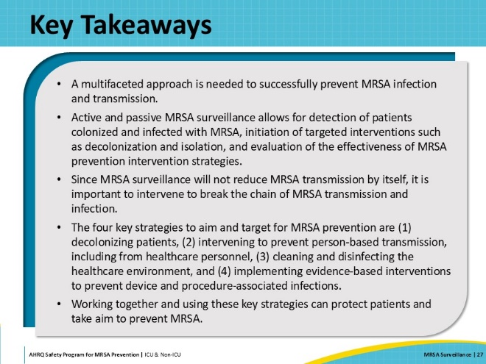
Disclaimer  SAY:  The findings and recommendations in this presentation are those of the authors, who are responsible for its content, and do not necessarily represent the views of AHRQ. No statement in this presentation should be construed as an official position of AHRQ or of the U.S. Department of Health and Human Services.  Any practice described in this presentation must be applied by healthcare practitioners in accordance with professional judgment and standards of care in regard to the unique circumstances that may apply in each situation they encounter. These practices are offered as helpful options for consideration by healthcare practitioners, not as guidelines. | Slide 28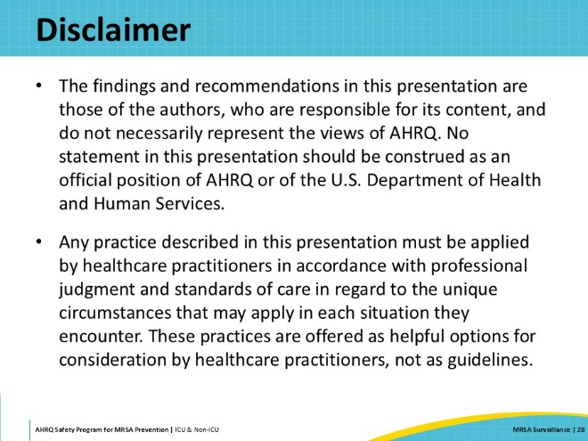
Reference List—1 | Slide 29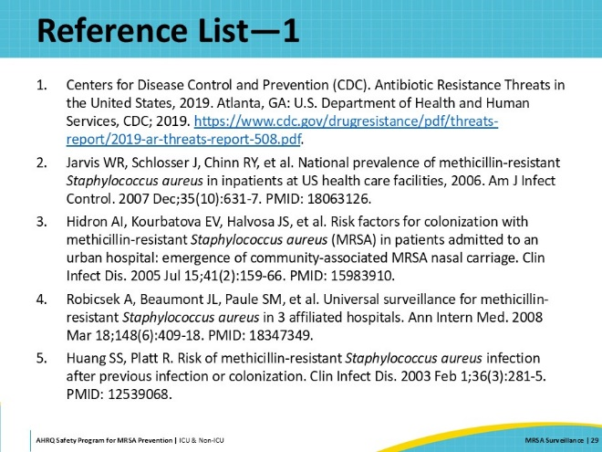
Reference List—2 | Slide 30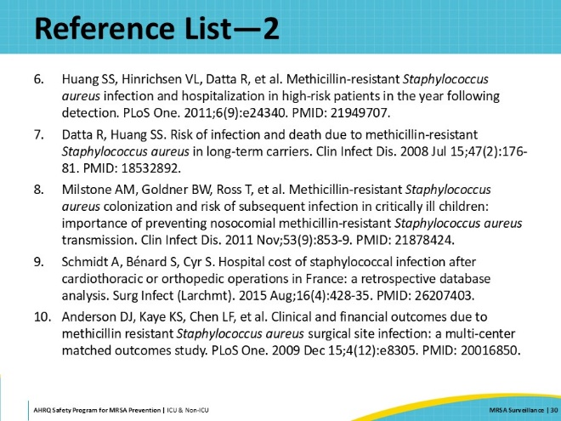
Reference List—3 | Slide 31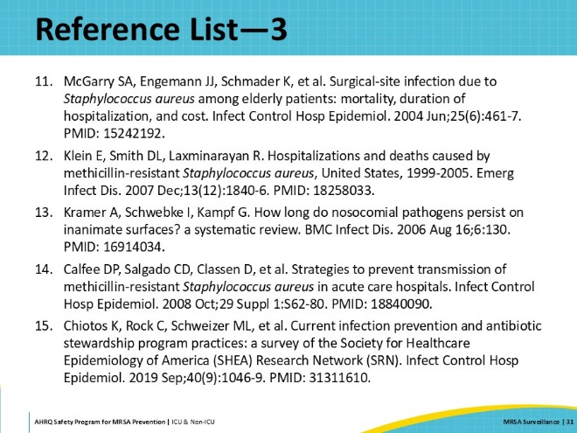
Reference List—4 | Slide 32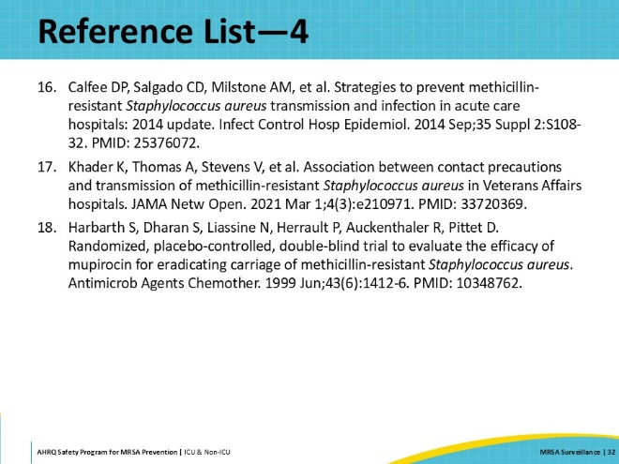

AHRQ Pub. No. 25-0007
October 2024

