Prevention of Ventilator-Associated Pneumonia & Non-Ventilator Healthcare-Associated Pneumonia
ICU & Non-ICU
Slide Title and Commentary | Slide Number and Slide
Prevention of Ventilator-Associated Pneumonia & Non-Ventilator Healthcare-Associated Pneumonia  SAY:  Welcome to this presentation about preventing healthcare-associated pneumonia. This presentation will provide information about the incidence, morbidity and mortality, and best practices to prevent both ventilator-associated pneumonia (VAP) and non-ventilator healthcare-associated pneumonia (NV-HAP). | Slide 1  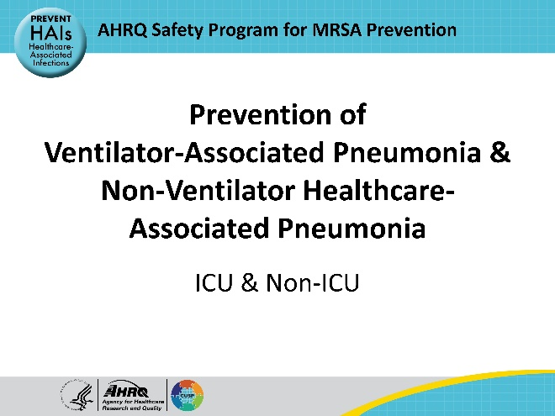
Educational Objectives  SAY:  This presentation will discuss the causes and risks associated with healthcare-associated pneumonia; describe the current guidelines and key best practice recommendations to prevent healthcare-associated pneumonia; and review implementation strategies to prevent these infections. | Slide 2  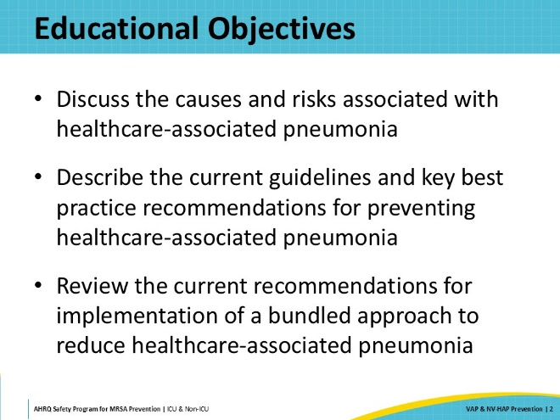
Key Strategies To Take Aim and Target MRSA Infection  SAY:  Reducing or eliminating VAP and NV-HAP is part of the key strategy of preventing device- or procedure-related infections.  While NV-HAP is not device related, there are common infection prevention themes for both VAP and NV-HAP, and both types of infections are healthcare-associated. | Slide 3  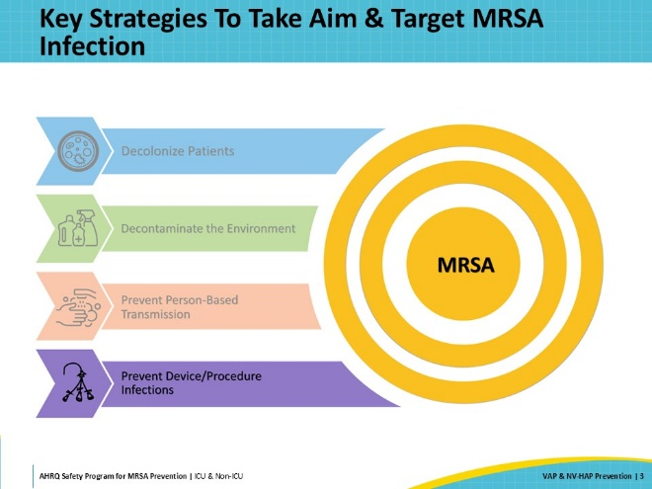
Preventing Device- & Procedure-Related Infections  SAY:  The Centers for Disease Control and Prevention (CDC) estimates that each day, 1 in 31 U.S. patients develops a healthcare-associated infection, or HAI. Healthcare-associated pneumonia is reported to be the most common HAI. VAP tends to be more frequently mentioned and is reported to affect up to 20 percent of mechanically ventilated patients. Despite this, Magill et al. found that 65 percent of healthcare-associated pneumonia occurs in patients who are not mechanically ventilated.  This presentation includes information on both ventilator-associated pneumonia and non-ventilator healthcare-associated pneumonia, their risk factors, morbidity and mortality, and best practices for prevention. | Slide 4  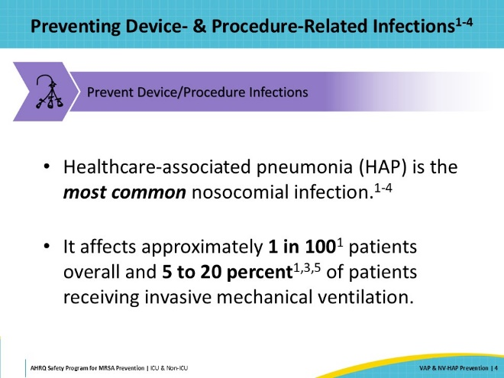
Pneumonia  SAY:  For this presentation's purposes, pneumonia will be defined as an inflammatory condition of the lung tissue, caused by an infectious pathogen.  “Healthcare-associated pneumonia”—or HAP—indicates pneumonia that was not present or incubating at the time of hospitalization and developed 48 hours or more post-admission.  “Ventilator-associated pneumonia”—or VAP—indicates the patient was mechanically ventilated for 48 hours before developing the pneumonia.  Clinical diagnosis of pneumonia is based on a combination of signs, symptoms, and positive diagnostic testing. HAP—both ventilator-associated and non-ventilator associated—is associated with significant attributable mortality rates and contributes to longer lengths of hospitalization and increased healthcare costs. | Slide 5  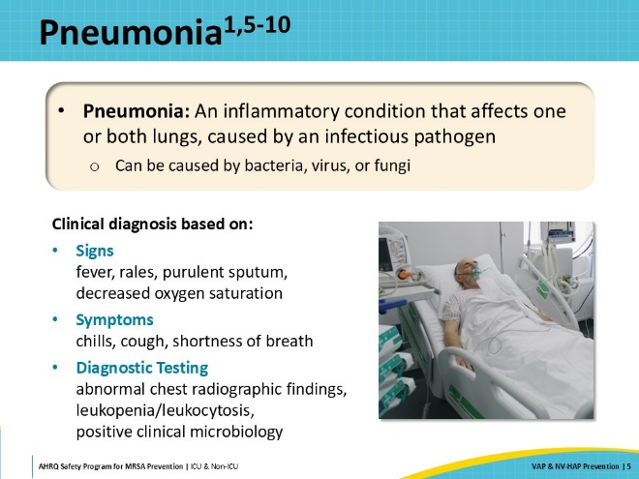
Ventilator-Associated Pneumonia (VAP) Risk Factors  SAY:  There are certain risk factors for VAP. Patients with certain underlying medical conditions are at higher risk for acquiring VAP than others. These include patients with chronic obstructive pulmonary disease (COPD) and other cardiopulmonary conditions. Cancer and trauma patients are also at a higher risk of developing VAP than other populations.  Some risk factors are somewhat modifiable, such as: managing patients’ fluid balance, reducing the use of medications that alter the pH of the gastrointestinal system when possible, and avoiding gastric distension. | Slide 6  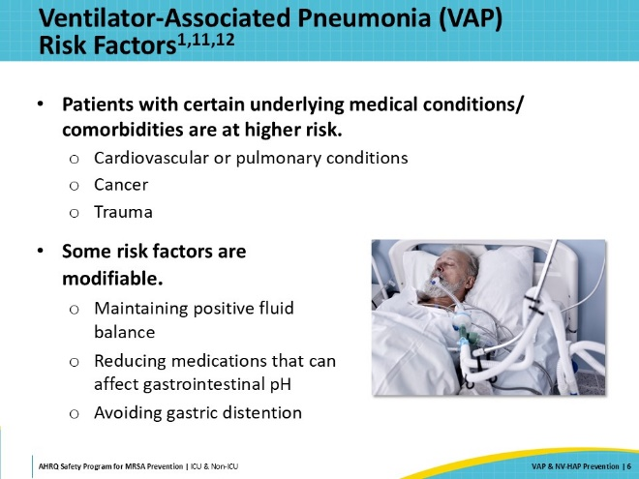
VAP Risk Factors: Medical Interventions  SAY:  There are also medical interventions that increase the risk of VAP for patients. Some examples include reintubation and opioids and sedatives. Additionally, transport of ventilated patients, blood transfusions, and neuromuscular blockade have demonstrated an increased risk of VAP.  Of note, the SHEA/IDSA/APIC Practice Recommendation, updated in 2022, now explicitly recommends against the use of chlorhexidine gluconate (CHG) oral care in this population as there has been some published data that suggest potential for increased mortality associated with CHG oral decontamination. This may be a practice change for facilities who have previously implemented routine CHG oral care for intubated patients. | Slide 7  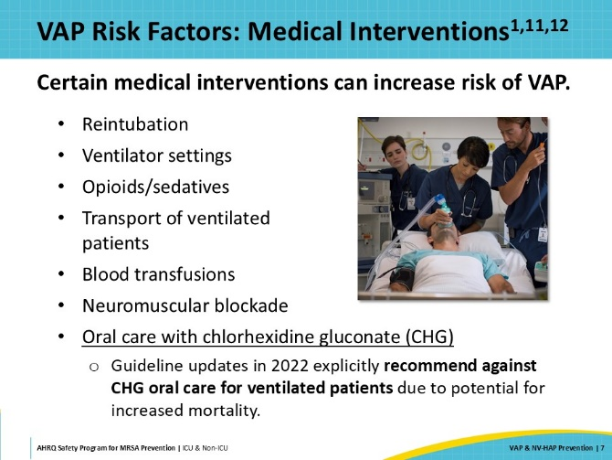
VAP Morbidity and Mortality  SAY:  Although the estimated mortality associated with VAP ranges broadly in the literature, current data suggest that it is somewhere around 10 percent. Occurrence or treatment of VAP is associated with an increased duration of mechanical ventilation, as well as increases in intensive care unit (ICU) and overall lengths of stay. AHRQ estimates that the additional cost for a patient who experiences VAP is approximately $47,000.  It is also important to note the increased use of antimicrobials associated with VAP and the potential repercussions this can have on antimicrobial resistance. Recent guidelines on the treatment of VAP have focused on de-escalation and short-course antibiotic therapy in an effort to mitigate these unintended risks. | Slide 8  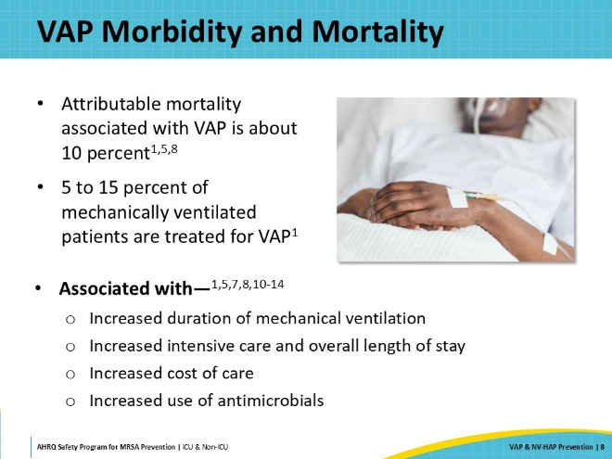
Non-Ventilator Healthcare-Associated Pneumonia (NV-HAP) Risk Factors  SAY:  Underlying medical conditions and comorbidities are also risk factors in non-ventilator healthcare-associated pneumonia (NV-HAP). Patients with altered immune status and patients with existing cardiovascular or pulmonary conditions—such as COPD, asthma, and cystic fibrosis—are at a well-known higher risk.  Some risk factors for the development of NV-HAP are modifiable. Reducing the use of medications that alter the pH of the gastrointestinal system, including antacids and H2 blockers, can lower this risk. In the hospital setting, other risk factors that can be controlled include nutritional status and optimal glucose control.  Increasing activity and positioning can also greatly reduce the risk of NV-HAP for patients, though mobility is not always achievable.  Aspiration is another potentially significant risk that can be modified for some patients. There are over 700 species of organisms in the oral biome. When patients aspirate, they face a high risk of introducing an organism from the oral biome into the lungs. This process is also called self-inoculation—the introduction of a pathogen from one part of the body to another, leading to infection. Patients who are taking central nervous system depressants are at a higher risk for aspiration. Some prevention strategies will be discussed later in this presentation.  An important nonmodifiable risk factor is age. The very young and the very old are more likely to develop NV-HAP.  There are also healthcare-related risk factors introduced to patients when they have certain surgeries, are receiving enteral feeding, or are exposed to antimicrobials. | Slide 9  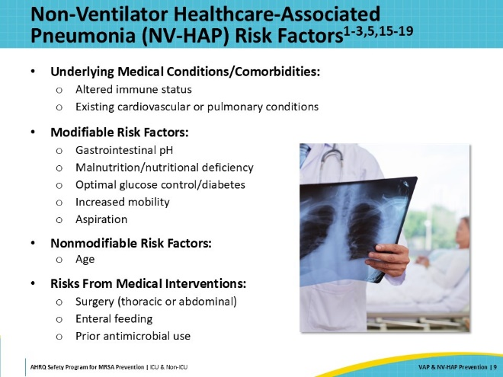
NV-HAP Morbidity and Mortality  SAY:  While VAP sometimes gets more attention, the majority of healthcare-associated pneumonias actually occur in nonventilated patients. Estimates of mortality in this patient population range from 15 to 31 percent. The literature demonstrates that patients who experience NV-HAP can have a length of hospital stay that is twice that of nonaffected patients.  Bacterial pathogens cause 50 to 80 percent of all NV-HAPs, with gram-negative organisms being the most commonly cultured. Influenza and respiratory syncytial virus (RSV) are most frequently associated with viral pneumonias. Fungal infections, such as aspergillus, are more likely to occur in immunocompromised patients. | Slide 10  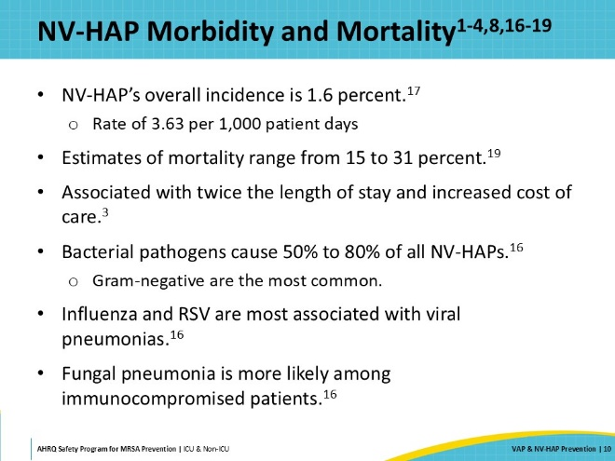
Published Recommendations for NV-HAP  SAY:  Because of the high frequency of NV-HAP and the relative lack of performance improvement implementation literature in this area, in 2019, the Association for Professionals in Infection Control and Epidemiology (APIC) published a position statement calling for increased attention and spotlighting the need for a standardized NV-HAP prevention bundle. As a followup, in 2020, APIC further published an Implementation Guide outlining best practices. These recommendations will be reviewed in greater detail later in this presentation.  Following the release of the APIC Implementation Guideline, The Joint Commission published an article in its Quick Safety newsletter, highlighting the importance of healthcare facilities prioritizing prevention efforts on the reduction of NV-HAP. | Slide 11  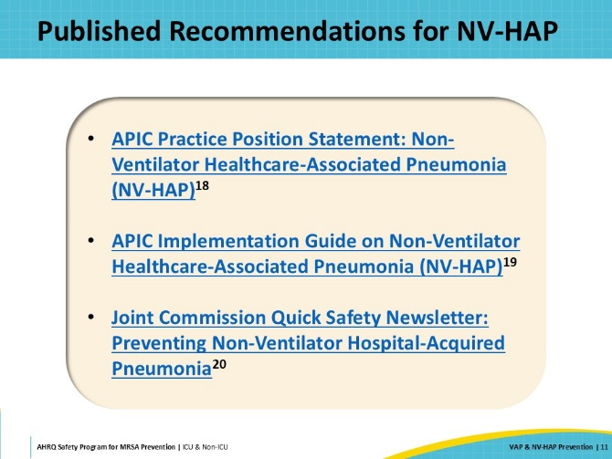
NHSN Ventilator-Associated Event (VAE)  SAY:  As mentioned earlier, earlier attempts at defining HAP and VAP were not objective enough to be considered valid or reliable, and consequently were not widely used as measures of quality of care. Literature has demonstrated that improvements in VAP rates do not necessarily correlate with improvements in clinical patient outcomes.  In response to these challenges, the CDC convened a workgroup in 2011 to develop new surveillance criteria. The workgroup established the term “ventilator-associated event,” or VAE, in order to address the well-known limitations to the correlation between clinical diagnosis and existing surveillance definitions for VAP.  The VAE criteria can identify a number of complications associated with mechanical ventilation. Of note, VAE is not synonymous with VAP; fluid overload, atelectasis, and acute respiratory distress syndrome can also be potential causes of VAE.  On this slide is a brief summary of the criteria from the VAE module of the CDC Patient Safety Component Manual.  The NHSN surveillance definitions are quite complex and outside the scope of this presentation. It is worth noting, however, that the biggest change in the VAE definition was the elimination of the requirement for radiographic imaging, which was present in the PNEU chapter, that is no longer used. This change was an effort to eliminate the concerns regarding variation in imaging technique, interpretation, and reporting.  Also absent from the VAE criteria are any signs and symptoms that rely on manual documentation or those that can be considered subjective. Most elements of the VAE definition are amenable to automated data extraction, making surveillance more passive and less labor intensive than in the past.  Also, as noted on this slide, this chapter of the CDC Patient Safety Component Manual is intended for use in adult patients only. A Pediatric VAE chapter is also available that outlines specific oxygenation criteria for that population. Currently, the pediatric VAE chapter does not include the VAC, IVAC, and PVAP categories. These categories are currently under review by the CDC but have not yet been published. | Slide 12  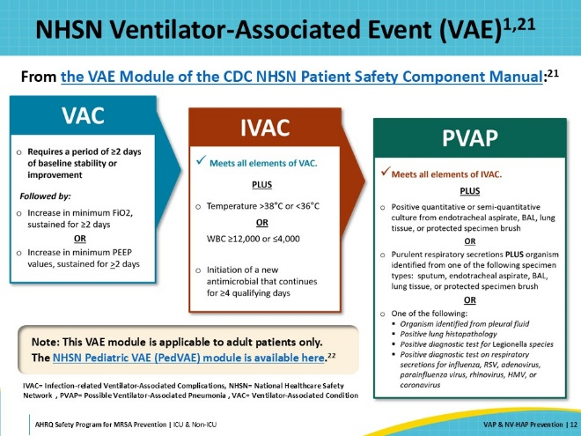
NHSN Resources  SAY:  If your facility is not already conducting pneumonia or VAE surveillance and would like to explore it, the NHSN website provides free access to training resources and materials. This slide provides links to specific chapters of the NHSN Patient Safety Component Manual with additional training available regarding infection windows, site-specific criteria, and “present on admission” definitions.  - NHSN Patient Safety Component Chapter 6 (PNEU)  - NHSN Patient Safety Component Chapter 10 (VAE)  - NHSN Patient Safety Component Chapter 11 (PedVAE) | Slide 13  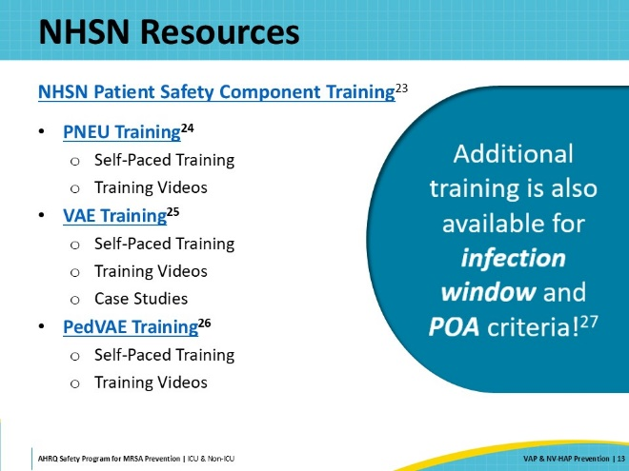
Pneumonia and S. aureus  SAY:  Clinical pneumonia can be caused by any number of pathogens, including bacteria, viruses, and fungi. Although pneumonia, including VAP, may not be a topic that typically comes to mind when thinking about MRSA, Staphylococcus aureus is the most commonly identified gram-positive organism to cause both HAP and VAP. Incidence in the literature for MRSA VAP ranges from 15 to 28 percent. The mortality rate for patients with MRSA HAP and VAP can be as high as 55 percent.  Intravenous antibiotic use within the past 90 days increases the risk of MRSA HAP and VAP for patients. A history of or current nasopharyngeal colonization with MRSA may also be a risk factor. | Slide 14  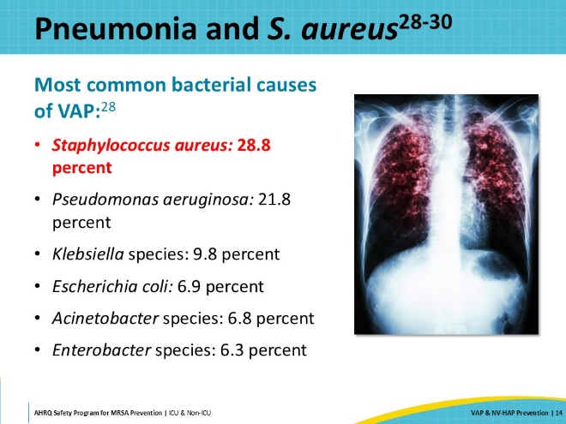
Guidelines and Resources  SAY:  On this slide are listed a few of the most current guidelines for VAP and NV-HAP prevention. This includes the VAP/VAE/NV-HAP strategies from the Society for Healthcare Epidemiology of America (SHEA) Compendium: 2022 Update. The Society of Critical Care Medicine (SCCM) ICU Liberation Bundle (A-F) addresses ventilator best practices, as well as best practices in ICU care generally. APIC has also published an Implementation Guide for NV-HAP.  Additionally, AHRQ provides a Toolkit To Improve Safety for Mechanically Ventilated Patients. Resources available on the AHRQ website include detailed technical bundle modules focused on daily care processes, early mobility, and low tidal volume ventilation. | Slide 15  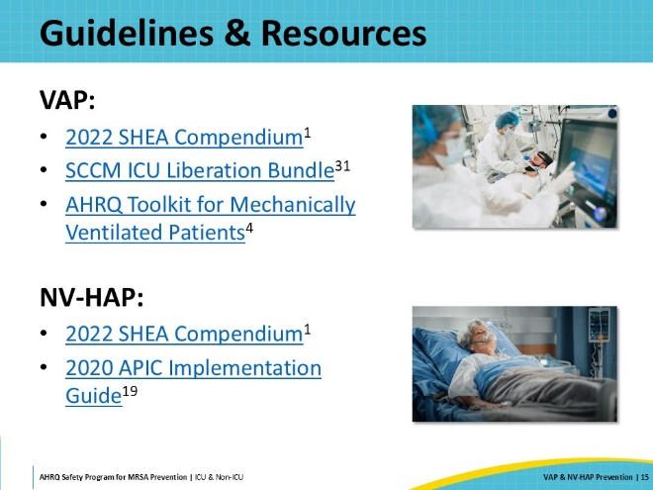
VAP Preventive Interventions  SAY:  Having established a shared mental model of the definition and clinical significance of HAP, let’s explore some of the best practices aimed at prevention, starting with the best practices and published guidelines about how best to prevent ventilator-associated pneumonia. | Slide 16  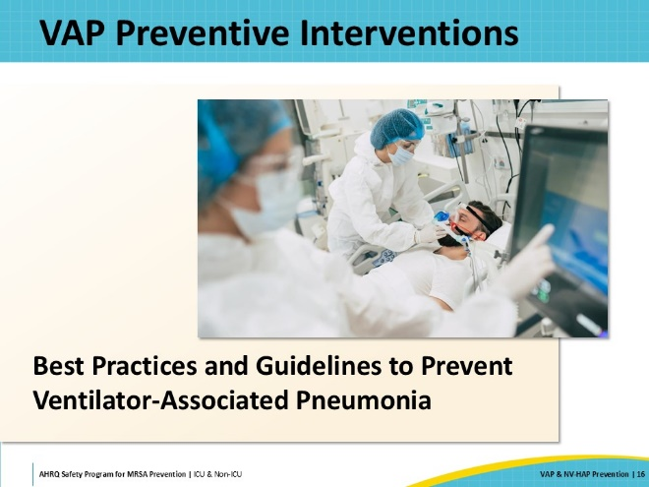
VAP Essential Practices 1  SAY:  The most obvious way to prevent VAP is to not intubate the patient at all. However, in most circumstances, mechanical ventilation is initiated out of necessity. That being said, there are some alternative strategies that should be considered when possible. These include high-flow oxygen or noninvasive positive pressure ventilation (NIPPV). These therapies, along with placing patients in the prone position, have become much more common in the post-COVID era. In addition to preventing intubation, high-flow O2 and NIPPV may also lower the risk of reintubation following extubation. There are contraindications to both high-flow O2 and NIPPV, so the risks and benefits should be carefully considered when planning care for the patient.  When patients require sedation, consider multimodal and alternative strategies, rather than relying solely on sedatives. When sedation is required, clear targets should be set and communicated to the care team. Establishing protocols and utilizing functionality within the electronic health record can assist with automating and communicating these goals. Daily sedation awakening trials should be conducted, unless contraindicated, to evaluate patients’ readiness for extubation. Instituting nurse-driven sedation protocols has been shown to contribute to sedation lightening practices and increase the consistency of sedation awakening trails.  Spontaneous breathing trials also should be completed daily on all ventilated patients without existing contraindications. These plans should be coordinated during the daily goals discussion to ensure that they occur concurrently with the sedation awakening trial. This will ensure that the patient is in an optimal state for the best results. | Slide 17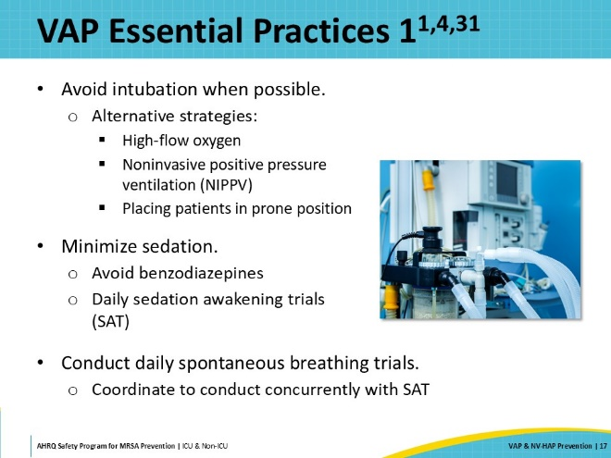
VAP Essential Practices 2  SAY:  Consider also including plans for mobilization of ventilated patients in daily care. The literature demonstrates that early exercise and mobilization contribute to both a reduction in the duration of mechanical ventilation and shorter stays in the ICU.  Elevating the head of bed at least 30 degrees and performing routine oral care are recommended to reduce the risk of VAP. The 2022 SHEA Compendium does not offer specific guidelines regarding oral care but suggests that a minimum of daily toothbrushing has been shown to reduce VAP. The addition of CHG to oral care regimens is NOT recommended given the lack of literature on its benefit and a potential link to increased VAP and morbidity.  Although data on the effect on VAP specifically is limited, there is some evidence that early enteral feeding over parenteral feeding is associated with a reduced risk of overall HAP in general.  Finally, the last essential practice is to only change the ventilator circuit when needed. Timed or routine circuit changes have not been shown to impact VAP rates, and changes should only be performed if recommended by the manufacturer or if the circuit is visibly soiled or otherwise compromised. When condensation is present in the tubing, it should always be drained away from the patient. | Slide 18  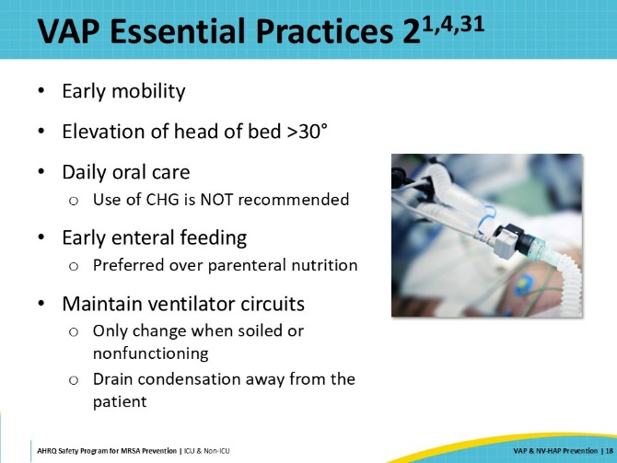
Daily Goals Checklist  SAY:  An effective way of tracking these essential practices for ventilated patients is to employ a Daily Goals checklist. By reviewing this checklist together, a team can run through the different items to confirm what care the patient has received and what needs to be done. The Daily Goals process integrates well into rounding, supporting the team in their review of key items and concerns. It prompts the team to focus on what needs to be done and to define the day’s goals for the patient.  The Daily Goals checklist also enables tracking whether certain practices are being carried out. The data collected can guide further adjustments and identify goals for future plans.  Sample Daily Goals Checklists are provided as part of this toolkit. The items on the checklist can be edited to fit your unit’s needs:  - Daily Goals Checklist for ICU  - Daily Goals Checklist for Non-ICU  Reviewing the daily goals is a straightforward and effective way to make sure that all of the team members are on the same page and have a shared understanding of each patient’s plan of care.  More information on the Daily Goals tool and its uses can be accessed on AHRQ’s website. | Slide 19  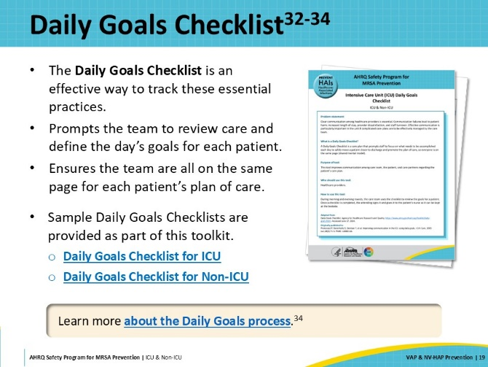
VAP Additional Interventions  SAY:  In addition to the recommendations on the previous slides, the 2022 SHEA Compendium also offers some additional approaches for facilities or units that may continue to struggle with VAP despite implementation of the essential practices. These approaches have been shown to decrease VAP, duration of mechanical ventilation, length of stay, and/or mortality—but may present increased cost or potential risks to the patient. For this reason, thoughtful consideration and multidisciplinary discussion should occur prior to inclusion into practice.  The first additional approach is selective decontamination of the oropharynx and digestive tract. This should only be considered in populations or units that are not already struggling to control multidrug-resistant organisms (MDRO). Studies conducted in countries with low prevalence of MDROs have shown significant reductions in hospital mortality associated with the use of topical, oral, and parenteral antibiotics. If this approach is considered, it must be coupled with a mechanism to closely monitor any impact on antimicrobial resistance and Clostridioides difficile infections.  Another additional approach is the use of endotracheal (ET) tubes with subglottic suction. This may reduce VAP rates but has not been shown to decrease overall outcomes such as mortality, duration of mechanical intubation, or length of stay. These devices have been shown to reduce the rate of VAP by as much as 44 percent. ET tubes with subglottic suction ports are more expensive than standard ET tubes, so it is best to consider their use for patients who will be intubated for longer durations and will be at higher risk for VAP. The decision on whether to use these products is one that should be made prior to intubation, as ET tube exchange is not routinely recommended. However, decision making for many patients can be difficult at the time of intubation.  Tracheostomy within 7 days of intubation has also demonstrated the potential to decrease VAP rates by as much as 40 percent. However, this is an invasive procedure with lifelong effects on the patient and should be reserved for those who may be intubated for longer durations. If possible, include the patient and their loved ones in this discussion to ensure that the decision is well-informed and takes their values into consideration.  The last additional approach for consideration is post-pyloric feeding. Placement of duodenal and jejunal feeding tubes requires a specially trained practitioner, which may not be available at all facilities. However, this method of enteral feeding has been associated with a lower incidence of pneumonia than gastric feeding. It reduces the risk of gastrointestinal complications such as gastric distention and reflux, as well as minimizes the risk of aspiration associated with feeding, making this a good approach to consider in patients who may not tolerate gastric feedings well or who are at high risk for aspiration. | Slide 20  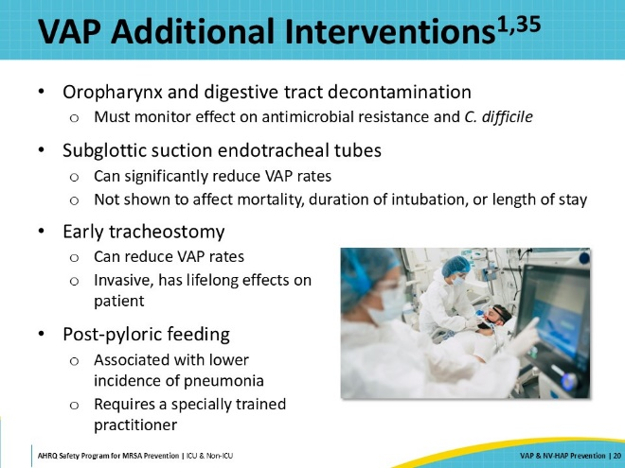
NV-HAP Preventive Interventions  SAY:  The next few slides will review preventive interventions in nonventilated hospital patients. | Slide 21  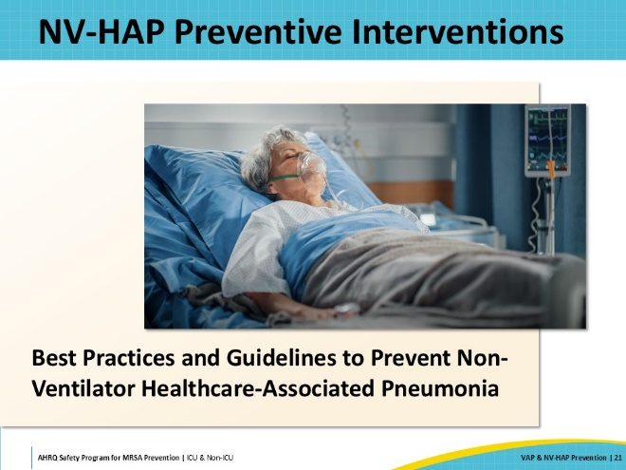
NV-HAP Essential Practices  SAY:  Oral care is one of the most widely recommended interventions to aid in the prevention of healthcare-associated pneumonia. There is a plethora of research showing the relationship between the oral microbiome and HAP. As S. aureus is a common pathogen in dental plaque, oral care is especially important in MRSA prevention efforts. There is no consensus in the literature regarding the ideal frequency of oral care in nonventilated patients, but the APIC Implementation Guide calls attention to the importance of conducting an individualized assessment for each patient. The patient's ability to perform self-care should be considered when planning the products and components of their oral care regimen. At a minimum, toothbrushing, application of an alcohol-free antiseptic rinse and daily use of a lip and mouth moisturizer should be part of the plan. Suction should be available for patients who have a lot of secretions or are at increased risk for aspiration.  Identifying and reducing risk of aspiration is another essential practice. It can sometimes be difficult to identify which patients have silent, or micro aspiration—which is common in hospitalized patients. Patients who have suffered a stroke or other neurologic injury are those that come to mind most often, but other risk factors may include decreased mobility, supine positioning, use of sedatives and other medications, and presence of nasogastric or orogastric tubes. If your facility does not already have an aspiration screening tool in place, then consider implementing one. Patients identified as “at risk” should have a swallow screening performed. Fluoroscopic or endoscopic studies are the most thorough methods to evaluate for aspiration. For patients with an identified risk factor, keep the head of the bed elevated at least 30 degrees if possible. Incorporate head of bed elevation and assessment of the need for sedatives and gastric tubes into the daily goals conversation. If gastric tubes are still necessary, ensure that frequent assessments are complete, and avoid bolus feedings whenever possible.  Similar to VAP, many studies have shown a significant decrease in pneumonia related to patient mobilization. Despite the benefits of early mobility being widely known, a 2019 study found that hospital inpatients spent 87 to 100 percent of their time in bed. When attempting to increase mobility, nursing and providers should partner with rehabilitation professionals to evaluate patients' limitations and carefully plan mobility interventions to reduce the risk of falls. When clinically appropriate, engaging family members can help increase patients’ time out of bed, while also helping them feel involved in their loved one's care.  Acid suppressive therapy can reduce natural protective effects. Proton-pump inhibitor (PPI) use has been associated with risk for pneumonia. Over the past 20 years, prescribing PPI upon admission to the hospital has become increasingly common. An article looking at the use of acid suppressive therapy in patients outside of the ICU states that approximately 70 percent of admitted patients receive this therapy during their hospital stay, with a majority receiving a PPI. The benefit of acid suppressive therapy is different for ICU versus non-ICU patients, though the necessity of PPI use should be evaluated daily in either setting. Discontinuation of PPI should occur as soon as clinically appropriate. | Slide 22  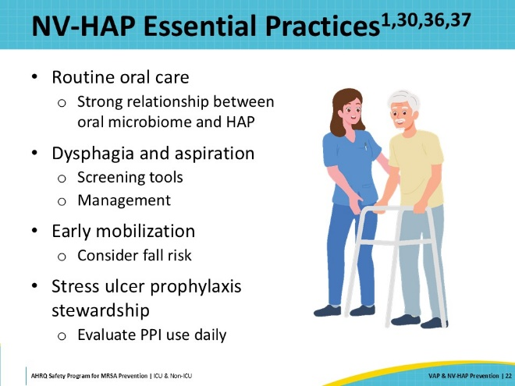
NV-HAP Essential Practices  SAY:  Malnutrition is another risk factor associated with NV-HAP. While patients are hospitalized, nutritional screenings and assessments should be conducted frequently to ensure that their nutritional needs are being met and their nutrition is optimized. Accurate assessment and documentation of intake will assist in this effort.  Glycemic control is also important, as persistently high blood glucose levels can make patients more vulnerable to developing infection. While this is important for all patients, those who have a history of diabetes should be closely monitored and treated.  The last essential practice is to prevent viral infections. Early identification and isolation of infected patients is one way to do this. Due to COVID-19, many organizations have adopted additional practices that may also assist—such as staff and visitor symptom screening, active surveillance screening for patients, and the use of universal masking during periods where transmission rates are high. Immunizations for staff and patients are also important to prevent long-term infection and severe illness from some respiratory viruses, such as influenza, SARS-CoV-2, and pneumococcal disease. These practices are especially important in the pediatric patient setting where childhood immunizations may not be complete and there may be more visitors. | Slide 23  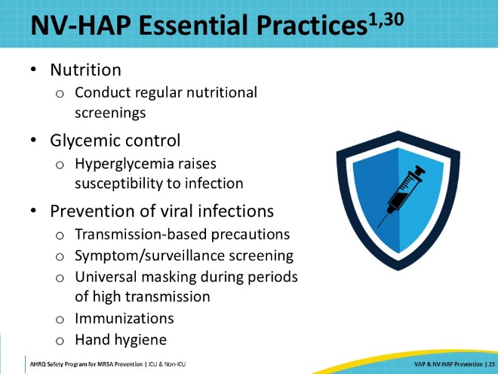
Implementation  SAY:  This next section will shift the focus to implementation of interventions. It will provide examples of interventions that teams may implement to prevent healthcare-associated pneumonia. | Slide 24  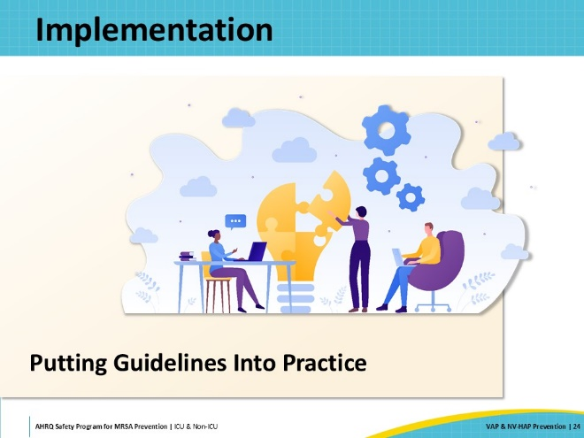
SCCM ICU Liberation Toolkit  SAY:  The first example will be geared towards mechanically ventilated patients and will draw upon the Society of Critical Care Medicine ICU Liberation Toolkit, which was developed to improve patient outcomes and reduce the risk of long-term consequences after an ICU stay.  Each element of the A-B-C-D-E-F bundle addresses an issue that can have detrimental effects to an ICU patient.  - A stands for assess, prevent, and manage pain  - B advocates for both a spontaneous awakening trial and spontaneous breathing trial  - C stands for the choice of analgesia and sedation  - D stands for assess, prevent, and manage delirium  - E stands for early mobility and exercise  - F stands for family engagement and empowerment  The ICU Liberation bundle on the SCCM website offers additional information about program implementation, data collection, and analysis for the specific elements. | Slide 25  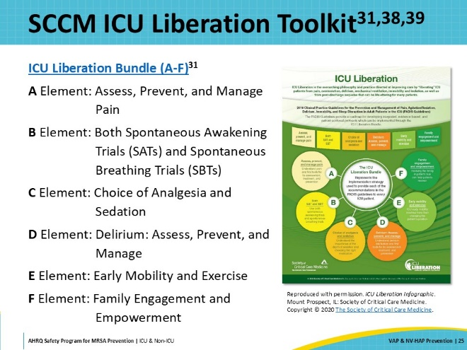
Steps To Improve Care Delivery  SAY:  The first step of the process to improve care delivery is to identify the problem. This includes a review of the local data and a review of the literature to see what has been published about the issue.  Once the team has decided on an intervention, it is important to identify barriers or challenges that might arise when implementing the intervention. At the same time, it is important to identify tools or metrics to use that will measure performance and outcomes.  Once these steps are completed and you are ready to implement your intervention, educate staff on the importance of the new changes and implement the intervention for all appropriate patients. The 4 Es should be followed to ensure the intervention is implemented across all appropriate patients.  Now, let’s review a hypothetical case of how one surgical ICU tackled a problem with rising rates of VAP. | Slide 26  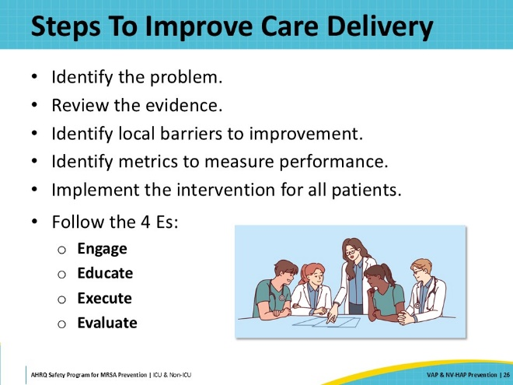
VAP Case Example: A Recent Increase in VAP Rates  SAY:  Over the past few months, the VAP rates in the surgical ICU (SICU) have been on the rise. This particular unit has a well-developed CUSP team. Through the efforts of the CUSP team, the unit implemented the ICU Liberation Bundle 2 years ago.  Based on their recent VAP data, they decide to conduct a point prevalence audit of current practices to look for opportunities for improvement. They find that they have adequate compliance with almost all aspects of the ICU Liberation bundle. However, they discover that staff have been experiencing some difficulties with early mobilization of their ventilated patients. Only 25 percent of patients are mobilized by day 2 after intubation. After realizing this, the team decides to focus their efforts on improving patient activity levels and mobilizing the patients after intubation. It is important to ensure that they have the right team members involved to help with early mobilization. | Slide 27  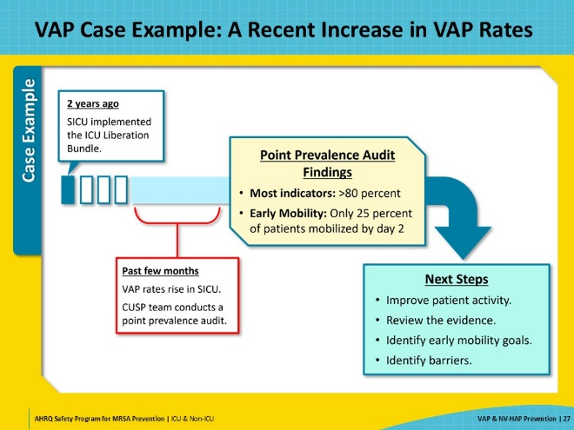
VAP Case Example: Reviewing the Evidence  SAY:  The team conducts a thorough review of the most current literature looking for evidence to support its focus on early mobility. The team finds data that demonstrate that early mobility within the first 36 to 48 hours of intubation leads to less delirium, fewer ventilator days, and improved functional status in mechanically ventilated patients.  It next spends time observing staff, reviewing current workflows, and auditing electronic health records to try to determine where the breakdowns in practice are occurring. They find that the current protocol includes passive range of motion, but only 25 percent of its mechanically ventilated patients are getting out of bed. | Slide 28  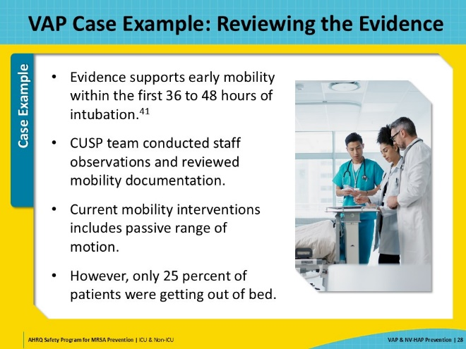
VAP Case Example: Identifying Barriers and Challenges to Early Mobility  SAY:  The team reviews the information it has gathered during its observations and conversations with staff to help identify barriers. The questions it is trying to answer are:  - Why aren’t patients getting out of bed?  - What would need to change in order to get a ventilated patient out of bed?  The team finds workload and coordination challenges in the unit and within the Physical Therapy (PT) department. Nursing turnover rates are high, and new hires and float staff are working in the SICU. These nurses are worried about risks to patient safety with early mobility and don’t realize how important it is. In addition, physical therapists are being asked to cover multiple ICUs and are no longer dedicated specifically to the surgical ICU.  These challenges make it harder to coordinate early mobility activities for the patients. The nurses are waiting for PT to initiate the effort, and PT is relying on the nurses to carry the program. | Slide 29  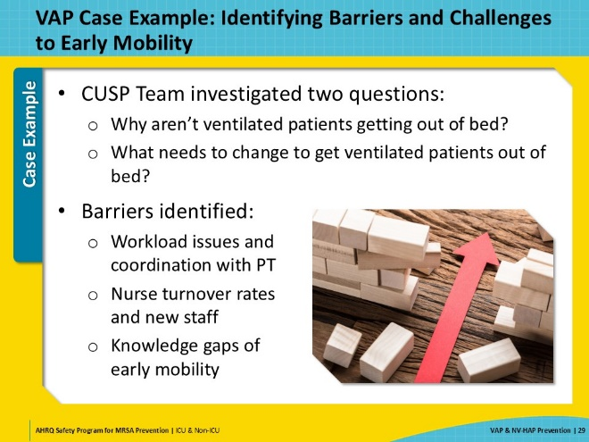
VAP Case Example: Measuring Performance  SAY:  The next step in the process is to identify the appropriate metrics to measure the unit’s performance and effectiveness of the intervention. The team has current data on VAP rates and point prevalence bundle compliance data, but team members look for other metrics or tools to help measure ongoing performance. They find and decide to use the ICU Mobility Scale to measure activity levels achieved by patients.  At the next CUSP meeting, they discuss their findings and plans for improvement. Someone on the CUSP team points out that mobility goals were not part of the Daily Goals checklist. The checklist is revised to ask specific questions on mobilization.  Their new plan of action includes developing a mobility champion team. These are staff members who will be knowledgeable about the current evidence, focused on increasing patient mobility, and available to other staff as an “at the elbow” resource. They will consistently review daily mobility goals for all ventilated patients and be responsible for collecting patient data using the ICU Mobility Scale. They will also monitor the new strategy for a few months to see if there is an improvement in compliance. | Slide 30  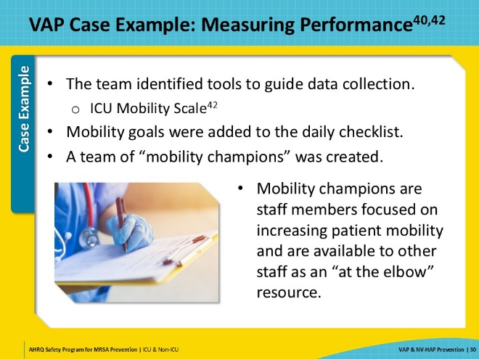
Implementation Strategies: The 4 Es  SAY:  The final stage of the process is to ensure that all eligible patients receive the intervention as planned. To accomplish this, follow the 4 Es: Engage, Educate, Execute, and Evaluate. These describe four basic stages to develop and implement your initiative.  For more information on the 4 Es, please refer to the 4 Es section on the Toolkit for MRSA Prevention in the ICU and Non-ICU website. Resources in the section include a presentation and a one-pager.  If your hospital already has a CUSP program implemented, the departmental or unit-based CUSP teams can be a great resource to help support this work. CUSP team champions can assist with assessments of unit culture, determining future education needs, updating policies and procedures, and conducting common-cause analyses. | Slide 31  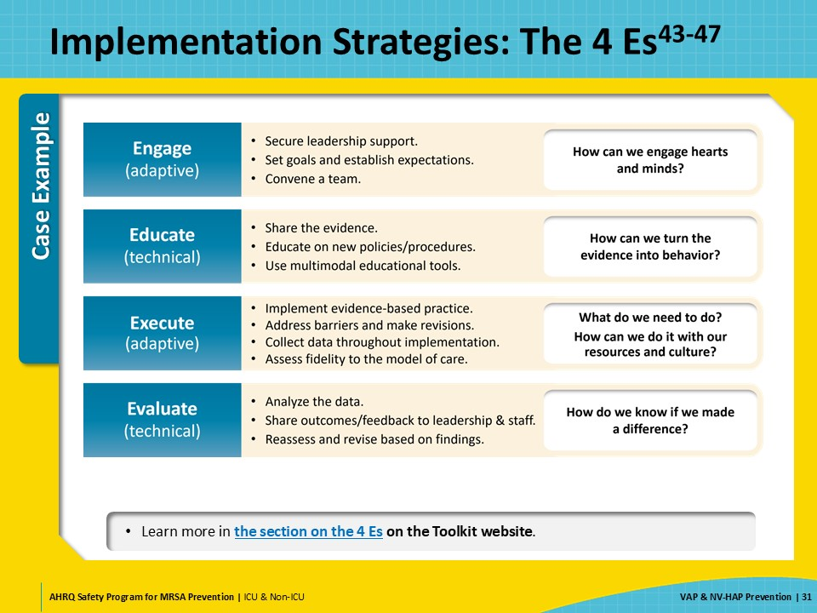
VAP Case Example: Ensuring All Patients Receive the Intervention  SAY:  Once the mobility champions are identified, the team partners with PT and Respiratory Therapy to create a plan. Together with the Mobility Champion, the physical therapist and respiratory therapist perform daily rounds on all ventilated patients. They engage staff through staff meetings, huddles, and daily rounds. They share stories of previous patients and their experiences, both positive and negative as it relates to early mobility, or lack thereof.  The team sets up an education plan for the staff, patients, and their family members. The education campaign includes information about the benefits and rationale for early mobility interventions. Fast fact sheets are posted for staff. Orientation packets for new staff are updated to include information about the Liberation Bundle and include a focus on the importance of early mobility activities.  Performance goal targets are posted on the huddle board and shared with Nursing, PT, Occupational Therapy, Respiratory Therapy, and provider staff.  Over time, the unit is able to look at its VAP data to see if the interventions are having the intended impact. As the interventions are applicable to most ventilated patients, the emphasis on early mobility becomes part of the culture of the unit. | Slide 32  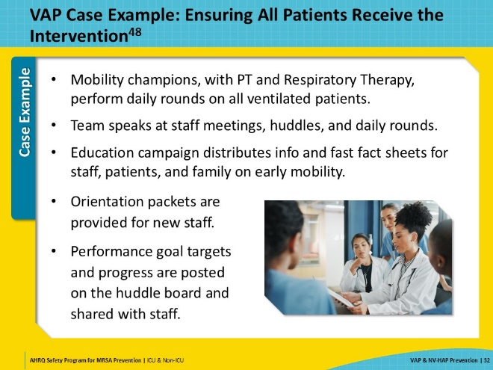
NV-HAP Case Example: Implementing an Oral Hygiene Prevention Bundle  SAY:  Next, let’s walk through a hypothetical example of an intervention focused on preventing non-ventilator healthcare-associated pneumonia.  In this case example, there has been a spike in NV-HAP rates on a 30-bed acute care medical floor. Over the past 6 months, rates have gone from 1.1 to 2.4 percent.  The CUSP team meets to discuss the issue. The CUSP executive leader has just joined the team, as the previous leader retired, and this executive is ready to learn how to be helpful to the team.  The team follows the steps to improve care: identify the problem, review the local data, and review the literature for studies to identify interventions. Then, once this is completed, identify any challenges or barriers to implementation and develop a plan. Educate staff and ensure that all patients receive the intervention. | Slide 33  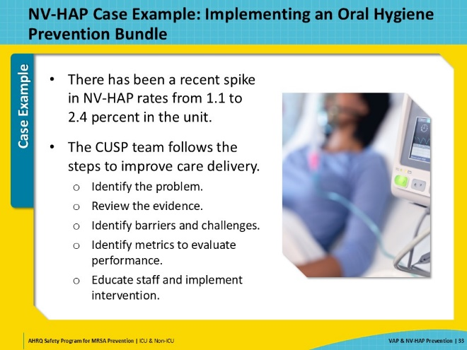
NV-HAP Case Example: Reviewing Evidence for Oral Care  SAY:  While conducting a preliminary literature review, the team finds the APIC call to action to address the prevention of NV-HAP, as it is one of the most common and morbid healthcare-associated infections. The team also notes that it is underreported and interventions to lower rates are not well prioritized in the hospital setting.  The team also discovers the Hospital Acquired Pneumonia Prevention by Engaging Nurses (HAPPEN) initiative, a nurse-led initiative to deliver oral care targeting NV-HAP, developed within the Department of Veterans Affairs (VA), which was successfully implemented in medical-surgical and extended care units at six VA medical centers. It also finds successful examples of oral care interventions in other strong trials.  At the next CUSP meeting, the team reviews the findings and starts a discussion about current oral care practices on the floor. It is important to allow frontline staff to have a safe space to discuss what is currently being done, or not, and why. This is a good place to brainstorm about things like—  - Is there a shared mental model of what oral care really means?  - Is there an expectation that oral care is documented on the medical record?  - Do we provide adequate oral care supplies to both our staff and our patients?  - Do we merely encourage patients to complete self-care, or do we assist them with it? | Slide 34  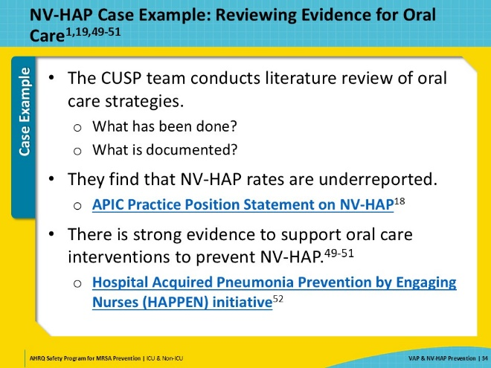
NV-HAP Case Example: Identifying Barriers and Challenges  SAY:  The next step is to engage the team in identifying the barriers to implementing oral care intervention. To do this, the team sends out a survey to the staff. Based on the feedback, team members assemble this list of barriers and challenges that they need to address:  - Getting support from staff AND leadership about the significance of NV-HAP  - Increasing staff knowledge about the importance of oral care as a pneumonia prevention strategy  - Setting an expectation that oral care should be a standard of care, and not an optional activity  - Engaging patients and their families in the effort to perform adequate oral care  - Ensuring easy access to quality oral care supplies  - Difficulties with staffing and coordination with other departments  Identifying and sharing these barriers helps everyone understand the real and potential operational issues with the current process and the new interventions. | Slide 35  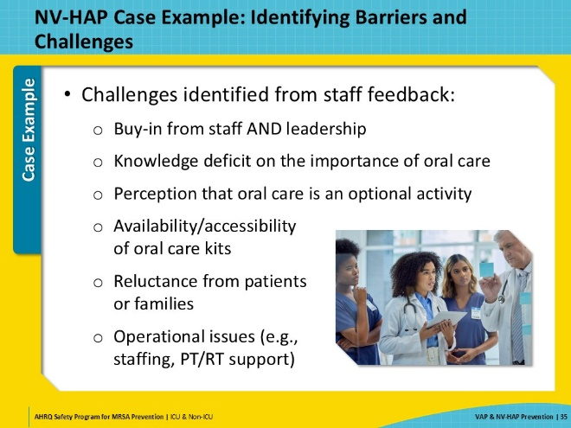
NV-HAP Case Example: Evaluating Performance  SAY:  As with the VAP case study, knowing which metrics are available and what to collect is a critical step to ensuring that teams are able to evaluate and demonstrate success after implementation of their interventions. This includes rates of HAI, but also process and outcome measures. Being able to track adherence to the intervention is necessary to understanding how it is being carried out.  In this case example, while determining their metrics, the team learns that documentation of oral care completion is not part of the current standard workflow and that staff often make assumptions that the patients have performed their own oral care. The team decides to establish a new procedure for documentation of oral care, which allows the team to track completion as one of their metrics. | Slide 36  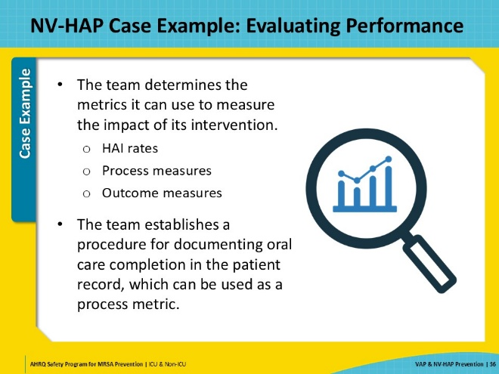
NV-HAP Case Example: Implementing the Intervention  SAY:  The CUSP team, with the support and engagement of its executive leader, decides to implement an oral care protocol similar to the one in the HAPPEN trial. This protocol requires purchasing a custom oral care kit that makes it easy for staff to have what they need at the bedside.  Once the protocol materials are developed and the kit is ready to use and stocked on the unit, it is time to ensure all eligible patients receive the intervention. To make sure no steps are skipped in the implementation process, the CUSP team relies on the 4 Es. All staff are engaged and educated on the importance of oral care and the expectations about the new oral care protocol. The intervention is rolled out and over the next 2 months, the team reviews compliance with use of the kit, tracks compliance with documentation, and surveys the patients on the unit.  The CUSP team continues to follow the unit’s NV-HAP rates to see if there is a change in the trend over time. These data are then shared at unit-based meetings and displayed on the staff huddle board. The unit has made a big step in the right direction to prevent NV-HAP. | Slide 37  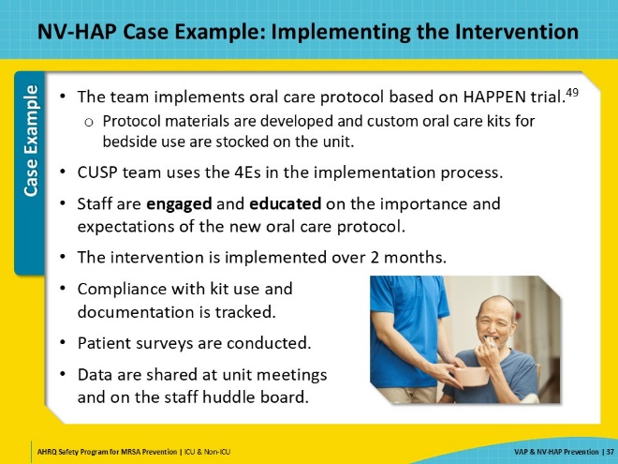
NV-HAP Case Example: Celebrating and Recognizing Success!  SAY:  Again, it is important to celebrate successes. Implementation of any performance improvement activity requires a lot of time and energy. Recognizing team members and frontline staff for their efforts is critical to making them feel like their efforts are worthwhile and motivate them to continue their engagement in performance improvement activities and sustain the improvements and gains.  In this case example, the unit sees a significant reduction in NV-HAP rates. The compliance rate with the oral care protocol is consistently above 90 percent.  The unit was recognized internally by the hospital administration for its outstanding improvements in patient outcomes. This included a formal acknowledgment during the quarterly staff meeting, a feature in the hospital newsletter, and a "Best Practices" award from the overall health system’s quality improvement committee, highlighting its impressive results.  Inspired by their success, other units in the hospital began adopting similar protocols. The CUSP team was happy to share their lessons learned, leading to overall improvements in patient care and outcomes hospital-wide. | Slide 38  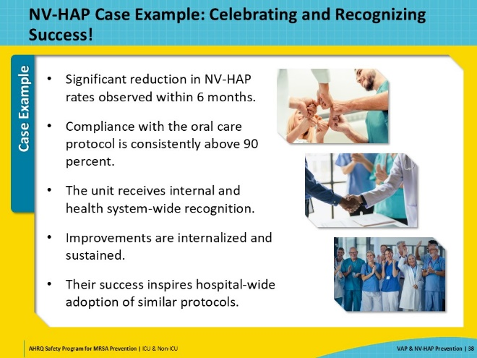
Recognize Efforts and Celebrate!  SAY:  As with any performance improvement project, it is important to give feedback to the staff and recognize their contributions. This can be done by publishing progress in staff newsletters and displaying data on huddle boards or other areas to share early mobility information and its impact on key metrics. Proudly share the number of days since the last patient developed a VAP on the unit. Encourage staff to present their work at CUSP team and staff meetings. Better yet, if your facility has been able to sustain an improvement over time or overcome a particularly challenging barrier, encourage staff to submit posters or presentations at national conferences. | Slide 39  
Key Takeaways  SAY:  To summarize the key takeaways from today’s presentation:  Healthcare-associated pneumonia is a significant, but often overlooked HAI. Despite calls from APIC, SHEA, IDSA, and TJC to increase attention on this metric, it continues to be the most common HAI, and VAE rates have increased throughout the COVID-19 pandemic.  As MRSA has become an increasingly common cause of pneumonia, the work of this collaborative, coupled with the implementation of nationally recognized best practices, is necessary.  Teams can use existing tools and resources, such as the TRIP Model, to help bridge the gap from their current state to their desired future state.  Since no one infection prevention strategy can eliminate MRSA on its own, it’s important to continue to take a multimodal approach to break the chain of MRSA transmission and infection through decolonizing patients, cleaning and disinfecting the healthcare environment, and using evidence‐based interventions to prevent device- and procedure‐associated infections such as VAP.  Remember that MRSA is preventable. Working together and using these key strategies, we can protect patients and take aim at MRSA. | Slide 40  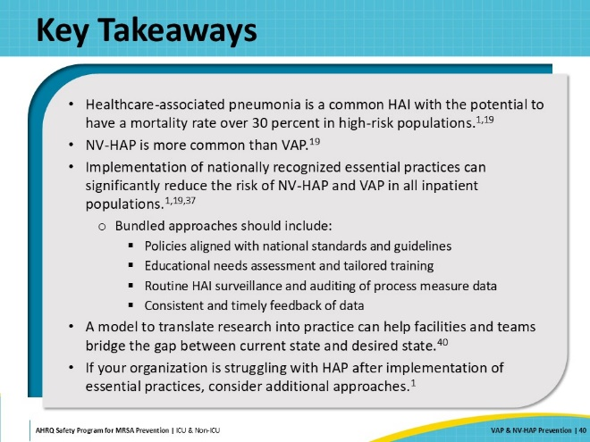
Disclaimer  SAY:  The findings and recommendations in this presentation are those of the authors, who are responsible for its content, and do not necessarily represent the views of AHRQ. No statement in this presentation should be construed as an official position of AHRQ or of the U.S. Department of Health and Human Services.  Any practice described in this presentation must be applied by healthcare practitioners in accordance with professional judgment and standards of care in regard to the unique circumstances that may apply in each situation they encounter. These practices are offered as helpful options for consideration by healthcare practitioners, not as guidelines. | Slide 41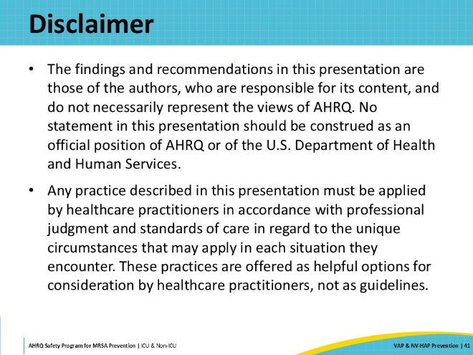
Reference List—1 | Slide 42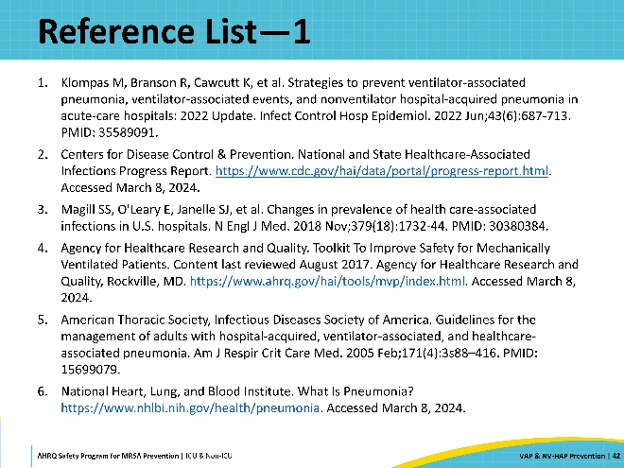
Reference List—2 | Slide 43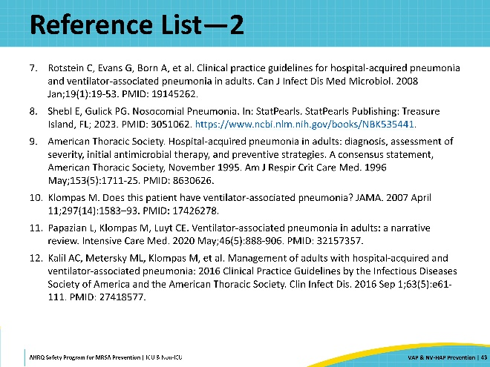
Reference List—3 | Slide 44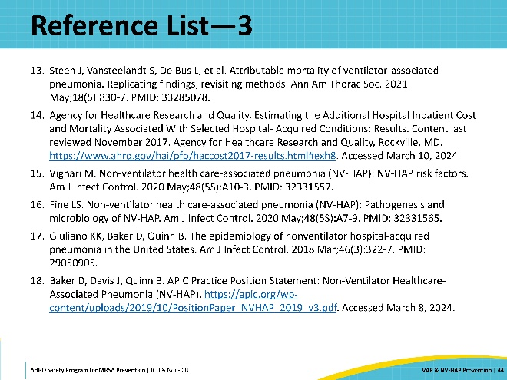
Reference List—4 | Slide 45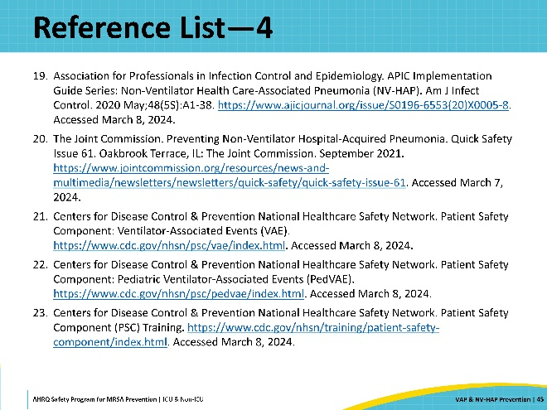
Reference List—5 | Slide 46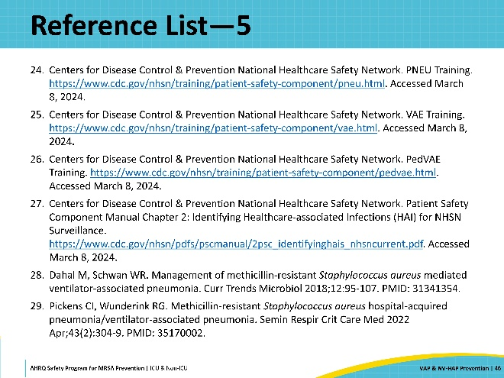
Reference List—6 | Slide 47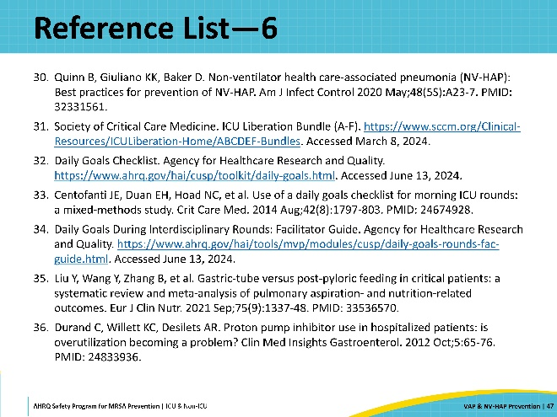
Reference List—7 | Slide 48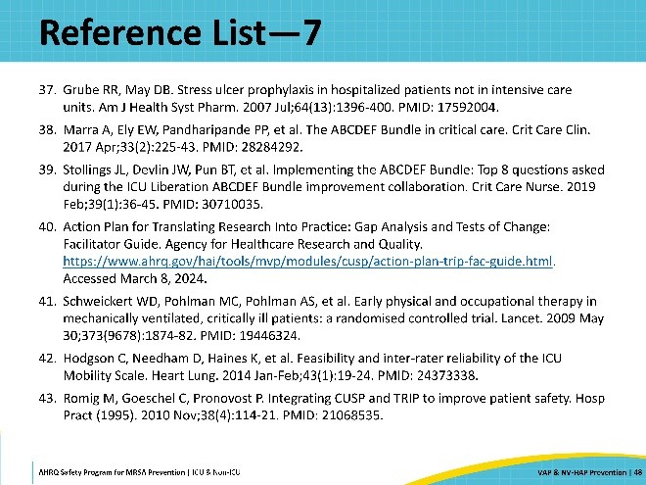
Reference List—8 | Slide 49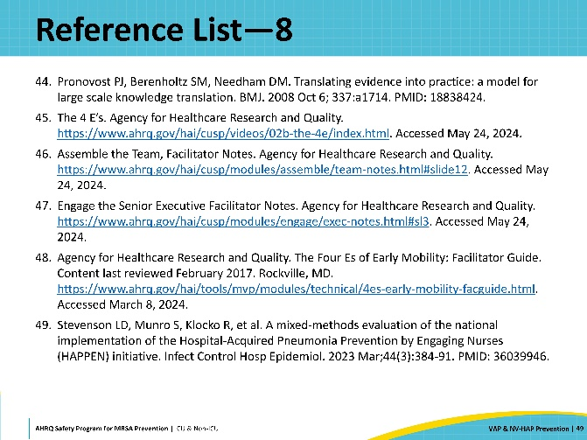
Reference List—9 | Slide 50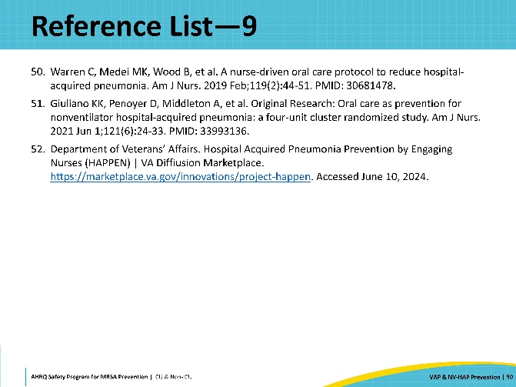

AHRQ Pub. No. 25-0007
October 2024

