Ventilator-Associated Pneumonia (VAP) Prevention Essential Practices¹

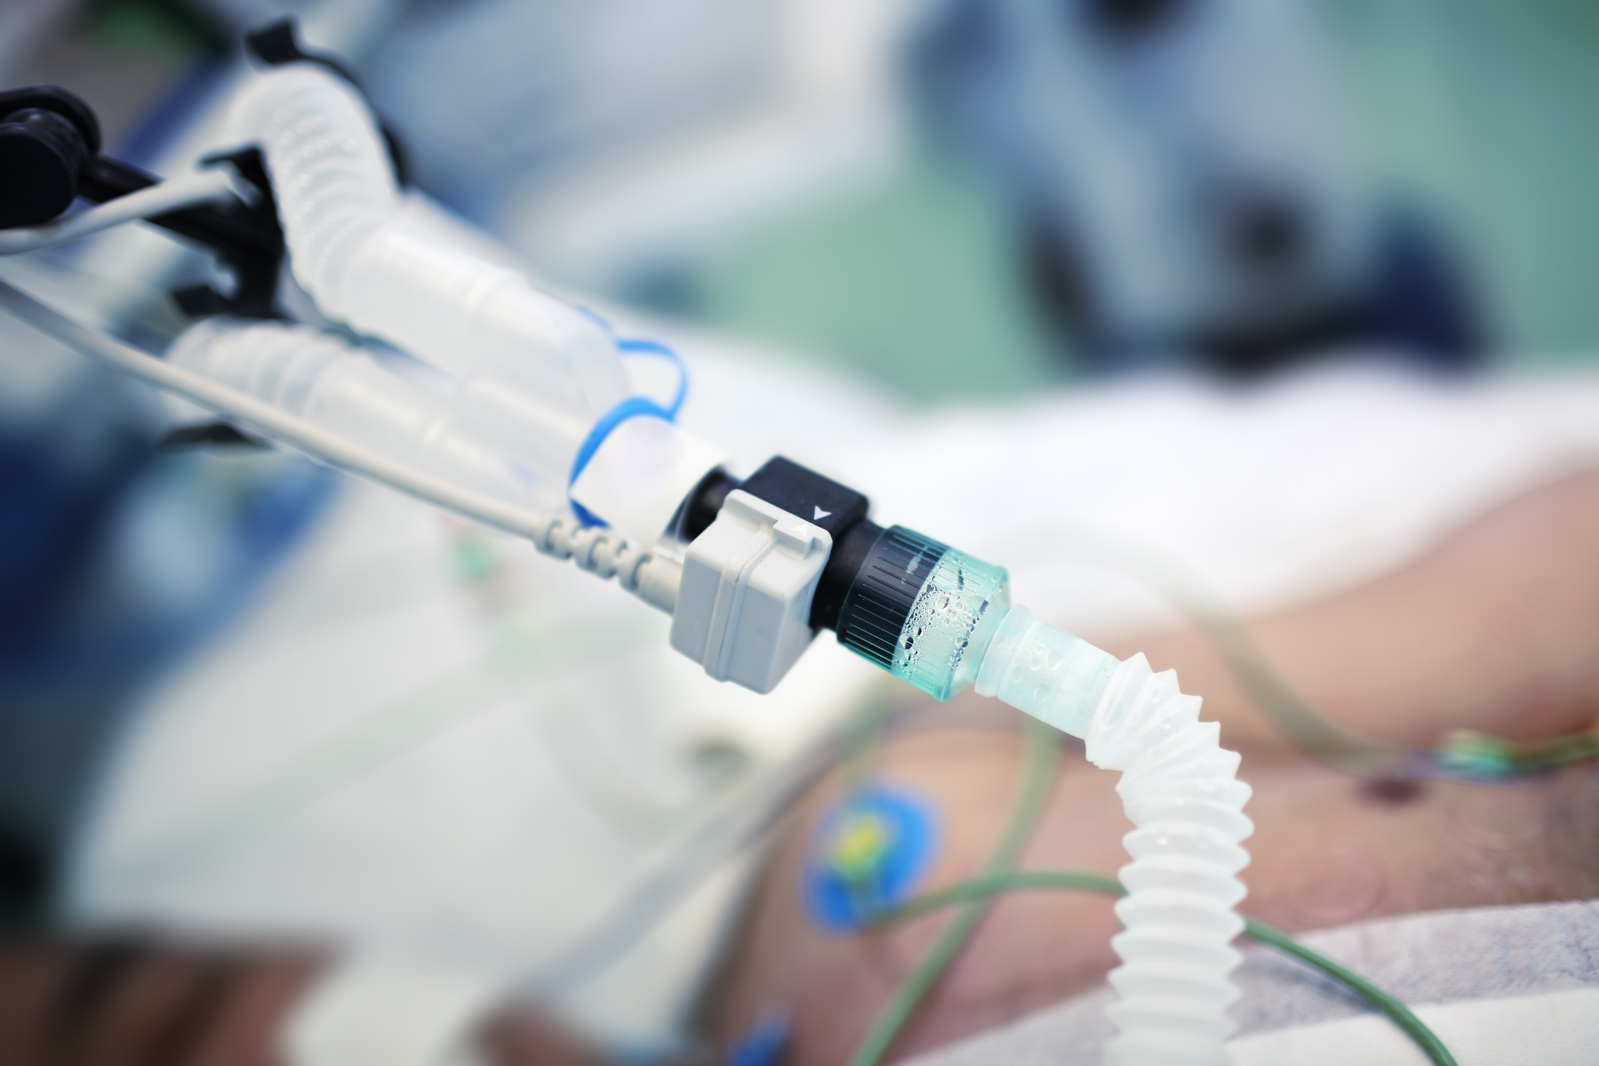
Avoid intubation if possible.²⁻³
- Consider alternative strategies, such as, high flow O2 or noninvasive positive pressure ventilation.
- Consider each patient’s clinical scenario to determine the most appropriate strategy.

Minimize sedation.²⁻⁵
- Determine a clear plan and targets for sedation. Consider multimodal and alternative strategies.
- Conduct daily sedation awakening trials, unless contraindicated.

Conduct daily spontaneous breathing trials.^{2, 4-5}
- Perform for all ventilated patients without contraindications.
- Coordinate concurrently with sedation awakening trials.

Mobilize patients as soon as possible.⁴⁻⁵
- Early mobilization contributes to reduction in duration of mechanical ventilation and shorter ICU stay.
- Identify barriers to early mobility and discuss solutions with staff.

Elevate head of bed above 30 degrees.²⁻⁴
- Current evidence recommends avoiding the supine horizontal position.

Complete daily oral care.
- Daily toothbrushing is an essential practice.
- Do NOT use chlorhexidine for oral care. Evidence suggests potential for increased mortality rates.

Provide early enteral feeding.²⁻³
- Early enteral nutrition is preferred over parenteral nutrition.

Maintain ventilator circuits properly.³
- Change circuits only when soiled or nonfunctioning, or according to manufacturer instructions.
- If condensation occurs, drain away from patient.

Additional Interventions To Consider

Perform selective decontamination of oropharynx and digestive tract.^{2-3,6}
- Should only be considered in populations/units with low rates of multidrug-resistant organisms.
- Must be coupled with a mechanism to monitor for antibiotic resistance.

Use endotracheal tubes with subglottic suction.⁴
- Associated with reduced VAP rates but has not been found to affect other outcomes (e.g., mortality).

Consider early tracheostomy (within 7 days of intubation).³
- Associated with reduced VAP rates but the broader impact on patient health must be considered.

Consider post-pyloric feeding.^{2,7}
- Associated with a lower incidence of pneumonia than gastric feeding.

Guidelines and Resources
- 2022 SHEA Compendium Strategies to Prevent VAP, Ventilator-Associated Events, and Non-Ventilator Hospital-Acquired Pneumonia¹
- Society of Critical Care Medicine ICU Liberation Bundle (published 2020)⁵
- AHRQ Toolkit To Improve Safety for Mechanically Ventilated Patients (2017)⁴

References

- Klompas M, Branson R, Cawcutt K, et al. Strategies to prevent ventilator-associated pneumonia, ventilator-associated events, and nonventilator hospital-acquired pneumonia in acute-care hospitals: 2022 Update. Infect Control Hosp Epidemiol. 2022 Jun;43(6):687-713. PMID: 35589091.
- American Thoracic Society, Infectious Diseases Society of America. Guidelines for the management of adults with hospital-acquired, ventilator-associated, and healthcare-associated pneumonia. Am J Respir Crit Care Med. 2005 Feb;171(4):388–416. PMID: 15699079.
- Rotstein C, Evans G, Born A, et al. Clinical practice guidelines for hospital-acquired pneumonia and ventilator-associated pneumonia in adults. Can J Infect Dis Med Microbiol. 2008 Jan;19(1):19-53. PMID: 19145262.
- Agency for Healthcare Research and Quality. Toolkit To Improve Safety for Mechanically Ventilated Patients. Content last reviewed August 2017. Agency for Healthcare Research and Quality, Rockville, MD. https://www.ahrq.gov/hai/tools/mvp/index.html. Accessed March 8, 2024.
- Society of Critical Care Medicine. ICU Liberation Bundle (A-F). https://www.sccm.org/Clinical-Resources/ICULiberation-Home/ABCDEF-Bundles. Accessed March 8, 2024.
- Shebl E, Gulick PG. Nosocomial Pneumonia. In: StatPearls. StatPearls Publishing: Treasure Island, FL; 2023. PMID: 3051062. https://www.ncbi.nlm.nih.gov/books/NBK535441.
- Liu Y, Wang Y, Zhang B, et al. Gastric-tube versus post-pyloric feeding in critical patients: a systematic review and meta-analysis of pulmonary aspiration- and nutrition-related outcomes. Eur J Clin Nutr. 2021 Sep;75(9):1337-48. PMID: 33536570.

AHRQ Pub. No. 25-0007
October 2024

