The Evidence Behind Decolonization Strategies for MRSA
ICU & Non-ICU
Slide Title and Commentary | Slide Number and Slide
Evidence Behind Decolonization Strategies for MRSA  SAY:  Welcome to this presentation on the current evidence behind decolonization strategies as part of an overall approach to preventing MRSA in ICU and non-ICU settings. | Slide 1  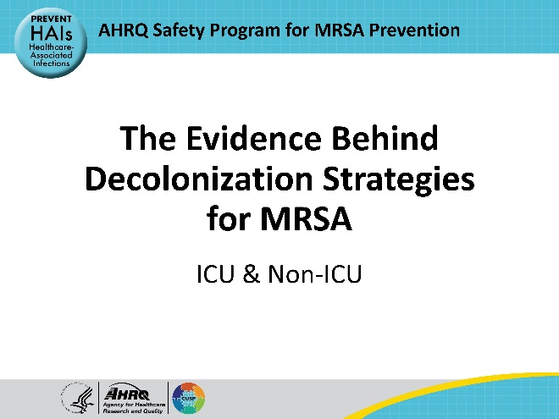
Educational Objectives  SAY:  The objectives of this presentation are:  - Discuss the importance of decolonization for MRSA prevention  - Review the evidence behind use of chlorhexidine gluconate (CHG) for skin decolonization  - Review the evidence behind use of nasal decolonization  - Discuss universal vs. targeted strategies for decolonization | Slide 2  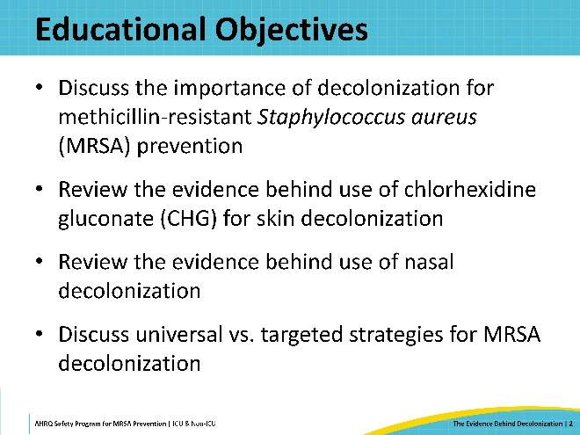
Four Key Strategies to Prevent MRSA  SAY:  The Toolkit for MRSA Prevention in the ICU & Non-ICU highlights four key strategies for MRSA prevention. This presentation will focus on the first strategy: Decolonizing patients. | Slide 3  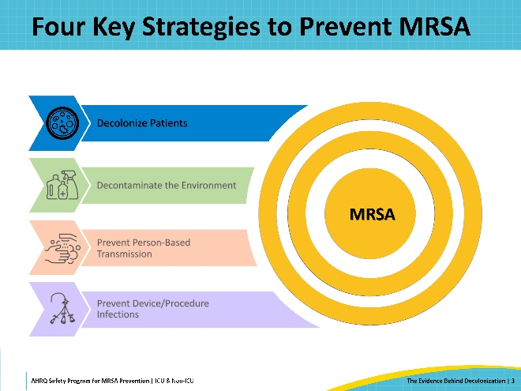
Decolonizing Patients  SAY:  Colonization is defined as the presence of bacteria on or in a patient’s body without any current signs or symptoms of infection. About 1 in 3 of the general population is estimated to be colonized with Staphylococcus aureus.  However, hospitalized patients are more vulnerable to MRSA infection due to several factors, including reduced immunity from underlying illness or medication, or portals of entry provided by invasive procedures or devices. Decolonization is the process of reducing or suppressing colonizing bacteria on a patient's body. This process aims to lower the risk of progressing to infection or transmitting bacteria to other patients. | Slide 4  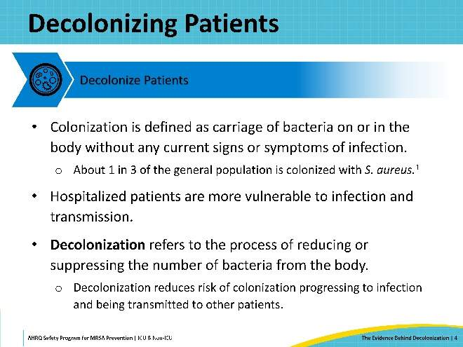
Prevalence of S. aureus  SAY:  Each year, there are 120,000 Staphylococcus aureus bloodstream infections and 20,000 associated deaths.  Among all healthcare-associated infections (HAIs), Staphylococcus aureus is the second most common causative pathogen.  Staphylococcus aureus is the number 1 cause of central line-associated bloodstream infections (CLABSI) in the non-ICU, and the number 5 cause in ICUs. For ventilator-acquired pneumonia (VAP), Staphylococcus aureus is the number 2 cause in non-ICUs, and number 1 in ICUs. Staphylococcus aureus is also the leading causative pathogen of surgical site infections (SSIs).  Staphylococcus aureus remains a clear threat and a major priority for prevention in all acute care settings. | Slide 5  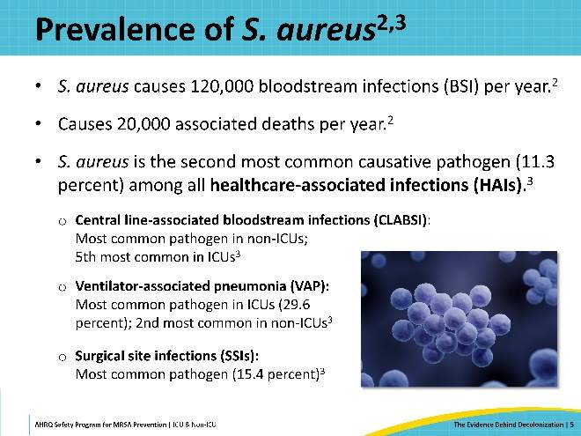
S. aureus Colonization Patterns  SAY:  The main reservoir of Staphylococcus aureus is the nose. This figure displays Staphylococcus aureus colonization in multiple body sites. On the left is the general population. Approximately 1 in 3 individuals are carriers. The nose is the most colonized site, but the hands are almost as prevalent. This demonstrates how often people touch their nose and face and then touch other parts of their body.  On the right is the subpopulation of individuals who carry S. aureus in the nose. As you can see, among nasal carriers, every other part of the body is more likely to be colonized with Staphylococcus aureus compared with the general population. This can give you a sense of how the nose provides a continuously repropagating reservoir for colonization of the rest of the body. | Slide 6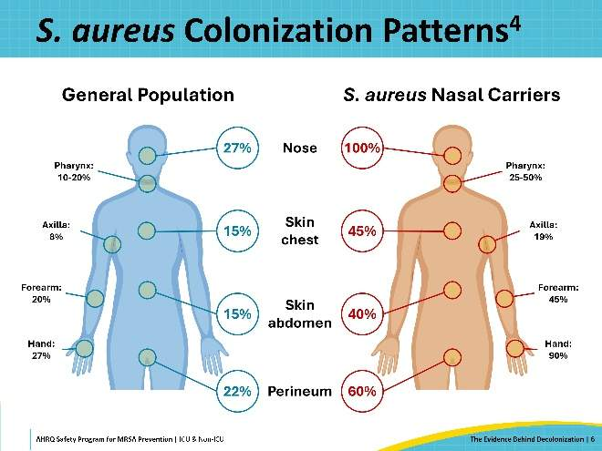
Decolonization Prevents a Cascade of Unfortunate Events  SAY:  HAIs represent a cascade of unfortunate events. There are a lot of pathogens on human skin, in the nose, and in the mouth, and these pathogens are shed profusely into the environment. As pathogens are shed, contamination can occur and persist if surfaces are not cleaned or disinfected. Staphylococcus aureus can be picked up by healthcare personnel by touching contaminated surfaces and, if the Staphylococcus aureus is not removed, it can then be transferred to other patients, who now have an increased risk for infection.  Decolonization works at the beginning of this cascade– stopping the shedding of pathogens and thereby preventing environmental contamination, acquisition, and transfer. Decolonization is unique among common infection prevention strategies in that it addresses the multidrug-resistant organisms (MDROs) that people already have. Almost all the other infection prevention strategies – hand hygiene, environmental cleaning – are designed to prevent spread from one person who already has an MDRO to another who does not. Decolonization is the one strategy that can prevent progression from colonization to infection in people who already harbor the MDRO. It is broadly active against a whole array of MDROs, and it protects MDRO carriers, who have highest risks of infection from those pathogens. | Slide 7  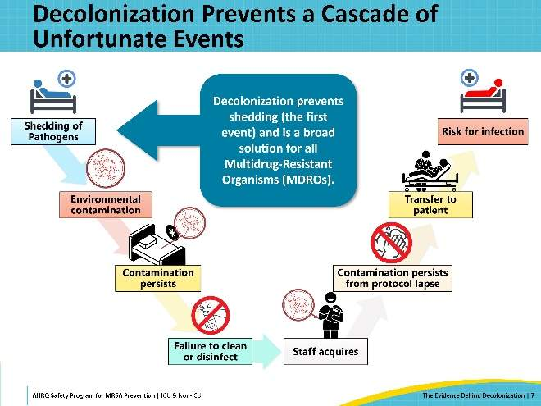
The Evidence for Decolonization  SAY:  In the next section, this presentation will explore the evidence for decolonization with chlorhexidine gluconate bathing. | Slide 8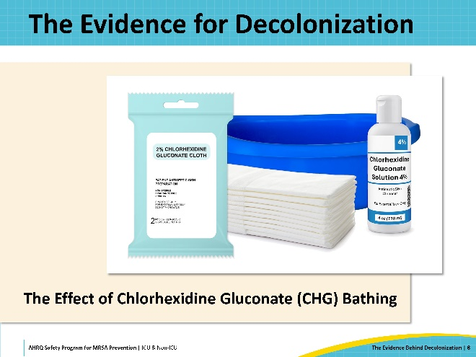
Chlorhexidine Gluconate (CHG)  SAY:  Chlorhexidine gluconate, or CHG, is an antiseptic. It binds to skin proteins and kills germs for up to 24 hours. For this reason, chlorhexidine is much more effective than regular soap and water. With regular soap and water, there is often recontamination from the environment. In contrast, CHG continues to kill germs on skin for up to 24 hours, providing prolonged protection against recontamination.  CHG comes in several formulations: mouthwash, soap, shampoo, and 2 and 4 percent solutions which are most used for bathing. Prepackaged CHG-impregnated cloths are also available. | Slide 9  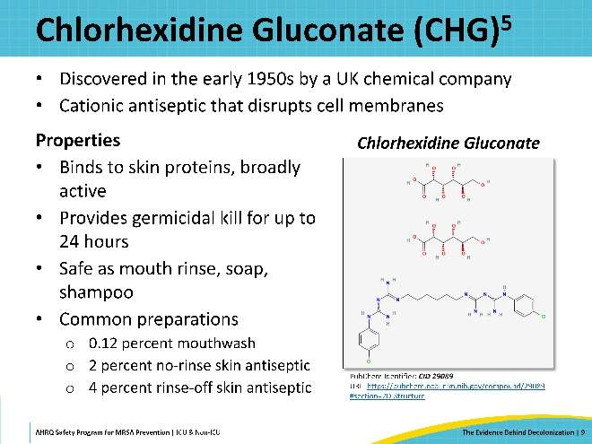
Uses for CHG in Healthcare  SAY:  Several uses for chlorhexidine over the years have been proven effective through a series of randomized clinical trials. These trials provide the foundation for the evidence behind CHG usage for decolonization.  Prior to 1990, CHG was used for hand antisepsis, dental hygiene, and oral care.  In the 1990s, there were several major randomized controlled trials that demonstrated that cleaning the skin with CHG prior to central line insertion was the most protective action against central line-associated bloodstream infection (CLABSI).  This was followed by trials in the 2000s that showed that CHG with alcohol was superior to other forms of antiseptics for surgical preparation of skin to prevent SSI. This was then followed by trials showing that pre-operative decolonization of Staphylococcus aureus carriers with nasal decolonization was an effective way to prevent Staphylococcus aureus infections.  In 2013, three major randomized clinical trials were conducted, demonstrating the value of universal decolonization with CHG bathing to prevent infections in intensive care units (ICUs).  More recently, in 2019, Huang et al. published a trial that evaluated chlorhexidine and mupirocin use in non-ICU hospital units. | Slide 10  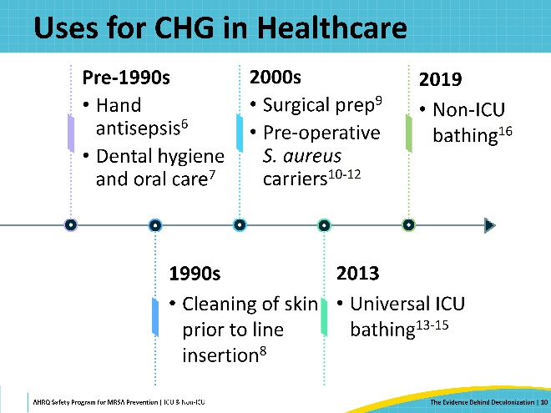
Decolonization Trials  SAY:  Many trials have examined the use of CHG decolonization to prevent Staphylococcus aureus infections in different modes and settings, both in and outside of hospitals. This includes targeted use of decolonization to prevent recurrent infections, avoid post-operative infections, and lower post-discharge infection risk, and universal decolonization strategies in nursing homes, ICUs, and non-ICU hospital units. This presentation focuses on decolonization in ICU and non-ICU hospitalized patient populations. | Slide 11  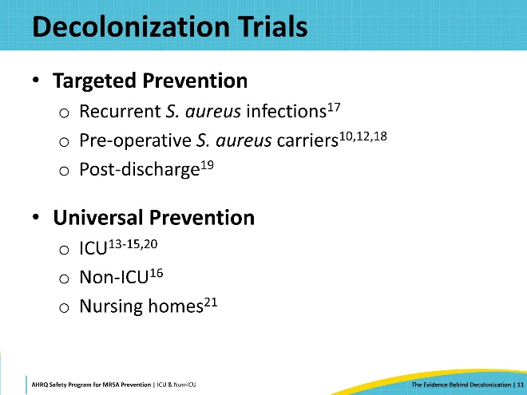
Decolonization Evidence Summary  SAY:  This table summarizes the key evidence for decolonization in the acute care hospital setting. The evidence includes several single center and small multi-center studies followed by large cluster randomized trials. Findings consistently identify a sizable reduction in both MDRO carriage and bloodstream infection events. | Slide 12  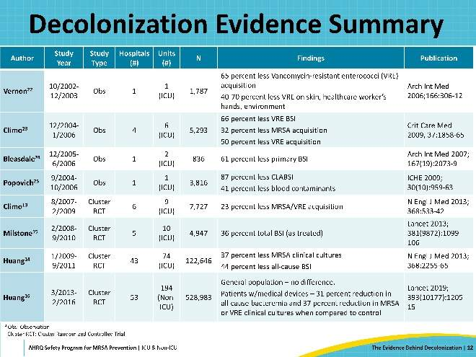
Vernon et al., 2006: CHG Bathing in the ICU  SAY:  From 2002 to 2003, Vernon et al. conducted a single center three-phase study in a medical ICU. They compared results from three 5-month phases – beginning with a 5-month phase when patients were bathed with regular soap and water, followed by another 5-month phase when patients were bathed with 2 percent no-rinse CHG cloths, and then a final 5-month phase, when patients were bathed with non-medicated, non-antiseptic cloths. The study conducted serial sampling of rectal and skin areas and environmental sampling, with vancomycin-resistant Enterococci (VRE) as their primary outcome.  This study showed that CHG bathing not only reduced VRE skin colonization, but also reduced environmental contamination, contamination of the hands of healthcare workers, and patient acquisition of VRE. This effect was not seen with non-medicated, non-antiseptic cloths. | Slide 13  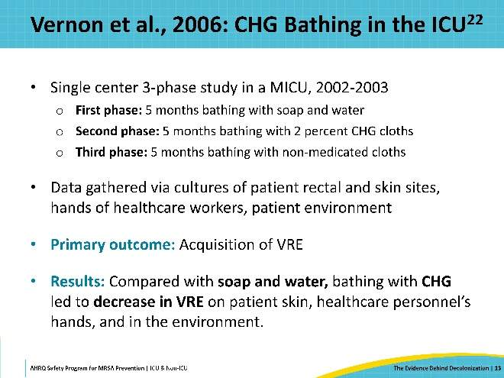
Popovich et al., 2009 and 2012: Bioburden on Skin by Cleansing Method  SAY:  From 2004 to 2006, a study was conducted by Popovich et al. in a single ICU, examining the relationship of daily skin cleansing with different bathing methods and microbial density on patients’ skin. This study found that CHG bathing resulted in 87 percent reduction in CLABSI and a 41 percent decrease in blood culture contamination.  Further research was conducted by Popovich et al. in a 2012 study in the same ICU. A semi-quantitative, colorimetric indicator test was used to determine the effectiveness of skin cleansing with soap and water, pre-soaked CHG cloths, and non-medicated cloths. Bathing with CHG cloths was the most effective method of the three, resulting in the lowest microbial density on the skin for VRE, gram-positive bacteria, gram-negative bacteria, and yeast. | Slide 14  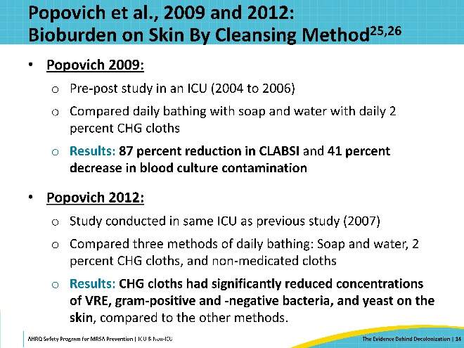
Bleasdale et al., 2007: CHG and CLABSI  SAY:  From 2005 to 2006, Bleasdale et al. conducted a single center, 2-arm crossover clinical trial in two ICUs. The study compared 2 percent CHG impregnated washcloths against regular soap and water for daily bathing, with primary outcomes of occurrence of CLABSI and clinical sepsis. Not only was bacterial colonization on the skin reduced, but so was the rate of infection. This study was notable as the first trial to show reduction in CLABSI with CHG bathing. | Slide 15  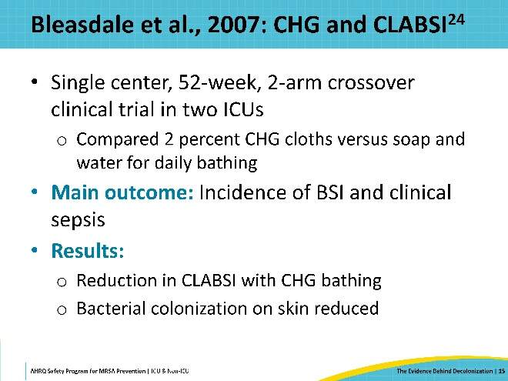
Three Decolonization Trials in 2013  SAY:  Because of this, three major decolonization trials were launched over the next few years – all of which were published in 2013. Unlike the earlier studies, these were multi-center randomized trials. They included two trials in adult ICUs and one trial in pediatric ICUs. | Slide 16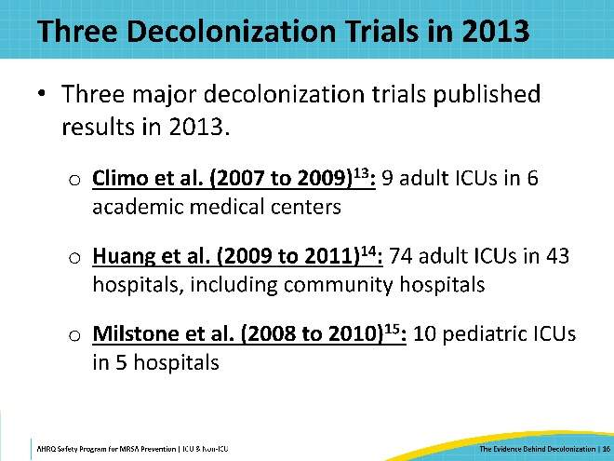
Climo et al., 2013: Effect of Daily CHG Bathing on Hospital-Acquired Infection  SAY:  Climo et al. was the first of these studies, running from August 2007 to February 2009. This study was a cluster-randomized cross-over trial of 9 ICUs at six hospitals, evaluating the effects of daily CHG baths versus daily baths with non-antimicrobial washcloths. (Initially, seven hospitals participated, but one hospital dropped out for low compliance with study protocols). All ICUs performed MRSA and VRE screening at the time of hospital admission. The investigators used a cross-over study design wherein each ICU received 6 months of each protocol. They analyzed the composite outcome of MRSA and VRE acquisition (new cases), and all-cause bloodstream infections (BSI). | Slide 17  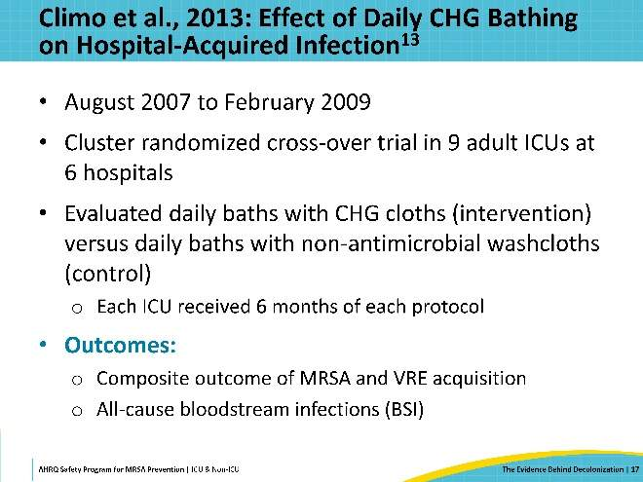
Climo et al., 2013: Results  SAY:  Overall, the trial included 7,735 patients. Overall MDRO acquisition rates were reduced by 21 percent during the intervention period, when the units were conducting daily CHG bathing, compared to the control period. Acquisition rates of MRSA or VRE were reduced by 23 percent. The trial also observed a 31 percent reduction in primary bloodstream infection rates and a 53 percent reduction of CLABSI rates when patients received a daily CHG bath. Most importantly, susceptibility testing showed no evidence of chlorhexidine resistance, and the CHG was well-tolerated by patients. | Slide 18  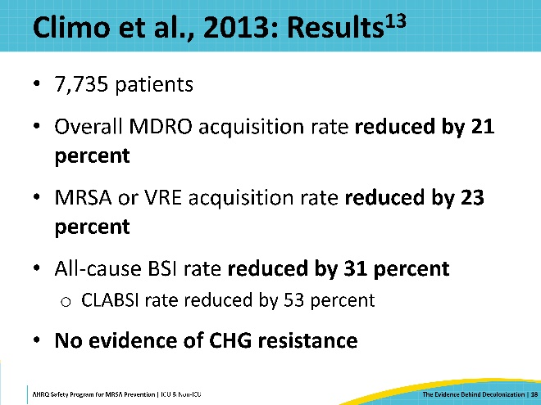
Huang et al., 2013: REDUCE MRSA Trial  SAY:  The REDUCE MRSA Trial, by Huang et al., running from January 2009 to September 2011, was by far the largest and most comprehensive study on CHG decolonization than anything before it. Conducted in HCA Healthcare hospitals, REDUCE MRSA was a pragmatic, 3-armed cluster-randomized trial that included 43 hospitals and 74 adult ICUs. The participating hospitals were randomized into 3 arms. Arm 1 was routine care, which involved nasal screening for MRSA of all ICU admissions and application of contact precautions for patients who tested positive or had a known history of MRSA. Arm 2 did the same thing – screened all patients, applied contact precautions – but added a targeted decolonization protocol. All patients known to have MRSA were treated with 5 days of twice-daily intranasal mupirocin and 5 days of daily CHG baths. In Arm 3, contact precautions were the same as the other two arms, but no screening for MRSA was conducted. Instead, this arm implemented a universal decolonization strategy: all patients received decolonization with 5 days of twice-daily mupirocin and daily chlorhexidine baths for the duration of stay.  Data was collected for a 12-month baseline period, followed by a 4-month phase-in, followed by an 18-month intervention period, which included more than 74,000 patients and almost 283,000 ICU patient days. The trial design allowed comparison between each hospital's intervention period to its own baseline data to account for unmeasured confounding. | Slide 19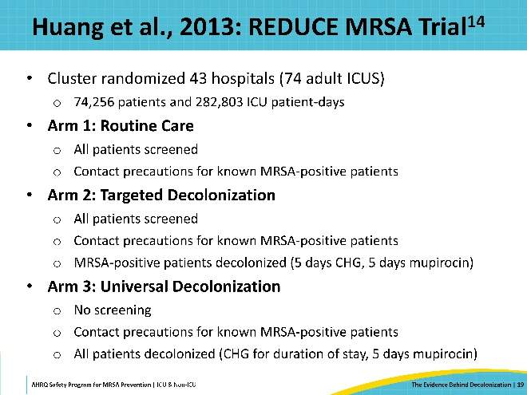
REDUCE MRSA Results: MRSA Cultures  SAY:  This graph illustrates the primary outcome of ICU-attributable MRSA-positive cultures. Within this bubble plot, every circle represents a hospital. The size of the bubble reflects the number of ICU patients contributing to that data point. The y-axis reflects the hazard ratio, which is the comparison between the hospital’s intervention period and their own baseline. A hazard ratio of 1 indicates no significant difference between baseline and intervention. If the hazard ratio is below 1, there's a preventative benefit for the outcome of clinical cultures growing MRSA.  Arm 1, which had no change in protocol between baseline and intervention, has a hazard ratio of about 1.  Arm 2, targeted decolonization, performs a little bit better with a hazard ratio of 0.75.  Arm 3, universal decolonization, performs the best with a hazard ratio of 0.63. This represents a 37 percent reduction in clinical cultures growing MRSA compared to the baseline, significantly better than the routine care arm. | Slide 20  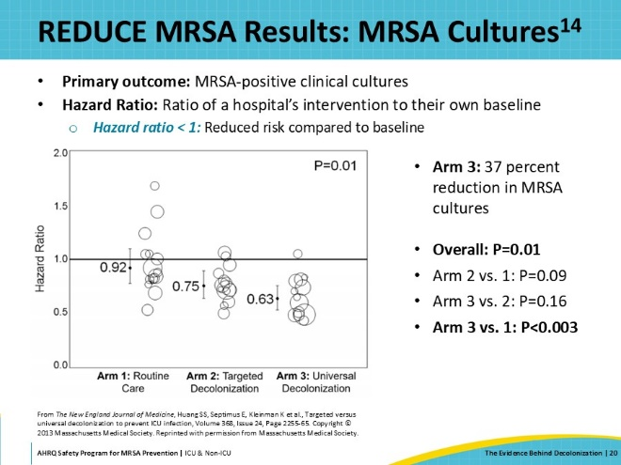
REDUCE MRSA Results: MRSA BSI  SAY:  Similarly, for MRSA bloodstream infection, there was a large reduction in the universal decolonization arm compared to the baseline. All the bubbles within this arm are below the line and grouped closely together, suggesting that many hospitals benefitted from the intervention. This is a desired outcome, as opposed to one larger hospital benefiting and driving trial results while others show little difference. This reduction was not statistically significant because the trial was not well-powered for this outcome.  What's striking about this graph, however, is that neither of the other two arms showed any improvement in the MRSA BSI rate. The targeted decolonization arm did not perform any better than the routine care arm for MRSA BSIs. This is unexpected, as the investigators predicted some benefit from screening and targeted decolonization of MRSA-positive patients. This highlights that screening the nose once is likely insufficient for finding all patients who might harbor MRSA. This demonstrates a limitation of targeting decolonization based on MRSA surveillance alone; the efficacy is dependent on the accuracy of the screening method. | Slide 21  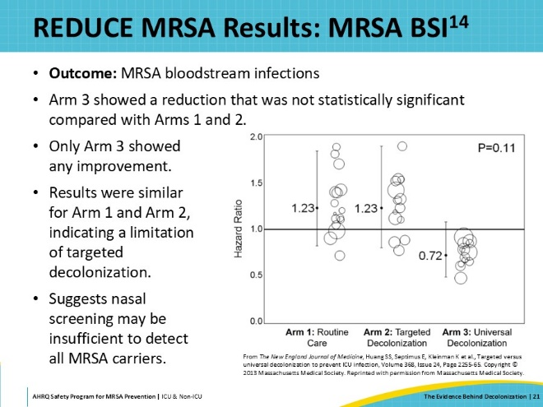
REDUCE MRSA Results: All-Pathogen BSI  SAY:  For ICU-attributable, all-pathogen BSIs, targeted decolonization was associated with a 22 percent reduction compared to routine care. Universal decolonization was associated with a 44 percent reduction in all-pathogen bloodstream infection, significantly better than both routine care and targeted decolonization.  This outcome of all-pathogen bloodstream infection became a particular appeal for hospitals to adopt ICU decolonization. | Slide 22  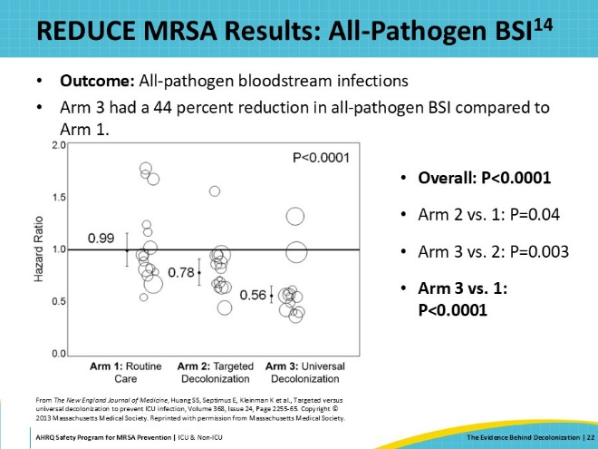
REDUCE MRSA Results: Cost Savings of Universal ICU Decolonization  SAY:  The REDUCE MRSA Trial estimated the healthcare costs of each of the three strategies and found that universal ICU decolonization was the most cost-effective. This was true even considering the costs related to decolonization, because of the magnitude of cost savings from reduced infections. For every 1,000 ICU admissions, universal ICU decolonization prevents 5 MRSA clinical cultures and 9 bloodstream infections, compared to the routine practice of screening and contact precautions, representing an estimated $155,000 in savings.  Additionally, intervention costs are lower, because not screening all patients saves those related funds. For every 1,000 ICU admissions, there are $17,000 in savings in intervention costs compared to routine care and $21,000 in savings compared to targeted decolonization.  Overall, accounting for infections averted, universal decolonization produces a $171,000 cost savings per 1,000 admissions compared to screening and isolation, and a $100,000 cost savings compared to screening, isolating, and targeted decolonization. | Slide 23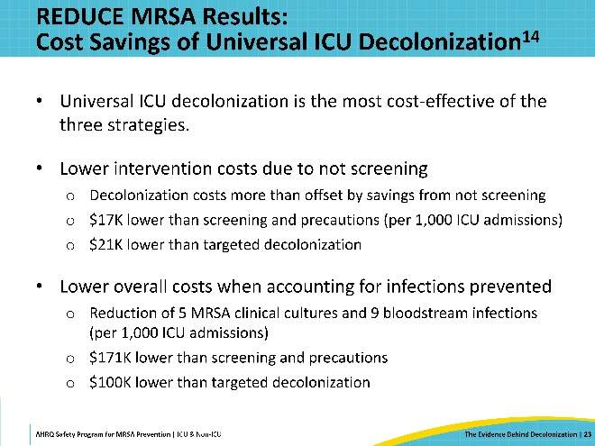
REDUCE MRSA Results: Additional Decolonization Impact  SAY:  Additional analysis found further benefits for universal ICU decolonization, including a reduction in blood culture contamination, and a reduction of bacteriuria and candiduria, though only in men. This may be tied to how well the perineal area is cleaned, which is generally easier to do in men than women.  Importantly, analysis showed no emergence of chlorhexidine or mupirocin resistance in the thousands of isolates collected during this trial.  When universal decolonization was implemented in the remaining 95 hospitals in the HCA healthcare system, there was a significant CLABSI reduction system-wide. In a 2021 survey, 63 percent of U.S. hospitals had adopted universal ICU chlorhexidine bathing, supported by the results of these trials. | Slide 24  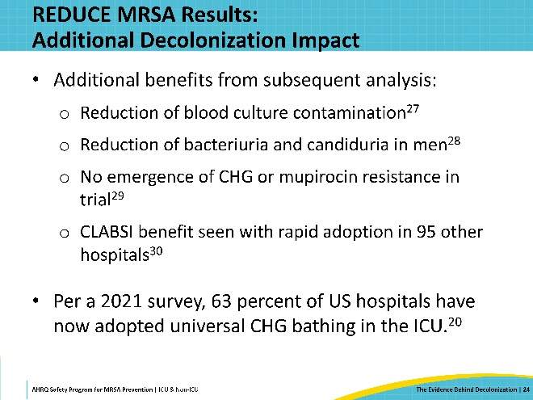
Milstone et al., 2013: Pediatric SCRUB Trial  SAY:  The benefit of universal decolonization is not restricted to adults. The Pediatric SCRUB trial by Milstone et al. implemented universal CHG bathing in 10 pediatric ICUs at 5 academic medical centers, for all pediatric ICU patients at least 2 months old. The trial’s primary outcome was bacteremia and did not evaluate MRSA. The results of the trial found a 36 percent reduction in bacteremia among patients who received the CHG bathing compared to standard bathing practices. These results are consistent with findings from the other trials. The trial also found that CHG was well-tolerated by the pediatric population. | Slide 25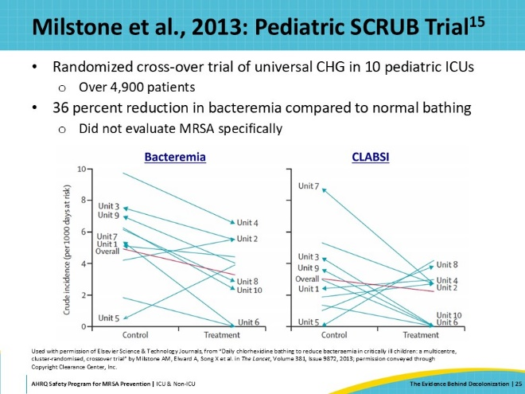
Decolonization in the Non-ICU Setting: ABATE Infection Trial  SAY:  Based on the results of these studies, the next question was whether similar universal decolonization strategies would be effective in non-ICU hospital units.  To examine this question, the ABATE infection trial was conducted within the HCA Healthcare system, focusing on the non-ICU setting. This was a cluster-randomized trial in 53 hospitals involving 194 adult non-ICUs. Units included medical, surgical, oncology, and stepdown units. It compared two arms – Arm 1, or Routine Care, involving the usual care shower and bathing regimen with whichever soap was commonly in use, and Arm 2, or Decolonization, involving daily showers with 4 percent rinse-off CHG or bed baths with 2 percent CHG cloths. Patients in the Decolonization arm also received mupirocin for 5 days, twice a day, if they were known to be MRSA-positive by history, culture, or screening.  The study’s primary outcome was combined MRSA or VRE clinical cultures attributable to a non-ICU unit, as well as a key secondary outcome of all-pathogen bloodstream infection. This was a large trial with a study design like the REDUCE MRSA Trial, with a 12-month baseline period, crossing over into a 21-month intervention period. The intervention period included 339,902 patients and over 1.3 million patient-days. | Slide 26  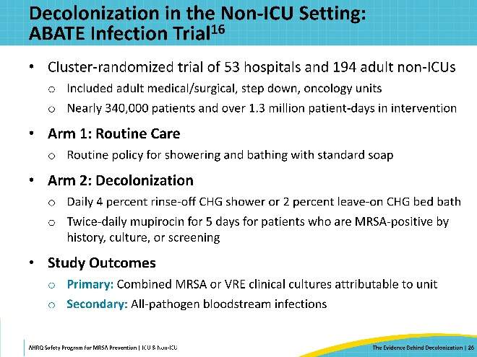
ABATE Trial: Results  SAY:  In the overall study population, no statistically significant difference was observed between the Routine Care and Decolonization arms in the primary or secondary outcomes.  In this bubble plot comparing the intervention to the baseline period, there was no significant difference between the routine care arm and the decolonization arm. This was true for both the primary outcome of MRSA and VRE clinical cultures and the secondary outcome of all-pathogen bloodstream infections. | Slide 27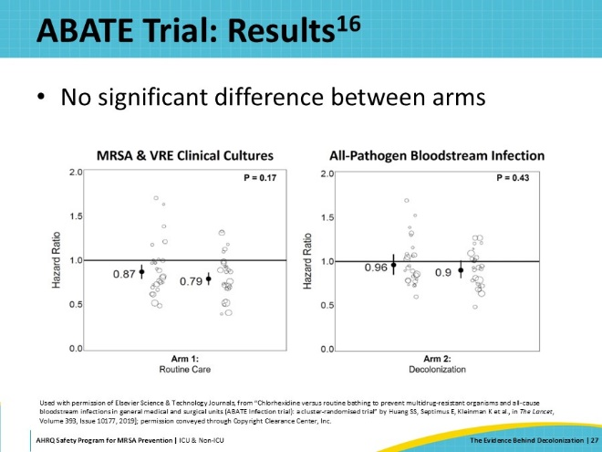
ABATE Trial: Patients With Devices  SAY:  The research team conducted a post-hoc subpopulation analysis in patients with invasive medical devices. Using electronic health records to identify the subset of patients who had central lines, midlines, or lumbar drains, this analysis found that there was a significant 37 percent reduction in MRSA and VRE clinical cultures in this high-risk population. This reduction was similar and significant for MRSA alone and VRE alone. In addition, there was a 31 percent reduction in bloodstream infection in this high-risk population, which is like the ICU setting. | Slide 28  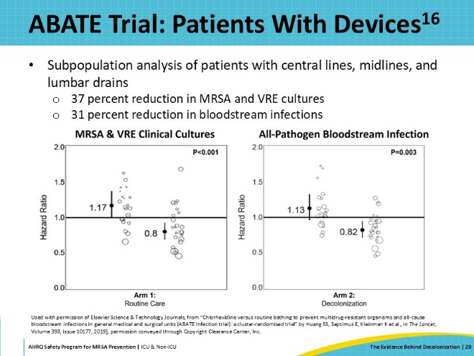
Decolonization in Non-ICUs  SAY:  The benefit of universal decolonization outside of the ICU depends on the patient population. Overall, there is not enough evidence that universal decolonization has a broad benefit in this setting. Compared to ICUs, there is a lower infection risk in non-ICUs. There is not enough of an effect size to support decolonization of all non-ICU hospitalized patients.  However, there may be benefits to decolonization in higher risk patients, such as patients with medical devices. In the ABATE trial, patients with devices had a 37 percent reduction in MRSA and VRE cultures and a 32 percent reduction in all-pathogen bloodstream infections. Notably, in the ABATE trial, only 10 percent of the intervention patients had lines and devices, but these patients accounted for over a third of MRSA and VRE cultures and 56 percent of bloodstream infections. Thus, non-ICU patients with devices represent a high-yield target population. In higher risk units, such as stepdown units, the proportion of patients with devices may be substantial.  In sum, the results indicate that universal decolonization does not have sufficient effect in non-ICUs to be worthwhile. However, the results suggest that non-ICUs may benefit from a targeted decolonization strategy, wherein decolonization is targeted at patients with medical devices, and other high-risk patients, thus optimizing the impact of the decolonization by focusing on the patient population that is most likely to benefit. | Slide 29  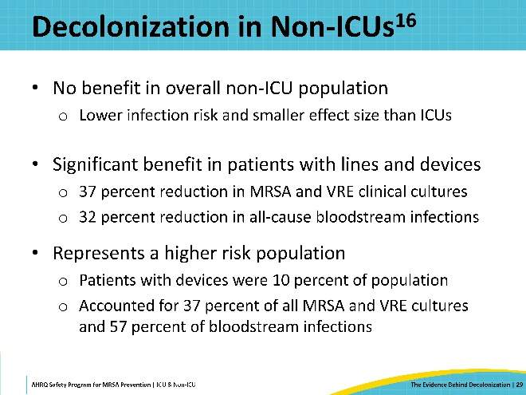
The Evidence for Nasal Decolonization  SAY:  The next area of focus is the evidence for the importance of nasal decolonization. | Slide 30  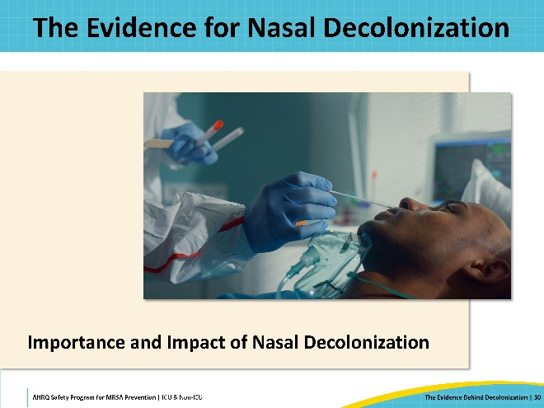
S. aureus Nasal Carriage Confers Disease Risk  SAY:  Nasal carriage confers a clear risk for Staphylococcus aureus infections. Most Staphylococcus aureus infections are from endogenous strains already present on patients. There are several studies to support that the strain within the patient’s nose is most often the strain that infects them, specifically among surgical site infections or bloodstream infections. Among those with serial, but unrelated, Staphylococcus aureus infections, the infections tend to be caused by the same strain, and they tend to match the strain in the nose. This raises the question: could clearing S. aureus from the nose reduce infection risk? | Slide 31  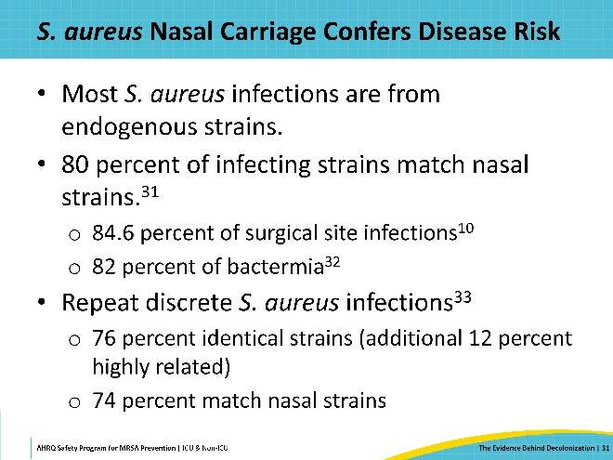
Mupirocin Alone Reduces Infection  SAY:  A Cochrane review published in 2008 found that mupirocin alone reduces MRSA infection. In a meta-analysis, the authors found that mupirocin was associated with a 45 percent reduction in healthcare-acquired MRSA infection among treated carriers. This was supported by a separate systematic review by Ammerlaan et al. in 2009.  In their Cochrane review, van Rijen et al. analyzed randomized controlled trials to compare mupirocin with no treatment, alternative treatment, and placebo treatment. The primary outcome studied was Staphylococcus aureus infection rate. Nine randomized controlled trials met the inclusion criteria, and among these trials, there was a statistically significant reduction in the rate of Staphylococcus aureus infection when mupirocin was used as the treatment option for nasal decolonization. This effect disappeared when only surgical site infections were considered, possibly due to a lack of power. The effectiveness of mupirocin was related to carriers only. Short-term use of intranasal mupirocin, as used in these studies, was not associated with resistance. | Slide 32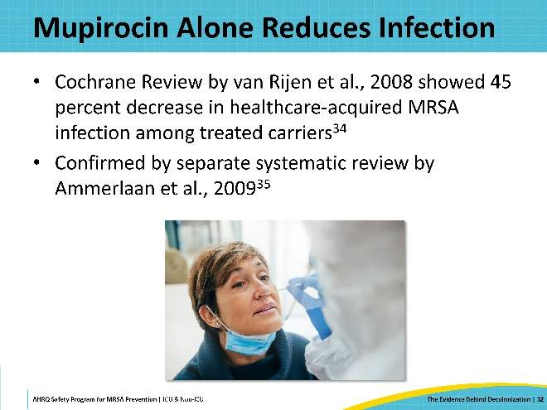
Harbarth et al., 1999: CHG With and Without Mupirocin  SAY:  Harbarth et al., 1999, was an early trial examining the impact of intranasal mupirocin when used in combination with CHG. The study involved 98 patients who were colonized with MRSA but had no active infection. All participants were given daily CHG baths and randomized to receive either 5 days of mupirocin or 5 days of a placebo agent. Swabs were taken from multiple body sites and cultured at 12, 18, and 26 days after initiation of treatment.  The results showed that patients who received mupirocin had greater clearance of MRSA in the nares and better overall clearance from all body sites. The mupirocin group also saw a reduction in MRSA infection. Because of the small size of this trial, it was not sufficiently powered to answer questions definitively. But as the first randomized controlled trial to examine CHG and mupirocin decolonization, it was nevertheless instructive. | Slide 33  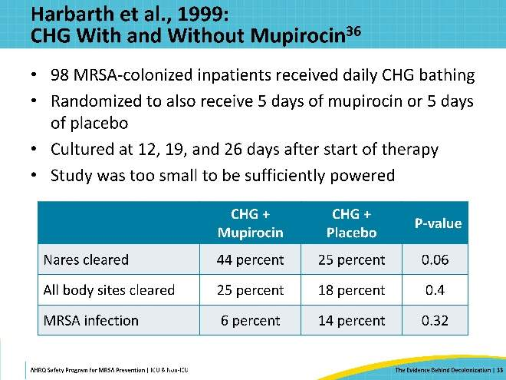
Fritz et al., 2011: Mupirocin for Eradicating S. aureus Carriage  SAY:  Fritz et al., 2011, examined mupirocin’s efficacy for eradicating Staphylococcus aureus carriage among outpatients. Four different regimens were studied in children and adults with acute community-onset skin and soft tissue infection, who were confirmed to be colonized with Staphylococcus aureus. 300 patients were randomized to receive education only, mupirocin only, mupirocin plus CHG for 5 days, and mupirocin plus dilute bleach baths for 5 days. Outcomes included eradication of Staphylococcus aureus after 1 month and 4 months. | Slide 34  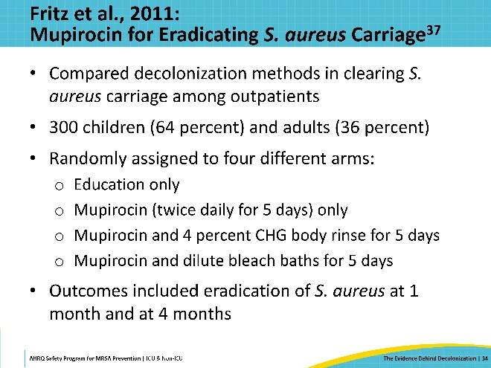
Fritz et al., 2011: Results  SAY:  The study found that all decolonization arms had significantly greater eradication than the control group, which only received education. Interestingly, chlorhexidine appears to provide no added benefit compared to mupirocin alone. Results also show that mupirocin plus bleach confers a big benefit. | Slide 35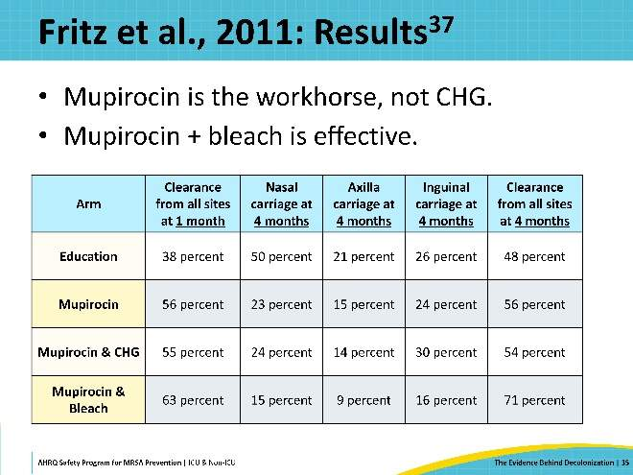
Importance of Mupirocin  SAY:  Overall, mupirocin has been shown to be critical for targeting Staphylococcus aureus colonization. People who are most likely to get an MRSA infection are those who carry MRSA. Mupirocin alone can decolonize MRSA carriers and prevent infection.  Because CHG bathing targets the skin, it is very effective at preventing transmission from someone who is a carrier to those around them who are not carriers. However, CHG bathing does not target the nose, the primary reservoir for Staphylococcus aureus. Skin decolonization is thus limited in the benefit it provides to the already-colonized patient, in terms of interrupting progression to infection or clearing Staphylococcus aureus carriage. For that reason, it's important to clear the nose, which is why nasal decolonization remains a key intervention. | Slide 36  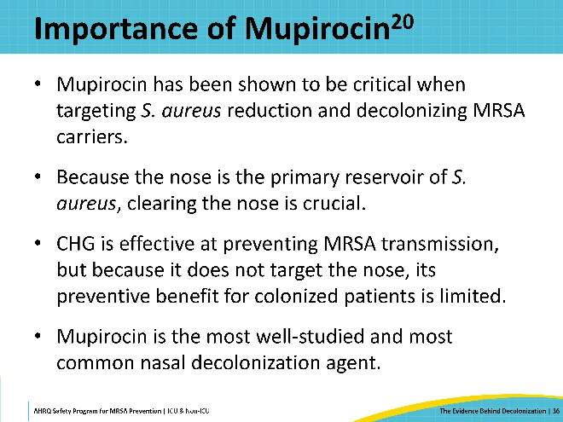
Nasal Iodophor  SAY:  Mupirocin is the most well-studied nasal decolonization agent, and the most widely used. The next best-studied agent is nasal iodophor, or 10 percent povidone-iodine, which has been examined as an alternative to mupirocin.  Interest in an alternative to mupirocin appeared due to concerns over the potential for mupirocin resistance. Iodophor is a small molecule antiseptic which is broadly effective against a wide range of pathogens, including MDROs such as MRSA. Generally, antiseptics are less prone to resistance than antibiotics such as mupirocin. To date, there is no evidence of emergent resistance to iodophor with Staphylococcus aureus.  An additional consideration is that unlike mupirocin, iodophor does not require a prescription for use. This can be advantageous in circumstances when obtaining provider prescription could be time consuming or impractical. Recent trials in long-term care settings, where providers are not always available, have used iodophor for nasal decolonization.  There is evidence to support iodophor as better tolerated than mupirocin, with patients reporting fewer adverse events and higher levels of satisfaction with the decolonization experience compared with mupirocin.  One drawback to iodophor is that it does not have sustained effect on MRSA cultures. Iodophor simply suppresses MRSA growth but does not eliminate the organism. The next study compared nasal mupirocin and iodophor for nasal decolonization. | Slide 37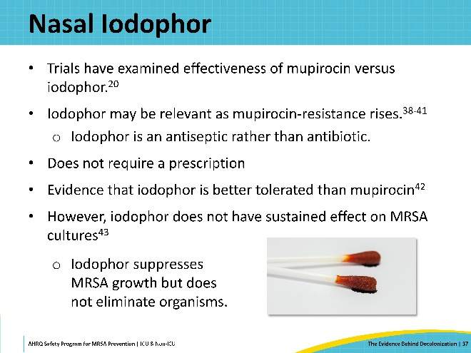
Huang et al., 2023: Mupirocin-Iodophor ICU Decolonization Swap Out Trial  SAY:  The Mupirocin-Iodophor ICU Decolonization Swap Out Trial was conducted to measure and compare the effectiveness of mupirocin and iodophor as nasal decolonization agents in the ICU setting, as part of a universal decolonization strategy in combination with CHG bathing. This trial was a pragmatic, noninferiority, cluster-randomized trial, involving 137 hospitals and 233 adult ICUs in the HCA Healthcare system.  During the 24-month baseline period, all participating ICUs conducted universal decolonization with daily CHG and 5 days of twice-daily mupirocin. During the phase-in period, half of the hospitals were randomized to switch over to 5 days of iodophor. In the 18-month intervention period that followed, there were a total of 353,323 admissions and over 1.4 million ICU patient-days.  The primary outcome was ICU-attributable Staphylococcus aureus clinical cultures. Secondary outcomes included MRSA clinical cultures, all-cause bloodstream infections, and emergence of resistance to mupirocin or iodophor. | Slide 38  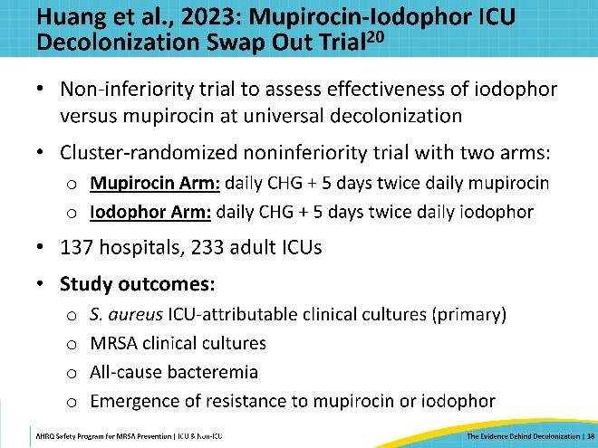
Swap Out Trial Results: S. aureus Cultures  SAY:  This bubble plot shows the primary outcome of Staphylococcus aureus clinical cultures. The iodophor arm has a higher hazard ratio compared to baseline, meaning the risk increased. Compared to the iodophor arm, there were 18 percent fewer Staphylococcus aureus infections in the mupirocin arm during the intervention period. | Slide 39  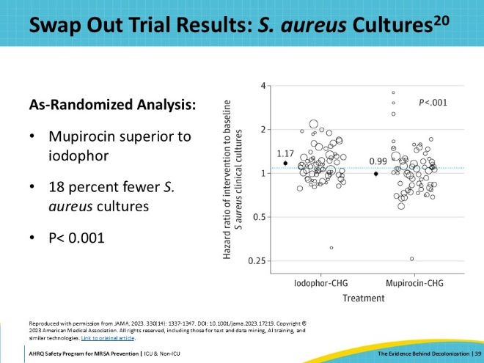
Swap Out Trial Results: MRSA Cultures  SAY:  For the secondary outcome of MRSA clinical cultures, there were 14 percent fewer MRSA cultures in the mupirocin arm compared to the iodophor arm. | Slide 40  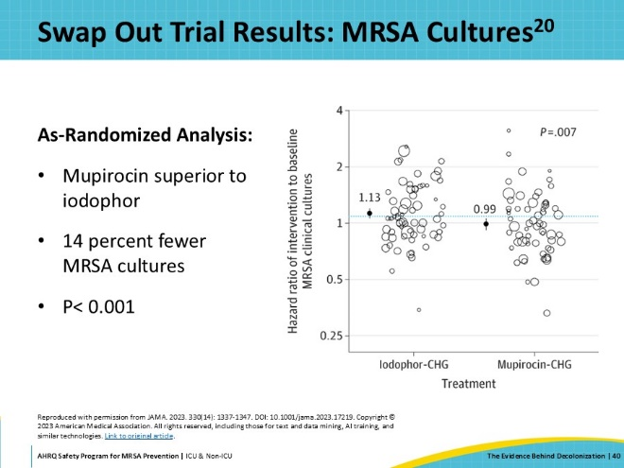
Swap Out Trial Results: Bloodstream Infections  SAY:  When evaluating all-cause bloodstream infections, there was no observed difference between mupirocin and iodophor. This is likely due to combining all the different pathogens for which CHG is active, but for which neither iodophor nor mupirocin are effective. | Slide 41  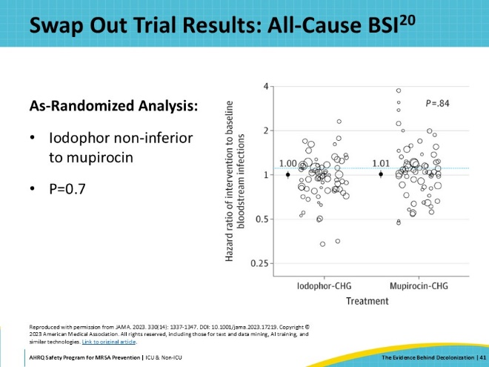
Examining Long-Term Resistance  SAY:  The REDUCE MRSA Trial and the Swap Out Trial were conducted in ICUs in the same healthcare system about 10 years apart. This allows a comparison between the two trials to look for any evidence of the emergence of mupirocin resistance. This graph represents the universal decolonization arm of the REDUCE MRSA Trial in the baseline and intervention periods. During the baseline period, there was no decolonization. The dark purple line shows patients’ cumulative daily hazard of having a Staphylococcus aureus clinical culture. With increased length in ICU stay, the potential for positive Staphylococcus aureus clinical cultures rises. Looking at the same group in the intervention period, when universal decolonization with mupirocin and chlorhexidine is in place, the light purple line illustrates that the risk of acquiring Staphylococcus aureus clinical cultures is much lower over time.  By overlaying the Swap Out trial findings for the mupirocin arm over the REDUCE MRSA findings, it is possible to see if 10 years of universal decolonization with CHG and mupirocin have caused resistance that has reduced the benefit of the intervention over time? | Slide 42  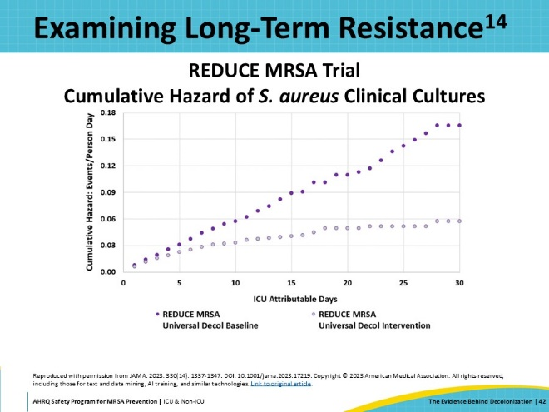
Long-Term Resistance: Comparing Results  SAY:  This graph shows the same baseline and intervention data from the REDUCE MRSA trial. Overlaid on this is the data from the mupirocin and CHG arm of the Swap Out Tria, represented by the green line. Compared to the data from the mupirocin and CHG arm of the REDUCE MRSA trial, there is no decrement in clinical benefit over time for the outcome of all Staphylococcus aureus clinical cultures (both MRSA and MSSA). If meaningful mupirocin resistance had emerged over the 10 years of its use, a reduced clinical effect would be expected. This illustrates that universal use of mupirocin over a 10-year period has stable substantial clinical benefit. | Slide 43  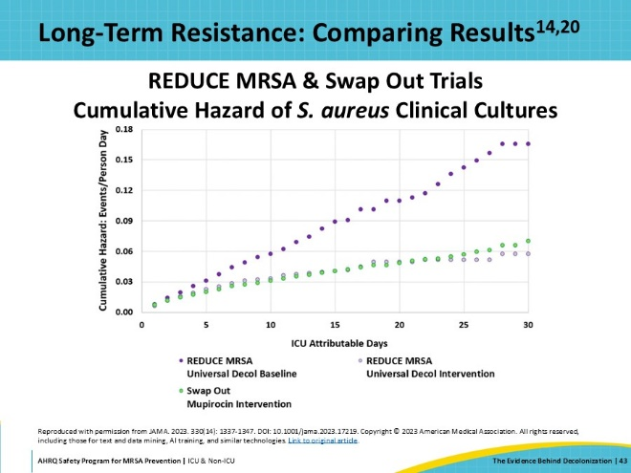
Comparing Results: Iodophor  SAY:  This graph also overlays the data from the iodophor and CHG arm from the Swap Out Trial. The orange dotted line shows that nasal decolonization with iodophor has a benefit less than mupirocin. Still, iodophor is significantly better than the baseline of no decolonization for reducing Staphylococcus aureus clinical cultures. | Slide 44  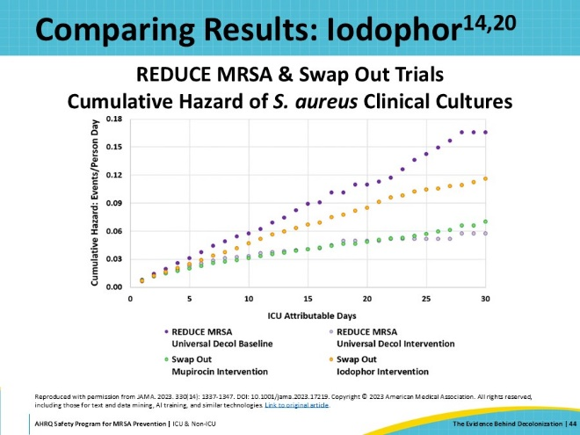
Comparing Results: MRSA Clinical Cultures  SAY:  This effect is also seen for the outcome of MRSA clinical cultures. This graph shows the same steady, persistent benefit with mupirocin over 10 years, with iodophor being more effective than no decolonization, but less effective than mupirocin. | Slide 45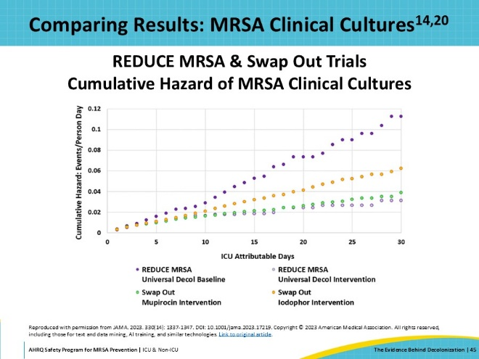
Comparing Results: All-Cause BSI  SAY:  Similarly, for the outcome of all-cause bloodstream infection, the data again shows not only persistent benefit, but even improved benefit with continuous use of mupirocin and CHG across the 10-year period. | Slide 46  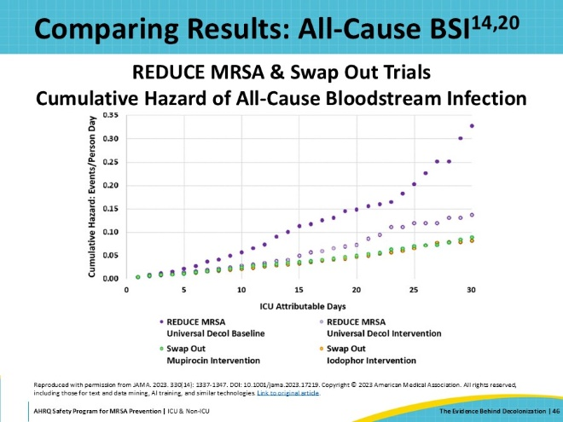
Getting Started With Decolonization  SAY:  The next slides will discuss key considerations and questions when starting decolonization. | Slide 47  
Which Type of Decolonization Will Work Best in Your Unit?  SAY:  When getting started with decolonization, you will need to make an important early decision: Will you use a Universal Decolonization approach or a Targeted Decolonization approach?  Universal Decolonization means all patients in the unit receive decolonization for their entire stay.  Targeted Decolonization means only patients who meet specific criteria for higher risk receive decolonization.  This Toolkit provides a guidance document to help you make this decision that you can download here: Which Type of Decolonization Will Work Best in My Unit? | Slide 48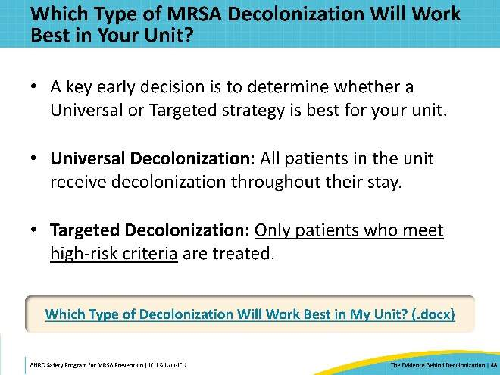
Universal Decolonization  SAY:  Universal Decolonization is strongly recommended for all ICUs. Studies have consistently proven that universal ICU decolonization is an effective strategy to reduce MRSA transmission and infection.  Non-ICUs may want to consider Universal Decolonization if a significant proportion of their patient population includes higher-risk patients. These may include circumstances such as:  - The unit is intended for high-acuity patients – such as Stepdown or Oncology units.  - The unit has a high percentage of patients with devices, such as central lines, midline catheters, PICC lines, and lumbar drains.  Universal Decolonization is also appropriate for units currently experiencing high MRSA acquisition rates. | Slide 49  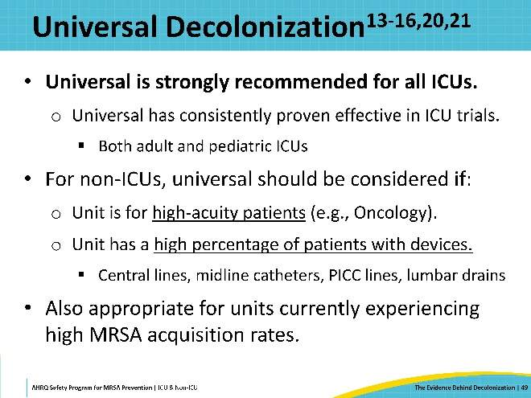
Targeted Decolonization  SAY:  Targeted Decolonization is only used for targeted, high-risk patients. This type of decolonization is mainly a consideration for non-ICUs. Among the general hospital population, MRSA and other HAIs do not have enough of a presence for universal decolonization to have a significant effect.  Targeted Decolonization is recommended for non-ICUs that have some patients with medical devices, such as central lines, midline catheters, PICC lines, and lumbar drains. These patients are considered to be at a higher risk for infection, so prioritizing them for decolonization can have optimal results.  Non-ICUs that see many patients with devices should consider whether a universal approach would be more effective or logistically feasible.  An alternative approach is to base the targeting criteria on active or passive MRSA surveillance results, conducting decolonization for patients identified as infected or colonized with MRSA.  Targeted Decolonization is not recommended for ICUs or other units that mostly care for high-risk patients. | Slide 50  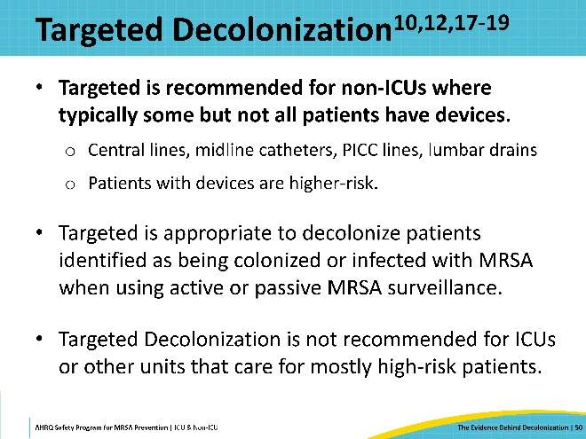
MRSA Surveillance for Decolonization  SAY:  When considering targeted decolonization based on MRSA surveillance, it is important to recognize the limitations. Roughly one-third of humans carry nasal Staphylococcus aureus at any time. A single MRSA nasal swab is only about 60 percent sensitive. It is not tenable to swab all body sites continuously to know every patient’s exact MRSA status. Consequently, basing decolonization on surveillance will result in many missed cases. For high-risk populations – such as ICU patients – universal decolonization is the most effective strategy. | Slide 51  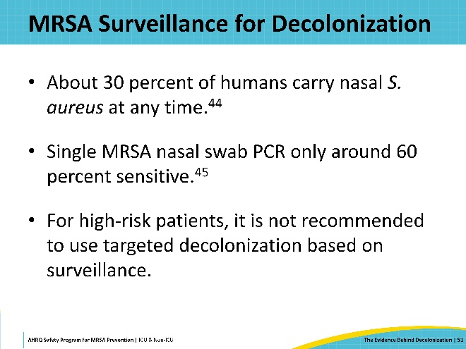
For More on Implementation  SAY:  More information on implementation can be found in the presentation, “Implementation of CHG Bathing and Nasal Decolonization,” available in the Decolonization section of the website. This presentation goes into more depth on planning and prep, decolonization protocols, and launching your decolonization program.  The Toolkit website also offers Tools and Resources for Decolonization to support your implementation efforts.  - First Steps, Readiness, and Pre-Launch  This section focuses on readiness and pre-launch activities. It is recommended to start here.  - Sample Protocols  This page includes sample protocols for skin decolonization with CHG and nasal decolonization with mupirocin or iodophor. Multiple approaches are available. These protocols should be adapted to fit your needs.  - Staff Training Materials  This section offers materials for staff training and education, including training documents, FAQs, and talking points.  - Patient Educational Resources  Access this section to find resources and info sheets for patient education. | Slide 52  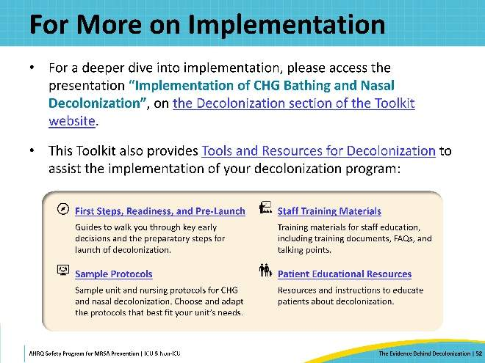
Using the 4 Es  SAY:  Implementation of any intervention – but particularly a complex initiative like decolonization – is always a challenge. However, following a structured implementation approach can help organize and coordinate your progress. This Toolkit makes use of the 4 Es framework to guide implementation. Following this framework, a team can carry out patient safety initiatives and focus on changes through technical and adaptive work.  The 4 Es model consists of 4 processes; Engage, Educate, Execute, and Evaluate. This slide offers a brief overview of each.  The first E is to engage. This is an example of adaptive work where CUSP teams help staff and leaders understand the impact of preventable harm caused by a clinical problem and engage them to take action to solve that problem.  The second E is for educate. Educate is a technical process, in which the CUSP team transmits information to personnel and leaders regarding actions needed to prevent clinical problems.  The execute phase refers to the implementation of the patient safety interventions and putting the plan into action.  The evaluate phase is the continuing process of evaluation, monitoring, assessing, and disseminating data and feedback about the effectiveness of the intervention.  To learn more about the 4 Es, access the one-pager on the 4 Es, or visit the What Are The 4 Es? page on the Toolkit website.  In the following slides, let’s review a case example of a community hospital ICU addressing rising MRSA rates. This case study will highlight the first two steps of the 4 Es process. | Slide 53  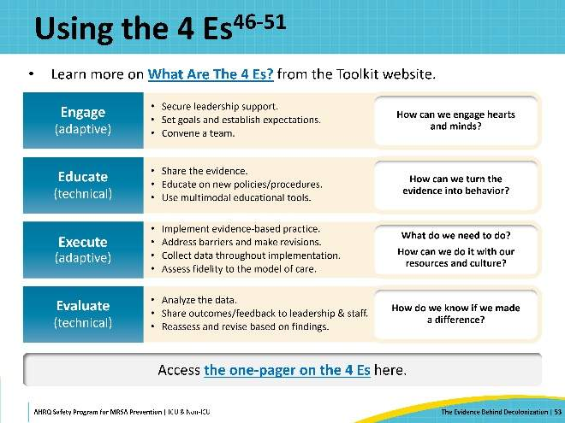
Case Example: Engaging the ICU CUSP Team  SAY:  MRSA infection rates were on the rise in the ICU of a small community hospital. The ICU had implemented decolonization several years ago, to great success – but in the past quarter, the unit’s rates was higher than the hospital’s average. Changes were needed. The ICU had an established CUSP team with senior leadership support. The CUSP team examined the problem of the rising rates using the 4 Es approach.  In the 4 Es model, engaging leadership and personnel is an inclusive way to help everyone understand the severity of the problem and participate in the process of making improvements.  As a team, it is important to identify the problem and establish a shared understanding. At their next monthly meeting, the team first reviewed the MRSA rates over the past year. They confirmed that there had been a steady and consistent rise in MRSA rates for the past two years. A couple team members also shared stories of recent patients who developed MRSA infections to show the negative impact of the problem. Now everyone on the team understood and recognized the problem.  Next, the team members decided to examine current decolonization practices in the ICU by engaging with the staff and leaders. | Slide 54  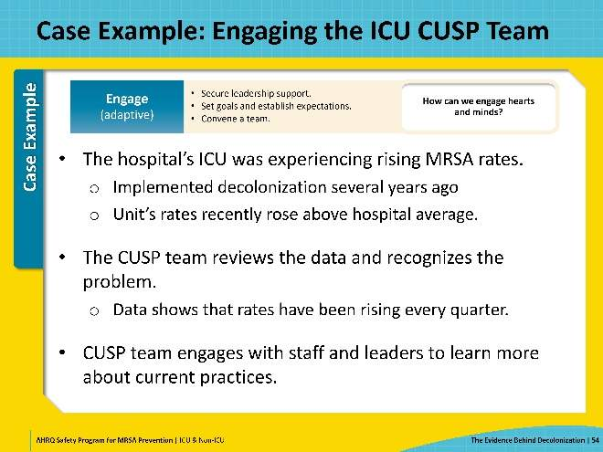
Case Example: Assessing Current Practice  SAY:  Discussions with the staff revealed that decolonization was no longer being consistently given to all ICU patients. Soap and water bathing was preferred by many of the staff over the CHG cloths, saying that soap-and-water left the patients feeling cleaner, while the CHG often made patients feel “sticky.” Additionally, some unit leaders viewed soap-and-water as more cost-effective, in an effort to reduce costs.  Additionally, the team discovered that decolonization was not being documented in the electronic health record (EHR) system. After an EHR software upgrade last year, staff had not received training on proper documentation in the new system.  The CUSP team also conducted a literature search for the latest evidence on decolonization and reviewed national guidelines to identify best practices. | Slide 55  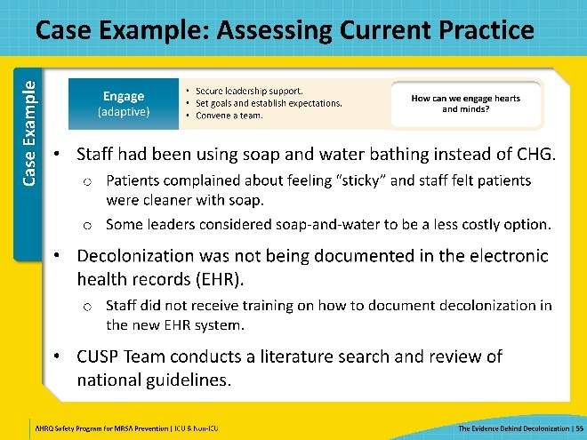
Case Example: Educating the Staff  SAY:  At their next meeting, the CUSP team reviewed their findings thoroughly. This important step was to help ensure that the CUSP team fully understood and reviewed the evidence before disseminating it to unit personnel.  They decided to use team huddles, emails, unit meetings, and visual displays to educate the staff and share the information.  The team found strong evidence that supported CHG bathing over bathing with soap and water. They shared this strong evidence for CHG bathing for all ICU patients, emphasizing how it lowers infection rates and provides a continuing protective effect.  In team huddles, they shared tips and talking points to help communicate the benefits of CHG to patients. The CUSP team also held training sessions to demonstrate how to document decolonization in the EHR system.  With the unit leaders, they shared data showing that universal ICU skin decolonization with CHG bathing was actually more cost-effective in the long run, given the costs associated with HAIs and bloodstream infections.  The team used their review of the evidence as a discussion point and engaged the staff to co-create intervention strategies to better incorporate CHG bathing and nasal decolonization into daily workflow for the ICU patients. By engaging leadership and unit personnel, educating teams about the evidence for decolonization, and collaboratively developing interventions to improve patient outcomes, this CUSP team was well on the way to reducing MRSA infections. | Slide 56  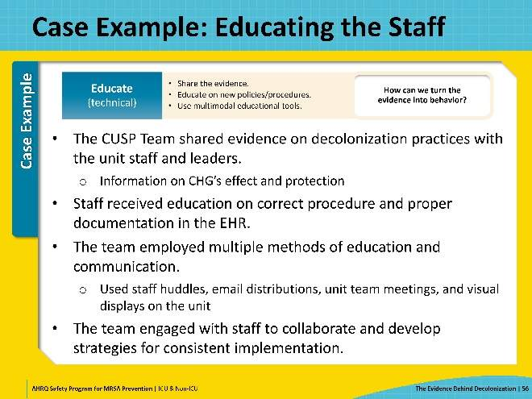
Key Takeaways  SAY:  In summary, universal decolonization is a proven strategy for reducing MRSA. Staphylococcus aureus, including both MRSA and MSSA, remains a common and formidable pathogen in ICU and non-ICU settings. Prevention of MRSA involves not only preventing MRSA from transferring from a carrier to a non-carrier, but importantly, protecting MRSA carriers themselves from disease. MRSA carriers are the highest risk group for invasive disease.  Nasal decolonization is key to clearing the MRSA carriage state, and the best way to do that is with mupirocin and chlorhexidine. Among ICU and high-risk non-ICU patients, this combination is superior to screening and contact precautions, and it's superior to targeted decolonization for reducing MRSA clinical cultures and all-cause bloodstream infections. This benefit has been shown to persist over a 10-year period of continuous use, providing reassurance about the longevity of benefit and the lack of engendered resistance that would produce a decrement in clinical benefit. Mupirocin with chlorhexidine is superior to iodophor with chlorhexidine for Staphylococcus aureus and MRSA outcomes. Nevertheless, if mupirocin resistance increases or if prescription logistics are problematic, then iodophor provides a valuable alternative as a non-prescription antiseptic. | Slide 57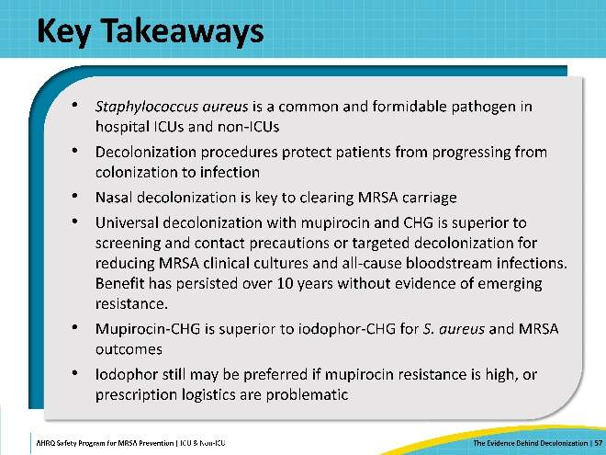
Disclaimer  SAY:  The findings and recommendations in this presentation are those of the authors, who are responsible for its content, and do not necessarily represent the views of AHRQ. No statement in this presentation should be construed as an official position of AHRQ or of the U.S. Department of Health and Human Services.  Any practice described in this presentation must be applied by healthcare practitioners in accordance with professional judgment and standards of care in regard to the unique circumstances that may apply in each situation they encounter. These practices are offered as helpful options for consideration by healthcare practitioners, not as guidelines. | Slide 58  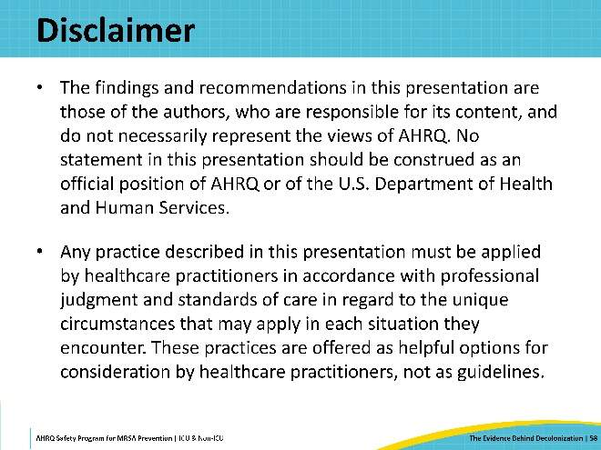
Reference List—1 | Slide 59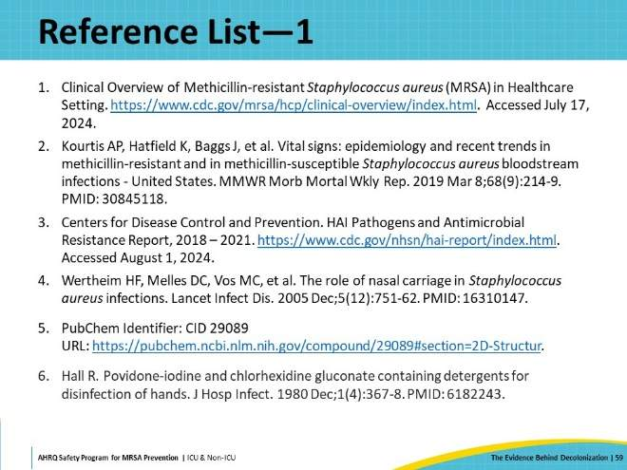
Reference List—2 | Slide 60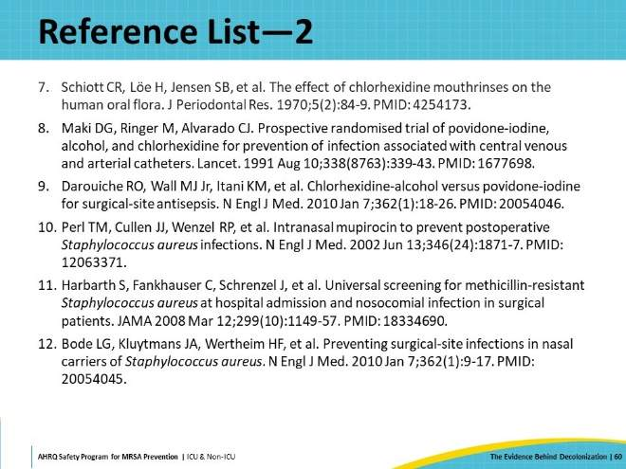
Reference List—3 | Slide 61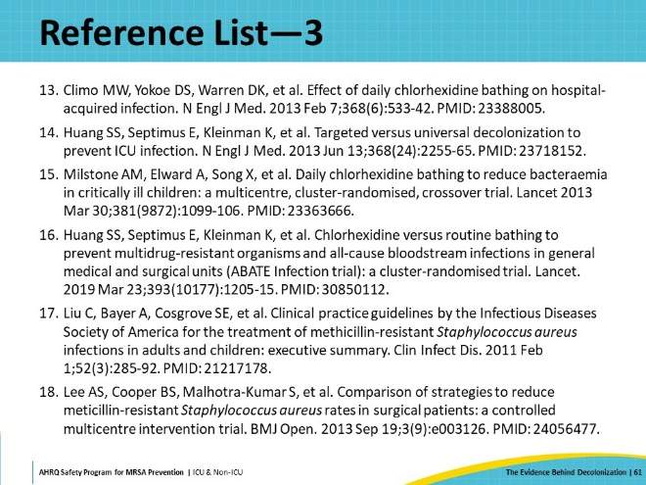
Reference List—4 | Slide 62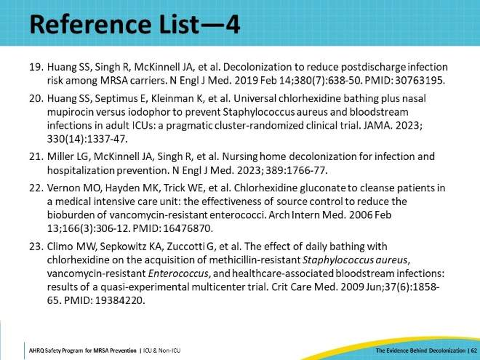
Reference List—5 | Slide 63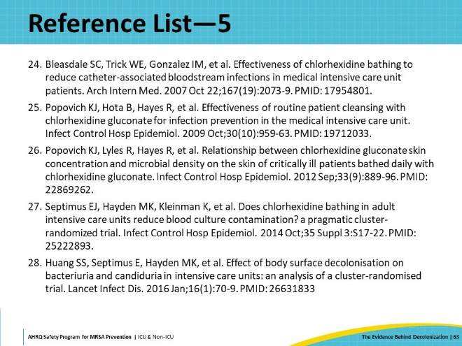
Reference List—6 | Slide 64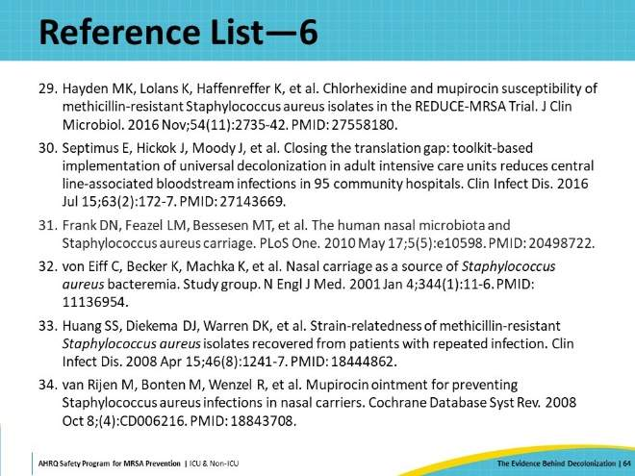
Reference List—7 | Slide 65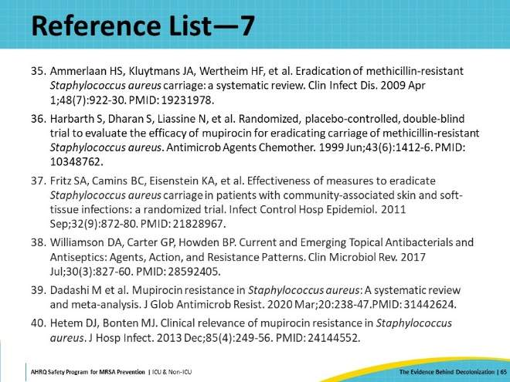
Reference List—8 | Slide 66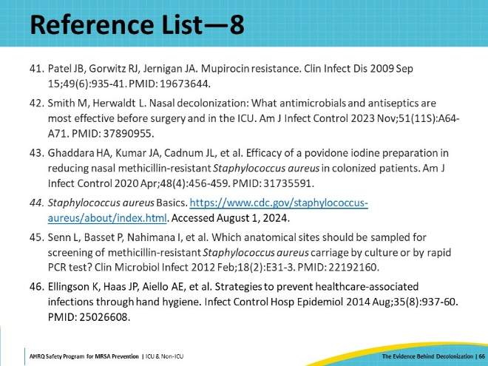
Reference List—9 | Slide 67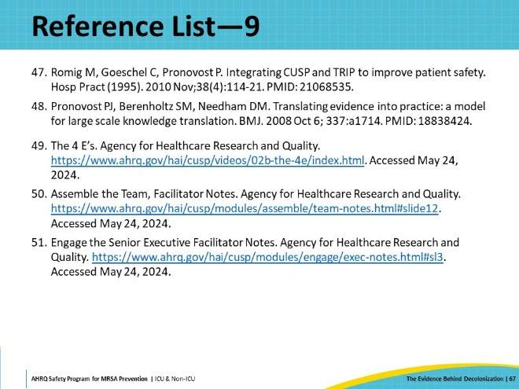

AHRQ Pub. No. 25-0007
October 2024

