Implementation of Chlorhexidine Gluconate (CHG) Bathing and Nasal Decolonization
ICU & Non-ICU
Slide Title and Commentary | Slide Number and Slide
Implementation of Chlorhexidine Gluconate (CHG) Bathing and Nasal Decolonization  SAY:  Welcome to this presentation on the implementation of chlorhexidine gluconate (CHG) bathing and nasal decolonization as part of an overall approach to preventing methicillin-resistant Staphylococcus aureus (MRSA) in intensive care units (ICU) and non-ICU settings. | Slide 1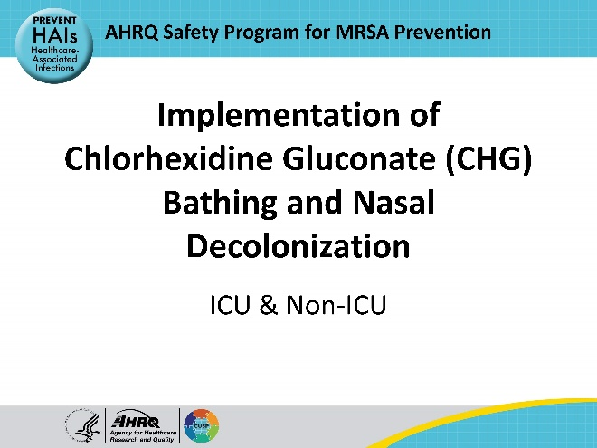
Educational Objectives  SAY:  This presentation will discuss MRSA decolonization strategies. The presentation will then describe key steps and decisions leading up to the launch of decolonization and review procedures for CHG bathing and nasal decolonization. Finally, the presentation will identify barriers to implementation and conclude with helpful tips and advice. | Slide 2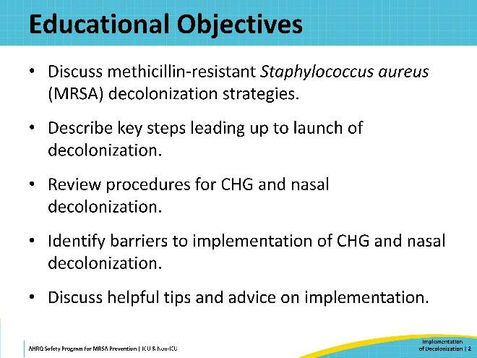
Key Strategies for MRSA Prevention  SAY:  The AHRQ Toolkit for MRSA Prevention in the ICU and Non-ICU focuses on Four Key Strategies to prevent MRSA:  - Decolonizing patients  - Decontaminating the healthcare environment  - Preventing person-based transmission  - Preventing device- and procedure-associated infections  This presentation will focus on the first strategy, on decolonizing patients. | Slide 3  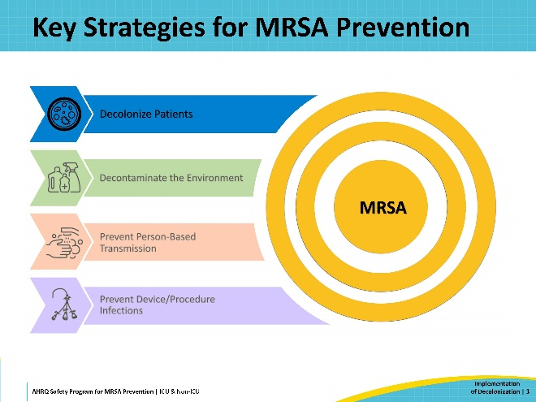
Decolonizing Patients  SAY:  MRSA decolonization targets the skin and nares, the primary reservoirs of methicillin-resistant Staphylococcus aureus or MRSA in the human body. Protocols involve CHG bathing to decolonize the skin and application of nasal mupirocin ointment or nasal iodophor (povidone-iodine) to decolonize the nose. Studies indicate that decolonization can significantly reduce the risk of MRSA infection and transmission in acute care environments. For further details on the supporting evidence, please refer to the presentation titled The Evidence Behind Decolonization Strategies, accessible from the Decolonization Main page of the Toolkit website.  Effective implementation of decolonization will require coordination, preparation, engagement, and training. This will be a major initiative for your unit or hospital, requiring dedicated effort from leaders and champions.  To support implementation, the Toolkit for MRSA Prevention offers documents, training materials, and other resources to guide your planning and implementation of decolonization. You can access all these tools and resources on the Toolkit website, on the Tools and Resources for Decolonization page. | Slide 4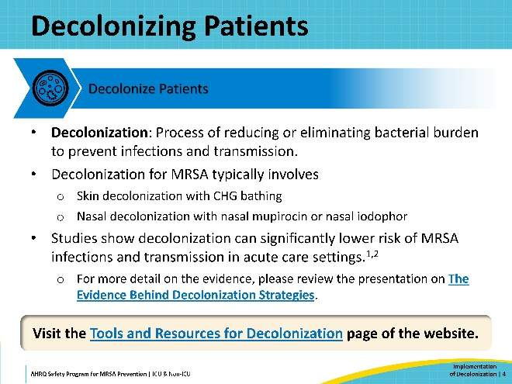
Decision-Making and Pre-Launch Activities  SAY:  This presentation will cover two phases: the preparation phase—which includes pre-launch and planning—and the implementation phase.  First, the presentation will discuss decolonization planning activities in the pre-launch phase. What should you know as you consider adopting decolonization? What steps need to be taken ahead of time? | Slide 5  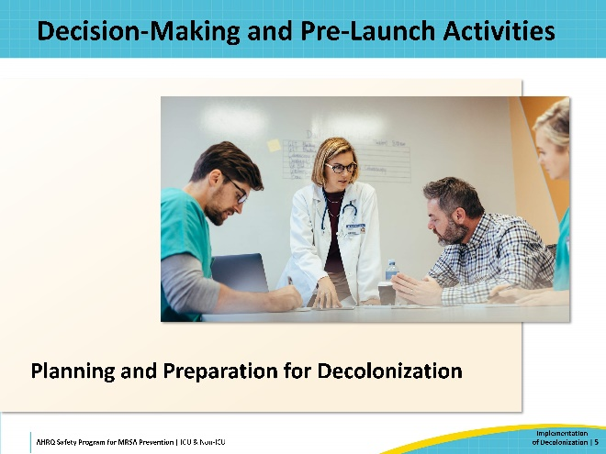
Steps for Implementation  SAY:  On this slide is a chart of the key steps for implementation. It can assist your planning and ensure you have covered all your bases. A downloadable copy of this chart is available here: Action Chart for Implementing Decolonization. | Slide 6  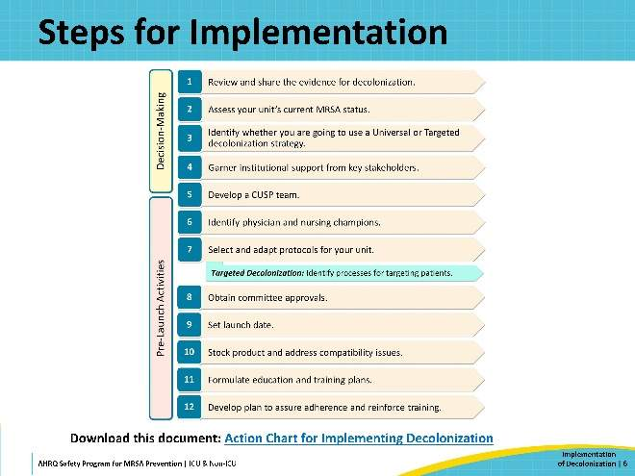
Decision-Making and Readiness  SAY:  A key first step is to Review and share the evidence for decolonization. Sharing the evidence can help your team members, staff, leadership, and other stakeholders understand the MRSA problem, as well as the potential benefits of decolonization. Reviewing the evidence at the start ensures everyone is on the same page as you begin.  Another important step is to Assess your unit’s current MRSA status. Conducting this assessment establishes a baseline for your unit, which you can use to set your future metrics and track your progress. It is essential to share this baseline data with your team, staff, and other stakeholders as vital background information on the unit’s current status and potential for improvement.  Coordinate with your hospital’s Infection Preventionist to estimate your baseline MRSA rates over the last year. Estimates for baseline assessment can include:  - All-cause bloodstream infection (BSI) rate: Number of all-cause BSI events per 1,000 patient-days  - MRSA clinical cultures: Percentage of patients on the unit with any positive MRSA clinical culture over the past year  Knowing this information will also help you Decide between a Universal or Targeted decolonization strategy. This will be discussed in further detail on the next slide.  Garner institutional support from key stakeholders. It’s essential to start this process early because the support of key stakeholders and partners within your hospital will have a large impact on the success of your decolonization program. Engage stakeholders by making them aware of the MRSA issue, sharing the benefits of decolonization, presenting your plan, and addressing any concerns.  Develop a CUSP team. CUSP, or Comprehensive Unit-based Safety Program, is a patient safety and quality improvement framework integrated into this Toolkit. While implementing a formal CUSP team is not a requirement, you will need to assemble a decolonization team to oversee the implementation. Your team should consist of engaged and dedicated individuals, including people from every relevant role to ensure you receive input from different perspectives.  Putting together your team and sustaining their engagement is a process that begins early and continues to develop throughout the implementation process and beyond.  For more detailed information on these steps, please refer to the guide document Decolonization Decision-Making and Readiness for Implementation. | Slide 7  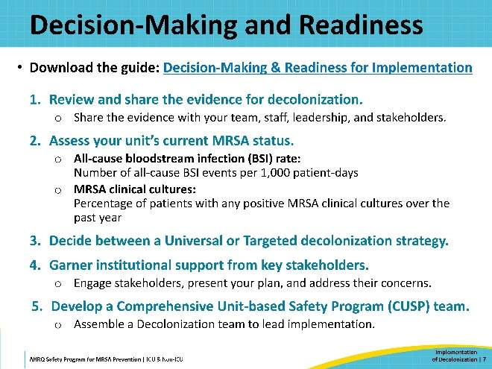
Decision-Making: Universal Versus Targeted Decolonization  SAY:  There are two primary strategies of decolonization: Universal Decolonization and Targeted Decolonization. Deciding which approach to adopt will be one of your crucial early decisions.  Universal Decolonization is a strategy wherein decolonization is provided to all patients in a unit, with no criteria for eligibility. Studies indicate that this approach is more effective and less costly in intensive care units (ICUs). Non-ICUs with a significant number of high acuity or at-risk patients might also consider this strategy.  Universal decolonization is also appropriate for units currently experiencing elevated MRSA acquisition rates.  Targeted Decolonization is a strategy wherein decolonization is provided only to specific populations who meet high-risk criteria. This approach is mainly suitable in non-ICU settings, where patient populations generally do not have a sufficiently high healthcare-associated infection (HAI) risk for universal decolonization to provide a significant benefit.  Criteria for high risk includes patients with medical devices, such as central lines, midline catheters, PICC lines, and lumbar drains, as these devices serve as potential entry points for infection.  Alternatively, decolonization may be targeted for patients identified as infected or colonized with MRSA based on screening results or patient history. However, this approach is constrained by the accuracy and effectiveness of the MRSA surveillance methods.  For more help in deciding which method would work best for your unit or hospital, please download Which Type of Decolonization Would Work Best in My Unit? | Slide 8  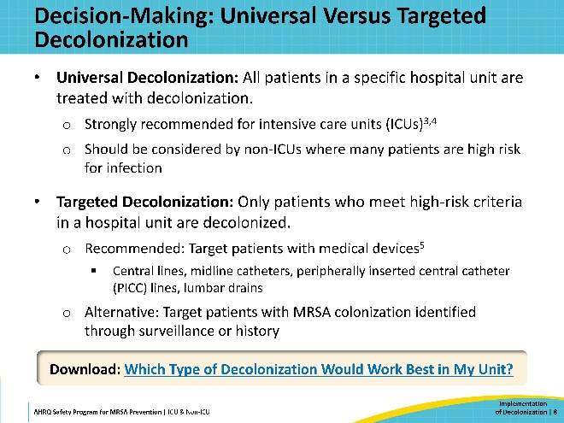
Pre-Launch Activities  SAY:  In the pre-launch phase, certain tasks must be addressed before decolonization can begin. Detailed information on each step is available in the guide document Decolonization Pre-Launch Activities.  Identify physician and nursing champions. Identify individuals on the unit who can take on leadership roles. These champions will promote decolonization, support the implementation process, and engage with personnel.  Select and adapt the protocols for your unit. Develop decolonization protocols tailored for your unit’s needs. These protocols should align with your chosen decolonization strategy and reflect your unit structure and hospital infrastructure. This Toolkit provides sample protocols for decolonization that can serve as a template for your protocols. It is important to note that the use of mupirocin requires a physician order, and your protocols must account for that.  Obtain committee approvals. Most hospitals require committee approval for standing nursing protocols and order sets. Identifying the appropriate committees and navigating the approval process is crucial for your planning and timetable. | Slide 9  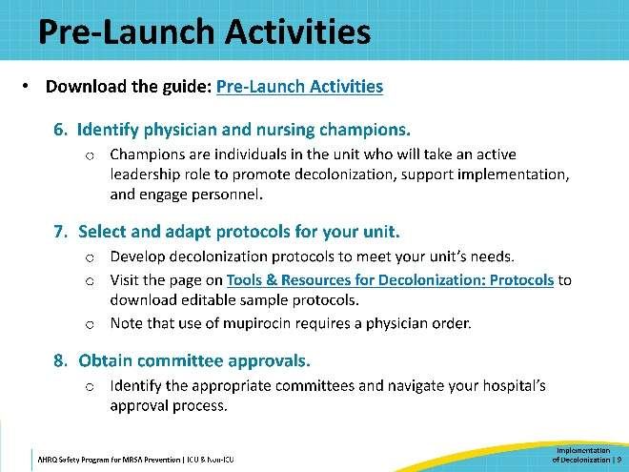
Pre-Launch: Identifying Patients to Receive Decolonization  SAY:  (If using Targeted Decolonization): Design a process for identifying and decolonizing the target patient population (e.g., patients with devices). Discuss the proposed workflow with nursing and medical leadership, information technology (IT), pharmacy, and supply chain leaders.  There are multiple options to consider. This process can be done manually. Your unit may choose to conduct daily rounds to identify individual patients with new or existing medical devices. For each identified patient, nurses activate standardized nursing protocol for daily CHG bathing and contact the treating physician to order nasal mupirocin.  The process can also be performed automatically. You could set up your hospital’s electronic health record (EHR) software to automatically identify and flag patients with devices and activate an order set with the CHG bathing nursing protocol and a nasal decolonization order set.  Or you may use a mixed approach wherein the EHR identifies high-risk patients and generates a daily report, which the unit nurse champion uses to determine which patients should receive decolonization.  Obviously, this workflow is not a concern if you are implementing Universal Decolonization, but it is still prudent to reach out and connect with IT, supply chain, and other groups to examine your processes for tracking which patients have received decolonization.  For detailed information, refer to the section on Identification process for targeting patients with devices in the Decolonization Pre-Launch Activities guide document. | Slide 10  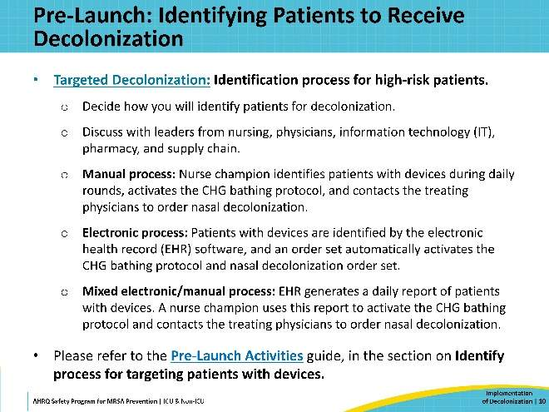
Pre-Launch: Putting Plans Into Action  SAY:  Set launch date. When you set your program’s launch date, make sure to consider the time required to stock products, provide staff training, and gain necessary approvals. Also consider other competing priorities and upcoming holidays.  Stock product and address compatibility issues. Make sure you have adequate stocks of all decolonization supplies and a reliable distribution system. Verify that all skin and hair products used in your unit are compatible with CHG. If a currently used product is not compatible, then you will need to switch to a different product.  Formulate education and training plans. It’s essential to convey all the important information and training to unit personnel. Ensure your staff are familiar with decolonization procedures.  This Toolkit provides staff education and training resources, accessible on the Decolonization Staff Training Materials page.  Develop a feedback plan to assure adherence and reinforce training. Don’t overlook the importance of regularly assessing unit adherence and progress. Working with unit champions and your team members, develop a plan to track adherence to the protocols and to provide feedback to unit personnel. Training, assessments, and reminders are critical for maintaining best practices. A Sample Adherence Report is provided in this Toolkit. | Slide 11  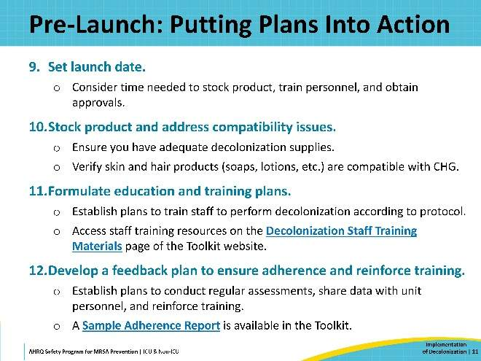
Resources for Decision-Making and Pre-Launch  SAY:  This slide shows links to the resources provided in the Toolkit related to decision-making and pre-launch activities.  - Tools & Resources for Decolonization: First Steps, Readiness, and Pre-Launch Webpage  - Action Chart for Implementing Decolonization (.docx)  - Decision-Making & Readiness for Implementation (.docx)  - Which Type of Decolonization Would Work Best in My Unit? (.docx)  - Pre-Launch Activities (.docx)  - Decolonization Nursing Practice Guide (.docx)  A document summarizing key nursing practice processes  - Tools & Resources for Decolonization: Protocols Webpage | Slide 12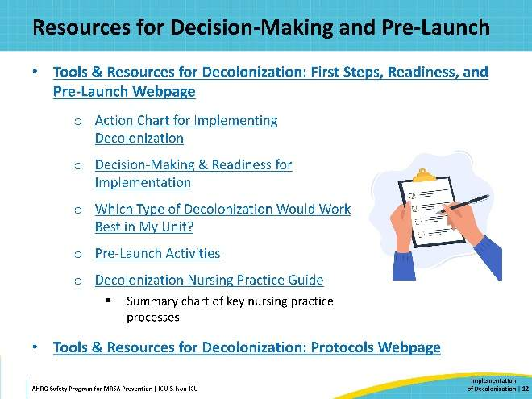
How To Decolonize With CHG  SAY:  In the next section, this presentation provides a detailed overview of skin decolonization procedures using chlorhexidine gluconate or CHG. | Slide 13  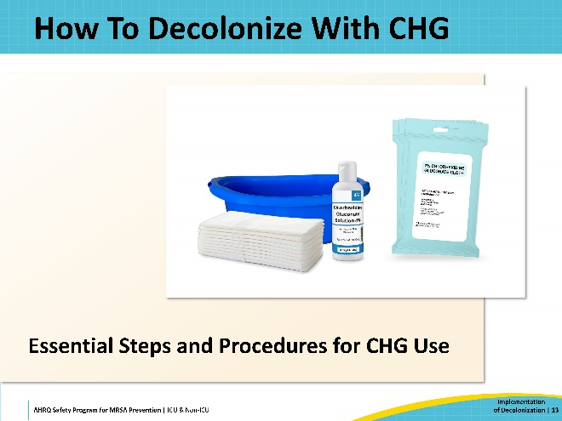
Overview of CHG  SAY:  CHG is a widely used topical antiseptic that is highly effective at killing bacteria and maintains its antibacterial effect for 24 hours. It is safe for use on the face, perineum, and external mucosa. However, care must be taken to avoid the eyes and ear canals.  Decolonization should be conducted daily during the patient’s stay in the unit to maintain the protective effect. CHG should replace regular soap for all bathing needs, as most soaps inactivate its antiseptic properties. CHG works better than regular soap at removing bacteria.  For more on CHG, its use, and its application, please refer to the Decolonization With CHG: Nursing Protocol Training PowerPoint. This document is designed to assist staff training on proper CHG decolonization procedures. | Slide 14  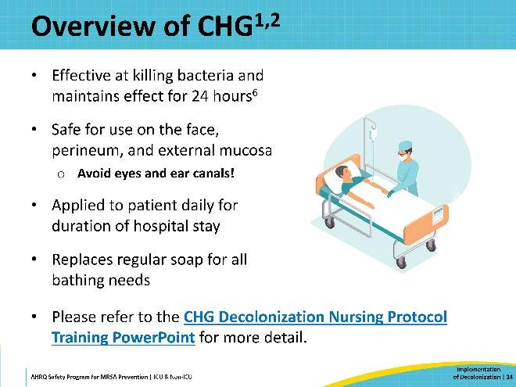
Chlorhexidine Products  SAY:  CHG for decolonization is typically available as either packets of 2 percent CHG pre-impregnated cloths or bottles of 4 percent CHG liquid.  When bathing patients, 2 percent CHG should be applied by hand, using firm pressure and ensuring full coverage. You can use either pre-soaked cloths or dilute a bottle of 4 percent CHG in a basin. Both methods will be discussed in this presentation.  Units may offer patients the option to apply their own CHG, either with cloths or in the shower. For showering, a bottle of non-diluted 4 percent CHG is used. | Slide 15  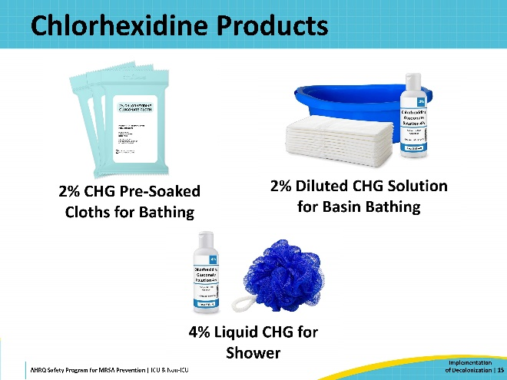
2 Percent CHG Pre-Impregnated Cloths  SAY:  Due to their convenience, 2 percent CHG pre-soaked cloths are often preferred for decolonization. Each packet holds two or six cloths; typically, six cloths are used for a patient bath.  To maximize effectiveness, the CHG must be allowed to air dry completely. Do not rinse, wipe off, or dry CHG with another cloth.  Patients might mention feeling sticky. CHG cloths contain built-in moisturizers. The stickiness will subside once the CHG has dried.  For patient comfort, you may consider using approved CHG warmers. Warming is not required; CHG will work at room temperature. | Slide 16  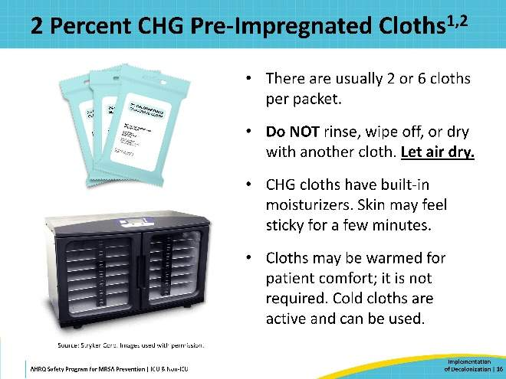
4 Percent CHG Liquid for Basin Bathing  SAY:  An alternative method is to dilute 4 percent liquid CHG to a 2 percent solution in a bath basin. This process is simple, requiring one 4-oz bottle of 4 percent liquid CHG, water, a bath basin, and six disposable non-cotton cloths.  First, empty the 4-oz bottle of 4 percent CHG into the basin. Then, fill the same bottle with water. Finally, empty the water into the same basin.  A key point to keep in mind is not to over-dilute. Use only equal parts of water and CHG. The goal is to achieve 2 percent CHG.  Please note, it is crucial to avoid using cotton cloths. Cotton binds to CHG and prevents it from being released from the cloth onto the skin. | Slide 17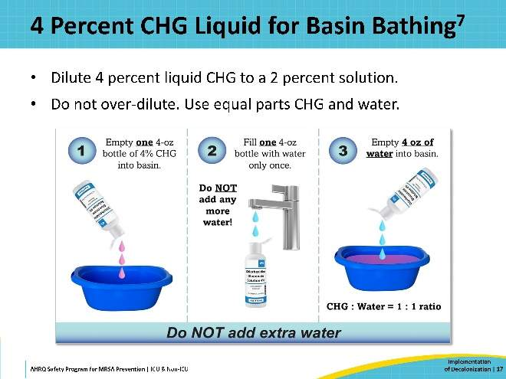
CHG Bed Bathing Procedure  SAY:  When performing CHG bathing, all six cloths should be used to clean different areas of the body in the sequential order shown on the diagram:  - Face, neck, and chest. Avoid the eyes and ear canals.  - Both shoulders, arms, and hands.  - Abdomen, then groin/perineum.  - Right leg and foot  - Left leg and foot.  - Back of neck, back, then the buttocks.  Massage the CHG cloth firmly to ensure it binds to the skin and effectively removes bacteria. Allow the CHG to air dry completely. Do not rinse or wipe off the CHG! Patients may mention feeling sticky, but this will fade in a few minutes once the CHG fully dries.  Ensure all six cloths are used. Cloths should not be re-used. Use additional cloths if needed, especially for larger or obese patients. CHG cloths should also be used in cases of incontinence or any other necessary clean-up between the daily baths. Other soaps or cleaning products may inactivate the CHG.  Pay special attention to the neck, joints, and skin folds, as these areas are often missed. Ensure these areas remain exposed to air until they are fully dry. | Slide 18  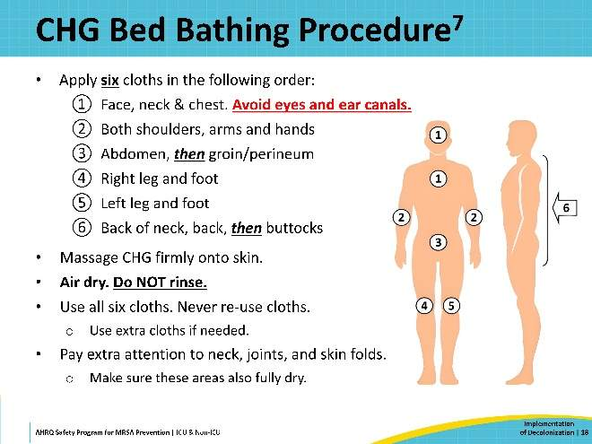
CHG for Medical Devices  SAY:  Medical devices, while lifesaving, can easily act as entry points for pathogens that cause HAIs, including MRSA. Patients with central lines, midline catheters, PICC lines, or lumbar drains are at risk. When conducting decolonization, it is critical to use CHG to clean any device connections—lines, tubes, and drains.  Take special care to thoroughly clean the skin around where the device connects to the body using a clean CHG cloth. Then clean at least 6 inches of the device connections that are closest to the body. | Slide 19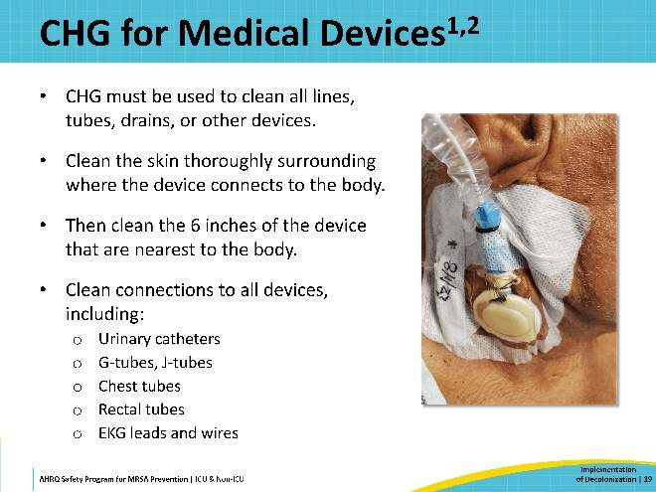
CHG for Wounds and Dressings  SAY:  CHG can be applied to certain wounds. It is recommended for use on superficial wounds, including friable skin and rashes, superficial burns, and stage 1 and 2 pressure injuries. It should also be applied over sutured or stapled wounds. However, CHG is not recommended for large, deep, or packed wounds.  CHG is suitable for use over semipermeable and occlusive dressings, including vacuum-assisted closures and surgical drains.  For permeable dressings, like gauze, CHG should be applied up to the edge of the dressing but not over the dressing itself. | Slide 20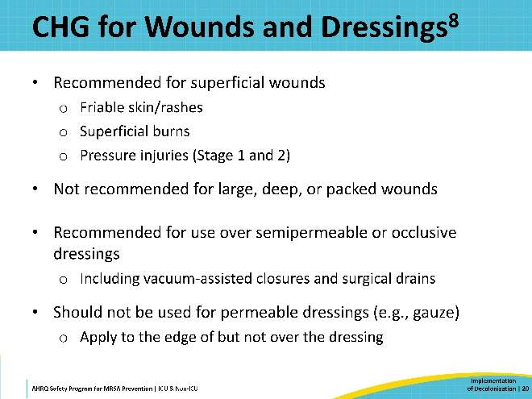
Ensuring Compatibility With CHG  SAY:  CHG compatibility is a crucial consideration. Before launch, you should conduct a thorough assessment to ensure that any skin or hair products used in your unit are compatible with CHG. Most soaps, shampoos, deodorants, lotions, and barrier products will inactivate the CHG and negate its antiseptic effect.  Check with the manufacturers to confirm CHG compatibility. If they cannot confirm, switch to products that are confirmed to be compatible.  Compatibility is not a concern with any prescribed medicated creams.  Patients may ask to use their own personal soap or shampoo. Encourage patients to use CHG for all cleaning and bathing needs during their stay. CHG is safe for use on the face and hair, avoiding the eyes and ear canals.  If the patient insists on using their own shampoo or facewash, have them use it before applying the CHG. Advise them to use it sparingly and advise them to avoid getting it on other areas of the skin. It should then be thoroughly rinsed off before the CHG is applied. Other soaps or shampoos should not be used after CHG has been applied. | Slide 21  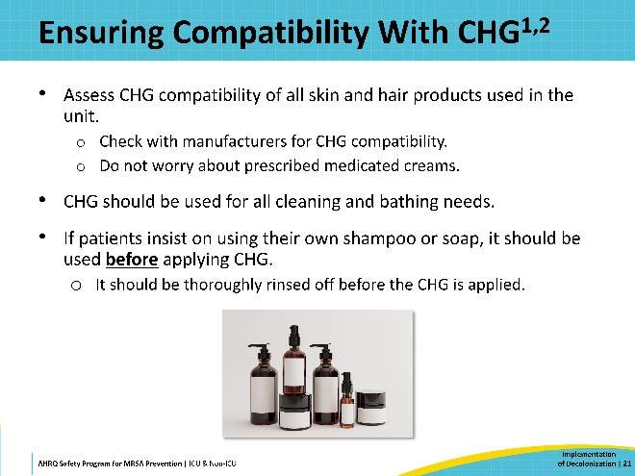
How To Conduct Nasal Decolonization  SAY:  The next section will provide a detailed overview of nasal decolonization procedures.  Remember, the primary reservoir for MRSA is inside the nose. When people touch their face and rub their nose, they transfer MRSA to other parts of the body. Therefore, nasal decolonization is essential for clearing MRSA and reducing infections. | Slide 22  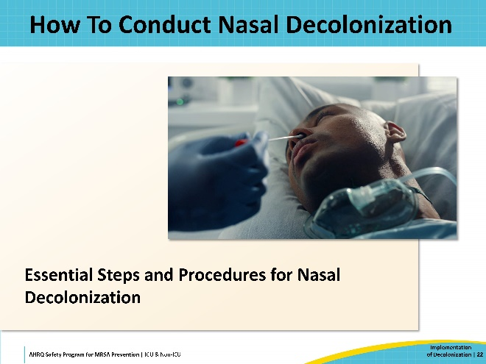
Nasal Decolonization Protocol  SAY:  Nasal decolonization is a 5-day course, performed twice a day, starting on that patient’s first day on the unit. This includes patient transfers who have already completed a full course in another unit. If a patient was mid-course in their previous unit, then the course should be continued from where it left off. If a patient is readmitted to the unit after any length of absence, then the 5-day course should be restarted—except for temporary transfers for imaging or surgery.  If a patient is in the unit for more than 2 weeks, then the full 5-day course is restarted.  If a dose is missed, decolonization should be resumed according to the original schedule, without doubling up doses. If more than two doses are missed, then restart the 5-day course.  For more on nasal decolonization, please refer to the Nasal Decolonization: Nursing Protocol Training PowerPoint. This document is designed to assist staff training on proper nasal decolonization procedures. | Slide 23  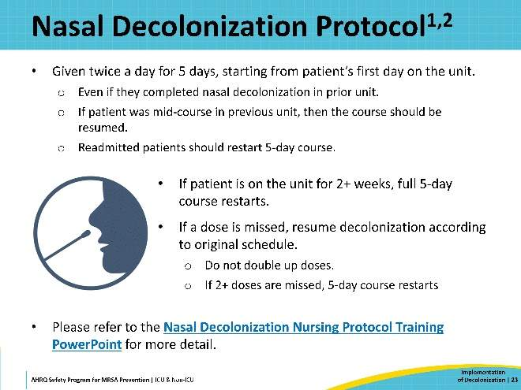
Nasal Decolonization Products  SAY:  Several agents have been studied for nasal decolonization, but two stand out as supported by substantial data.  The most well-studied and proven decolonization agent is 2 percent mupirocin ointment. It is a prescription antibiotic, available as generic. Mupirocin is often provided in single-patient, multidose tubes, so one tube can cover the whole 5-day course for one patient. Mupirocin is not systemically absorbed.  The next best studied agent is iodophor, or 10 percent povidone-iodine. As an antiseptic, iodophor swabs are available over the counter. Iodophor has the advantage of bypassing the need for a prescription and is also typically lower in cost.  Current evidence indicates that mupirocin is more effective than iodophor for decolonization. The Mupirocin-Iodophor Swap Out Trial, a recently published pragmatic cluster-randomized trial, compared decolonization protocols using CHG-mupirocin versus CHG-iodophor. The mupirocin protocol resulted in 18.4 percent fewer S. aureus clinical cultures and 14.1 percent fewer MRSA cultures than iodophor. Therefore, mupirocin should be chosen over iodophor if possible, unless there is a known high prevalence of mupirocin resistance or there are logistical concerns about obtaining physician orders. | Slide 24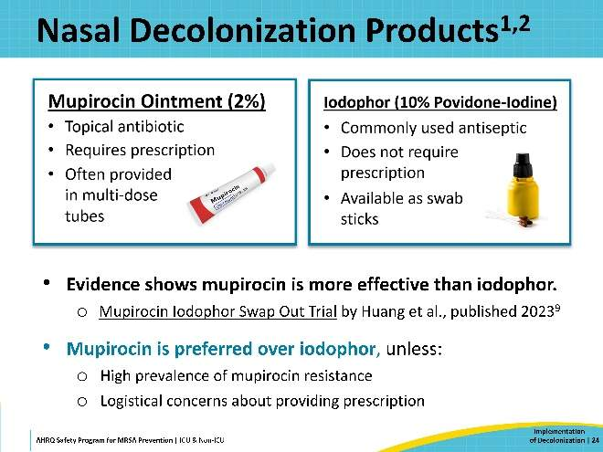
Procedure for Nasal Mupirocin  SAY:  Before applying nasal mupirocin, have the patient blow their nose to clear their nostrils. If tolerated, the head of the patient’s bed should be placed at a 30-degree angle.  Dispense 0.5 grams (the size of a pea) onto a clean swab for each nostril. If using a multidose tube, the tube should not be taken into the room of a patient on contact precautions. Apply the ointment with even pressure to ensure full coating of all sides of the nostril.  After applying mupirocin to both nostrils, press the nostrils together and gently massage for 60 seconds to obtain an even distribution. Contact should be avoided with eyes and other intranasal products.  Side effects are uncommon and may include nasal irritation, runny nose, and sneezing. Rare side effects include burning, stinging, and itching. Side effects generally resolve with discontinuation.  The most common patient complaint is that the ointment feels thick or “goopy.” Having patients blow their nose beforehand can help, as well as the massaging of the nostrils. Patients can also perform the massaging themselves if they are able. Do not allow patients to blow their nose after mupirocin is applied. | Slide 25  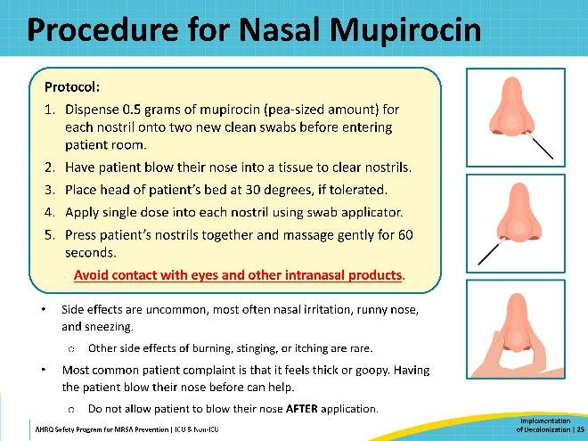
Procedure for Nasal Iodophor  SAY:  The protocol for nasal iodophor is like the one for mupirocin. Have the patient blow their nose and position the head of the bed at a 30-degree angle. Apply one swab to each nostril. Rotate the swab in each nostril for 30 seconds, coating all surfaces. Apply firm pressure so you can see the nostril bulge as the iodophor is applied. Go around each nostril slowly at least three times to ensure full coverage.  Side effects are uncommon and may include nasal irritation, runny nose, and sneezing. Rare side effects include burning, stinging, and itching. Side effects generally resolve with discontinuation.  Do not allow patients to blow their noses after iodophor is applied. The solution may drip or leave a brown tinge at the end of the nose. Dab with a tissue to clear away. | Slide 26  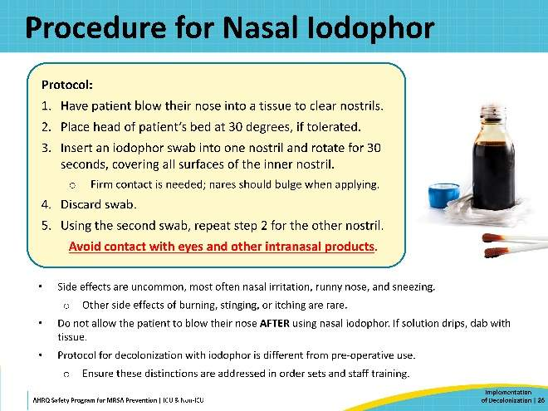
Other Nasal Medicines and Nasal Devices  SAY:  Patients should continue to use any other prescribed nasal medicines. Prescriptions may not be compatible with the decolonization product. Discuss any conflicts with the patient’s providers. If possible, separate the administration of conflicting medicine and decolonization by several hours.  If tolerated, briefly remove nasal prongs or other nasal devices to apply decolonization. For patients with nasal tubes, apply the decolonization product to the area around the tube.  For patients with recent nasal surgery or trauma—if unable to conduct decolonization, do not apply to that nostril. Discuss with your hospital’s ENT surgeons to establish general guidelines for specific circumstances. | Slide 27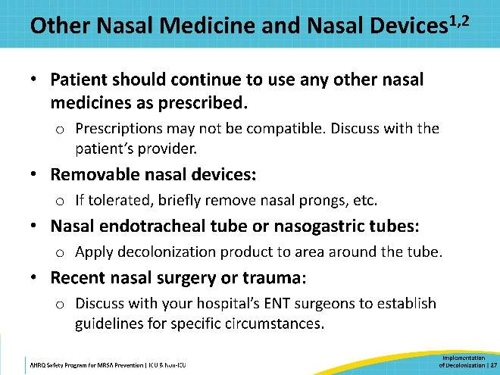
Do’s and Don’ts of Decolonization  SAY:  This slide shows a quick summary of key Do’s and Don’ts that unit personnel must remember.  Among the Do’s:  - Do use CHG for daily bathing, in place of soap and water.  - Do apply CHG onto the skin firmly, to ensure binding to skin.  - Do pay special attention to areas such as the neck, joints, and skin folds.  - Do use CHG to clean the 6 inches closest to the body of any connections—including lines, tubes, and drains—for all medical devices.  - Do use CHG over superficial wounds, rashes, friable skin, sutured and stapled wounds, and semipermeable dressings.  - Do use CHG-compatible skin products only to avoid inactivating the CHG.  Among the Don’ts:  - Don’t get CHG into the eyes or ear canals.  - Don’t rinse or wipe off the CHG; allow it to air dry.  - Don’t use CHG on deep or large wounds or wounds that are packed.  - Don’t flush CHG cloths; discard them in the trash, not the toilet or commode.  - Don’t save open CHG packs for later use.  - Don’t perform CHG bathing or nasal decolonization if the patient has known allergies to the product.  A downloadable reminder sheet of these Do’s and Don’ts is available here: Decolonization Do’s and Don’ts (.docx). | Slide 28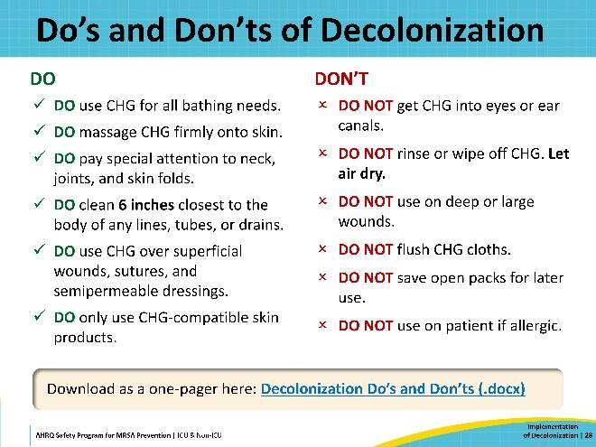
Resources for Staff Training  SAY:  Training materials can provide important information to staff who are not familiar with the process. People may want to understand a little bit more about CHG—How long has it been around? Is it safe? What does it do?  This slide shows links to the resources provided in the Toolkit for staff training.  - Tools & Resources for Decolonization: Staff Training Materials  - Nursing Protocol Training PowerPoint: Decolonization With CHG (.pptx)  - Nursing Protocol Training PowerPoint: Nasal Decolonization (.pptx)  - Staff FAQs: CHG, Nasal & Wound Care  Frequently asked questions from staff on the topic of decolonization  - Staff FAQs: Safety & Side Effects  Frequently asked questions on safety and side effects  - Decolonization Do’s and Don’ts  Reminder sheet of important Do’s and Don’ts  - Talking Points for Patients: CHG Bathing  Common questions and key talking points from patients on CHG bathing  - Talking Points for Patients: Nasal Decolonization  Common questions and key talking points from patients on nasal decolonization | Slide 29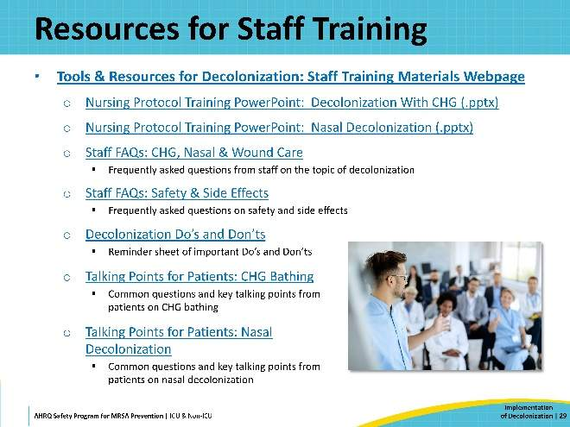
Training Videos for Decolonization  SAY:  These training videos were originally developed by AHRQ as part of the “ABATE Toolkit for Decolonization of Non-ICU Patients With Devices.” While these videos were created with non-ICU patients in mind, the techniques demonstrated are suitable for patients in all acute care settings. These videos feature step-by-step demonstrations of decolonization with CHG and mupirocin, and scenes with live actors acting out common scenarios.  These videos are short and can be instrumental in staff training. These AHRQ videos can be streamed online or downloaded so that they may be available in the hospital’s system and to use as you see fit. These videos are publicly available on YouTube. Click on the following links for these instructional videos. | Slide 30  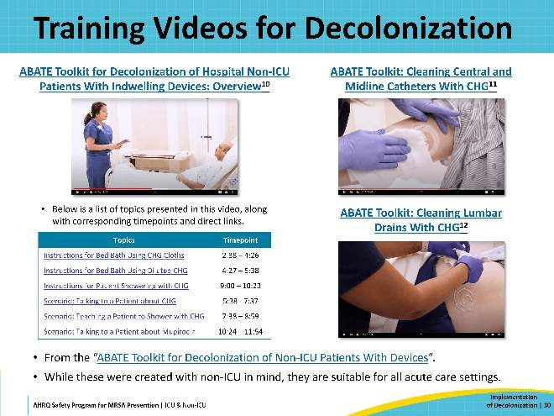
Resources for Patient Education  SAY:  The Toolkit website provides patient resources and documents to convey information on the purpose and importance of decolonization to patients, families, and caretakers.  This slide shows links to the resources provided in the Toolkit for patient education.  - Tools & Resources for Decolonization: Patient Educational Resources  - Info Sheet for Patient & Family: Daily Bathing With CHG  Information sheet on the importance of CHG bathing  - Patient Instruction Sheet: Bathing With CHG Cloths  Patient instructions for self-bathing with CHG using CHG cloths  - Patient Instruction Sheet: Showering With CHG  Patient instructions for showering with CHG  - Wall Poster: CHG Bathing Reminder  Reminder poster designed for placement in visible areas  - Talking Points for Patients: CHG Bathing  Key talking points for patients on CHG bathing  - Talking Points for Patients: Nasal Decolonization  Key talking points for patients on nasal decolonization | Slide 31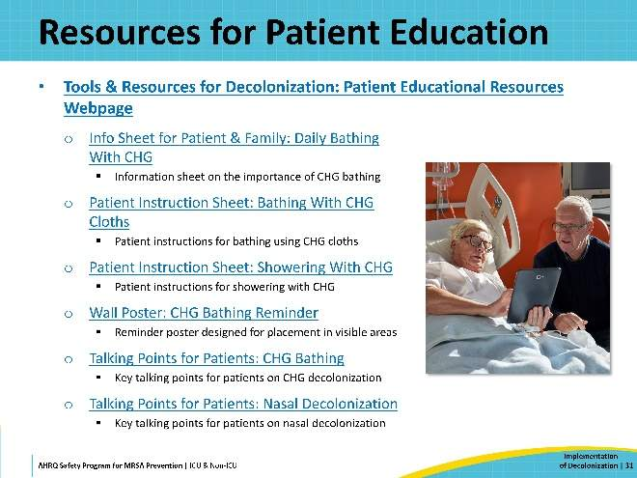
Top 10 Pearls for Success  SAY:  Now, let's move on to the top 10 pearls for successful decolonization. These are tips for effective implementation of MRSA decolonization. | Slide 32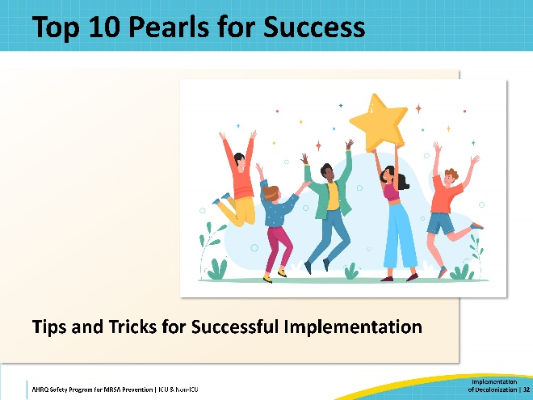
#1: CHG Is the Bath, Not a Topcoat  SAY:  The first pearl is that CHG is the bath, not a topcoat. Some personnel might misunderstand and think they’re supposed to bathe the patient with regular soap and water and then apply CHG as a topcoat. It’s important that staff understand that CHG is intended to replace all bathing. Even though it doesn’t produce a lather, CHG is more effective than regular soap and water for removing germs. Inform personnel and patients that this is a protective bath that not only removes germs that can produce infection but also germs that produce odors. The CHG provides an efficient and comfortable way of bathing while staying in bed. | Slide 33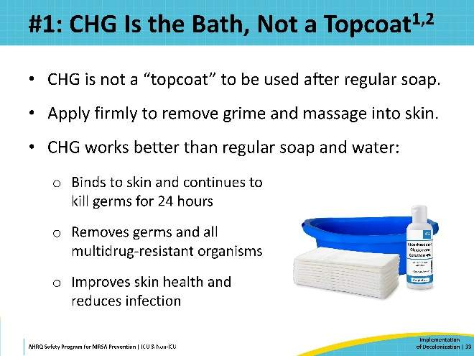
#2: Cleaning Face and Hair Is Important  SAY:  The second pearl for success is that cleaning the face and hair with CHG is important. CHG is safe to use as a face wash and as a shampoo. Just like soap, avoid getting CHG into the eyes or ear canals. Some manufacturers will caution against using CHG above the neck, but it is safe for the face if it doesn’t come into direct contact with nervous tissue. For instance, if a patient had a ruptured eardrum, then CHG in the ear canal could get past the eardrum and contact nervous tissue.  If eyes and ear canals are avoided, you can safely use CHG as a regular soap over the face, neck, and chin.  For hair, CHG can be used as a shampoo. Remember that regular shampoos will inactivate CHG. If a patient insists on using their own shampoo, then instruct them to avoid getting the shampoo on other parts of their body, and thoroughly rinse out the shampoo before applying CHG. | Slide 34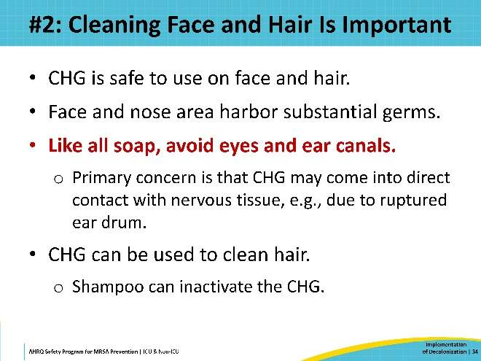
#3: Be Attentive to Commonly Missed Areas  SAY:  Number 3: Check commonly missed areas. Remind staff that certain areas, like the neck, are easy to miss. The neck has a lot of folds and creases which hide a lot of bacteria. It is also often in contact with many lines, tubes, and other devices. Be sure to clean between every skin fold, under the breasts, and under the pannus.  Make sure these areas also get a chance to air dry. CHG needs to dry fully to have maximum effect. CHG is active against yeast and can improve candidal rashes, but only if it dries properly. If moisture remains in skin folds, it can make these rashes worse. You can use towels to prop open skin folds until they dry. | Slide 35  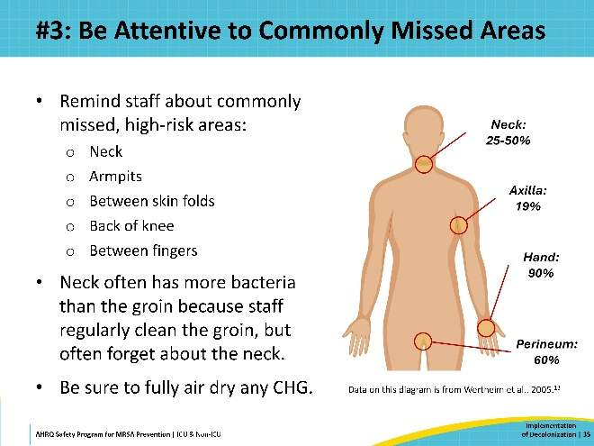
#4: Clean Wounds and Rashes With CHG  SAY:  Number 4: Remember to clean wounds and rashes. Staff are used to bathing intact skin and might hesitate when they see wounds, rashes, friable or denuded skin, or pressure injuries. However, it is crucial to clean these areas thoroughly with CHG. Breaks in the skin are entry points for germs to get in and cause infection, making it essential to clean these areas.  Ensure that all unit personnel understand that CHG is safe for friable skin, abrasions, superficial burns, superficial pressure injuries (stage 1 and 2), superficial wounds, and sutured or stapled wounds. CHG is approved as a wound cleanser. It should not be used on large or deep wounds, or wounds that are packed.  Having a wound care expert among the nursing staff to act as a champion may be beneficial. This person can serve as a resource for other personnel, demonstrate the correct procedures, and encourage staff to follow the protocol. | Slide 36  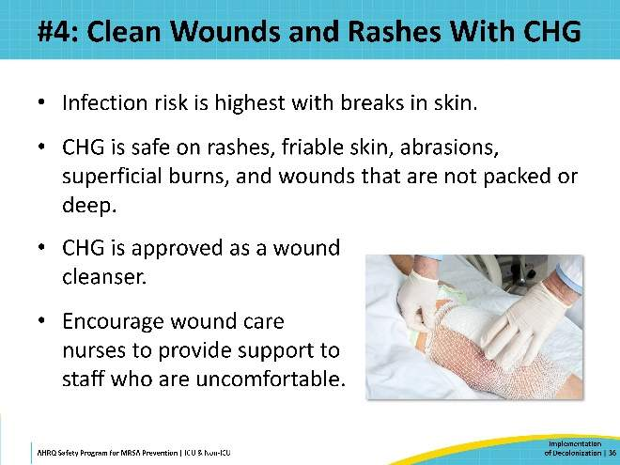
#5: Clean All Medical Devices  SAY:  Number 5: Clean all medical devices. Medical devices create breaks in the skin that increase the risk for infection. Make sure healthcare personnel are aware that decolonization includes cleaning all devices.  Clean all lines, tubes, drains, and other connections to devices, any ports, and every dressing that is occlusive or semipermeable. Wipe over it, around it, and the actual device itself, making sure that you're left with a patient with clean skin, clean dressings, and clean devices.  If the patient uses CHG in the shower, the staff should wrap the devices in waterproof material beforehand. After the shower is complete, the staff is responsible for cleaning the devices. | Slide 37  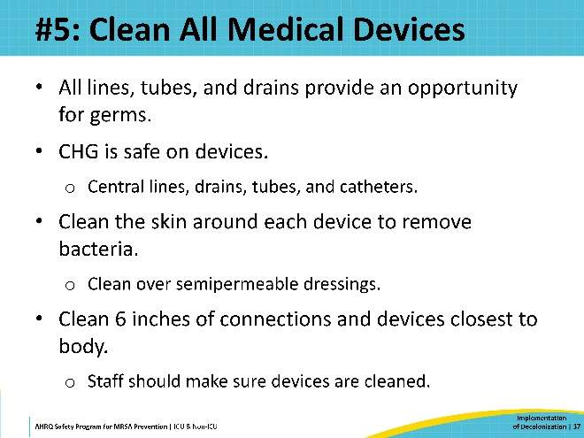
#6: Allow CHG to Dry  SAY:  Number 6: Allow 2 percent CHG to fully air dry. CHG is most effective when it is allowed to dry. Do not wipe it off. CHG binds to the skin proteins and works for up to 24 hours. For large skin folds, you can fan them dry, or use rolled towels to hold the folds open so the CHG can dry. If a patient complains that the CHG is making their rash worse, it may be due to not letting the CHG fully air dry.  When using 4 percent CHG in the shower, the CHG should be rinsed off. The patient must allow the CHG to sit for 2 minutes before rinsing. | Slide 38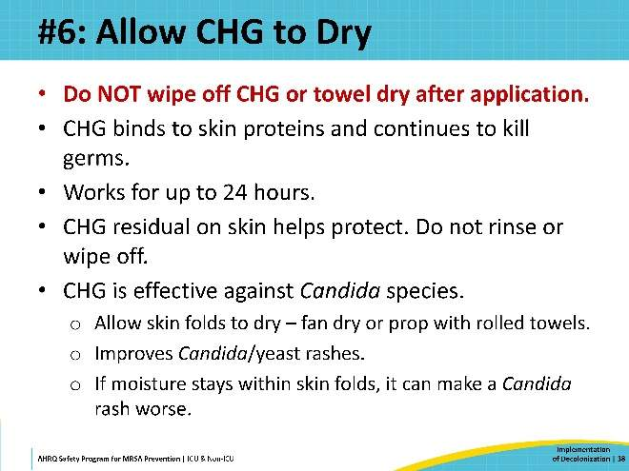
#7: Apply CHG Closest to the Skin  SAY:  Number 7: Apply CHG closest to the skin. CHG should be applied first before any other skin product, to allow the CHG to bind to the skin effectively. After applying CHG, you may apply CHG-compatible lotions, creams, or barrier protection if they are needed.  Do not use skin or hair products that are not CHG-compatible. | Slide 39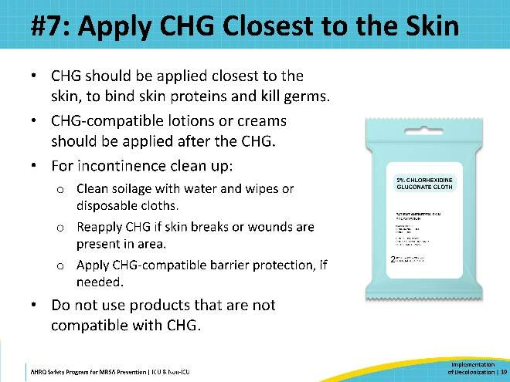
#8: How CHG Is Applied Matters  SAY:  Number 8: How CHG is applied matters. Studies show that proper training is essential for effective use. Staff need to know to let CHG air dry, massage it firmly into the skin, and apply it over wounds and devices. A lack of clear messaging can lead to incorrect assumptions from staff and reluctance from patients.  Successful decolonization relies on engaging, educating, and empowering personnel to know how to correctly perform decolonization. It's important to build rapport between members of the nursing team. Nursing staff should be trained to properly clean dressings and the first 6 inches of any line, tube, or drain. Ensure that staff feel confident in their role and understand that this bath is vital for patient safety and infection prevention. | Slide 40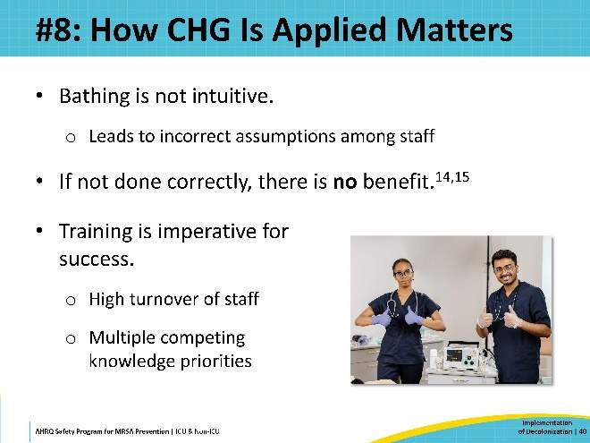
#9: Nasal Decolonization Is Important  SAY:  Number 9: Emphasize the importance of nasal decolonization. Some staff members may believe that the CHG bathing alone is sufficient, without performing nasal decolonization.  To effectively target S. aureus, nasal decolonization is crucial. The nose is the primary reservoir for MRSA, and patients can easily re-contaminate the rest of the body by touching their face.  Nasal decolonization is easy to do, and it's important to make sure unit personnel understand why it's a critical part of the process. | Slide 41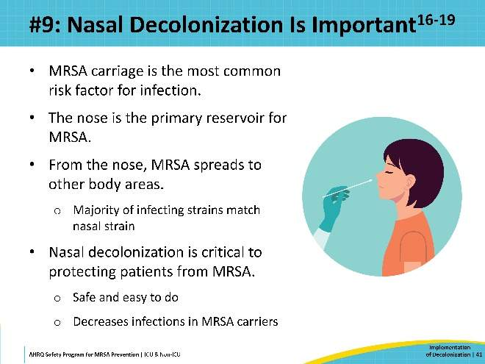
#10: Try, Try Again  SAY:  Lastly, number 10: if a patient refuses decolonization—try, try again. When a patient declines a CHG bath, it's important to understand their reasons. While patients have the right to refuse any care, staff should take time to explain how CHG bathing prevents infection.  Patients might refuse because they feel uncomfortable, tired, hungry, cold, or in pain. Addressing their current issue and asking again later might be enough to gain their acceptance.  Additionally, some patients might not realize that the bath is not just for their comfort, but for their protection.  Develop a plan for re-approaching patients who refuse and ensure all staff are familiar with it. Many hospitals have found success setting up a protocol for patient refusal. If initial attempts are unsuccessful, the unit staff can escalate the matter to a peer champion or nurse manager to approach the patient later. This additional conversation can help clarify the importance of CHG bathing and encourage the patient’s acceptance. Often, once patients understand the benefits and receive appropriate support, they will agree to decolonization. | Slide 42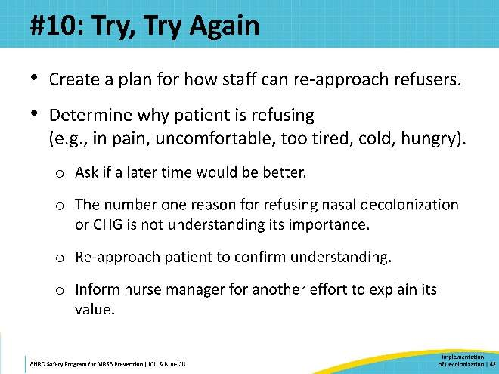
Implementation Considerations  SAY:  Next, this presentation highlights key points you should consider when establishing your decolonization program. | Slide 43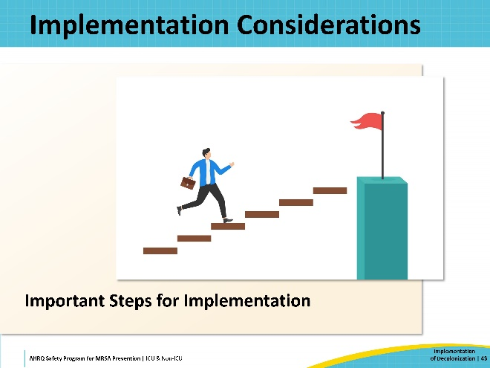
Admission Bath Is Critically Important  SAY:  CHG bathing at the time of hospital admission is critically important, but it is sometimes overlooked. When first admitted, a patient may have been ill for days and hasn’t felt up to bathing. They may carry many germs, including MDROs, on their body, particularly if they were transferred from another healthcare setting, like a skilled nursing facility. It is vital to emphasize the importance of the unit admission bath to your personnel.  Ensuring that all patients who come into your unit are bathed at the time of admission protects not only your patient but also the other patients on the unit. | Slide 44  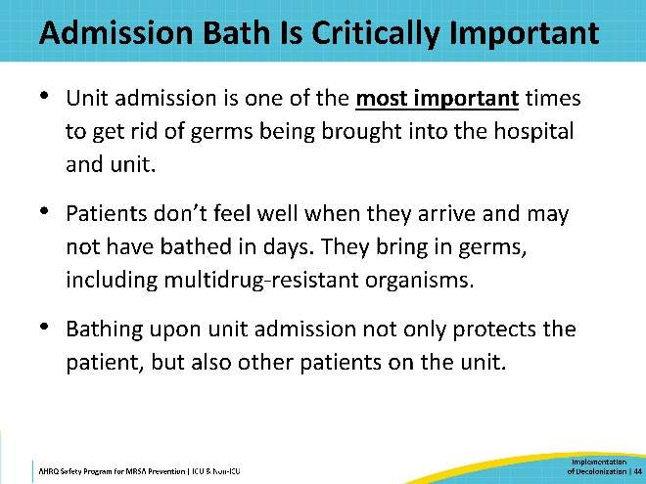
Order Set—Pearls  SAY:  When setting up a decolonization program, you should strongly consider implementing order sets for each unit to standardize and streamline their decolonization processes. Order sets are invaluable as they post decolonization tasks to the nursing dashboard, facilitating proper documentation and report generation.  Remember that the admission bath is particularly important, but it can be easily overlooked. Order sets can help by ensuring the admission bath is ordered in addition to the daily bathing.  Similarly, setting up order sets for nasal decolonization, starting on patient admission, can help address logistical challenges involving prescriptions. | Slide 45  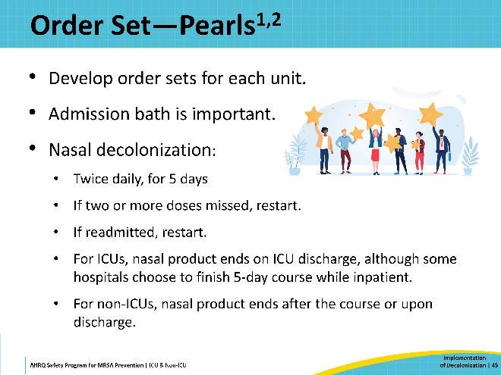
Pre-Launch One-Time Skin Check  SAY:  Before launching your decolonization program, it is advisable to conduct a baseline skin check for all the patients in the unit, documenting existing skin lesions, wounds, and rashes. Without this initial assessment, staff may incorrectly attribute a previously unnoticed skin condition to the CHG, especially if they are unfamiliar with CHG. Performing these baseline skin checks can help ensure that your program starts off on a good footing.  Skin checks are standard practice in healthcare and provide an opportunity to call attention to skin health, prior to starting decolonization. This approach can also help reassure patients who may have qualms about the new regimen.  Typically, after the first few days, staff recognize that CHG is safe and beneficial for patients. | Slide 46  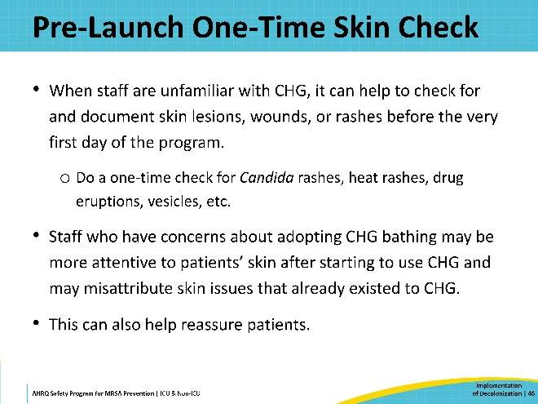
Value of Checking Adherence  SAY:  Monitoring adherence to decolonization is critical to its success. Once your decolonization program has been launched, it is essential to track whether the decolonization practices are being consistently followed.  Utilize all available tools to facilitate this process. Your EHR software is essential for this purpose. Collaborate with your IT department and supply chain to explore what options are available.  One effective method is to have the unit staff document CHG bathing for each patient during their shifts. This is a straightforward but effective method of accurately tracking adherence. Reports should be able to detail frequency of daily baths and allow filtering by unit, shift, and staff members.  Regular tracking and report generation are necessary for evaluating compliance. Your team should meet regularly to review these reports to interpret the data and identify trends.  Are certain staff or units performing better than others? Recognizing their success is important to sustain motivation and momentum. Their success can also function as an example for other groups that are having trouble. Often having a decolonization champion is the strongest way of getting people to adopt new practices.  Are there certain times or shifts when compliance is better than others? This will allow you to identify lapses. Groups or individuals who are struggling should receive targeted training and encouragement and the intervention adjusted to address their needs.  A crucial part of the data cycle is to share the data. This includes sharing with staff and leaders. Letting people know how they’re doing is important.  Based on the data, you can modify your intervention approach. This includes providing direct feedback, support, documentation, reports, and order sets—all these things are going to be invaluable for checking and compelling adherence. | Slide 47  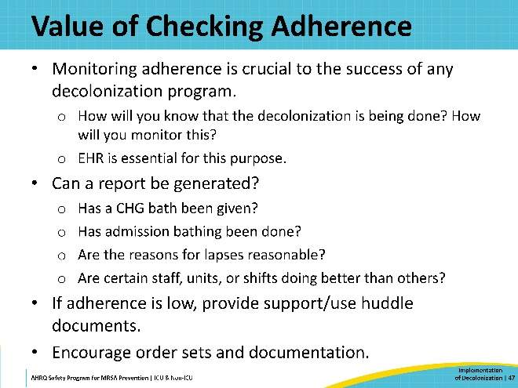
Sample CHG Bathing Adherence Report  SAY:  This slide presents an example of a CHG bathing adherence report. This comparison report enables units to benchmark their performance against others, highlighting what can be achieved.  When launching your decolonization program, select a realistic target that is achievable and encouraging for staff. Adjust these targets over time based on observed performance and improvements.  This report should also distinguish between admission baths and daily baths. Admission bathing may be more difficult to accomplish because of the competing demands on nurses during patient intake. Therefore, it may be beneficial to set different targets for admission and daily baths to better reflect these challenges.  A template for this adherence report can be downloaded here. | Slide 48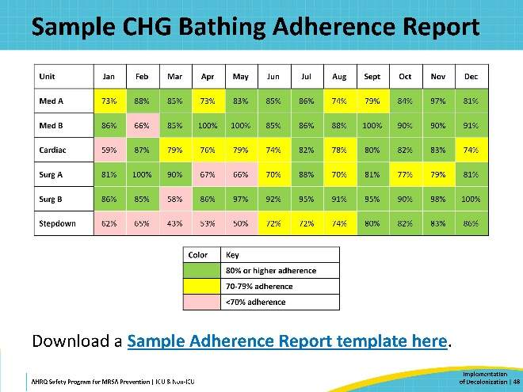
Implementing Decolonization: A Case Example  SAY:  For this next section, let’s walk through an example of a hospital planning and launching a decolonization program. | Slide 49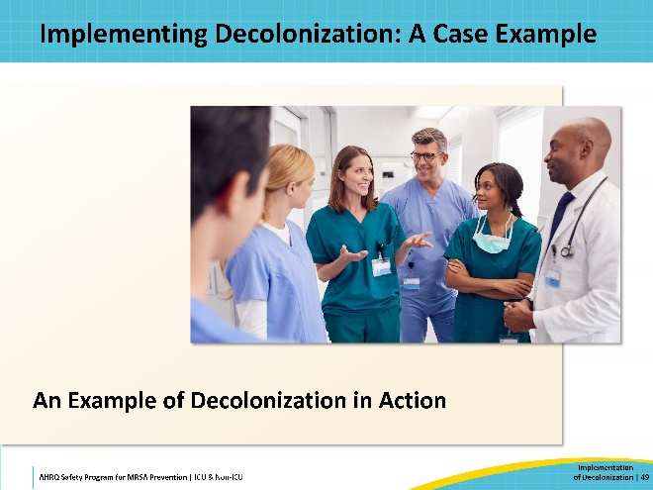
The 4 Es and Implementation  SAY:  The AHRQ Toolkit for MRSA Prevention utilizes the CUSP 4 Es framework for implementation. It is handy, straightforward, and effective. The 4 Es consist of: Engage, Educate, Execute, and Evaluate. These describe the four components of effective implementation. For more information on the 4 Es, please refer to the section on the Toolkit for MRSA Prevention in the ICU and Non-ICU website.  On this slide is the Action Chart for Implementation. This chart presents the key steps of planning and pre-launch for intervention. Keep the 4 Es in mind as you progress through these steps. | Slide 50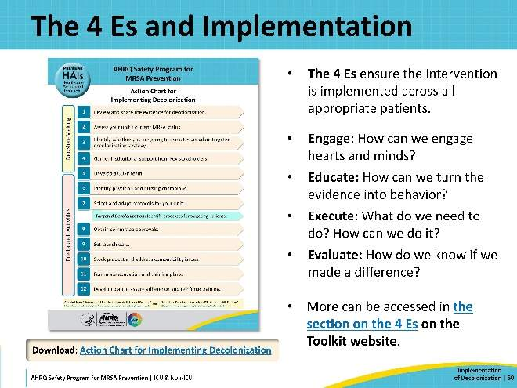
Case Example: Reviewing Evidence, Assessing Current Status, Garnering Support  SAY:  MediocreCare™ Hospital has never been a highly rated institution. And now, the hospital is at risk of losing its accreditation, due to major deficiencies in infection prevention. They have had multiple MRSA outbreaks over the past 2 years. While MRSA rates have currently stabilized, they remain higher than average. The staff members and leaders from three units—the Cardiovascular ICU, the Progressive Care Unit, and the General Medicine Unit—and the hospital’s Infection Prevention Department agree to set up a CUSP team with the goal of implementing a decolonization program.  One of the team’s first steps is to review the published literature on decolonization. Together, they discuss the findings from various studies, carefully weighing the merits of different colonization approaches and products.  The team also assesses the current status of their units. Working with Infection Prevention, they gather unit data going back 12 months and calculate estimates of MRSA clinical cultures and all-cause bloodstream infection rates for each unit.  Next, they reach out to key stakeholders to garner institutional support—including senior leadership and staff members. They engage with the stakeholders and present the literature and data they’ve gathered. When engaging, the team’s goals are (1) to communicate the extent and impact of the problem, (2) present the proposed solution and its benefits, and (3) communicate their project’s goals. The data and current estimates help to establish a baseline context and to set achievable targets.  For more detailed guidance on this phase of your planning, please refer to the guide on Decision-Making and Readiness for Implementation provided in this Toolkit. | Slide 51  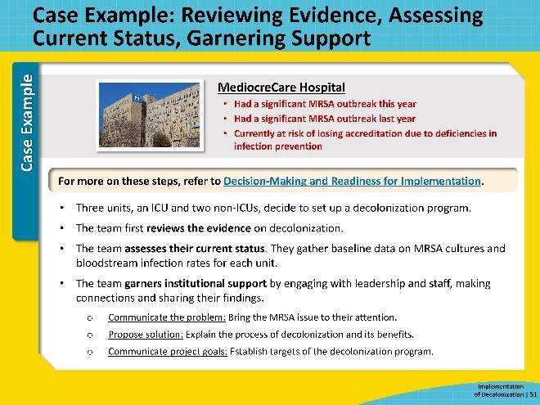
Case Example: Deciding on Universal Versus Targeted  SAY:  Early in the planning process, the team must resolve a crucial question: Do we implement universal or targeted decolonization? (This question is focused on in more detail in the Toolkit: Which Type of Decolonization Would Work Best in My Unit?)  The team realizes that different units have different needs—so they choose to determine the best approach for each unit individually.  The Cardio ICU will implement a universal protocol, as evidence strongly supports the effectiveness of a universal approach in intensive care settings. Their protocol is closely modeled after the REDUCE-MRSA trial.  The General Medicine Unit decides to adopt a targeted protocol. Evidence does not support a universal approach in non-ICUs, where the patient population is at a lower risk for infection. Their decolonization protocol will target high-risk patients with central lines, midline catheters, PICC lines, or lumbar drains—matching the criteria from the ABATE trial.  Initially, the team intended to target patients who tested MRSA positive—but they find limited evidence for the efficacy of this approach in the literature. Additionally, after the experience of the recent outbreaks, the team feels some lack of confidence in the accuracy and quality of MRSA surveillance procedures at MediocreCare.  The decision for the Progressive Care Unit (PCU) is more complex. Although the PCU is not an ICU, many of its patients are transitioning from intensive care—especially from the Cardio ICU. Many PCU patients are recovering from recent surgeries and have invasive devices, which makes them more vulnerable to infection.  Upon reviewing the baseline data, the team finds that over the past year, more than 50 percent of PCU patients met the criteria of the targeting protocol. Consequently, they decide that a universal strategy will be more appropriate for the PCU. | Slide 52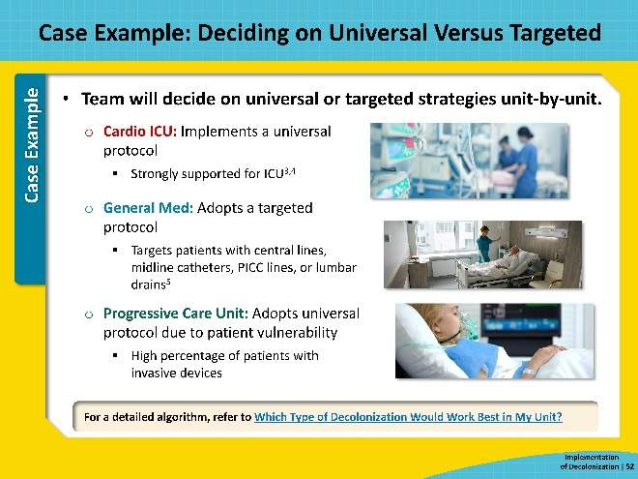
Case Example: Developing a CUSP Team, Identifying Champions, Developing Protocols  SAY:  As the project gains momentum, the CUSP team focuses on the preparation activities leading up to the program's launch. These steps are discussed in more detail in the guide on Pre-Launch Activities.  The CUSP team develops their team and organizes into a more formal and structured working group, scheduling regular meetings and assigning roles and responsibilities to team members. The team continues to engage new members throughout the project. (For more on putting together a CUSP team, access the resources on How To Integrate a CUSP Approach on the Toolkit website.)  During this time, the team also identifies physician and nurse champions for each unit. These champions will promote decolonization among their peers, support program implementation, and encourage protocol adherence.  The CUSP team collaborates with other departments on developing and finalizing the decolonization protocols, the order sets, and documentation processes in the EHR.  For the targeted protocol, the team also needs to figure out a process to identify the high-risk patients with devices. The EHR software can flag patients with medical devices, so the team considers setting up an automatic process. However, the team nurses advise that in their experience, the flagging's accuracy can be spotty. The team decides on a hybrid approach: the EHR software will generate daily reports identifying patients with devices, and the nursing staff will review the list and activate decolonization protocols manually. | Slide 53  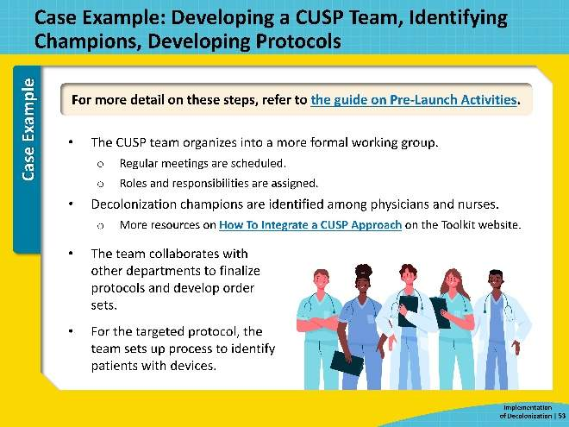
Case Example: Obtaining Approvals, Setting Launch Date, Stocking Product, Addressing Compatibility  SAY:  The team remains vigilant about securing all necessary approvals from hospital committees, as the time required for these approvals will affect their project timeline and launch date. When determining the launch date, the team considers factors such as the duration of training, potential conflicts with other priorities, and upcoming holidays. They schedule the launch for mid-January.  With the launch date established, the team focuses on preparing all elements required for a smooth rollout. Ensuring that decolonization products are adequately stocked is a key priority. They work closely with the supply chain department to maintain a sufficient inventory of CHG packets. They also procure cloth-warming devices for each unit to enhance patient comfort. Additionally, they coordinate with the pharmacy to stock mupirocin ointment and verify the distribution processes for CHG and mupirocin across the units.  The team also conducts a thorough compatibility review of all skin products used in the units. They make necessary adjustments in stock—such as replacing the petroleum-based barrier cream after discovering it’s not CHG compatible. | Slide 54  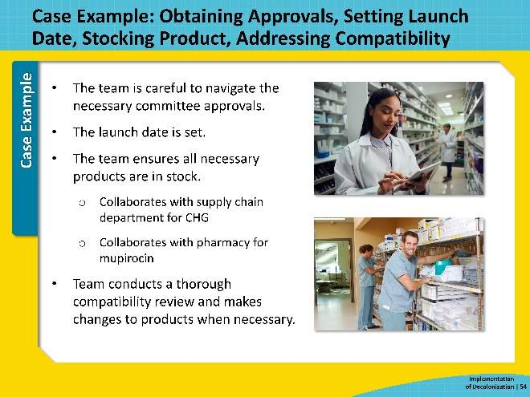
Case Example: Formulating Education and Training Plan, Developing a Feedback Plan  SAY:  A key component of the planning process is developing the education and training plan. The effectiveness of any intervention depends on staff understanding and correctly implementing new processes. The training plan should align with the current knowledge and skills of the unit personnel, addressing specific needs and gaps.  Fortunately, the CUSP team has actively engaged unit personnel from the very beginning and has made a conscious effort to keep them informed of project developments and regularly seek their input, to ensure they remain invested in the project. This engagement has provided the CUSP team with broad insights into the staff’s knowledge and where the gaps are, helping them tailor educational plans to meet their specific needs and concerns.  The education plan they design emphasizes hands-on demonstrations, which are more effective for teaching complex techniques such as decolonization. The plan also includes multiple modes of education to be flexible for different learning preferences. The unit champions will play a major role in the education, serving as coaches, guides, and experts to support all personnel.  Developing a feedback plan is often considered in the later stages of planning, but its importance cannot be overstated. Feedback is essential for the success of any patient safety intervention—for monitoring protocol adherence, reinforcing training, and identifying and addressing issues. The CUSP team has prudently been thinking about and planning feedback mechanisms since their earliest discussions on processes and protocols.  Staff will document decolonization in the EHR, and the data will be used to track compliance and generate regular adherence reports (A Sample Adherence Report template is available on the Toolkit website). These reports are promptly shared with each unit via the unit champions.  However, EHR data alone cannot indicate whether the decolonization is conducted correctly. To address this, the team will conduct regular audits by direct observation in each unit. The team decides that increased observation frequency at the onset of the decolonization program will help them to identify and correct errors in technique quickly and to address areas for improvement.  At the start, the team encounters some skepticism among unit personnel. The decolonization champions in each unit play a crucial role—correcting misperceptions, encouraging colleagues, and building up confidence among their colleagues. | Slide 55  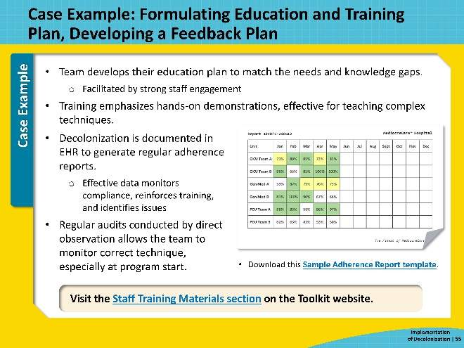
Case Example: Launch, Monitoring, Adjustment  SAY:  Effective execution requires continuous evaluation and adjustment to the intervention as new challenges and barriers arise during implementation. As the program rolls on, the team makes sure to keep communication channels open with staff and with leadership. They share data openly, to maintain transparency and foster trust. The team also actively solicits feedback, which, combined with the adherence data, helps identify barriers and make necessary adjustments to maximize success.  The day before the launch, the team conducts skin checks in all three units. Documenting any skin issues helps in accurately assessing any potential negative reactions to the CHG. This also provides an opportunity to address any questions or concerns about the decolonization from both staff and patients.  Early on, direct observations reveal that staff are not conducting CHG bathing thoroughly for patients with surgical wounds. Asking at rounds, the team learns that many staff feel uncertain about applying CHG over wounds. To address this, the team decides to designate wound care champions—experts who can provide guidance to staff. The Cardio ICU has an assigned wound care nurse, who is an obvious candidate. In the PCU, the charge nurses volunteer, as they have experience with wound care. The General Medicine Unit doesn’t have a wound care specialist, but the nurse manager identifies veteran nurses who are trusted by the staff. These selected individuals meet with the CUSP team to review clinical guidelines for CHG use on wounds.  Around Month 2, the team starts receiving reports of unused, unopened packets of CHG cloths being found in patient rooms in the General Medicine Unit. General Medicine patients have the option to perform their own CHG baths, but patients are often unclear about the instructions. The team suspends patient self-bathing, while they develop a staff training module to improve patient education.  In Month 4, the team learns of an unexpected issue: Brown stains are appearing mysteriously on freshly laundered bed sheets. Rumors are circulating about the cause. The team investigates and determines that CHG residue in cotton bedsheets is reacting with the chlorine bleach used by Laundry Services. The team distributes a document advising staff not to place used CHG cloths on patient beds and to discard them directly after use. Meanwhile, they submit a recommendation for the hospital to switch to peroxide bleach. The brown stains stop appearing.  After a later incident involving an emergency plumbing bill, the team distributes another huddle document, reminding staff to never, ever flush CHG cloths in the toilet. | Slide 56  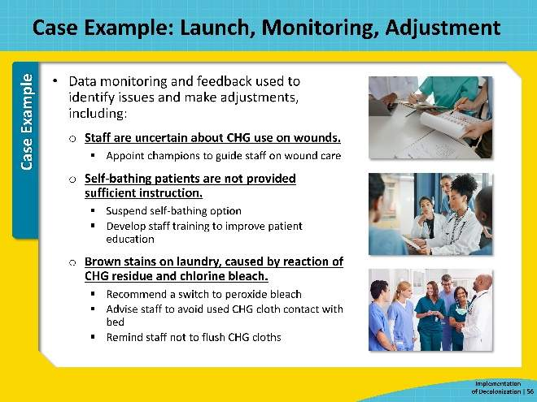
Case Example: Results  SAY:  Keeping communications open is also key to sharing success! Sharing and celebrating the successful efforts of the staff not only recognizes their hard work but also reinforces their commitment to sustain the intervention. It’s important that staff are aware of their own success to keep them motivated and remind them of their contributions to patient safety.  After 6 months, the data show significant improvements across all three units. In the Cardio ICU, the reduction in MRSA cultures and bloodstream infections is particularly dramatic. The improvements in the General Medicine Unit and the PCU are less pronounced but still substantial.  To highlight these achievements, the team published the results in the hospital newsletter, recognizing the units for achieving the lowest HAI rates across the entire MediocreCare™ system. This success convinces institutional leadership to expand the decolonization program hospital-wide.  The original CUSP team is eager to support the broader rollout and share the benefit of their experience. Following the CUSP principle of “Learn Locally, Share Globally,” they aim to help other units avoid the same pitfalls and ensure a smoother process as the program scales up. | Slide 57  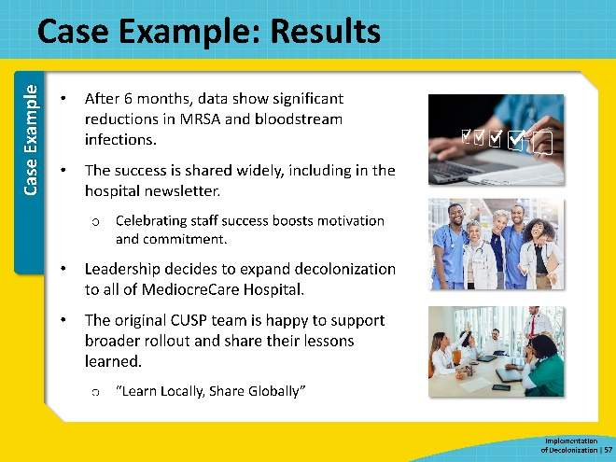
Key Takeaways  SAY:  We’ve just reviewed the components of the decolonization process and how they can be applied to your unit. Now, let’s focus on the key takeaways to ensure a successful implementation:  To effectively implement decolonization, it's essential to focus on engagement, preparation, and coordination. Utilize the Toolkit for MRSA Prevention, which includes detailed resources such as planning guides, sample protocols, training materials, and patient resources.  Various decolonization strategies and methods exist, each with its own set of advantages and disadvantages. Choose protocols that are most suitable and appropriate for your unit’s specific needs.  Establish strong data and feedback mechanisms to monitor compliance, track progress, and identify areas for improvement. Ensure that all staff are thoroughly trained in decolonization procedures and understand their critical role in the process.  Once implementation begins, continually review the data, and make necessary adjustments to maintain effectiveness. | Slide 58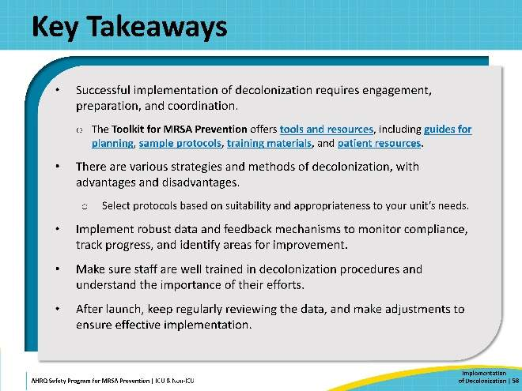
Disclaimer  SAY:  The findings and recommendations in this presentation are those of the authors, who are responsible for its content, and do not necessarily represent the views of AHRQ. No statement in this presentation should be construed as an official position of AHRQ or of the U.S. Department of Health and Human Services.  Any practice described in this presentation must be applied by healthcare practitioners in accordance with professional judgment and standards of care regarding the unique circumstances that may apply in each situation they encounter. These practices are offered as helpful options for consideration by healthcare practitioners, not as guidelines. | Slide 59  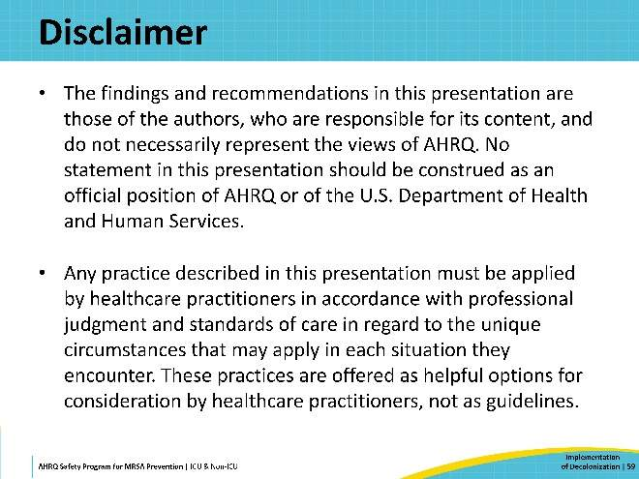
Reference List—1 | Slide 60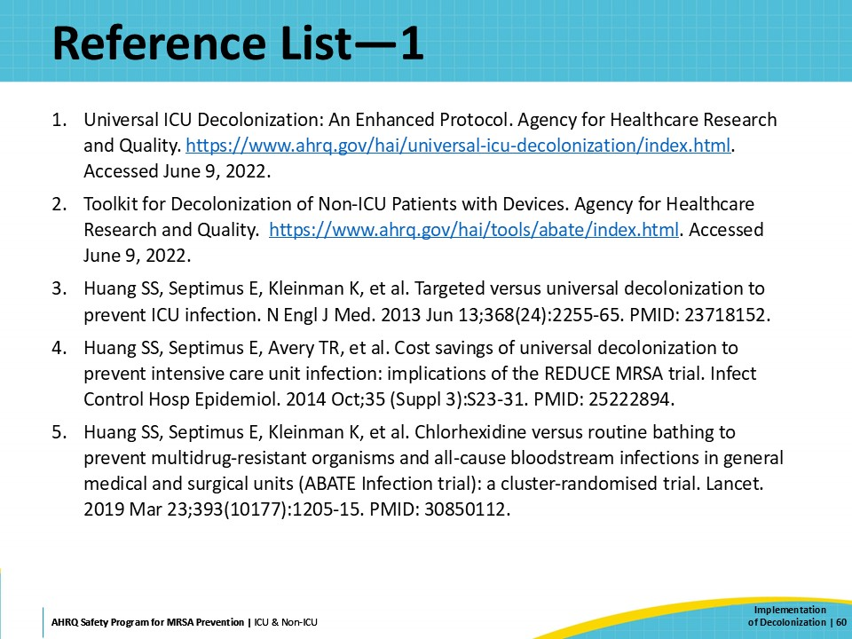
Reference List—2 | Slide 61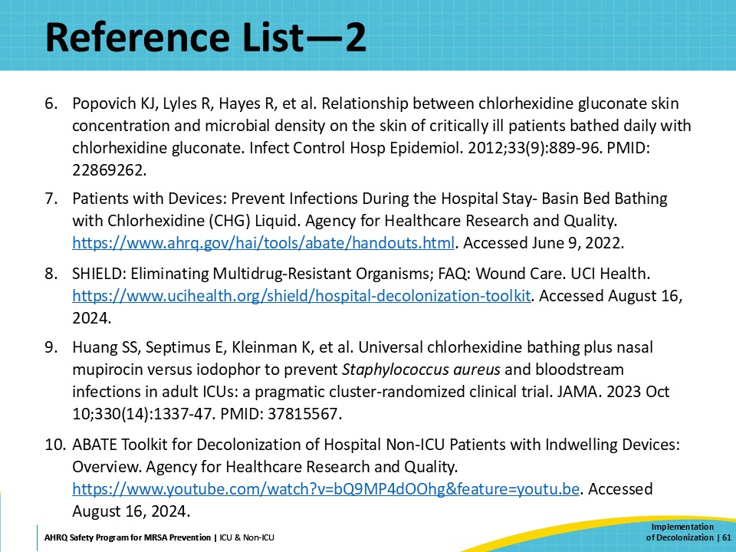
Reference List—3 | Slide 62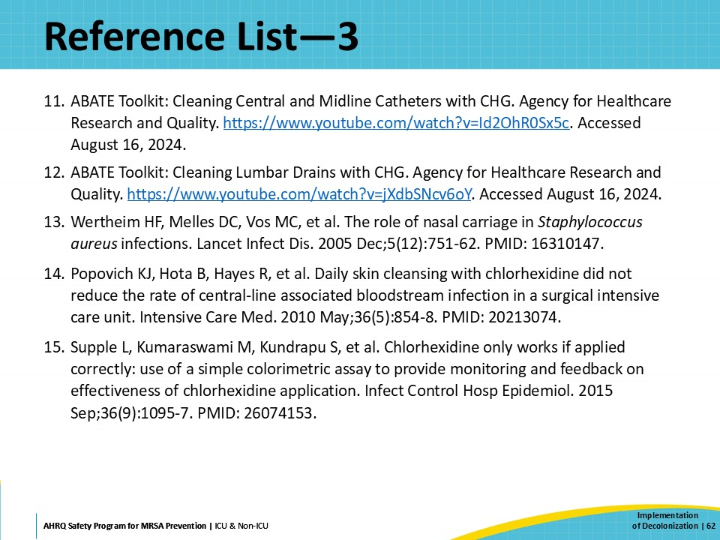
Reference List—4 | Slide 63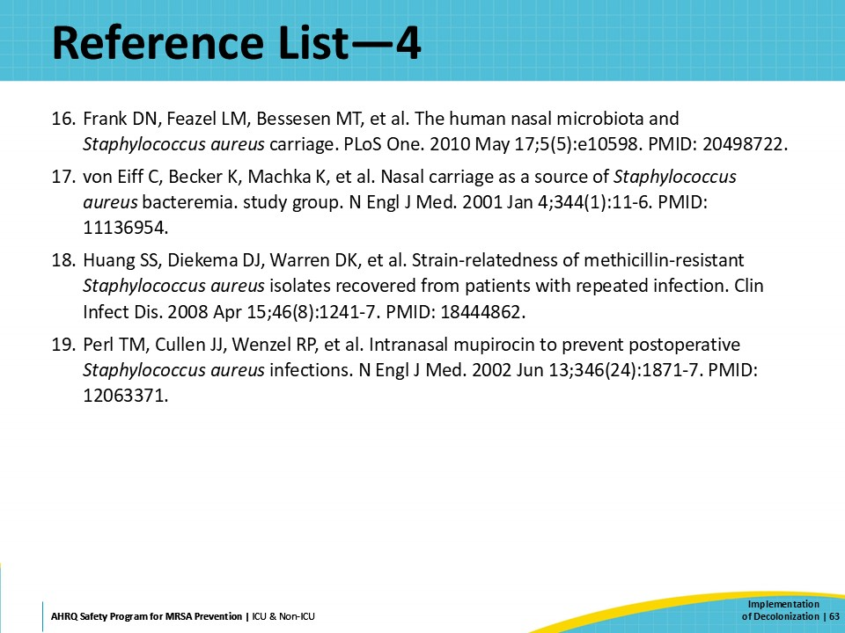

AHRQ Pub. No. 25-0007
October 2024

