## Chlorhexidine gluconate (CHG) is the bath, not a top coat.1,2

* CHG is the bath itself. Do not bathe the patient with regular soap and water and then follow up with CHG.
* CHG is better than regular soap and water and binds to skin proteins, killing germs for 24 hours.

## Ensure cleaning of the face and hair.3

* CHG is safe to use on the face and hair.
* Avoid the eyes and the inside of the ears.
* If using a non-CHG shampoo, keep the shampoo off the rest of the body. Shampoo will inactivate CHG’s effect.

## Be attentive to commonly missed areas when cleaning.1

* Remember to thoroughly clean high-risk areas, including:
  + Neck and shoulders
  + Between skin folds
  + Back of knees
  + Between fingers

## Clean wounds, pressure injuries, and rashes.3,4

* CHG is safe to use on friable skin, abrasions, superficial burns, superficial pressure injuries, and wounds that are not packed or deep.
* Wound care nurses who are comfortable with the use of CHG on wounds can provide support to other staff.

## Clean all medical devices.3,5

* CHG is safe to use on medical devices, including central lines, drains, tubes, and catheters.
* Clean the skin around each device and 6 inches of the device closest to the body.
* CHG can be applied over semipermeable and occlusive dressings, including vacuum-assisted closures and drains.
* For permeable dressings (e.g., gauze), use CHG up to the edge of the dressing, but not on its surface.

## Allow CHG to dry.1

* Do not wipe off CHG or towel dry after application.
* After application, allow skin folds to dry to prevent moisture retention.

## Apply CHG closest to the skin.2

* Apply CHG before applying any other lotions, creams, or skin products.
* Use only lotions, creams, and skin products that are CHG-compatible.

## Ensure correct application of CHG.6,7

* 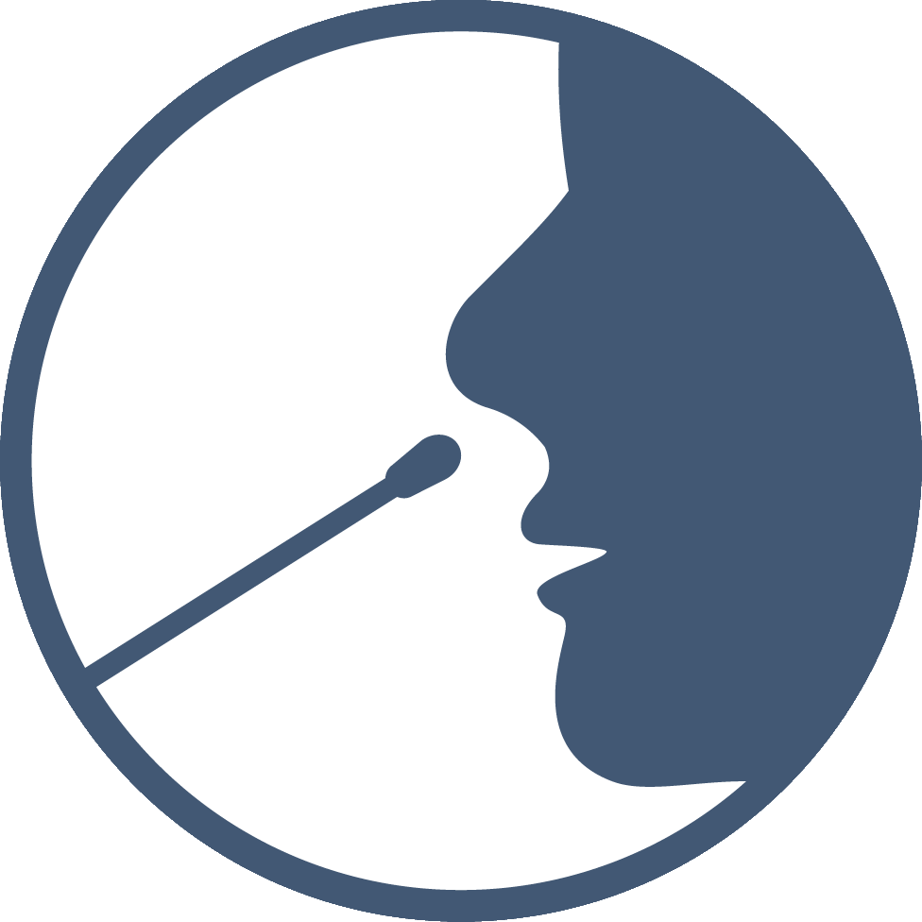Incorrect bathing with CHG will reduce or inactivate its effectiveness.
* Promote training to ensure that staff will use CHG correctly.

## Incorporate nasal decolonization.8

* The nose is the most common place for methicillin-resistant *Staphylococcus aureus* (MRSA).
* Nasal decolonization is a safe, easy, effective, and critical method of MRSA prevention.

## Try, try again.5

* Patients can refuse bathing. Re-approach and ask again at a later time.
* The main reason for refusal is patients not understanding the purpose or importance of decolonization.
* Consider creating a plan with staff to address and re-approach patients.

# References

1. Appendix E. Training and Educational Materials (continued). Content last reviewed September 2013. Agency for Healthcare Research and Quality, Rockville, MD. <https://www.ahrq.gov/hai/universal-icu-decolonization/universal-icu-ape3.html>. Accessed June 14, 2024.
2. UCI Health. SHIELD: Eliminating multidrug-resistant organisms. Hospital Decolonization Toolkit. Step 3: Products and Protocols. 2. CHG Compatibility. <https://www.ucihealth.org/-/media/files/pdf/shield/hospital/hospital-step-3-chg-compatibility-doc.doc>. Accessed June 14, 2024.
3. UCI Health. SHIELD: Eliminating multidrug-resistant organisms. Hospital Decolonization Toolkit. Step 4: Staff Education and Training. 13. FAQ: Do and Don’t.  <https://www.ucihealth.org/-/media/files/pdf/shield/hospital/hospital-step-4-faq-dos-and-donts-doc.docx>. Accessed June 14, 2024.
4. UCI Health. SHIELD: Eliminating multidrug-resistant organisms. Hospital Decolonization Toolkit. Step 4: Staff Education and Training. 12. FAQ: Wound Care. <https://www.ucihealth.org/-/media/files/pdf/shield/hospital/hospital-step-4-faq-wound-care-doc.docx>. Accessed June 14, 2024.
5. UCI Health. SHIELD: Eliminating multidrug-resistant organisms. Hospital Decolonization Toolkit. Step 4: Staff Education and Training. 11. FAQ:CHG For Bathing.  <https://www.ucihealth.org/-/media/files/pdf/shield/hospital/hospital-step-4-faq-chg-for-bathing-doc.doc>. Accessed June 14, 2024.
6. Popovich KJ, Hota B, Hayes R, et al. Daily skin cleansing with chlorhexidine did not reduce the rate of central-line associated bloodstream infection in a surgical intensive care unit. Intensive Care Med. 2010 May;36(5):854-8. PMID: 20213074.
7. Supple L, Kumaraswami M, Kundrapu S, et al. Chlorhexidine only works if applied correctly: use of a simple colorimetric assay to provide monitoring and feedback on effectiveness of chlorhexidine application. Infect Control Hosp Epidemiol. 2015 Sep;36(9):1095-7. PMID: 26074153.
8. van Rijen M, Bonten M, Wenzel R, et al. Mupirocin ointment for preventing *Staphylococcus aureus* infections in nasal carriers. Cochrane Database Syst Rev. 2008 Oct 8;(4):CD006216. PMID: 18843708.​

AHRQ Pub. No. 25-0007

October 2024