Action Chart for
Implementing Decolonization
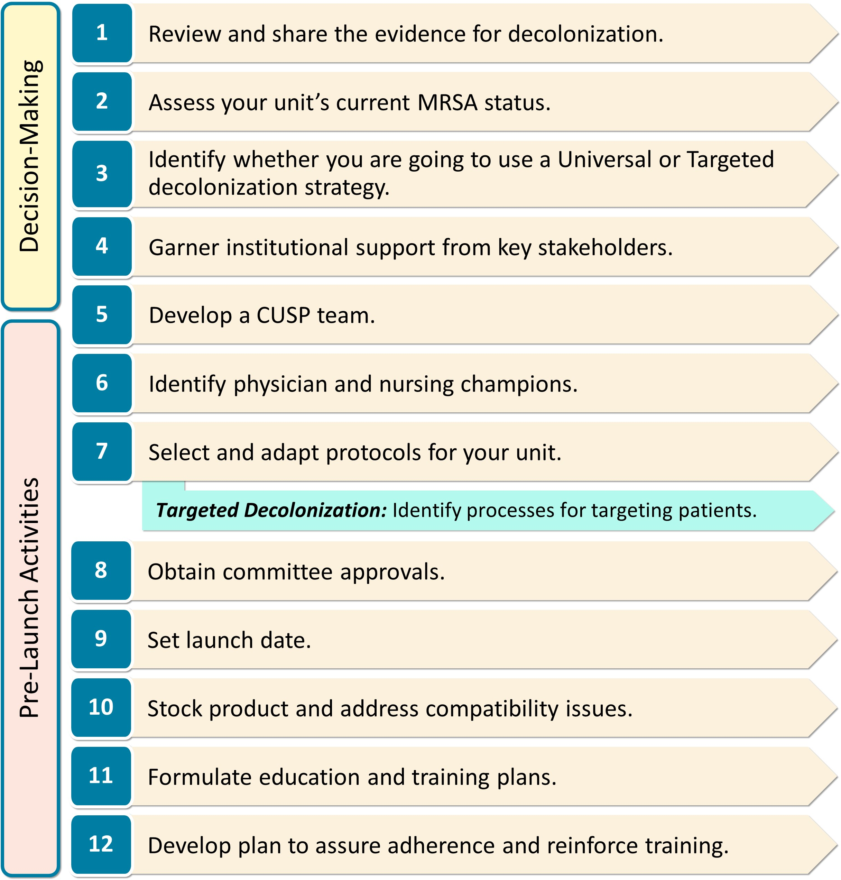
Adapted from “Universal ICU Decolonization: An Enhanced Protocol”  https://www.ahrq.gov/hai/universal-icu-decolonization/index.html | and | “Toolkit for Decolonization of Non-ICU Patients With Devices”  https://www.ahrq.gov/hai/tools/abate/index.html

