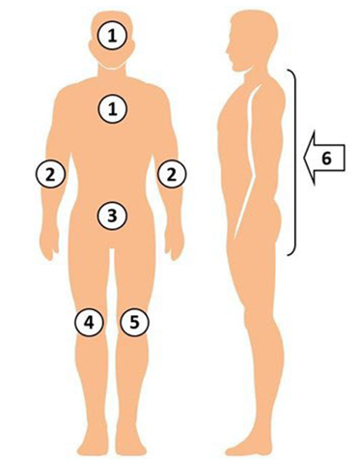Nursing Decolonization Protocol: Bed Bathing With 2% Chlorhexidine Gluconate (CHG) Pre-Impregnated Cloths

The following protocol details the process for performing skin decolonization using impregnated 2% chlorhexidine gluconate (CHG) cloths.

## Protocol Overview

* Daily CHG bathing for duration of unit stay.
* Initiate the protocol each time an eligible patient is admitted to the unit, even if the patient has received the protocol in a prior unit admission or earlier in the hospital stay.
* For each adult patient, each day—
  + Bathe patient with CHG daily, starting on day 1 of admission, for entire unit stay.
  + If patient is readmitted to the unit, restart the protocol.

## What You Will Need

* A 6-pack of 2% no-rinse bathing cloths
  + Additional cloths may be needed in cases of obesity or incontinence.
  + Cloths may come as a bundled set of three two-cloth packets. Consider storing single two-cloth packets separately in the cloth warmer in case extra cloths are needed.

## Chlorhexidine (CHG) 2% Bathing Cloths – Key Points

* You may use an approved warmer to warm up the cloths.
  + Warming is for patient comfort; it is not required. Cold cloths are active and can be used if cool cloths are desired.
* Always don gloves before bathing the patient.
* Apply CHG cloths to skin with a firm massage.
* Clean neck well even if it is not visibly soiled.
  + The neck area commonly accumulates debris and moisture.
* Avoid getting CHG in the eyes or into ear canals.*
* CHG replaces routine bathing:
  + Do NOT bathe with other soaps while using CHG.
  + Use CHG as a shampoo. Many shampoos and soaps will inactivate CHG.
  + Use CHG cloths after incontinence clean up.
* Do NOT rinse, wipe off, or dry with another cloth. Let air dry.
* CHG cloths have built-in moisturizers. Skin may feel sticky for a few minutes.
* If additional moisturizer is needed, use only CHG-compatible products.
* Certain lotions will inactivate CHG; check with manufacturer for compatibility.
* Dispose of leftover cloths.
* Do NOT save, reheat, or reuse opened packets of cloths.

## Chlorhexidine (CHG) 2% Bathing Process

1. Use the six cloths for bathing all body areas:

* **Cloth 1:** Face,* neck, and chest.   
  Avoid getting CHG into eyes or ear canals.
* **Cloth 2:** Both shoulders, arms, hands, between fingers, and then axilla.
* **Cloth 3:** Abdomen first, *then* groin/perineum.
* **Cloth 4:** Right leg, foot, and between toes.
* **Cloth 5:** Left leg, foot, and between toes.
* **Cloth 6:** Back of neck, back, and *then* buttocks.

1. Use additional CHG bathing cloths, if necessary, to thoroughly cleanse the body.
2. After application to each body site, clean at least 6 inches closest to the body of ALL lines, drains, and tubing (e.g., central lines, midline catheters, chest tubes, surgical drains, G-tube/J-tube, urinary catheter, rectal tube).
   * Use a new clean cloth or a clean portion of a cloth to clean lines and tubing.
3. 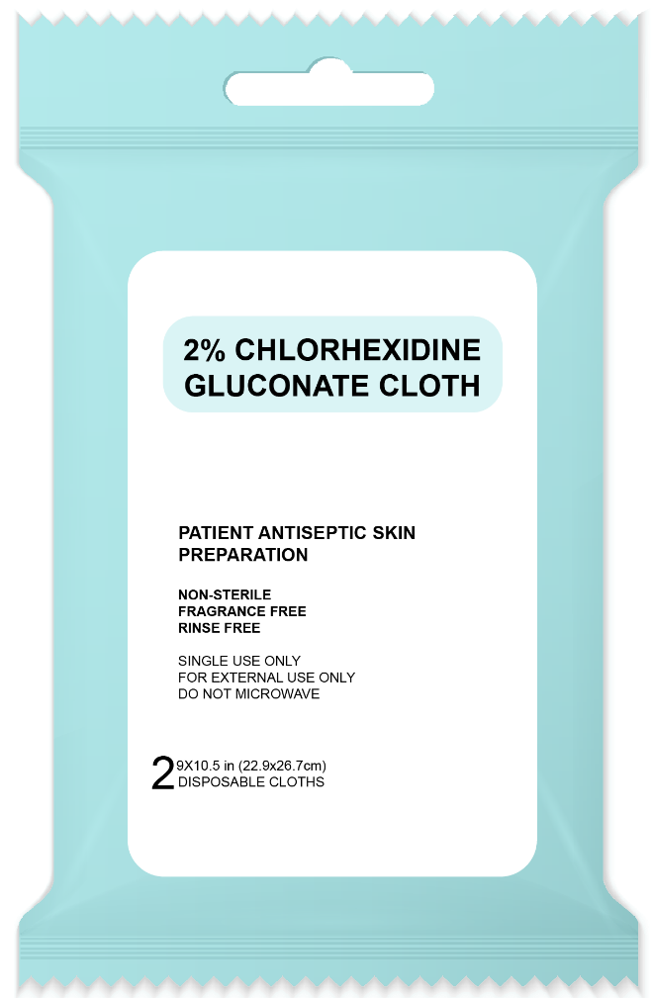Ensure thorough cleaning, with special attention to commonly soiled areas such as the neck, skin folds, and perineal areas. CHG is safe to use on perineal areas, including external mucosa.
4. Ensure that CHG is applied to skin by firm massage to ensure the binding of CHG to skin proteins. This allows CHG to continue to kill germs for up to 24 hours.
5. CHG is also safe for superficial wounds, including stage 1 and stage 2 pressure injuries.
6. Pay special attention to cleaning skin areas surrounding lines and other devices to ensure removal of bacteria from skin. CHG is safe on devices and can be used over semi-occlusive and occlusive dressings.
7. Skin may feel sticky for a few minutes after application.
8. Do not rinse with water or wipe off. Allow to dry naturally.
9. Dispose of CHG cloths in the trash. Do not flush.
10. CHG cloths have moisturizers. If additional moisturizer or lotion is needed, only use products that are known to be compatible with chlorhexidine. CHG compatibility should be assessed by the product's manufacturer.
11. Do not place CHG cloths directly onto bedding because CHG can interact with bleach to cause brown stains during the laundering process.
12. If incontinence occurs, or if there are other secretions on the skin, remove soilage with disposable wipes or towels. Rinse or wipe the affected area with water. Then, clean skin with CHG bathing cloths.
    * If needed, use CHG-compatible barrier protection products for barrier protection (contact product manufacturers to confirm CHG compatibility).

_________________________________________

*CHG has been safely used on the face and hair in several large studies and clinical trials. Pay special attention to avoid getting CHG into the eyes or into the ear canals, as should be avoided with all soaps. The risk associated with having CHG in the ear canals is that if a patient has a perforated ear drum, CHG could come in direct contact with deep nerves of the ear. If CHG comes in contact with the eye itself, flush well with water or saline. Use of CHG on the skin over and around the eyes during face washing or on the external ear is safe as long as CHG does not get into the eyes or into the ear canals.

## Graphic states: Dispose of each washcloth in the trash. Do NOT flush washcloths in the toilet.CHG Bathing Process – Cleaning Up

AHRQ Pub. No. 25-0007

October 2024

**Adapted from** “Universal ICU Decolonization: An Enhanced Protocol”:

[*https://www.ahrq.gov/hai/universal-icu-decolonization/index.html*](https://www.ahrq.gov/hai/universal-icu-decolonization/index.html)

and

“Toolkit for Decolonization of Non-ICU Patients With Devices”:

[*https://www.ahrq.gov/hai/tools/abate/index.html*](https://www.ahrq.gov/hai/tools/abate/index.html)