Nursing Decolonization Protocol:   
Basin Bed Bathing With 4% Chlorhexidine Gluconate Liquid (Diluted to 2%)

The following protocol details the process for performing skin decolonization with chlorhexidine (CHG) liquid diluted in a basin.

## Protocol Overview

* Daily CHG bathing for duration of unit stay.
* Initiate the protocol each time an eligible patient is admitted to the unit, even if the patient has received the protocol in a prior unit admission or earlier in the hospital stay.
* For each adult patient, each day:
* Bathe patient with CHG daily, starting on day 1 of admission, for entire unit stay.
* If patient is readmitted to the unit, restart the protocol.

## What You Will Need:

* 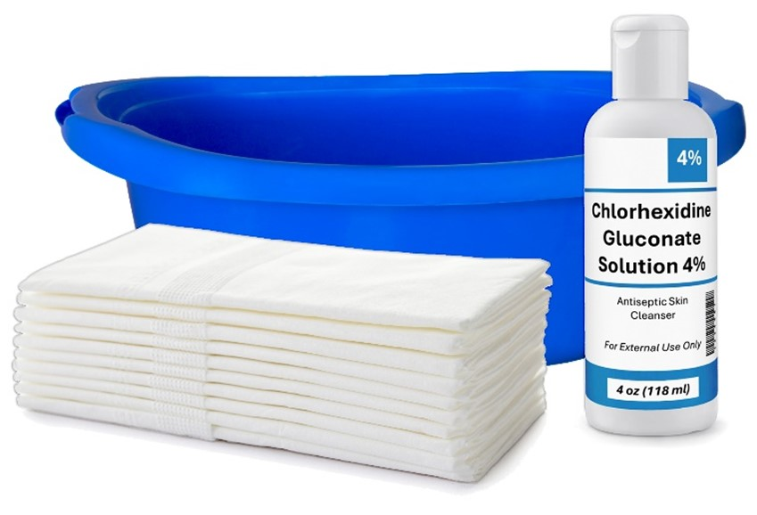4% liquid CHG, to be diluted to 2%   
  (dilution instructions below)
* Bath basin
* Six disposable non-cotton wipes   
  (more if needed for lines, tubes, drains, or larger patients)

## Chlorhexidine Gluconate (CHG) 2% Bathing – Key Points

* Always don gloves before bathing the patient.
* Apply CHG to skin with a firm massage.
* Clean neck well even if it is not visibly soiled.
  + The neck commonly accumulates debris and moisture.
* Avoid getting CHG in the eyes or into ear canals.*
* CHG replaces routine bathing:
  + Do NOT bathe with other soaps while using CHG.
  + Use CHG as a shampoo. Many shampoos and soaps will inactivate CHG.
  + Use CHG after incontinence clean up.
* Do NOT rinse, wipe off, or dry with another cloth. Let air dry.
* If moisturizer or other skin products are needed, use only CHG-compatible products.
* Certain lotions will inactivate CHG; make sure to check with manufacturer for compatibility.

## No-Rinse Bed Bath With 2% CHG Bathing Process

1. You will need to dilute the 4% liquid CHG. Obtain a bath basin and dispense the contents of the 4% CHG bottle into the basin.
2. Fill the same bottle with water and pour it into the same basin. Do not dilute more than an equal part of water to CHG. The goal is to achieve 2% CHG (Figure 1).
3. Bring basin to bedside.
4. Soak disposable wipes in basin. Wring each disposable wipe prior to application.
   * Only use each disposable wipe once. DO NOT place the used wipe back in basin to rinse and apply again.

A step-by-step diagram of the CHG basin bathing procedure.
Step 1: Empty one 4-ounce bottle of 4 percent CHG into a basin.
Step 2: Fill one 4-ounce bottle with water only once. Do not add any more water!
Step 3: Empty the 4 ounces of water into the basin. The goal is to reach a one-to-one ratio of CHG and water.
Remember, do NOT add extra water.

1. 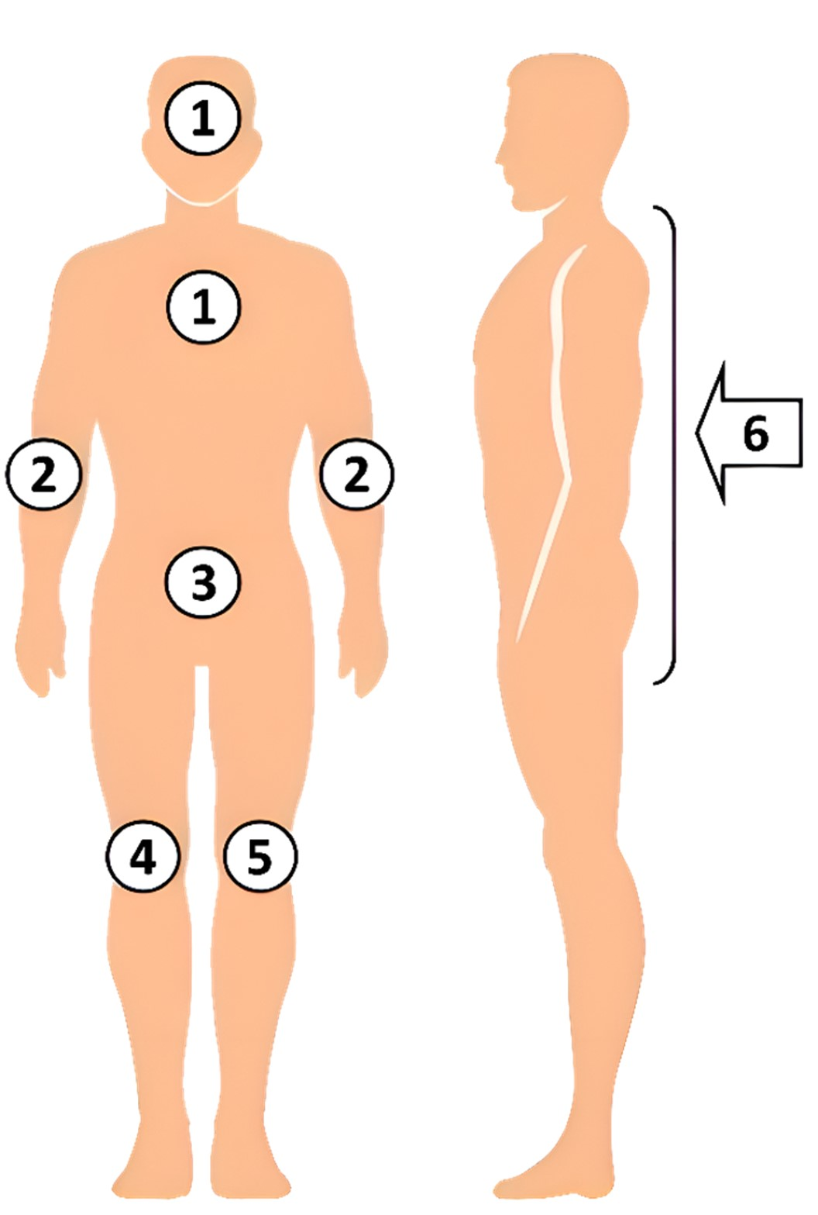Use the six wipes for bathing all body areas:

* **Cloth 1:** Face*, neck, and chest.   
  Avoid getting CHG into eyes or ear canals.
* **Cloth 2:** Both shoulders, arms, hands, between fingers, and then axilla.
* **Cloth 3:** Abdomen first, *then* groin/perineum.
* **Cloth 4:** Right leg, foot, and between toes.
* **Cloth 5:** Left leg, foot, and between toes.
* **Cloth 6:** Back of neck, back, and *then* buttocks.

1. Use additional CHG soaked cloths, if necessary, to thoroughly clean the body.
2. After application to all body sites, clean at least 6 inches nearest to the body of ALL lines, drain, and tubing (e.g. central lines, midline catheters, Foleys, drains, G-tube/J-tubes, rectal tubes, chest tubes urinal catheters).
3. Use a new cloth or a clean portion of a cloth to clean lines and tubing.
4. Ensure thorough cleaning, with special attention to commonly soiled areas such as the neck, skin folds, and perineal areas. CHG is safe to use on perineal areas, including external mucosa.
5. Ensure that CHG is applied to skin by firm massage to ensure the binding of CHG to skin proteins. This allows CHG to continue to kill germs for up to 24 hours.
6. CHG is also safe for superficial wounds, including stage 1 and stage 2 pressure injuries.
7. Pay special attention to cleaning skin areas surrounding lines and other devices to ensure removal of bacteria from skin. CHG is safe on devices and can be used over semi-occlusive and occlusive dressings.
8. Do not rinse with water or wipe off. Allow to dry naturally.
9. If moisturizer or lotion is needed, only use products that are known to be compatible with chlorhexidine. CHG compatibility should be assessed by the product's manufacturer.
10. Do not place CHG-soaked cloths directly onto bedding because CHG can interact with bleach to cause brown stains during the laundering process.
11. Dispose of used cloths in the trash. Do not flush.
12. If incontinence occurs, or if there are other secretions on the skin, remove soilage with disposable wipes or towels. Rinse or wipe the affected area with water. Then, clean skin with CHG.
    * If needed, use CHG-compatible barrier protection products for barrier protection (contact product manufacturers to confirm CHG compatibility).

_________________________________________

*CHG has been safely used on the face and hair in several large studies and clinical trials. Pay special attention to avoid getting CHG into the eyes or into the ear canals, as should be avoided with all soaps. The risk associated with having CHG in the ear canals is that if a patient has a perforated ear drum, this could allow CHG to come in direct contact with deep nerves of the ear. If CHG comes in contact with the eye itself, flush well with water or saline. Use of CHG on the skin over and around the eyes during face washing or on the external ear is safe as long as CHG does not get into the eyes or into the ear canals.

## CHG Bathing Process – Cleaning Up

Icons to indicate the following: Dispose of each washcloth in the trash.
Do not flush washcloths in the toilet.

**Adapted from** “Universal ICU Decolonization: An Enhanced Protocol”:

[*https://www.ahrq.gov/hai/universal-icu-decolonization/index.html*](https://www.ahrq.gov/hai/universal-icu-decolonization/index.html)

and

“Toolkit for Decolonization of Non-ICU Patients With Devices”:

[*https://www.ahrq.gov/hai/tools/abate/index.html*](https://www.ahrq.gov/hai/tools/abate/index.html)

AHRQ Pub. No. 25-0007

October 2024