Nursing Decolonization Protocol: Showering With 4% Chlorhexidine Gluconate (CHG) Liquid Soap

The following protocol details the process for performing skin decolonization with 4% chlorhexidine gluconate (CHG) liquid in the shower.

## Protocol Overview

* Daily CHG showering for all adult patients for the duration of the hospital stay.
* Exclude:Patients who are incapable of showering or patients with known allergies to CHG
* Initiate the protocol each time an eligible patient is admitted to the unit, even if the patient has received the protocol in a prior unit admission or earlier in the hospital stay.
* For each adult patient, each day—
* Have the patient shower with CHG daily, starting on day 1 of admission, for entire unit stay.
* If patient is readmitted to the unit, restart the protocol.

## What You Will Need

* 4 oz bottle of 4% liquid CHG
* Mesh sponge or non-cotton cloths
* Patient instruction infosheet for showering with CHG

## Chlorhexidine (CHG) Showering – Key Points

* It is key to demonstrate and explain how to use the CHG correctly.
  + Verbal instruction must be provided along with the instructions sheet!
* The patient must apply CHG to their skin with a firm massage.
* Remind the patient to avoid getting CHG in their eyes or ear canals.*
* Patient should be advised to clean from their head on down and wash their groin and buttocks last.
  + The general guideline is to apply CHG from the cleanest to the dirtiest areas.
* Make sure patient understands that they need to allow the CHG to dry on their skin for at least 2 minutes before rinsing it off.
* Ensure the patient understands that they should not use any non-CHG soap during their stay.
* CHG replaces routine bathing while the patient is in the unit.
  + Patient should NOT bathe with other soaps while using CHG.
  + CHG should be used as a shampoo. Many shampoos and soaps will inactivate CHG.
  + CHG should be used after incontinence clean up.
* If moisturizer or lotion is needed, only use products that are known to be compatible with chlorhexidine. CHG compatibility should be assessed by the product's manufacturer.

## Protocol for Showering With 4% Liquid Chlorhexidine

* 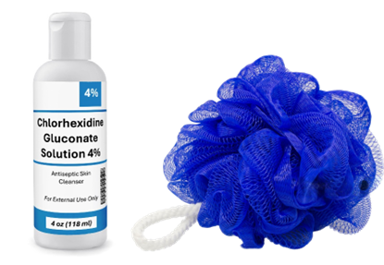Provide patient instruction sheet on CHG showeringto read prior to beginning shower.
  + Patients will be more likely to read the instructions when they are given time to do so.
* Wrap all devices as needed, to protect from water in the shower.
* Provide patient with a single-use rinse-off **4 oz 4% CHG bottle** for each shower.
  + This bottle should not be diluted when used in a shower.
* Provide patient with **a mesh sponge or non-cotton cloths**, which allow CHG to lather well, aiding application to the skin.
  + Do not use cotton cloths. Cotton binds CHG and does not release CHG well onto the skin. In addition, CHG can interact with bleach during the laundering process and cause brown stains.
* Provide the patient with the following verbal shower instructions:

1. Clean face with a small amount of CHG, avoiding getting into eyes or ear canals. Rinse well.
2. Wet skin with water. Turn off water or stand out of water stream.
3. Pour 4% CHG onto wet sponge or cloth and rub sponge until it is foamy.
4. Firmly massage soapy sponge all over skin in the order indicated on the diagram.
   * Reapply CHG generously to keep sponge or cloth full of foamy lather.
5. 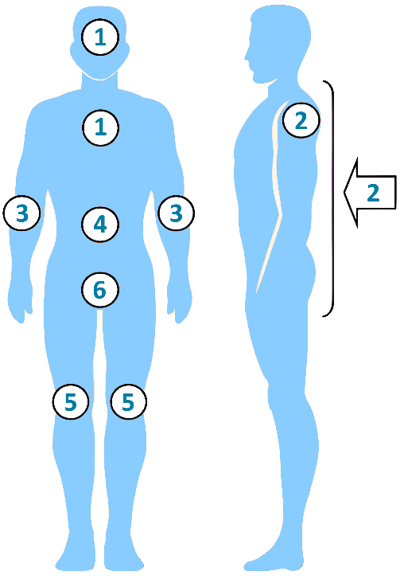Clean from the top down (cleanest to dirtiest areas).
6. Face, neck, and chest, including under breasts for women
7. Shoulders and back
8. Arms, hands, between fingers, then armpits
9. Abdomen and hips
10. Both legs, feet, and between toes
11. Groin, perineum (genitals), and buttocks last
12. **For best results, leave soapy lather on skin for 2 minutes before rinsing.**
13. Staff may need to help the patient wash areas that they cannot reach.
14. After the shower, unwrap devices. Use a single packet of two 2% CHG cloths to clean the 6 inches of ALL lines, drains, and tubing (e.g., central lines, midline catheters, chest tubes, surgical drains, G-tube/J-tube, urinary catheter, rectal tube) that are closest to the body.
15. Wipe over semi-occlusive and occlusive dressings. This will help remove bacteria close to where devices penetrate the skin.
    * CHG is safe on devices and should be used over semi-occlusive and occlusive dressings.
    * **If a patient asks to use their own personal shampoo or face products:**

* Encourage them to use CHG for all uses, including hair, face, and body.
  + 1. If they insist on using personal shampoo or face products, instruct them to use their personal products first, **BEFORE** the CHG, with a separate washcloth. Rinse well and try to keep soap/shampoo off the rest of the body.

_________________________________________

*CHG has been safely used on the face and hair in several large studies and clinical trials. Care should be taken to avoid getting CHG into the eyes or into the ear canals, as should be avoided with all soaps. The risk associated with having CHG in the ear canals is that if a patient has a perforated ear drum, this could allow CHG to come in direct contact with deep nerves of the ear. If CHG comes in contact with the eye itself, flush well with water or saline. Use of CHG on the skin over and around the eyes during face washing or on the external ear is safe as long as CHG does not get into the eyes or into the ear canals.

**Adapted from** “Universal ICU Decolonization: An Enhanced Protocol”:

[*https://www.ahrq.gov/hai/universal-icu-decolonization/index.html*](https://www.ahrq.gov/hai/universal-icu-decolonization/index.html)

and

“Toolkit for Decolonization of Non-ICU Patients With Devices”:

[*https://www.ahrq.gov/hai/tools/abate/index.html*](https://www.ahrq.gov/hai/tools/abate/index.html)

AHRQ Pub. No. 25-0007

October 2024