Protect yourself during your stay. Use chlorhexidine gluconate (CHG) every day to reduce the risk of infection.

|  |  |
| --- | --- |
|  | Face, neck, & chest  **Avoid eyes and ears.** |
|  | Shoulders & back |
|  | Arms, hands, fingers, ***then*** armpits |
|  | Abdomen & hips |
|  | Both legs, feet, & toes |
|  | Groin & buttocks ***last*** |

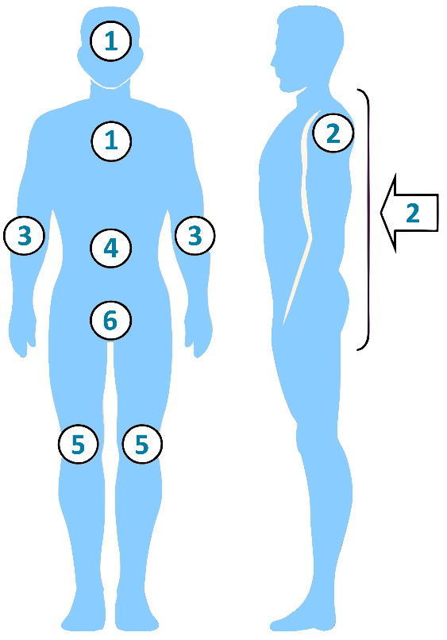

**How To Wash With CHG**

**Important: Do not get CHG in your eyes or ears.**

* Clean your face with a small amount of CHG, being careful not to get it into your eyes or ears. Rinse well.
* Wet your skin with water. Then turn the water off.
* Rub the CHG firmly on your skin to get a deep clean.
* Clean from the top down, from head to toe, using the diagram on the right as a guide.
* Save the groin area and buttocks for last.
* **Leave the CHG on your skin for 2 minutes.**
* Turn the water back on and rinse thoroughly.

|  |  |
| --- | --- |
| **Adapted from** “Universal ICU Decolonization: An Enhanced Protocol”  [*https://www.ahrq.gov/hai/universal-icu-decolonization/index.html*](https://www.ahrq.gov/hai/universal-icu-decolonization/index.html) | “Toolkit for Decolonization of Non-ICU Patients With Devices”  [*https://www.ahrq.gov/hai/tools/abate/index.html*](https://www.ahrq.gov/hai/tools/abate/index.html) |

***Make sure you get all of these areas!***

* Around your neck
* In your armpits and groin
* Between fingers & toes
* Between and under all skin folds
* Skin areas around all lines, tubes, and drains

Your nurse can help with hard-to-reach areas.

**Key Points and Reminders**

* You also need to clean any lines, drains, and tubes you may have. A nurse can help you with this.
* If using your own shampoo or face soap, **use it BEFORE the CHG.** Thoroughly rinse off any shampoo or face soap before applying CHG.
* Do not use a different shampoo or face soap **AFTER you use the CHG.** It can prevent the CHG from working.
* **Do not apply any skin or hair products afterward,** except those approved by your nurses and doctors.