Protect yourself during your stay. Use chlorhexidine gluconate (CHG) every day to reduce the risk of infection.

**How To Wash With CHG**

**Important: Do not get CHG in your eyes or ears.**

* Rub the CHG firmly on your skin to get a deep clean.
* Apply the CHG, following the body diagram on the right.
* **Leave the CHG on your skin to dry.**
* **Do not rinse it off!** Let it dry naturally.

|  |  |
| --- | --- |
|  | Face, neck, & chest  **Avoid eyes and ears.** |
|  | Shoulders, arms, hands, fingers, ***then*** armpits |
|  | Abdomen, ***then*** groin |
|  | Right leg, foot, & toes |
|  | Left leg, foot, & toes |
|  | Back, ***then*** buttocks last |

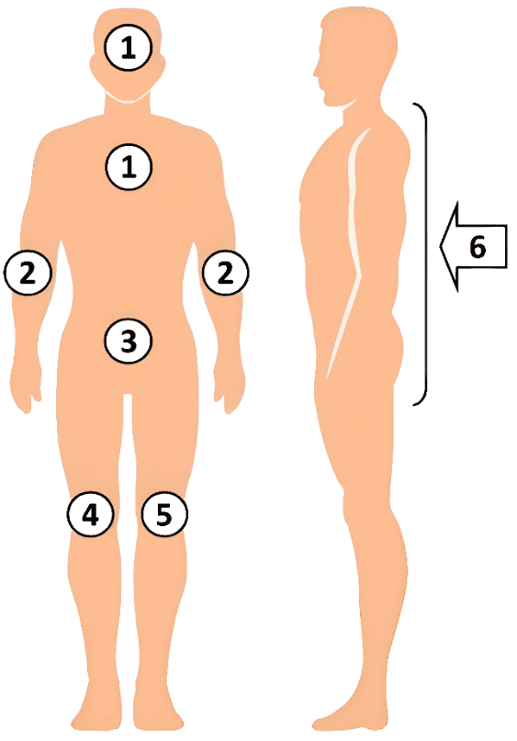

***Make sure you get all of these areas!***

* Around your neck
* In your armpits and groin
* Between fingers & toes
* Between and under all skin folds
* Skin areas around all lines, tubes, and drains

Your nurse can help with hard-to-reach areas.

|  |  |
| --- | --- |
| **Adapted from** “Universal ICU Decolonization: An Enhanced Protocol”  [*https://www.ahrq.gov/hai/universal-icu-decolonization/index.html*](https://www.ahrq.gov/hai/universal-icu-decolonization/index.html) | “Toolkit for Decolonization of Non-ICU Patients With Devices”  [*https://www.ahrq.gov/hai/tools/abate/index.html*](https://www.ahrq.gov/hai/tools/abate/index.html) |



**Key Points and Reminders**

* **Use all 6 cloths that you are given.** Ask for more cloths if you need them.
* Do not flush used cloths in the toilet— – they will clog!
* **Your skin might feel sticky for a few minutes.** The stickiness will go away when the skin completely dries.
* You also need to clean any lines, drains, and tubes you may have. The nurses can help with this.
* Avoid using any other soaps or shampoo.They can prevent the CHG from working.
* **Do not apply any skin or hair products afterward,** except those approved by your nurses and doctors.
* **Do not flush the cloths. Throw them away.**

AHRQ Pub. No. 25-0007

October 2024