Why Choose a CUSP Approach?
ICU & Non-ICU
Slide Title and Commentary | Slide Number and Slide
Why Choose a CUSP Approach?  SAY:  Welcome to this presentation on the topic of “Why Choose a CUSP Approach?” The term CUSP is short for “the Comprehensive Unit-based Safety Program.” This presentation will discuss how choosing a CUSP approach helps when addressing patient safety issues and sources of preventable harm – such as the prevention of methicillin-resistant Staphylococcus aureus (MRSA). | Slide 1  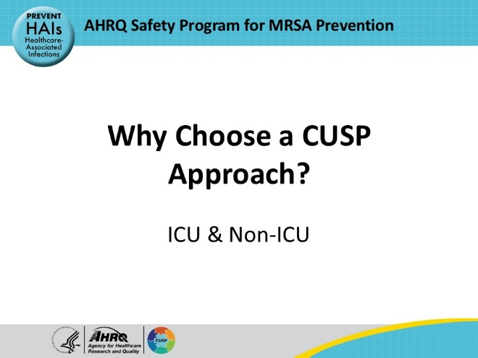
Educational Objectives  SAY:  This presentation will describe the CUSP model, explain the cultural influence that CUSP can have on safety and teamwork, and define the core roles that compose a successful CUSP team. | Slide 2  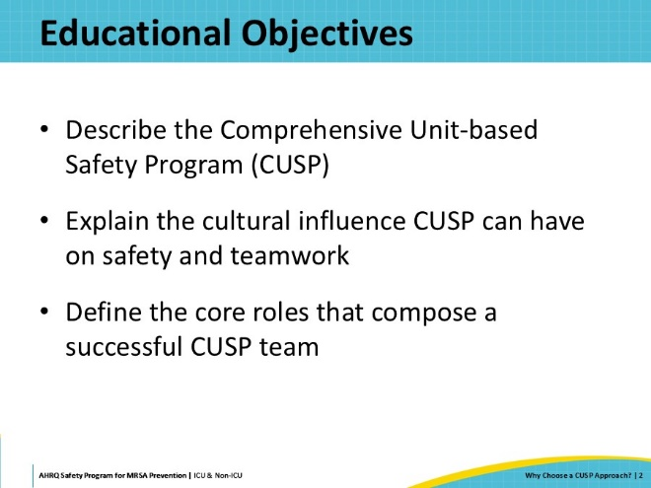
CUSP Model  SAY:  The CUSP model has been successfully used in patient safety and quality programs since 2002. As a result of its productive, engaging, and empowering nature, CUSP has been used in many healthcare settings to improve both patient safety and quality of care. CUSP emphasizes interdisciplinary cooperation, instilling safety culture, and fostering collaboration and accountability.  For organizations that do not already have CUSP teams, this presentation shares some key facets of the model so that CUSP can at least be mimicked or can be incorporated into the quality improvement team the hospital is using. AHRQ also has a wealth of resources to support CUSP development available for public use on the AHRQ website.  Links to some of these resources and tools will be provided on the next slide. | Slide 3  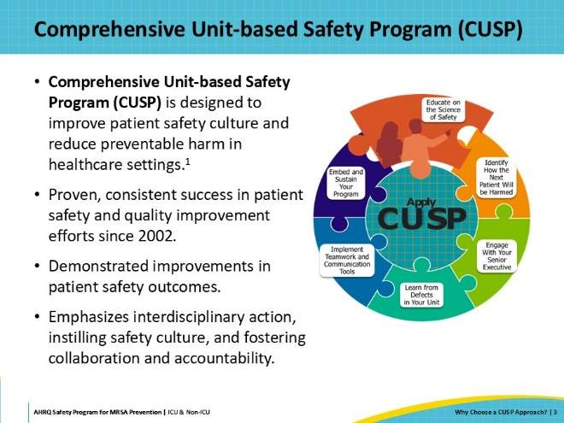
CUSP Resources  SAY:  The Toolkit for MRSA Prevention offers a brief introduction to applying the CUSP approach, with more comprehensive resources available on the AHRQ CUSP Core Toolkit on the AHRQ website.  Certain CUSP tools have been identified and adapted for use as part of this toolkit on MRSA prevention. These include:  - MRSA Prevention Team Checkup Tool: This questionnaire collects information on the unit’s current status in relation to MRSA prevention best practices. It is intended to be used at regular intervals (monthly is recommended) to track progress.  - CUSP Roles and Responsibilities Tool: This tool is intended to help in the process of putting together a CUSP team. It identifies the different roles and their responsibilities and expectations, as well as questions for self-assessment for each role.  - Staff Safety Assessment: The purpose of this tool is to survey staff and gather staff insights on potential safety issues and areas for improvement in their work environment. This tool helps identify potential defects.  - Learning From Defects (LFD) Tool: This tool provides a structured walkthrough of the CUSP Learning From Defects process of identifying defects, contributing factors, and strategies for improvement and sustainment.  - LFD Investigating a Defect Worksheet: This worksheet is intended to be used along with the Learning From Defects process. | Slide 4  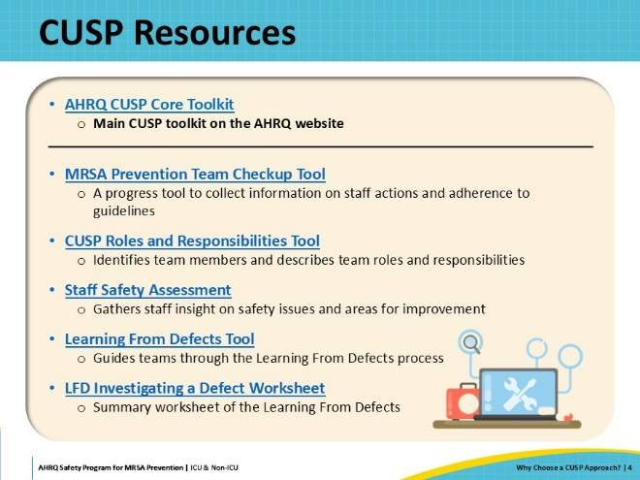
Background  SAY:  One of the basic principles of CUSP is acknowledgement that healthcare can be complicated, and sometimes unsafe. CUSP was originally developed as a method for multidisciplinary teams to identify safety issues—also known as “defects.” In CUSP, a “defect” is defined as “any clinical or operational event or situation that you do not want to have happen again.”  In 1999, the Institute of Medicine (IOM) published a report called “To Err Is Human.” The report recognized patient safety as a critical nationwide problem. Inspired by these findings, and in an effort to improve patient safety, the first CUSP teams were formed at Johns Hopkins Hospital. These teams established key concepts and tools that led to significant improvement in patient safety. At its core, CUSP fosters a culture to engage and empower frontline staff to lead safety efforts with the active support of leadership. | Slide 5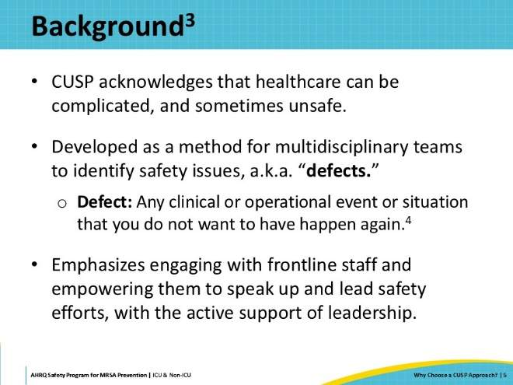
How Can Healthcare Be Unsafe?  SAY:  Healthcare is a complex environment, regardless of setting. Layers of systems contribute to the safety of every patient. These layers include microsystems of various people, technology, equipment, and policies, just to name a few. Often healthcare runs on budgetary restraints. Therefore, with all these moving parts, even the best of systems can fail. None of them are perfect, and all of them rely on people.  Humans are also not perfect. Healthcare personnel specifically face long hours and strenuous working conditions with a hefty responsibility of caring for other humans. Therefore, failure is a risk and can have high stakes connected to it.  Successes and failures are outcomes dependent on the design of the systems. Every system is only as good as its parts; if there are errors at any point along the way, the system is not designed for success and will inevitably fail. In order to reduce patient safety events and improve healthcare, deficiencies in individual parts of the system must be addressed, because every system is perfectly designed to achieve the results it gets. | Slide 6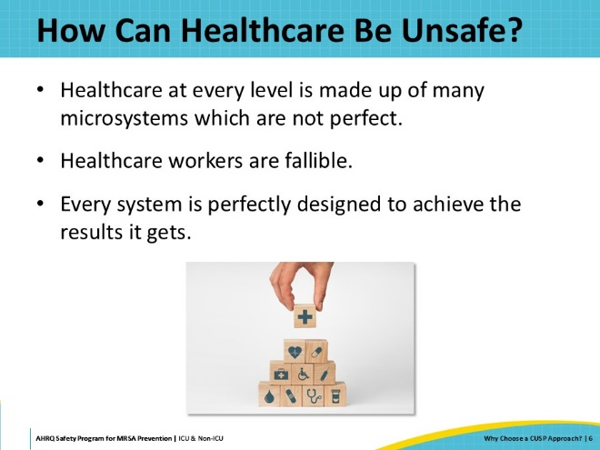
CUSP  SAY:  So, what is CUSP? CUSP stands for the Comprehensive Unit-Based Safety Program.  A CUSP team is intended to include all disciplines to be sure that all aspects of the system are represented. The wider the variety of members, the deeper the breadth of knowledge. In this way, the team is comprehensive.  There are designated staff who lead CUSP teams towards success, and part of their leadership includes engaging the local unit. Within your organization, there may be a different core CUSP team for each specialty. For example, the core members of an ICU CUSP team might be different than the core members of a psych unit CUSP team. Together, these members work to address CUSP with respect to the culture and operations of their local work setting. This means focusing on safety issues that are relevant to the patients who receive care as well as to the staff who work there. In this way, it is a unit-based team, focusing on specific safety concerns.  The work of one CUSP team has the capacity to improve other processes throughout your organization, even in different practices. And, unlike other quality improvement programs, CUSP is not a committee exclusive to only certain members of staff. Anyone who wants to be involved in a CUSP team, can be. Since its origin at Johns Hopkins, CUSP has evolved into an official program that includes guides and roadmaps for addressing many issues. The CUSP team is designed to support an evidence-based methodology to address any issues that may arise in local practices. | Slide 7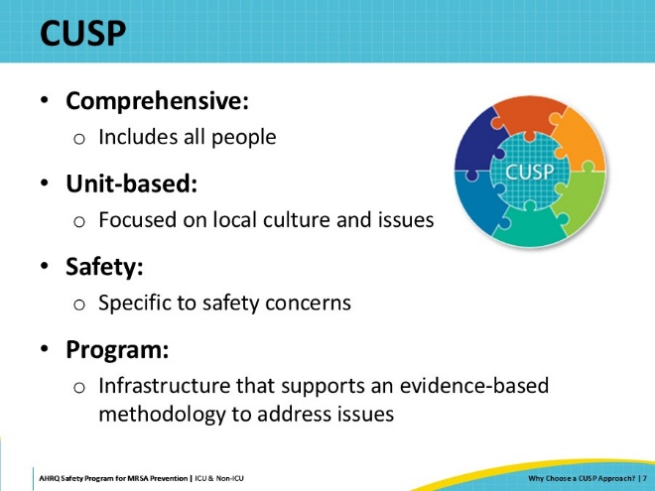
The Goal of CUSP  SAY:  CUSP is not a top-down approach to uncovering issues or creating and implementing interventions to mitigate issues. CUSP is a partnership that is led by frontline experts and supported by leadership. CUSP enables teams and frontline staff to own safety and quality in a way that values their input, engages their expertise, and creates innovations that improve their local work setting. This work may also improve the work settings of other similar areas in the facility facing similar issues when the lessons learned are shared. | Slide 8  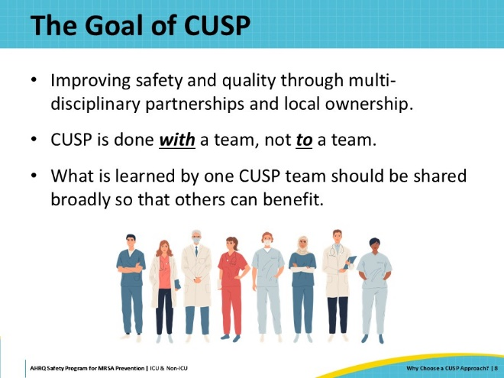
CUSP Vision  SAY:  CUSP aims to eliminate any potential or actual preventable harm. CUSP focuses attention on the system and empowers all healthcare personnel to speak up and address any issue, big or small, in a way that shifts blame from people to the imperfect systems these issues exist in. CUSP challenges teams to create solutions that will improve the system and/or eliminate or minimize the defect. CUSP believes that defects are opportunities for learning, rather than punishment. | Slide 9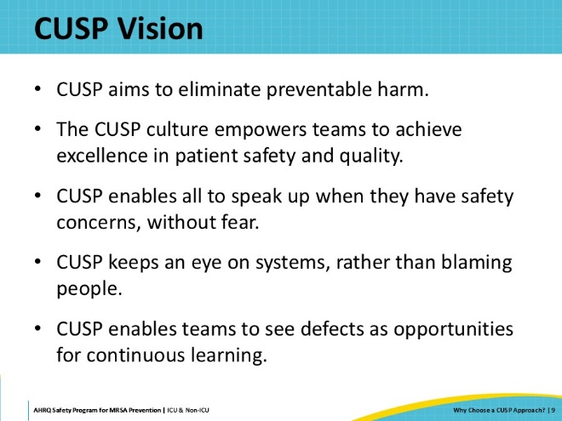
CUSP Promotes a Culture of Safety  SAY:  Creating a climate where staff feel psychologically safe and empowered to have a voice influences the very culture of the work setting. Culture can be described as how we think, feel, and ultimately behave.  While Technical work gives you the what, Adaptive work can give you the how. The technical work of creating interventions and changes to practices, alone, will likely not yield safer results if the adaptive aspects are not included. Change can be difficult. Healthcare providers, just like everyone else, are hesitant to change their way of approaching their work. People are more likely to adapt changes to their practices when there is clear evidence to do so. Adaptive work can help break down these barriers and encourage healthcare providers to work together to find solutions to patient safety problems.  Local safety culture influences the effectiveness of other safety and quality interventions. In other words, teams with better safety culture are more likely to be able to effectively implement evidence-based interventions, including the prevention of MRSA. It is important to note that safety culture is not stagnant—it can be changed. CUSP is one of the best validated approaches to improve local safety culture. | Slide 10  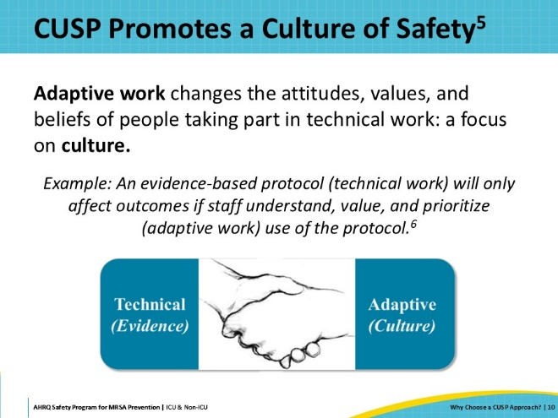
Why Does Culture Matter?  SAY:  Culture matters because it has a direct impact on individuals, teams, and outcomes. If people enjoy coming to work and feel a sense of belonging to a team, they are more likely to make safe choices and demonstrate supportive behaviors. A positive culture of safety can enhance the effectiveness of the CUSP work, just as negative perceptions can sabotage safety and quality. In turn, involving staff in interventions can generate a more positive culture. | Slide 11  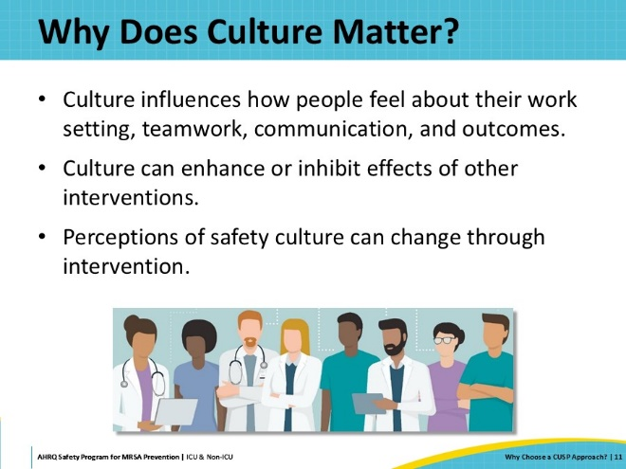
Safety Culture Is Related to Outcomes  SAY:  Since The Joint Commission mandated healthcare organizations to assess safety culture on regular intervals, plenty of evidence has been produced to support the connection between culture and outcomes, both with patients and with healthcare personnel. Improved safety culture has been associated with reduced patient safety issues, such as infection rates and treatment errors. Healthcare personnel also experience reduced incidents and burnout from improved safety culture. | Slide 12  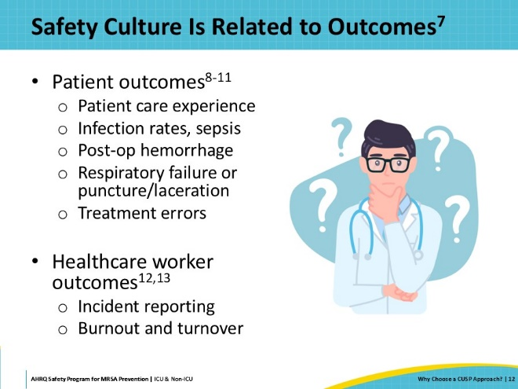
Statewide Michigan CUSP ICU Results  SAY:  In a collaboration with the state of Michigan, CUSP was implemented in ICUs to assess its impact on staffs’ perceptions of safety climate as well as teamwork climate. In these studies, “safety climate” was defined by the Safety Attitudes Questionnaire (SAQ) as “perceptions of a strong and proactive organizational commitment to safety,” while “teamwork climate” was defined as “perceived quality of collaboration between personnel.” The SAQ was used to assess ICU staff members’ perceptions of their unit’s safety and teamwork climate. ICU staff members across the state of Michigan completed the SAQ before and after implementing CUSP in their units. In both studies, average ICU climate scores increased significantly following CUSP implementation. The graph seen in this slide depicts the staff’s perceptions before, in 2004 (blue bar), and after, in 2007 (yellow bar), CUSP implementation. | Slide 13  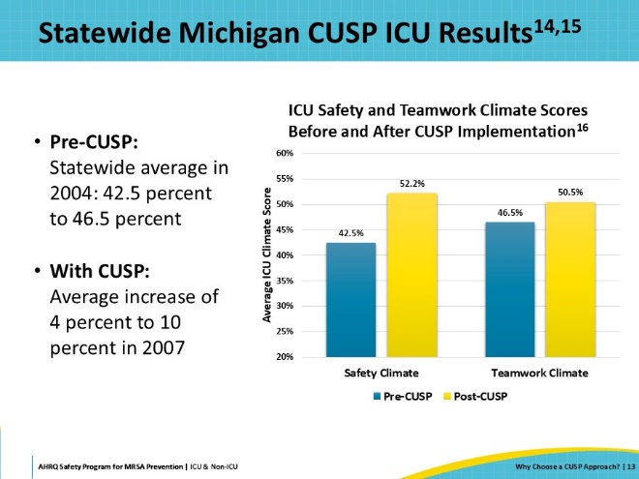
CUSP Implementation Has Been Associated With:  SAY:  The list of publications associated with preventable infections and change due to the implementation of a CUSP is impressive. From these, there was a 66 percent reduction in catheter-related bloodstream infections among 103 ICUs, and a 71 percent reduction in ventilator-associated pneumonia infections among 112 ICUs. A Michigan hospital noted a 10 percent reduction in hospital mortality compared to 350 hospitals in surrounding states. Among more than 1,000 hospitals, there was a 40 percent reduction in central-line associated bloodstream infections. Furthermore, these studies showed a $1.1 million annual savings for the average hospital, and a 33 percent reduction in SSIs. Across the board, there are significant improvements in safety climate, teamwork climate, and nurse turnover rates. | Slide 14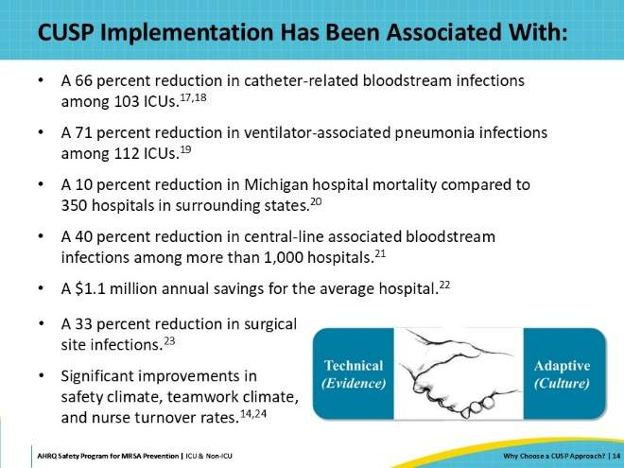
Successful CUSP Teams: Members  SAY:  The first step in establishing a CUSP team is to identify a team of core champions. Successful CUSP teams should identify staff members that want to serve as champions in leading the work. This desire comes with a passion for safety and quality. The champions should also be respected among their peers and able to engage and influence others. Leadership by title roles is not necessary but can contribute to the work of CUSP. It is usually the informal leaders from various disciplines that partner and represent the local operations, as they are typically at the heart of the issues. More information on CUSP team structure, including how to select a core team, key roles within the core team, and how to integrate this structure into current practices can be found in the presentation “How to Integrate a CUSP Approach.” | Slide 15  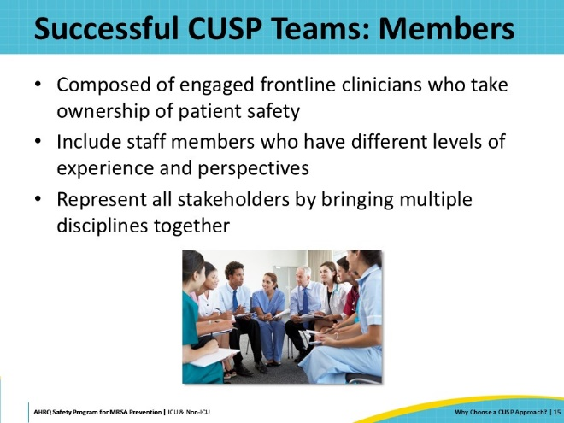
Successful CUSP Teams: Meetings  SAY:  Successful CUSP teams establish regular meeting dates and times that do not get interrupted by daily operations. The core champions ideally receive protected time to dedicate to the work of CUSP. They share leadership with the core members and their fellow colleagues who are engaged even if they do not have a champion role. No one person or discipline dominates the team, and silos should be abolished as much as possible. CUSP can often naturally break down silos and enhance teamwork and communication across disciplines. | Slide 16  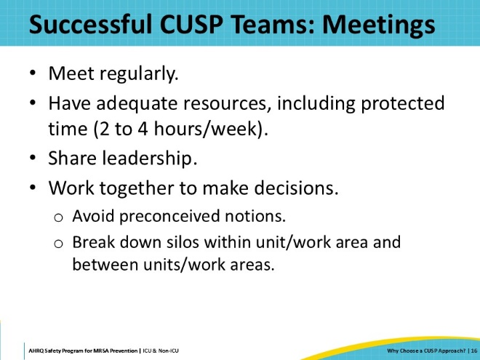
Science of Safety  SAY:  The Science of Safety focuses on principles of safe system designs and provides new lenses for staff to recognize that every system is designed to achieve the results it gets. All members of CUSP teams are encouraged to view the AHRQ Science of Safety video.  For more information and resources, please visit the Understanding the Science of Safety module of the Core CUSP Toolkit for more information. | Slide 17  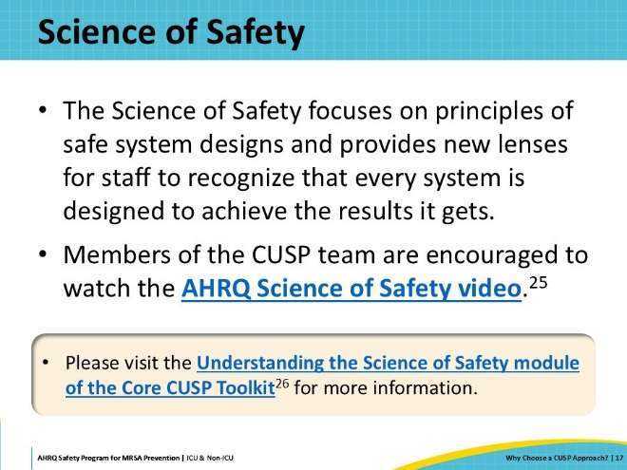
For More On CUSP  SAY:  The information on CUSP provided in this Toolkit for MRSA Prevention is not intended to be comprehensive, but to just provide a brief primer on applying the CUSP approach to your MRSA prevention efforts. To learn more about CUSP and to access more tools and resources, please visit the AHRQ CUSP Core Toolkit on the AHRQ website.  Modules of the CUSP Core Toolkit include:  - Learn About CUSP  - Assemble the Team  - Engage the Senior Executive  - Understand the Science of Safety  - Identify Defects Through Sensemaking  - Implement Teamwork and Communication  - Apply CUSP  - The Role of the Nurse Manager  - Spread  - Patient and Family Engagement | Slide 18  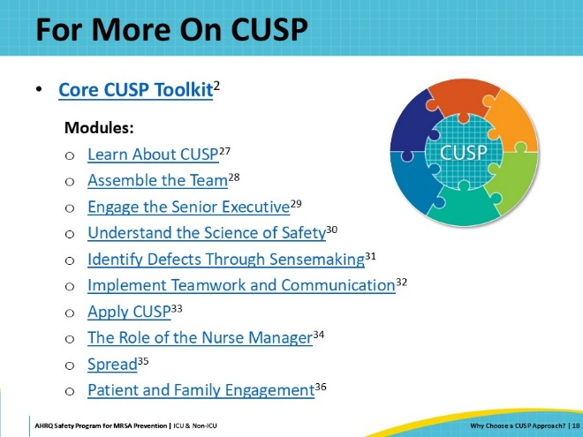
Key Takeaways  SAY:  In summary, CUSP is a method for multidisciplinary teams to identify and address safety concerns. CUSP acknowledges that healthcare can be complicated and errors can occur, as all people are fallible. CUSP enables all staff members to speak up when they have safety concerns, without fear of reprisal. CUSP enables teams to see defects as opportunities for continuous learning, not as reasons to pass blame. CUSP teams are composed of frontline clinicians and staff members from multiple disciplines. By including multiple disciplines and leadership support, CUSP teams can represent all stakeholders. | Slide 19  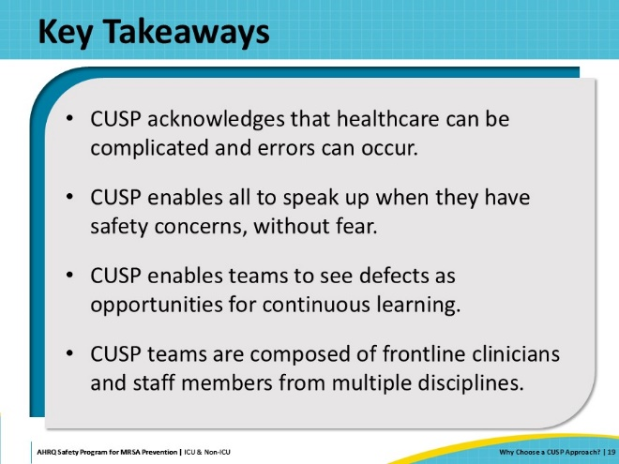
Disclaimer  SAY:  The findings and recommendations in this presentation are those of the authors, who are responsible for its content, and do not necessarily represent the views of AHRQ. No statement in this presentation should be construed as an official position of AHRQ or of the U.S. Department of Health and Human Services.  Any practice described in this presentation must be applied by healthcare practitioners in accordance with professional judgement and standards of care in regard to the unique circumstances that may apply in each situation they encounter. These practices are offered as helpful options for consideration by healthcare practitioners, not as guidelines. | Slide 20  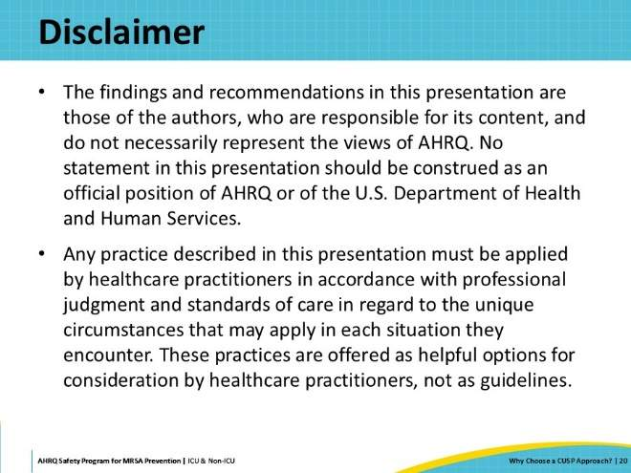
Reference List—1 | Slide 21  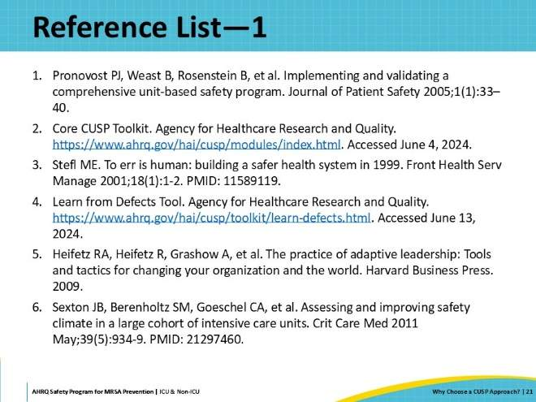
Reference List—2 | Slide 22  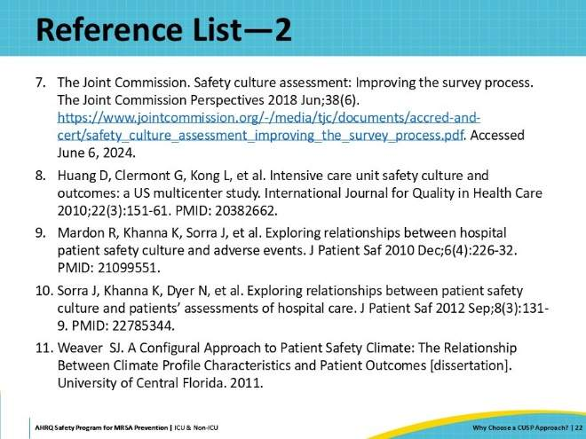
Reference List—3 | Slide 23  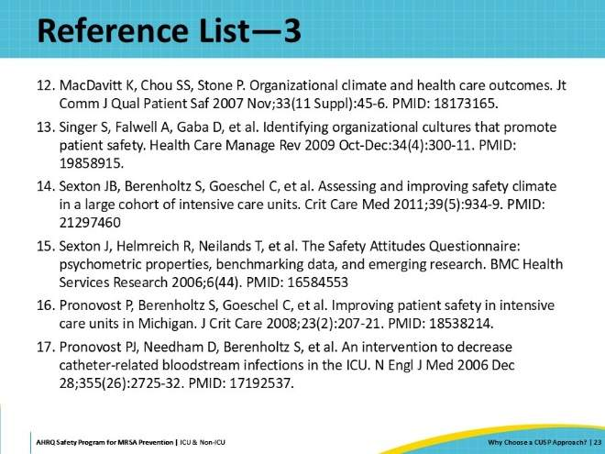
Reference List—4 | Slide 24  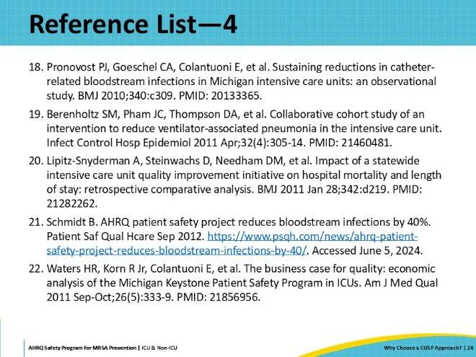
Reference List—5 | Slide 25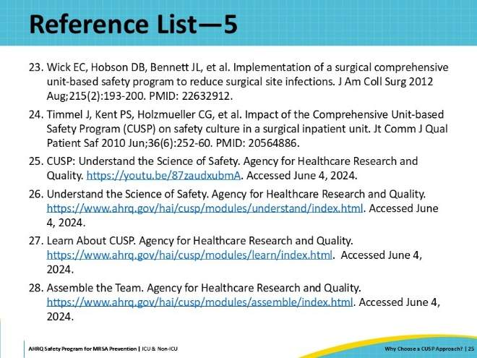
Reference List—6 | Slide 26  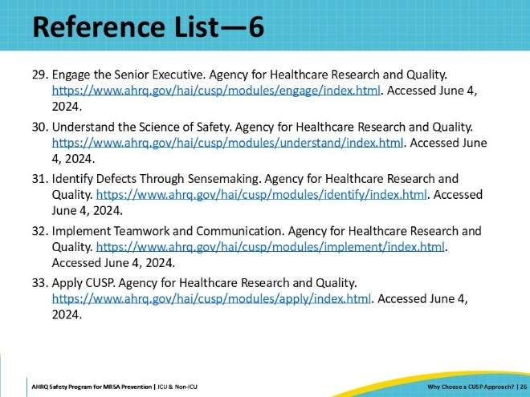
Reference List—7 | Slide 27  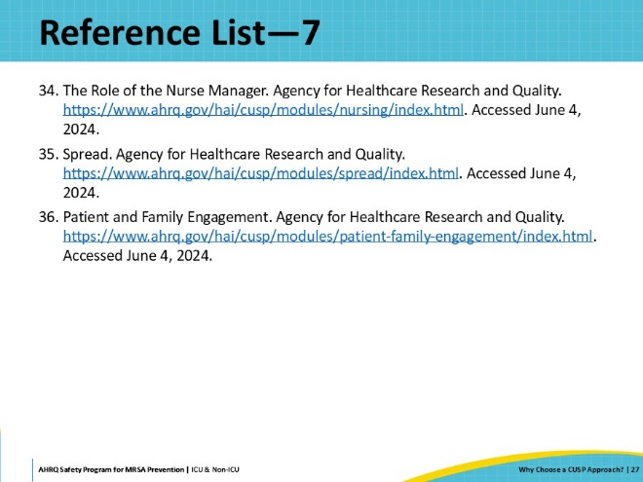
AHRQ Pub. No. 25-0007
October 2024

