How To Integrate a CUSP Approach
ICU & Non-ICU
Slide Title and Commentary | Slide Number and Slide
How to Integrate a CUSP Approach  SAY:  Welcome to this presentation about the Comprehensive Unit-based Safety Program, or CUSP. This presentation discusses how to integrate a CUSP approach in your unit practice. | Slide 1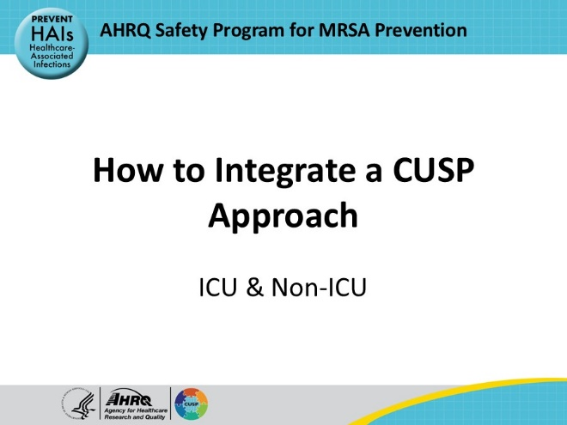
Educational Objectives  SAY:  This presentation will  - List the key steps to integrating a CUSP approach  - Explain the role of the core CUSP team  - Define the core roles that compose a successful CUSP team  - Review CUSP tools that can enhance the work of your team | Slide 2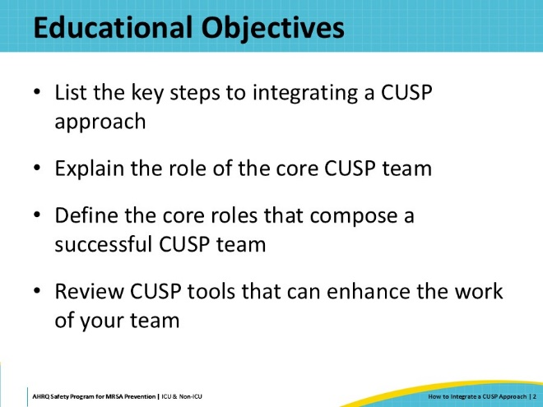
Assembling the CUSP Team  SAY:  This section will discuss the core CUSP team and the roles and responsibilities. | Slide 3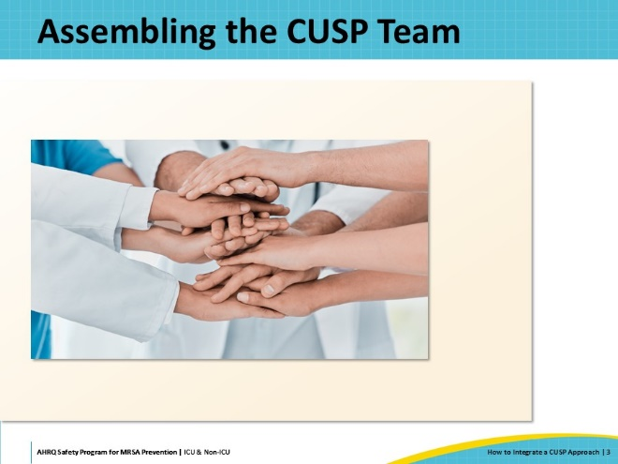
Key Steps to Using CUSP Approach  SAY:  To start integrating CUSP into current practices, a core CUSP team must be established. This requires identifying people who are interested in putting forth effort to increase the unit’s focus on improving patient safety, teamwork, and communication, and who have the appropriate time to donate to this task. Diverse representation is always wise – try to include team members of different skills, disciplines, shifts, etc.  Once members are identified, roles should be defined. The Roles and Responsibilities Tool can be used to help establish who is responsible for what. Unlike a committee, CUSP is not exclusive to only certain staff members. And, unlike many other initiatives, CUSP can be led by frontline staff rather than a manager or director. The CUSP team should ideally be led by those who are close to operations and supported by their leaders. Make sure all members are on board and understand your purpose.  As you plan to launch the team, set up a kick-off meeting where you can invite all colleagues to gather. The kick-off is a time where core team members are recognized and roles are explained. The kick-off can even take place in the form of a celebration!  Before or during the meeting, you should engage all colleagues by asking for their input as to what issues they are most concerned about on the unit. The Staff Safety Assessment Tool is a useful tool to facilitate and guide these conversations. You can always modify it to better fit your program’s goals.  The kick-off is also a great place to ensure psychological safety and encourage staff to speak up when they see potential for defects. Staff generally like to feel empowered; the CUSP framework cultivates an environment where they have a core team to whom and a forum where they can bring forward and own their concerns. | Slide 4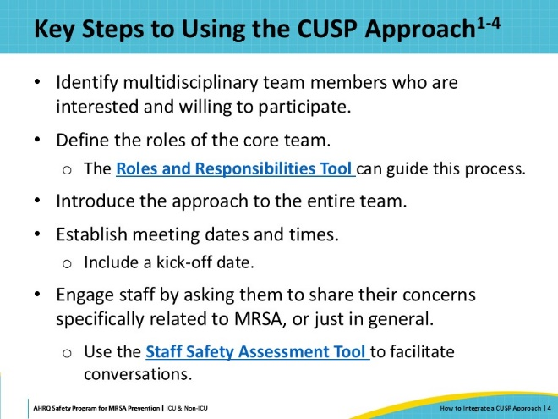
Core Team and Team Meetings  SAY:  The core team should be representatives for their discipline. They are responsible for establishing and running the CUSP meetings. Core team members should invite others to join the meeting or ask their colleagues who cannot join if they have any important agenda items they would like represented at the meeting.  At CUSP team meetings, the core team should be prepared with an agenda and manage meeting minutes that can be disseminated among the rest of the team. At each meeting, there should be a review of any assigned tasks or action items that were distributed at the previous meeting.  This Toolkit provides the follow resources to assist with meeting preparation.  - CUSP Monthly Meeting Pre-Work: This one-pager provides a guide on how to prepare for each meeting.  - CUSP Monthly Meeting Agenda Template: Use this template as a basis for your CUSP monthly meeting agenda.  Additionally, the team should openly welcome new issues and any potential solutions. Being open and considerate of all thoughts and suggestions can help foster a sense of psychological safety, which will result in a healthy, collaborative, and productive team. | Slide 5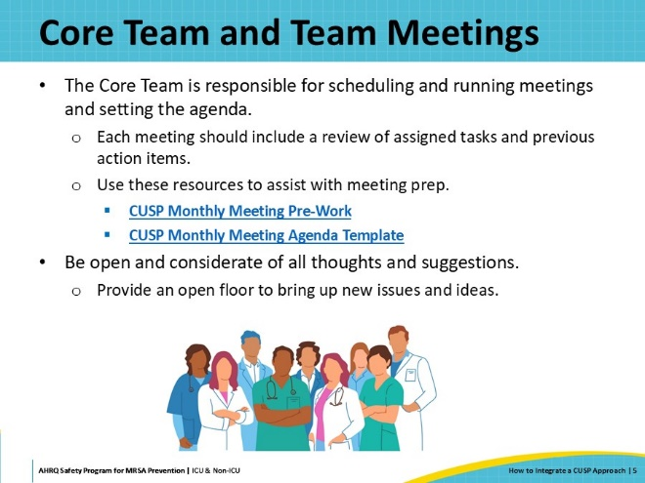
Core CUSP Team Roles  SAY:  CUSP team composition is centered around patient care. In fact, patients and families can serve as core team members. Each of these roles plays a key part in maintaining and improving the CUSP team. The following slides will break down these roles in more detail. | Slide 6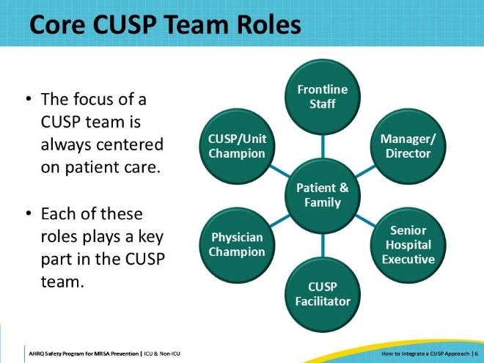
Patient and Family  SAY:  As the receiver of care, a patient can provide a valuable perspective on how they would like to be cared for, give voice to concerns that they have identified, contribute direct input on interventions, and advocate for patient-centered care. A family member, as someone who observes both providers and patients, can also provide a different perspective on care. | Slide 7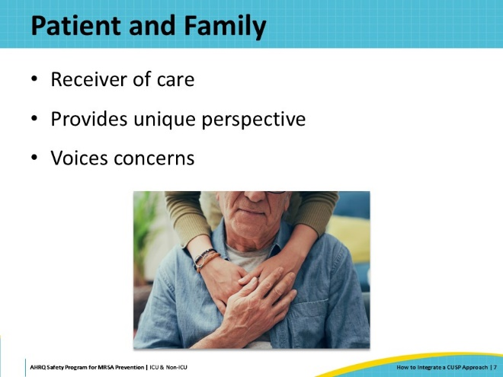
Manager/Director  SAY:  The manager or director is the leader of the local area but not of the CUSP team. This formal leader role is a support role to the champions and the team. The manager/director should empower the champions to own the work and provide resources, such as time, so they may do it effectively. | Slide 8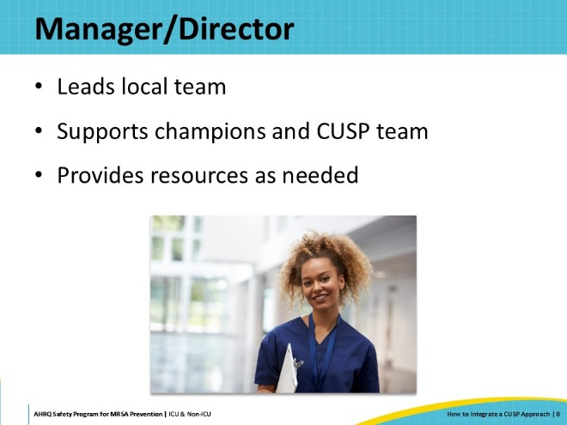
Senior Hospital Executive  SAY:  The Senior Executive is an active member of the CUSP team, partnering with team members so they can achieve safety and quality improvement goals and develop problem-solving and leadership skills. The executive can be the best facilitator of resources and can mitigate barriers. The executive can help share the great work of the CUSP team with organizational leadership. | Slide 9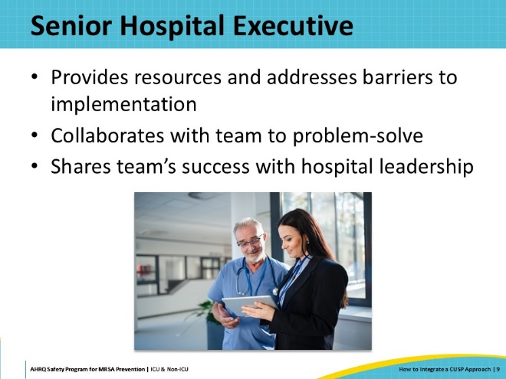
CUSP Facilitator  SAY:  The CUSP facilitator is a safety expert who is intimately familiar with CUSP and the key concepts that make CUSP work. The facilitator can coach the champions, ensure that CUSP is understood by the team, and that tools are being used appropriately. | Slide 10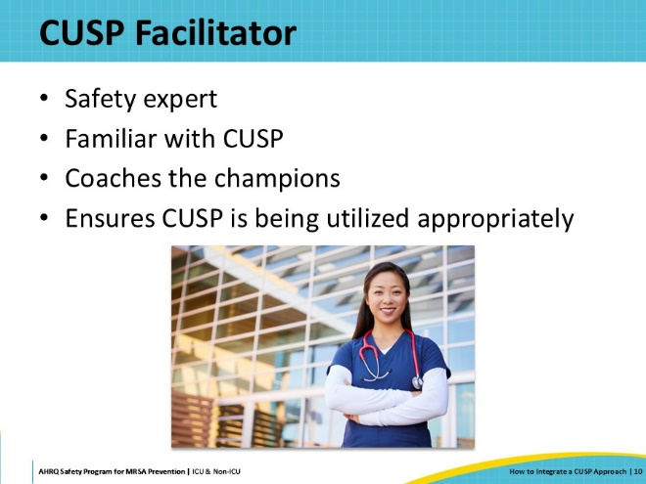
Provider Champion  SAY:  The provider champion is a physician or advanced practice provider who serves the patients of the unit or work area most of the time. The provider should be closely familiar with unit operations, well respected among peers, and willing to be a liaison for the rest of the medical team. | Slide 11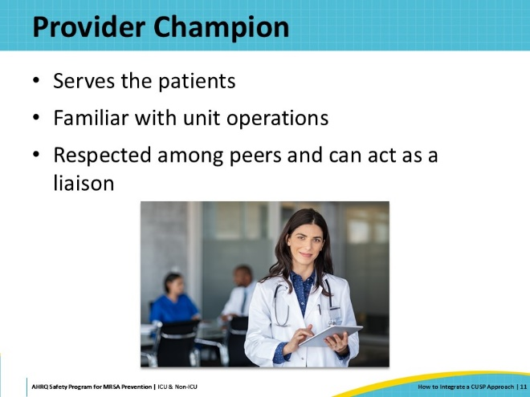
CUSP/Unit Champion  SAY:  The CUSP champion is the one who leads CUSP. This person should be in a role that is close to the point of patient care and very familiar with the unit operations. Often, the champion is a nurse, tech, or therapist who works on the unit or in the area 100% of the time. This person should be well respected among peers and able to communicate the work of CUSP, as well as engage others. | Slide 12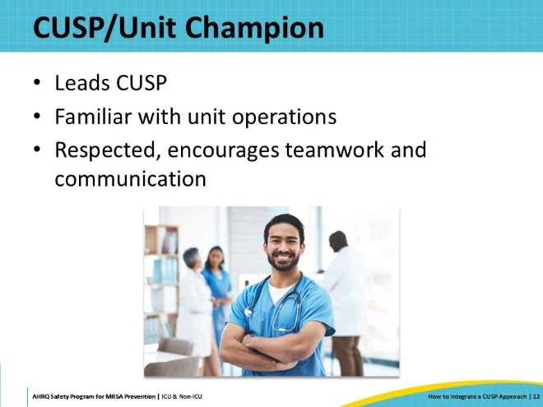
Frontline Staff  SAY:  Frontline staff, even those who are not assigned members of the team, should always be invited to meetings for many reasons! Frontline staff are the heart of the program.  Other core members can be unique to the work setting. For a team that is working on infection prevention such as with MRSA, an infection preventionist should be a core member. If pharmaceuticals are used in the work area, a pharmacist should be a core member. Any role that is relevant to the work area or to the project topic should be considered.  Also, consider setting up “co-champions” for any of the roles discussed. Having more members whose roles overlap is always a good thing and can lead to more educated and productive conversations about patient safety and quality. | Slide 13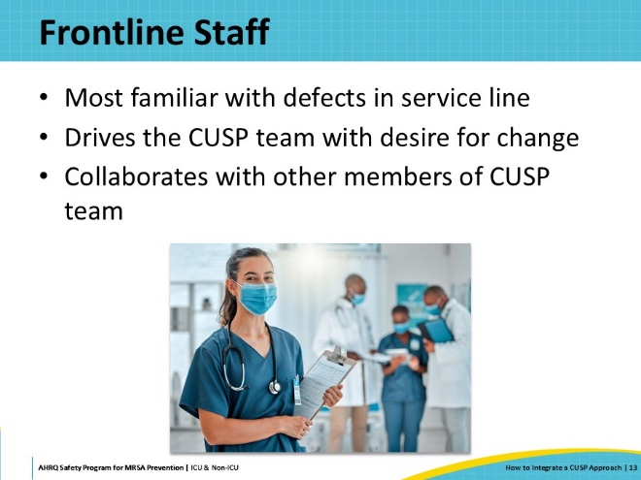
Putting CUSP Into Practice  SAY:  The next section will discuss the steps of initiating the CUSP program. | Slide 14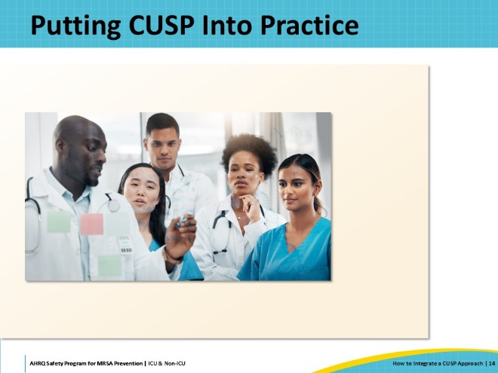
The Purpose of the CUSP Approach  SAY:  CUSP is not a top-down approach to surfacing issues or creating and implementing interventions to mitigate issues. CUSP is a partnership that is led by frontline experts and supported by leadership. CUSP enables teams to own safety and quality in a way that values their input, engages their expertise, and creates innovations that improve their local work setting. Their interventions and work may also improve patient quality and safety in other “like” areas facing similar issues when the work is shared broadly. | Slide 15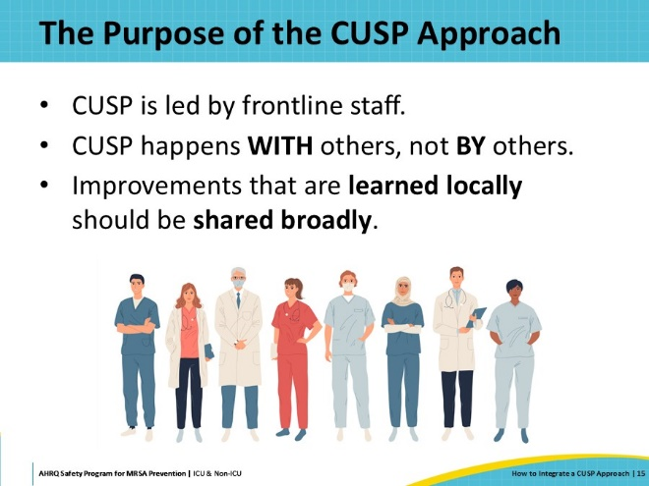
Align With Principles of High Reliability  SAY:  The CUSP approach is a method to achieving a highly reliable organization (HRO). CUSP incorporates all principles of HRO. These principles include:  - Preoccupation with failure (potential or actual)  - Reluctance to simplify  - Deferring to the experts (i.e., those who work in the local unit or area)  - Sensitivity to operations  - Commitment to resilience | Slide 16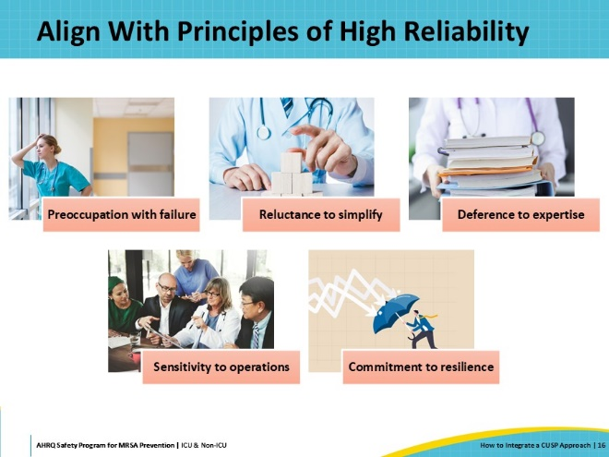
Have a Kick-Off!  SAY:  What’s a kick-off? A kick-off is a meeting that signals the launch of your CUSP program and extremely important work. A kick-off sounds like a lot more fun than a meeting, and it absolutely can be! This is your opportunity to get staff excited about your CUSP approach to tackling safety issues.  Familiarize your team with the Science of Safety. The Science of Safety can help emphasize that safety issues should be viewed as the result of systems, and that it is important to establish “psychological safety.” People need to feel safe to speak up. Remind members of your CUSP team that their voices are at the heart of CUSP, and they are the experts. Always empower them to participate! Remember, successful teams have strong engagement, so this should be a priority from the very beginning.  There are also several “fun” ways to engage staff at your kick-off: examples include distributing “CUSP cakes” (aka cupcakes) or UV glow sticks (to detect germs, like fluorescent gel monitoring). Find a successful method of engagement within your own local practices! | Slide 17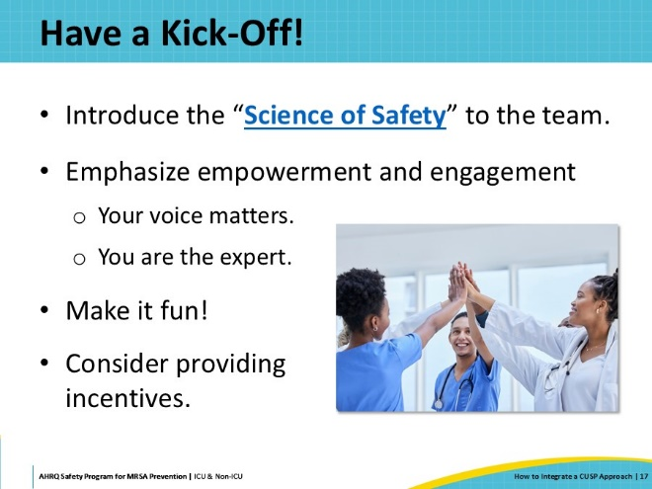
Powerful Questions  SAY:  Once you have your core team and frontline staff at your kick-off, it’s time to ask them two powerful questions:  - How will the next patient be harmed?  - What can we do to minimize or mitigate that harm?  The first question facilitates discussion of potential problems, while the second focuses on potential solutions. Record people’s responses using post-it notes, flip charts, whiteboards, or similar tools.  During the kick-off, core team members should start organizing the responses by themes, to identify emerging trends. Theming helps the team to prioritize issues to be addressed, based on their frequency, severity, and potential harm. Involving the staff in this process also shows how their input is utilized. This transparency helps staff understand why certain issues are prioritized, especially if their own concerns are not selected. | Slide 18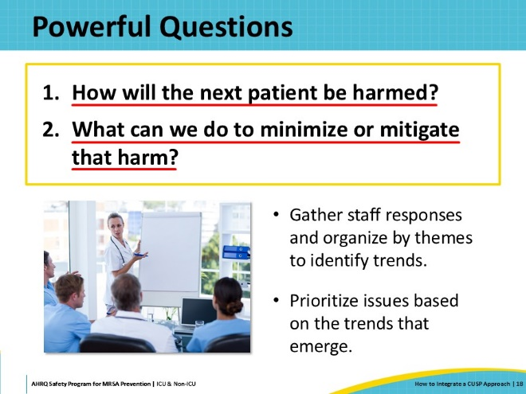
Staff Safety Assessment  SAY:  These important questions aren’t just asked at the start. The Staff Safety Assessment is a short survey tool that asks staff to answer these two questions in writing. It should be administered regularly (quarterly or semi-annually) to continuously gather input, to monitor the progress of implemented solutions, and to keep you updated of new or developing concerns.  The Staff Safety Assessment can be administered with paper forms, via email, or online. It’s important that the staff understands the purpose of the Staff Safety Assessment and that their input is valuable and will be used to prioritize and address safety concerns.  The advantage of a survey approach is that it is more flexible, allows staff to take their time when responding, and can preserve anonymity, which encourages honest feedback.  However, this approach provides no opportunity to engage staff, and the process is not as transparent. Your team will need to make an active effort to share findings with the staff and involve them in the development of action plans to tackle the prioritized issues. | Slide 19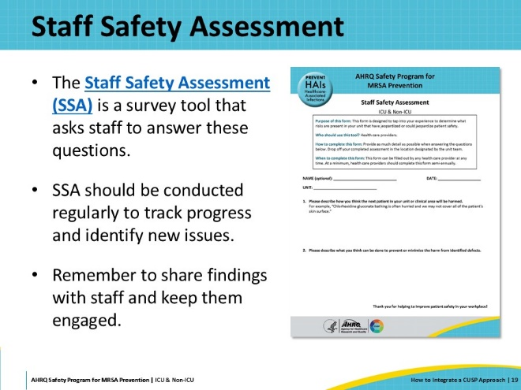
Learn From These Defects  SAY:  After gathering this input, the CUSP team will have a list of defects to tackle in their unit. Prioritize these defects to solve them most effectively. Start by focusing defects that are easiest to operationalize interventions for and will have the greatest impact on patient safety and quality. Then, tackle those that may be harder to operationalize or that have less effect on practices.  Consider attacking one defect per quarter—or more, depending on local practices. Set a goal during the CUSP kick-off meeting and aim to meet it.  And don’t forget other methods of obtaining data from staff. Feedback is gathered from more than the Staff Safety Assessment tool. You can get data on defects during briefings, at department or CUSP meetings, via event reporting, or even more creative means, such as a locked suggestion box or a whiteboard in a common area.  For more information on defects, please refer to the page on “Learning From Defects” on the Toolkit website. | Slide 20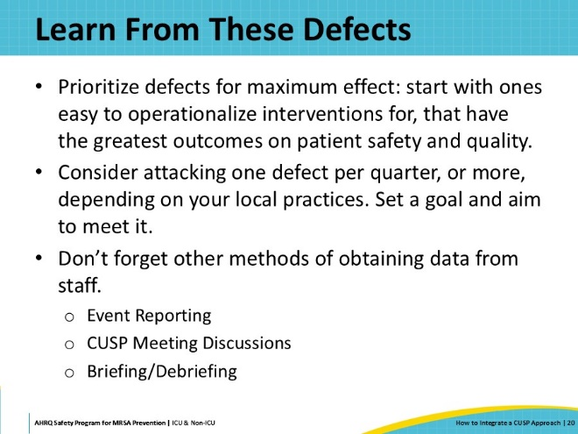
Key Takeaways  SAY:  Staff may be anxious when issues arise and want to immediately fix the problem. By using the CUSP framework, and by taking the time to systematically dig deep into the contributing factors, your team will be better able to identify the right solution.  Dedicating time and effort pays off, especially when you see the effectiveness of your work.  Using the Learning From Defects (LFD) methodology for any problem that is identified is a great way to integrate a CUSP approach. LFD is an effective way to understand all aspects of what happened, why it happened, including a comprehensive collection of contributing factors, what solutions could target the factors to minimize the risk of future harm, and strategy for evaluating if your interventions were effective. | Slide 21  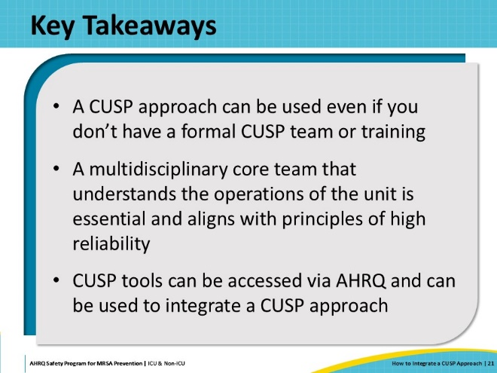
Disclaimer  SAY:  The findings and recommendations in this presentation are those of the authors, who are responsible for its content, and do not necessarily represent the views of AHRQ. No statement in this presentation should be construed as an official position of AHRQ or of the U.S. Department of Health and Human Services.  Any practice described in this presentation must be applied by healthcare practitioners in accordance with professional judgement and standards of care in regard to the unique circumstances that may apply in each situation they encounter. These practices are offered as helpful options for consideration by healthcare practitioners, not as guidelines. | Slide 22  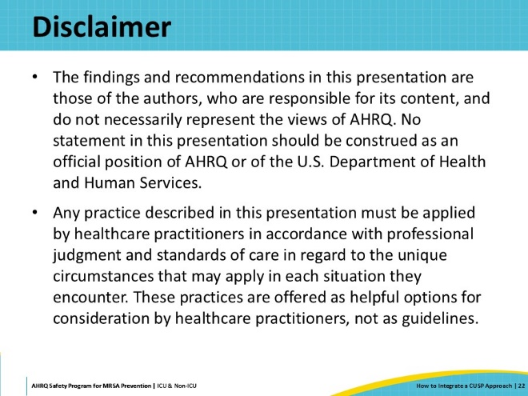
Reference List | Slide 23  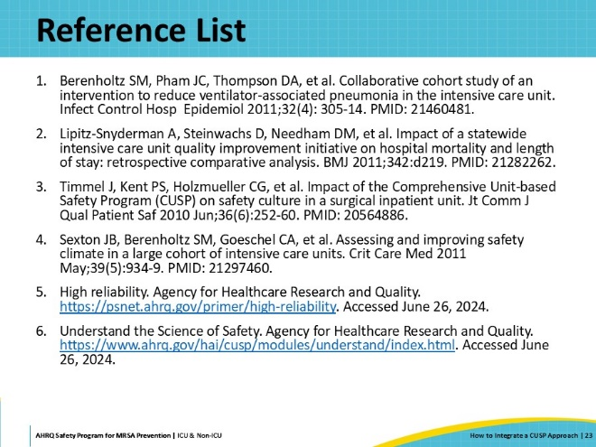
AHRQ Pub. No. 25-0007
October 2024

