CUSP Program: Psychological Safety
ICU & Non-ICU
Slide Title and Commentary | Slide Number and Slide
CUSP Program: Psychological Safety  SAY:  Welcome to this presentation on Psychological Safety as part of the overall approach to preventing MRSA in ICU and non-ICU settings. | Slide 1  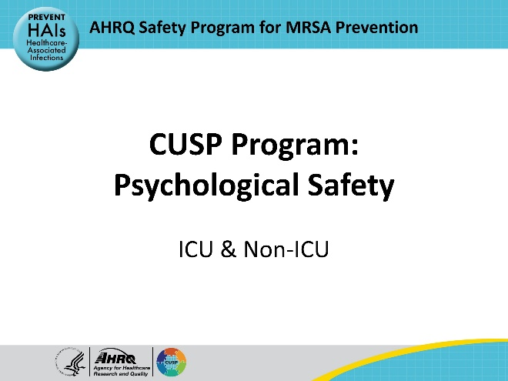
Educational Objectives  SAY:  This presentation will define psychological safety, explain the importance of a psychologically safe environment for quality improvement projects, describe core attributes of a psychologically safe environment, identify barriers and facilitators that impact psychological safety, and describe steps to create and implement a psychologically safe environment through a case example. | Slide 2  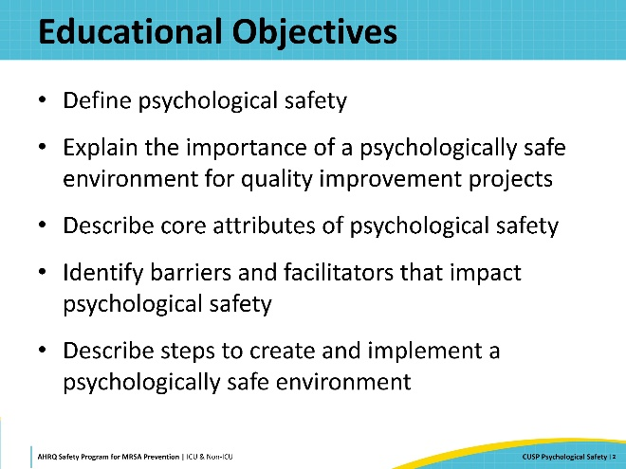
What Is Psychological Safety?  SAY:  To create a psychologically safe environment, the CUSP team must first understand the definition of psychological safety and its impact on members of the team.  Psychological safety is defined as the belief that one will not be punished or humiliated for speaking up with ideas, questions, concerns, or mistakes and that the team is a safe environment for interpersonal risk-taking. Amy Edmondson articulated this definition in the early 1990s to describe an environment wherein members feel respected and acknowledged for speaking up about issues in the workspace without being reprimanded, labeled, or punished.  Any time a person speaks up about something, there is a potential for conflict and negative consequences may arise toward the person who spoke up or others. Psychological safety reflects the shared belief among team members that the space or work environment is safe for open dialogue about difficult situations or processes of care.  Psychological safety improves communication and teamwork among the healthcare team; however, it is not easy to establish and must be intentionally fostered. | Slide 3  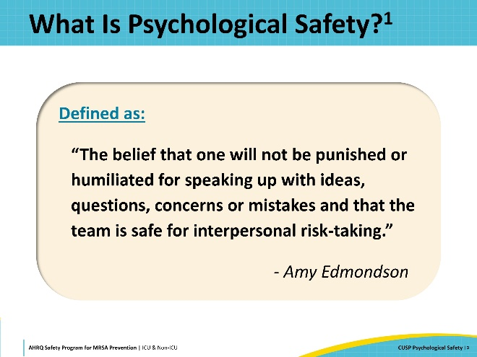
Core Attributes of Psychological Safety  SAY:  Trust, respect, and accountability are core components of a psychologically safe environment. The CUSP team leaders should model desired behaviors, including respect, integrity, and accountability, and set the tone for others to feel comfortable in meetings.  Leaders should share personal challenges as examples for the team to follow and appreciate all members. It is okay for team leaders and members to be human and imperfect. When a psychologically safe environment is created, team members feel comfortable sharing ideas and speaking up. Leaders should be honest and acknowledge that it sometimes feels difficult and risky to bring up topics and issues. Leaders must reinforce that speaking up is not a matter of finger-pointing or blame; rather, it is an opportunity to share information, investigate a process, and create avenues of change. Leaders can stress the importance of dialogue and feedback about the topic and that discussion is not criticism but a means for the team to mutually determine next steps and co-create solutions.  In a psychologically safe environment, open communication and active listening are successful strategies to engage participants. Personnel should be reminded of their importance and the value they bring to the project. Responses should be voiced with respect and support as the team discusses issues, provides feedback, and learns from the process. Every member of the team plays an important role in patient safety, and encouraging staff to participate and be involved creates a sense of belonging and team unity.  Leaders should create a psychologically safe meeting space that consistently establishes clear goals and responsibilities. This standardized, consistent approach allows members to know what to expect.  Goals and objectives of the overall project should be discussed so that all members can work from a shared understanding instead of a directive from the leader. Participation and shared decision-making leads to a healthier work environment. Allowing and encouraging involvement leads to greater accountability and a shared responsibility for finding solutions and achieving the desired outcomes. Acknowledging and supporting the team helps to empower individuals and builds their confidence.  The idea of a psychologically safe environment sounds appealing. But creating one requires work and the ability to recognize and overcome common barriers. | Slide 4  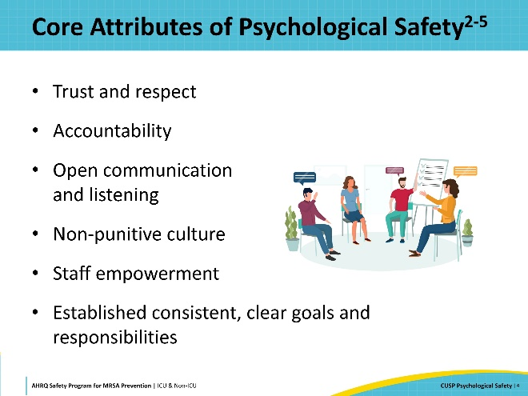
Barriers and Facilitators  SAY:  The infrastructure of the organization impacts the safety of the environment. Different leadership structures, leaders, and leadership styles set the tone of the organization. A punitive top-down approach fosters negativity, fear, and lack of participation, whereas an inclusive, nonjudgmental style encourages the team to participate. A leader who encourages input from the team creates an atmosphere of trust and open communication.  Relying on established policies and protocols helps the organization run efficiently, smoothly, and consistently define processes, expectations, and rules for operations. Policies guide the operation of the organization and establish standards of care. Following established policies allows the team to know what is happening and that standards are in place.  All departments and divisions of an organization are expected to meet benchmarks and deliver quality patient care. Well-established teams and quality improvement protocols support a psychologically safe environment because safety is a routine part of patient care.  It is vital to set clear expectations and common goals so that the team understands the mission. Setting clear goals and providing a supportive atmosphere will lead to improved outcomes.  Additionally, focusing on the abilities of the team members can lead to project success. A psychologically safe environment requires open communication and listening skills. It is important to acknowledge that there are varying styles of communication and to provide education to increase team members’ communication skills. | Slide 5  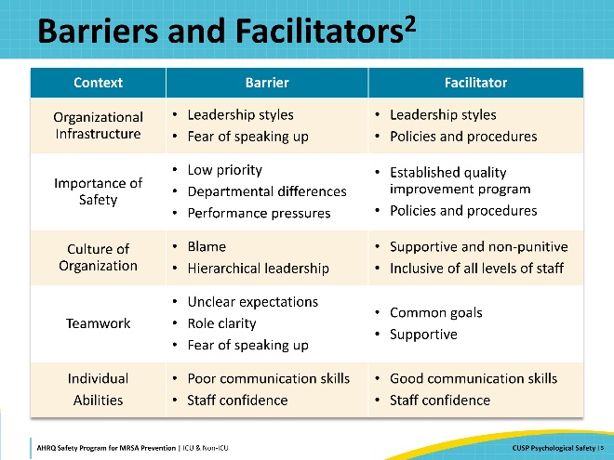
Case Example: Implementation of Psychological Safety  SAY:  The following case example involves a team working to create a psychologically safe environment to tackle an antibiotic stewardship challenge.  A routine audit showed frequent delays in IV antibiotic administration on a hospital’s medical unit. In response, the unit assembled a CUSP team including a diverse membership of nurses, pharmacists, and physicians with varying years of experience. In the last month, the hospital received lower than usual safety scores, and the medical floor did not achieve its quality and safety targets. Staff morale was low. Several junior team members were reluctant to participate in the meetings about antibiotic administration because they did not feel they could speak freely without repercussions. | Slide 6  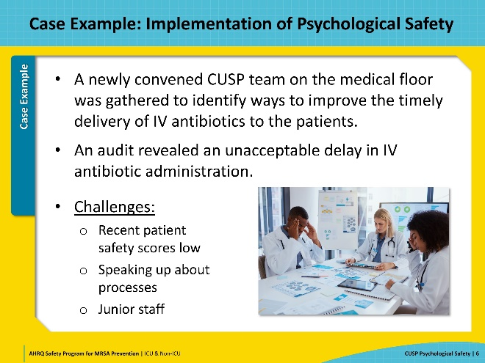
Case Example: Team Building  SAY:  Creating a safe environment is not an easy task. The CUSP team leader knew that some personnel were afraid to speak up. They began by establishing clear goals for the project, and expectations for every meeting. The first agenda item of each meeting was a reminder statement about trust and respect.  Each member of the team had a key role in the delivery of antibiotics. Instead of relying on assumptions, the CUSP team leader facilitated a discussion allowing each team member to talk about their role in the process and learn from each other. Roleplay exercises allowed team members to walk in the shoes of their colleagues to see how a series of factors can contribute to a delay in antibiotic administration. This simple, yet valuable, exercise created a learning environment for the team to openly discuss and identify issues without blaming others.  In the psychologically safe environment, the CUSP team members stepped out of their comfort zones and spoke without fear. They collaborated and generated creative solutions to solve the antibiotic administration problem. Finally, they celebrated the success of their team and the project. | Slide 7  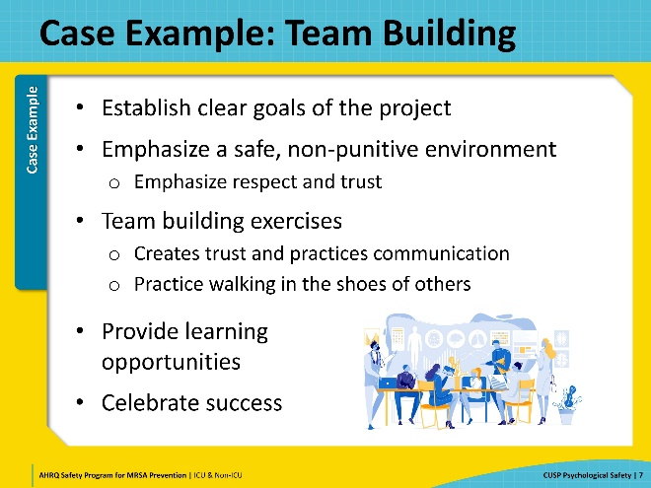
Key Takeaways  SAY:  In summary, psychological safety is defined as the belief that one will not be punished or humiliated for speaking up with ideas, questions, concerns, or mistakes and that the team is a safe environment for interpersonal risk-taking.  A psychologically safe environment is part of a culture that is non-judgmental and non-punitive. All members of the team are encouraged to participate and speak freely without fear of retribution. It is important for teams to use open communication and good listening skills. In a psychologically safe environment, the project's objectives, goals, and ground rules should be established and well-known to the team members. Identifying barriers and facilitators can help create a psychologically safe environment. It is important for team leaders to model desired behaviors for the team. | Slide 8  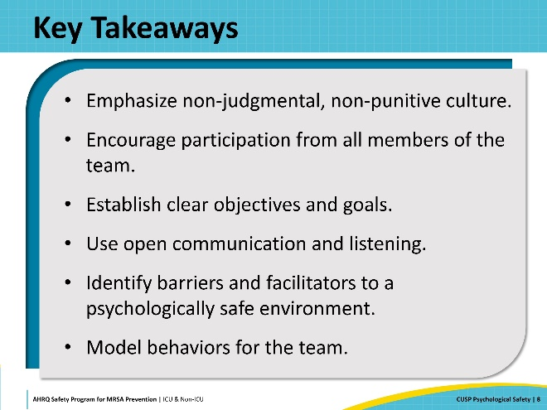
Disclaimer  SAY:  The findings and recommendations in this presentation are those of the authors, who are responsible for its content, and do not necessarily represent the views of AHRQ. No statement in this presentation should be construed as an official position of AHRQ or the U.S. Department of Health and Human Services.  Any practice described in this presentation must be applied by healthcare practitioners in accordance with professional judgment and standards of care in regard to the unique circumstances that may apply in each situation they encounter. These practices are offered as helpful options for consideration by healthcare practitioners, not as guidelines. | Slide 9  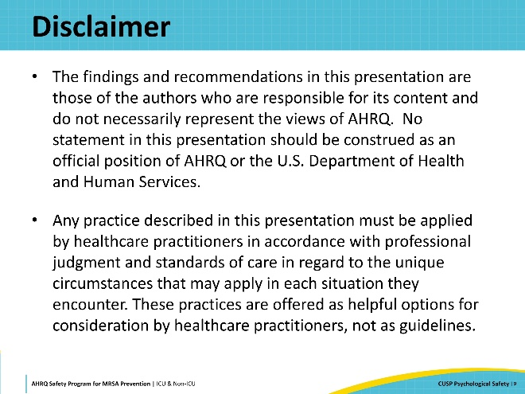
Reference List | Slide 10  