CUSP Program: Sustainability
ICU & Non-ICU
Slide Title and Commentary | Slide Number and Slide
Program Sustainability  SAY:  Welcome to this presentation on optimizing CUSP Program sustainability as part of the overall approach to preventing MRSA in ICU and non-ICU settings. | Slide 1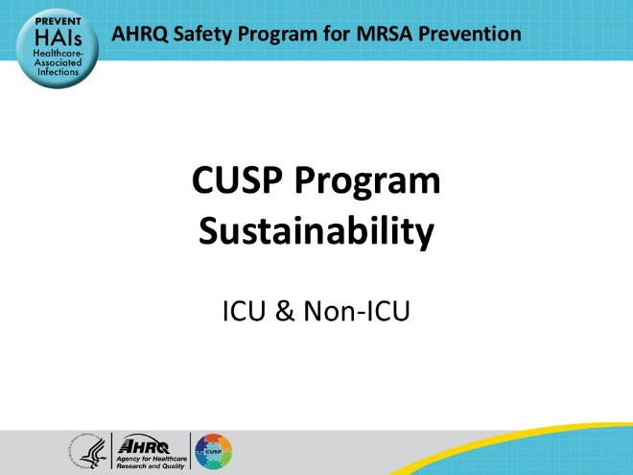
Educational Objectives  SAY:  Viewers of this presentation will be able to:  - Define sustainability for quality improvement success  - Identify key components of sustainability  - Identify challenges and successes in sustainability  - Describe steps to create and implement a sustainability plan  - Define a core Comprehensive Unit-based Safety Program (CUSP) team, roles, and responsibilities  - Discuss challenges and successes in sustainability  - Describe strategies to sustain interventions  - Identify tools to help maintain success | Slide 2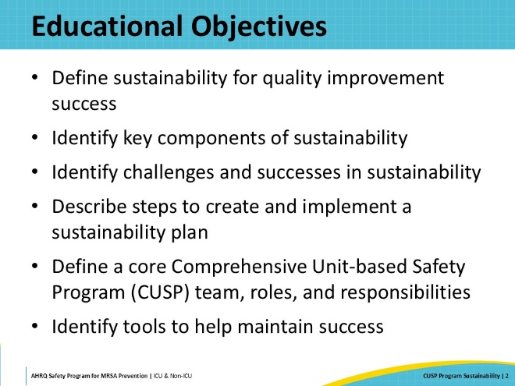
Sustainability Defined  SAY:  Once gains are made through a quality improvement project, it is important to make and execute a plan to ensure the sustainability of the improvements.  Sustainability ensures that gains of a quality improvement program are maintained beyond the project's life. In essence, sustainability is achieved when the improved processes and interventions are embedded into the culture and norms of an organization to improve overall patient care delivery and patient safety. At the beginning of a patient safety or quality improvement project, the team gathers information about the problem, uncovers gaps in processes, implements new strategies to tackle the problem, and evaluates the outcomes. The Comprehensive Unit Based Safety Program, or CUSP, fosters a culture of patient safety by improving patient care through evidence-based interventions and ongoing evaluation of outcomes. Throughout this process, the concept of sustainability ensures that improvements made throughout the safety initiative are maintained over time and embedded into the organization's culture. | Slide 3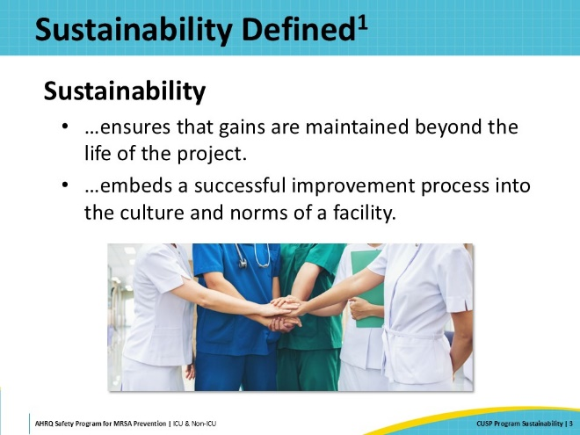
Keys to Sustainability  SAY:  It is vital to think about the sustainability of the interventions and program implementation early in the quality improvement process, not at the end of the project or after the outcome is improved.  For example, when a CUSP team initially gathers to discuss ways to lower MRSA rates, the team should consider interventions that can be sustained and long-lasting, not just actions that will help in the short term.  Quality improvement efforts should be constructed in a way that enhances current patient care processes and the delivery of patient care in a manner that can continue over time. The process of sustainability starts in the early stages of any QI project; therefore, the interventions should align with the institution's mission and vision and fit seamlessly into the workflow of the unit. The interventions must be designed in a way that does not overburden unit personnel with tasks that are unrealistic or that cannot be maintained.  Another important piece to the long-term impact of the QI project is the continued involvement and engagement of the CUSP team members, including leadership and staff members, after the initial phase of the project ends. Psychological safety should be incorporated into the work environment so that everyone is comfortable with speaking up when they see problems. This continued involvement should be maintained throughout all phases of the project, including before, during, and after project implementation so that momentum remains. Finally, the project’s interventions must be designed with the necessary resources, processes, leadership, engagement, and ongoing evaluation to ensure that they can endure. | Slide 4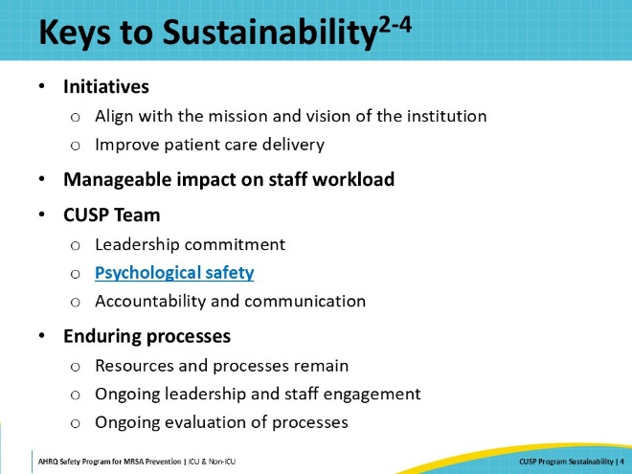
Identify Challenges and Successes  SAY:  When considering any QI project and whether it will be successful, it is important to identify challenges and outcomes that might occur over time. Once these potential challenges and possible outcomes have been considered, the team should make plans and implement strategies to guard against factors that might undermine the project or cause its success to diminish over time. | Slide 5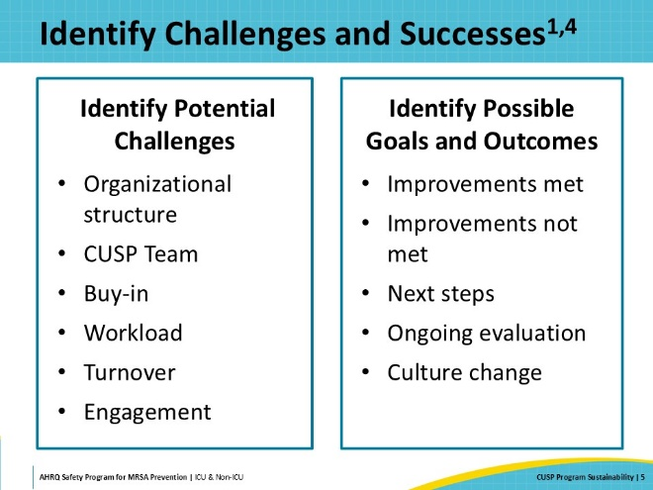
Challenges and Successes: Personnel  SAY:  All quality improvement projects involve and have an impact on personnel. Whether it is a change in workflow, the introduction of new equipment, or new processes or steps in the care of patients, all interventions will require staff members to participate. Involving personnel in the process of designing interventions provides a sense of engagement and empowers individuals to contribute their perspective and expertise. Asking frontline personnel to help identify gaps in patient care or how processes can be improved engages members of the team and leads to better interventions. Actively incorporating psychological safety into the program allows all participants to speak up. All these tactics together lead to professional growth and opportunities for personnel, including leadership skills, teamwork, accountability, and communication.  On the other hand, participating in QI projects can be daunting for some. It can increase staff workload, which may have a negative impact on morale, causing stress or fatigue. Engaging in QI projects may require additional training, as staff may not have the requisite skills for project implementation or communication. This additional training can lead to burnout or disengagement. It is essential to consider these factors when implementing and sustaining a QI project.  Other sustainability challenges related to personnel include turnover rates and changes to the available team members. If the team is composed of a mixture of full- and part-time staff, or agency or temporary staff, they may have incomplete knowledge of the project and unit protocols. Some personnel may be resistant to change and may not understand the need for new interventions. Therefore, ongoing communication and training might be necessary. Being aware of and actively addressing these potential challenges enhances the sustainability of the project. | Slide 6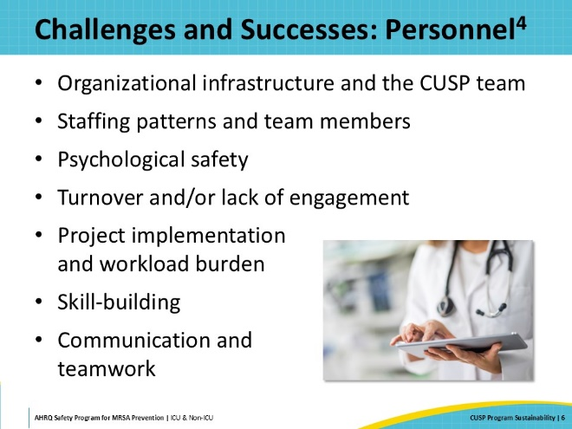
Challenges and Successes: Reaching Goals  SAY:  Not all QI projects are successful or sustainable. Reaching and sustaining the desired outcome is a challenge. Once the goal of lower MRSA rates is achieved, congratulate the team and celebrate the success! Continue to focus on the project’s interventions and monitor the team’s progress over time to ensure practices continue and don’t slip back into previous behavior patterns. If MRSA rates rise, again identify areas that need improvement. Use the data to inform the team’s decisions. Ask questions about the processes. For example:  - Are staff still adherent with MRSA decolonization practices?  - Are patient rooms still being disinfected appropriately?  - Has antibiotic stewardship changed?  - Are central lines being removed as soon as possible?  - Are the necessary resources still available?  - Is data capture accurate and timely?  Asking tough questions about the project and examining the data helps identify areas of weakness so that changes can be made to ensure the sustainability of the project’s interventions. | Slide 7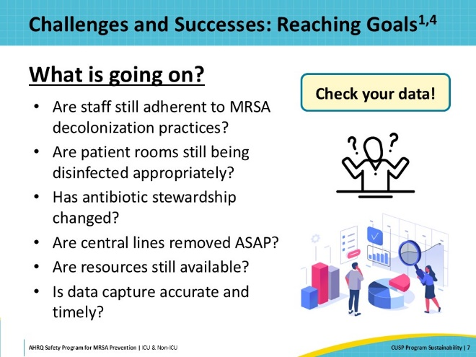
Steps to Create and Implement a Sustainability Plan  SAY:  Start drafting your sustainability plan at the beginning of the project. Clearly define the project outcomes and make sure they are congruent with the institution's mission. Identify and maintain the CUSP team and identify members with clearly defined roles. This includes CUSP champions, key stakeholders, frontline staff, executive and local leadership, and other professionals who will be impacted and involved in the process.  Perform a gap analysis to identify issues and provide data about gaps that need to be addressed. As the interventions are implemented, continue to collect data on the impact of the program, analyze the data, and implement changes as needed based on outcomes. A key part of the sustainability plan is to identify potential challenges or barriers and design strategies to overcome them. It is important to keep open lines of bi-directional communication with stakeholders so that the project can be adjusted as necessary to maintain success. As always, recognize the efforts of team members and personnel to celebrate their successes. | Slide 8  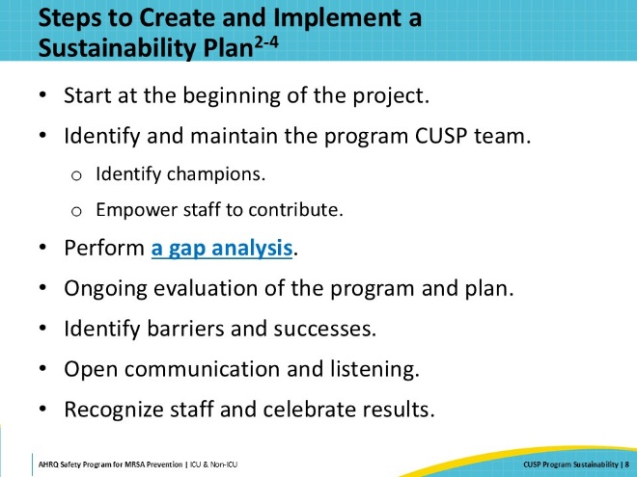
Maintaining Sustainability  SAY:  Strategies to achieve sustainability in QI programs involve ongoing education and training on CUSP, patient safety, infection prevention interventions, evidence-based practices, and principles of patient safety. Maintaining hospital leadership engagement alongside frontline personnel helps to build a strong team for long-lasting impact. Organizational leaders help ensure resource allocation and provide support for the concerns and input from the frontline staff. An established sustainable data collection process and ongoing evaluation and feedback are essential to measure the impact of interventions on outcomes and the need for improvement. Routinely evaluating and sharing data maintains engagement and prompts periodic changes as appropriate. | Slide 9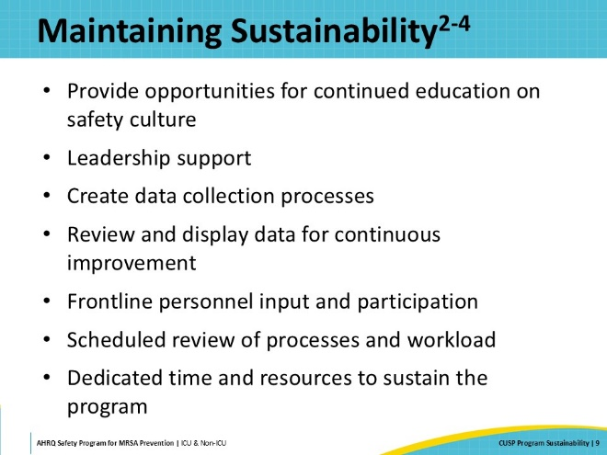
Key Members of the CUSP Team  SAY:  The CUSP team has a vital role in delivering the patient safety initiatives and in transforming the unit's culture. The infrastructure of the CUSP team plays an important role in sustainability of the QI efforts.  Patients and their families are at the heart of the work of the QI project. When possible, it is valuable to invite a patient or family member to serve on the CUSP team. Their unique perspectives provide insight into the approach used and how it is received by the care recipients.  Frontline personnel should always be part of the team and attend CUSP meetings. Including frontline personnel provides their vital perspectives and promotes engagement.  The senior executive member of the CUSP team partners with team members to achieve safety and quality improvement goals and develop problem-solving and leadership skills. The executive helps to provide resources and remove barriers. They disseminate information about the initiative to other members of the organizational leadership.  A CUSP Facilitator contributes structure and process to interactions so that groups can function effectively and make high-quality decisions. This person(s) supports the goal and should have expertise in safety and quality. The facilitator should be present and visible at meetings to coach the team members as needed.  The Provider Champion, who is often a physician, models leadership for the CUSP team and demonstrates commitment to the program by actively participating in CUSP work. The provider champion brings their perspective to the project and helps to disseminate information and influence practices among their colleagues.  The Unit Champion works to ensure that the vision of CUSP is translated into action and that all unit personnel are engaged in CUSP work. This person is at the heart of operations and is often a nurse, technician, or another role who is willing and able to dedicate time and effort to the project.  The Director/Clinical Manager, who is often a Nurse Manager, plays an essential role supporting a unit’s CUSP work. In this supportive role, it is important for the manager to support the champions rather than leading the work. The manager supports providing the time and resources that are needed for the project to be successful.  Creating co-champions for each role is an important strategy for sustainability because staffing and work responsibilities shift over time.  View the CUSP Roles and Responsibilities document for more information on the positions in a CUSP team. | Slide 10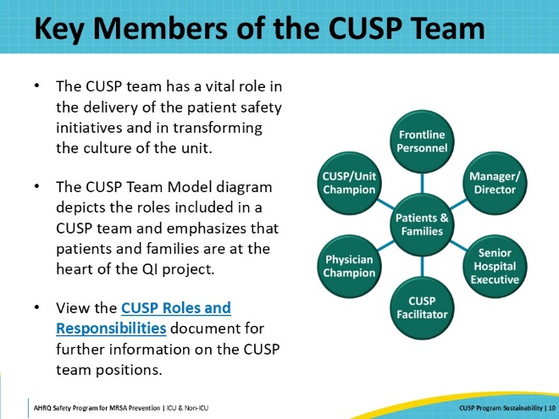
The Importance of the CUSP Team  SAY:  Re-evaluate your team as the project progresses. Are all the roles filled? Do members regularly attend meetings? Do you have co-champions in place to ensure continuity and sustainability? If not, seek new members to join the team.  Identify additional key stakeholders that should be a part of the team. For MRSA prevention and evaluation, infection preventionists or IPs should be active participants in addition to non-clinical staff, such as environmental service personnel. Database personnel or an informaticist who has a working knowledge of electronic medical records is also very helpful.  Provide ongoing training to ensure the team understands the expectations, goals, and outcomes of the project.  Check in routinely with the team to measure engagement and continued participation. Ask for their perceptions of value and any potential barriers that might prevent them from participating.  The team is the breath that gives life to problem identification, learning from defects and ongoing success with any or all interventions. | Slide 11  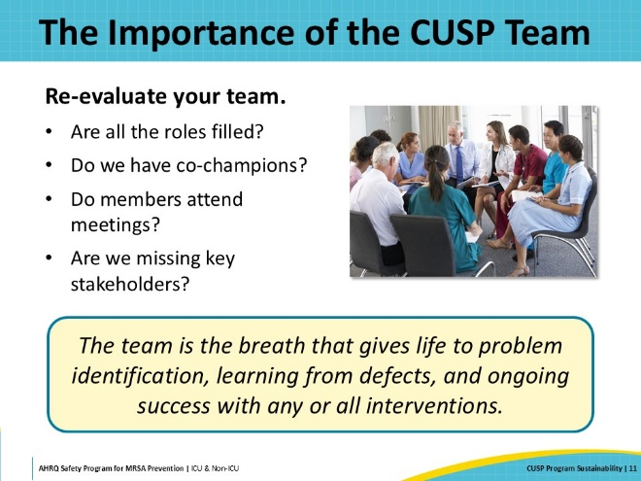
Where, When, and How?  SAY:  Standardizing meetings, agendas, and meeting times are important parts of the sustainability of the program. Periodically revisit the location and times for the CUSP meetings. Meetings should be conducted at times that work for the key stakeholders and unit operations. Separate implementation or work group meetings may be required to continue the work. It is vital that the team stay connected monthly to keep the project at the forefront of unit operations. Consider virtual or hybrid (in person and virtual) options to improve team members’ ability to regularly attend meetings.  Use a standard methodology like Learning From Defects, and/or sharing a dashboard that is easy to interpret so that team members know what to expect from the meeting format. Share the dashboard and results with leaders across the organization. Update these formats as necessary and make it as easy as possible for team members to stay involved and informed. | Slide 12  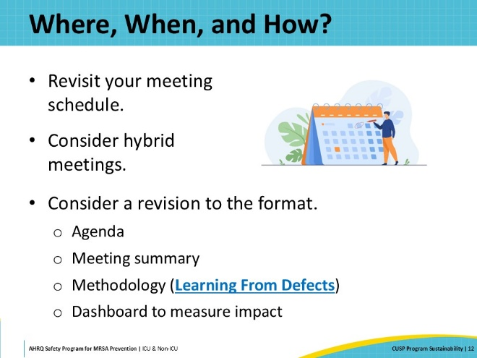
Create a 12-Month CUSP Meeting Schedule  SAY:  Ensure that everyone knows meetings are important, not only during the project but also after implementation is complete.  Having a schedule allows core team members and frontline personnel to plan the meeting into their calendars. This facilitates better team member participation.  Create a calendar invite with a virtual link and/or the room location 12 months in advance. Choose dates and times that promote the most engagement and allow all to be involved. | Slide 13  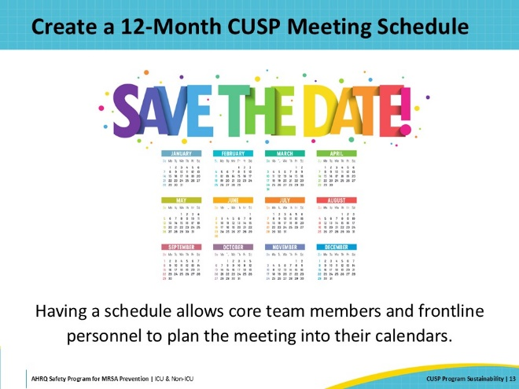
CUSP Meeting Agenda  SAY:  A meeting agenda helps team members anticipate and prepare for the meeting topics. Don’t fill the allotted time with speakers and topics so that you allow time for discussion and input from the team members. Set time limits for presentations leaving time for team members to respond and discuss the information or propose new topics.  Change it up! Empowering the frontline staff to run meetings is highly effective!  However, all team members may not know how to run a meeting. Helping them to create an agenda is a great first step to support them. For additional examples, please review the CUSP Monthly Meeting Pre-Work. | Slide 14  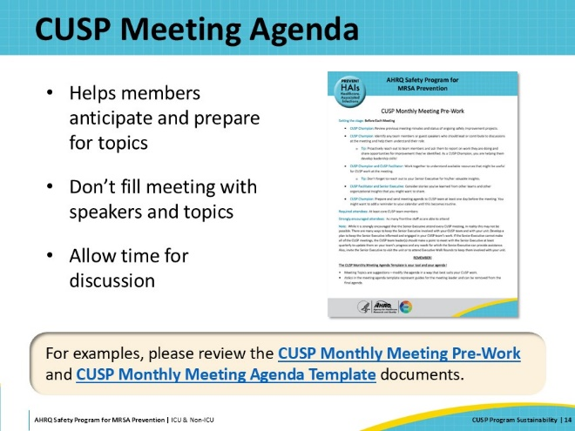
A Sample Agenda  SAY:  What might a sample agenda look like? This slide shows some standard discussion topics.  For examples, please review the CUSP Monthly Meeting Pre-Work and CUSP Monthly Meeting Agenda Template documents. | Slide 15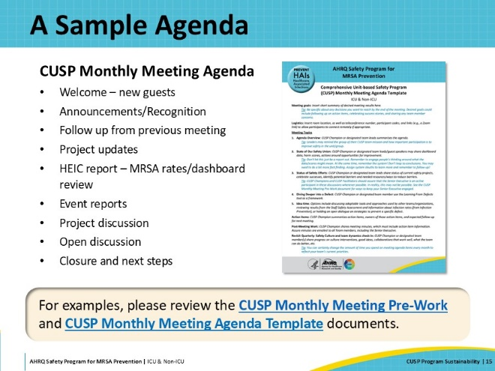
Data Sources and CUSP Tools  SAY:  Data are collected throughout the QI project to track progress on outcomes and examine whether the project is on the right track. Collecting data from a variety of sources informs the team. It is important to continue data collection after implementation of the intervention is complete. This helps to ensure the sustainability of the project’s outcomes.  The team can decide the desired number and frequency of audits, what to audit, and who should perform the audits. Unit-specific data can also be qualitative and captured at unit huddles. It is important to utilize metrics that are pertinent to the QI initiatives and not outside the scope of the project.  For more information on data sources for monitoring QI initiative progress, please see the following documents:  - Staff Safety Assessment  - Learning From Defects Tool  - LFD Investigating a Defect Worksheet  - Example of Completed Learning From Defects Tool | Slide 16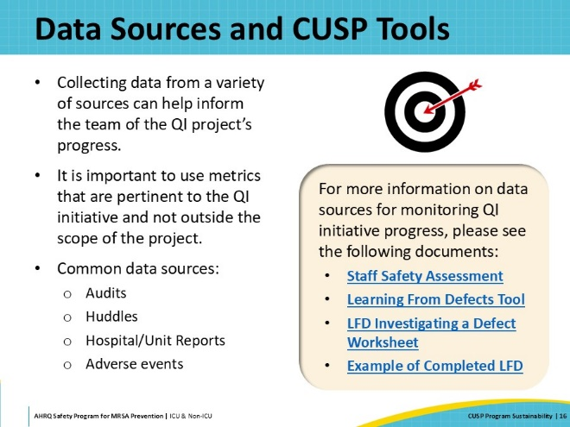
Share the Data and Celebrate Success!  SAY:  Sharing data and celebrating successes are key components of sustainability. Disseminating the project’s results provides an opportunity to demonstrate its value and discuss issues, progress, setbacks, and next steps. Open discussions help to continually improve the process and inform future collaborations or innovations. All members of the team contribute to the outcomes; thus, it is important to celebrate achievements to visibly show the impact of the work. Embedding patient safety into the culture of the unit leads to long-lasting impact and motivation for future QI projects. | Slide 17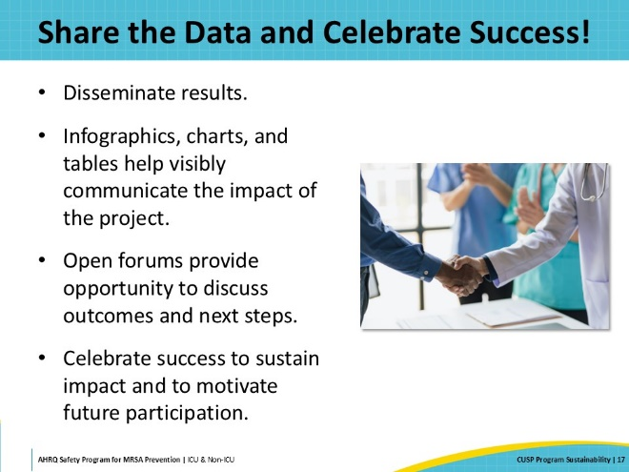
Key Takeaways  SAY:  In summary, start planning for sustainability early in the QI process. Establish, maintain, and periodically re-evaluate the CUSP team membership. Seek ongoing executive leadership engagement for continued success. Engage the frontline personnel and encourage their active participation. Co-champions are a good way to ensure sustainability as staffing and workloads shift. Identify and address challenges along the way. Review and disseminate data to evaluate the project’s impact even after implementation is complete. Following these steps can ensure the sustainability of the project’s impact and embed the initiative into a culture of safety that improves long-term patient outcomes. | Slide 18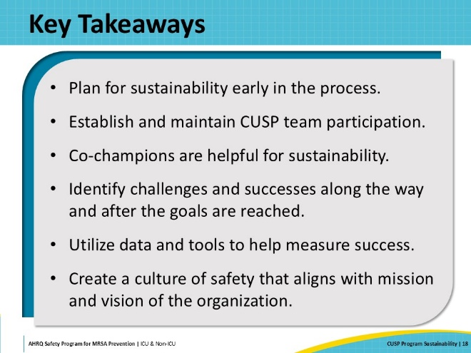
Disclaimer  SAY:  The findings and recommendations in this presentation are those of the authors who are responsible for its content and do not necessarily represent the views of AHRQ. No statement in this presentation should be construed as an official position of AHRQ or the U.S. Department of Health and Human Services.  Any practice described in this presentation must be applied by healthcare practitioners in accordance with professional judgment and standards of care regarding the unique circumstances that may apply in each situation they encounter. These practices are offered as helpful options for consideration by healthcare practitioners, not as guidelines. | Slide 19  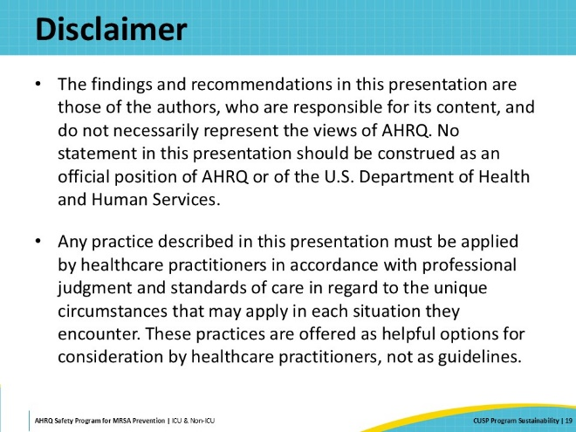
Reference List | Slide 20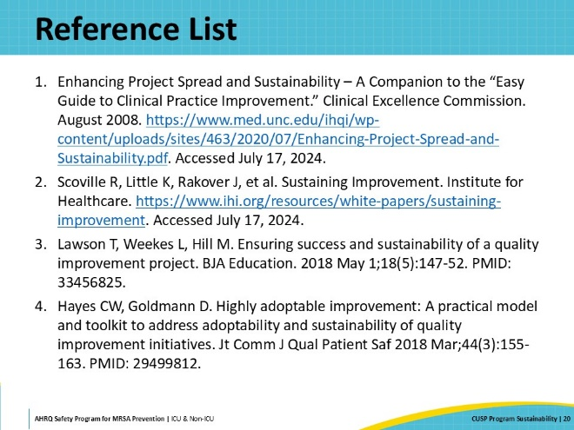
AHRQ Pub. No. 25-0007
October 2024

