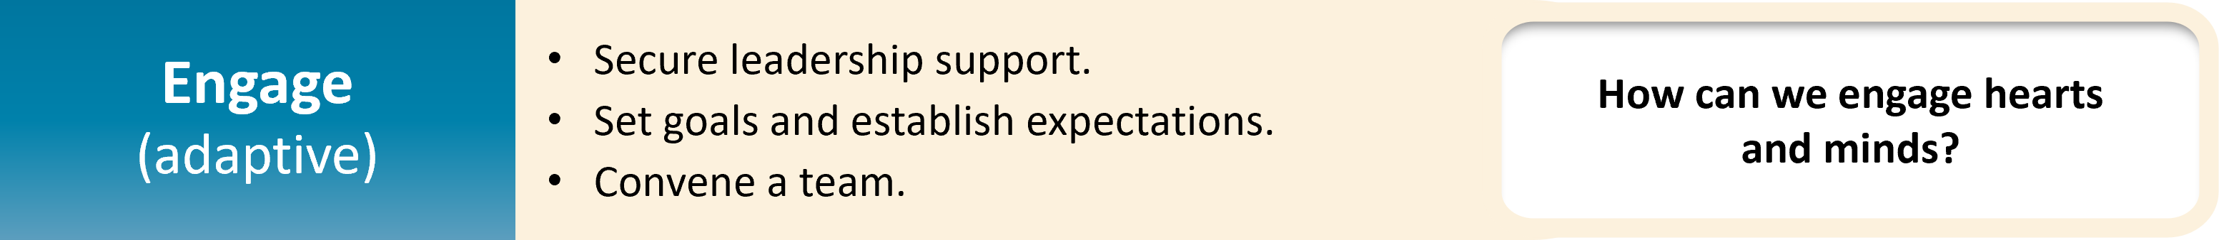

* The aim is to Engage hearts and minds and thus, change attitudes and behaviors.1-6
* Raise awareness of the problem, communicate benefits of the solution, and lay out the goals for the intervention.
  + Use unit data, published literature, and national benchmarks. Storytelling is an underrated tool.
* **Engagement is not a one-way process**—the goal is not to just convey information, but to invite their input.
  + Feedback from many perspectives is essential to assess current status and identify barriers.
  + Getting people to actively contribute helps to gain their buy-in for the intervention.
* Engagement occurs on multiple fronts, including team members, senior leaders, and frontline staff.

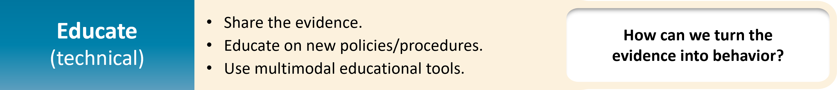

* Education is the technical work in which the team transmits vital knowledge and new procedures.1-6
  + For complex techniques, simulation-based education tends to be more effective.
  + Make the education flexible to meet needs. Provide multiple methods of training.
* **The goal is to equip staff with knowledge and skills to implement interventions effectively and identify potential issues.**
* Confirm that all policies are familiar and available to both leadership and frontline staff for review.

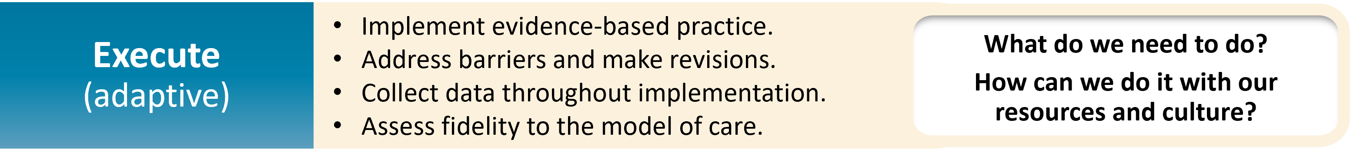

* **Execution hinges on the principles of safe design1-6:**
  1. Simplify the system.
  2. Create redundancy.
  3. Learn from mistakes.
* **The guiding principle of execution is to make it easy for people to make the right decision.**
* Continuous monitoring, re-evaluation, and adjustment are vital.
  + Execution is when the shortcomings of our plans are revealed.
  + Your processes to monitor ongoing performance and gather data on the implementation need to be robust.
  + Consider multiple methods of monitoring—e.g., direct observation, record review, surveys.
  + Actively seek feedback. Maintain open lines of communication with staff and leaders.
* Have a dynamic approach and make adjustments to implementation in real-time.
  + Meet regularly to review performance, discuss issues, and decide on adjustments.

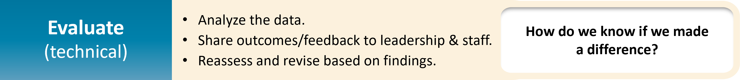

* Plan out your methods of data collection and analysis. Assess progress as data are collected, analyzed, and reported.1-6
* Learn from errors and defects and adjust your approach as needed.
* A key component of Evaluation is feedback. Share your data and findings broadly and openly, and in a timely manner.
  + Communication and transparency keep people engaged and active as implementation progresses.
  + **Remember to celebrate success!** Reward the contributions that your team, staff, and leaders have made.

# References

1. Ellingson K, Haas JP, Aiello AE, et al. Strategies to prevent healthcare-associated infections through hand hygiene. Infect Control Hosp Epidemiol. 2014 Aug;35(8):937-60. PMID: 25026608.
2. Romig M, Goeschel C, Pronovost P. Integrating CUSP and TRIP to improve patient safety. Hosp Pract (1995). 2010 Nov;38(4):114-21. PMID: 21068535.
3. Pronovost PJ, Berenholtz SM, Needham DM. Translating evidence into practice: a model for large scale knowledge translation. BMJ. 2008 Oct 6; 337:a1714. PMID: 18838424.
4. The 4 E’s. Agency for Healthcare Research and Quality. <https://www.ahrq.gov/hai/cusp/videos/02b-the-4e/index.html>. Accessed May 24, 2024.
5. Assemble the Team, Facilitator Notes. Agency for Healthcare Research and Quality. [https://www.ahrq.gov/hai/cusp/modules/assemble/team-notes.html#slide12](https://www.ahrq.gov/hai/cusp/modules/assemble/team-notes.html). Accessed May 24, 2024.
6. Engage the Senior Executive Facilitator Notes. Agency for Healthcare Research and Quality. [https://www.ahrq.gov/hai/cusp/modules/engage/exec-notes.html#sl3](https://www.ahrq.gov/hai/cusp/modules/engage/exec-notes.html). Accessed May 24, 2024.