There Are Four Fundamental Steps For CLABSI Prevention⁵⁻⁶
Pathogens, including MRSA, can reach the bloodstream by entering through the central line catheter hub or at the skin exit site. These central line-associated bloodstream infections (CLABSI) cause significant harm to patients and add costs to the healthcare system.¹⁻⁴

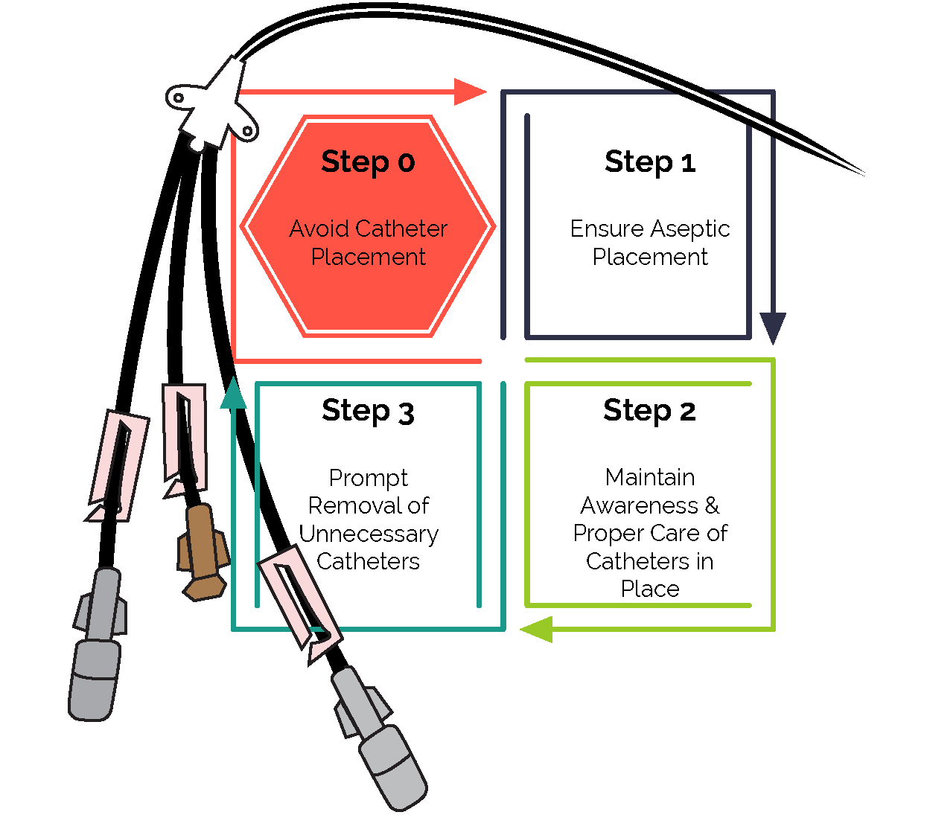
Step 0: Avoid Catheter Placement⁵
The best way to prevent CLABSI is to avoid central line catheter placement.⁵
Before inserting a central line, ask yourself and the clinical team if the line is necessary. Review appropriate clinical indications for a central line and consider if alternatives are available.⁶⁻⁸
Access AHRQ’s educational module on Central Venous Catheter Indications & Alternatives:
- Slides (.pptx)⁷ • Guide (.docx)⁸

When a central line is necessary…
- Follow evidence-based best practices at every stage of central line care (placement, maintenance, and removal).⁹
- Bundles of best practices result in better outcomes than if each practice is implemented alone. ¹⁰

Step 1: Ensure Aseptic Placement⁵
- Implement a central line insertion bundle.^{6,9-13}
- Central line insertion bundle components include:
  - Optimal site selection ○ Hand hygiene
  - Chlorhexidine skin preparation ○ Maximal sterile barrier precautions
  - Use of a central line insertion checklist ○ Use of a central line insertion cart or kit
Access AHRQ’s educational module on Central Venous Catheter Insertion:
- Slides (.pptx)¹² • Guide (.docx)¹³

Step 2: Maintain Awareness & Proper Care of Catheters in Place⁵
- Implement a central line maintenance bundle to establish best practices for routine care.^{6,9-11,14-15}
- Central line maintenance bundle components include:
  - Central line site care ○ Central line dressing changes
  - Hub disinfection ○ Daily chlorhexidine skin treatment
Access AHRQ’s educational module on Central Venous Catheter Maintenance:
- Slides (.pptx)¹⁴ • Guide (.docx)¹⁵

Step 3: Promptly Remove Unnecessary Catheters^{5-6,16-17}
- Central line maintenance includes daily review of central line necessity.
- Conduct daily evaluation of each patient’s need for the central line and remove the line as soon as possible.
Access AHRQ’s educational module on Central Venous Catheter Removal:
- Slides (.pptx)¹⁶ • Guide (.docx)¹⁷

References

- 2022 National and State Healthcare-Associated Infections Progress Report. Centers for Disease Control and Prevention. https://www.cdc.gov/hai/data/portal/progress-report.html. Accessed January 17, 2024.
- Chovanec K, Arsene C, Gomez C, et al. Association of CLABSI with hospital length of stay, readmission rates, and mortality: A retrospective review. Worldviews Evid Based Nurs. 2021;18(6):332-8. PMID: 34779128.
- Ziegler MJ, Pellegrini DC, Safdar N. Attributable mortality of central line associated bloodstream infection: Systematic review and meta-analysis. Infection. 2015;43(1):29-36. PMID: 25331552.
- Stevens V, Geiger K, Concannon C. Inpatient costs, mortality and 30-day readmission in patients with central-line-associated bloodstream infections. Clinical Microbiology and Infection. 2014;20(5):O318-24. PMID: 24112305.
- Playbook for Preventing CLABSI and CAUTI in the ICU Setting. Content last reviewed April 2022. Agency for Healthcare Research and Quality, Rockville, MD. https://www.ahrq.gov/hai/tools/clabsi-cauti-icu/implement/playbook.html. Accessed January 25, 2024.
- CLABSI and CAUTI Prevention Modules. Content last reviewed April 2022. Agency for Healthcare Research and Quality, Rockville, MD. https://www.ahrq.gov/hai/tools/clabsi-cauti-icu/implement/prevention-modules.html. Accessed January 25, 2024.
- Central Venous Catheter Indications and Alternatives: Avoiding Placement and Determining Appropriateness. Agency for Healthcare Research and Quality. https://www.ahrq.gov/sites/default/files/wysiwyg/hai/tools/clabsi-cauti-icu/central-catheter-indications.pptx. Accessed January 25, 2024.
- CLABSI Module: Central Venous Catheter Indications and Alternatives. Agency for Healthcare Research and Quality. https://www.ahrq.gov/sites/default/files/wysiwyg/hai/tools/clabsi-cauti-icu/central-catheter-indications-notes.docx. Accessed January 25, 2024.
- Buetti N, Marschall J, Drees M, et al. Strategies to prevent central line-associated bloodstream infections in acute-care hospitals: 2022 Update. Infect Control Hosp Epidemiol. 2022;43(5), 1-17. PMID: 35437133.
- Central Line-Associated Bloodstream Infections Toolkit and Monograph. The Joint Commission. https://www.jointcommission.org/resources/patient-safety-topics/infection-prevention-and-control/central-line-associated-bloodstream-infections-toolkit-and-monograph/. Accessed January 17, 2024.
- Toolkit for Preventing CLABSI and CAUTI in ICUs. Content last reviewed March 2023. Agency for Healthcare Research and Quality, Rockville, MD. https://www.ahrq.gov/hai/tools/clabsi-cauti-icu/index.html. Accessed January 25, 2024.
- Central Venous Catheter Insertion: Avoiding Improper Placement Techniques. Agency for Healthcare Research and Quality. https://www.ahrq.gov/sites/default/files/wysiwyg/hai/tools/clabsi-cauti-icu/central-catheter-insertion.pptx. Accessed January 25, 2024.
- CLABSI Module: Central Venous Catheter Insertion. Agency for Healthcare Research and Quality. https://www.ahrq.gov/sites/default/files/wysiwyg/hai/tools/clabsi-cauti-icu/central-catheter-insertion-notes.docx. Accessed January 25, 2024.
- Central Venous Catheter Maintenance: Maintaining Awareness and Proper Care of Catheters in Place. Agency for Healthcare Research and Quality. https://www.ahrq.gov/sites/default/files/wysiwyg/hai/tools/clabsi-cauti-icu/central-catheter-maintenance.pptx. Accessed January 25, 2024.
- CLABSI Module: Central Venous Catheter Maintenance. Agency for Healthcare Research and Quality. https://www.ahrq.gov/sites/default/files/wysiwyg/hai/tools/clabsi-cauti-icu/central-catheter-maintenance-notes.docx. Accessed January 25, 2024.
- Central Venous Catheter Removal: Prompting Removal of Unnecessary Catheters. Agency for Healthcare Research and Quality. https://www.ahrq.gov/sites/default/files/wysiwyg/hai/tools/clabsi-cauti-icu/central-catheter-removal.pptx. Accessed January 25, 2024.
- CLABSI Module: Central Venous Catheter Removal. Agency for Healthcare Research and Quality. https://www.ahrq.gov/sites/default/files/wysiwyg/hai/tools/clabsi-cauti-icu/central-catheter-removal-notes.docx. Accessed January 25, 2024.
AHRQ Pub. No. 25-0007 | October 2024

