# Central Line Maintenance: Maintain Awareness and Proper Care of Catheters in Place

* Once a central line is inserted, it must be maintained and cared for meticulously to prevent introduction of pathogens.
* 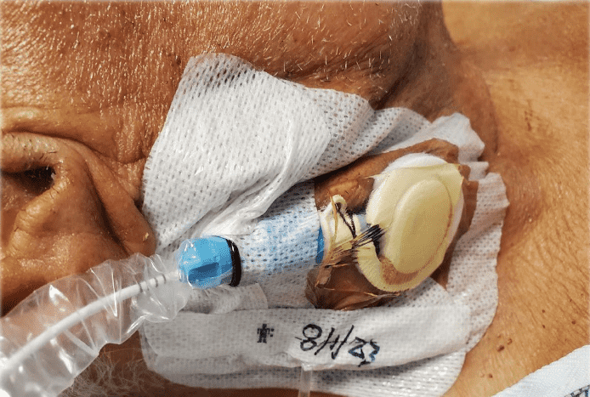**Step 2** of CLABSI prevention is **to maintain awareness and proper care of catheters in place**. Best practices should be implemented to prevent MRSA during maintenance.1
* Below are the most widely recognized best practices associated with central line maintenance.2-5

## Central Line Site Care2,5

* Assess central line sites regularly, particularly for any pain and redness.
* Ensure dressings are clean, dry, intact, and sealed. Loose or leaking dressings must be changed immediately.

## Hub Disinfection6

* [**Scrub the hub**](https://www.youtube.com/watch?v=x96cU3_Nkas)**.**: All parts of the hub, including connection and access ports, should be scrubbed with chlorhexidine-, alcohol-, or povidone-iodine-based disinfectant.
* Only sterile devices should be used to access the hub. The importance of this should not be overlooked.
* IV tubing and administration sets should be replaced every 7 days.
* Tubing used for blood products, parenteral nutrition, and lipids should be replaced every 24 hours.

## Central Line Dressing Change5,7

* The preferred choice of dressing is a transparent dressing that contains chlorhexidine (CHG).
* Central line dressings should be changed every 5 to 7 days or sooner if they become loose, damp, or soiled.
  + A CHG-based antiseptic should be used to clean the site with every dressing change.
* If the site oozes, has blood accumulating underneath the dressing, or is not properly adhering to the skin, then a gauze dressing can be used instead.
  + Gauze dressings need to be changed every 2 days.

## Daily CHG Bathing (unless contraindicated)8-13

* All areas of the skin should be cleaned every day, with care to avoid the eyes and ear canals.
* Six inches of every line, tube, or drain nearest to the body should also be cleaned with CHG.
* For more on CHG bathing, refer to the [**Decolonization section of the ICU & Non-ICU toolkit**](https://www.ahrq.gov/hai/tools/mrsa-prevention/toolkit/decolonize-patients.html).

## Daily Review of Line Necessity and Prompt Removal of Unnecessary Lines14-17

* A systematic evaluation of all central lines should be conducted daily by a multidisciplinary team.
  + Lines should be discussed at each handoff.
* Evaluation should be conducted case by case to assess each patient’s individual status.

# References

1. A Playbook for Preventing CLABSI and CAUTI in the ICU Setting. Agency for Healthcare Quality and Research and Quality. <https://www.ahrq.gov/hai/tools/clabsi-cauti-icu/implement/playbook.html>. Accessed January 17, 2024.
2. Toolkit for Preventing CLABSI and CAUTI in ICUs. Agency for Healthcare Research and Quality.<https://www.ahrq.gov/hai/tools/clabsi-cauti-icu/index.html>. Accessed January 17, 2024.
3. APIC Implementation Guide: Guide to Preventing Central Line-Associated Bloodstream Infections. Association for Professionals in Infection Control and Epidemiology. <https://apic.org/Resource_/TinyMceFileManager/2015/APIC_CLABSI_WEB.pdf>. Accessed January 17, 2024.
4. Central Line-Associated Bloodstream Infections Toolkit and Monograph. The Joint Commission. <https://www.jointcommission.org/resources/patient-safety-topics/infection-prevention-and-control/central-line-associated-bloodstream-infections-toolkit-and-monograph/>. Accessed January 17, 2024.
5. Buetti N, Marschall J, Drees M, et al. Strategies to prevent central line-associated bloodstream infections in acute-care hospitals: 2022 Update. Infect Control Hosp Epidemiol. 2022;43(5), 1-17. PMID: 35437133.
6. Rupp ME, Yu S, Huerta T, et al. Adequate disinfection of a split-septum needleless intravascular connector with a 5-second alcohol scrub. Infect Control Hosp Epidemiol. 2012;33(7):661-5. PMID: 22669226.
7. Reducing CLABSI Toolkit: Appendix 3: Guidelines to Prevent Central Line-Associated Blood Stream Infections. Agency for Healthcare Research and Quality. <https://www.ahrq.gov/hai/clabsi-tools/appendix-3.html>. Accessed January 17, 2024.
8. Climo MW, Yokoe DS, Warren DK, et al. Effect of daily chlorhexidine bathing on hospital-acquired infection. N Eng J Med. 2013;368(6):533-42. PMID: 23388005.
9. Sharara SL, Maragakis LL, Cosgrove SE. Decolonization of *Staphylococcus aureus*. Infect Dis Clin North Am. 2021;35(1):107-22. PMID: 33303331.
10. Kassakian SZ, Mermel LA, Jefferson JA, et al. Impact of chlorhexidine bathing on hospital-acquired infections among general medical patients. Infect Control Hosp Epidemiol. 2011;32(3):238-43. PMID: 21460508.
11. Huang H-P, Chen B, Wang H-Y, et al. The efficacy of daily chlorhexidine bathing for preventing healthcare-associated infections in adult intensive care units. Korean J Intern Med. 2016;31(6):1159-70. PMID: 27048258.
12. Huang SS, Septimus E, Kleinman K, et al. Chlorhexidine versus routine bathing to prevent multidrug-resistant organisms and all-cause bloodstream infections in general medical and surgical units (ABATE Infection trial): a cluster-randomised trial. Lancet. 2019;393(10177):1205-15. PMID: 30850112.
13. Pallotto C, Fiorio M, De Angelis V, et al. Daily bathing with 4% chlorhexidine gluconate in intensive care settings: a randomized controlled trial. Clin Microbiol Infect. 2019;25(6):705-10. PMID: 30267930.
14. Lederle FA, Parenti CM, Berskow LC, et al. The idle intravenous catheter. Ann Intern Med. 1992;116(9):737‐8. PMID: 1558345.
15. Parenti CM, Lederle FA, Impola CL, et al. Reduction of unnecessary intravenous catheter use: internal medicine house staff participate in a successful quality improvement project. Arch Intern Med. 1994;154(16):1829‐32. PMID: 8053750.
16. Pronovost P, Needham D, Berenholtz S, et al. An intervention to decrease catheter-related bloodstream infections in the ICU. N Engl J Med. 2006;355(26):2725-32. PMID: 17192537.
17. Berenholtz SM, Pronovost PJ, Lipsett PA, et al. Eliminating catheter-related bloodstream infections in the intensive care unit. Crit Care Med. 2004;32(10):2014-20. PMID: 15483409.

AHRQ Pub. No. 25-0007

October 2024