Mini Presentation:
Performing a Premortem Project Assessment
ICU & Non-ICU
Slide Title and Commentary | Slide Number and Slide
Mini Presentation: Performing a Premortem Project Assessment  SAY:  Welcome to this mini presentation on why and how to use a Premortem Project Assessment. | Slide 1  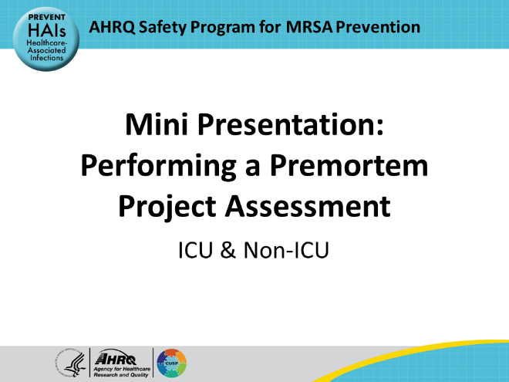
Educational Objectives  SAY:  At the end of this presentation, participants will understand the purpose of the Premortem Project Assessment, how to use the Premortem Project Assessment Tool, and will have an understanding on how to ensure results from holding a premortem project assessment are actionable. | Slide 2  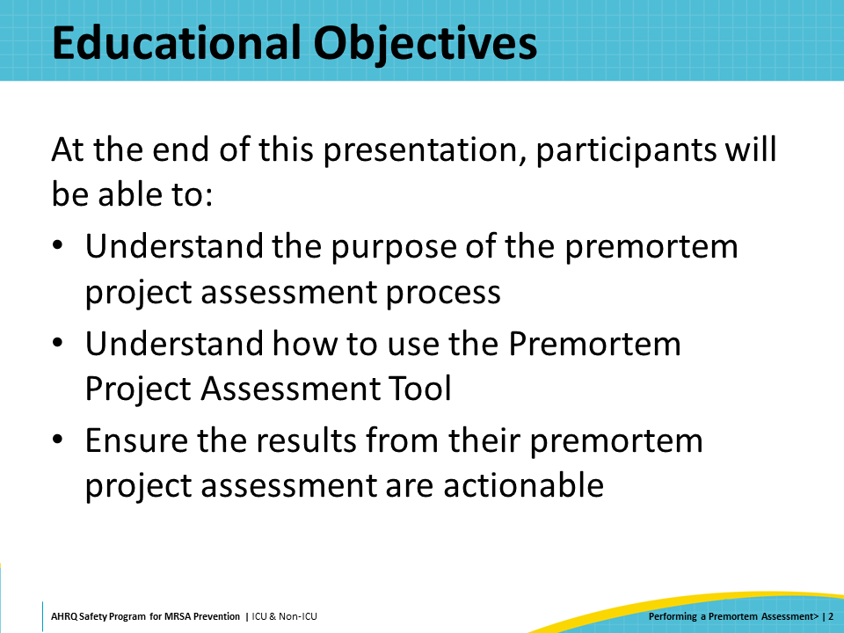
Failure in Quality Improvement Programs  SAY:  While not many studies have been conducted on success or failure rates for quality improvement programs in healthcare, several articles in quality improvement journals have stated they believe that 50 to 70 percent of the organizational changes involving these programs are not sustained.  There are many reasons such programs can fail. Some examples include inadequate education for staff, a lack of buy-in for the program, insufficient resources or essential supplies at kick-off, and so on.  All these reasons are possible, but they are not inevitable.  Performing a Premortem Project Assessment before you start your quality improvement program could help you push your program into the 50 percent that succeed. | Slide 3  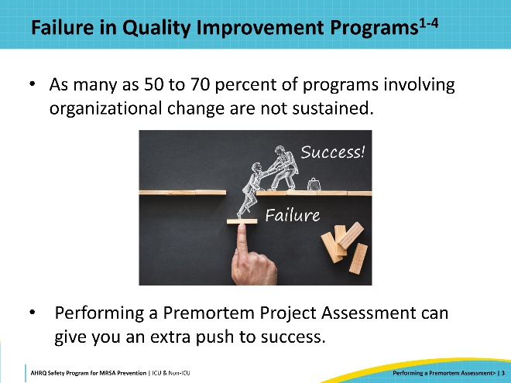
What Is a Premortem Project Assessment?  SAY:  Usually, people look at failed projects in post-mortem project analysis. They review what happened and say, “If we had only known that this was the reason that this project failed, we could have kept it from happening. We could have taken steps to fix the problems before we started.” And while that information might be useful for the next project, it doesn’t help the failed project that started with good intentions.  So, what if you could determine your team’s possible failure points before you start a new project? What if there was a magic telescope that could look into the future and let you see what is going to happen with your MRSA prevention program?  Mitchell et al. published an article on this topic in 1989. They found that if you can look at an upcoming event as though it has already happened, it makes it easier for you to anticipate what might cause the event.  That is what a Premortem Project Assessment can help you do. A premortem analysis is a technique wherein you and your team look forward to the end of the project and imagine that it has failed. Ask your team: What could have happened? What could have gone wrong? And, most importantly – since you are just at the start of the project – what can you do to keep that failure from happening? | Slide 4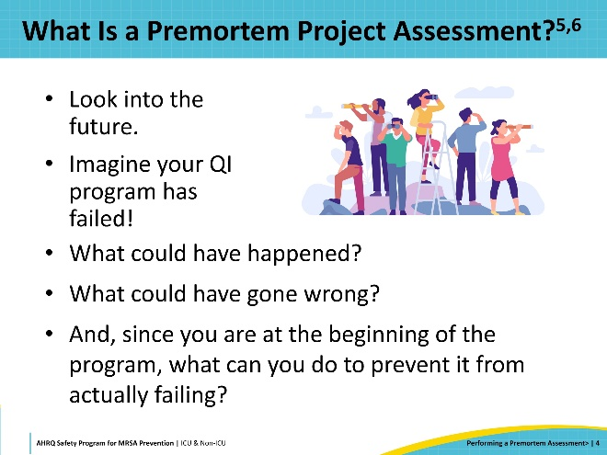
What Are the Benefits of a Premortem Project Assessment?  SAY:  There are other benefits to using this technique.  - Gain prospective hindsight: Mitchell et al., in 1989, found about 30 percent of groups correctly identified failure points using this technique.  - Reduce overconfidence: Your group wants the project to succeed so badly that unconscious bias will lead the group to underestimate the risks. The Premortem Project Assessment can bring things back into perspective.  - Involve cross-functional teams: When you schedule your Premortem Project Assessment, make sure you invite representatives from all stakeholder groups. For instance, if your interventions include setting up a decolonization program, make sure that leaders from Supply Chain are invited. If you plan to focus on improving environmental cleaning, invite members of the environmental cleaning team.  - Align on project risks: Performing a Premortem Project Assessment can ensure that everyone is aware of the potential failure points and, if something does start to happen, it will be caught and addressed much more quickly.  - Take action to increase the probability of success: The most important benefit of the Premortem Project Assessment is the opportunity to make plans and take actions to mitigate the risks that are identified. This increases the chances for the project to be successful! | Slide 5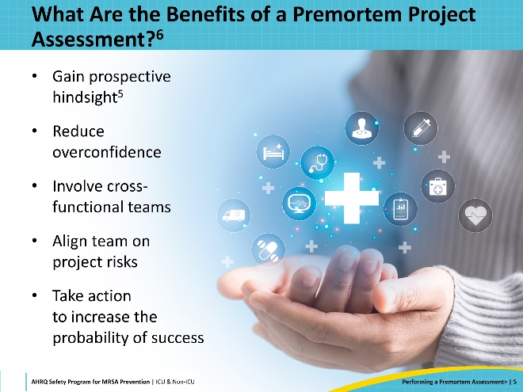
Your Premortem Project Assessment  SAY:  To start your Premortem Project Assessment, set up a meeting and invite the Comprehensive Unit-based Safety Program (CUSP) team and all key stakeholders for your program to it. Make sure to schedule your meeting with plenty of time to discuss all concerns.  This is a brainstorming exercise – so set up some easels, or use Post-its, or a white board on Zoom. Imagine and talk about why your program “failed.” What could have gone wrong? Can you foresee staffing issues? Educational issues? Concerns around buy-in? These issues are quite common. However, your team knows your unit. What might cause a failure specifically for your new program? | Slide 6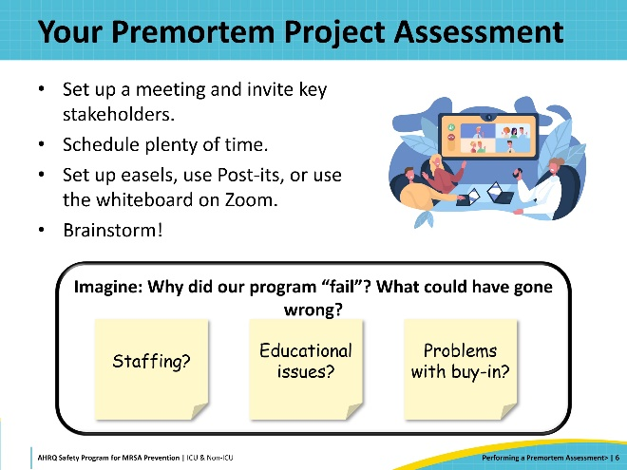
Comprehensive Unit-based Safety Program (CUSP) Premortem Project Assessment  SAY:  Brainstorm reasons things might have ended badly and write them down. After everyone has contributed and you feel you have a good group of reasons for failure, rate the reasons by level of concern from 1 to 5, where 1 is lowest concern.  Choose a few of the reasons you feel have the highest levels of concern and discuss each one, with an eye to determining action steps to prevent that failure.  At the end of this process, you should have several action plans to forestall the failure of your program and increase its likelihood of success.  You can download a copy of the CUSP Premortem Project Assessment Tool from the Toolkit website. | Slide 7  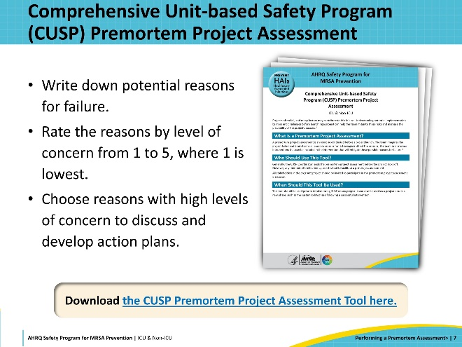
Now What?  SAY:  Take those action plans and weave them into the plans you are putting in place for your program. Assign tasks to members of the team based on the interventions you have identified.  If staff education is a foreseeable problem, you may want to assign the task to the nurse educator. Their responsibility will be to draft plans to educate staff, to have periodic reviews, and to ensure new and temporary staff are educated on your program and their specific project responsibilities as they join your unit. They should check on the educational process regularly. Team members should report on their tasks at CUSP meetings to ensure everyone knows the plans are being carried out. | Slide 8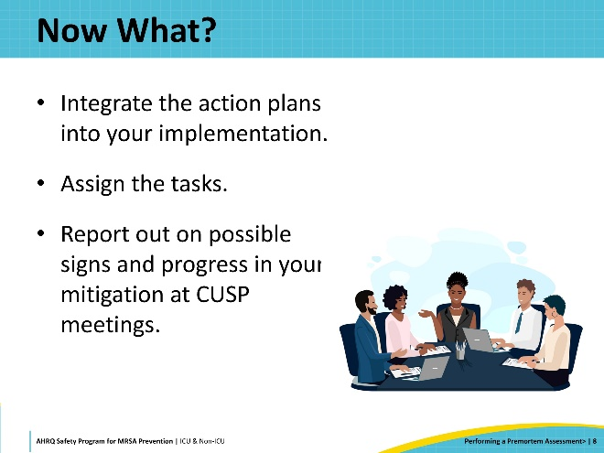
Repeat the Process  SAY:  It is a good idea to repeat the Premortem Project Assessment periodically– perhaps once a year or when you feel your program has reached the sustainability stage.  When repeating the process, you will go through the same steps. Upon entering the sustainability stage, you may think, “We have this process hardwired. Our staff know what to do and when to do it. We are ready to focus on a new problem. We have solved this one.”  But things change – staff move on, products you’re relying on go out of production, or prices may increase. You may lose executive support for the program.  These are times to meet again and look forward in time to imagine how all the progress you have achieved might fall apart. What could have happened? What can we do to keep it from happening?  Performing a regular Premortem Project Assessment can help keep your program going strong. | Slide 9
Key Takeaways  SAY:  Perform a Premortem Project Assessment before you begin your QI program. This assessment will help you ensure your program runs more smoothly.  Use the assessment to imagine a time when your program is failing. Make sure you invite key stakeholders for the program to the meeting. Everyone’s input is important.  Determine the most likely reasons for failure.  Develop plans and strategies to prevent those foreseen potential failures.  Implement your new plans and strategies together with your program to ensure your program is a success. | Slide 10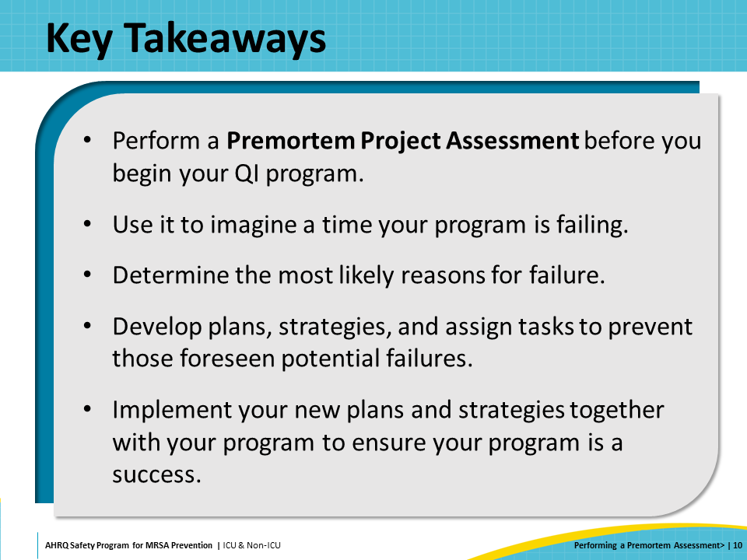
Disclaimer  SAY:  The findings and recommendations in this presentation are those of the authors, who are responsible for its content, and do not necessarily represent the views of AHRQ. No statement in this presentation should be construed as an official position of AHRQ or of the U.S. Department of Health and Human Services.  Any practice described in this presentation must be applied by healthcare practitioners in accordance with professional judgment and standards of care in regard to the unique circumstances that may apply in each situation they encounter. These practices are offered as helpful options for consideration by healthcare practitioners, not as guidelines. | Slide 11  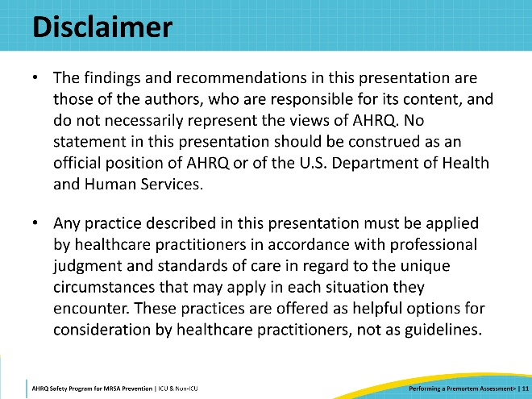
Reference List—1 | Slide 12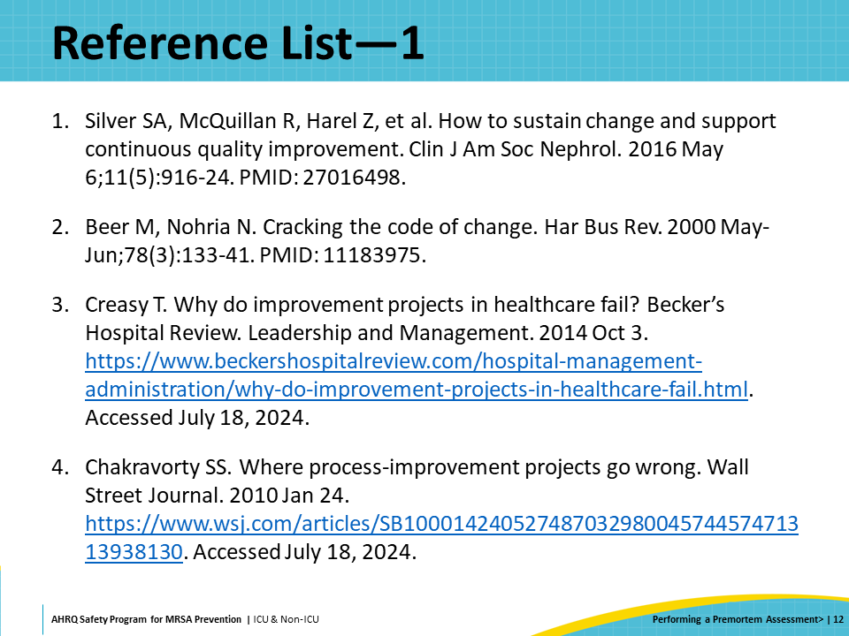
Reference List—2 | Slide 13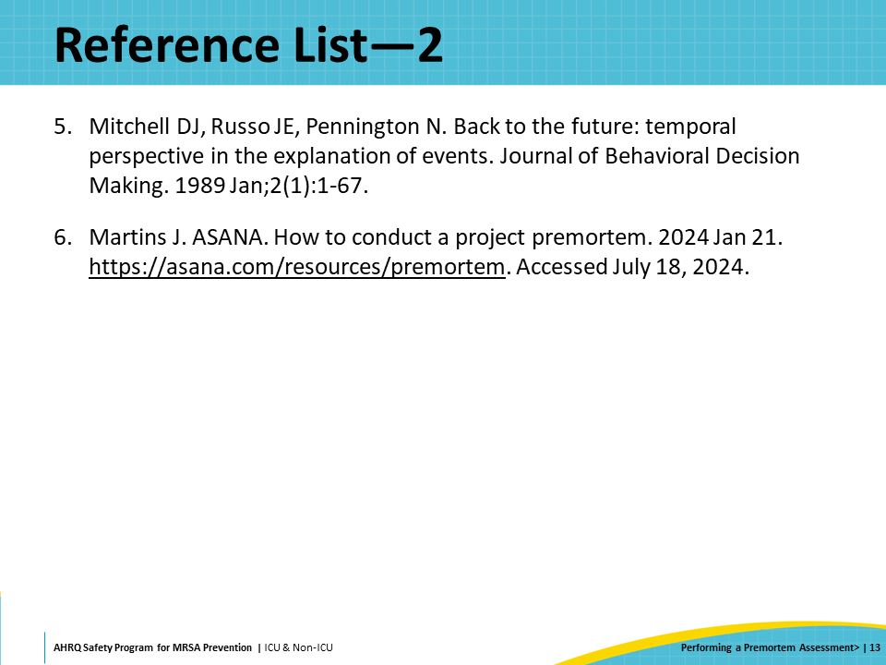

AHRQ Pub. No. 25-0007
October 2024

