What Are the 4 Es?
ICU & Non-ICU
Slide Title and Commentary | Slide Number and Slide
What Are the 4 Es?  SAY:  This presentation reviews the 4 Es, a framework to guide the implementation of patient safety interventions. This framework integrates well with the Comprehensive Unit-based Safety Program (CUSP).  The following slides describe how organizations can use the 4 Es to implement their MRSA prevention interventions. A case example is provided to show how the 4 Es might be used. | Slide 1  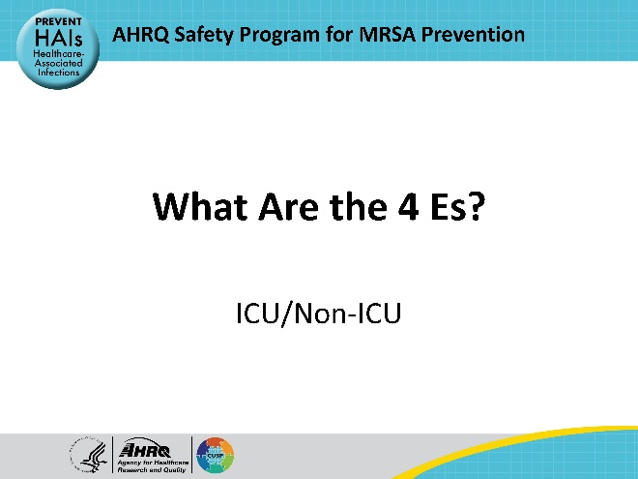
Educational Objectives  SAY:  By the end of this presentation, participants will be able to:  - Define the 4 Es framework—Engage, Educate, Execute, Evaluate—and explain its significance in implementing effective interventions.  - Identify common implementation barriers within their systems and how each component of the 4 Es can address these barriers.  - Implement and prioritize interventions based on the 4 Es framework to address identified issues.  - Disseminate findings and results to stakeholders using the 4 Es framework to ensure widespread understanding and adherence to best practices. | Slide 2  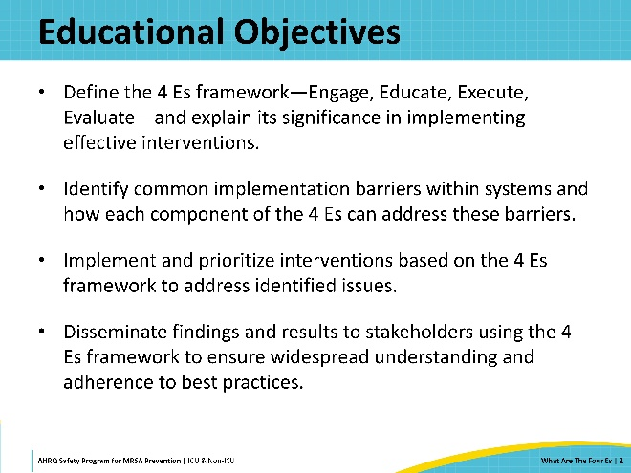
Using the 4 Es Framework  SAY:  The AHRQ Toolkit for MRSA Prevention utilizes the CUSP 4 Es framework because it is straightforward and effective. The 4 Es are designed to address both adaptive and technical challenges. Technical challenges are usually easily identified and can be addressed by education and implementation of evidence-based practices. Adaptive challenges are more complex and involve peoples’ beliefs, behaviors, feelings, values, and preferences. Adaptive challenges are therefore harder to identify and address.  The 4Es stand for: Engage, Educate, Execute, and Evaluate. These describe four basic components of implementation.  Engage: Engaging people in the patient safety process includes encouraging open communication, active participation, and empowerment among all members of the healthcare team. Engaged individuals are more likely to identify safety hazards, report incidents, and contribute to developing and implementing safety improvements.  Educate: Educating people on patient safety and best practices ensures that they are equipped with the knowledge and skills to identify safety issues and implement solutions effectively.  Execute: Execution refers to the implementation of patient safety interventions based on identified issues. This step involves putting plans into action, which may include changes to policies, procedures, protocols, or workflows.  Evaluate: Evaluation is an ongoing process of monitoring and assessing the effectiveness of interventions. Regular evaluation helps identify areas of success, areas for improvement, and any unintended consequences of implemented changes.  A brief one-page summary of the 4 Es is available on the Toolkit website.  If your hospital already has a CUSP program, the departmental or unit-based CUSP teams can be a great resource to help support implementation. CUSP team champions can assist with assessments of unit culture, determining future education needs, updating policies and procedures, and conducting common-cause analyses. For more on CUSP teams and how they can assist, please refer to the page on “Integrating a CUSP Approach” on the Toolkit website. | Slide 3  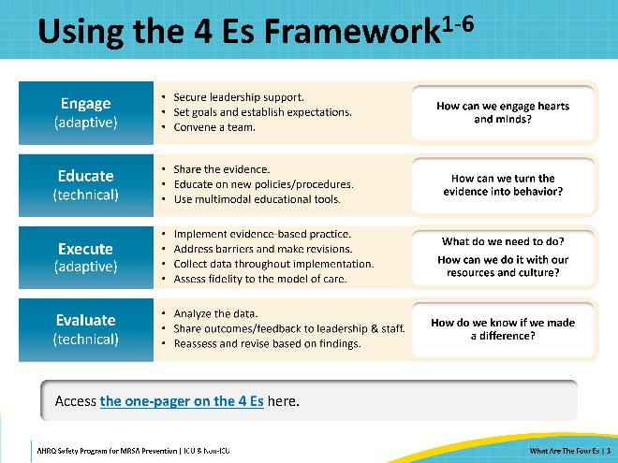
Case Example: St. Misfortune’s Hospital  SAY:  In the following slides, we will follow a case example that illustrates how a hospital can utilize the four Es framework.  St. Misfortune’s Hospital is an older, small community hospital that has been experiencing a major shortfall in available resources.  St. Misfortune’s has many chronic issues. Among them is a MRSA rate that is well above the average for similar hospitals in the region.  Last month, MRSA rates at the hospital exceeded 15 infections per 1,000 patient-days. Clinicians and personnel decide to set up a MRSA Prevention Team to comprehensively examine and address the problem. | Slide 4  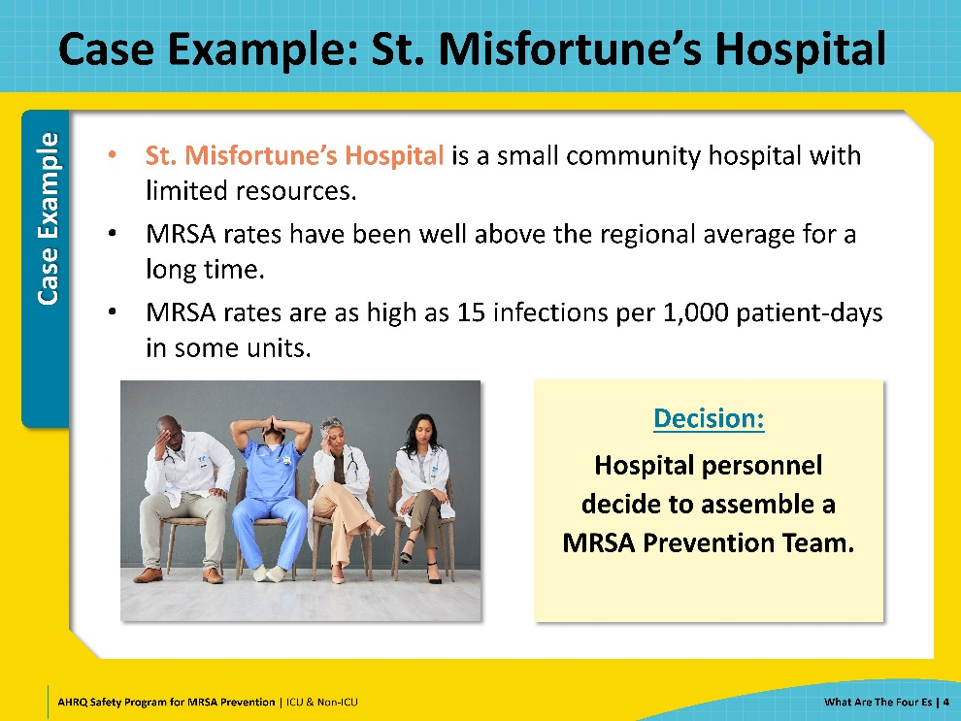
Engage  SAY:  The first E stands for Engage. The aim is to engage hearts and minds, and subsequently change attitudes and behaviors. Changing attitudes and behaviors is the adaptive or cultural component of safety interventions, which is sometimes overlooked. Getting people to understand the impact of their contributions and the importance of intervention establishes the groundwork to realize and sustain change. People need to buy in and have an active stake in the outcomes.  Engagement is not a one-way process—the goal is not only to make individuals aware of the problem, but also involve them and invite their contributions to improvement. Improvement teams must foster open communication, encourage collaboration, and invite all to share input and feedback freely. Making sure everyone feels heard and supported is key to engagement.  Engagement occurs on multiple fronts. Key groups for engagement include team members, senior leadership, and frontline staff. | Slide 5  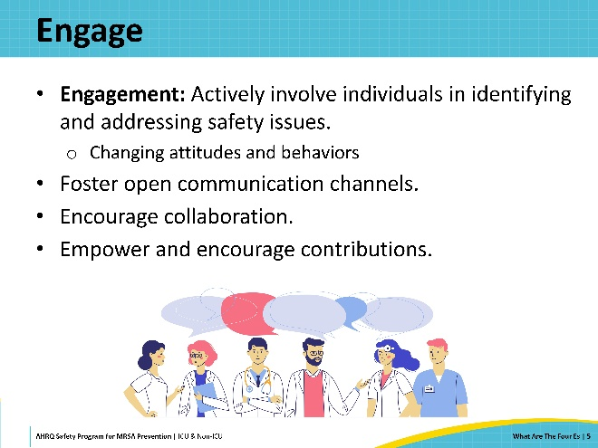
Engage: Convene the Team  SAY:  Engagement is an important part of assembling and sustaining your improvement team. Team members should be active, interested, and involved in the program. Team members who understand the problem's depth and the intervention processes will be engaged. The key to an effective team is to stay on top of issues identified and to follow through until resolution.  Representation is important when convening a team. Ideally, the team will include people from every role that is relevant to the problem you're facing. This includes representatives from not only clinical disciplines, but other personnel such as those in the environmental services or the supply chain departments. The diversity of perspectives reduces the chances that something might be overlooked. Any others interested in participating should also be welcomed.  Recruiting a senior executive to be a team member is recommended. Having an engaged and active senior executive on the team can help in many ways—by prioritizing safety initiatives, identifying resources, addressing barriers, connecting the team to stakeholders and personnel, and ensuring that the team’s efforts align with organization’s strategic goals.  For more details on assembling the team, please refer to the Assemble the Team and Engage the Senior Executive sections of the AHRQ Core CUSP Toolkit. | Slide 6  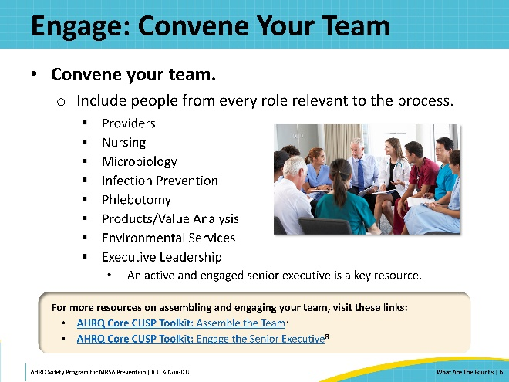
Engage: Secure Leadership Support  SAY:  An important early step of any implementation strategy is to engage the leadership of your organization. The goal is for leadership to support and have an active stake in the outcome—not just sign off on the project. It is important for all levels of leadership to see the value in the work being done to reduce preventable harm. Support from leadership assists throughout the program by providing access to the necessary resources for implementation and mitigating and removing barriers that arise during implementation.  First, you need to articulate the concern. You need to make the leadership aware of the severity of the problem and the magnitude of the preventable harm. This can be done by sharing organization-wide baseline data and presenting existing standards and benchmarks for comparison. When engaging with leadership, it’s particularly important that you have sufficient baseline data to support your program—ideally, 6 months of data or more.  Don’t underestimate the impact of storytelling. Sharing stories about patients who were affected by the problem is a powerful tool for engagement. Later, sharing stories of success when the potential harm was averted can help reinforce engagement.  Next, you need to communicate the benefits of the proposed solutions and to establish the goals of your intervention. Use current evidence and published literature to support the intervention’s efficacy.  A business case can also be particularly useful when seeking leadership engagement. A long-term plan will be persuasive; make sure you can discuss the ongoing commitment and the resources needed to keep the program in place and sustain the results. Review existing policies to ensure clear procedures.  Support from senior leadership is important for shaping the priorities and goals of intervention. Collaboration with leadership helps to align project goals with organizational strategic priorities. Communicating and mutually developing goals helps to ensure that everyone has shared expectations of what success will look like.  Here are the links for more tips on how to engage with your senior leadership.  - AHRQ Core CUSP Toolkit: Engage the Senior Executive  - CUSP Toolkit: Engage the Senior Executive (Video)  - CUSP Tip Sheet on Engaging Senior Leaders in MRSA Prevention (.docx) | Slide 7  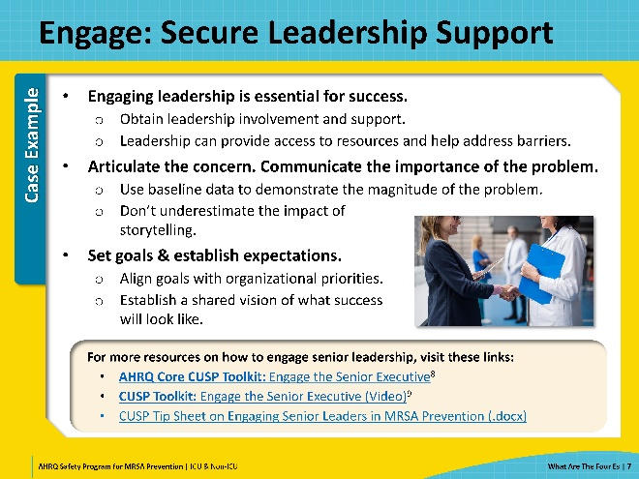
Engage: Set and Communicate Goals  SAY:  When setting and communicating goals, first determine the scope of implementation—whether it will be targeted to a few units, or organization-wide.  Next, determine the appropriate metrics and benchmarks. When defining and communicating the goals of your intervention, use the available baseline data and explain how your project will affect these metrics.  Part of setting goals is to ensure that you have the data collection, analysis, and reporting capabilities to measure and track your chosen outcomes. Consider the processes and resources required to collect and analyze these data.  Leadership can help you align intervention targets with organizational goals and strategic priorities that may already be in place. Communicating and mutually developing your goals will help ensure that everyone has shared expectations of what success will look like. Discuss in detail what you want to accomplish and what will need to happen to get the best results.  Consider including requirements for a unit-based action plan to ensure local leadership engagement and accountability. | Slide 8  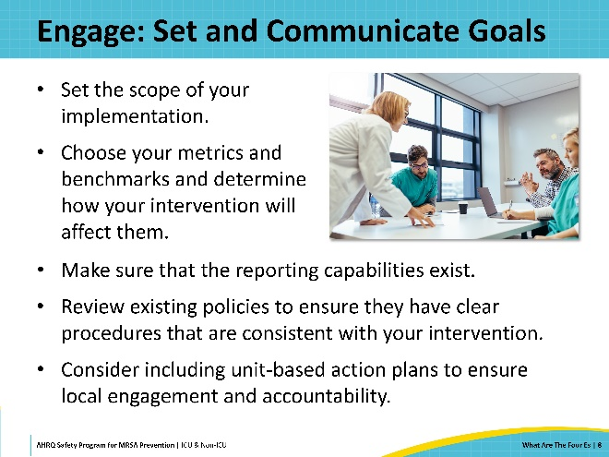
Case Example: Convening the Team and Engaging Leadership  SAY:  At St. Misfortune’s Hospital, the staff assemble a team to focus on the MRSA problem. They identify and engage with individuals from multiple roles and departments and recruit them to the team. The team includes physicians, nurses, nursing aides, and personnel from Microbiology, Infection prevention, and Environmental Services. The team also includes a representative from the Finance team, whose role doesn’t directly deal with MRSA, but he became very interested after learning about the financial impacts of MRSA infection and wanted to join the team.  The team begins meeting with unit and hospital leaders to raise awareness and gain support. They focus on communicating the problem. They present hospital data from the past 2 years to demonstrate convincingly that the MRSA rates are an ongoing issue and not just a recent occurrence.  The team also seeks to recruit a senior executive team member who can connect them with stakeholders, facilitate access to resources, and help to address barriers. The team approaches the recently appointed Vice President of Information Technology. The VP doesn’t have a clinical background and didn’t know about the MRSA problem, but once informed, she shows great enthusiasm and pledges to support the team in any way she can. She appears regularly at meetings and visits units in-person to learn directly about MRSA prevention practices. She ensures the MRSA problem stays high on the priorities of hospital leadership, and advocates on the team’s behalf within the institution. Working with their Finance team member, she also crafts a business case customized to St. Misfortune’s Hospital that provides a detailed estimate of the extra costs and adverse outcomes caused by the elevated MRSA rates and the potential benefits of preventing MRSA infections. This business case proves very persuasive among hospital leaders. | Slide 9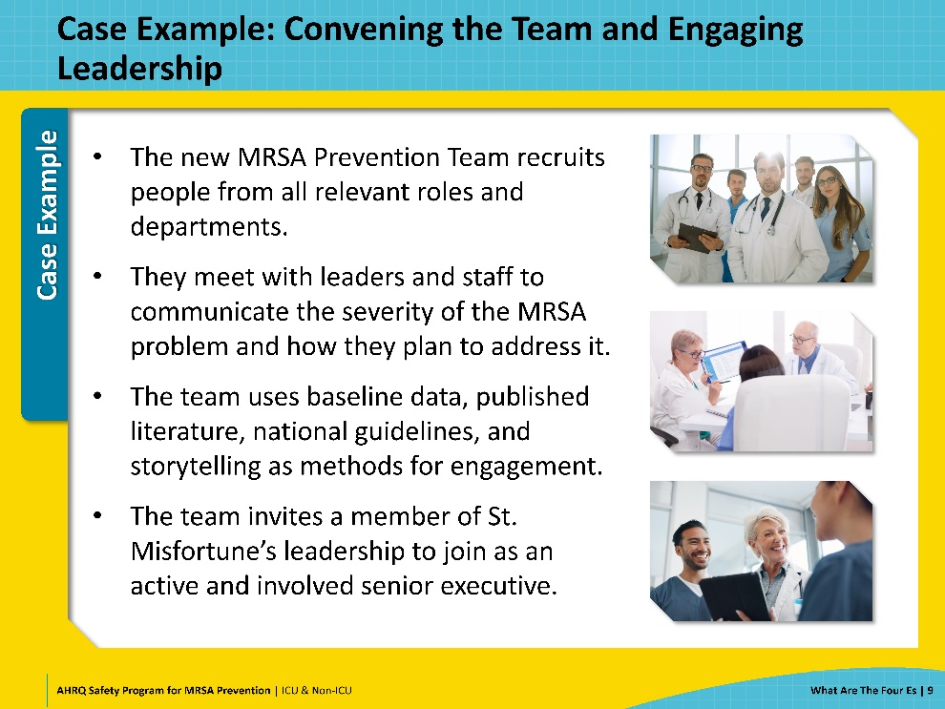
Engage: Frontline Personnel  SAY:  Engaging frontline personnel is a vital part of success for any implementation.  A common reason personnel may not seem engaged is because they don’t recognize that there is a problem. Particularly if the relevant data are not widely shared, staff may not be aware of the issue or the potential harm that the issue poses.  Engage bedside personnel in conversation and use educational tools and policy updates to convey the issue's importance.  Remember, engagement is not a one-way process. Engagement also means involving the personnel and inviting their input and contributions. This will help you determine the current situation, understand the barriers they are facing, and obtain their engagement for the project’s success.  Tips for engagement strategies can be found at these links.  - AHRQ Core CUSP Toolkit: Implement Teamwork and Communication  - CUSP Tip Sheet: Engaging Unit Staff in MRSA Prevention (.docx)  - CUSP Tip Sheet: Engaging Physicians in MRSA Prevention (.docx) | Slide 10  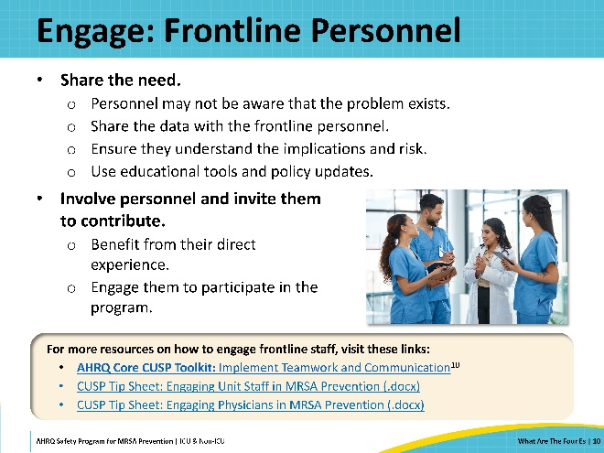
Engage: Assess Current Practice  SAY:  Assessing current practice is necessary before you can determine your scope, set your priorities, and plan your interventions. You need to obtain an accurate picture of how things currently stand. What is the current practice? How are things currently being run?  The best way to do this is to go to the gemba. Gemba is a Japanese word that refers to the “factory floor” or “the place where the work happens.” The phrase denotes that the most effective way to assess current practice is to go right to where the work is happening and gather information firsthand.  By going to the gemba, you can observe the actual workflows, engage and talk directly with frontline personnel, explore opportunities for improvement, and gain knowledge about what is actually happening.  Don’t assume that what you have written in policy is what’s done in practice. You may be surprised to discover how many shortcuts and workarounds are part of standard practice. Workarounds arise in response to barriers and challenges—staffing issues, supply shortages, changes in other workflows that have unintended downstream consequences, or other factors. Over time, a temporary quick fix becomes accepted as normal workflow and may be passed along to new personnel.  Engaging with frontline personnel directly is a part of the assessment process. They are experts on the challenges, workarounds, and opportunities for improvement because they do the work and deal with them daily.  Remember to consider variations in practices that may occur within the organization. Different units may have very different practices. You will need to account for these variations when rolling out your intervention in each unit. | Slide 11  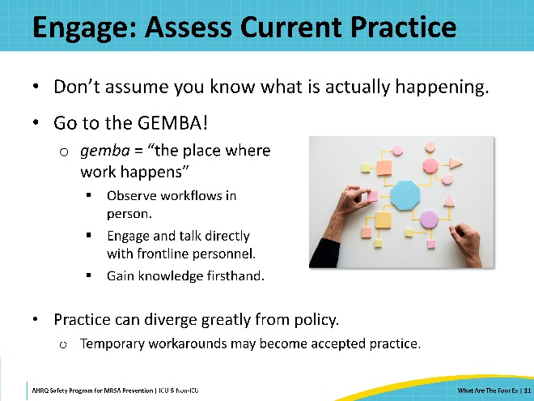
Case Example: Engaging Personnel and Assessing Current Practice  SAY:  St. Misfortune’s MRSA Prevention team visits all the units in-person—speaking at rounds, engaging and talking directly to the frontline personnel, and conducting observations of unit workflows.  The team quickly discovers staff are generally not aware of the MRSA problem at St. Miz. MRSA data are not shared widely through the hospital. Once the staff are informed of the high MRSA rates, they are eager and willing to help address the issues. Personnel are open and candid with the team when asked questions about their processes, including when they deviate from policy; they value the opportunity to contribute and give input.  From their observations, the MRSA Prevention Team learns that actual practices are very different from what they expected. Personnel often deviate from policy and best practices, and practices vary significantly between different units. The team conducts a closer review of the existing hospital policies and finds them to be confusing and inconsistent. Some policies and intervention bundles are not up to date with current guidelines. | Slide 12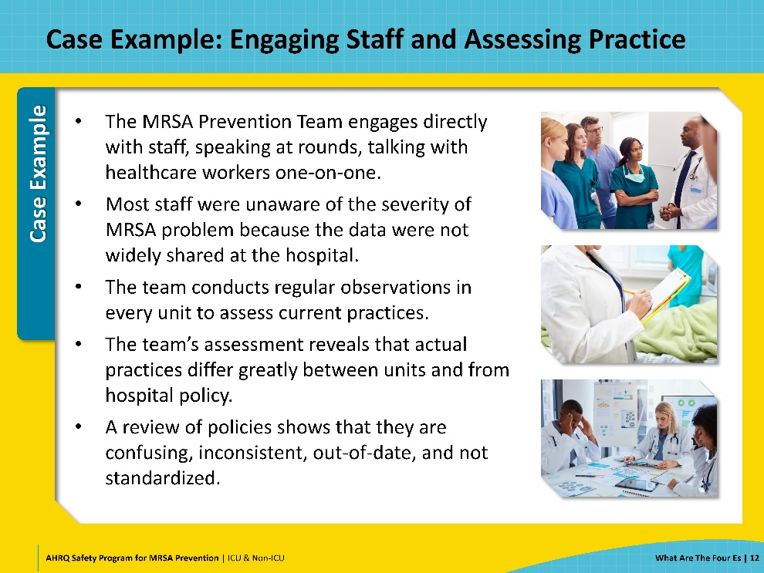
Engage: Identify Causes  SAY:  The next step is to identify causes and determine where opportunities for improvement exist. When a failure in the standard of care is identified, it’s important to examine beyond the “obvious” first reason. Healthcare is a complex system, and the problems are equally complex. There are always many contributory factors in healthcare that had to line up for an error to make their way through the layers of the system.  There are different methodologies you can use to investigate the causes, such as using a fishbone diagram, fault tree analysis, or a Root Cause Analysis. The method demonstrated on this slide is “the 5 Whys.”  The 5 Whys is a simple technique used to identify the root cause of a problem by asking "Why" repeatedly, each time probing deeper into the underlying causes until the underlying cause is revealed. It encourages thorough investigation and uncovering deeper issues rather than addressing only surface-level symptoms —recognizing how the upstream variables could be unknowingly affecting the outcome.  Begin by outlining a problem statement. Determine as a team “why” this happened. Then ask: “If this cause was corrected, is it likely that the problem would recur?” If yes, then keep asking “why.” In actual practice, you may have more or fewer than 5 whys.  Ideally, individuals with personal knowledge of what happened should participate in the analysis, as well as individuals with expertise and familiarity of the processes and systems.  For more on the 5 Whys and Root Cause Analysis, refer to the resources available at these links:  - CMS: Five Whys Tool for Root Cause Analysis  - CMS: Guidance for Performing Root Cause Analysis (RCA) with Performance Improvement Projects (PIPs) | Slide 13  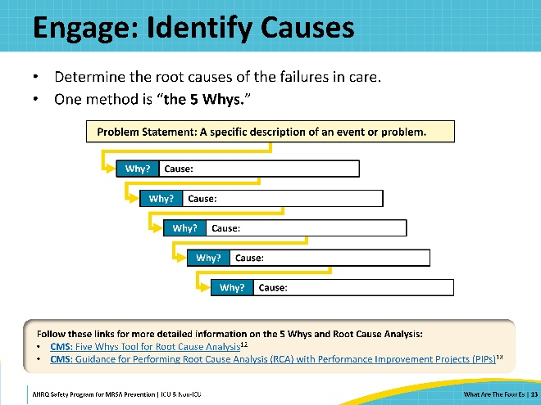
Case Example: Identifying Causes  SAY:  Back at St. Misfortune’s Hospital, the team identifies some key contributing factors.  The criteria for contact isolation precautions vary from unit to unit, which generates confusion.  There is no system in place at the hospital to optimize prescribing antibiotics.  Hand hygiene is currently tracked via a single question on a quarterly questionnaire for unit leaders. Observations suggest that actual hand hygiene compliance is far below what is reported.  Environmental cleaning processes are not assessed in any unit. The team reviews electronic records that show that daily cleaning is not always carried out.  The CLABSI prevention bundles for central line insertion and maintenance have not been updated to match current national guidelines.  Most unit personnel have not received adequate training in optimal blood culture collection techniques, resulting in contamination.  Although VAP prevention bundle was implemented 4 years ago, observations reveal that many of the practices are no longer being followed. | Slide 14  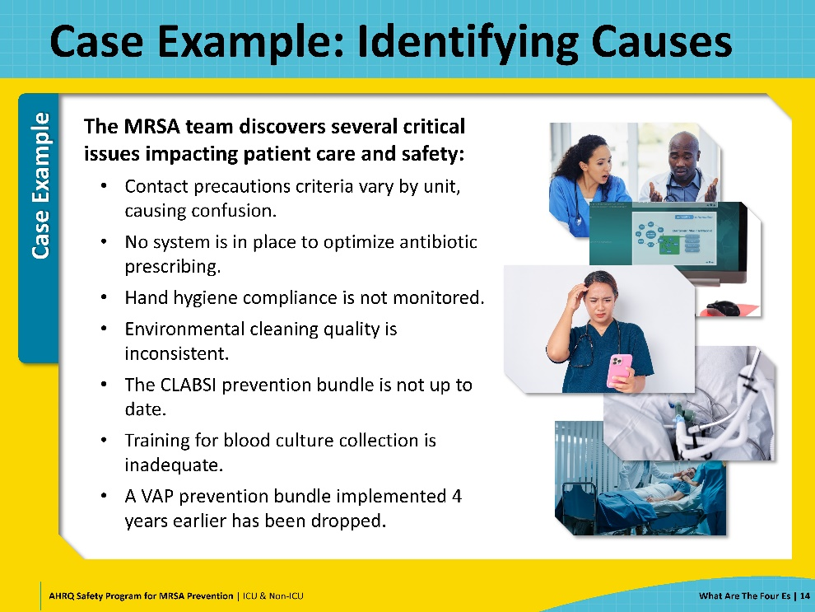
Engage: Prioritize Interventions  SAY:  Once you identify contributing factors, the results of your assessment should guide you in determining and prioritizing your interventions. The Action Hierarchy is a useful model to prioritize interventions. It categorizes actions as Strong, Intermediate, or Weak based on their level of impact.  Strong Actions are interventions that do not rely on human memory and behavior. These are enduring interventions that remove the possibility of individuals choosing an incorrect course of action or minimize the complexity and variability of a task.  Intermediate Actions reduce reliance on human behavior but do not fully eliminate it. These interventions are designed to provide guidance or aid memory and accommodate human limitations.  Weak Actions are interventions that support the process, but still rely mostly on humans to perform tasks correctly and avoid error. Weak interventions can still be very impactful as part of a multi-intervention improvement plan, combining with and reinforcing other interventions. They should not be used alone.  There may be more opportunities than can be addressed at once. In that case, consider prioritizing stronger actions, which rely less on humans and are more likely to lead to a consistent and sustainable improvement. | Slide 15  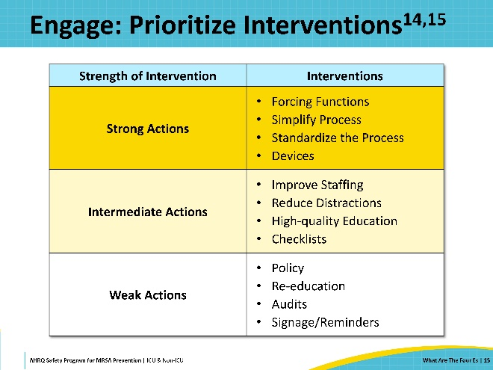
Case Example: Prioritizing Interventions  SAY:  The St. Miz MRSA Prevention Team prioritizes their interventions using the Action Hierarchy Model.  First, they prioritize strong interventions with immediate impact. They focus on installing a computerized clinical decision support system for antibiotic prescribing, mandatory EHR checklists, and automated alerts to reinforce CLABSI prevention practices.  In the short term, the team focus on implementing a program to monitor hand hygiene and standardizing contact precaution criteria across units. The team also updates and standardizes their CLABSI and VAP prevention policies.  For long-term improvements, they will conduct personnel training in quarterly workshops on blood culture collection and establishing consistent environmental cleaning protocols with standardized checklists and regular audits.  By using the Action Hierarchy model, the hospital aims to achieve significant and lasting improvements in patient care and safety, prioritizing strong actions for immediate impact, supported by intermediate and weak actions to further reinforce and sustain the changes. | Slide 16  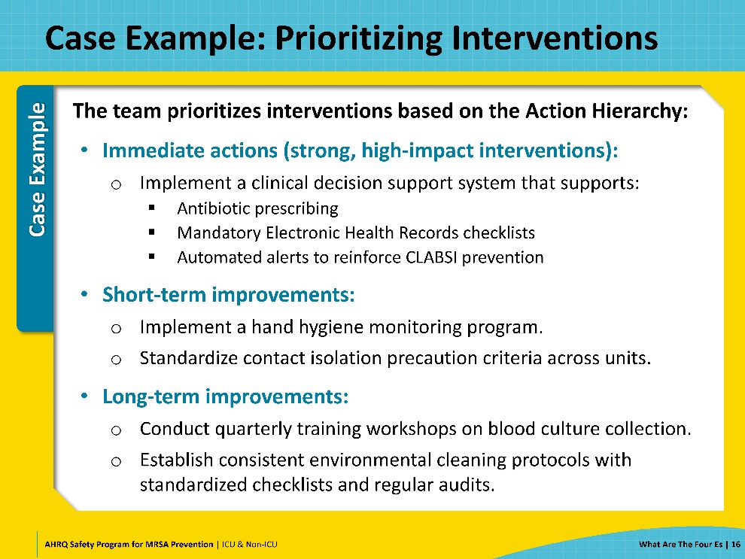
Educate  SAY:  The second E of the 4 Es is Educate. Education is the technical work in which the team transmits information to staff and senior leaders. As noted, education when implemented by itself is considered a weak action because it primarily relies on human memory and behavior. Education is important but most effective when it is used along with stronger interventions as part of a multi-modal performance improvement plan.  Educate personnel on the evidence to support the intervention and train them about how to perform the new procedures. This can be done with demonstrations, videos, or hands-on training. This should be reinforced at annual recertifications. Make the literature available to frontline staff or provide a synopsis of the evidence. Simulation-based education is more effective than didactic materials when teaching complex, multi-part skills.  Ensure that all policies have been read and approved by the unit leadership and then provide them to frontline personnel for review. Policy content should also be included in annual recertification, especially as changes occur and you need to assess whether personnel understand the policies and procedures for different populations if they vary from unit to unit.  Try to make your program as easy to implement as possible. Have a fast fact sheet available; ensure personnel have access to policies and references; use multiple methods of training; and listen to and address staff concerns. | Slide 17  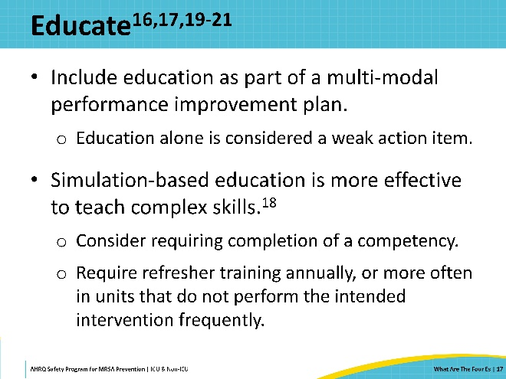
Case Example: Education Plan  SAY:  The MRSA Prevention Team implements a new education plan to effectively inform and engage their staff. They start by developing a variety of resources, including instructional videos, hands-on guides, and evidence summaries about MRSA prevention. These resources will ensure that staff have a thorough understanding of the new measures. They also plan to conduct interactive training sessions, which will feature live demonstrations and simulations, allowing staff to practice the new procedures in a hands-on environment.  Additionally, the team intends to integrate MRSA training into the annual recertification process, including assessments to verify staff proficiency with the new protocols.  Lastly, they are planning to make MRSA prevention policies easily accessible. They will require staff to review the policies and sign off on their understanding. The team will also provide educational fact sheets. This comprehensive plan is designed to ensure that the staff is well prepared and effectively equipped to implement MRSA prevention measures. | Slide 18  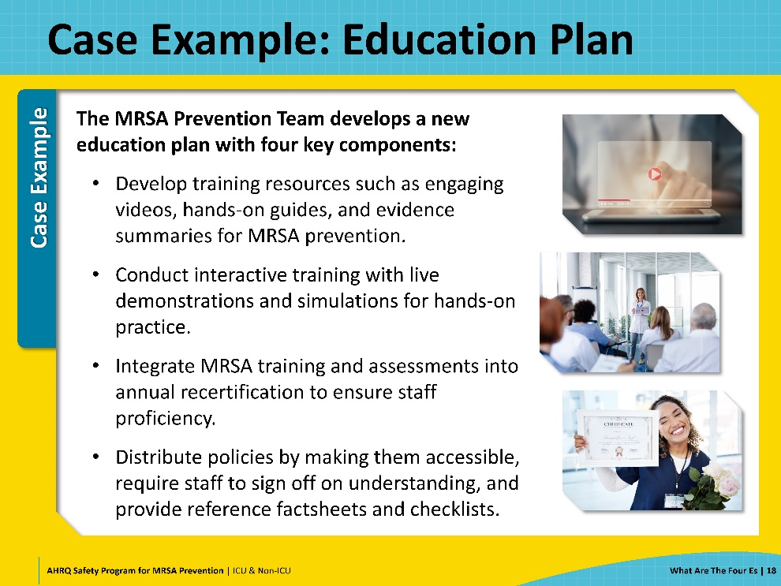
Execute  SAY:  The third E, Execute, is the step of putting your plans into action.  Preparation is extremely important. Personnel must be trained in how and when to perform the required tasks and use the materials. Supply inventory on the unit must be prepared. A method to document the intervention must be created. This may include assessing current electronic flow sheets to ensure the team can easily find accurate documentation of MRSA prevention activities.  Once everything is in place, you are ready to Execute your plans.  Successful execution is based on following the principles of safe system design:  - Simplify the system.  - Create redundancy.  - Learn from mistakes.  During execution, it is important to maintain open lines of communication among team members, with frontline personnel, and with hospital leadership. This facilitates coordination and allows the team to address issues promptly. Execution is when we discover shortcomings in our plan, so it is important to get feedback about the execution of the project from personnel about what worked well and what didn’t.  As the improvement strategies are implemented, continuous monitoring is essential to track progress. This involves regular meetings to review performance metrics to evaluate how well the execution aligns with goals, what obstacles or challenges have been identified, and what adjustments can be made to keep on target. Effective execution requires a dynamic approach, where feedback is actively sought, and adaptations are made in real time to address any emerging issues.  You also want to confirm that data on adherence to the interventions are being collected throughout the execution process. Ongoing data will be evaluated and compared to the baseline performance. Ensure your documentation is accurate and easily identified.  Additionally, you may want to observe the intervention in practice. Consider completing a random audit of a percentage of the patient population to assess if the measures are being implemented consistently. Maintaining fidelity to the model enables the long-term success of the program.  The aim of execution is not just to implement improvements, but to ensure the improvements are sustainable. This means embedding the new practices into daily routines and ensuring that personnel can and will continue to follow them consistently.  In the Execution phase, the guiding principle is to make it easy for people to make the right decision and do the right thing. | Slide 19  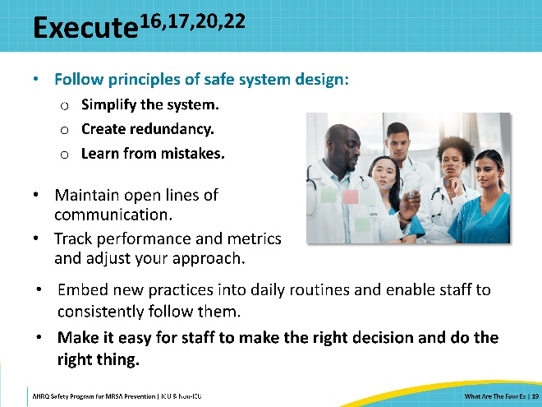
Case Example: Execute  SAY:  Let’s check back in with the MRSA Prevention Team and see how their plan is coming along.  - The team schedules their first hands-on training session for the end of the month. Staff are required to complete these sessions as part of their annual recertification, ensuring they are well prepared to implement the new protocols.  - To keep everyone informed, MRSA prevention policies have been uploaded to the hospital’s internal website.  - Quick reference fact sheets have been distributed to staff, who are required to electronically sign off to confirm their understanding of the new procedures.  - Random audits are planned to begin next month to observe and verify adherence to MRSA prevention practice.  - The team hold a weekly review meeting to assess performance metrics, gather staff feedback, and make necessary adjustments to improve execution. | Slide 20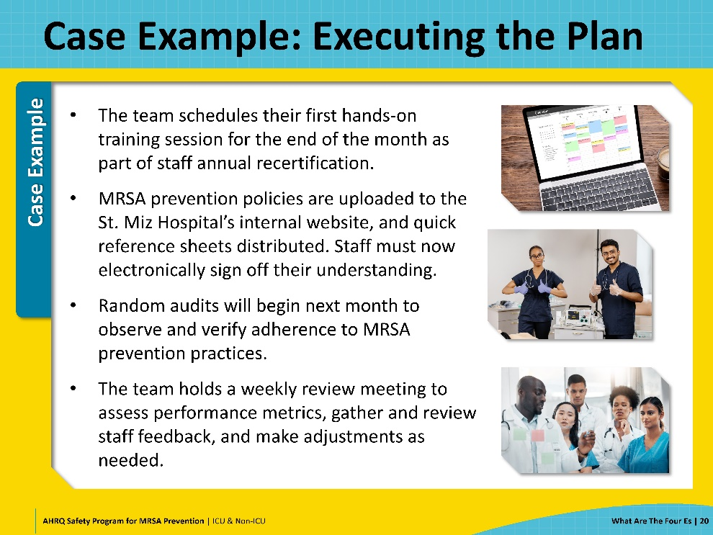
Evaluate: Surveillance and Feedback  SAY:  The 4th E stands for Evaluate. Data are collected, analyzed, and reported to track progress. This allows your team to review and learn from defects and to adjust interventions and approaches as needed. Continuous evaluation allows teams to track successes, identify challenges, and make improvements.  Your team should plan the method of analysis you will use prior to the go-live date. If you are implementing changes in more than one unit, data unique to a department or unit can help identify high versus low performers and early adopters. Lessons learned from the high performing units should be shared with units whose performance was less successful. Revise the interventions if further opportunities for improvement are identified. | Slide 21  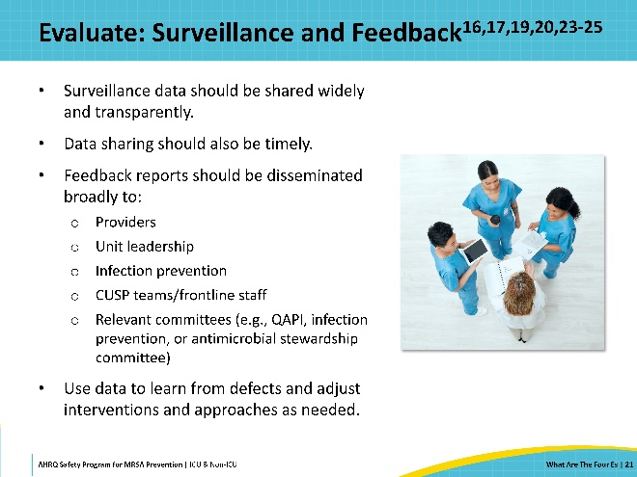
Disseminate Findings  SAY:  Communication is key to keeping everyone engaged and active in any quality improvement initiative. After all the hard work that goes into your intervention, disseminate your results to executive leadership, department chairs, mid-level management, and, very importantly, to frontline personnel. They need to know they made a difference in reducing MRSA and preventable patient harm. Relevant committees (for example, infection prevention or antimicrobial stewardship) and hospital leaders should be included in feedback reports to foster ongoing engagement.  Data should always be shared in a timely manner. Some organizations may be able to leverage their electronic health records to even provide near real-time reports. Celebrate your successes and investigate the reasons your adherence rates may not be as high as you would like. Remember as you share data, you will continue to ensure your unit’s project remains visible and a priority. | Slide 22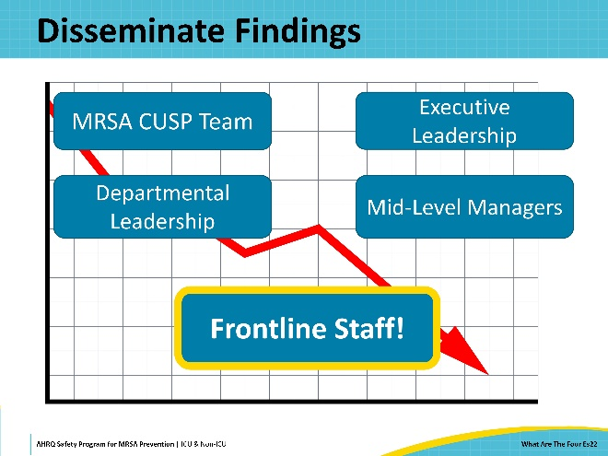
Case Example: Evaluating  SAY:  At St. Misfortune’s, the MRSA Prevention Team collects and shares key performance data through dashboards available to unit leaders and staff. These dashboards provide information on MRSA infections, CLABSI, VAP, and antibiotic usage patterns. The team strives to ensure this data is updated as close to real-time as possible.  The team also monitors several process measures related to their interventions. The computerized decision support system enables tracking of alert acknowledgements, completion of checklists, and how often the clinical decision support system is used. Audits are conducted to assess unit adherence to best practices, including CLABSI prevention, VAP prevention, and blood culture collection. This performance data helps to identify quickly when a unit is struggling, and to address issues promptly. Compliance data is also shared regularly with units so they can be aware of their progress. The team also collaborates with Environmental Services to implement a fluorescent gel monitoring system to evaluate environmental cleaning.  The team also tracks completion of the annual MRSA prevention training and attendance at hands-on training sessions.  To gain a broader understanding of the hospital’s safety culture, the team decides to administer a survey to get staff perceptions on patient safety. Staff are asked to anonymously evaluate aspects of patient safety culture. The survey is administered before implementation to establish a baseline; the team intends to repeat the survey every 6 months. | Slide 23  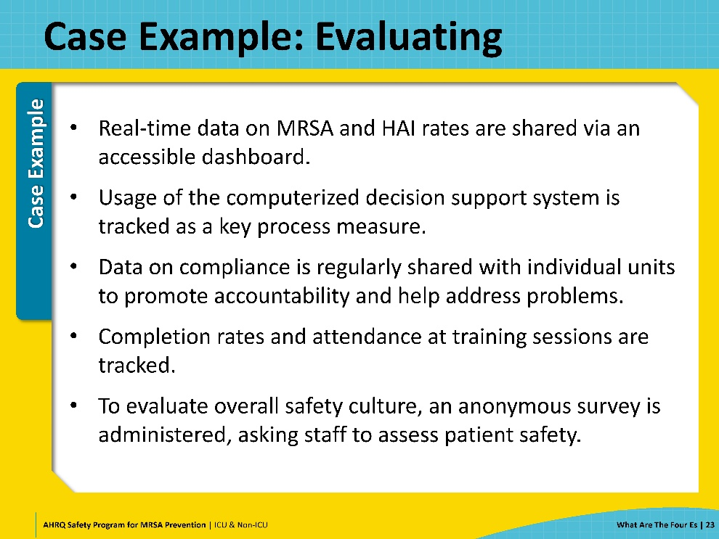
Sustain and Celebrate!  SAY:  The 4 Es – Engage, Educate, Execute, Evaluate - is a continuing process that doesn’t end after your initial implementation. For your program to succeed and to ensure long-term sustainability, you need to continue cultivating engagement, providing education, adapting your execution of interventions, and maintaining evaluation.  Remember to celebrate success! Recognizing improvement and acknowledging achievements are important to reward and reinforce engagement, making improvements more likely to last. | Slide 24  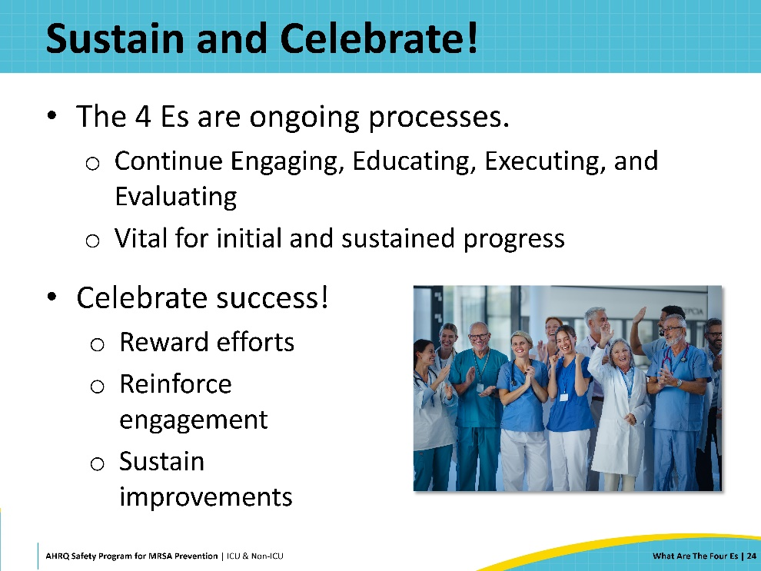
Case Example: Evaluate  SAY:  After a year of implementing the plan, let’s review the results achieved by the St. Misfortune’s Hospital MRSA Prevention Team.  Weekly review meetings are held to address staff feedback and performance metrics, leading to ongoing improvements. Regular feedback reports are provided to providers, unit leadership, infection prevention teams, CUSP teams, frontline staff, and relevant committees for transparency and accountability.  In the first three months, less than 75% of staff complete the training. Based on staff feedback, the team schedules additional live hands-on training sessions and redesigns the fact sheets into quick references guides, which staff find more practical. By 12 months, certification rates have risen to 93%.  Adoption of the computerized clinical decision support system goes relatively smoothly, aside from minor technical glitches. It integrates well into clinical workflows, with staff feedback indicating that the system is convenient to use and actually saves them time. Usage of the system remains consistently high throughout the 12 months.  Initial audits reveal that many of the units are struggling to fully adhere to best practices, particularly in regard to CLABSI prevention. In response, the team designates “champions” on each unit to promote best practices, reinforce training, and serve as knowledgeable resources for the staff. This leads to steady improvements, and after 12 months, about 80% of units are consistently adhering to MRSA prevention practices, while the other 20% are showing progress with targeted support.  The team also consults the results of their anonymous patient safety survey. At baseline, fewer than 35% of respondents rated overall patient safety at the hospital as “positive”. After 12 months, this figure increases to nearly 60%, reflecting notable improvement.  After 12 months, MRSA rates at St. Misfortune’s Hospital have significantly decreased and are now only slightly above the regional average, representing a dramatic turnaround for St. Miz. The success is celebrated hospital wide. Staff are rewarded with extra paid time off and a free t-shirt.  By involving all stakeholders and applying the 4 Es—Engage, Educate, Execute, and Evaluate—the team has made substantial progress and is now on a stronger path toward effective infection control. | Slide 25  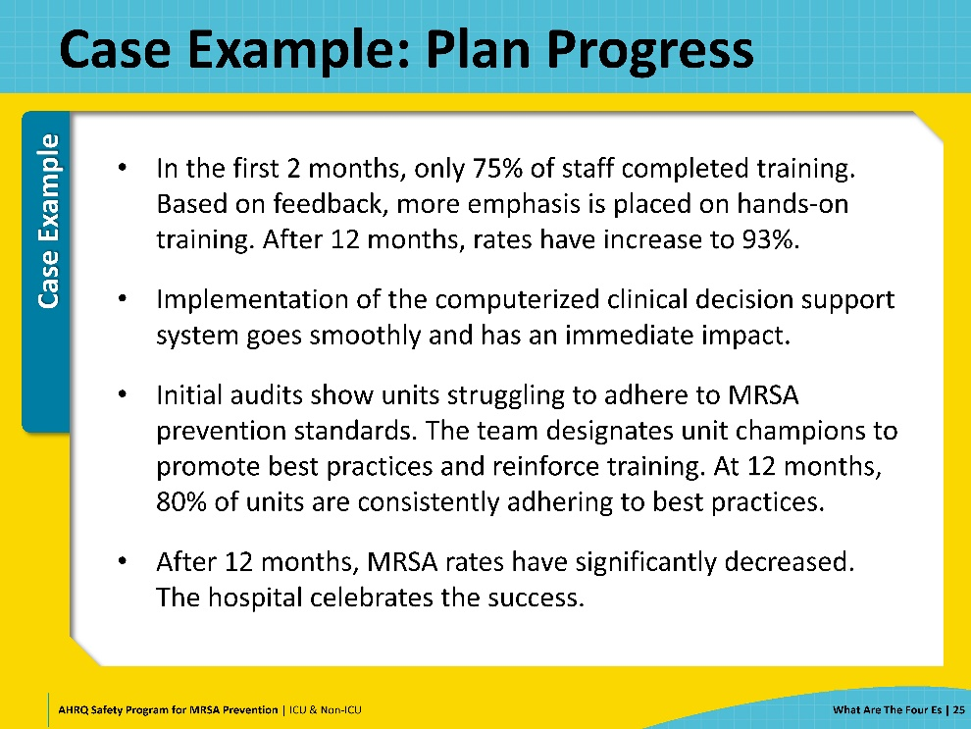
Key Takeaways  SAY:  Let’s take a moment to summarize the key takeaways from the 4 Es Framework for safety improvement.  The 4 Es Framework stands for Engage, Educate, Execute, and Evaluate. This approach addresses both technical and adaptive challenges and ensures comprehensive coverage of all aspects of the process.  Actively involve both leadership and personnel in safety initiatives to foster open communication and empower everyone to contribute effectively.  Provide ongoing education and training to keep the team informed and skilled in best practices for managing safety concerns.  Implement interventions based on identified needs and use the Action Hierarchy model to prioritize actions by their impact level.  Continuously assess the effectiveness of interventions, refine approaches based on feedback, and share data broadly and transparently to drive improvements and progress. | Slide 26  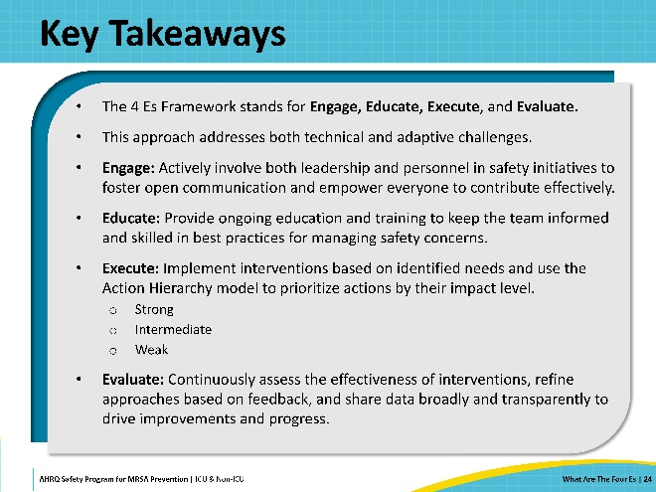
Disclaimer  SAY:  The findings and recommendations in this presentation are those of the authors, who are responsible for its content, and do not necessarily represent the views of AHRQ. No statement in this presentation should be construed as an official position of AHRQ or of the U.S. Department of Health and Human Services.  Any practice described in this presentation must be applied by healthcare practitioners in accordance with professional judgment and standards of care in regard to the unique circumstances that may apply in each situation they encounter. These practices are offered as helpful options for consideration by healthcare practitioners, not as guidelines. | Slide 27  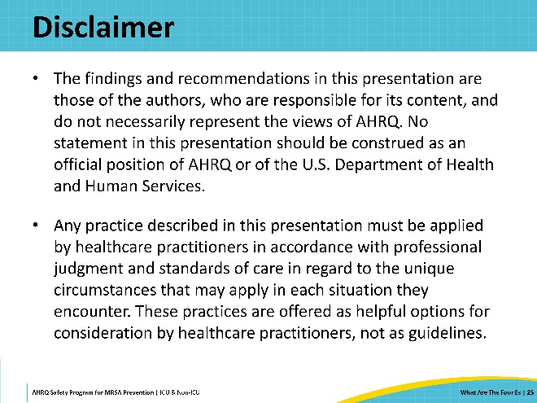
Reference List—1 | Slide 28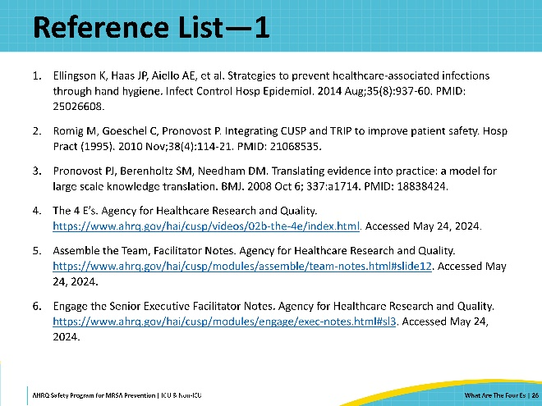
Reference List—2 | Slide 29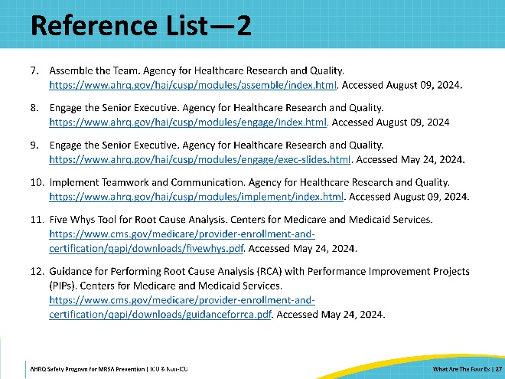
Reference List—3 | Slide 30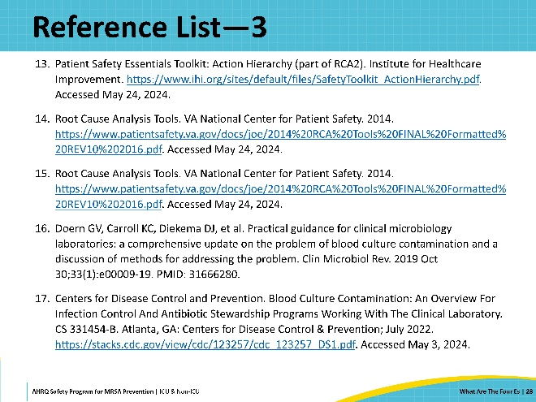
Reference List—4 | Slide 31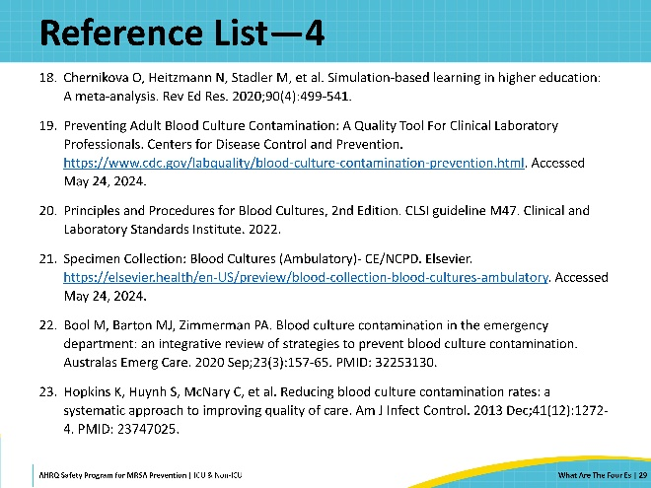
Reference List—5 | Slide 32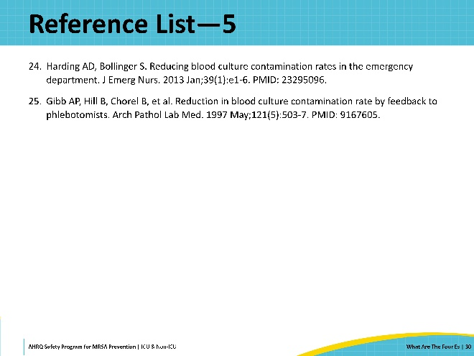
AHRQ Pub. No. 25-0007
October 2024

