Central Line Maintenance
A comprehensive approach to daily central line maintenance is essential to prevent central line-associated bloodstream infections (CLABSIs).
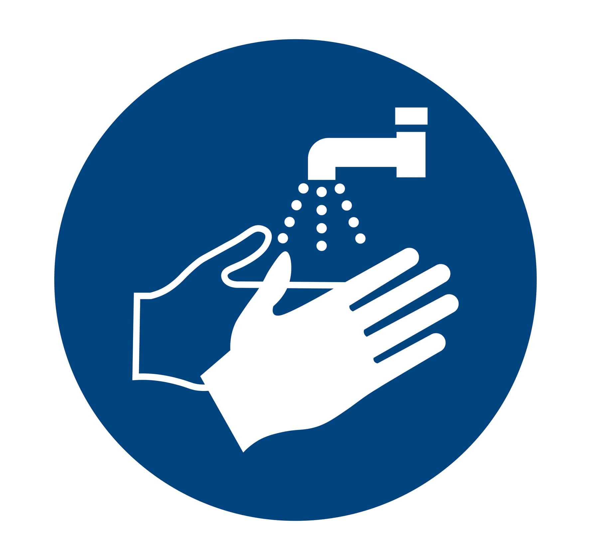
Hands and Hub
- Clean your hands and wear clean gloves before accessing the central line
- Scrub the hub for at least 10 seconds and allow to air dry EACH time you access the line
- Sterile technique to administer medications
- Check connections, patency, and blood return

Assess & Dress
- Assess the line site daily for signs of infection
- Assess the dressing daily and change as needed to keep it:
  - Clean (free of blood and debris)
  - Dry (free of drainage and fluid)
  - Fully occlusive (intact and adherent on all borders)
- Use a standardized dressing kit to replace dressings

Chlorhexidine Gluconate (CHG) Treatment
- Perform CHG treatment (bath) daily
- Change the bed linens at the time of the CHG treatment (bath)
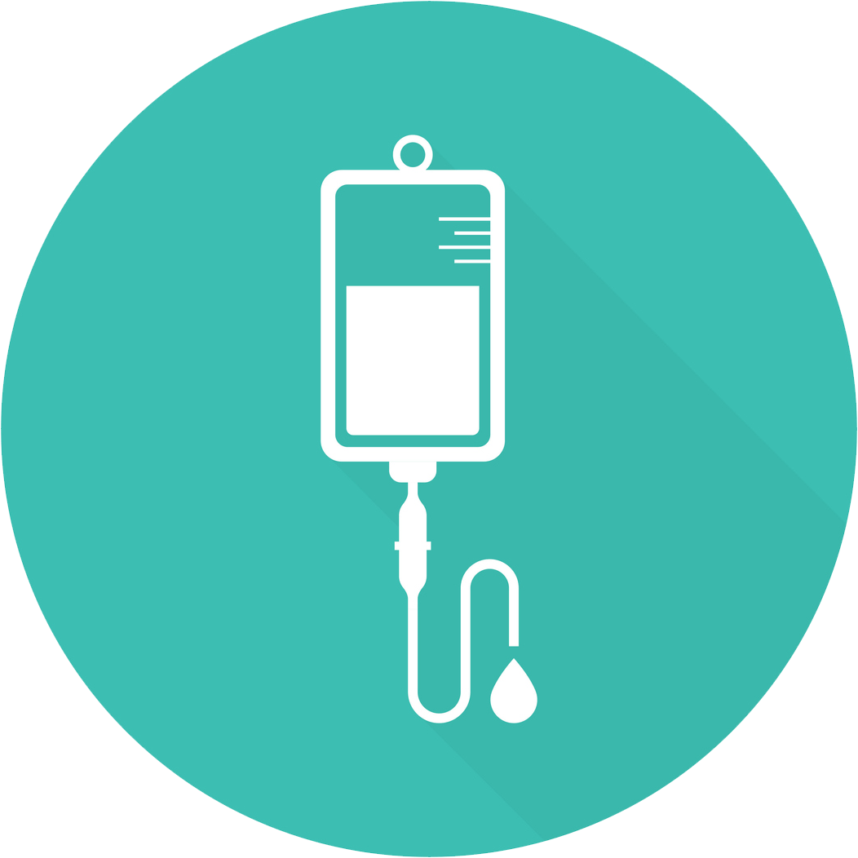
Lines and Labels
- IV tubing stabilized and secured
- Label and date dressings, infusions, and IV tubing
- Change tubing per guidelines and policies

Reevaluate Daily
- Ask every day if the central line can be removed
- Consider alternatives to the central line and/or IV medications
- Remove the central line as soon as possible to remove CLABSI risk

Documentation
- Date of insertion
- Site of insertion/location of catheter
- Type of catheter (tunneled, non-tunneled, number of lumens, other)
- Line placement confirmation
- Dressing date documented
- Type of dressing line securement type (stat-lock, sutures, other)

References
- Gorski LA, Hadaway L, Hagle ME, et. al. Infusion therapy standards of practice, 8th edition. J Infus Nurs. 2021 Jan-Feb 01;44(1S Suppl 1):S1-224. PMID: 33394637.
- Quinn M, Ameling JM, Forman J, et. al. Persistent barriers to timely catheter removal identified from clinical observations and interviews. Jt Comm J Qual Patient Saf. 2020 Feb;46(2):99-108. PMID: 31879072.
- Wei AE, Markert RJ, Connelly C, et. al. Reduction of central line-associated bloodstream infections in a large acute care hospital in Midwest United States following implementation of a comprehensive central line insertion and maintenance bundle. J Infect Prev. 2021 Sep;22(5):186-93. PMID: 34659456.
- Xiong Z, Chen H. Interventions to reduce unnecessary central venous catheter use to prevent central-line-associated bloodstream infections in adults: A systematic review. Infect Control Hosp Epidemiol. 2018 Dec;39(12):1442-8. PMID: 30305194.
- The Joint Commission. Preventing Central Line-Associated Bloodstream Infections: Useful Tools, An International Perspective. Jan 11, 2017. http://www.jointcommission.org/CLABSIToolkit. Accessed July 14, 2024.

AHRQ Pub. No. 25-0007
October 2024

