The Science of Safety:
Principles in Practice
ICU & Non-ICU
Slide Title and Commentary | Slide Number and Slide
The Science of Safety: Principles in Practice  SAY:  Welcome to this presentation on the topic of “The Science of Safety: Principles in Practice.”  As you consider establishing a CUSP-like approach, it is crucial to consider the culture of the team, unit, department, and organization. Safety culture is highly dependent on the dual foundations of the science of safety and psychological safety. This module reviews the science of safety to elucidate system factors that lead to errors and strategies that can help teams and organizations cultivate a strong safety culture and a high-performing team environment. | Slide 1  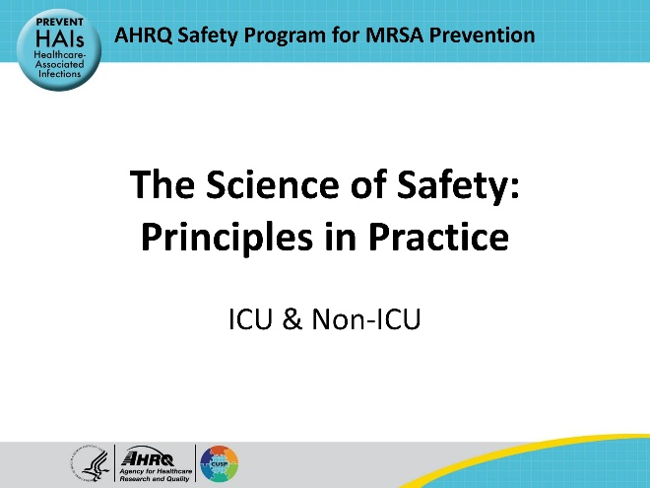
Educational Objectives  SAY:  At the end of this presentation, participants will be able to: Describe the patient safety risks that patients face in healthcare environments.  Explain the four principles of the science of safety and how they inform teams who seek to strengthen their organization's safety culture.  Describe the characteristics of safe systems and outline the main strategies used to create them.  And explain how diverse teams foster a safety culture and protect patients from safety defects. | Slide 2  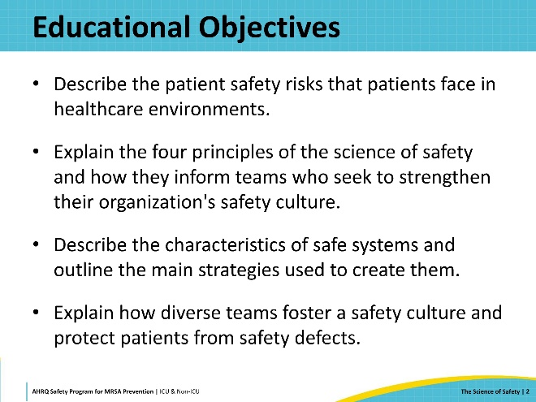
Patient Safety and Preventable Harm  SAY:  Healthcare has focused on safety since the Institute of Medicine released a report in 1999 entitled “To Err Is Human.” Although significant improvements occurred following that report, there’s still a tremendous need for improved safety in healthcare. According to a World Health Organization report, 1 in 10 patients are harmed when they stay in a hospital. In the United States, preventable patient error in hospitals is among the leading causes of death. | Slide 3  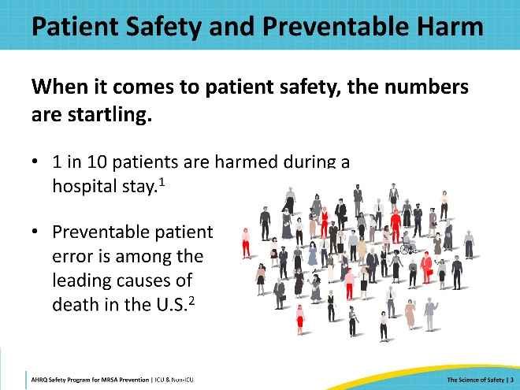
Risks of Healthcare-Associated Infections (HAI)  SAY:  The risk of healthcare-associated infections (HAIs) is a major contributor to patient harm. One in 20 hospitalized patients will experience a healthcare-associated infection. The risk is even higher for patients in intensive care units (ICU), where 30 percent develop an HAI. Two million people contract HAIs each year during their hospital stay. And HAIs contribute $28–$33 billion per year to healthcare costs in the United States.  The impact of preventable harm on our ability to provide safe, effective, and value-based healthcare is tremendous. | Slide 4  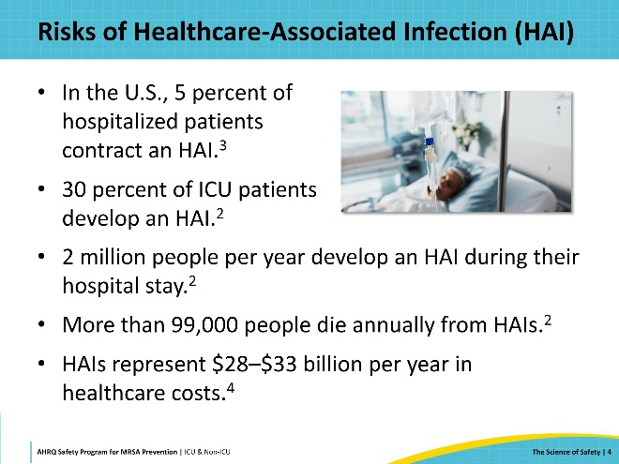
How Can Safety Be Such a Big Problem?  SAY:  There is a reason that patient care is not handled by robots. The human touch and human reasoning in complex situations are essential to healthcare. However, we are human. And as humans, we make errors and can fail.  Our healthcare system isn’t perfect by any means. As time goes on, the methods and means to care for patients improve and each of these improvements adds to the complexity of patient care.  Time and resources are limited, causing stress among the healthcare team as they work to provide the best and safest care they can.  The healthcare team isn’t alone in carrying that stress. Patients and their caregivers are under extreme stress as they navigate the healthcare system and deal with the physical and emotional toll of their illness. Therefore, we must deliberately study the science of safety and incorporate it into healthcare systems and organizations to keep patients safe in this complex environment. | Slide 5  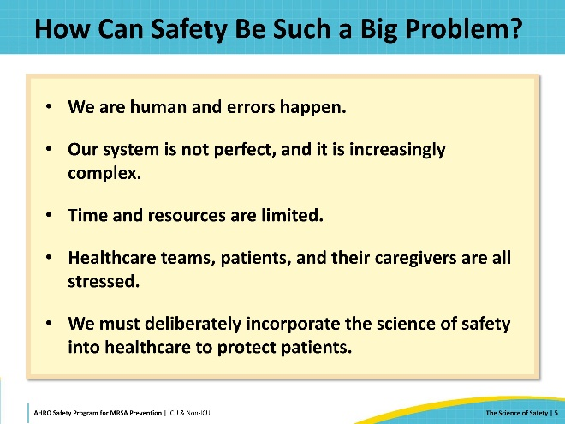
The Science of Safety  SAY:  Having an understanding of the science of safety is essential to the improvement of patient safety. The science of safety seeks to understand the causes and consequences of each accident and incident and develop effective solutions to prevent them and mitigate the risks of those or related accidents from happening in the future. Encourage your team members to watch the Science of Safety video. | Slide 6  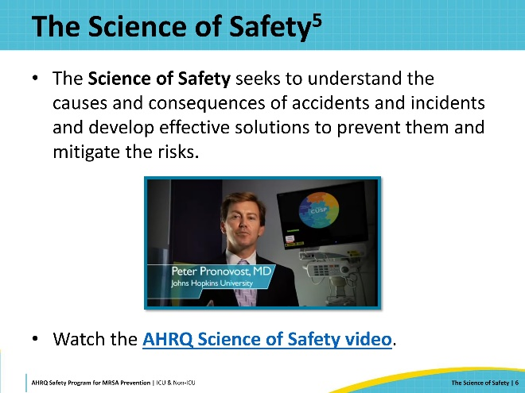
The Four Principles of the Science of Safety  SAY:  To address the issues in healthcare safety, we need to understand the science behind safety. The first principle of the science of safety is that safety risks do not belong exclusively to individuals or the healthcare team but are often inherent in the organizational system itself.  The second principle is that safe systems can be designed by applying human factors and other approaches to address technical problems.  The third principle of the science of safety is that safe teamwork can be fostered by applying sociology and other approaches to address cultural and adaptive problems.  And the fourth principle of the science of safety is that teams make wiser decisions when there is diverse input from stakeholders.  We will explore each of these principles on the following slides. | Slide 7  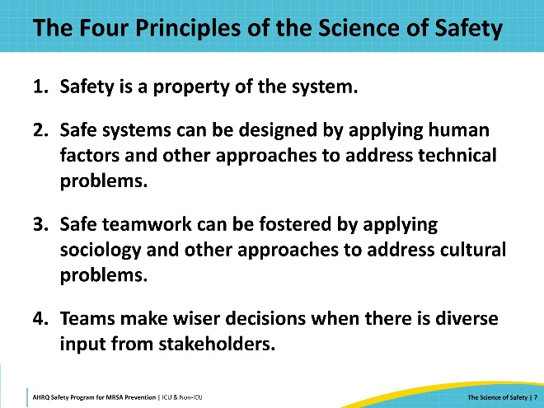
Principle 1 of the Science of Safety  SAY:  The first principle of the science of safety is that safety risks do not belong exclusively to individuals or the healthcare team but are often inherent in the organizational system itself. It is said that every system is perfectly designed to achieve the results it gets. Or, put another way, we must change the system itself to change the results.  The characteristics of patients, providers, care team, and the environment all impact safety.  Communication errors are common causes of healthcare errors. Communication is one example of a teamwork factor that impacts safety, and there are many others.  Hospitals face many kinds of pressures and make decisions that impact safety, including how the hospital decides they will balance safety risks with managing healthcare costs.  Environmental factors such as staffing, workflows, equipment, and the flow of people through the healthcare space can also impact safety.  Careful and honest review of these system factors improves patient safety by offering teams an opportunity to recognize and address the underlying factors that can cause safety problems. The CUSP framework and CUSP team are helpful for doing this work.  Blaming individual healthcare workers rarely solves safety problems. | Slide 8  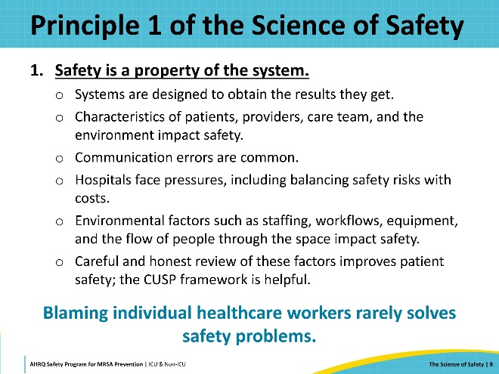
Principle 2 of the Science of Safety  SAY:  The second principle of the science of safety is that safe systems can be designed by applying human factors and other approaches to address technical problems.  To do this, the science of safety and the principles of safe design tell us that we must standardize care whenever possible. This makes it easy to do the right thing and harder to make mistakes. One example of standardization is providing a central line insertion kit or cart so that providers have everything they need to safely insert a central line. Another example is providing a checklist to ensure that a standardized series of events occur every time a certain high-risk procedure is performed, or action must be taken in a stressful situation.  Safe systems also utilize independent double-checks for important things. These double-checks must be truly independent. Encourage different roles to feel confident speaking up when they see safety concerns. Automatic system reminders can also be utilized in healthcare to prompt important actions or warn of impending errors.  Safe systems have a mechanism to learn from events when something goes wrong. Teams strive to learn from the event and to take steps to prevent the same error from recurring. This reduces the risk that future patients will be harmed by the same type of error.  Teams in safe systems ask themselves and their colleagues how they think the next patient will be harmed and what can be done to prevent that harm from happening.  The application of these principles is important not just to the technical aspects of healthcare work, but also to its cultural and human interaction aspects. | Slide 9  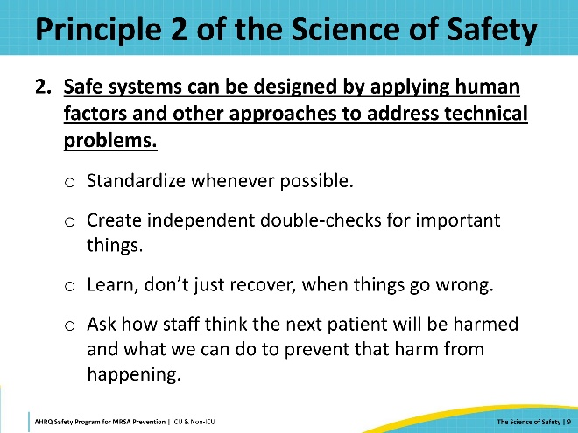
Principle 3 of the Science of Safety  SAY:  The third principle of the science of safety is that safe teamwork can be fostered by applying sociology and other approaches to address cultural and adaptive problems.  Healthcare is noisy and chaotic, time is often short, and communication errors are common safety risk sources. Teams can employ safe design principles to guard against communication mistakes such as misinterpreting ambiguous language. One approach is to standardize the format for important communications. Examples include the SBAR format that allows healthcare personnel to concisely convey information in a familiar, standardized format that includes the Situation, Background, Assessment, and Recommendation. Briefings can also be standardized so that important information is conveyed without inadvertently omitting vital details. Daily goal sheets are another example of standardized communication that facilitates patient care and guards against mistakes and lost information.  A second approach is to incorporate independent checks into healthcare communications. One example is requiring a nurse or provider to repeat back a critical action laboratory value or verbal order to confirm correct information and avoid misunderstandings.  Finally, it is important to learn from common mistakes by analyzing communication errors and taking steps to guard against the same future mistakes. | Slide 10  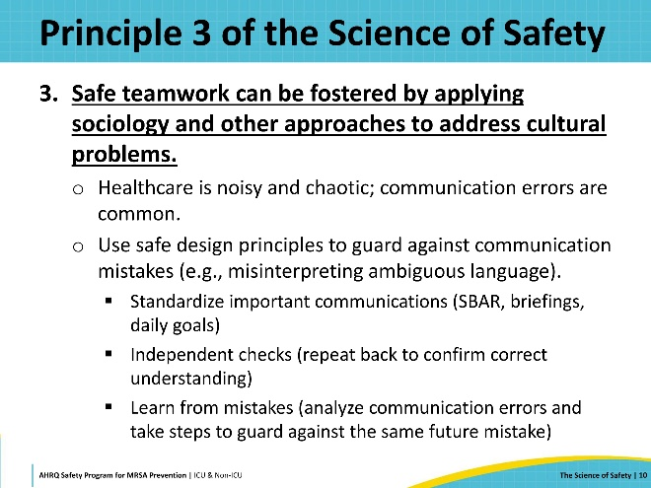
Principle 4 of the Science of Safety  SAY:  The fourth principle of the science of safety is that teams make wiser decisions when there is diverse input from stakeholders.  When creating a team to address a safety problem, it’s important to remember that diverse groups offer a broader perspective. Including members from different roles and all relevant stakeholder groups leads to a better understanding of system flaws.  As was stated earlier, blaming individual healthcare workers for errors rarely solves safety issues. | Slide 11  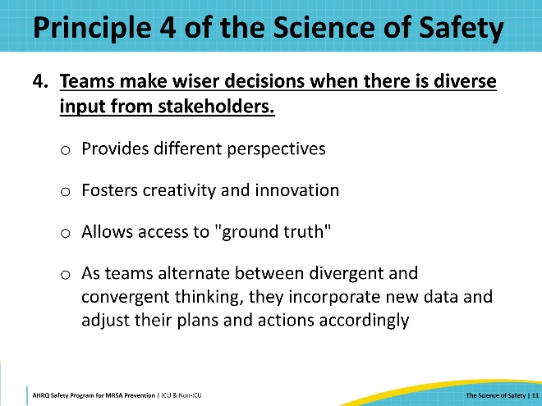
CUSP and the Science of Safety  SAY:  So how does a CUSP approach integrate the science of safety? The CUSP team includes diverse roles and focuses on local learning, driven by expertise that is diverse in nature. The CUSP team applies systems thinking, seeking to understand the why behind the problem without blame. The team utilizes the principles of safe systems by standardizing care when possible. They promote accountability and open multidirectional communication, which essentially creates a culture of psychological safety, allowing members to feel empowered to speak up. Finally, the CUSP team is laser focused on learning from defects so they can implement action plans to keep mistakes from recurring. All elements are interdependent. For example: a sense of psychological safety facilitates multi-directional, open communication, and systems thinking from diverse perspectives helps the team to understand the problem and the contributing factors. | Slide 12  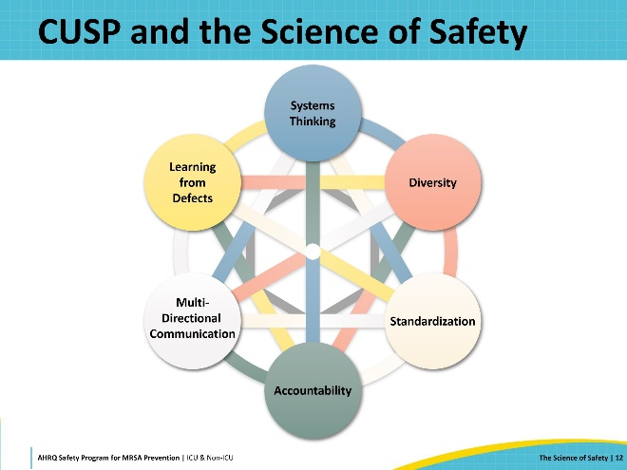
So… What Is a Safety Culture?  SAY:  So, what is a safety culture? “Patient safety culture is the extent to which an organization's culture supports and promotes patient safety. It refers to the values, beliefs, and norms shared by healthcare practitioners and other personnel throughout the organization that influence their actions and behaviors. Patient safety culture can be measured by determining the values, beliefs, norms, and behaviors related to patient safety that are rewarded, supported, expected, and accepted in an organization. It is also important to note that culture exists at multiple levels, from the unit level to the department, organization, and system levels.”  Key elements of a strong safety culture:  - People are encouraged, even rewarded, for providing essential safety-related information, but clear lines are drawn between human error and at-risk or reckless behaviors.  - Due to psychological safety, there is no risk when people report their errors and near-misses.  - There is a willingness to learn and the competence to draw the right conclusions from safety information systems, and the will to implement major reforms when their need is indicated. | Slide 13  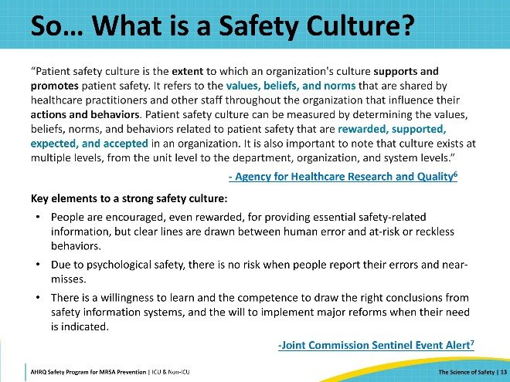
Principles Of High Reliability Organizations (HRO) Align With Safety Culture  SAY:  There are five principles used by highly reliable organizations that align with safety culture that are achieved through a CUSP approach.  First, organizations should defer to expertise. In healthcare, staff are the experts in what they do. Make sure you include frontline staff in your team. And, when you need to know what is going on at the bedside, ask. They know what is going on at the point of care. Be sure to include a diverse group of people in your team—if you are working on getting patients out of bed, include a representative from physical therapy; if you’re working on antibiotic stewardship, include a pharmacist and someone from your antibiotic stewardship team. Remember that you are working with a group of people with a vast body of knowledge on how to take care of patients. Encourage your team to speak up. Ask for their input instead of automatically choosing the expert’s voice. And listen when your frontline staff has something to say.  Second, the organization needs to commit to resilience. Plan for success. Set up meeting agendas with your intended goals in mind. Use a PDSA approach and incorporate it into your timeline. Set your project’s expectations and include the scope.  Show a reluctance to simplify both the problem and the solution. While simplification is definitely a valid goal, beware of oversimplification. Nuances count. Make sure every individual truth is validated. Seek diverse truths. Ask hard questions to get to the truth.  Cultivate a preoccupation with failure. Challenge your staff and leadership directly and invite dissent. Your team needs to be vigilant and watch for problems to arise. Everyone should actively seek blind spots and bring them to the group to develop solutions. Use the Staff Safety Assessment and consider starting your program with a Premortem Assessment. Maintain a sensitivity to operations. Situational awareness is important at all levels. All staff need to be constantly cognizant of anomalies, near misses, and potential and actual errors. Errors need to be caught before they reach the patient. Aim for a proactive approach to issues, rather than reactive. When you are problem solving, evaluate feasibility. Make sure the team understands the structure of the system. Observe firsthand and seek variability. Make sure you have access to the resources you need. Request project management resources and support. | Slide 14  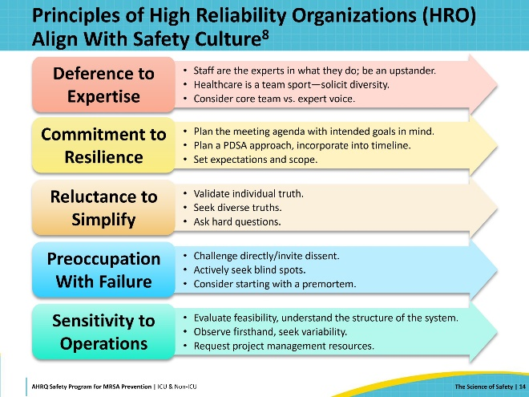
System Factors Impact Safety  SAY:  Let’s return to the first principle of the science of safety that tells us that many safety risks are inherent in the healthcare system itself. What does it mean to look at each defect through a system lens? It means that we consider many things when examining an event, at all levels of the organization. A systems lens allows us to see a composite view of all the factors that could be causative or contributive to an event. These contributory factors can include:  - Patient Characteristics (e.g., patient acuity; language barrier)  - Task Factors (e.g., task is unclear, equipment not available)  - Provider Factors (e.g., insufficient training; sleep deprivation)  - Team Factors (e.g., communication errors; lack of supervision)  - Work Environment (e.g., lack of space; noisy environment)  - Department Factors (e.g., staffing levels; admission policies)  - Hospital and Institutional Factors (e.g., type of facility, budgetary restraints)  Each of these sets of factors could contribute to or reduce harm—but for the most part, we are not aware of them in day-to-day tasks. | Slide 15  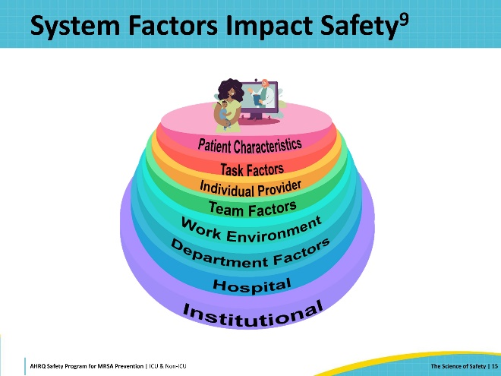
Beyond Personal Responsibility  SAY:  When errors happen, we are often quick to focus on the actions of individual staff members. Yet, as we can see, personal responsibility is just one part of the system. In many cases, the defect would have happened eventually, regardless of the individual provider—and not addressing the other system factors means the defect will eventually happen again.  James Reason, an early influential researcher on human error and patient safety, wrote, “Rather than being the main instigators of an accident, providers tend to be the inheritors of system defects […] Their part is that of adding the final garnish to a lethal brew that has been long in the cooking.”  Shifting our focus to a system lens and away from individual actions helps to alleviate fear of retribution and promotes valuable contribution from team members. The purpose of a CUSP approach is not to find blame, but to understand the system factors behind the defect, fostering engagement and establishing psychological safety so that team members feel empowered to speak up. | Slide 16  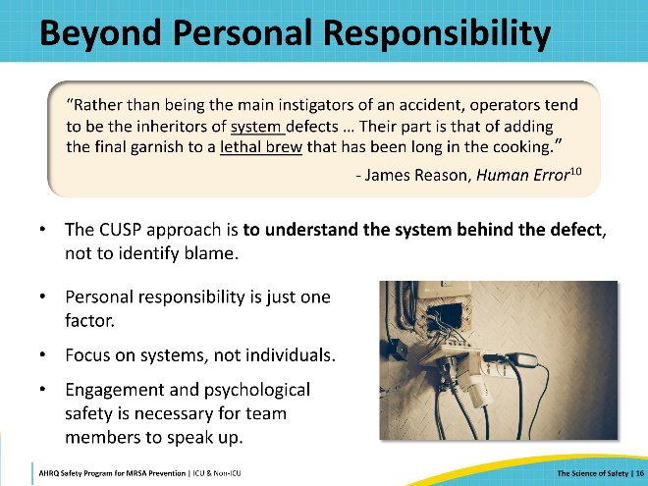
Swiss Cheese Model  SAY:  James Reason was the first to describe the “Swiss Cheese Model,” which is now widely used to understand system failures and why sometimes they lead to an adverse event and sometimes they don’t.  We can visualize a healthcare system as a stack of Swiss cheese slices. The slices represent potential layers of defenses, and the holes represent opportunities for processes to fail.  Active Failures are identified when an “operator” performs an unsafe event. It is their action that enables the event to occur. For example, an anesthesiologist gives a patient the wrong antibiotic or the wrong dose of an antibiotic for preoperative surgical prophylaxis.  Latent Failures are decisions or actions dormant in an organization until revealed by active failures. For example, a patient receives the right antibiotic and the right dose but receives the antibiotic in 10 minutes instead of over an hour as recommended. During the investigation, the team identifies that the hospital opted not to purchase the medication library or software program for their infusion pumps. Failure to install the software that prevents infusions from running too fast is an example of a latent failure that enabled the defect to happen.  In other words, active failures are the adverse events we are used to thinking about and attempt to avoid. Latent failures are the “holes in the system”—the weaknesses that could allow an active failure to happen. | Slide 17  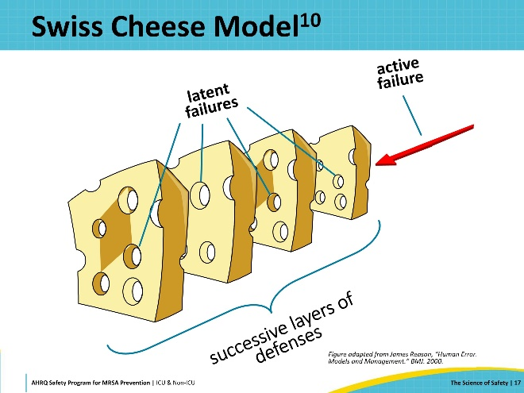
Swiss Cheese Model: Layers of Defense  SAY:  Layers of defense usually prevent the defect from reaching the patient and causing harm. Layers of defense include policies and procedures, skilled troubleshooting, and occasionally lucky catches that prevent or reduce the possibility of errors and harm. | Slide 18  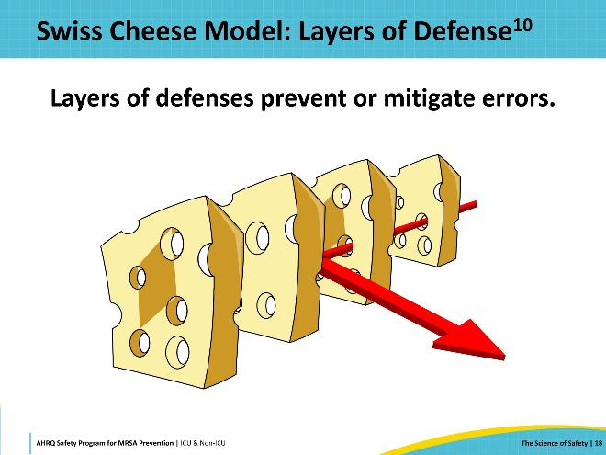
Swiss Cheese Model: How Errors Happen  SAY:  But sometimes defenses fail, and errors line up, allowing for a catastrophic outcome. These adverse outcomes are our “defects”—the events that occur and we don’t want them to happen again.  The Swiss cheese model helps us to understand that defects are not the result of a single failure, but of multiple contributing factors within the system. | Slide 19  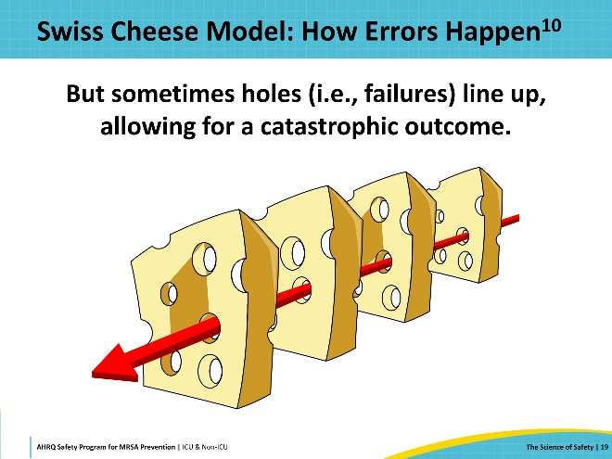
Susan’s Story – Part 1  SAY:  Let’s review a specific patient’s experience and identify the system factors and failures that played a role.  Susan was in a car accident and brought to the hospital by ambulance. The ED nurse collected Susan’s medical history, which included hormone replacement therapy and daily unprescribed aspirin use. The nurse shared Susan’s medical history with the attending physician but failed to write down the hormone therapy on Susan’s chart due to an urgent call.  Simon has been a surgeon at the hospital for less than a year, after completing his residency at a much smaller hospital. When Susan was admitted, he’d been working for 13 hours and had just been told he needed to be on call for another 6 hours, because another surgeon called in sick. Many of the hospital’s senior surgeons often bragged that they could push through 18-hour shifts and still stay sharp. Feeling insecure in his new role, Simon decided not to say anything about being fatigued.  Simon reviewed Susan’s X-rays and saw a hip fracture. Given her trauma, he was concerned about Susan’s bleeding risks. He knew he should assess the patient for her venous thromboembolism (VTE) risk, but he didn’t have much experience doing so. The hospital didn’t have a standardized protocol for VTE risk assessment.  Simon asked Susan if anyone in her family had a history of VTE. Susan wasn’t sure what VTE was, so she said “no” and Simon didn’t press further. The hospital had recently replaced their electronic medical records and not all the data had carried over; otherwise, information about Susan’s father, who died of a deep vein thrombosis and pulmonary embolism, might have surfaced. Simon proceeded with the surgery, focusing on repairing her hip fracture. | Slide 20  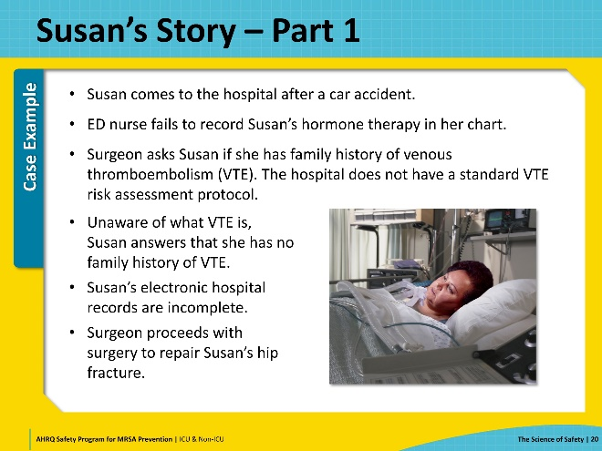
Susan’s Story – Part 2  SAY:  Simon completed the procedure successfully and Susan remained hospitalized and with limited mobility during her recovery. On post-operative day 6, Susan began complaining of pain in her leg. Simon attributed this to postoperative discomfort and ordered pain medication. The nursing staff, already stretched thin due to a high patient load, administered the medication, but noted Susan's persistent complaints.  Over the next few hours, Susan's condition deteriorated rapidly. She developed shortness of breath and a rapid heart rate. The nurses, hesitant to challenge the surgeon's authority and lacking clear protocols for post-surgical complications like VTE, delayed before escalating the issue.  By the time a hospitalist was called in, Susan was in acute distress. A rapid assessment revealed signs of a massive pulmonary embolism. Despite aggressive treatment attempts, Susan passed away within hours of the embolism being diagnosed. | Slide 21  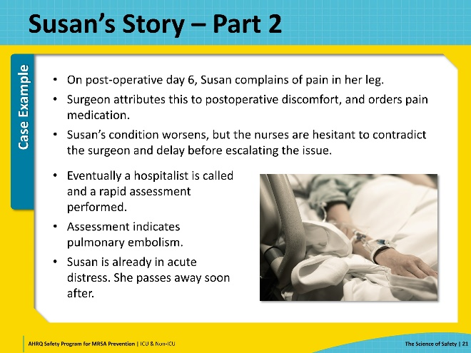
What System Factors Did You Identify?  SAY:  Using Susan’s case example, what are some of the system factors that contributed to Susan’s death? Look at the puzzle pieces to prompt you to think of all the contributing factors or holes in the system that led to this bad outcome. | Slide 22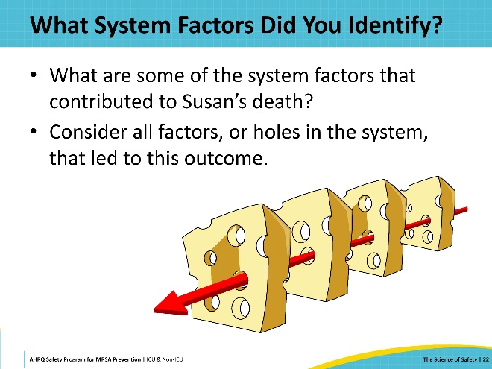
Susan’s Swiss Cheese Model  SAY:  You can see that communication, protocols, culture, technology, staffing, and teamwork all played a role in one patient situation.  These are just some of the system factors at play. Some of these system factors were local, part of the microsystem providers worked in. Some were organizational, part of the macrosystem—the institution or hospital. | Slide 23  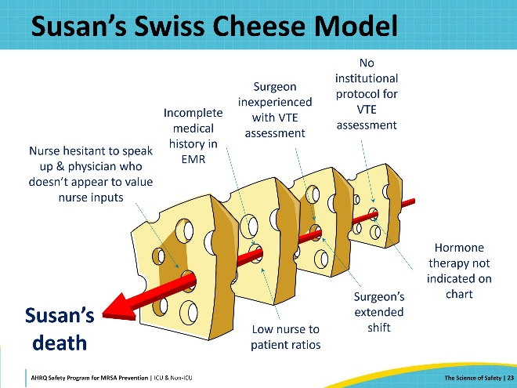
What’s Wrong With This Picture?  SAY:  Leadership support is critical for safety and quality improvement work. But the right kind of leadership support matters too. Imagine this scenario: at an All-Staff meeting, a senior executive tells staff to review a checklist about VTE risk screening and says, “The procedure’s simple. Follow the checklist. If someone doesn’t, you need to speak up.”  Do you think this is a successful strategy? How do you think staff might react? This approach is contrary to a CUSP approach and is rarely effective.  Winning hearts as well as minds is vital to the success of your efforts. This is what is called “adaptive work.” | Slide 24  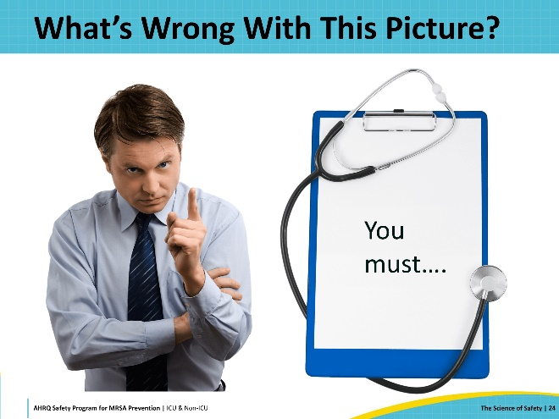
Leading Change  SAY:  Creating a psychologically safe environment where staff feel empowered to engage and speak up, own safety issues, and feel a sense of responsibility for the organization’s culture with leadership support has proven to be the most effective method for improvements. One of the most common leadership mistakes is expecting technical solutions to solve an adaptive problem. | Slide 25  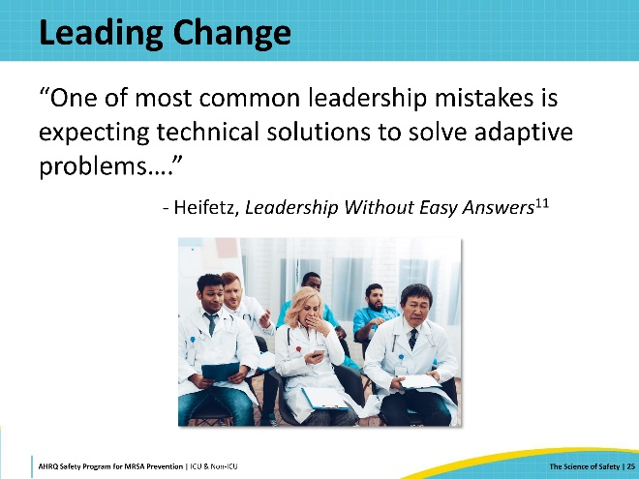
Diverse Voices, Wiser Decisions  SAY:  Teamwork and communication are essential in the complex systems in which we work. A team of just physicians or just nurses won’t lead to the change efforts you’ll need.  Diverse voices equal wise decisions. Diverse teams are the only way to create solutions that are truly aimed at the system level. | Slide 26  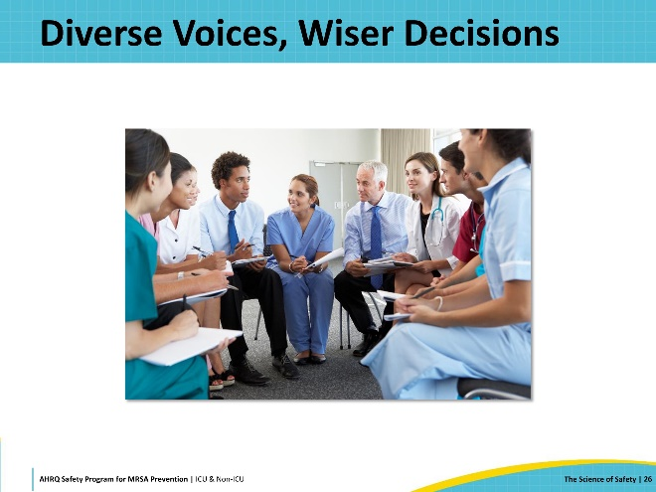
Power of CUSP  SAY:  Don’t be intimidated. If there’s one thing that gives hope to teams who wish to protect patients from harm, it is that change is possible when people work together. CUSP teams are quite powerful when they utilize the principles of the science of safety. Margaret Mead put it this way, “Never doubt that a small group of thoughtful, committed citizens can change the world; indeed, it’s the only thing that ever has.” | Slide 27  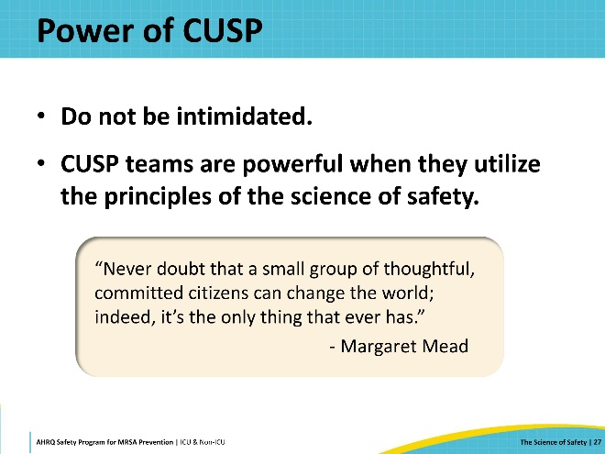
Important Messages to Share With Your Teams  SAY:  See the system, see the risks—your teams’ insights into conditions that can harm patients are critical.  Speak up and speak out for safer systems—don’t hesitate to stop and question when you have patient safety concerns. Share your concerns. Your voice matters! Patient safety is not about finger pointing. It’s about using the science of safety to create safer systems.  Value each other—teamwork means respecting each other regardless of role. It means listening to patients and family members who are also part of our care teams.  Learn and share—everything healthcare personnel do helps them learn so teams can continually improve. Be open to learning and sharing with others. | Slide 28  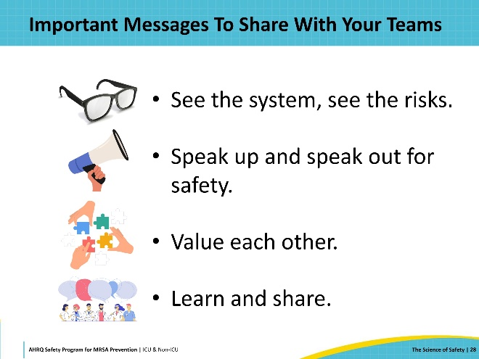
Key Takeaways  SAY:  These are some take-homes we’d like you to consider.  Patient harm is largely preventable.  Change efforts require a focus on systems, not individuals.  The science of safety is the foundation that allows us to create safe systems and safe teams by standardizing processes, incorporating independent double-checks for important things, and learning from defects.  Patient safety efforts require adaptive work, technical work, and diverse team members' input to succeed. | Slide 29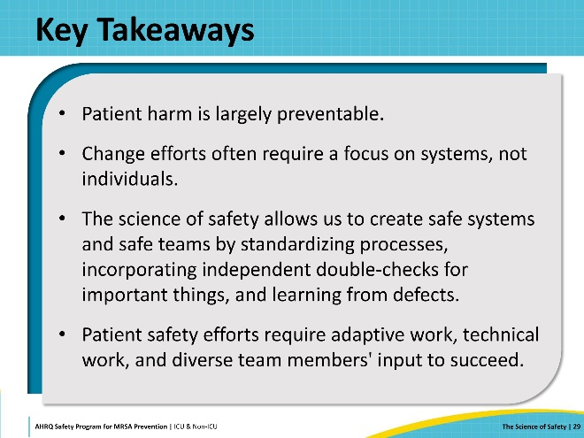
Disclaimer  SAY:  The findings and recommendations in this presentation are those of the authors, who are responsible for its content, and do not necessarily represent the views of AHRQ. No statement in this presentation should be construed as an official position of AHRQ or of the U.S. Department of Health and Human Services.  Any practice described in this presentation must be applied by healthcare practitioners in accordance with professional judgment and standards of care regarding the unique circumstances that may apply in each situation they encounter. These practices are offered as helpful options for consideration by healthcare practitioners, not as guidelines. | Slide 30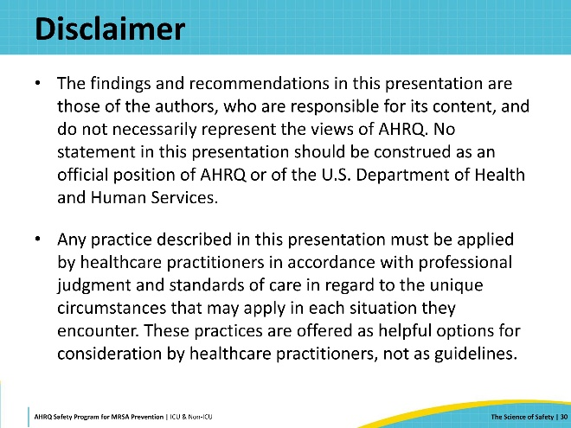
Reference List—1 | Slide 31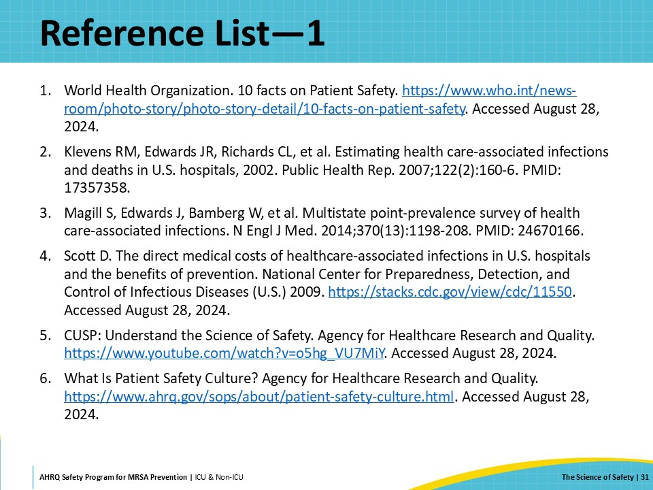
Reference List—2 | Slide 32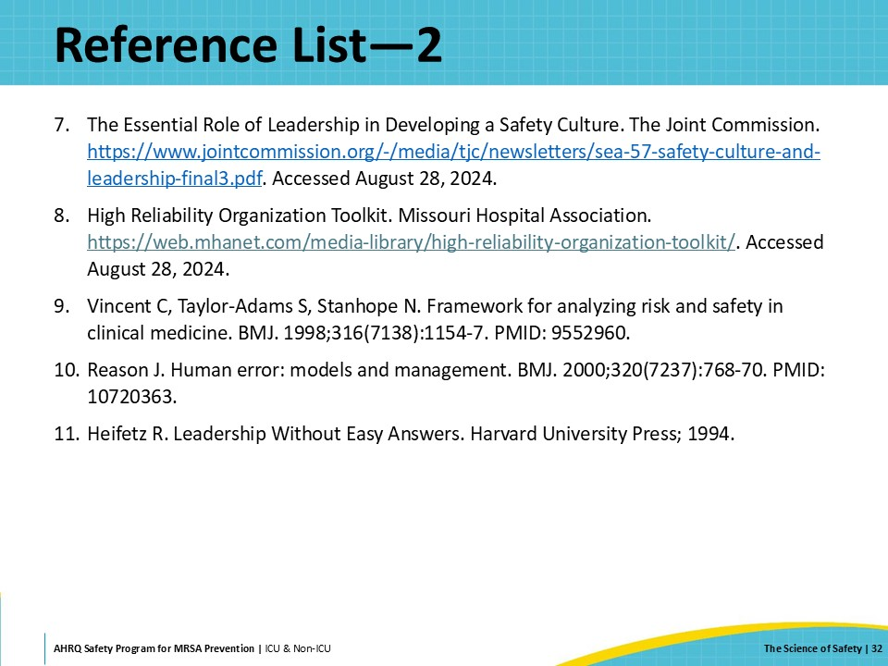
AHRQ Pub. No. 25-0007
October 2024

