Comprehensive Antibiogram Toolkit: Phase 2
Sample Laboratory Data Printout
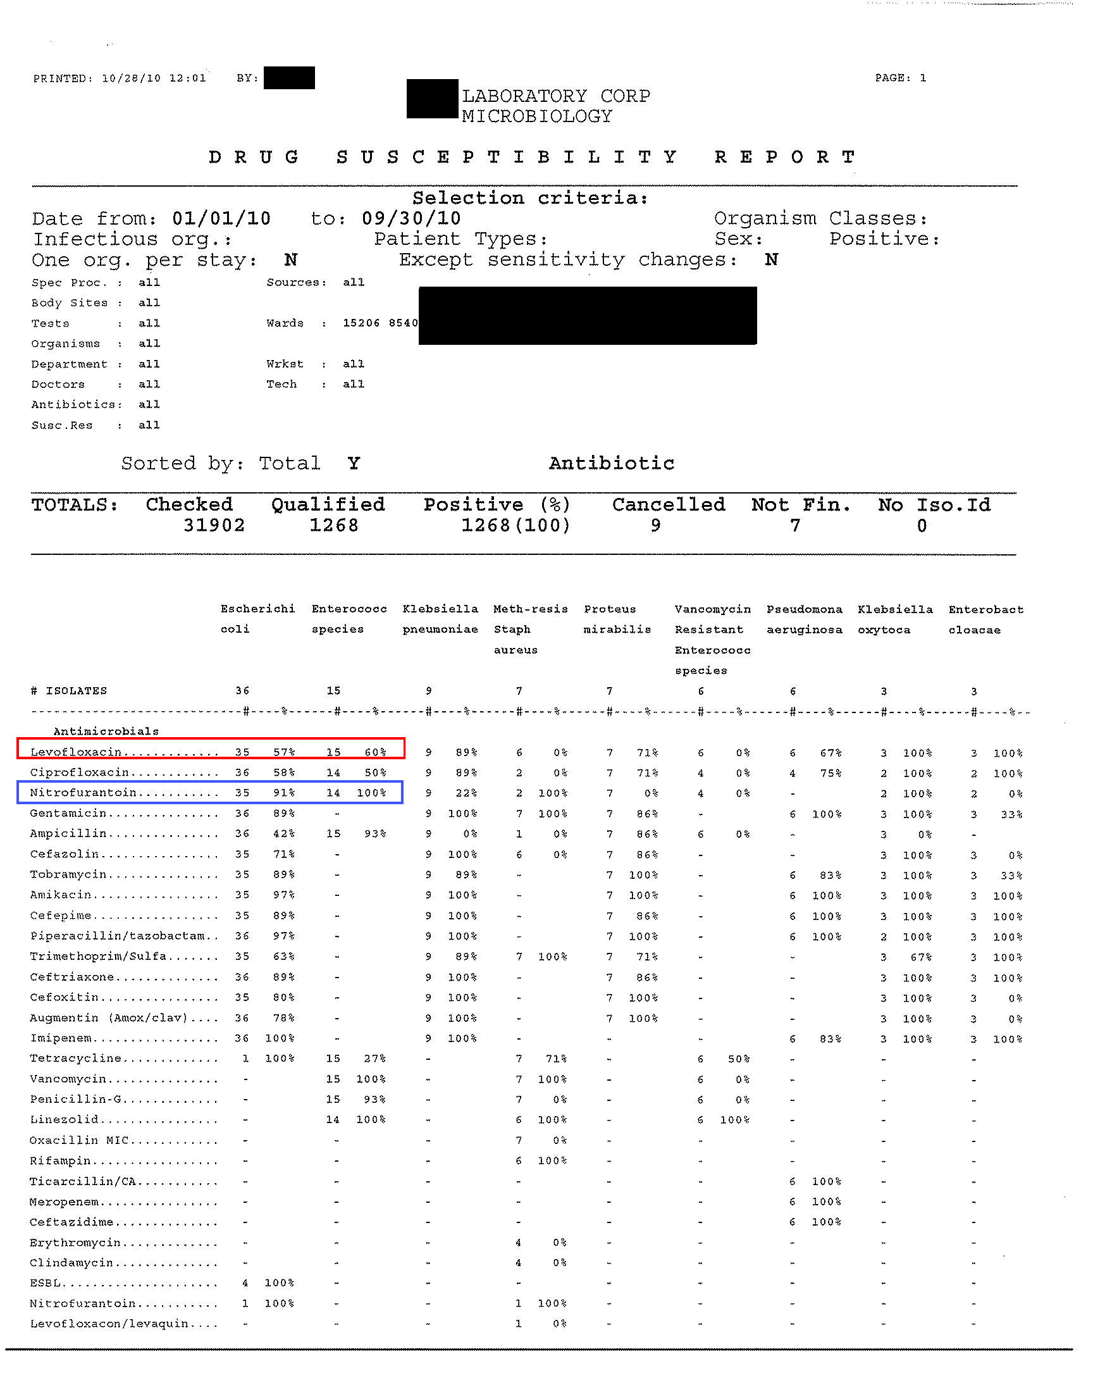
Note. The red box shows that this laboratory had 36 isolates of E. coli, and 35 were tested for levofloxacin, and 57 percent were sensitive. The blue box shows that the laboratory tested 35 isolates for nitrofurantoin, and 91 percent were sensitive.

