Concise Antibiogram Toolkit

Getting Started—Sources of Data
Once you decide that an antibiogram will be a useful tool for your nursing home, there are a few things to consider.
- What will you need to create the antibiogram?
- What data are needed to create an antibiogram?
- How do you interpret your antibiogram?
- How will the tool be implemented in your nursing home?
- How often will the antibiogram be updated?

What will you need to create the antibiogram?
To create an antibiogram for your nursing home, you will need a strong working knowledge of computers and a good understanding of culturing practices and infection control.
The resources included in this toolkit can be used with the 2007 (or later) Microsoft Office suite. The WHONET software recommended to create the antibiogram can be downloaded for free from the Internet at http://www.whonet.org/software.html. It is important that you be able to use Microsoft Office and are confident about learning new data analysis software.
You will also need some knowledge of how the tool will be used in your nursing home. An infection control professional could be ideal for creating and maintaining the antibiogram as well as for teaching other personnel how to interpret the results.

What data are needed to create an antibiogram?
An antibiogram cannot be developed without specific information about the nursing home’s microbiological cultures. You will need the results of diagnostic cultures—that is, cultures taken from residents suspected of having an infection—and the results of antibiotic susceptibility tests conducted on the isolated organisms. At least one year’s data are needed to create an antibiogram.

Potential Data Sources

Laboratory—electronic or paper based
The best way to obtain data for the antibiogram is to contact the primary laboratory from which you obtain culture results. The laboratory that processes your cultures will have a record of the antibiotic susceptibility tests performed for each culture. Ask the laboratory for a copy of the susceptibility test data for all diagnostic cultures processed during a specific period of time for your nursing home residents.

Who do you ask for the data?
If you have a regular contact person at your primary laboratory, speak with them about how to best obtain the data for an antibiogram. Alternatively, you can contact the director of your primary laboratory. If you commonly use more than one facility, you will need to contact each one.

What data do you request?
Ask for culture data specific to your nursing home and within the date range of interest. A period of one year is recommended, but you may need to use data from more than one year, for example 18 months, in order to meet the minimum number of isolates required to make a useful antibiogram. Request this data for diagnostic cultures (cultures from residents suspected of having an infection). The Clinical and Laboratory Standards Institute (CLSI) recommends against including surveillance cultures when creating an antibiogram.
Request the following data elements from your lab:
- Culture ID number
- Patient ID number
- Patient name
- Culture date
- Culture source
- Culture results (organism(s))
- Antibiotic susceptibilities

What format of data should you request?
If at all possible, obtain your data electronically, either in a spreadsheet or text file. Paper-based results will require that the data be manually entered into a spreadsheet before you can use WHONET (See Tool “How to Enter Data Manually Into an Antibiogram Template” and Tool “Antibiogram Data Entry Form”).
If you will be adding elements to the laboratory data once you receive it, ask for the data in a spreadsheet format. For example, you could add the floor or even the room number, or other patient characteristics before converting the spreadsheet into a text file and importing the file into WHONET.
If the laboratory cannot send you this information electronically, ask if you can receive a printed report. As long as the data elements are present in the report, you can enter the information into a spreadsheet manually.

Resident medical charts
If you cannot obtain the required data directly from your laboratory, you can review the charts of your residents and abstract the culture results by hand. You should record the culture information for every diagnostic culture result in the timeframe of interest. If you have some record (e.g., billing or laboratory) of all of the cultures that were ordered during that timeframe, you should review all of the patient charts noted in that record to identify the diagnostic cultures (that is, cultures for patients suspected of having an infection). If this information is located in individual charts, it may be easiest to photocopy the culture reports. You will then need to enter the information you collect into a spreadsheet before WHONET can be used. The information can be directly entered into a spreadsheet from the resident charts as well. A spreadsheet template is provided in the toolkit (“Antibiogram Data Entry Form”). If you have to use this method, you may find it makes sense to collect this information prospectively or on a monthly basis. Then, after a period of 1 year (or 18 months if necessary), you can create an antibiogram. You may also find it helpful to keep the diagnostic culture reports in a binder in order of date.

How do you interpret your antibiogram?
Below is an example antibiogram that will be similar to how your nursing home’s antibiogram may look.
Title: Figure 1: Example Antibiogram
Major Headings: Gram (-), Gram (+), # of patients, Aminoglycoside, B-Lactams, Cephalosporins, Quinolones, Others
Description: This figure depicts an example antibiogram that may be created by your nursing home. The first column lists the organisms that were included, separated by Gram-positive and Gram-negative results. The second column shows the number of patients in your nursing home who had the organism and were included in the antibiogram. The remaining columns of the antibiogram are the antibiotics that were tested and the organisms’ susceptibilities. Yellow highlighting in any row indicates that an insufficient number of patients were included in the set of cultures; these results are less reliable than those for 30 cultures or more. Asterisks are used to indicate organisms for which more than one year of data is used in creating the antibiogram.
 |  | Aminoglycosides |  |  | B-Lactams |  |  | Cephalosporins |  |  |  | Quinolones | Others
Gram (-)  Highlighted rows include less than 30 isolates; interpret these results with caution | # of Patients | Amikacin | Gentamicin | Tobramycin | Ampicillin | Imipnem | Pipercillin- Tazobactam | Cefazolin | Cefoxitin | Ceftriaxone | Ceftazidime | Ciprofloxacin | Nitrofurantoin |  | TMP/SMX
Escherichia coli | 37 | 100 | 100 | 100 |  | 100 | 100 |  |  |  | 100 | 75
Klebsiella sp* | 33* | 100 | 84.6 | 92.3 | 38.5 | 100 | 92.3 | 84.6 | 100 | 100 | 100 | 38.5 | 92.3 |  | 38.5
Proteus sp | 31 | 71.4 | 57.1 | 71.4 |  | 85.7 | 85.7 |  |  | 57.1 | 57.1 |  | 28.6 |  | 71.4
Pseudomonas aeruginosa | 23 | 100 | 83.3 | 92.3 | 91.7 |  | 100 |  | 81.8 | 100 | 100 | 30.8 |  |  | 69.2
 |  | Penicillins |  |  |  | Cephalosporins |  | Quinolones |  | Others
Gram (+)  Highlighted rows include less than 30 isolates; interpret these results with caution | # of Patients | Penicillins | Ampicillin | Oxacillin | Nafcillin | Cephalothin | Ceftriaxone | Ciprofloxacin | Moxifloxacin | Gentamacin | Linezolid | Rifampin | Tetracycline | TMP/SMX | Vancomycin | Nitrofurantoin
Staph aureus (all) | 17† | 0 | 0 | 0 | 0 |  |  | 0 | 0 | 87.5 | 100 | 100 | 100 | 100 | 100 | 100
Methicillin Resistant (MRSA) | 34 | 0 | 0 | 0 | 0 |  |  | 0 | 0 | 87.5 | 100 | 100 | 100 | 100 | 100 | 100
Methicillin Susceptible (MSSA) | 0
Enterococcus sp* | 30* | 100 | 100 |  |  |  |  | 50 |  | 75 |  |  | 25 |  | 100 | 100
*This antibiogram uses two years of culture data for these organisms †Results based on fewer than 20 isolates are less reliable and should be interpreted with caution

The first column lists the organisms that were included, separated by Gram-positive and Gram-negative results. The second column shows the number of patients in your nursing home who had the organism and were included in the antibiogram. The tool only includes the first isolate per person, regardless of culture source within your timeframe. This ensures that each person contributes equally to the antibiogram. You may find that a resident is cultured multiple times in a year and the results consistently reveal Staphylococcus aureus. Only that person’s first Staphylococcus aureus culture will be counted.
The remaining columns of the antibiogram are the antibiotics that were tested and the organisms’ susceptibilities. For example, E coli was isolated in 37 people. It was tested against ciprofloxacin. Of the E coli cultures tested against ciprofloxacin, 75 percent were susceptible to the antibiotic.
The antibiogram should be used to guide empiric therapy and to monitor antibiotic susceptibility trends within your nursing home. Selection of empiric therapy in a particular patient should not be based solely on an antibiogram. A patient's particular infection history, including past antimicrobial use, must also be considered.

How will the tool be implemented in your nursing home?
Once your antibiogram has been created, you will need to decide how to distribute the results to the physicians and other health care providers at your nursing home. The distribution of the antibiogram should be accompanied with instructions for use and interpretation. Printing the antibiogram on 3x5 or 4x6 index cards is one option for distributing the tool to practitioners. Below is an example of formatting for a 3x5 card (Figure 2). Gram-positive bacteria appear on one side and Gram-negative bacteria are on the other side.
You may also choose to post the antibiogram in a central location for easy reference.
When it is time to implement your nursing home’s antibiogram, take special care to communicate the strengths and limitations of your tool as discussed in the background. Seminars and in-person presentations of the antibiogram can be the most direct and effective format to distribute the tool and explain its implications. Face-to-face communication is imperative for answering questions as well. One presentation may be all that is needed for the nursing home; however, you may want to plan for more than one in order to make sure that everyone who will be using your antibiogram has the pertinent information.
One additional goal of the presentation(s) may be to encourage prescribing clinicians to order more cultures for suspected infections when prescribing empiric antibiotics, especially if confidence in the antibiogram data is low due to infrequent testing.
Title: Figure 2: Example Antibiogram for Distribution to Providers
Headings: Gram-Positive, MRSA, Enterococcus sp, Streptococcus agalactiae, Gram-Negative, Escherichia coli, Klebsiella sp, Proteus sp, Pseudomonas aeruginosa,
Description: This figure shows an example of a format for printing an antibiogram on a 3x5 index card. One side shows the gram-positive bacteria and the other side shows gram-negative bacteria.

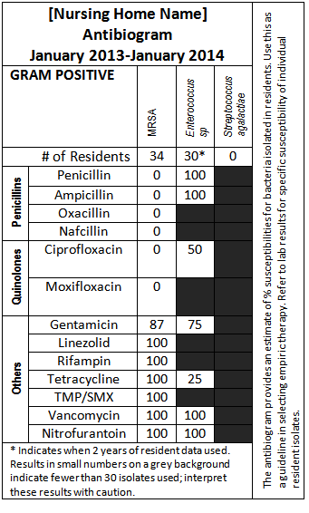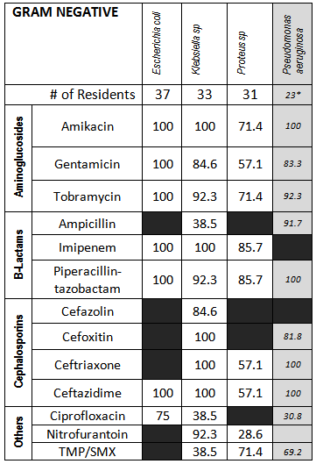

How often will the antibiogram be updated?
You can choose how often to update your nursing home’s antibiogram. CLSI guidelines recommend that antibiograms be updated annually. More frequent updates would only be recommended if the number of isolates substantially exceeded the minimum of 30 on a routine basis. This is highly unlikely to happen in a nursing home.
It is also important to keep in mind the frequency at which culturing occurs within your nursing home. If you have a small number of cultures for particular organisms, data can be collected for a period of longer than one year in order to reach the recommended minimum. When this is done, the antibiogram should be clearly marked to indicate which organisms are using more than one year’s data. Remember, an antibiogram may not highlight emerging infection outbreaks, but it can monitor trends in antibiotic susceptibilities.

