Development of a Planning Tool
to Guide Research Dissemination
Deborah Carpenter, Veronica Nieva,
Tarek Albaghal, Joann Sorra

Abstract
Investigation in patient safety improvement is constantly yielding new research results, yet efforts to put the results into practice are inconsistent. Therefore, a pragmatic tool is needed. The Dissemination Planning Tool was developed to assist the Agency for Healthcare Research and Quality (AHRQ) Patient Safety grantees with disseminating their research results. It was designed to help researchers consider major areas in dissemination: packaging research results, identifying target users, engaging connector organizations, identifying barriers, developing success measures, and allocating resources to implement the plan. Developing the tool included several stages, beginning with adapting Rogers’ seminal diffusion theory. Literature was reviewed from health care, sociology, organizational development, psychology, and social sciences, thus providing a breath of dissemination theory and practices. Tools currently used in field-specific instances were reviewed. All of these sources were synthesized through a process of refinement, expert review, and testing.

Introduction
New research results regularly provide an abundance of information to improve health care. Unfortunately, putting these results into practice often falls short of their envisioned potential. Even when research results are successfully disseminated, diffusion of the innovation occurs slowly, if at all.¹ In many cases, it sometimes takes decades to put research into practice.²
Most grant-funding entities typically support basic research rather than intervention or implementation studies. An exception is the Agency for Healthcare Research Quality (AHRQ)—a division of the Department of Health and Human Services—which is committed to helping bridge the time gap between discovering scientific evidence and improving patient care. For example, through their Translating Research into Practice (TRIP) initiative, AHRQ aims to accelerate the impact of research on patient care to improve clinical outcomes and enhance cost effectiveness and efficiency using partnerships between researchers and health care organizations.³ Beginning in 2001, AHRQ awarded a series of grants and contracts to stimulate research and demonstrations in patient safety and medical error reduction. These grants and contracts were collectively named the AHRQ Patient Safety Portfolio. AHRQ’s Patient Safety Research Coordinating Center (AHRQ-PSRCC) provides assistance and support for the Patient Safety Portfolio in collaboration with the coordinating center’s steering committee, whose members represent patient safety grantees across the portfolio. As with its TRIP initiative, AHRQ is committed to disseminating the research results from this portfolio to improve patient care practices, thus ultimately helping to make the health care system safer.
Dissemination and implementation are complex processes, involving many disciplines and players within an organization. No one approach or strategy universally applies in every situation. Researchers, therefore, need to use multiple methods and tools to navigate their dissemination course (Figure 1). Members of the AHRQ-PSRCC and the steering committee developed a conceptual framework that gives context for the patient safety researchers’ dissemination plans. The Framework for Knowledge Transfer of Patient Safety Research (Framework) includes three major processes: knowledge creation and distillation, mass diffusion and targeted dissemination, and organizational adaptation and use.⁴ As an outgrowth of this conceptual framework, the AHRQ-PSRCC, in response to the steering committee’s recommendation, developed a practical planning tool to help researchers spread actionable knowledge to potential users.
The process of implementing any research outcome begins with awareness—when potential users learn about the products, tools, or findings and gain some understanding about how they work.⁵ This planning tool helps increase awareness in a systematic way by wedding the constructs of diffusion and dissemination. Diffusion is defined as a passive process by which an innovation is communicated through channels over time in a social system.⁵ Dissemination involves a more active, tailored process of communication, with a goal of persuading users to adopt the innovation.⁶ Alone, neither construct offers sufficient guidance for successful dissemination of research results; together, the ideas complement and support each other. Both constructs are embodied in the development of this planning tool to guide dissemination of research results.

Purpose of the tool
The Dissemination Planning Tool was designed to help researchers create a dissemination plan that reaches beyond the traditional ways of getting the message out (e.g., peer-reviewed publications and conference presentations). Research shows that employing only traditional methods is ineffective. In a systematic review of 102 controlled trials examining the effectiveness of strategies for changing behavior, Oxman⁷ found that passive approaches to sharing information, such as conference presentations, were less effective than social influencing interventions, such as having respected opinion leaders promote the innovation.
The planning tool encourages researchers to think through the dissemination process and to assemble the building blocks needed to construct a formal dissemination plan specific to their particular research and their intended users’ needs and interests. Dissemination plans created by using this tool highlight ways that researchers can attain their unique project goals and reach target user audiences. The tool also helps researchers evaluate the best ways to distribute patient safety information by emphasizing the benefits of working with

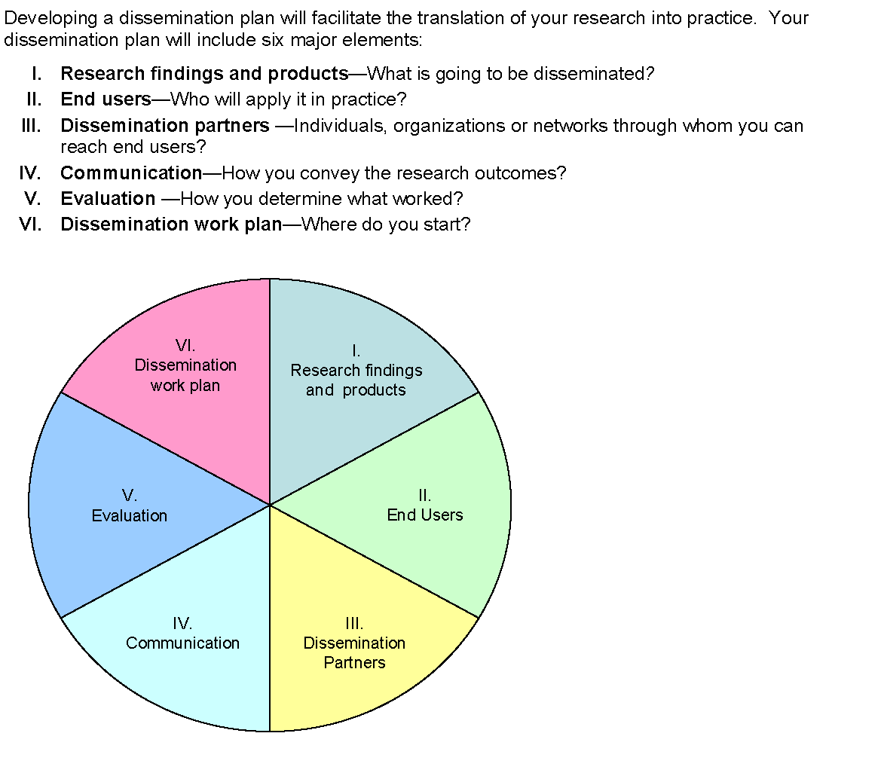
Figure 1. Components of a dissemination plan*

* A complete model of the Dissemination Planning Tool is available at: http://www.ahrq.gov/qual/advances/planningtool.htm .

intermediaries and dissemination partners to amplify the reach to, and receptivity of, user communities.
The planning tool is useful at various points in the research process. One obvious time to complete it is toward the end of a research project, when findings are known or the research efforts have produced a product, tool, or program. Having the research results with associated evidence and pilot information on implementation can provide a compelling case for dissemination partners and end-users. The tool also is applicable at the early stage of the research proposal process—it can help determine user needs and dissemination partner interests. This information will refine research questions to address the users’ practical questions. Using this tool will also plant the seeds of interest of both users and partners, enlisting their support throughout the project.^{8, 9} Furthermore, this tool is appropriate for funding organizations that, through their grant solicitation structures, increasingly influence and guide researchers to consider and plan for dissemination as a key component of their initial research designs.

Development and early testing
Developing the tool involved several stages, beginning with adapting Rogers’ work on the theory of diffusion.⁵ In particular, Rogers describes the innovation decision process in progressive stages: knowledge, persuasion, decision, implementation, and confirmation. The key processes in his first two stages involve understanding the innovation, including its importance and cost benefit; and identifying key adopters, their values and culture, and how to reach them. The aim of these processes is to convince the user of the merit of the innovation. Additional research that was applied in designing the tool was Lavis’¹⁰ organizing approach for transferring knowledge, which includes specifying the message, the target audience, the messenger, how the message should be transferred, and how to evaluate the effect. We further reviewed relevant literature from health care, sociology, organizational development, change management, psychology, and social sciences, all of which provided a wide breadth of knowledge in dissemination theory and practices.
We also searched for existing dissemination self-assessment tools for researchers in the public domain. Although much literature has been produced on the implementation of research results, a pragmatic assessment tool that prepares patient safety researchers to effectively put their results into practice has yet to be developed. In fact, with one notable exception, The Dissemination Self Assessment Inventory from The National Center for the Dissemination of Disability Research (NCDDR), there appears to be an absence of practical dissemination planning tools for researchers. The NCDDR inventory is specifically aimed at disability researchers’ dissemination efforts in the assessment of four areas: organizational structure and policies, research design, dissemination, and evaluation plans.¹¹
We synthesized all sources to identify key aspects of dissemination planning, and narrowed down to the current sections described later in this paper. We then developed draft questions to assess each of these key areas and invited expert reviews of the draft tool from a variety of disciplines. Reviewers included experienced health services researchers involved in patient safety research, national and international experts in dissemination research, professors involved in dissemination theory, knowledge management professionals, leaders in research dissemination organizations, and professionals who are responsible for developing and maintaining dissemination partnerships.
Based on their feedback, the tool transitioned through a series of iterations. For example, experts recommended that the questions be open-ended in order to help educate and stimulate researchers’ thoughts about dissemination. This format was suggested over one featuring descriptive sentences with an agree/disagree scale of responses (a style that is frequently used in other instruments). Experts also wanted to include additional content to account for the human and financial resources needed for dissemination and to specify tactical activities and individuals responsible for achieving the activities. They also noted the importance of considering informal user networks, where, as evidence suggests, vital opportunities for dissemination exist.¹² They further encouraged highlighting the importance of linking research results to the agenda of connector organizations and recognizing the importance of timing—identifying events and issues in the partner’s environment that may help or hinder their interest in the research results.
Patient safety researchers within the Patient Safety Portfolio also were recruited to complete the draft tool with their own research in mind. In line with the expert feedback, researchers also recommended adding an action planning section to help the respondent consider practical next steps to help make the plan operational.

Description of the tool
The tool is intended to produce a working document that requires several iterations to fully complete. Changes are made as additional information emerges. While an individual such as the principal investigator may coordinate completing the tool, he or she should expect to consult with other members of the research team to fully capitalize on their knowledge and, importantly, to gain their support of the plan. The planning tool serves as a discussion structure for the team, with every member providing his or her unique perspective. Optimally, the dissemination planning team should include end users and partners to better understand their needs and, thus, the best possible methods for and approaches to “selling” the innovation.
The tool is structured into six sections: defining the research, identifying target users, working with dissemination partners, communicating the research, evaluating the success of the dissemination process, and developing an action plan. Each section builds on another to help researchers create their comprehensive plan. A construct rationale and overview for each section is briefly discussed below.
Research findings and products—what is going to be disseminated? Patient safety research efforts may yield several findings and/or tools that warrant distribution to other researchers or target users. This section helps researchers specifically identify what they want to disseminate and how to craft the value statement for the user. In traditional marketing terms, this section helps define the “product,” which is a fundamental step in the dissemination process. To define the product, the tool helps researchers consider ways to bundle or package their research. For example, if the research results include an event reporting system, the researcher could choose to disseminate it as a package, or separately disseminate the taxonomy or data analytic methods that were developed as a component of the reporting system. For each product that the researcher develops, an evaluation of its readiness for dissemination is vital. The planning tool helps researchers consider if the finding or product is ready for immediate use by assessing its track record of success in practice, the strength of scientific evidence that supports the results, and whether it conforms to established procedures. This evaluation of product-implementation readiness helps the researcher create a compelling value proposition to influence user interest.
End-users—who will apply it in practice? End-users are individuals or organizations that could benefit by applying the research results. Specifying end- users focuses the dissemination plan and targets the message. Change programs often do not work because they fail to involve formal structures and systems.¹³ Understanding the behaviors of the end-users and the systems they work within is important in planning for dissemination,¹⁴ because these user networks are a powerful milieu for sharing innovation. The Dissemination Planning Tool prompts the researcher to think about the users’ (consumers’) needs and values, and why the research is important to them (e.g., saves time, improves their work). User needs are often driven by external forces in the environment, such as regulatory pressures. The tool invites the researcher to think about related events that may help or hinder users’ interest in their research. For example, a standard issued from the Joint Commission on Accreditation in Healthcare Organizations (JCAHO) on assessing organizational leadership responsibility in creating a nonpunitive culture may prompt a hospital administrator to seek a patient safety culture-assessment instrument. The Dissemination Planning Tool also prompts the researcher to think about barriers of user implementation and how to mitigate them. Considering the end-users’ needs transforms the research message from a research-centric to a user-centric one, aimed at creating a pull from the users who will want to “buy the product.” Attracting users to the product, rather than pushing it on them, will enhance the dissemination effort.¹⁵
Dissemination partners—how can you reach the users? End-users share information in both formal and informal social networks.⁵ Because who introduces an innovation can influence how rapidly an innovation is disseminated,¹⁶ social system norms can dictate how members communicate, and ultimately affect the rate of adoption. Dissemination is not a linear effort, but is often a fluid storytelling process. Informal spread of innovation—through networking, between users, or tapping into existing networks—is a powerful means of dissemination. The tool prompts researchers to list organizations with existing networks that can influence target users through their credibility, expertise, and power of their distribution capacity. By partnering with key intermediaries or connector organizations, researchers can capitalize on the organization’s reach to tailor and amplify their message to users. A key strategy in implementing innovations in organizations involves aligning the innovation with organizational goals and values.¹⁷ As in the end-user section, this section of the tool helps researchers think about the advantages for partners to take part in disseminating the research to help answer their inevitable “What’s in it for me?” question.
Communication—how do you convey the research outcomes? Effective dissemination relies on using varied channels. Bero¹⁸ found that multifaceted interventions were consistently effective in promoting change. While many communication strategies can influence provider practice, (e.g., published and unpublished material, education, academic detailing, etc.), Borenstein¹⁹ suggests that it also is the frequency of exposure to different strategies that most influences behavior. Furthermore, it is important to match the complexity of the research with the right medium. This section of the tool helps researchers to identify ways that users get their information and, importantly, to recognize those channels that are available through identified connector organizations, such as Web sites and newsletters. User feedback about their information-seeking behavior also can provide insight into the best ways to promote the research.
Evaluation—how do you determine what worked? While the ultimate measure of success is improved patient care, this section of the tool helps the researcher think about interim process measures of success, such as the number of physicians who request additional information following a product demonstration. Evaluating the success of the dissemination plan is an iterative process. Dissemination is not a one-time activity, but a process that involves a long-term relationship with users and partners. Continuous feedback helps researchers appraise the effectiveness of their messages, such as what method or approach worked best or which method was most cost-effective. Researchers can use the feedback to improve their dissemination plan. Moreover, a working dialogue among the researchers, partners, and users can improve how the research is applied and mitigate potential barriers, such as those categorized by TRIP grantees (behavioral, structural, process, human subjects, partner, study site, and costs).²⁰
Dissemination workplan—where do you start? In addition to helping develop the dissemination plan, the tool further provides a final section to begin accounting for resources, both human and financial, that will realistically make it happen. Dissemination plans often fall short in two places. First, they become an unrealistic “shopping list” of every possible or desired use for the product that can be identified, but without realistic time and resource commitments. Second, no lead person is identified who would be responsible for ensuring that the tasks planned are actually performed.²¹ The dissemination work plan section helps the researcher outline both immediate and long-term next-action steps with associated timeframes and people responsible. The work plan also prompts the researcher to consider what resources are needed to implement the dissemination plan.

Conclusion and future developments
In their review, experts confirmed the need for a planning tool. Comments included “What a good idea!” and “This tool is an important contribution; there generally appears to be an absence of practical dissemination planning tools for researchers, and it is nice to see this need addressed.” Feedback from researchers who completed the tool also was positive: “I learned a great deal completing it”; “It provides explicit and detailed thinking”; “I plan to assemble the research team to gather additional input”; and “I found myself iterating my thinking as I went through each question—a very effective developmental tool.”
Receptivity to this planning tool and the noted dearth of similar tools reinforce the need to convert dissemination theory into practical tools and techniques. This is especially true as researchers strive to bring patient safety innovations into practice. In consideration of these dynamics, we recognize the need to further develop a dissemination toolkit that would provide additional self-help aids—such as detailed workbooks, project management templates, and resource tracking grids—to further advance the adoption and practice of worthy patient safety innovations.
Researchers traditionally have not been expected to think about dissemination of research results for use in practice. With the recent and ongoing importance given by funding agencies to translating research into practice, researchers will benefit by understanding the dissemination process and its practical application. This does not suggest that researchers will become experts in dissemination, but rather that they will develop a sensitivity to the value and opportunities inherent in this process. The Dissemination Planning Tool is designed to promote awareness among researchers about where their research might and should be applied in practice. It provides a structure to think about what can appear to be a nebulous charge to which researchers are increasingly expected to respond. More importantly, it helps them recognize the importance of the research’s use and practical application.

Acknowledgments
The authors gratefully acknowledge the contributions of the AHRQ-PSRCC Steering Committee members in developing the tool, including Nancy Donaldson, R.N., D.N.S., John Combes, M.D., and Christine Kovner, Ph.D., R.N.

Author affiliations

All authors are affiliated with Westat, Rockville, MD.
Address correspondence to: Deborah Carpenter, R.N., M.S.N., Westat, 1650 Research Blvd.,
Rockville, MD 20850; phone: 301-314-2475; e-mail: deborahcarpenter@westat.com.

References

- Berwick DM. Disseminating innovations in health care. JAMA 2003;289(15):1969–75.
- Balas EA, Boren SA. Managing clinical knowledge for health care improvement. Yearbook of Medical Informatics 2000; pp. 65–70.
- Farquhar CM, Stryer D, Slutsky J. Translating research into practice: the future ahead. Int. J Qual. Health Care 2002;14(3):233–49.
- Nieva V, Murphy R, Ridley N, et al. From science to service: a framework for the transfer of patient safety research into practice. In: Advances in patient safety: from research to implementation. Rockville, MD: Agency for Healthcare Research and Quality; 2005.
- Rogers EM. Diffusion of innovations. 4th ed. New York: Free Press; 1995.
- Lomas J. Diffusion, dissemination, and implementation: who should do what? Ann N Y Acad Sci 1993;703:226–35.
- Oxman AD, Thomson MA, Davis DA, et al. No magic bullets: a systematic review of 102 trials of interventions to improve professional practice. CMAJ 1995;153(10):1423–31.
- Ross S, Lavis J, Rodriguez C, et al. Partnership experiences: involving decision-makers in the research process. J Health Serv Res Policy 2003;(8 Suppl 2):
26–34.
- Charles C, Schalm, J Semradek. Involving stakeholders in health services research: developing Alberta’s resident classification system for long-term care facilities. Int J Health Serv 1994;24(4):749–61.
- Lavis JN, Robertson D, Woodside JM, et al. How can research organizations more effectively transfer research knowledge to decision makers? Milbank Q 2003;81(2):221–48.
- The National Center for the Dissemination of Disability Research (NCDDR). Austin: SEDL; c1996-2004 Dissemination Self-Inventory. http://www.ncddr
.org/du/products/disseminv/index.html. (Updated 2004 Apr 6; accessed 2004 May 5).
- Greenhalgh T. Personal correspondence. 2004 Feb 17.
- Beer M, Eisenstat RA, Spector B. Why change programs don’t produce change. Harv Bus Rev 1990;
68(6):158–6.
- Backer TE. Integrating behavioral and systems strategies to change clinical practice. Jt Comm J Qual Improv 1995;21(7):351–3.
- Plsek PE, Kilo CM. From resistance to attraction: a different approach to change. Physician Exec 1999;25
(6):40–4.
- Cockerill R, Barnsley J. Innovation theory and its applicability to our understanding of the diffusion of new management practices in health care organizations. Healthc Manage Forum 1997;10(1):
35–8.
- Rosenheck R. Stages in the implementation of innovative clinical programs in complex organizations. J Nerv Ment Dis 2001;189(12):812–21.
- Bero LA, Jadad AR. Closing the gap between research and practice: an overview of systematic reviews of interventions to promote the implementation of research findings. BMJ 1998;317:465–68.
- Borenstein J, Chiou CF, Henning JM, et al. Physician attitudes toward strategies to promote the adoption of medical evidence into clinical practice. Am J Manag Care 2003;9(3):225–34.
- Feifer C, Fifield J, Ornstein S, et al. From research to daily clinical practice: what are the challenges in “translation”? Jt Comm J Qual Saf 2004;30(5):235–45.
- Clements D. Personal correspondence 2004 Mar 1.

